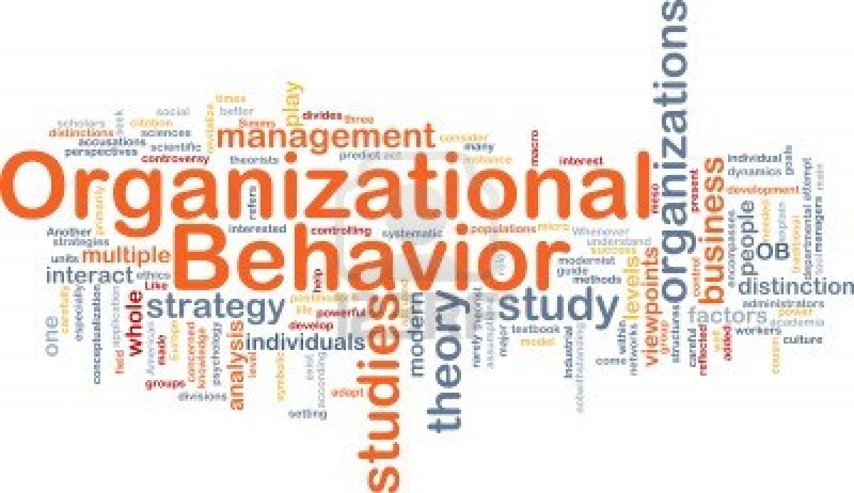

Management and Organizational Behaviour

Narcisa Maria Ieremie
1815100
Dale Clarke
M5x01924

Introduction
Management is considered as both art as well as science since it is concerned with the existence of systematic knowledge body as well as the existence of variety of principles that are applied for the organisational well-being. There are various functions of management such as organising, planning, coordinating, commanding, controlling, leadership and others (Christensen et al., 2020). The managers are required to plan their activities as well as lead their team for the fulfilment of the plan so that there is overall effectiveness of the plan. The organisational performance is greatly affected by the culture, structure and employees; hence, it is important to understand the interrelationship between these factors.
This essay would critically analyse the various dynamics of culture, organisation structure and their employees. It would also discuss about the nature of managerial work in an organisation and relate it to the organisational leadership. It would also aim to understand the various behavioural approaches towards management and how the individual behaviour is being affected.
Discussion
As per the opinions of Intezari and McKenna (2018), the organisational culture as well as the organisational structure is directly interconnected with organisational performance. The theory of strong culture believes in the fact that the employees as well as managers of the organisation are fully committed to customs, morals and collective principles, which would bring out positive outcomes in the organisation (Christensen et al., 2020). The theory states the fact that there is a strong interrelationship between the organisational culture and the organisational profit. It is also argued that the level of corporate culture is directly related with the level of profits in the organisation. It is employees and the organisation share a common culture in which it is possible to fulfil the goals of the company (Christensen et al., 2020). The organisational culture theory specifies the fact that the companies use communication in order to develop patterns of rituals, traditions, behaviours and other norms (Elsmore, 2017). The ultimate goal of this theory is prediction of different communication symbols that are evident in the organisation for the maintenance as well as development of organisational culture. A collective culture imbibes positive impact in the organization since the existence of common culture helps the employees to identify themselves with the organizations and feel responsible for their actions (Laforet, 2016). The managers are recommended to instil strong corporate culture in the organisation so that the employees can deliver excellent performance. It is important to motivate the employees so that there is overall organisational effectiveness. The term 'culture' can be defined as the various collective thinking of individuals that provide differences between multiple members of the same group from one another (Christensen et al., 2020). The cultural aspects are concerned with the behaviours, beliefs and the different values of societies that shape the individual behaviours. Karpati et al. (2017) argues that the organisational culture is largely based on the various cognitive systems that are helpful in explaining the behaviour of the employees and how they make effective decisions for the organisation.
The organisational culture is essentially comprised of several subcultures, that are segments of the varied culture that arise due to difference in demographic background of the employee, different geographical location, different job requirements and different perception of the employees (Salim and Jalil, 2018). It is important that managers try to reduce any conflicts between the employees of the organisation, so that there is an overall enhancement of organisational culture, which would enhance the performance of the employees. According to Hofstede's model of organizational culture, there are four dimensions of organisational culture (Minkov, 2018). The first dimension is the power distance that determines the degree to which the management as well as employees has distant relationship that can be both formal as well as informal (Salim and Jalil, 2018). The parameter of individualism is concerned with the degree to which there can be difference between the self-interest of the employees with that of the organizational interest (Bhatia and Bhatia, 2019). The third parameter is concerned with the uncertainty avoidance, which is concerned with the level in which employees are willing to tolerate ambiguity as well as uncertainty. The fourth parameter is concerned with masculinity that is concerned with the pattern in which employees define success as challenge, ambition, insolence rather than promotion and caring.
The performance measurement system is important in an organisation in which the effectiveness of work of the employees is being evaluated that is aligned with the achievement the mission of the organisation. The companies are increasingly managing their non-financial assets such as quality of services, quality of performance, link with customers, increasing level of customer satisfaction and others (Salim and Jalil, 2018). One of the most important tools of strategic performance management in organisation is implementation of balanced scorecard, which is helpful in determining whether strategy is being implemented into specific performance measurement sets (Maestrini et al., 2018). This scorecard includes four viewpoints such as internal business process, financial process, learning and growth and customers. The successful implementation of this tool is helpful in the achievement of organisational goals, communication improvement as well as providing effective feedback on the organizational performance.
It is true that various organisational structures have the ability to either promote or inhibit the performance of the employees that is dependent on the effectiveness of how the supervisors balance the relationship between the employees of organisation so that there is smooth workflow. The performance management activities require various goal setting activities as well as various periodic reviews by different managers. According to Mintzberg, the organisational structure is concerned with the division of jobs as well as job coordination in an organisation (Salim and Jalil, 2018). Organisational structure is also concerned with the various levels of hierarchy, centralisation of authority, horizontal integration level and the various communication patterns. Maestrini et al. (2018) defines that the organisational performance is concerned with the ability of the organisation to accomplish its mission through proper utilisation of resources through the implementation of proper structure. There are different dimensions of organisational performance such as gross profit, return on investment, return on assets, return on equity, export growth, revenue growth and others, which are used by the managers to determine the effectiveness of work force and how the employees are performing in an organisation.
It is important that the managers emphasize on satisfaction of the employees, different efficiency related measures and others so that they can measure the employee performance and suggest any suitable improvement (Salim and Jalil, 2018). The organisational performance can be measured through both financial as well as non-financial parameters. The financial measures help the managers on how to focus on different trend analysis as well as benchmarking analysis whereas the non-financial measures focus on commitment, communication and overall involvement with the organisation (Närman et al., 2016). It is evident that higher job satisfaction levels are witnessed in decentralized organisations, in which there is broad span of control, where the managers are responsible for the activities of a number of employees. It is widely accepted that the relationship between organisational effectiveness and organisational structure is determined by the information processing requirements so that the employees have adequate information required for fulfilling the organisational mission. It is true that in a good organisational structure, it is not possible for the good performers to give their best performance (Salim and Jalil, 2018). Hence it is important focus on both effectiveness as well as efficiency for managing the organisation in a better way.
Leadership is considered as one of the most important functions of management since it is considered to set new direction and inspire the team members to fulfil the organizational mission. Leaders are considered to create vision and motivate the team members so that they can deliver their best performance. Managerial work comprises of planning, organising, controlling and directing the people so that they can give optimum performance in the organisation. The leaders are said to influence their followers so that they can achieve the organisational goals by giving optimum level of performance. Van der Voet and Van de Walle (2018) argues that leaders are different from managers in the way of their functioning as well as the way perceive their tasks in an organisation. The leaders are creative and they find innovative ways of solving a particular problem, which can go beyond their expected boundaries, while the managers usually perform within their specified limits. The managers are responsible for day-to-day operations of the company while the leaders inspire people for giving their best performances (Van der Voet and Van de Walle, 2018). However, it is important to have the perfect blend of both managers as well as leaders for the global organisations that operates in the competitive business environment. The managerial leaders need to reshuffle their responsibilities so that the organisational tasks are completed in a perfect manner. The managerial leaders need to be down to earth, humble, flexible and should have effective soft skills so that they can manage their team members well.
Antonakis and Day (2017) opines that there are several factors that are responsible for determining effective leadership as well as management email organisational setting. The effective leaders should have essential personality traits such as responsibility, innovation, self-confidence, ability to solve organisational conflicts, create positive work environment and making effective decisions. Koohang et al. (2017) believes in the fact that there is positive interconnection between knowledge management, trust, organisational performance and various attributes of leadership. The leadership is concerned with knowledge management, leading self and organisational performance across various levels of the organisation.
It is evident that different employees in the organisation display different individual behaviour that is dependent on various factors. As per the opinions of Berry, Broadbent and Otley (2019), the Behavioural Management Theory identifies the different human behaviour at the workplace suggest group dynamics, expectations, conflict, motivation and improved productivity. According to this theory, the employees are considered as resources, assets and individuals who needs to be developed over time. Maslow's theory of needs focuses on the motivation, which is essentially based on the fact that motivation is concerned with the fulfilment of human needs such as physiological, safety, esteem, belonging and self-actualization (Koohang et al., 2017). He also believed in the fact that it is not possible to satisfy human needs completely and the human behaviour is considered as purposeful as well as dependent on the fulfilment of the needs. Managers of organisations need to understand the requirements of team members so that we can provide sufficient motivation to the team members, which would make them to deliver their best performance. According to the Hawthorne studies, attitudes and behaviours of the employees are interrelated and it is evident that the group standards are responsible for affecting the workers output (Muldoon, 2017). It has been observed that compensation is least affecting the output of the employees, instead the performance output is being affected by group attitudes, group standards and security. The modern-day managers use behavioural approach frequently in their organisation since they need to identify the various reasons for the particular performance of the employees.
Conclusion
The employees in the organisation have their unique set of beliefs and values, which are imbibed in them when they join the organisation. The organisational culture has considerable impact on the employee’s performance. If the employees are motivated and they operate in a mutually benefiting organisation culture, then they would definitely produce higher performance. The various inter relationship between organisational structures, employees, organisational culture and organisational performance are analysed. Managers are supposed to be leaders and the modern-day organizations should have managerial leaders who would be able to handle global corporation well. The leaders should have essential attributes that helps them to manage the organisation well. It is important to bring positive development in the organisation so that employees are motivated to give higher performance and better fulfil the organisation goals.

Reference List
Antonakis, J. and Day, D.V. eds., 2017. The nature of leadership. Sage publications.
Berry, A.J., Broadbent, J. and Otley, D.T. eds., 2019. Management control theory. Routledge.
Bhatia, R. and Bhatia, A., 2019. A Comparative Study on Models of Organizational Culture in Higher Education in India. research journal of social sciences, 10(6).
Breuste, J.H., Anwar, M.M., Nawaz, R. and Rani, M., 2017. Urban Ecosystems: Functions, Value and Management. In Ecosystem Functions and Management (pp. 123-154). Springer, Cham.
Christensen, T., Lægreid, P. and Rovik, K.A., 2020. Organization theory and the public sector: Instrument, culture and myth. Routledge.
Elsmore, P., 2017. Organisational Culture: Organisational Change?: Organisational Change?. Routledge.
Intezari, A. and McKenna, B., 2018. Creating organisational culture. Leadership: Regional and Global Perspectives, p.160.
Karpati, A., Freedman, K., Castro, J.C., Kallio‐Tavin, M. and Heijnen, E., 2017. Collaboration in visual culture learning communities: Towards a synergy of individual and collective creative practice. International Journal of Art & Design Education, 36(2), pp.164-175.
Koohang, A., Paliszkiewicz, J. and Goluchowski, J., 2017. The impact of leadership on trust, knowledge management, and organizational performance. Industrial Management & Data Systems.
Laforet, S., 2016. Effects of organisational culture on organisational innovation performance in family firms. Journal of Small Business and Enterprise Development.
Maestrini, V., Martinez, V., Neely, A., Luzzini, D., Caniato, F. and Maccarrone, P., 2018. The relationship regulator: a buyer-supplier collaborative performance measurement system. International Journal of Operations & Production Management.
Minkov, M., 2018. A revision of Hofstede’s model of national culture: old evidence and new data from 56 countries. Cross Cultural & Strategic Management.
Muldoon, J., 2017. The Hawthorne studies: an analysis of critical perspectives, 1936-1958. Journal of Management History.
Närman, P., Johnson, P. and Gingnell, L., 2016. Using enterprise architecture to analyse how organisational structure impact motivation and learning. Enterprise Information Systems, 10(5), pp.523-562.
Salim, A.N. and Jalil, S.J.S., 2018. Influence of National Culture on Business & Organizational Culture–in Iran &. Leadership Quarterly, 13(6), pp.673-704.
Van der Voet, J. and Van de Walle, S., 2018. How cutbacks and job satisfaction are related: The role of top-level public managers’ autonomy. Review of Public Personnel Administration, 38(1), pp.5-23.
Western, S., 2019. Leadership: A critical text. SAGE Publications Limited.

