Micros, Peripherals and Interfaces

Using and programming the 7-segment display prototype circuit

BEng Embedded Electronics systems

Module Code: ACCA4004

Name: Bailey Freeman Date: 13/01/2025

Contents

The circuit……………………………………………………………………..3
The programme plan………………………………………………………..5
The programme………………………………………………………………8

The Circuit
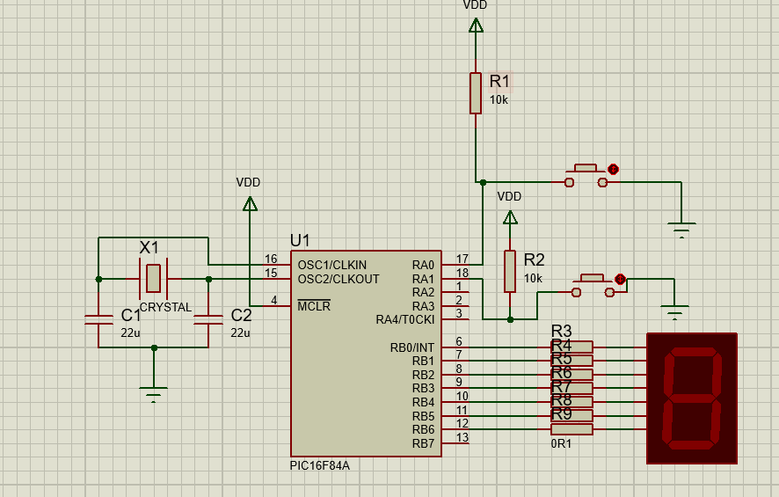
The circuit used for this assignment mainly focuses around a PIC16F84A which is an 8-bit microcontroller that can be used to control many different things but, in this case, it is being used to take inputs and operate a seven segment LED display. A circuit diagram is shown below.

It is important to understand the individual components in the circuit in order to understand the whole circuit, so the following section is a breakdown of each component in the circuit.
The Microcontroller:
The PIC16F84A microcontroller (U1) is the brain of the circuit. It operates by executing a pre-written programme stored in its memory, allowing it to process inputs and control outputs. This microcontroller includes two ports:
Port A (RA0-RA3) is configured as input for receiving user signals via push-button switches.
Port B (RB0-RB7) is configured as output, driving the 7-segment display to show numerical or symbolic results.
The microcontroller relies on a clock signal to execute instructions sequentially. Its performance depends on the external oscillator connected to its OSC1 and OSC2 pins, which ensures a consistent operational frequency.
Clock Circuit:
The clock circuit consists of a crystal oscillator (X1) and two capacitors (C1, C2). The crystal oscillator turns the natural vibration of a quartz crystal into an electrical square wave which can be used to set the clock speed of a microcontroller. The frequency of the oscillator determines how fast the microcontroller processes instructions, which is essential for precise timing in applications such as counters or timers. Faster clock speeds will in turn allow processors to process more data quickly but the speed at which processors can run at is dependant on the quality and specifications of the processor as well as the cooling precautions in place
The capacitors stabilise the oscillations generated by the crystal by filtering electrical noise. Without these capacitors, the oscillator's performance could become erratic, causing timing errors or inconsistent microcontroller behaviour.
Buttons:
The circuit includes two push-button switches connected to input pins on Port A (RA0, RA1). These switches allow user inputs into the system. Each switch is paired with a 10 kΩ pull-down resistor (R1, R2) to ensure the corresponding input pin reads a HIGH (logic 1) signal when the switch is not pressed. When a switch is pressed, it creates a direct connection to ground, making the pin read a LOW (logic 0) signal. This provides binary input signals that the microcontroller can process.
7 Segment LED:
The output of the circuit is a 7-segment display connected to Port B (RB0 to RB7). Each LED which makes up one segment of the display corresponds to one of the microcontroller's output pins, allowing it to control which segments are lit. By sending appropriate HIGH and LOW signals to these pins, the microcontroller can display numbers or certain letters on the 7-segment display.
To protect the display, current-limiting resistors (R3-R9) are placed between the microcontroller pins and the segments. These resistors prevent excessive current from damaging the LEDs in the display.

Programming the Microcontroller

Now that the circuit and the components within it have been explained, this report can go into the programming. The circuit needs to be programmed to display a count from 0 up to F as hexadecimal and have a delay of roughly 200ms. To do this you’d first have to find the binary output to give the 7-segment display to display each character you want and note this down so you can call it back later. You would then have to initialise the microprocessor and set up its input and output ports. Also, any variables that will be used in the code should be declared. Then you’d need to create a loop for the count to go in which can be created by declaring a function that ends by returning to the top. After that you would need a function that will pass a value to the output and then delay for 200ms. Once you have these things set up you can write code in the loop that will pass the value for which character you want to display and then call the function that outputs that value and delays and then repeat this for each value and allow it to loop back around.

Pseudo code for this programme:

Setup PIC16F84A
Setup portA input
Setup portB output

Count loop
0 value to active register
Call print and pause function
1 value to active register
Call print and pause function
2 value to active register
Call print and pause function
3 value to active register
Call print and pause function
4 value to active register
Call print and pause function
5 value to active register
Call print and pause function
6 value to active register
Call print and pause function
7 value to active register
Call print and pause function
8 value to active register
Call print and pause function
9 value to active register
Call print and pause function
A value to active register
Call print and pause function
B value to active register
Call print and pause function
C value to active register
Call print and pause function
D value to active register
Call print and pause function
E value to active register
Call print and pause function
F value to active register
Call print and pause function
Return to count

print and pause function
output active register value
delay for 200ms
return
end

The assembly programme
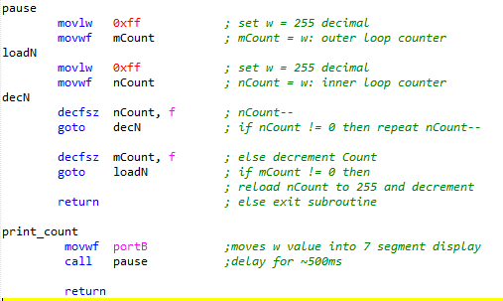
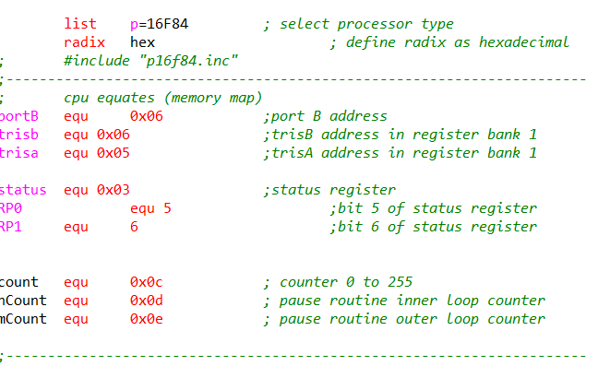
This method shown in the pseudo code was used to create a programme with assembly language and is shown in the below screenshots:
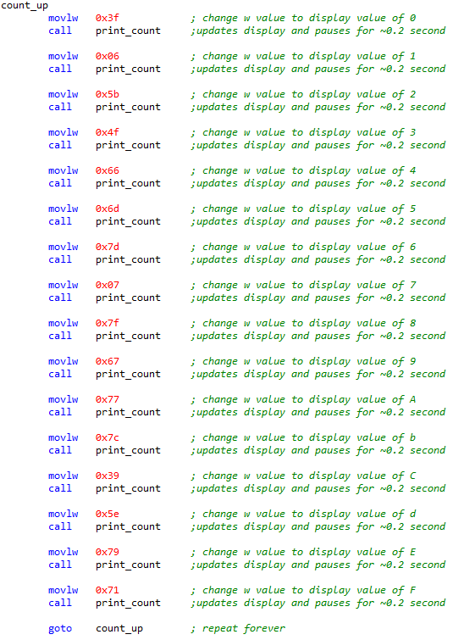

This programme produced the desired outcome of the 7-segment display count from 0 up to F with 200ms delay inbetween successfully.

