

Psychology for Health and Social Care
Assessment Component 2
Reflective Report

Module Code: BMHP4003
Student ID:2008341
Student Name: Elena Ruseva
Module Leader: Diya Ganguly

Table of Contents

Introduction
Kohlberg’s moral development theory
Overview
History of moral development theory by Kohlberg……………………………………
The moral development stages as per Kohlberg’s theory……………………………
The pre-conventional level
The conventional level …………………………………………………………….
The post-conventional level ………………………………………………………
Criticism ……………………………………………………………………
Application of Kohlberg’s moral development theory in practice …………………………
Reflection …………………………………………………………………………………………….
Conclusion ………………………………………………………………………………………....
References ………………………………………………………………………………………….

Introduction
This is individual reflective report which will focus on the various aspects of Kohlberg’s moral development theory, as discussed in our group presentation. It will look into Kohlberg’s moral development theory in depth, focusing on its history, its application and role, and its limitations. Kohlberg’s moral development theory will also be applied in relation to my role as an administrative team leader, working with clients with learning disabilities and autism. This report will also look into how Kohlberg’s moral development theory and module can be applied to social and health care practice.

Kohlberg’s moral development theory

Overview
Kohlberg’s work in the field of cognitive moral development is regarded as highly influential and innovative. (Gibbs, 2003) The theory is majorly focused on children’s moral development and is an expansion of Piaget’s model. Similar to cognitive development, according to Kohlberg’s theory, children’s moral development happens in six stages (Psychology Notes HQ, 2015). Furthermore, the stages are highly focused on justice, where seeking and maintaining it defines the moral compass. (Cherry, 2019).
Morality is described as the recognition of the difference between the good and bad, between what is wrong and what is right. It is based on the obedience and respect towards the rules. Morality is related to the right conduct - the characteristic or the mental disposition which describes behaviour which intends to do good. In the process of moral development, individuals develop the sense of differentiating what is good from what is bad. The question explored in Kohlberg’s work is how people develop this sense, their morality. While Piaget’s theory looks into two stages of morality which develop up until early adolescence, Kohlberg expands on that, suggesting additional stages that develop later in the lifespan – in adolescence and adulthood. (Crain, 1985), pp.118-136)check harvard
History of moral development theory by Kohlberg
Kohlberg’s moral development theory originated from the idea of moral dilemmas – when two values come from conflicting ideas. In his research, Kohlberg presented such moral dilemmas to participants and asked them how, and more importantly, why they would act in a certain way in such a scenario. (courses.lumenlearning.com, n.d.). One of the dilemmas - Heinz dilemma, Kohlberg presented to the subjects – boys aged 10-16, is a story about a husband trying to save his sick wife, ending up having to steal expensive medicine from a pharmacist who was not willing to help him (Lawrence Kohlberg, n.d.). However, Kohlberg was not interested if the participants think this was right or wrong to do. What he explored is the reasoning behind the subjects’ opinions. From this information, there are classified six stages which were the basis of Kohlberg’s moral development theory.

The moral development stages as per Kohlberg’s theory

Kohlberg proposed that moral reasoning develops in three levels: 1. Pre-conventional Morality; 2. Conventional Morality; and 3. Post-Conventional Morality (Lumen, 2008). Furthermore, and in each of the three levels, there are two stages, as can be seen in the figure below.
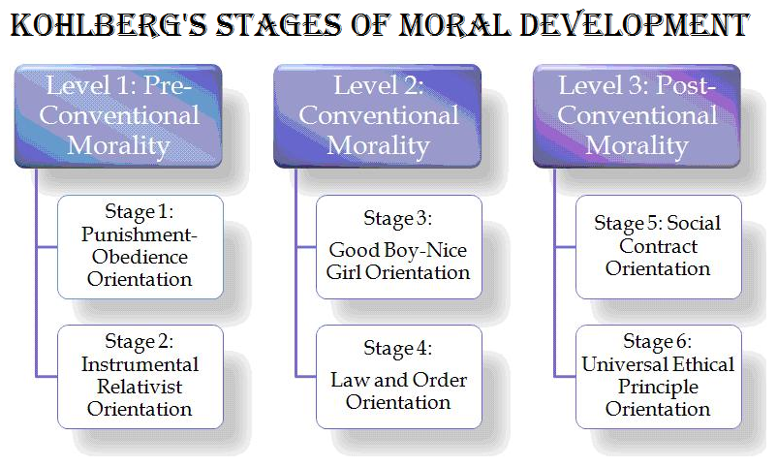 (saba4mi, n.d.)
The pre-conventional level. At this early level, children respect and use the moral values that figures of authority, such as parents and teachers present. The child here does not have an understanding about what is acceptable to the society, but can see that actions have consequences. This level is made up two stages; the first stage is the obedience and punishment stage. In this stage the children view rules as fixed and absolute. The second stage is the individualism and exchange stage where the children view the actions basing on how the actions serve their individual needs. According to Kohlberg and Hersch (1977), “Elements of fairness, of reciprocity and equal sharing are present, but they are always interpreted in a pragmatic way”.
The conventional level. At this level, the sense of morality among individuals is influenced by the society and the personal relationships. In this middle stage, figures of authority are still considered a reliable determinant of what is right and wrong, but children start following the rules in order to fit in and build good relationships (McLeod, 2013). The third stage of morality is focused on developing good interpersonal relationships, also known as “good boy-nice girl” stage - to behave according to the social expectations and roles. In the fourth stage in the model, individuals are very focused on maintaining law and order by respecting authorities, rules and doing as needed (Lumen, 2008).
The post-conventional level. At the third level, the sense of morality among individuals is based on values and principles which are more abstract. The post-conventional level is also made up of two stages – Social Contract: and Universal Ethical Principles (Kohlberg and Hersh, 1977). Under the first stage, the aspects of Social Contract and Individual Rights causes individuals to have different opinions, views, values, and beliefs from other people. The final stage of moral development by Kohlberg is the Universal Principles stage, which is based on abstract reasoning as well as ethical principles. According to Crain (1985), the definition of justice as acknowledged by Kohlberg was influenced by moral leaders such as Gandhi and Martin Luther Kind, as well as the philosophers Kant and Rawls. In the words of Crain (1985, pp118-136) “According to these people, the principles of justice require us to treat the claims of all parties in an impartial manner, respecting the basic dignity, of all people as individuals. The principles of justice are therefore universal; they apply to all.”

Criticisms
However, even though Kohlberg’s research is well-respected, more recent research has identified some criticisms to the theory, as shown on the figure below (McLeod, 2013). (Figure N).
FIGURE N & TITLE

Application of Kohlberg’s moral development theory in practice
I work as an administrative team leader at a company that offers care and support services for people with various disabilities. I supervise a team of care workers, that deals mostly with patients suffering from learning disabilities and autism. My main duty is quality assurance - ensuring that my team provides high quality care and support to the service users, following guidelines and the company’s principles. The main values that define my team and our work are diversity, equality, safeguarding, centred person care, duty of care, duty of candour, privacy, and dignity.
Kohlberg's moral development theory can be related to my practice at work. There are strong ethical standards set by the company and the government to ensure our clients receive high quality services. Moral development in line with these standards is therefore very important. As the theory suggests, values and ethics can be developed until later in life, which means that our workers can internalise some of the company’s ethical principles while working there at the post-convectional level. This way, workers can more effectively meet our clients’ needs enabling them to live high quality lives. This theory also enables us to evaluate the motivations and behaviours within the team, which can increase the effectiveness.
Reflection
In this module, I learnt about the various aspects of developmental psychology and how it applies to health and social care. According to (Apa.org, 2021) developmental psychology studies how people grow throughout the lifespan, and how they learn, change, and adapt. This module looked into the various theories that explore how human beings develop through lifespan such as Erikson’s psychosocial development model, Kohlberg moral development theory, Piaget’s theory of cognitive development as well as Freud’s psychosexual development theory. My presentation and report focused on the moral development theory where I learnt that individuals’ moral reasoning develops through six stages, and it continues throughout the lifespan.
In this module, I learned about different psychological techniques which can be applied in the health and social care. These include the Self-Compassion and Mindfulness Concept, (www.youtube.com, n.d.), which is particularly applicable in my workplace. As a fast paced and a stressful environment, it is very important that our team members stay healthy both physically and emotionally, in order to be able to provide quality care. One of the most important tools is mindful listening as it can help me not only when it comes to my residents, but also to manage my team, to make people feel heard, included and appreciated. Glomb et. al.(2011) share that such tools can lead to: “reduced symptoms of mental, psychological, and psychiatric conditions”. “Mindfulness and mindfulness-based practices have been clearly linked to reduced symptoms of mental, psychological, and psychiatric conditions” is in fact the outcome in Glomb et al., (2011) article. While participating in different reflection and self evaluation exercises as part of the program I am studying, I understood that I have some issues with self-compassion, because I believe in dedication and commitment, which for me means that I need to put my workplace duties as my high priority. In this course I have learned about different techniques which can help me balance my professional and private life.
This module has been very valuable to me, as it has helped me understand how human beings develop through their lifespan – knowledge that I can apply in my work to provide high quality care to the individuals in their various stages of psychological development. Furthermore, looking specifically into moral development has made me look at the principles and ethics in my workplace from a different point of view, which can contribute to my work as a team leader.

Conclusion
Human’s moral reasoning and values develop through various stages and across the lifespan. This development is best described through the stages of moral development by Kohlberg’s theory. The theory looked into what is individual’s reasoning to take a certain side in moral dilemmas, such as the Heinze dilemma. This enabled Kohlberg to differentiate three levels and six stages of moral development. I believe that the theory can be applied to the health and social care practise, especially in relation to guidelines and ethics applied by companies and governments.

References

- Apa.org. (2021). [online] Available at: https://www.apa.org/education-career/guide/subfields/developmental. [Accessed 18th July 2021]
- courses.lumenlearning.com. (n.d.). Moral Development | Introduction to Psychology. [online] Available at: https://courses.lumenlearning.com/wmopen-psychology/chapter/psychology-in-real-life-moral-development/. [Accessed 12 Aug. 2021].
- Crain W. C. (1985). Theories of Development. New York. Prentice-Hall,pp.118-136
- Gibbs, J. (2003). Kohlberg’s Theory: A Critique and New View. [online] SAGE Knowledge. Available at: https://sk.sagepub.com/books/moral-development-and-reality/n3.xml [Accessed 17 Aug. 2021].
- www.youtube.com. (n.d.). Mindfulness at Work - The Benefits. [online] Available at: https://www.youtube.com/watch?v=K5bzkl0Le-w. [Accessed 12 Aug. 2021].
- Glomb, T.M., Duffy, M.K., Bono, J.E. and Yang, T. (2011). Mindfulness at Work. Research in Personnel and Human Resources Management, p.121
- Cherry, K. (2019). Levels of developing morality in Kohlberg’s theories. [online] Verywell Mind. Available at: https://www.verywellmind.com/kohlbergs-theory-of-moral-development-2795071. [Accessed 18th July 2021]
- Kohlberg, L. and Hersh, R.H. (1977). Moral development: A review of the theory. Theory Into Practice, 16(2), pp.53–59.. doi:10.1080/00405847709542675
- Lumen (2008). Kohlberg’s Stages of Moral Development | Education, Society, & the K-12 Learner. [online] Lumenlearning.com. Available at: https://courses.lumenlearning.com/teachereducationx92x1/chapter/kohlbergs-stages-of-moral-development/./. [Accessed 18th July 2021]
- McLeod, S. A. (2013). Kohlberg's stages of moral development. Simply Psychology. [Online] Available at: https://www.simplypsychology.org/kohlberg.html [Accessed 17th July 2021]
- Psychology Notes HQ (2015). Kohlberg’s Theory of Moral Development. [online] Psychologynoteshq.com. Available at: https://www.psychologynoteshq.com/kohlbergstheory/ [ Accessed 18th July 2021]
- saba4mi (n.d.). Kohlberg’s stages of Moral Development | TET Success Key. [online] Available at: https://www.tetsuccesskey.com/2014/01/kohlbergs-stages-of-moral-development.html [Accessed 17th August 2021]
- Lawrence Kohlberg. (n.d.). The Heinz Dilemma. [online] Available at: http://kohlbergpsych.weebly.com/the-heinz-dilemma.html [Accessed 17th July. 2021].

