Title: How is guilt utilised in advertising?
Student Name: Dylan Davies
Student Number: 1702043
Course: BA(Hons) Advertising & Brand Design
Word Count: 5530
Tutor: Julia Lockheart/ Martin Bush
Date: 11th December 2019

Submitted in partial fulfilment of the requirements for the degree of BA(Hons) Advertising & Brand Design at University of Wales Trinity Saint David.
Contents
Sections | Page
List of Illustrations | 3
Summary of Topic | 3
Introduction | 4
Chapter One: The Psychology of Guilt  How Guilt Works  Society  Religion | 6  6  7  8
Chapter Two: Guilt in Film  TV Advertisements  Advertising on YouTube  YouTube Pre-Rolls  YouTube Content | 10  10  12  12  14
Chapter Three: Guilt in Digital Advertising  Sponsored Social Media Posts  Direct Emails | 16  16  17
Chapter Four: Guilt in Print  Magazines  Out of Home Advertising | 20  20  21
Conclusion | 23
Bibliography | 24

List of Illustrations
- Figure 1: What Would Jesus Do? Page 9
- Figure 2: Separation. Page 10
- Figure 3: On Your Child’s Life. Page 11
- Figure 4: Why are we all doing YouTube Preroll wrong? Page 13
- Figure 5: 38 Degrees – Sign the Petition. Page 17
- Figure 6: Missing you… Page 18
- Figure 7: #AMAZINGHOOD. Page 20
- Figure 8: I’m Me, Not Meat. Page 22

Summary of Topic
This dissertation is written to find out how the emotion of guilt can be used throughout advertising and if guilt-tripping an audience is an effective method of promoting a brand or service. I will be exploring its use within our society and religion, along with film, digital and print mediums, allowing me to come to a well-informed conclusion on the subject.

Introduction
Emotion is an incredibly powerful tool in the world of advertising and the world we live in as a whole. We use it to decide everything we do from buying a new t-shirt, to choosing what to eat for dinner. One of the most powerful, however, is guilt. To be able to explore this question, I must first be able to fully understand what guilt is.
The Oxford Dictionary of English provides multiple definitions of the word, including: “the fact of having committed a specified or implied offence or crime”; “a feeling of having committed wrong or failed in an obligation”; “guilt association [which is] guilt ascribed to someone not because of any evidence but because of their association with an offender”; and “guilt trip [which is to] make (someone) feel guilty, especially in order to induce them to do something” (Stevenson, 2010). The ultimate definition is the one that I am most interested in as it has been used countlessly by brands and advertisers in order to manipulate audiences to buy or interact with their products or services.
Jim Camp, the founder and CEO of the Camp Negotiation Institute, provides us with the scenario proving how emotions are more powerful than logic:
Think of a situation where you had bulletproof facts, reason, and logic on your side, and believed there was absolutely no way the other person could say no to your perfectly constructed argument and proposal. To do so would be impossible, you figured, because there was no other logical solution or answer. And then the other person dug in his heels and refused to budge. He wasn't swayed by your logic. (Camp, 2012)
Taking this situation into a consumer perspective, it is like buying a specific product even though you may have no particular need for it or could get a cheaper version, purely because of the emotional ties it has. This effect is amplified when that emotion is guilt as it is especially easy to guilt-trip people into doing something. Dr Thomas Jordan, a clinical psychologist, states that “people who are easily ‘guilted’ are people who have been taught to be over-responsible” (Jordan, 2013). This, for example, could be a parent purchasing only the best-recommended products for their baby so that they can be sure that they will be the safest option.
Advertising covers such a wide range of media in today’s corporate-heavy world it would be impossible to cover each area in detail, therefore I will examine the use of guilt (specifically being guilt-tripped) in film, digital media and print whilst also looking into its background in depth to allow for an even more informed conclusion. I have chosen these particular methods as it allows a diverse exploration of how even the use of vastly different mediums can still all use the same methods on a base level.
I have decided to investigate how guilt is utilised in advertising as despite there already being numerous documentations written on the subject, they all tend to focus on a specific medium within advertising. That is why I will be looking into multiple areas such as how society responds to guilt as well as using the emotion from a creative point of view.

Chapter One: The Psychology of Guilt
1.1 How Guilt Works
Human beings are easily influenced by emotions for many reasons, whether it is because they feel nostalgic by being taken back to their childhood or because they are comforted or filled with joy. Emotion is used everywhere to manipulate us as it “plays a key role in the directing of our attention” as stated by Du Plessis (2005).
One of the strongest emotions that has the greatest impact on us is guilt as nobody likes to feel responsible for an issue, even if they are not responsible anyway. Breggin mentions that guilt and shame are “more than a feeling” and “are emotional experiences that combine feelings, thoughts and judgement or values and that drive us towards inhibiting ourselves or making choices that we did not initially wish to make” (Breggin, 2015). This tells us that guilt is a direct result of a feeling such as embarrassment or regret which then makes us feel remorseful and that we need to take responsibility or action into making the situation right. This is due to us as people, in general, not wanting to be responsible for the cause of somebody else’s pain or misfortune.
Psychologist and professor, Susan Krauss Whitbourne explains that “guilt, in and of itself, isn't a destructive emotion. If you let it become all-consuming, however, guilt can get the best — or the worst — of you.” Here she is saying that guilt is not necessarily good or bad but depends on how we process it and the cause of the feeling initially, such as feeling guilty “for something you did” or because “you didn’t do enough to help someone” (Whitbourne, 2012). Guilt can be used to our advantage if we let it as it can help us become a better member of the community. However, if we allow ourselves to take the feeling in the opposite direction then it can weigh us down and cause us to eventually crash down into a metaphorical pit and spiral downwards.
1.2 Society
Society itself can be, and is, shaped around the notion of guilt and how it can be used for control and power and “in a strictly behavioural approach,” as Katchadourian states; “guilt is just another product of social conditioning” (Katchadourian, 2009). This suggests that we feel guilt purely because we have been told to be affected by our actions throughout our lives, not only to better ourselves but also those around us too. Guilt hasn’t only been disciplined into us, but also taught from our experiences of observing the guilt that others endure, which from a young age we are able to identify the experience from an outside point of view. Katchadourian further proves this with the example of seeing an “older sibling being punished for lying teaches you not to lie” (ibid).
Guilt is extensively used throughout society and one reason for this as Bybee suggests is “that guilt may be a more socially desirable response than shame, in part because guilt serves to satisfy a larger community” (Bybee, 1997). In this extract, Bybee is stating that we use guilt to make other people feel guilty in order to make ourselves feel better as instead of us shaming people and feeling bad about it, inducing guilt onto others places the entirety of the blame onto them. It makes everyone else feel innocent in case there is a negative outcome by not accepting the shaming they are actually doing.
Within relationships, guilt can work both in a positive and negative light. Katchadourian explained this as it causes “people to be more helpful and compliant towards their victims and others as well” (Katchadourian, 2009). This shows that guilt can be a useful emotion within society. Even though it may be used with selfish intentions, most people wish to be released from the burden, thus them helping the people they have hurt. However, Katchadourian follows this statement by saying that it “also has negative and antisocial consequences. We would rather avoid the person we have offended, as well as avoid the person who has offended us” (ibid) This illustrates the difference in people, as some of us would much rather suppress the guilt and cut all ties with the person we had hurt, which only ends up hurting us further, even if we do not recognise the initial cause.
1.3 Religion
Guilt is one of, if not the major subject in relation to religion as it features as a prominent theme throughout all beliefs, making its followers feel guilty if they don’t follow the rules stated in their religious teachings. The whole ideology of Christianity is not to live a pure life but to ask for forgiveness. In J.P Green’s literal translation of the bible (2010), we are told that we should not only feel guilty but that we have sinned. John Toews tells the ideology of the “original sin” which was “Adam’s sin in the Garden [of Eden]” where he and Eve had “mistrust and disobedience of God” (Toews, 2013). This sin has since been passed down over time resulting in us all being born with the original sin and thus being branded as “a sinner from birth” (ibid). This is what is responsible for all the temptations we have. Another example is Christianity’s view towards homosexuality where we “you shall not lie with a male as one lies with a woman; it is a perversion [Leviticus 18:22]” (Green, 2010). This not only teaches Christians to shame others who are homosexual but also makes those followers who are also homosexual feel guilty and potentially end up in eternal damnation for their lifestyle and because of their sexual orientation. This can then result in the individual keeping their preference to themselves and not feeling as though they are able to fully express themselves, making them feel isolated and more guilty.

Pennington and Staples tell the story of a 17-year-old woman who “received a scholarship to a prestigious college… however, she also got pregnant” (Pennington and Staples, 2011). Due to her financial circumstances, the scholarship was her only opportunity for an education, however, she was also Catholic which meant the church was against her having an abortion. This led to her having the baby and then giving it up for adoption, but as a result, she “carried and wrestled with a heavy load of guilt for most of her adult life” (ibid). This account highlights the implications religion can have on an individual and how guilt can force individuals to conform, especially when other factors have an influence.
Figure 1: Revolver/Will O’Rourke (2018) What Would Jesus Do? Dying to Live. TV Commercial.
The 2018 Australian advert by Revolver/ Will O’Rourke promoting the ‘Dying to Live’ documentary takes a very strong religious stance to deliver its aim, which is to encourage people to opt into becoming an organ donor since it was reported in 2016 that “almost 100 Australians travelled overseas to acquire an organ transplant on the black market… [this] illegal trade of organ transplants is driven by a shortage of donations” (Zaczek, 2018). The advert, titled 'What Would Jesus Do?’ depicts Christ on the cross with two guards who “humorously prod the religious figure into donating his organs” (Dawson, 2018). This controversial promotional commercial may be humorous to some people but could either anger followers of the Christian religion due to its blasphemous mockery of the faith, or they could be guilted into following through with their agenda, no matter of the good-willed nature behind it. The guards ask Jesus if he has thought of becoming an organ donor, as it changed from being on your driving licence to you having to sign up online instead, his reply is “obviously I would do it, I am Jesus.” At the end of the advert, we are shown the words “do what Jesus would do” (Revolver/ Will O’Rourke, 2018), which could make Christians feel guilty if they do not opt in to become a donor as it is something that their prophet would do.

Chapter Two: Guilt in Film
It is possible to trace the concept of guilt being used in film from the present day, all the way back to the early days of silent movies. Winer talks about how “the word pathos… became synonymous with Chaplin’s art” (Winer, 2013) as he was a master at evoking emotion in his films.
2.1 TV Advertisements

The Advertising Standards Authority (ASA) tell us that “when commercial TV started broadcasting in 1955… This was the first time that advertisements – and the claims they made - were subject to any form of formal regulation” (Advertising Standards Authority, n.d.). This resulted in television quickly taking over the popularity of radio adverts. This was largely to do with the fact that radio “doesn’t have pictures and doesn’t have the reach of television” (Sutherland, 2000) meaning it isn’t as memorable as television which uses images to back up the sound. Radio advertising faces a lot of challenges as the attention of the consumers tends to be a lot lower than when watching television, as for example, people listen to the radio at breakfast or whilst driving meaning their concentration is placed elsewhere, whereas “when people watch TV they more often do so with fewer distractions.”
Figure 2: Campaign Palace. (2008) Separation. Quit Victoria. TV Commercial.
A very poignant advert that capitalises on making its audience feel guilty is the 2008 Australian advert for Quit Victoria titled ‘Separation’ (Campaign Palace 2008) which features a young child who loses his mother in a busy crowd and he begins to cry in less than one minute through feeling abandoned. The narrator then speaks to the viewer directly, stating “If this is how your child feels after losing you for a minute, just imagine if they lost you for life.” This advert was aimed at trying to get smokers to quit in Victoria, Australia, specifically targeting parents. Fiona Sharkie, Quit Victoria’s Executive Director says “5% of the Victorian adult population have children 12 years or younger and are current smokers, which corresponds to approximately 211 273 smokers” and if the advertisement is able to “spare one young Victorian the grief of losing a parent to smoking then our job is done” (Macleod, 2008).

Another television advert that uses similar tactics is the 2013 ‘On Your Child’s Life’ video created for the Fire Kills Campaign (RKCR/Y&R 2013). This video addresses a different topic to Quit Victoria but still tells its story in a similar fashion. It too features a young child to promote the message. The Fire Kills Campaign was created to get parents to start testing their fire alarms, if not for their sake, but that of their child’s. The video opens with the young boy saying the hard-hitting fact that “last year, in England, 15 children died in house fires” and goes on talking to parents directly, making them pledge to test the fire alarms by repeating the words after him, like an oath. This is a very significant part of the advert to make us feel guilty as an oath is much like a promise, which we morally know is wrong to break and then creates more guilt within us if we do. There is also an element of legal obligation as people are made to take an oath when in court, making it a crime in itself to break that said oath. This advert is a lot more personal than the previous example as it does not only talk to the audience but puts them at the forefront by saying “children like yours.” This creates a stronger relationship with the viewer as most people are inclined to think that something this terrible would never happen to them, but this video insinuates otherwise.
Figure 3: RKCR/Y&R. (2013) On Your Child's Life. Fire Kills Campaign. TV Commercial.
Both of these commercials utilise guilt to persuade people to take action and target parents in particular. The two advertisements feature children as the protagonist as parents typically want to do whatever they can and “want the best for their children” (Grigorenko and Sternberg, 2001), even if they do not think it is necessary for themselves, such as Quit Victoria’s advert to quit smoking. ‘Separation’ and ‘On Your Child’s Life’ both share a similar dull-colour palette, creating a distasteful environment with only a single person narrating, ensuring their messages are delivered clearly and effectively.
2.2 Advertising on YouTube
YouTube is a video streaming platform that allows people to watch content uploaded by others from all over the world and allows them to upload their own videos for others to also view. It has an ever-growing list of users, viewers and content creators, since its creation in 2005. Reports provided by Kit Smith, a content writer for Brandwatch, state that due to increasing popularity the platform was getting, “The first adverts were rolled out in August 2007” and have been growing ever since. Today the platform has “over 1.9bn logged in monthly users” with an “average mobile viewing session [that] lasts more than 40 minutes” and is the “second most visited site after Google” (Smith, 2019), which makes it an ideal choice as an advertising platform.
2.2.1 YouTube Pre-Rolls
A pre-roll advert is simply a video commercial that plays before the start of the selected video on YouTube and can be a very effective way of reaching its specific demographic as it can be set to specific “geography [locations]… languages… age, gender” etc. or to different “keywords, topics or interests” (Forno, 2017). Despite this being an excellent method of reaching the desired audience, the consumers tend to despise it as “internet users are usually more goal orientated when searching for a video on YouTube… [pre-roll videos] are therefore perceived as more intrusive.” These adverts can then cause “undesirable outcomes like irritation, negative attitudes towards the ads and a wish for ad avoidance” (Verlegh et al., 2015). Before the company even try and sell their product or service, they have to find a way to avoid this major issue, hence the pre-roll advertisements must be designed with a purpose and give a reason for the viewer to stay engaged and not simply click the skip button to make it successful. This task can be very difficult, as “about 90 percent of consumers now skip pre-roll,” (Maguire, 2018) which highlights how little consumers want the intrusive ads.
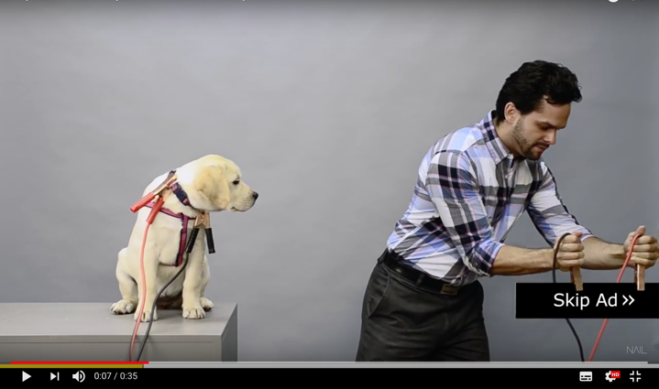
The American advertising agency, Nail Communications, managed to captivate audiences successfully by using the skip button as a tangible object within the video and then interacting with it. The 2014 commercial, titled ‘Why are we all doing YouTube Preroll wrong?’ advertises themselves and The American Society for the Prevention of Cruelty to Animals (ASPCA) as they agree that the money they pay for the advert, which is dictated by the number of people watching, they will also give the same amount to the ASPCA. They captivate the audience in a dark and sinister, yet light-hearted tone as the person in the video attaches cables to the skip button and tells us we "could skip this ad, but then, you'll electrocute this puppy." We are not alarmed by these actions however as we know that there is no real danger to the dog, yet we still feel guilty if we do not stay to watch the commercial mainly due to the fact an innocent dog is used with clips visibly attached to its collar, instead of the scenario being animated which wouldn’t evoke such strong feelings. Even though we know the animal is safe, we feel emotionally obligated to remain viewing as we don’t want to take the risk, especially since many people can relate to dogs with positive and enjoyable experiences. This pre-roll worked very successfully as it was reported that it had a “26% completion rate” (Savage, 2015) which is a very large difference compared to the number of people that typically skip pre-rolls.
Figure 4: Nail Communication (2014) Why are we all doing YouTube Preroll wrong?
2.2.2 YouTube Content
Content creators on YouTube, known as YouTubers, use the platform to advertise anything they wish, whether it be to promote a specific sponsored product or an upcoming tour they may be holding. One of the most prominent advertisements that a lot of YouTubers show in their videos is for their own merchandise as a way of earning more money alongside the revenue from external adverts. This is a result of YouTube being a difficult platform to make a living by only showing pre, mid and post-roll advertisements.
Early 2017 brought a “crackdown on YouTube advertising, which saw many YouTubers losing revenue and having their videos demonetised” (Townsend, 2018). Erik Kain at Forbes reported that this restriction came about when it was found that “terrorist groups like Hezbollah were using YouTube to upload and monetize videos promoting terrorism,” resulting in YouTube needing to “use machine learning to determine if a video meets [YouTube’s] advertiser-friendly guidelines.” The issue with this was that it inappropriately flagged and demonetised videos that “don't seem to have any logical reason behind [it].” This mess got dubbed as the ‘adpocolypse’ (Katin, 2017).
To combat the ‘adpocolyse’ YouTubers had to try and turn to alternative forms of income, such as Patreon, which is a membership-based, crowdfunding platform. The American comedy sketch YouTuber known as Door Monster (real name Kyle Sullivan) who has 315,000 subscribers created a video titled ‘Demonetization’ (2017) to specifically address the issue of demonetisation. He tells his viewers that his channel “has been operating almost exclusively because of the people who have been donating on Patreon” and that “ad revenue is just not a reliable income source.” He tells us this with an apologetic tone so that we then feel sympathetic for him. He uses guilt to manipulate the people who enjoy his videos into donating more money so that they can still watch new content from Door Monster.

Chapter Three: Guilt in Digital Advertising
The online world is a substantial place with endless opportunities for everyone. As of May 2019, the Office for National Statistics (ONS) reported that “virtually all adults aged 16 to 44 years in the UK [United Kingdom] were recent internet users (99%)… compared with 47% of adults aged 75 years and over” (Prescott, 2019). These results clearly highlight the benefit of advertising using a digital and online medium, especially when targeting sixteen to forty-four-year olds as there is a very high chance of them interacting.
The most important merit of online advertising is interactivity. This allows the user to click on an ad and enter the website. That is a direct way of gathering more information about the consumer, and that is a considerable point because advertising on the internet is the only media that facilitates this advantage. (Hanafizadeh and Behboudi, 2012)
3.1 Sponsored Social Media Posts
Social media has become one of the most common and effective ways of advertising due to its ease of being able to reach specific audiences and how it can be easily maintained and updated without any reprinting etc. This also allows adverts to be extremely topical due to the very short turnaround possible with social media.
Facebook is a major platform used by advertisers as Simon Kingsnorth, a senior digital leader and strategist, explains its “paid advertising is very simple… [it allows you to] target a wide range of demographics and interests very effectively” (Kingsnorth, 2019). This making advertising to the right audience far easier as you can target specific demographics and factors, narrowing down the platform’s “2.1 billion users” (ibid) so that only those people see your advert, as opposed to a poster or a billboard, which anybody walking past can see.

38 Degrees is a UK based online campaign organisation who aim to create a positive difference in the world by uniting people for good causes and betterment of our planet. Their paid Facebook advert utilises guilt effectively in order to persuade people to sign the petition to “stop precious forests being destroyed to make chocolate” as the use of palm oil in the ingredients are “pushing endangered species like Orangutans to the brink of extinction” (Mae Dobbs, 2019). This advert has been written in an informative manner as it is a very important subject to be talked about, but it is created to make us consumers feel guilty for continuing to support those chocolate companies that still use palm oil like “Cadbury’s, Mars and Nestlé.” They make us feel guilty by telling us that it is our “favourite Christmas treats [that] are contributing to the devastating destruction of huge swathes of precious forests,” (ibid) which makes us feel as though it is our fault these companies use palm oil in their products, and that is why we should sign their petition. This appeal also tells the companies that their customers want them to become more environmentally sustainable and by showing them in this manner it is more effective than simply asking them to change directly.
Figure 5: Mae Dobbs (2019) 38 Degrees – Sign the Petition.
3.2 Direct Emails
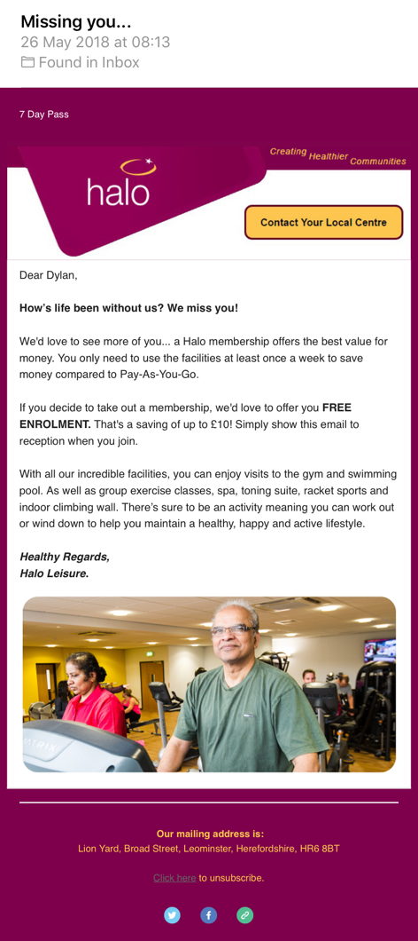
If used by businesses correctly then direct emails can be an invaluable asset to reach its audience and sell their services and products. They are able to easily communicate upcoming deals or promotions, offers or simply the latest news to keep their followers on their mailing list up to date with what is going on. Many companies favour this method of communication as “it’s much cheaper than traditional direct mail. There are no printing costs… [and] is virtually free for companies” (Jones, 2012). This factor alone is enough for businesses to prefer direct emailing, but there is also the benefit of its effective response rate, as “only one person in every 100 replies to junk [traditional direct] mail,” but when “properly targeted, direct email can get a response from one in three potential customers” (ibid).
Halo Leisure is a “registered charity and social enterprise running 22 sport and leisure centres throughout Herefordshire, Bridgend County Borough, Shropshire and Swindon on behalf of the local authorities.” They describe themselves as being “dedicated to providing the best sport and leisure choices” (Halo Leisure, n.d.). They offer membership schemes as well as pay-as-you-go, allowing customers to benefit from their centres in the way best suited to them. As with most membership-based businesses, they want you to keep renewing your subscription and stay with them, so when you cancel your membership with Halo Leisure, they send you a direct email to try and persuade you to become a member again.
Figure 6: Halo Leisure (2018) Missing you…
The email from Halo Leisure with the subject title “Missing you…” (Halo Leisure, 2018) subtly influences us to want to renew the membership as they make us feel guilty that we have not been to their facilities in a while. They begin the email by addressing the recipient by name for a personal approach and asking: “how’s life been without us?” (ibid). This opening question causes us to reflect on our time spent away from their sports facilities, which is often met with a negative response as we feel guilty for not keeping up with our fitness and health, making us think we should renew our membership. The content of the email is written in a friendly and casual tone which further encourages us to listen to what they have to say. The email offers the incentive of “free enrolment… [which saves] up to £10” (ibid) to push you for a renewal even further. We feel guilty about not re-joining the centre’s membership system as the email specifies that “there’s sure to be an activity meaning you can work out or wind down” (ibid) to suit your needs and wishes. This suggests Halo Leisure offer an activity for everyone and there is no excuse not to go.
Chapter Four: Guilt in Print
Print advertising can be used to target a different audience to that of an online one, or as supporting integration to other advertisements. Jim Aitchison quotes Indra Sinha, a British writer, by saying “print can actually liberate the mind and create far more intense illusions, far deeper experiences, than any television or film ever will” (Aitchison, 2008). However, this is only true when the adverts have been crafted perfectly, as print advertising also holds the danger being very monotonous and a “passive, one-dimensional medium” (ibid) if not completed to its highest standard.
4.1 Magazines
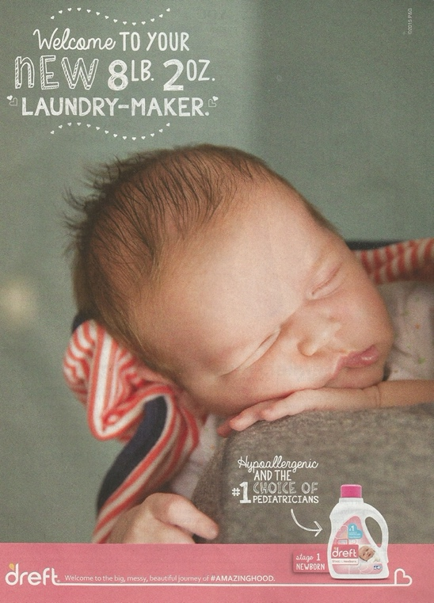
Magazine advertising can have many benefits for brands as you are able to choose specifically which magazine you wish to place your advertisement, which allows you to market your brand to a precise demographic that has already been researched thoroughly. Magazines also “have a long life… [as they are] preserved for a week, fortnight or month and is read time and time again” (Ruchi, 2012), this highlights that a magazine does not necessarily need to have the same memorability as a billboard as the audience is able to spend as much time as possible to look at it and absorb the brand and message. Magazines such as Time has “high credibility [which] lends prestige to the advertised product” (ibid), unlike placing an advert in a Beano comic magazine.
Figure 7: Dreft (2015) #AMAZINGHOOD.
The magazine print advertisement for Dreft laundry detergent, which was printed in 2015’s American Baby magazine, is targeted towards parents to buy for their new-born babies. The advert subtly guilts parents into choosing their brand for washing their baby’s clothes with the copy they have chosen of being the “#1 choice of paediatricians” (Dreft, 2015). By selecting this text, Dreft are telling us their product is the best detergent available for babies and also suggesting that “they perhaps do not care about providing the best for their child” (Alexander, 2016), which is a notion that most parents would despise being classed under. Dreft also makes use of the slogan “#AMAZINGHOOD” (Dreft, n.d.), which implies that their products can make parenthood into an amazing and fun time, which is further insinuated through its use of capital letters as if it is being screamed with joy.
These very small subtleties psychologically play a role to parents who are looking for a washing detergent specifically for their young child as they always want to be able to provide the best for their baby, so Dreft makes sure that detergent is no exception by faintly guilting them.
4.2 Out of Home Advertising
Out of home (OOH) advertising tends to be “regarded as a supplementary advertising medium,” but is actually “a very important form of marketing communications… [and] is the oldest form of advertising” (Andrews and Shimp, 2017). Out of home advertising methods include billboards (which is the predominant method), bus shelters, phone boxes, transport vehicles etc.
Billboard advertising “accounts for nearly two-thirds of total OOH advertising expenditures in the United States” (Andrews and Shimp, 2017), due to it being able to get the most attention from passers-by. As billboards are far larger than a bus stop poster, they can be much more memorable, making them an easy choice for businesses to use for brand awareness and to convey their message.
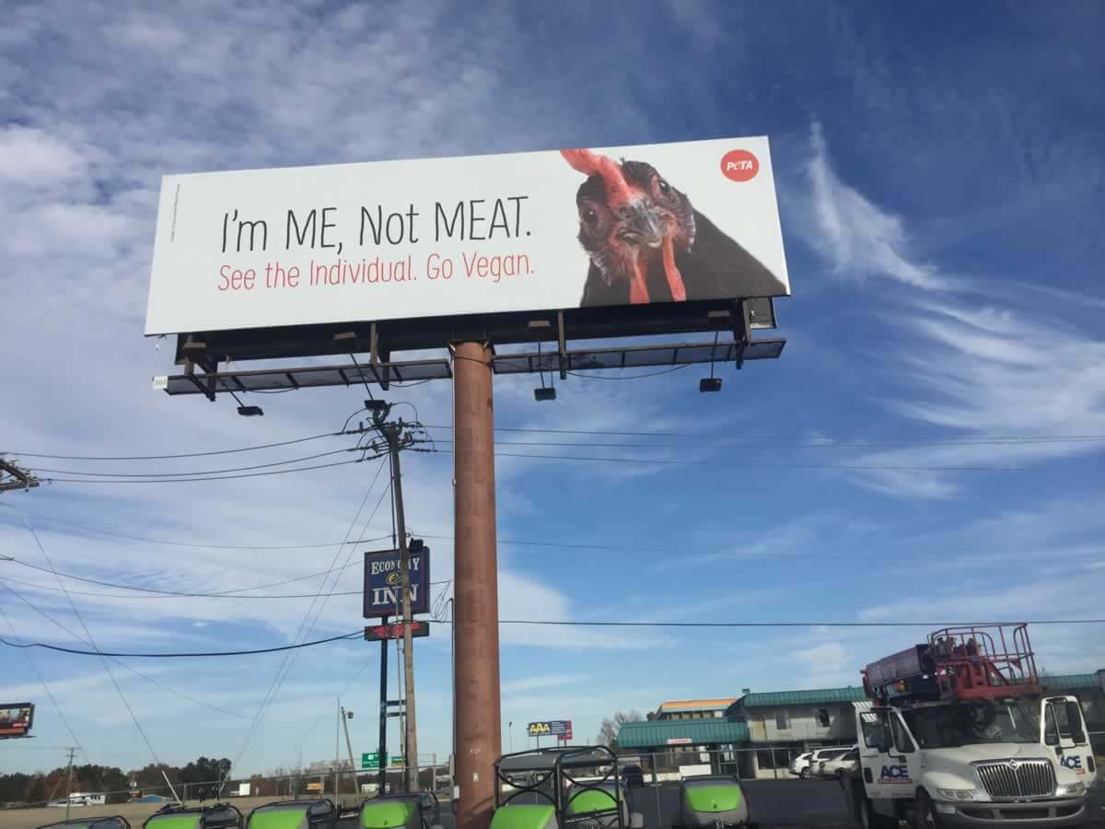
The animal rights group, People for the Ethical Treatment of Animals (PETA), released a series of billboards in an attempt to convert people to veganism. The series consisted of images of innocent different animals next to the large words, reading “I’m me, not meat.” PETA has said this was done as a “compelling reminder that there may be individuals behind the products we purchase” (PETA, 2017). Their campaign covers both billboards and bus shelters in order to target all passers-by to guilt them into looking at the traumatising process these animals endure to end up in our stores and on our plates which PETA go into detail about on their website. We are specifically told that these animals “suffer” and are informed of heart-breaking statistics these animals endure such as the “ninety-seven percent of pigs in the U.S…. [who will] never run across sprawling pastures, bask in the sun, breathe fresh air, or do anything else that comes naturally to them” (ibid). The chicken pictured in Figure 8 is facing towards the audience, making you look your victim directly in the eyes. This interaction along with the very simplistic and stripped back design helps the core message be conveyed instantly without people having to look at it for too long. This is effective as a few of these billboards were placed alongside roads where spectators have a very short amount of time to take in the information. It also helps with the memorability as there is a very little amount of information to remember, helping people retain the whole message and brand.
Figure 8: PETA (2017) I’m Me, Not Meat.

Conclusion
As a culmination of my research, I am able to say that guilt is used very heavily throughout advertising over all mediums but does not follow the same style as that is specific to each advert. Some advertisements use guilt as the key element to persuade customers and do not try to hide the use, whilst others use it very subtly as a way of quietly edging the customers to choose that brand. As Dr Thomas Jordan suggested, people can be easily manipulated and guilt-tripped into doing almost anything (Jordan, 2013) which is why it is so widely used within adverts and commercials.
One major question arising from this study is would these adverts all have the same impact if the element that evokes guilt were to be removed? As these are largely centred around the feeling of guilt, no matter how much it is used, the reaction would be shifted to the audience feeling very different emotions, however, it is unlikely that the same level of impact would still be there. Throughout my research, I was able to notice that in general the time period of the piece did not affect how its guilt was used, but perhaps different environments change how the emotion of guilt is utilised in advertising?

Bibliography
Books
Aitchison, J (2008) Cutting Edge Advertising. 3rd edn. New Jersey: Prentice Hall
Andrews, J and Shimp, T (2017) Advertising, Promotion, and other aspects of Integrated Marketing Communications. Boston: Cengage Learning
Breggin, P (2015) Guilt, Shame, and Anxiety: Understanding and Overcoming Negative Emotions. New York: Prometheus Books
Bybee, J (1997) Guilt and Children. Massachusetts: Academic Press
Du Plessis, E (2005) The Advertised Mind. London: Kogan Page Publishers

Green, J (2010) Holy Bible - KJ3 Literal Translation. Shallotte: Sovereign Grace Publishers Inc.
Grigorenko, E and Sternberg, R (2001) Family Environment and Intellectual Functioning: A Life-span Perspective. Oxfordshire: Psychology Press Ltd.
Hanafizadeh, P and Behboudi, M (2012) Online Advertising and Promotion: Modern Technologies for Marketing. Pennsylvania: Idea Group
Jones, G (2012) Effective Email. North Carolina: Lulu Press
Katchadourian, H (2009) Guilt: The Bite of Conscience. Stanford: Stanford General Books
Kingsnorth, S (2019) Digital Marketing Strategy: An Integrated Approach to Online Marketing. London: Kogan Page Publishers
Pennington, N and Staples, L (2011) The Guilt Cure. Wyoming: Fisher King Press
Ruchi, G (2012) Advertising Principles and Practice. New Delhi: S. Chand Publishing
Stevenson, A ed. (2010) Oxford Dictionary of English. Oxford: Oxford University Press
Sutherland, M (2000) Advertising and the Mind of the Consumer: What Works, What Doesn't and Why? London: Kogan Page Ltd
The Stationery Office (2011) Regulation of Television Advertising: House of Lords Paper 99 Session 2010-11. London: Stationery Office Books
Toews, J (2013) The Story of Original Sin. Cambridge: James Clarke and Co Ltd
Verlegh, P, Voorveld, H and Eisend, M eds. (2015) Advances in Advertising Research (Vol. VI): The Digital, the Classic, the Subtle, and the Alternative. Wiesbaden: Springer Gabler
Theses
Alexander, J (2016) Shame on You: An Analysis of Guilt-Based Advertising Strategies Directed at Parents. Masters. Illinois: Eastern Illinois University
Online Journals
Coulter, R and Pinto, M (1995) ‘Guilt Appeals in Advertising: What Are Their Effects?’ Journal of Applied Psychology [ONLINE] Available at: https://pdfs.semanticscholar.org/a7c0/9b9f78ca2906a554be040a91cda02b4a704f.pdf [Accessed 13th November 2019]
Reports
Department for Communities and Local Government (2014) Fire Kills Campaign: Annual Report 2013/14. Available at: https://assets.publishing.service.gov.uk/government/uploads/system/uploads/attachment_data/file/378374/2013-14_FK_Annual_Report_-_FINAL_ACCESSIBLE_VERSION.pdf [Accessed: 15th November 2019]
Websites
Advertising Standards Authority (n.d.) Our History. [ONLINE] Available at: https://www.asa.org.uk/about-asa-and-cap/our-history.html [Accessed 3rd December 2019]
BBC (2009) Original Sin. [ONLINE] Available at: https://www.bbc.co.uk/religion/religions/christianity/beliefs/originalsin_1.shtml [Accessed: 19th November 2019]
Bell, V (2019) How much time does YOUR country spend online? [ONLINE] Available at: https://www.dailymail.co.uk/sciencetech/article-6658237/How-time-does-country-spend-online.html [Accessed: 16th November 2019]
Byers, R (2015) 37 Emotional Marketing Campaigns. [ONLINE] Available at: https://www.trendhunter.com/slideshow/marketing-campaign [Accessed 27th October 2019]
Camp, J (2012) Decisions are largely emotional, not logical [ONLINE] Available at: https://bigthink.com/experts-corner/decisions-are-emotional-not-logical-the-neuroscience-behind-decision-making [Accessed: 8th December 2019]
Dawson, A (2018) ‘What would Jesus do?’ asks provocative organ donation ad. [ONLINE] Available at: https://mumbrel.la/2OlXmqi [Accessed: 1st December 2019]
Dobbs, M (2019) Stop precious forests being destroyed to make chocolate. [ONLINE] Available at: https://you.38degrees.org.uk/petitions/stop-precious-forests-being-destroyed-to-make-chocolate?bucket=email-blast-22_11_2019_palmoil-choc-petition-fb&utm_campaign=22_11_2019_palmoil-choc-petition-fb&utm_medium=blast&utm_source=email [Accessed: 2nd December 2019]
Door Monster (2017) Demonetization. [Online Video] Available at: https://www.youtube.com/watch?v=D1QSB7YePis [Accessed: 29th November 2019]
Dreft (n.d.) Our Story. [ONLINE] Available at: https://dreft.com/en-us/our-story [Accessed: 7th December 2019]
Forno, S (2017) YouTube Pre-Roll Ad Targeting: A Video Marketing Guide. [ONLINE] Available at: https://idearocketanimation.com/16111-youtube-pre-roll-ad-targeting/?utm_referrer=https%3A%2F%2Fwww.google.com%2F [Accessed: 26th November 2019]
Halo Leisure (n.d.) About Halo. [ONLINE] Available at: https://haloleisure.org.uk/info/about-halo [Accessed: 5th December 2019]
Jordan, T (2013) Are You Being ‘Guilted’ By Someone You Love? [ONLINE] Available at: http://lovelifelearningcenter.com/are-you-being-guilted-by-someone-you-love/ [Accessed: 8th December 2019]
Kain, E (2017) YouTube Wants Content Creators To Appeal Demonetization, But It's Not Always That Easy. [ONLINE] Available at: https://www.forbes.com/sites/erikkain/2017/09/18/adpocalypse-2017-heres-what-you-need-to-know-about-youtubes-demonetization-troubles/ [Accessed: 29th November 2019]
Macleod, D (2008) Separation Anxiety for QUIT Victoria. [ONLINE] Available at: http://theinspirationroom.com/daily/2008/separation-anxiety-for-quit-victoria/ [Accessed: 13th November 2019]
Maguire, F (2018) Reaching Consumers with Video: The Interruptibility Myth. [ONLINE] Available at: https://adage.com/article/sharethrough/reaching-consumers-video-interruptibility-myth/313945 [Accessed 26th November 2019]
Nail Communications (2014) Why are we all doing YouTube Preroll wrong? [Online Video] Available at: https://youtu.be/EekcG9bQGhw [Accessed 26th November 2019]
NFKRZ (2019) YouTube demonetization isn't so funny anymore. [Online Video] Available at: https://www.youtube.com/watch?v=gEt0k36Fw-4 [Accessed: 29th November 2019]
PETA (2017) PETA’s Message to The World: I’m Me, Not Meat [ONLINE] Available at: https://www.peta.org/blog/petas-message-world-im-not-meat/ Accessed: 6th December 2019]
Prescott, C (2019) Internet users, UK: 2019. [ONLINE] Available at: https://www.ons.gov.uk/businessindustryandtrade/itandinternetindustry/bulletins/internetusers/2019 [Accessed: 28th November 2019]
Savage, J (2018) A Guide To Pre-Roll Advertising (With Examples Of Successful Campaigns). [ONLINE] Available at: https://boldcontentvideo.com/2015/11/02/a-guide-to-pre-roll-advertising-with-examples-of-successful-campaigns/ [Accessed: 26th November 2019]
Smith, K (2019) How much time does YOUR country spend online? [ONLINE] Available at: https://www.brandwatch.com/blog/youtube-stats/ [Accessed: 16th November 2019]
Townsend, B (2018) PewDiePie Addresses Whether He Started The Adpocalypse. [ONLINE] Available at: https://www.wetheunicorns.com/youtubers/pewdiepie/adpocalypse-ads/ [Accessed: 30th November 2019]
Whitbourne, S (2012) The Definitive Guide to Guilt. [ONLINE] Available at: https://www.psychologytoday.com/gb/blog/fulfillment-any-age/201208/the-definitive-guide-guilt [Accessed: 4th November 2019]
Winer, S (2013) A Smile and a Tear. [ONLINE] Available at: https://www.criterion.com/current/posts/3004-a-smile-and-a-tear [Accessed: 22nd November 2019]
Zaczek, Z (2018) All Australians will have their organs harvested for donation unless they opt out under new proposal to address shortfall in supply for transplants. [ONLINE] Available at: https://www.dailymail.co.uk/news/article-6475215/Australians-organs-automatically-harvested-donation-die.html [Accessed: 1st December 2019]
Images
Figure 1: Revolver/Will O’Rourke (2018) What Would Jesus Do? - Donate Your Organs (Full Clip). [Online Video] 14th October 2018. Available at: https://youtu.be/4_5Kgy4qWms [Accessed: 1st December 2019]
Figure 2: Campaign Palace (2008) Separation. [Online Video] 27th October 2008. Available at: http://theinspirationroom.com/daily/2008/separation-anxiety-for-quit-victoria/ [Accessed: 13th November 2019]
Figure 3: RKCR/Y&R. (2013) On Your Child's Life. [Online Video] 5th March 2013. Available at: https://www.thedrum.com/news/2013/03/07/ad-day-fire-safety-your-childs-life [Accessed: 15th November 2019]
Figure 4: Nail Communications (2014) Why are we all doing YouTube Preroll wrong? [Online Video] 15th July 2014. Available at: https://youtu.be/EekcG9bQGhw [Accessed: 26th November 2019]
Figure 5: Mae Dobbs (2019) 38 Degrees – Sign the Petition [ONLINE] 22nd November 2019. Available at: https://www.facebook.com/ads/library/?active_status=all&ad_type=all&country=GB&impression_search_field=has_impressions_lifetime&id=544785182756981&view_all_page_id=200006375787 [Accessed: 2nd December 2019]
Figure 6: Halo Leisure <info@haloleisure.org.uk> (2018) Missing you… [Email] 26th May 2018. [Accessed: 4th December 2019]
Figure 7: Dreft (2015) #AMAZINGHOOD [ONLINE] 14th August 2015. Available at: https://dadmarketing.com/tag/dreft/ [Accessed: 7th December 2019]
Figure 8: PETA (2017) I’m Me, Not Meat. [ONLINE] 7th July 2017. Available at: https://www.peta.org/blog/petas-message-world-im-not-meat/ [Accessed: 6th December 2019]

