IANTO GRIFFITHS P144959

WORK BASED PROJECT
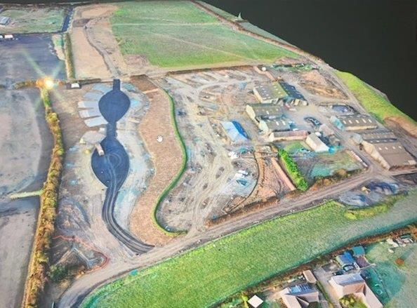
Contents
1. Background information on GD Harries and Sons 2
1.1 Health and Safety 3
1.2 Management Structure 4
1.3 Marketing, Communication and Presentation 6
1.4 Materials and Processes 6
1.5 Conclusion 6
2. Interim Submission 2 7
2.1 Skills 7
2.2 Developing the skills 7
2.3 Highlights 9
2.4 Challenges 9
2.5 Review 10
3. Interim Submission 3 11
3.1 Skills 11
3.2 Developing the skills 11
3.3 Highlights 11
3.4 Challenges 12
3.5 Review 12
4. Interim submission 4 13
4.1 Skills 13
4.2 Developing the skill 13
4.3 Highlights 13
4.4 Challenges 14
4.5 Review 14
Interim Submission 5 15
5.1 Skills 15
5.2 Developing the skill 15
5.3 Highlights 15
5.4 Challenges 16
5.5 Review 16
6. Reflection Submission 17
7. References/Bibliography 20

1. Background information on GD Harries and Sons

GD Harries is one of Wales’s largest suppliers of aggregate, located in West Wales it operates out of 6 granite and limestone quarries - incorporating three asphalt plants, six concrete plants, and a wharf operation, as well as a civil engineering division delivering significant infrastructure projects. The experienced civil engineering department is known for delivering multimillion pound infrastructure projects. With 240 employees, GD Harries are able to supply majority of the workforce as well as using in house materials from its own quarries, which allows the company to closely regulate quality and cost (GDH 2020)
GD Harries have a specialised fleet of vehicle that deliver all over Wales, which are serviced and maintained in their own VOSA standard onsite workshop. Products such as sand, are delivered by sea out of the port of Pembroke Dock (GDH, 2020).
The accreditations achieved by the company are ISO9001 and ISO 14001 Quality and Environmental Management Standards. There is a large emphasis on health and safety and sustainability within GD Harries (GDH 2020).
My involvement started at the pre-construction phase, following contract award. I prepared the health and safety construction phase plan, and reviewed the information from the pre-construction stage. I then used Microsoft Project to produce a programme of works and material schedules. I was assigned as site engineer/manager for the project. This involved, programming and scheduling of both direct and self-employed labour, plant and all required materials, alongside all measurements, including setting out, utilising a DGPS and LSS surveying programme to evaluate, producing as built drawings and accurate quantities. Monthly valuations were produced by myself from the information gathered and then submitted to the contracts managers for approval and submission. I was also responsible for on site design aspects, including both temporary permanent works which were required as additional works to the scheme.

1.1 Health and Safety
GD Harries have the responsibility of;
- The health and safety and welfare at work of all their employees’ delivery and maintenance of plant and methods of working within reason, which are safe and do not cause risk to health.
- Making sure waste management plans, risk assessments and method statements are in place when handling, using and transporting any substances.
- Ensure all information is relayed to the employees within tool box talks and inductions.
- Provide all training and supervision required prior to commencement of works on site.
- Maintaining the work place to a safe working environment without risks to health and providing and maintaining access and egress that are safe without such risks.
- Providing a safe working environment for all employees, including facilities and arrangements for their welfare at work.
Source HSE, 2020 from above was collected from Health and Safety at work act 1974 documents.
Before commencement of works, G D Harries & Sons LTD will ensure that the site establishment has been set up as agreed with the client. Welfare facilities will be provided within the Windbury Top Farm house Rooms will be designated for separate canteen, and drying rooms. A mains water supply is connected and Warm water for washing will be available within the kitchen area, where a notice board will be provided in the hallway of the main entrance.
A fully fitted first aid kit appropriately marked, suitably sized for up to 12 persons and the appointed person first aiders names will be displayed in the farm house.
First aid kits will be provided both at the canteen location and all site transport. First aid provision will be regularly reviewed by the foreman on site, to ensure that the provision remains appropriate. To help with this an informal record of any incidents dealt with by first aid will be kept. In accordance to the health and safety welfare management.

1.2 Management Structure
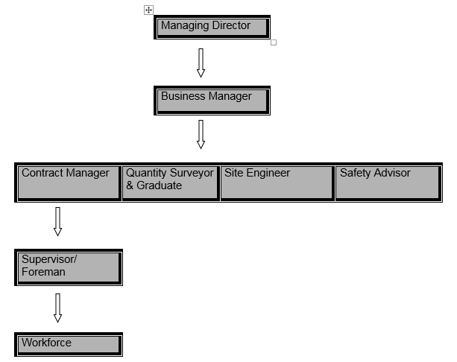

Figure 1: Showing the management structure involved in the project at Folly Farm Holiday Park Phase 1.

Roles and appointments | PersonA | Abbrev-iation
Managing Director | Ian Harries | IH
Business Manager | Janet Phillips | JP
Business Health and Safety Manager | Kirsty Fraser  Tel: 01834 860464  Fax: 01834 869156  Mobile: 07881 093695  e-mail: kirsty.fraser@gdharries.co.uk | KF
Quality Manager | Simon Dorken | SD
Commercial Manager | Richard Burton | RB
Manager (contract) | Richard Morris  Tel: 01834 860464  Mobile: 07785 455712  e-mail: richard@gdharries.co.uk | RM
Senior Manager | Ianto Griffiths | IG
Person-in-charge | Ianto Griffiths  Mobile: 07825459787  e-mail: iantogriffiths@gdharries.co.uk
Supervisors(s)/Foremen | John Soar | JS
Engineer | Ianto Griffiths | IG
Temporary Works Co-ordinator(s) | Ianto Griffiths and John Soar | IG/JS
Insert other responsible person roles relevant to requirements
Figure 2: Showing the roles and responsibilities of each person involved in the project.

1.3 Marketing, Communication and Presentation
With Folly Farm being such a popular tourist attraction, the project will naturally advertise itself by the millions of people who visit the attraction. GD Harries are currently working in the field behind the car park of Folly Farm, enabling visitors to watch the development unfold and identifying the GD Harries logo on all plant and at the entrance. The Ferris wheel inside the park gives a bird’s eye view of the project. Folly Farm have released press articles in local papers and radio stations advertising the project and highlighting the contractor carrying out the work. GD Harries are also proud to advertise the work carried out at Folly Farm by showing pictures on their website. By being involved in such a high profile project within the local community, this allows other clients to share similar ideas and contact the company to replicate similar work.

1.4 Materials and Processes
The processes and materials involved in this project included;
- Stripping top soil and constructing an attenuation pond using 35T excavator, 35T dump trucks and a D6 dozer from the GDH quarries.
- Foul and surface water drainage using a range of different pipe diameters, pre cast concrete rings, cast iron cover and frames, bends and junctions.
- Constructing a toilet block from sub-structure to super-structure, including the use of GDH own concrete for foundations and floor slab.
- Constructing caravan pitches including service bollards, aggregate supplied by GDH quarries.
- Surfacing the access roads using GDH tarmac from quarry, plant and labour.

1.5 Conclusion
Theoretical background given during the degree course is supplemented on a practical basis during my onsite training. This results in a better understanding of construction processes, whereas if the course was carried out on a full time basis, I would not fully understand the theoretical background given. The skills learnt and developed on this job enhances my progression and experience within the industry.

2. Interim Submission 2

2.1 Skills
Setting out the works using batter rails and profiles, alongside, designed gradients for both earthworks and drainage systems.

2.2 Developing the skills
All skills were demonstrated within a working environment, allowing me to visualise the skills and see the work being carried out effectively. I then practiced these new skills by, computing both earthworks and deep surface and foul water gradients. Enabling the setting out of earthworks profiles such as batter rails and providing the workforce with the requisite distances to formation level. The calculated drainage gradients were input into a pipe laying laser and the alignment set out using either DGPS or robotic surveying equipment. Reference was made to both Irvine and Maclennan 2005 and the guidance notes provided with the Xpad surveying programme (Xpad Geomax 2020). Horizontal and vertical control for the proposed carriageways was achieved using profiles set at 500mm above finished road level and a 950mm long traveller (depth of carriageway construction 450mm). Formation level was checked using a DGPS and earthworks volumes calculated using a standard surveying programme (LSS). Figure 8 shows programme outputs for soil strip volumes.

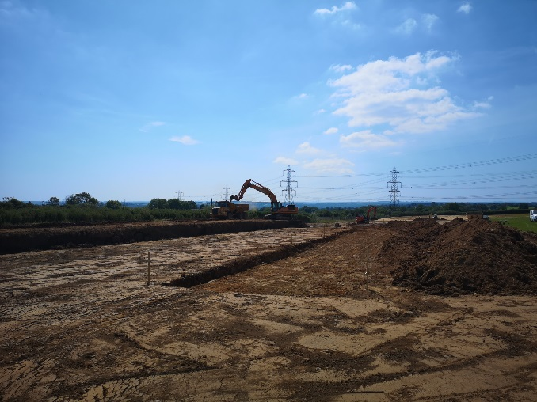  Figure 1: showing the carriageway excavation using profiles. | 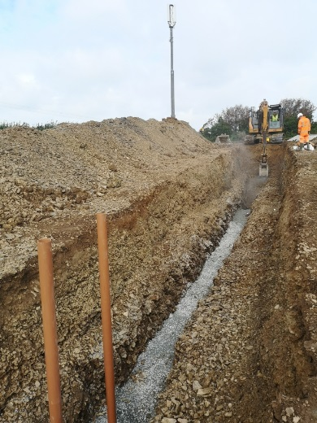  Figure 2: deep drainage with stepped trench to enable safer working environment.
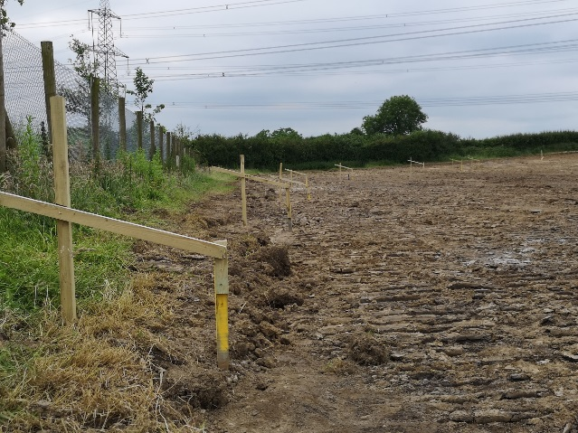  Figure 3: showing the batter rails for the attenuation pond. | 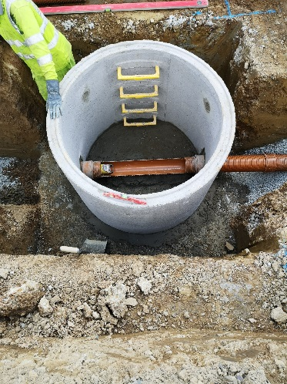  Figure 4: typical foul water manhole with pipe laser sitting in pipe.
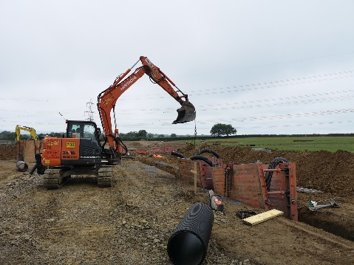  Figure 5: drag boxes being set in place during drainage excavation. | 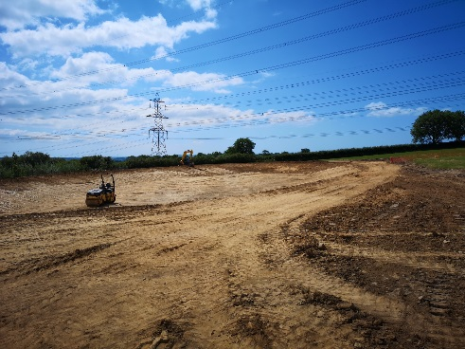  Figure 6: showing the attenuation pond near completion.
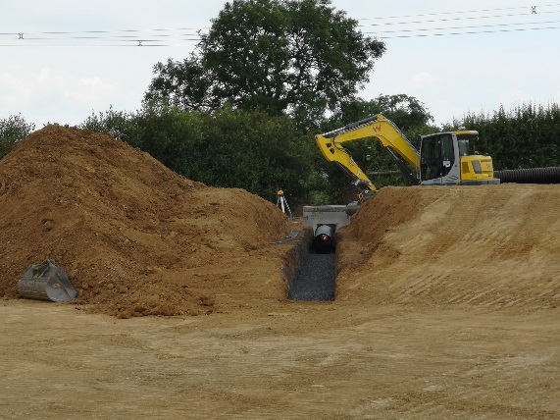
Figure 7: excavation for attenuation outlet using a pipe laser sat inside a 500mm pipe.
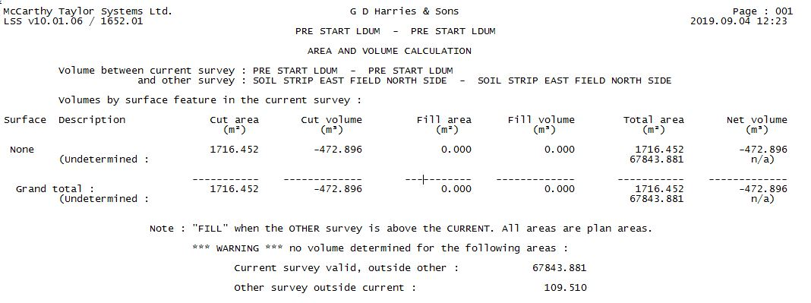
Figure 8: soil strip volumes produced by LSS programme.

2.3 Highlights
Setting out an attention pond using batter rails and calculating distances and programming the works with regards to labour and plant requirements for the particular operation. Also, with regard to deep drainage operations I realised how important the temporary works were (in this case digging and drag boxes alongside manhole shutters). One of the most important elements was the programming of material deliveries in order to maintain progress in accordance to the originally submitted programme. Also the importance of keeping suitable legible records whenever changes occur, such as, excavation of rock within drainage trenches affected the progress and therefore programme of works.

2.4 Challenges
Calculating the foul and surface water gradient was challenging as I had to take into account a dual gradient. The drainage gradient and the field gradient, with the field sloping from north to south and the drainage sloping west to east and south to north. The aim was to ensure that the manhole depths were not excessively deep, therefore to avoid this, I used back drop manholes resulting in less complex temporary works. Also, complying with the minimum and maximum gradients set out by the sewers for adoption agreement 2013.

Drawings given by the client were very basic with constant variations, meaning several interruptions in the original programmed works resulting in increased forecast cost overturn.

The use of modern day surveying equipment such as a pipe laying laser, significantly reduced the requirement for profiles at 10m intervals when excavating drainage lines.

2.5 Review
I personally feel that I am progressing well when looking back at my objectives. The wide variety of learning is enabling me to enhance my knowledge within the construction industry. Despite the inconvenience of variations, this allows me to improve my project awareness and ways of dealing with the client and workforce to ensure high standards continue at all times.

3. Interim Submission 3

3.1 Skills
Setting out carriageway kerb lines and the toilet block building (including its construction), alongside, calculating the required cross falls for the carriageway.

3.2 Developing the skills
Furthering the setting out skills, I have acquired additional experience during the course of the contract of on site design consisting of carriageway geometry. I have visualised the demonstration of kerb lines being set out, and understanding the different level heights required for the various kerbs (on this project half battered – HB2 & HB3, transition kerb, bull nosed kerb, radius kerbs) in order to achieve the required cross fall. Also, understanding how to halve and quarter between given chainages, for example on a radius when only certain points are given by the design engineer. The alignment of the carriageway geometry was set out using a DGPS and the toilet block building was set out using a robotic surveying instrument. The building was built in accordance with the CDM regulations 2019, with monthly visits from the building inspector which he instructed me to take photos at each stage. Reference was made to both Irvine and Maclennan 2005 and the guidance notes provided with the Xpad surveying programme (Xpad Geomax 2020).

3.3 Highlights
Setting out the carriageway geometry and calculating the required cross fall for the kerb lines, and then sweetening the kerb alignment by eye to make it more aesthetically pleasing. This was particularly satisfying after the tarmac was laid. Ordering the correct mix, aggregate size and amount of concrete was important when laying and backing the kerbs. With regards to the works carried out on the building, I was able to learn and enhance my knowledge about the CDM regulations 2019 and the standard of work that the building inspector requires. Also, the importance of ordering the correct amount materials to ensure the building progresses as originally planned in the submitted programme. Keeping records of the disruptions to the work such as bad weather, allowed me then submit an early warning to inform the client of the adverse weather conditions to ensure the programme did not fall behind schedule.

3.4 Challenges
Calculating the correct radius and also the size of the hammer to allow caravans to safely turn was challenging along with the required angles for the caravans to reverse into their pitches.
Using the minimum and maximum gradients to calculate the cross fall, aiming to avoid any standing water on the roads. And also ensuring that all the surface water was draining into the gullies. Again the information given by the client was vague resulting in myself having to propose a suitable design.

3.5 Review
The wide variety of work that I have already undertaken, is rapidly devolving my knowledge in the construction industry. I am feeling confident on site when it comes to the setting out aspects and when assigning plant and labour to a specific job. Also I have now got valuable experience in dealing with different trades during the construction of the toilet block, and also the construction of a building from sub structure to super structure.

4. Interim submission 4

4.1 Skills
Improve project awareness by comparing labour and plant utilisation on each task, allowing comparison with the original tendered contract resources.

4.2 Developing the skill
During the duration of the project I have kept records of the labour and plant used on each of the programmed tasks and analysed these against the programmed durations on Microsoft Project. The use of Microsoft Project has allowed me to gain further experience in both programming and resource scheduling. By keeping detailed records of labour and plant used for each task, this has developed my knowledge on what particular plant and how many labour resources are required to complete specific tasks.
Keeping records has also allowed me to understand its importance in terms of, making a claim for loss and expense on a project. Using the site records as evidence for the client when requesting applications for extra time (i.e. adverse weather). When claiming extra money for additional works that are not included in the original contract, during this project I have used day work sheets to record additional work and calculated the cost by using the rates in the bill of quantities. All information was forwarded to the contracts manager to be sent off to the client for approval of requests.

4.3 Highlights
Furthering me knowledge and understanding of Microsoft Project has been a stand out, as it is a widely used and recognised programme within the construction industry. Which is used for several different aspects other than just allocating labour and plant to tasks. It can be used to record costs of projects and provide percentage cost of the tasks complete to date.
Understanding the importance of keeping records on a project, and the way to utilise the information when required and in the correct format (claims, time, money and day works). Visualising the recommended plant and labour for a specific task and understanding the logic to this approach.

4.4 Challenges
Getting used to Microsoft Project can be challenging at times, as the programme can incorporate so many different aspects of a construction project. Especially assigning costs to specific tasks and calculating the percentage complete.
Managing my time correctly on site to ensure that I allocate time to record the labour time and plant hours daily for the task assigned to the workforce each day.

4.5 Review
Despite some of the challenges of using Microsoft Project, I feel that it is important to keep developing my skills within the programme as it is used for several different aspects of construction and widely recognised within the industry. I feel that my project awareness is continually developing on a daily basis, throughout the duration of the project.
A huge emphasis has been on, understanding the importance of recording all tasks and resources used on a daily basis to ensure that enough evidence is readily available when changes to the original programme occur. This could be the difference between the company making money on the project or not. Therefore site records are a huge part of a successful project manager’s role.

Interim Submission 5

5.1 Skills
Experience project management of a scheme in its entirety for the first time on a multi-phase contract, establish and improve my own understanding of site health and safety requirements.

5.2 Developing the skill
Control of documentation, such as plans, site instructions and requests for information. Record all programmed activities on a daily basis. Measurement of all installed works, such as, drainage, earthworks, and foundation works for both new building and attenuation system. Understanding the correct way to approach tasks, factoring in weather conditions and the number of gangs required to complete on programme. The Royal Institute of British Architects publishes the RIBA plan of work which has been used as a guide during this project. The RIBA plan of works uses a step by step planning process that is used to organise and control the construction process from the clients proposed idea to the design brief and from the final design to the construction process.
Ensure that all personal including visitors receive induction training prior to starting work on site. Conduct tool box talks on a regular basis and whenever a substantial change has occurred. Produce generic method statements and risk assessments from the experiences gained on this project, also implement inspection regime for method statements and statutory inspections, such as earthworks, scaffolding etc. Ensure all sub-contractors RAMS are signed off before commencing work on site. Liaising with the client with regards to their own sub-contractors and ensuring they had a permit to work from Folly Farm and then all relevant information was passed onto the GDH health and safety officer.

5.3 Highlights
Learning such valuable information on how projects are run and using the information to manage a scheme in its entirety. Conversing with the project members and using their experience to ensure the project runs as smoothly as possible. Building a rapport with sub-contractors who are involved in the project, which will aid the company on future projects.
Receiving positive feedback from the health and safety officer after site inspections. Ensuring that the safety of the employees is paramount. Understanding how to deal with sub-contractors and their RAMS, also recording near misses and how it results in a safer site.

5.4 Challenges
Project managing a scheme is challenging in many different aspects, but it is an enjoyable challenge. Organising my time accordingly to ensure that all daily paper work and health and safety forms were completed. Some days it proved difficult to achieve all this, but I then prioritised the next morning to ensure I did not fall behind.
Measuring and surveying volumes was challenging, but conversing with the quantity surveyor and gaining knowledge of how the tasks were priced allowed me to provide the correct information.

5.5 Review
Managing a project in its entirety has been a great experience, with lots of learning curves and lessons that I will only improve me on the next scheme. I have found my strengths and weaknesses, giving me plenty of focus moving forward in this profession.
Furthering my knowledge of health and safety has made me understand its importance and by following guidelines put in place by the HSE allows me comply with the CDM regulations 2019.

.

6. Reflection Submission

During the course of this exercise, I have identified my strengths and weaknesses which have allowed me to focus on the elements required to become a better-rounded project manager. Breaking down the project and reviewing certain aspects in the interim submissions has allowed me to fully understand what I am trying to achieve and what is required to successfully manage a project in its entirety. The exercise has allowed me to set myself benchmarks and enhance my knowledge of the construction industry.
I have learnt how to deal with constant alterations made by the client whilst still ensuring that the workforce continued to operate to high standards at all times. Despite the frustrations of aforementioned alterations, I have used my communication skills to build a good rapport with the client over the duration of the project. I also feel that my ability to communicate has helped immensely organising various sub-contractors that were required to attend the site.
Setting out and surveying has always been an enjoyable element of my job and this was certainly emphasised during this project. There were several different surveying skills that I developed as well as completely new techniques that I learnt on the job such as; calculating drainage gradients, and setting out batter rails for an attenuation pond.
Moving forward I will feel more comfortable when setting out certain aspects of the work and relaying instructions to the workforce. During the project I had a tendency to doubt my ability, which made me question myself when making particular decisions. However, the opportunity has also allowed me to realise that even project managers with great amounts of knowledge and experience can still make mistakes time to time!
Gathering the correct information from the client was a difficult and frustrating journey as there were basic designs that required a disproportionate amount of time spent being altered to suit the scheme’s needs. This resulted in an onset of delays to the project however, I ensured that the client was made aware from the start so that we would not be penalised for overrunning the programme.
I was fortunate to have the assistance of an experienced engineer in Dr Tony Thomas, who guided me through the re-designing of certain elements on the job. This was a valuable experience as it allowed me to expand my knowledge and exposed me to different scenarios that typically wouldn’t have arisen.
Redesigning the foul and surface water drainage was a success and I had to quickly understanding when it was necessary to introduce drop manholes. This ensured that the drainage was not excessively deep thus reducing the risk of trenches collapsing. Where this was not possible drag boxes were introduced and the gradients calculated complied with the minimum and maximum levels set out by the ‘Sewers for Adoption 2013’.
Managing my time correctly on site to ensure that I allocated enough time to record the labour and plant hours daily was also important. Time management improved as the project developed and I was able to incorporate these tasks in to my day as time went on. This was emphasised in monthly evaluations where I was able to provide vital information to the quantity surveyor to price extra work accordingly.
The main individual goal for myself during this project was to experience the project management of a scheme in its entirety for the first time on a multi-phase contract. There were several challenging factors during the duration of the project, one being the health and safety standards on site. This was particularly difficult to manage with several different sub-contractors attending site at different times of the contract. Some contractors were controlled by G.D.Harris, and some by Folly Farm, therefore ensuring all members on site were inducted became a difficult task when G.D.H we were not fully in control of site attendees. To overcome this I had to organise a meeting with the client and their health and safety representative to ensure all contractors on site received an induction from G.D.H and followed the correct safety guidelines provided.
From personal experience, every construction project presents different challenges and not one scheme is the same. This is what keeps the industry interesting and is one of the main factors that keeps me thoroughly engaged on a daily basis. If I had to execute the project again I would advise the client to spend time deciding on exact needs and wants so that accurate drawings and designs with the relevant information was included before commencing works. This would save the client a significant amount of time and money, whilst also allowing the main contractors to work efficiently and effectively without disruption. Furthermore, learning how to distribute specific labour and plant for each task has been invaluable and gaining this knowledge will allow me to improve the construction programme on the MS project.
Overall, the experience and knowledge gained from completing this project has only strengthened my future ambitions to continuously develop myself and become a respected professional in my field.

7. References/Bibliography

Authorities, W., 2013. Sewers for adoption- a design and construction guide for developers. Water Research Centre(1989) plc. Medmenham, 3 rd edition, 1989, 86.
CDM Regulations (2019). Construction Design and Management Regulations 2019. [online] Available at: https://www.hse.gov.uk/construction/cdm/2015/index.htm [Accessed 28th March 2020].
Cooke, B. and Williams, P., 2013. Construction planning, programming and control. John Wiley & Sons.
Gdharries.biz. (2020). What we do – GD Harries & Sons Ltd. [online] Available at: https://gdharries.biz/home/about/what-we-do/ [Accessed 12 Jan. 2020].
HSE. (2020). Legislation.gov.uk. (2020). Health and Safety at Work etc. Act 1974. [online] Available at: http://www.legislation.gov.uk/ukpga/1974/37/section/2 [Accessed 11 Jan. 2020].
Irvine, W. and Maclennan, F., 2006. Surveying for construction. McGraw-Hill.
Roberts, A.H., 2014. Code of practice for project management for construction and development.

Xpad Geomax, 2020. Geomax-positioning.com. X-PAD Ultimate. [online] Available at: https://geomax-positioning.com/products/software/x-pad-suite/x-pad-ultimate [Accessed 15 Jan. 2020].

