

Tsvetomila Metodieva
1808619

Workplace culture and its impact on organization efficiency
(BMSW5105_LON)
Hossein Shokri


ADIDAS

Contents
Introduction 1
Company background 1
Organization structure 2
Organization culture 4
• Definition 4
• Importance of the culture 5
• Value 7
PESTLE Analysis of Adidas 8
SWOT analysis of Adidas 9
Adidas strategy 10
Ethical Behavior 12
Leadership and culture 13
Critical evaluation 15
Recommendation 16
Conclusion 16
References 17

Introduction
Today’s modern workplace is combined of various groups work collectively with unique views of work ethics in order to deliver an effective people management practices and company success. The principles of workplace culture and performance management are closely linked. Understanding that culture is significant in influencing corporate behavior and success in public sector organizations is one thing, then ethical behaviour, organisational structure and leadership are the other important part for company efficiency. In this work it will be analyse and evaluate Adidas culture and its impact on the organization efficiency. All of the components as brief background of the company, organisation structure, culture, company values and strategy, ethical behaviour and leadership of Adidas will be analysed in order to understand Adidas efficiency now a days. Moreover, in order to identify internal and external factor affected Adidas it will be applied PESTLE and SWOT analyses of the company. Although, of the end it will be provided recommendation for amazing organizational success by intentionally improving their workplace culture.
Company background
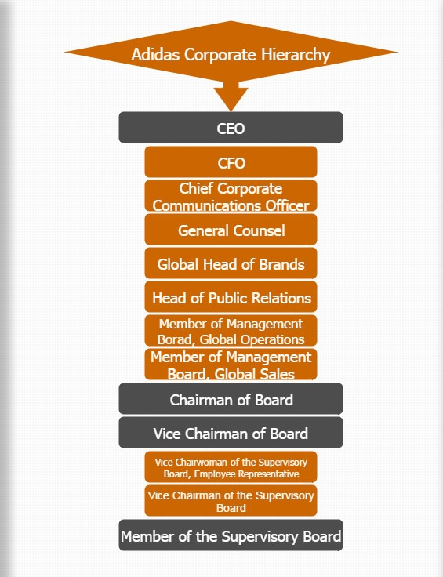
The term "Adidas" is an anagram of the expression "all day I dream of athletics," the athletic clothing company is named after its creator, Adolph "Adi" Dassler. He and his brother created a company that would become a global brand (Flippo, 2019). In 1920, at the age of 20, Adolph (Adi) Dassler, an enthusiastic soccer player, patented track and field spiked spikes. Four years later Adi and his brother Rudolph formed the German athletic shoe company Gebrüder Dassler OHG, later known as Adidas (LHistory, 2019). This sporting footwear, clothing and athletic goods manufacturer was the largest sportswear producer in Europe in the early 21st century and the world's second largest (after Nike). The first company recognition was made in 1936 at the summer Olympic in Berlin, where adidas shoes was wear from a famous track star Jesse Owens. Adidas goods are historically branded with a three-stripe label which remains an item in the current "trefoil" and "mountain" logos of the brand. The Adidas’s mission aims to be the global leader in the sporting goods industry with brands built on a sports passion and a sporting lifestyle. Adidas is a major brand in the athletic footwear market, and while in recent years this industry has developed at a fast pace, it is also renowned for intensive competitiveness. As an affect of this, companies spend in various areas to address the competitive pressure from advertising and HR and control of activities (Adidas, 2019).

Organization structure
Organizational structure is the foundation for working relationships and processes, organisational procedures, individuals and groups are making efforts to achieve the objectives. Although, organizational structure is a series of system that break the task into and organise specific tasks (Monavarian, et al., 2007). It is also a way of sorting, organising and coordinating administrative tasks. Organizations establish processes for organising work factors practises and regulating the actions of participants (Rezayian, 2005). There are various types of organisational structure as formal, informal, flat, hierarchical, divisional, matrix and functional. Formal structure is a designed framework which represents a systematic attempt to establish a network of relationships between members that will successfully fulfil the objectives. On the other side informal organisation relates to those aspects of the system that are not deliberately organised but naturally emerge from the behaviours and experiences of the stakeholders. Therefore, the flat structure has very few grades and a relatively large scope of managers at each tier. An organisation will hold the organisational structure stable by decentralising the power to low-level administrators and non-management staff. Functional framework occurs as divisions and sub-units of operations are formed within the organisation based on roles. A large structure would have several centralised grades. There is a huge distance between both the top and the bottom leader. As the system causes larger problems, the architecture of the organisation becomes less elastic and the manager's reaction to shifts in the corporate climate can be slower. Decisions and orders by top-level managers may take a lot of time to meet lower-level supervisors, and it could take long for top-level directors to know how their choices actually turned out. Matrix structure creates an adaptable framework that is perfectly suited to the need for changes in the environment. The structure of the divisional organisation is also more suited to every large company, especially those operating with several products in order to satisfy more than one specific market. (Ezigbo, 2011).

Figure 1. Adidas’s hierarchical organisational structure
Source: https://www.hierarchystructure.com/adidas-corporate-hierarchy/
Adidas organization’s architecture is well structured as there are numerous operational divisions such as development, sales, R&D, customer service, logistics, procurement and human resources and clearly defined roles at all levels. Adidas has a structured framework that clearly defines a high organisational structure for the operation of their mission, so the organisational structure of Adidas represents their power from top to bottom, which ensures that each main decision is taken from the top level and passed downwards (Slack & Parent, 2006). In the scope of a corporate strategy, Adidas needs to ensure that its organisational structure makes it possible and versatile to follow their plan. The goals identified in the corporate strategy demonstrate that the mission statement turns into practise, while also directing and organising decisions. The Adidas Group involves of four participants of the Executive Board, plus one Chief Executive Officer and three members of the Board serving the investors and six members comprising the employees. The Supervisory Board shall advise and supervise the Executive Board in the matter referred to above. It is the responsibility of the Supervisory Board to ensure that the direction and vision laid out by the Executive Board are immediately followed by the majority of the company from the top to those responsible for the production of their goods (Adidas, 2019).
Organization culture

Definition
Organizational culture distinguishes from all the rest the extraordinarily successful companies. It can be a competitive advantage that is powerful. The culture of the companies is always different, but the big winners consistently make culture a goal for the organizations. The concept of culture has varied over the years. Herskovits, for instance, proposed a broader definition of society more than four decades ago by proposing that culture was a "human-made part of the environment" (Herskovits, 1955). Adidas spend more than ever in their HR gaining a significant advantage, therefore the emphasis at Adidas is on creating a culture of teamwork among employees that positions the development and career management of employees at the core. With contrast to career development activities, it focuses on creating an atmosphere that attracts workers effectively and can attract them for longer. Over the last few years, the company has done many major improvements in its business model. However, Adidas focuses on creating a people-centered environment that recognizes price of staff and helps them meet their job aim for improvements important and long-lasting effects. Human resource capital of an enterprise has a main function in the growth of its bottom line and the success of its corporate strategy. What they do has a bearing on the end result of the company and its future (Adidas, 2019).
Confidence
Collaboration

Creativity
Figure2. Adidas culture
Source: www.adidas-group.com/en/
Adidas believes that the important to the success of the company is their staff. In the organization, they have great talents functioning with desire for athletic and their types. It is their people who give life to the strategy and create the change in accomplishing their lengthy-term aims. They cultivate the mentality of that person through a series of characteristics they want to see in their men, which are at the root of their corporate culture–the 3Cs –Confidence, Collaboration and Creativity. Confidence for Adidas means recognizing that they do not have all the solutions, but they are prepared to take risks, and trying new things. And if they struggle, that is a part of their education–that makes them get stronger. Adidas beliefs in Collaboration, they do realize that together they are better. Winning with one team takes an open and frank conversation, inclusiveness and faith in the skills and talents of each other. Another belief of Adidas is Creativity as imagination is needed for achieving the greatest athletic firm in the world. They need to be available, experiment, gain an edge, and stick out for new ideas. That is the only way they will thrive (Adidas, 2019).

Importance of the culture

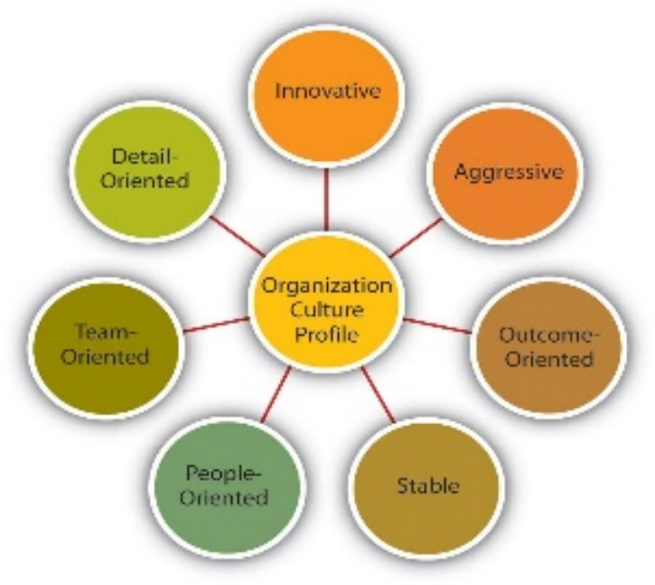
Loewe, Dominiquini (2006) suggests that corporate culture and values are among the four key areas of successful execution of change, in addition to leadership practises, management structures, personnel and abilities. Based on these regions, competitive internal rivalry is designed as a continuous process of development, not accidental, short-term initiative (Loewe & Dominiquini, 2006)

Figure 3. Organization Culture Profile
Source: https://open.lib.umn.edu/principlesmanagement/chapter/8-4-measuring-organizational-culture/
Adapted from information in O’Reilly, C. A., III, Chatman, J. A., & Caldwell, D. F. (1991). People and organizational culture: A profile comparison approach to assessing person-organization fit. Academy of Management Journal, 34, 487–516.
The organizational culture profile is an evaluation that describes the distinguishing characteristics of the company. This may include organizational values, priorities, and total team interactions. The profile could also include data on how external forces have influenced the organization. Organizational culture may encourage or hinder communication, information sharing, expertise and ideas effectively. Open culture, encouraging involvement of all members of the team in the development process, is conducive to workplace engagement and programme, whereas culture based on a rigid control is certainly not conducive to creativity and innovation. Enthusiasm, flexibility, rapid adaptation to changing circumstances and resolutions characterize cultures aimed at developing innovation. The key for support and promotion of the production of creativity within the company for employees to strive achieving objectives and performing tasks (Biswas, 2009). Adidas ' workplace culture plays a major role in the company, controlling the actions of members and, in extreme cases, governing the company. If the company has been pursuing a common and successful strategy for some time, achieving objectives and achievements are guaranteed (Adidas, 2019).

Value

According to Manchiraju and Sadachar the values of an individual are predictors of one's intention to engage in ethical fashion consumption behavior. The researchers describe self-improvement ideals as the most important for U.S. consumers who are less likely to engage in moral clothing consumption(Manchiraju & Sadachar, 2013). Adidas use their Workplace Values as a tool to help people find and attract business partners who adopt their business practises in accordance with their policies and principles. The Workplace Guidelines often help identify potential problems as a collection of guiding principles so that they can work alongside the business partners to resolve issues of concern as they occur. Adidas states that their employees make an important commitment to their efficiency. The People Plan it has developed to better manage its human resources has four foundations–recruitment and development of good talent, leadership role models, diversity and inclusion and innovation. The brand uses a shared enterprise system dubbed' A Live.' The forum allows staff for knowledge sharing, interact in other ways, and explore with others current topics. A Live' is also the means to provide access to the Learning campus for the employees. In a virtual environment, workers can provide training content 24/7. The company has also concentrated on workers ' individual needs in order to have a balanced working life and lead more healthy lives. Besides these items, the company also offered flexible work options for its staff, such as teleworking, sabbaticals as well as parent children's offices. Adidas also concentrated on the education of managers because they have discovered that bosses need to consider organizational expectations as they work directly with staff and can have the greatest impact on job satisfaction. Although Adidas use innovation in Grievance Mechanisms and Confidential Reporting in order to reach better communication and successful company development. Adidas has begun working with its distributors to transfer text messaging to a mobile application (app) and a short message system (SMS) to create a SMS Employee Hotline (Adidas, 2019).
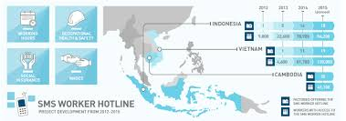
Source: https://adidasshoescommoditychain.wordpress.com/processing-of-raw-materials/

PESTLE Analysis of Adidas
In order to be identified external factor affecting company effectiveness it will be analysed PESTLE analyse of Adidas. Moreover, the PESTLE study for Adidas gets into the particulars of the rules and regulations which they obey.
Political Factors | Mani systems
Economics Factors | Counterfeit issue
Social Factors | Health conscious shopper
Technical Factors | Smart sportswear opportunities
Legal Factors | Patents
Environmental Factors | Reduces impact on the environment

Adidas manufactures, stores and distributes its goods worldwide. This helps them to extend and obey global supply chains with diplomatic processes while selling products digitally. Adidas needs to follow international agreements, workplace safety rules, employment laws and consumer product safety rules. The 50 biggest corporations contribute approximately 70% of the income of the sector. Adidas is another one of those organisations. The goods Adidas produces, are "leisure items." Prices are guided by the patterns and desires of sports consumers. Adidas will examine where goods are to be purchased and delivered. This creates success and development for the business. Adidas produces goods in China because they are labour-intensive and low rate of manufacture. Adidas has to play smart with the quality of goods. Another factor for Adidas is social - their focus group is health-conscious, sports-loving consumers. They need to keep up with medical developments and priorities in order to conform to their audience. Although, they sell company volunteer programmes and help societies and encourage the wellbeing of people. Adidas are seeking to improve the quality of managers and athletic practitioners. Organic material replacement parts are used for reliable solutions to sporting issues. They allow online sales via their web site as well as through social networks. Now, they are researching the clever sports clothing sector. Software, like the Fitbit, is quite common in the fitness world. Adidas will make use of these advances in technology to plunge into new industries and build a competitive edge. Company controls intellectual property and IP schemes, they also have patents on model, protecting their interests from duplication and misuse. As a large company, Adidas naturally have the production of trademarks and they supports celebrity sponsors as a form of marketing. Although Adidas reduces impact on the environment. It is their responsibility to track and remove dangerous substances. This may be the explanation why they provide traditional materials in their goods. They follow ethical behaviour by having committed themselves to ensuring that supplies meet the rules in each country where their items are produced. Adidas faces debate over the endorsement of low salaries in developing countries. But this lowers the cost of components— so, they're not going to slow down. They also face difficulties with industries copying and sell Adidas ' goods to be their own. Fortunately, Adidas has trademarks that prevent the sale of exact replicas. They appeal to the wellbeing-conscious shopper. They also improve designs in order to get closer to this general public. And with buyers moving towards smart technology in fitness, Adidas can widen to overseas markets. The organisation follows ethical practises as well as national and local laws (Frue, 2017).

SWOT analyses of Adidas
In order to be identified internal factor affecting company effectiveness it will be analysed SWOT analyse of Adidas.
STRENGTHS | WEAKNESSES
Wide geographical footprint  Focus on research and development activities  Improved performance of footwear category | Dependence on third party suppliers
OPPORTUNITIES | THREATS
Positive outlook for global footwear market  Positive outlook for e-retail market in Europe | Competitive pressure  Currency fluctuations risks  Increase in labour wages in Europe

The company sells its goods to nearly each country in the world. The business has strong market positions in all the countries in which it works. Adidas ' operation in several geographical regions would provide a diversified revenue stream and mitigate business risk. It also makes society less susceptible to the vagaries of a single market. Emerging economies are increasing faster than mature markets like the US, Japan, and some European countries. In recent years, Adidas has created significant income from these strong-growth developing markets. The organization devotes tremendous resources and attention to the development of new design ideas, technologies, production methods and software solutions for its products. Adidas ' clothing division was the main contributor to its income. Increase in revenue was due to increased sales of sport-inspired and sport-powered fitness items.There is heavy reliance on third party vendors and distributors borders the flexibility to move rapidly to more competitive product lines. It also opens the organisation to numerous threats that could have an effect on its activities. Adidas is projected to benefit from the rise of the global apparel and online retail industry in Europe. A large portion of the company's sales are produced outside the euro currency zone, and the sourcing of manufacturing materials and funding is also coordinated around the globe, as well as the rise in labour wages in Europe could have an effect on the competitiveness of the company (Marketline, 2019).

Adidas strategy

Adidas concentrates more on a wide-ranging differentiation approach. Adidas ' corporate strategy relies on creativity, making new products, technologies and systems in order to cope with rivalry. The multi-brand strategy of the group gives them a significant competitive advantage. It generated a worldwide sales structure that was responsible for commercial operations and a strong brand function that was responsible for the advertising of both labels. (Adidas, 2019). They adopted a multi-brand approach by having a strong portfolio of brands that enabled them to appeal to everyone else in all market segments. It allowed them to establish A clear personality and emphasis on their core competencies. Adidas based its resources on the right marketing and distribution networks in different countries by strategically evaluating customer purchasing habits and their continuing efforts to secure prime shelf space. Adidas have also welcomed e-commerce in order to become more effective and accessible to more customers and make shopping even simpler for them (Adidas, 2019). Their supply chain is easily shared and therefore allows them to tailor their services which appeal to a wide variety of consumers. The organisational culture of the Adidas Group obliges workers to be creative. This environment encourages them to produce products that are incredibly innovative and by the use of the latest technology, their products are also of good quality. To become a profitable business, they find the right balance between corporate desires and the wishes and demands of their shareholders, staff in their manufacturers ' factories and the climate.
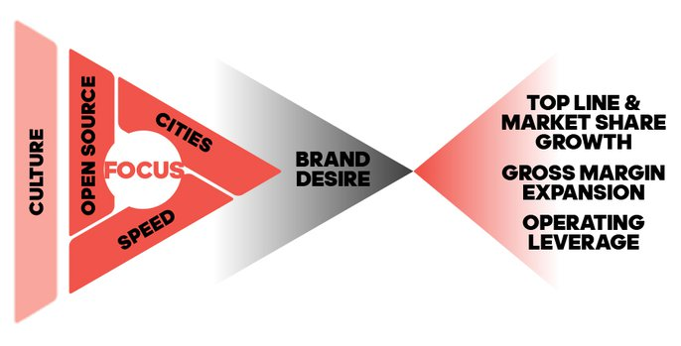
Figure 4. Adidas business plan
Source: www.adidas-group.com/en/
The Adidas business model was strongly focused on developing innovations specifically to meet the demands of customers. Rather than engaging in product endorsements, the organisation aims to show its quality by development of a high-performance item line based on the specific desires of athletes and customers. It also attentions on quicker brand development and production by continually improving technology, procedures and programmes. In contrast, they further highlight a significantly reduced uncertainty at the group level by streamlining the international product range, consolidating the warehouse base as well as harmonising the customer operation. The desire to produce the best advertised customer experience at all customer contact points. Innovative speed models in the supply chain are designed to respond quickly to consumer needs. That approach has inspired investors from around the globe to buy the common stock of Adidas, and the business has shown steady growth over many years. (Adidas, 2019)
Ethical Behavior
Ethical actions have been an important element of success in business in the modern world. There are many studies that describe the aspects and variables that affect the ethical behavior of the individual in the company and therefore their ethical decision-making. Furthermore, there are a various theory on the grounds of which most scientific experiments are tested. Cavanagh et al. (1981) offered utilitarian, right philosophy and the principle of justice, all these ideas and philosophies were distinct. According to Gresham, Ferrel and Mclaves N. (1985), both organizational and individual factors are drivers of ethical behavior (Geeta, et al., 2016). Although organizational influences are factors intrinsic to the individual that occur in the individual's work atmosphere which affect people in their ethical behavior directly or indirectly. There are many organizational variables concepts that are essential such as code of ethics, education in ethics, compensation process, environment, structure, etc. (Geeta, et al., 2016).
Adidas is a step ahead of most other major sports clothing companies whenever it relates to sustainability. They further dedicated themselves to establishing context-based goals, a new conservation thinking process which acknowledges that water effects are local and key activities in water-stressed basins. They also formed a partnership with the Ocean Conservation Group, Parley for the Oceans, to create a variety of products produced from aquatic recycled waste. While part of its Sustainability Policy, Adidas has set several goals to reduce its carbon footprint. They also made a public promise to increasing their waste output, energy usage and water use by at least 20% in all their facilities by 2020. Adidas actively engages with production partners in the hunt for emission reduction reductions, although they have not yet established a concrete goal for this. Moreover, Adidas is also dedicated to steadily increasing the use of more natural fabrics and to ensure that 100% of its cotton production meets the standards of the Good Cotton Initiative. Adidas is a founding partner of the Better Cotton Project and of the Sustainable Apparel Alliance. These are also partly approved by Blue sign, which supports the removal of harmful chemicals from the fabric manufacturing, the health of textile workers and the fair use of assets. (Robertson, 2017).
The employment ranking for Adidas was based on the 2018 Australian Fashion Survey, which looks at factors including the allocation of living wages, accountability and equality programs to staff. The company achieved an' A-' rating in the study, raising its 2016 ranking in most places, and earning the highest score for its Supplier Code of Conduct. (Australia, 2019). Adidas monitors and reviews most of its supply chain and openly reports most of its distributors. Notwithstanding these positive steps, though, the company still has no programmers to inspire workers. Although, another point there where Adidas has a little way to go is guaranteeing the staff in its manufacturing process are compensated a fair wage (Campaign, 2019). Adidas does not use angora, cashmere or any other exotic animal fur or hair that is a step in the right direction. Having said that, Adidas claims that it utilizes non-molded sheep wool and partners with the Leather Working Group to boost the quality of the leather industry (Robertson, 2017).
Generally, Adidas has ' Good ' rating based on the 2017 Australian Fashion Survey. Compared to the competition, Adidas is a long way ahead in terms of quality and working conditions. Adidas still have a long to go before they can be called a genuinely moral company. They should begin by paying a living wage for their staff. The manufacture of vast quantities of clothes (most of which are not produced from recycled materials) has disastrous effects not only on the climate, but also on employees who often have to work long hours with very little wages to meet production targets. (Robertson, 2017).

Leadership and culture
Leadership is another important part of success as a structure's productivity and efficiency. Manager who does not have the ability to lead other people, manager who does not acquire a leading role, will never succeed in bringing together subordinates and organizational needs to promote effective operations (Mintzberg, 1980a, p. 96). Leadership of the role model is an essential component of the leadership plan for Adidas. Also, in the making of Adidas is a new leadership group named the High Potential Management Category. In an effort to effort precision and responsibility, Adidas ' core leadership group has certified the first framework for global leadership. Three important components, called collaboration, creativity and trust, are at the core of this framework. This system has been developed in collaboration with workers who have been able to demonstrate their views on it. Adidas is also launching a special training system for HR executives entitled the People Manager Development System throughout the U.S., Japan, Australia, Middle East & Africa, which is the first people managers moving up to five staff. The course gives them the practical abilities and understanding required to be a worthy director of human resources (Adidas, 2019).
According to Fred Fiedler's theory, it is not simple for managers to be versatile with their management styles, particularly if their management style has made them popular as managers. He claims that any attempt to change the style of leadership of a boss to adapt to a changing situation also helps to assess effective leadership (Fielder, 1967). According to Path-goal philosophy, focused on the promise of incentives, the ruler is the origin of compensation. The director must recognize the good service or quality of his employee in order to influence them to function towards the goals set. Rewards are in the form of advertising and reward, as well as assistance, inspiration, protection and recognition. Although leadership styles have influenced the morale of the representative. The manager who uses the correct leadership styles should guide the subordinate to do the best mission. Leadership was seen as a mix of personality traits, such as self-confidence, concern for people, maturity, and trustworthiness (House, 1975).
Adidas set up a way to grow the business, to allow their brand more popular. They boost their product quality in order to make their brand more successful and robust. Adidas not only controls their method of operation; they also have a good lead in the production process. Adidas diligently directs and oversees their workers from the first phase of the production process to the end of the production process, which is why its business could become so famous and rich today. Throughout this evaluation it can be stated that management training and clearly communicated priorities from the senior management will improve the quality of leadership (Adidas, 2019).
Critical evaluation
It is very important to say that there is a lot of interconnection between framework, governance and interaction in Adidas. That area influences and shapes another, and changes in each zone will have a spillover effect on the other. This is very familiar with Leavitt's (1964, p. 325) assertion that the key and most effective fields of corporate control are design, personnel, and technology; it is very possible that interfering with any of these factors will have a significant effect on the other two. According to Bloisi et al. (2007), effective coordination is essential in order to achieve organizational performance, and communication breakdowns trigger various organizational issues, from failure to perform simple commands to low productivity and functional reliability. With this in mind, the communication level of speed and effectiveness is not that high due to Adidas’s Tall structure, which has a minus – slow communication. (Adidas, 2019)
Adidas ' efficiency and productivity are influenced by structure, leadership and communication. Structure determines how efficient the organizational procedures are, how successful they are achieved. Leadership and the skills and abilities of members, in effect, affect the entire workforce and how they strive to achieve this aim of increased productivity. Eventually, interaction determines how easily things are done, how happy and willing workers are, and how much change they are going to resist / catalyze. Other problems, however, impact each of the above-mentioned areas and thus influence results. The first of these issues is the organization's development and its exponential growth. Although size affects the structure, making it increasingly hierarchical (Leavitt, 2005). Scale frequently affects human factor, rendering interaction more difficult and leading people to separate themselves from their superiors (Leavitt, 1964). People working at Adidas should therefore learn to deal with it, adjust their organizational elements in relation to development, and have someone to manage such adjustments. (Adidas, 2019)
Lack of time and job pressure triggered unhappiness, opposition, and negative feelings. In terms of meetings, the amount of personal vertical communication exceeds the level required, thus taking time from senior managers, middle managers, and staff. The existing structure has proven to be the most rational, as Leavitt (2005) notes that organizational layout is the only one that allows big complex organizations to successfully achieve their hard work. Nevertheless, both leadership and interaction did not prove to function well enough; in particular, management qualities, weak contact, and impersonal communication. In order to help Adidas gain improved efficiency and productivity, company needs to change their communication way and keep implementing more and more innovation (Adidas, 2019).

Recommendation
Figure3. Innovation effectiveness of the company

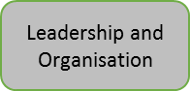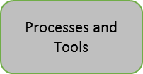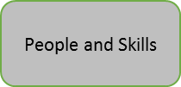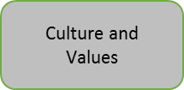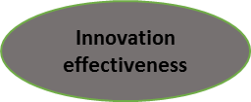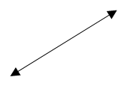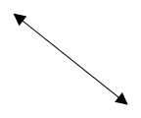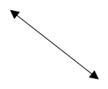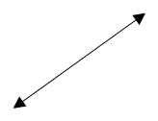

In summary, for innovation effectiveness of company Adidas, there are 4 important dimensions like Processes and tools, Culture and value, people and skills and Leadership and organisation as shown in Figure3. There is a need of Systematic methodology and methods for generating and developing new innovations, maintaining the inventory of goods. In particular, the involvement of many people in the application of technology and the use of effective institutional resources. Therefore, an open community that encourages teamwork and recognizes obstacles, and, finally, management and organization must be based on a common understanding of creativity.

Conclusion

This report was analysed Adidas culture and its impact on the organisation. As a result of analysing internal and external company's environment, together with company structure, culture, ethical behaviour and leadership of Adidas, it can be concluded that Adidas working effectively for achieving their goals. They understand the effectiveness of their culture and they implemented good practices. The point they need to improve is communication as results of tall organisation structure. Adidas's strengths has a strong management team and a great business strategy in North American and international markets, brand awareness and public image, uniqueness and range in web-based productions (footwear, clothing, sports, equipment, etc.), tight control over its own service offering, strong business base, and solid financial place with limited lengthy-term debts (Adidas, 2019). Of the end of this report was provided executive Recommendations to strengthen their management systems and policy improvements in an effective manner.

References

Adidas, 2019. Adidas. [Online]
Available at: https://www.adidas-group.com/en[Accessed 4 11 2019].
Adidas, 2019. Adidas Strategy. [Online]
Available at: https://www.adidas-group.com/en/group/strategy-overview/[Accessed 25 11 2019].
Australia, B. W. A., 2019. 2019 Ethical Fashion Report. [Online]
Available at: https://baptistworldaid.org.au/resources/2019-ethical-fashion-report/
[Accessed 4 12 2019].
Bloisi, W., Cook, C. & Hunsaker, F., 2007. Management and Organisational Behaviour. 2nd ed. s.l.:McGraw-Hill Education.
Campaign, 2019. Adidas and Nike pay record-breaking amounts to footballers, but deny decent wages to women stitching their shirts. [Online]
Available at: https://cleanclothes.org/news/2018/06/11/adidas-and-nike-pay-record-breaking-amounts-to-footballers-but-deny-decent-wages-to-women-stitching-their-shirts
[Accessed 4 12 2019].
Champaign, C. C., 2019. Adidas and Nike pay record-breaking amounts to footballers, but deny decent wages to women stitching their shirts. [Online]
Available at: https://cleanclothes.org/news/2018/06/11/adidas-and-nike-pay-record-breaking-amounts-to-footballers-but-deny-decent-wages-to-women-stitching-their-shirts
[Accessed 4 12 2019].
Ezigbo, C. A., 2011. Justification of Organisations’ Structure for Strategy Implementation. Advanced Management Theory and Practice , 3rd edition( Enugu Immaculate Publications Ltd.).
Fielder, F., 1967. A Theory of Leadership Effectiveness.". Print book : English ред. New York: McGraw-Hill.
Flippo, H., 2019. A Brief History of Adidas. [Online]
Available at: https://www.thoughtco.com/quick-history-of-adidas-1444319
[Accessed 4 11 2019].
Frue, K., 2017. PESTLE Analysis of Adidas. [Online]
Available at: https://pestleanalysis.com/pestle-analysis-adidas/[Accessed 18 12 2019].
Geeta, M., Pooja, J. & PN, M., 2016. Journal of Research in Business and Management. Ethical Behaviour in Organizations: A Literature Review, 4(1 (2016)), pp. 01-06.
Herskovits, M. J., 1955. Cultural anthropology. New York: Alfred, A. Knopr. Inc. Ltd. .
House, R. and Mitchell, T. (1975). Path-Goal Theory of Leadership. [Online] Apps.dtic.mil. Available at: https://apps.dtic.mil/docs/citations/ADA009513 [Accessed 9 Dec. 2019].
LHistory, 2019. The Adidas History: Historical Events. [Online]
Available at: https://www.learning-history.com/adidas-history-historical-events/
[Accessed 4 11 2019].
Loewe, P. & Dominiquini, J., 2006. Overcoming the Barriers to Effective Innovation. Strategy & Leadership, 34(1), pp. 24-31.
Manchiraju, S. & Sadachar, A., 2013. Personal values and ethical fashion consumption.. Journal of Fashion Marketing and Management, Том 18(3), pp. 357-374.
Marketline, 2019. adidas AG. [Online]
Available at: https://advantage-marketline-com.ezproxy.uwtsd.ac.uk/Company/Profile/adidas_ag_gd_27031?swot
[Accessed 20 12 2019].
Monavarian, A., Asgari, N. & Ashena, M., 2007. Structural and content dimension of know;edge-based organizations.The first national conference of knowlege management. :Bahman.
Rezayian, A., 2005. The basics of organization and management. Tehran: SAMT publications.
Robertson, L., 2017. How Ethical Is Adidas. [Online]
Available at: https://goodonyou.eco/adidas-ethical/[Accessed 5 11 2019].
Senior, B. & Swales, S., 2010. Organizational change. От: Harlow: Prentice hall, p. 74.
Slack, T. & Parent, M., 2006. Understanding Sport Organizations. In: 2. edition, ed. The Application of Organization Theory. Unated State of America: Human Kinetics, p. 355.

.

