ECPS4018
Study Skills for Psychology

E-portfolio
Contents
Summary 1
Infrographic 2
Essay Outline 3

Use of AI.

I have used Chat GPT for assignment ECPS4018 in November 2024. The question I asked Chat GPT was:
- Please explain what is meant by psychological, social, and physical benefits of owning a pet.
Then I scrolled through Google before I decided what sources I would use. I did not copy my work from Chat GPT. I also have my own research in my notebook.
I also asked the question:
- If a question asks for the benefits of owning a pet, does this mean I should put in a counterargument?

Summary

Create an article from the Psychologists Journal to summarise.

The bear necessities of stress. Mark Wetherell’s article demonstrates the body’s reaction to acute stress, and the physiological effects. It starts off by explaining that the first stages of stress occur when an individual experiences a sudden fright or shock. This reaction begins in the brain and quickly travels through the nervous system, and the hormone system. When these two systems have been activated, it influences the other system in the body. This is also known as fight, flight, or freeze. This article will look at this in more detail.

There are two pathways triggered by an individual experiencing a stressful situation. The first response is called the sympathetic adrenal medullary system, and this releases adrenaline and noradrenaline. Whereas the second response, which is called hypothalamic pituitary adrenal pathway, releases the hormone cortisol which helps keep the fight or flight response active by providing energy to deal with the immediate threat. This response manifests itself 20-30 minutes later.

In laboratory settings, participants were assessed during numerous methods, such as multi-tasking whilst being watched, and public speaking. They were then evaluated to see if their heart rate/blood pressure increased (Wetherell & Carter, 2014 cited in Wetherell, 2022). The results showed that cortisol is at its highest in the morning, and then declines throughout the day (Elder et al., 2014 cited in Wetherell, 2014). If cortisol is suppressed it can lead to severe stress.

But there are two types of stress, acute stress, (skydiving) and chronic stress (caring for a child with autism). Chronic stress causes severe depression, and they are prone to illness. If caregivers have a support network the effects of stress are reduced.

The answer to dealing with stress is finding the right balance. If not, the effects on well-being and good health will not be good.

Reference:

Wetherell, M., (2022). The bear necessities of stress. ‘The Psychologist’ 35 (10), 42-45. https://www.bps.org.uk/psychologist/bear-necessities-stress.

Infographic

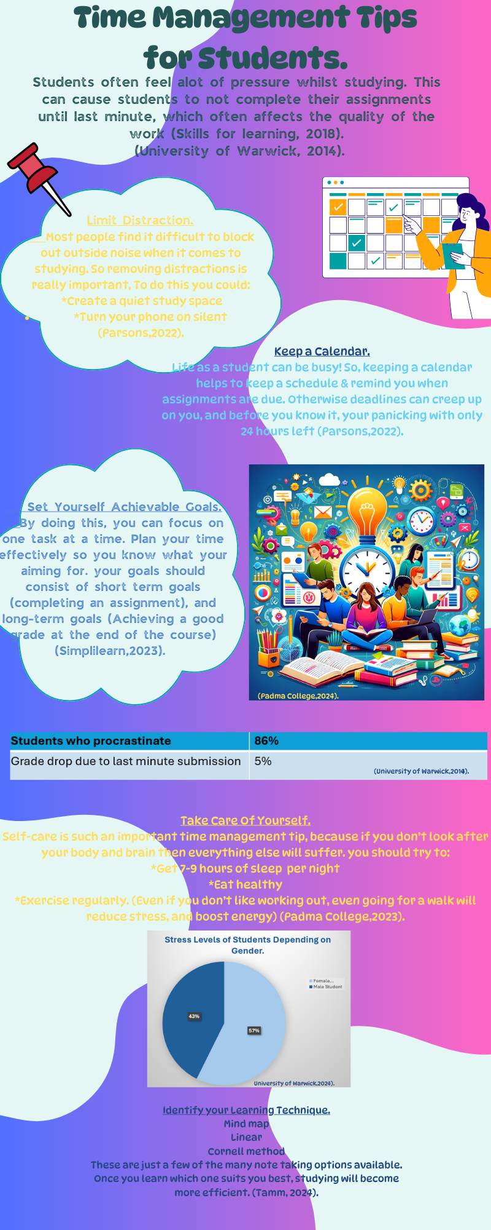

References:

Padma College (2024). ‘Effective Time Management Techniques for Busy College Students.’ Collegenp. Available at: info@collegenp.com

Parsons, L, (2022). ‘8 Time Management Tips for Student’ Harvard Summer School. Available at: https://summer.harvard.edu/blog/8-time-management-tips-for-students/.

Sander, T., (2024). ‘The 13 Most Effective Note-taking Methods’ e-student.org. Accessed: November 2024. Available at: https://e-student.org/note-taking-methods/

Skills for learning (2018). Guide to management (online) Wolverhampton: University of Wolverhampton. Accessed: November 2024. Available at: <http:11www.wlv.ac.uk/skills>.

University of Warwick (2014). ‘Students take note: Evidence that leaving essays until last minute ruin your grades.’ Science Daily. Accessed: November 2024. Available at: www.sciencedaily.com/releases/2014/09/140909144542.htm

Duggal, N., (2024). 10 Time Management Skills for Students ‘SimpliLearn’ https://www.simplilearn.com/tutorials/time-management-tutorial/best-time-management-tips-for-students.

Essay Outline

Describe and discuss the psychological, social, and physical benefits of owning a pet.

Intro-
There are more than 57% of pet owners worldwide, with dogs being the most popular pets owned, followed by rodents, then cats (Pet Food Industry, 2016). With 97% of pet owners in the US saying their pets were a part of their family (American Pet Association, 2023-2024 cited in Megna, 2024). But pets have proven to be more than a ‘part of the family.’ Evidence has shown that they have a positive impact on the lives of their owners.
- Then go onto to say the purpose of the essay and the examples that will be used in the essay.

Paragraph 1- Psychological Benefits.
- Owning a pet helps with emotional support and reduces stress.
- Interacting with pets helps to reduce stress and anxiety.
- Helps to balance cortisol, and oxytocin levels, which help problems with anxiety, depression, sleep, memory, and concentration.
- Evidence has shown that petting animals, can calm and relax pet owners, resulting in lower blood pressure.
- Another study showed that petting a pet for a minimum of 5 minutes a day increases dopamine. This helps give an individual a sense of pleasure and wellbeing (Osten, 2018).

Paragraph- Social, and physical benefits.
- Owning a pet helps to get individuals outside more, this helps to stop humans from isolating, and results in increased sunlight which helps depression.
- This also includes getting exercise, e.g., walking your dog, playing with them, even cleaning up after them.
- Meeting other like-minded dog owners, and engaging in conversation, or social activities helps to combat depression.
- Walking a dog in the park, field, or woods helps to pull humans towards nature.
- Leads to improved cardiovascular.
- Research has shown the positive impacts and significant benefits this brings offering stress relief, boosting mood, soothing pain.
- Another study on dog owners who are in a wheelchair found that when they were out with their dog, people were more likely to stop, or more likely to smile at them than if they were not with their pets (Osten, 2018).

Paragraph 2- Mental health and wellbeing during Covid (Grajfoner et al, 2021).
- Research in western societies showed a positive impact from owning a pet, on pet owners. However, there was little research done on the interaction between humans and animals in Southern Asia.
- A study was conducted in Malaysia during Covid
- The results showed that pet owners had significantly higher levels of mental wellbeing. Additionally, the pet owners felt they could cope better in adverse situations.
- Experienced higher levels of positive emotions during lockdown compared to non-pet owners.
- 448 Malaysian participants took part in an additional study online (Grajfoner et al., 2021).
- Research showed more resilience in pet owners resilient better wellbeing.
- Different results between showed when cat owners and dog owners. The cat owners showed to have more positive emotions and wellbeing compared to dog owners (Grajfoner, Guek & Wong, 2021).

Paragraph 3- Owning a pet in childhood.
- Evidence shows that owning a pet in childhood is associated with improvements in child health and wellbeing (Reilly, Somerville & Hecht, 2024).
- A study showed in the case of children-just by being in the presence of a dog they show improvements in their social and learning outcomes.
- With the presence of a dog in the classroom-children of pre-school age-complete cognitive tasks with fewer reminders from the teacher.
- Owning a pet dog with an infant at home-shown to reduce the risk of developing delays in infants-dog gives full attention, this helps the child to feel motivated.
- The child’s feelings are validated-they feel important-want to learn more (Reilly, & Somerville, 2024).
- The Covid pandemic caused children to struggle with anxiety and caused them to face social challenges. This is due to them not interacting in social settings. Children who were in the presence of a dog showed a reduction in stress levels, which were assessed via cortisol levels.
- In another example Poresky and Hendrix (1990) found that the stronger the relationship between a child and a pet, the more beneficial the physical health outcomes (as cited in Riley & Somerville, 2024)
- The American Academy of Child and Adolescent Psychiatry (2019) noted that pets provide comfort and emotional support to children, such as love, loyalty, and affection cited in Reloji-Howell, 2021).
- Children tell pets their secrets, increasing pro-social behaviour. (especially with children who are an only child).

Paragraph 4- Negative benefits of owning a pet (Pros Plus Cons, 2024).
- Time commitments-pets take up a lot of time. They rely on their owners to take care of them. They need daily care such as feeding, exercise, grooming, and attention. Can be demanding.
- Can be financially difficult-vet bills, vaccinations, and buying products/food can all add up to quite alot. An emergency vet trip can lead to significant expenses.
- Life span and emotional impact-pets become a part of the family, so when they pass away, it can leave owners heartbroken. The trauma of losing a pet can have a long-lasting effect.
- Isolation-this is because you cannot leave your pet e.g. dog/cat for extended periods of time. This has limitations on an individual’s social life.
- Pets can cause allergies-humans prone to allergies from fur, saliva and even urine.

Conclusion-
This essay has discussed the claim that owning a pet can have psychological, social, and physical benefits. The examples have shown that animals help their owners in many ways, but overall, its due to their love, loyalty, and companionship. Which in turn, leads to health improvements, giving them purpose, and expanding their social circle. However, despite these advantages, pets can also come with limitations. Pets take up a lot of time and are a lot of work. This can be difficult for owners who are not used to the restraints owning a pet can bring. However, evidence has shown that the positive impacts of owning a pet, outweigh the negative.

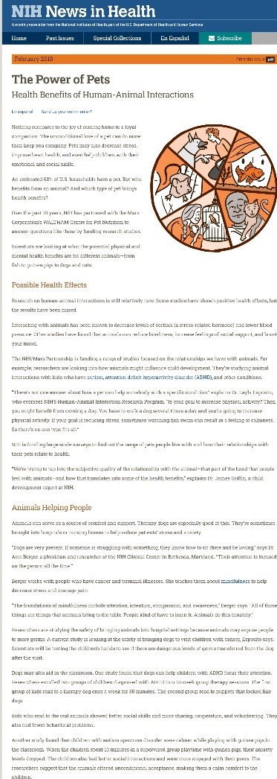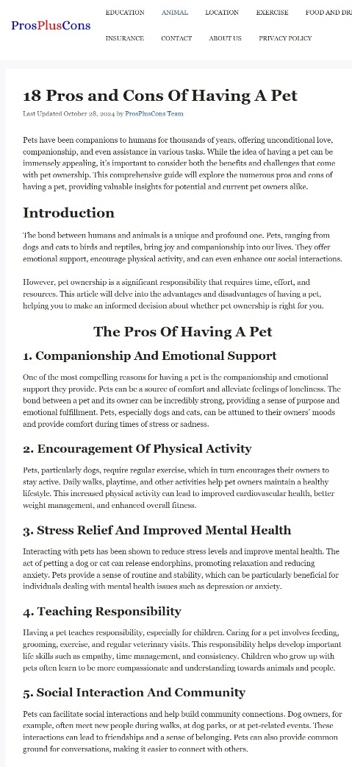

References:
Grajfoner, D., Guek, N, K., and Wong, R, M. M. (2021). The effects of pets on human mental health and wellbeing during COVID-19 lockdown in Malaysia. ‘Animals, 11 (9)’, 2689 https://doi.org/10.3390/ani11092689.

Osten, C. (2018). How dogs drive emotional wellbeing today? ‘Psychology Today.’ https://www.psychologytoday.com

Pro Plus Cons Team. (2024). Pros and Cons of Having a Pet. ‘ProPlusCons.’ https://propluscona.com/pros-and-cons-of-having-a-pet.

Relojo-Howell. D. (2021). What makes pet ownership so good for mental health? ‘Psychreg.’ https://www.psychreg.org?pet-ownership-mental-health.

Reilly, O, T., Somerville, L, H., & Hecht, E, E. (2024) Mechanism of Social Attachment Between Children & Pet Dogs. ‘Animals 14 (20), 3036. https://doi.org/10.3390/ani14203036.

Megna, M., (2024) Pet Ownership Statistics 2024. ‘Forbes Advisor.’ Https://www.forbes.com/advisor/pet-insurance/pet-ownership-statistics.

