Fatima Aljaboobi (1708339)
University of Wales Trinity Saint David | word count: 5018
How do brands benefit from social media use when compared to traditional marketing methods?
Submitted in partial fulfillment of the requirements for the degree of BA (Hons) Advertising and Brand Design, University of Wales Trinity Saint David, (1st. Feb. 2019)

Abstract
This report looks at the potential impact of modern marketing methods on companies, and how this compares with traditional methods. While traditional methods do have their place, they sacrifice speed and the precise targeting that is available to those using social media marketing. Companies should look towards a full transition to modern marketing methods, unless they are in a relatively slow industry, where trends take years to come and go, as the relative slowness of the traditional marketing methods will not be holding them back.

Table of Contents
Abstract 1
Introduction 3
Chapter 1 5
Chapter 2 10
Chapter 3 15
Conclusion 18
References 20

Introduction
This dissertation will discuss influencer marketing on YouTube and how it might affect users interest, Videonitch states that three hundred hours are uploaded every single minute, and it has thirty million visitors each day (2017). Moreover, over one point three billion people are the total users that YouTube has, and five billion videos are watched every single day. In addition, 8 out of 10 people aged between 18-49 watch YouTube monthly and generally 6 out of 10 people prefer online video platforms such as YouTube, Vine and Vimeo to that of live TV.
YouTube has a massive impact on the society such as the influence of many ways including news, music, influencers and their actions, gaming and advertisers. Social media and YouTube have grown extremely in the last decade since it was founded back on February 14th,2005 by Jawed Karim, Steve Chen, and Chad Hurley. All of these components make up the great platform that is YouTube. The great influence on society from YouTube will continue on for many years to come (mynorsecode.com, Mar. 2018). YouTube took another path from where it started from funny cats’ videos to countless video providers in every subject imaginable with several hours spent daily by individuals, that will definitely affect the viewers either directly or indirectly. In addition, YouTube had brought new marketing methods such as influencer marketing which will be discussed in this dissertation, and furthermore explore what influencer marketing is, who is the influencer, how influencers use YouTube platforms and whether this method is better nowadays than traditional marketing before social media. Moreover, recently there are so many brands which have been popular only from using influencer marketing methods. This method within a couple of years has been so successful in selling what was normal to get to that point just one decade ago.
For example, Gymshark active wear only used influencer marketing and achieved in 5 years what took Adidas half a century, and this is what this dissertation will argue. This dissertation will help to understand this platform, what is the most effective way to use it, how to target the right audience in their own language and in the platform of choice.


Chapter 1
This chapter will look at traditional and modern advertising, how it has been used by companies over time, and give a brief history of social media.

“In the old days, advertising was about newspapers and magazines, with occasional radio ads and local TV spots. Today, you need an internet presence— and you need to be visible on search engines. Again, consider advertising on social-media platforms” (Knittle, 2017).
Advertising was started to help business communicate with companies’ target audience and build a strong bond with the loyal customer but since 2004, social media has taken advertising to another level and has created new ways to market products and services. So what is social media and what is its history? According to TechTarget in September 2016, “social media is the collective of online communications channels dedicated to community-based input, interaction, content-sharing and collaboration”.
“Social media are changing the way that information is
passed across societies and around the world”

The birth of social media was in 1997 as a website called Six Degrees of Separation’s Theory and lasted between 1997 to 2000. This website allowed people to create a profile and make friends and contacts. During the 2000’s the internet access raised to one hundred million and became more accessible which made people start with online engagement and other internet users, who were contactable in chat rooms to make friends and to discuss topics. After four years in 2004 Mark Zuckerberg launched Facebook which now is social media’s number one platform which has over two-billions monthly users (dreamgrow.com, 2018). A year later YouTube was founded by three young men. After three months, the first video was posted, which was about one of the founder’s days in the zoo. After this, YouTube became viral for funny cat videos. Over time it has changed to become the second most popular social media platform, where you can find every type of genre (buisnessinsider.com, 2013). The most viewed videos on YouTube are music videos, and the third most subscribed music channel is for Justin Bieber. He was discovered through YouTube, in a video he had created and posted to the site. Not only music is popular on YouTube, through the years, vlogs, blogs, and games have also increased their fan-base. PewDiePie has the most subscribed channels on YouTube, and he is a gamer. The fifth most subscribed channel is called Crafty and is about hand crafted and dyeing skills. This shows the diversity that can be found on YouTube, and how each user can find what their interest on the platform. In 2010 most of the social media platforms had been founded, such as Snapchat, Instagram, Pinterest, LinkedIn, Twitter, and Tumblr. After all of these platforms had been established, people took advantage and created their own profiles, making these accessible to the public, such as providing ideas, entertainment, or personal blogs. Some of these people went viral, with a lot of social media’s users interested in the things that they post. With time, their number of viewers grew, and the followers started to brand them, turning them into role models. These people became influencers and began what is known as influencer marketing. Influencer marketing is a form of marketing focussed on key people, rather than the target market. It uses those with large followings to attract the audience, and then tailors the marketing around them (Defenitions.net, 2018). Any individual can create an account in any social media platform and has the freedom to post whatever they want but accounts who have two hundred followers or subscribers will not have the same influence as an account which has one hundred thousand followers. Influencers worth is raised dependent on three factors; the number of followers, engagement and reach, as the higher the number of followers equates to the higher engagement and reach of the adverts to the audience (hireinfuluncer.com, 2018). However, any business account which includes public figure and personal blog that has over ten thousand followers on Instagram will use a feature it had created in May 2017, which is clickable links on stories to promote products and services in an easy way of calling to action (socialmediaexaminer.com, 2017).
On the other hand, people who have millions and millions of followers, for example, Kylie Jenner, who has one hundred twenty-one million followers on Instagram and twenty-five million followers on Twitter, made Snapchat lose over a billion dollars of its market value because of a tweet she wrote on Twitter which is below,
“sooo does anyone else not open Snapchat anymore? Or is it just
me... ugh this is so sad”.

And that happened after Snapchat download a new update for its users but the TV reality star who consider one of snapchat influential users was not impressed by it and in in one tweet that made Snapchat lose 6% of its stock value. Following the changing tweet, over one million signed a petition on Change.org requesting from snapchat to remove the redesign. Snapchat faced backlash after Kylie’s followers reacted and that led to Snapchat trying to calm down the users by announcing that the update aimed at making it easier for users to view and contact, they want to see (money.cnn.com, 2018).

"We hear you and appreciate that you took the time to let us know how you feel. We completely understand the new Snapchat has felt uncomfortable for many,"
the company wrote on Change.org, in response to the petition.

Influencers are considering brands themselves as it took them time and hard work to build the connection with their followers and that is like any other brand not every decision was made always been approved by the customer. Influencers can have impact on their followers but is up to the followers believes and morals and it can flip around the influencer themselves if they misbehave or show stuff that may harm the viewers, they can face backlash or lose their career and fan base. For example, the 22-year-old American Logan Paul lost around $5 million after traveling to a suicide hotspot in Japan and creating a video that featured a suicide (Deason, 2018). Even though he was an extremely popular and large influencer, this single video was enough to severely damage his career. The $5 million figure is only what he lost after he was removed from the “Google preferred partner” program and doesn’t include any other sponsorships or deals he may have had. Google preferred partnership allows advertisers to access the most popular YouTube channels, and to choose between the categories of channels that they want to target (Google, 2016). The sums of money paid out with the Google Preferred Partner program are vast when compared to the amount earned by those at the standard creator rank.

Figure 1 - Logan Paul, youtube.com
At creator level, a creator could expect to earn $4.18 for every thousand views on their video, as long as every viewer watched the advert (Influencer Marketing Hub, 2018). Because of the large sums of money involved with the partner programme, the influencers are held to a much higher standard than the rest of the community, and despite still being allowed to get away with a variety of other questionable activities, such as PewDiePie with his anti-Semitic “jokes”. This method of advertising does add a risk for companies, as even though there are not often issues with the content the adverts are attached too, any issues that do arise will occur on a massive scale, and there is a chance of the brand being tarnished by association. In 2017, a number of brands removed their adverts from YouTube, after they were playing on videos promoting terrorism and other extremist content (Snider, 2017). This highlights another risk with this form of advertising, as companies cannot guarantee what their adverts will be shown with, or who will see them. While most people that saw the adverts would probably understand that the company has not deliberately asked to sponsor those videos, and that they likely have no idea about it, it is a concern for the companies creating the adverts, as they are inadvertently giving money to those publishers.

Chapter 2
This chapter looks at a variety of articles and journals related to advertising, and how different companies approach it.
In 2014, Marshall Cheney developed his PHD practice research on thirty-three Vapor store owners, to discover what methods they preferred for marketing their stores. He found out that approximately one quarter of the owners had used radio adverts, and only two owners have used tv ads, while the other owners believe that traditional marketing is too expensive to use and used social media, mainly using Facebook to connect with their target. This is further confirmed by another study (Cheney, Gowin, Wann, 2015), in America, which showed that vaping (electronic cigarette) stores rely heavily on online marketing, as the costs for traditional marketing are often too great for them. Through online marketing, they can tailor the adverts to their customers, and respond in real-time with promotions and discounts, whereas traditional media would have a longer lead-time between updates, reducing the company’s ability to react. As a marketer, being able to react quickly is important because people will engage more, as it is a hot topic, and this will help keep the company relevant and in every bodies mind. From an article on social media marketing (VENCIŪTĖ, 2018), it is suggested that firms invest into social media internally, through hiring staff to manage it, as even though it may not provide a performance advantage, it is vital to a competitive advantage. Social media is a current global trend, and companies that aren’t using it fully are wasting the opportunity.
An article from the Entrepreneurial Executive (2012), found that whilst social media marketing was an extremely useful strategy, the company had to ensure that the media was kept up to date, as a stale feed could be harmful to a smaller business. Because firstly, keeping things updated will build a stronger bond with the target and build a really connected loyal club. As well, there is the social media strategy itself. If you have a large social media following, you need to post more to be able to reach more of that audience, as social networks work to stop companies doing less frequent posts to all of their followers. It could be argued that social media will not always be effective positively each target if they lose interest in social media in the first place, as shown in the following article. In an article by Remodeler (2011), construction workers were questioned about their advertising methods, and how useful they felt that they were. In the survey (conducted yearly), social media saw the largest jumps, going from 0% to 18% between 2009 and 2010, and then up to 29% in 2011. It also showed that 27% of the respondents do not use social media at all, as some felt that “social networks are for playtime, not for serious work”. In most industries, such an attitude would be frowned upon, as social media marketing represents a cheap and fast way of advertising to potential customers.
In a survey conducted by Harris Interactive and the PRSA Foundation (2005), over a thousand adults in the U.S were surveyed to discover how acceptable they thought certain marketing techniques acceptability rating of between 64% and 87%, whereas “paying private citizens” was rated at 45% to 57%. This is interesting because in both cases, the company would be paying the person to promote them, and the methods used to do this would likely be similar. Because the influencer works so hard to brand themselves, so that they build a connection with their followers, and they have always been authentic and real. This helps their followers to trust them, they are more likely to go with anything they promote. One of the most effective ways to promote through influencers is to choose one that has the target audience that you need to promote too, for example if you are promoting computer games, PewDiePie would be ideal, as he is the most subscribed Youtuber. For strategies like this, it is important to follow the rules, as Warner Bros were caught paying Youtubers to promote a game and trying to hide it. The videos promoted had more than 5.5 million views, with PewDiePie’s viewers counting for 3.7 million of them (BBC, 2016).
According to a Tennis Industry article (Bruce, 2017), tennis clubs are being encouraged to use both traditional and modern marketing, so that they can stay current for a younger audience and preserve the traditional audience. They also suggest using the electronic version of the traditional methods, such as sending out email versions of their fliers. The younger audience are more likely to use social media, as according to a survey carried out by Pew Research Center (2012), 67% use at least one social networking site. A recent study in Turkey (Batum, 2016), found that Instagram was the best social media marketing method for customer interaction compared to the other platforms used. Because Instagram is a visual platform, and people now-a-days are in a really fast paced life, and they do not spend time reading and analysing things, they would prefer to visualise it or use pictures, and Instagram is the number one visual platform. In addition, the audience see the product and the service, which can be better than describing it. This ties in well with the previous article from the Tennis Industry, as Instagram can use short videos, which could be long enough in some cases, and would give the companies a better chance at competing with the more established brands, as they will be able to react much quicker. It has been found that there is a positive relationship between social media performance, and marketing performance (Tafesse, 2018). Because a good marketing performance will build loyal customers, and the loyal customers will go the company’s social media to be updated with all of their new products and services. This is another important advantage of modern marketing, as companies are able to target and reward good customers instantly, ensuring their continued custom. In a study that looked at a company over time, and how it trialled modern marketing, it was found that the company could save more than $0.4 million a year from switching to social media marketing (Kumar, 2017). Traditional marketing will be more expensive, costing £5.25 per column inch, and it cannot be guaranteed to reach the companies target audience. When using social media, you can control which demographic to target your adverts at. With this money, and with a high number of the same demographic targeted, such as on Facebook ads start from 70p reaching up to a thousand people of the chosen demographic.
A 2016 study (Godey et al, 2016) found that social media marketing efforts have a positive effect on two areas of brand equity, those being awareness and image. Because it is a really competitive and digital designer world that is why each company should focus on quality of its image to stand out, or it will be lost in the amount of competition out there. In addition, the first marketing method to achieve good quality and image will be through social media. Moreover, the brand who focuses on these areas, quality of image, and use influencers to its favour to promote their products, such as Louise Vuitton, when it is expensive, but seeing it so often gives the illusion that everyone can have it, which in turn can make people want to have it. A recent study on the impact of social media marketing on luxury brands found that maintaining a “psychological distance” was important to protect the perceived value of the brand (Park, Im & Kim, 2018). The influencers showing off on purpose that they have all of the luxury products, usually given to them by the company, shows people a life that they could have, which is why they continue to follow these people. And that is why luxury products look better using influencer marketing, because it has been modelled on a real-life role model, that have many followers. A 2012 study (Kim & Ko, 2012) found that there was a “significantly positive” effect on a luxury brand from the use of social media marketing, and that these brands should continue to use it. It is important for brands using this marketing method to remember that their reputation can also be harmed by the influencers, and although it is not a frequent problem, it does still happen now and again.
The” Invest in Your Love” competition was used just after the 2008 economic crisis to encourage people to create their own video of paradise and submit it in the hope of winning a trip to Tahiti (Kahn, 2014). This marketing method resulted in many people uploading their videos to YouTube, in the hope of winning the competition. Using another company like this is an effective cost saving method, as the marketing company only has to direct people to YouTube and doesn’t need to concern itself with any of the costs or issues associated with running such a service. This a clear example of driving followers and encouraging them to get involved with the company, aiming to win the prize, and in turn inviting their friends and family to enter the competition, saving the company from marketing at them directly. The Tennis Industry (Torsiello, 2017) also suggest that facilities and instructors use YouTube to attract customers, by creating tutorial videos for them to follow. They suggest using social media to spread the videos, and to post new videos regularly. YouTube is the second most popular social media platform, after Facebook. For example, tennis is all about movement, and as YouTube is a video-based platform, it allows the instructors to authentically demonstrate their skills, whereas they would struggle to do this with an image.

Chapter 3
In this chapter, Adidas and Gymshark will be looked at, and their marketing methods and the differences between using influencer marketing, and traditional marketing. Adidas began in 1924, and by 1928 had sponsored athletes winning medals in the Olympics. However, it wasn’t until Germany beat Hungary in the 1954 World Cup final, that Adidas went global with their fame. Adidas continues to focus on sportswear, going from strength to strength, until the year 2000, where they began to branch out, and introduced a new “lifestyle” segment, focused on streetwear. Throughout this, Adidas have relied on traditional marketing methods, especially using professional athletes to show off their products during their competitions. Whilst these athletes used to be called role models, they could also be called influencers, as the top athletes are highly influential. Footwear was the main form of sponsorship provided to these athletes, especially footballers, as the shoes would be featured in all goal replays and highlights, providing yet more advertising. As computer games rose on popularity, the top athletes also benefitted from this, as they would be featured on the merchandising promotional materials. The Adidas group targets its different brands towards different customer segments, allowing them to easily tailor the marketing used to suit the desired demographic. The different segments are competitive sports, casual sports, and sports fashion.
Gymshark is a fitness clothing brand targeting gym-goers, who were underserved by the traditional sportswear manufacturers. They created clothing that was both fitted and practical for exercise, whilst also looking good. Instead of using any traditional marketing methods, Gymshark focused on using social media influencers. Initially, they used big names in the bodybuilding industry to promote themselves, and these athletes wore the clothing to exhibitions, further promoting the brand. Additionally, Gymshark sell directly to customers, allowing them to cut out the middle-men, and save money. As Gymshark sales increased, they began to sponsor social media fitness starts, which allowed them to break into the US market, which is far larger than the UK market. From the success of this strategy, they expanded their social media campaign to include hundreds more influencers (Marketline, 2018). While this company was only founded in 2012, it has rapidly grown to become one of the biggest names in sportswear fashion.
As previously said, Gymshark rely on influencers marketing their products, as the first approach to the female fitness industry was through Nikki Blackketter, who is a popular fitness youtuber, with over seven hundred thousand current subscribers. Gymshark also use affiliate linking, where influencers provide custom links to their viewers, which allows the company to track how many of the influencer’s viewers are interacting with the sponsorship. These links gave a cut of the money back to the influencer, giving them an incentive to promote these links, and the sales of the goods. After using Nikki, Gymshark started to become more known, and had new customers, which led to an annual sales increase of over 190% over the three years leading up to 2016.

Figure 2 - Nikki blackketter, gymshark.com

Whereas it took Adidas many years to become a truly global brand, thanks to social media and the modern marketing techniques, companies such as Gymshark are able to do this in a much shorter time. While social media marketing is an extremely efficient method of marketing when used correctly, it does not leave companies with the same levels of stability that the traditional methods would bring. Without a store presence, Gymshark are entirely reliant on people either discovering them through social media, or from people seeing others wearing the clothing, and discovering them that way. This is also due to them selling directly to customers, meaning that there would not be any stores that stock their clothing, which would open up their sales opportunities, although it would likely increase the price of products and company overloads.

Conclusion
In conclusion, the report has found that influencer marketing is a new method to help companies to reach their target using the most popular social media stars in different areas in the market from gaming to book hauls. Influencer marketing can be cheaper and more effective when choosing the right candidate to promote through them the products and services, because their audience believe in them and admire their life style. As shown in the previous chapter, Gymshark grew massively and it was considered one of the most competitive brands for other companies, even though it was founded five years ago after using influencer marketing and continued using it after the positive impact it brought to Gymshark as a newly started business. YouTube has a high number of users and they can be influenced by YouTube but in barriers if misbehaving in the audience it risks the influencers lose their reputation and audience interest in them. The report has also found that not all companies make use of modern marketing techniques, as some feel they are a waste of their time. There are also groups trying to encourage their members to use social media more, such as the Tennis Industry. The construction industry could also benefit from using social media marketing better, but there is still a sizable amount of them that refuse to interact with social media, cutting them off from a large market.
The examples found in the report are useful, because as a marketer the job could be for any sort of industry and having some knowledge of each industry could save a lot of hassle at the start of the job. Living in this fast-paced life style has taught us to always be up for change and to be flexible with new methods in terms of communication with different target audiences. In the future, Influencer Marketing may well be more expensive than what it is nowadays and that’s due to the effective outcome it has created lately. Advertising always surprises us with new methods of targeting audience. Who knows It might get a new marketing platform which will beat social media and will be beneficial to do a report about it?

References
Anon, 2005. Majorities Think Traditional Marketing Methods Are Acceptable Practices; Fewer View Newer Techniques Such as Internet Pop-ups or Text Messaging as Acceptable Ways to Market to Customers. PR Newswire, p.1.
BATUM, Tahsin Perçin, 2016. THE USE OF SOCIAL MEDIA IN B2B MARKETING COMMUNICATIONS: AN EXPLATORY STUDY ON TURKISH COMPANIES. Journal of Economics & Administrative Sciences / Afyon Kocatepe Üniversitesi Iktisadi ve Idari Bilimler Fakültesi Dergisi, 18(2), pp.139–152.
BBC (2016). Warner Bros paid YouTubers thousands to promote games. [online] BBC. Available at: http://www.bbc.co.uk/newsbeat/article/36771304/warner-bros-paid-youtubers-thousands-to-promote-games [Accessed 3 Dec. 2018].
Cheney, M., Gowin, M. and Wann, T. F. (2015) ‘Marketing Practices of Vapor Store Owners’, American Journal of Public Health, 105(6), pp. e16–e21. Available at: https://ezproxy.uwtsd.ac.uk/login?url=https://search.ebscohost.com/login.aspx?direct=true&db=s3h&AN=112287663&site=ehost-live (Accessed: 10 December 2018).
Deason, R. (2018). Logan Paul reveals how much money he lost by getting cut from 'Google Preferred'. [online] Dexerto. Available at: https://www.dexerto.com/entertainment/logan-paul-reveals-how-much-money-he-lost-by-getting-cut-from-google-preferred-207316 [Accessed 9 Dec. 2018].
Defenitions.net (2018). What does INFLUENCER MARKETING mean?. [online] Available at: https://www.definitions.net/definition/INFLUENCER%20MARKETING [Accessed 11 Dec. 2018].
Geho, P. & Dangelo, J., 2012. THE EVOLUTION OF SOCIAL MEDIA AS A MARKETING TOOL FOR ENTREPRENEURS. The Entrepreneurial Executive, 17, pp.61–68.
Godey et al., 2016. Social media marketing efforts of luxury brands: Influence on brand equity and consumer behavior. Journal of Business Research, 69(12), pp.5833–5841.
Google (2016). Google Preferred. [online] Think with Google. Available at: https://www.thinkwithgoogle.com/products/google-preferred/ [Accessed 11 Dec. 2018].

Kahn, Miriam, 2014. “Invest In Your Love”: Romantic desires, YouTube videos, and the online marketing of Tahiti. Tourist Studies, 14(2), pp.144–168.
Kim & Ko, 2012. Do social media marketing activities enhance customer equity? An empirical study of luxury fashion brand. Journal of Business Research, 65(10), pp.1480–1486.
KNITTLE, B. (2017) ‘Something Old, Something New: Boost your club business by combining traditional marketing methods with modern strategies’, Addvantage, 45(5), p. 24. Available at: https://ezproxy.uwtsd.ac.uk/login?url=https://search.ebscohost.com/login.aspx?direct=true&db=s3h&AN=125257971&site=ehost-live (Accessed: 2 December 2018).
Kumar, V., 2017. Synergistic effects of social media and traditional marketing on brand sales: capturing the time-varying effects. Journal of the Academy of Marketing Science, 45(2), pp.268–289.
Influencer Marketing Hub (2018). YouTube Money Calculator - See How Much Money You Can Make. [online] Influencer Marketing Hub. Available at: https://influencermarketinghub.com/youtube-money-calculator/ [Accessed 11 Dec. 2018].

Marketline (2018). Gymshark is a prime example of millennial marketing done right. [online] Verdict Retail. Available at: https://www.retail-insight-network.com/comment/gymshark-prime-example-millennial-marketing-done-right/ [Accessed 12 Dec. 2018].

Park, Im & Kim, 2018. "You are too friendly!" The negative effects of social media marketing on value perceptions of luxury fashion brands. Journal of Business Research, pp.
Sweet, J., 2011. Remodelers Research: Marketing and Social Media. Professional Remodeler, p.n/a.
Snider, M. (2017). YouTube says it's removing terrorist and extremist content faster. [online] Usatoday.com. Available at: https://eu.usatoday.com/story/tech/talkingtech/2017/08/01/youtube-says-its-removing-terrorist-and-extremist-content-faster/526705001/ [Accessed 11 Dec. 2018].

Tafesse, Wondwesen, 2018. Implementing social media marketing strategically: an empirical assessment. Journal of Marketing Management, 34(9/10), pp.732–750.
Torsiello, John, 2017. Video Frequency: YouTube can be an important marketing tool for tennis facilities and teaching pros. Addvantage, 45(1), pp.23–24.
VENCIŪTĖ, Dominyka, 2018. Social Media Marketing - from Tool to Capability. Management of Organizations: Systematic Research, (79), pp.131–146.

Appendix
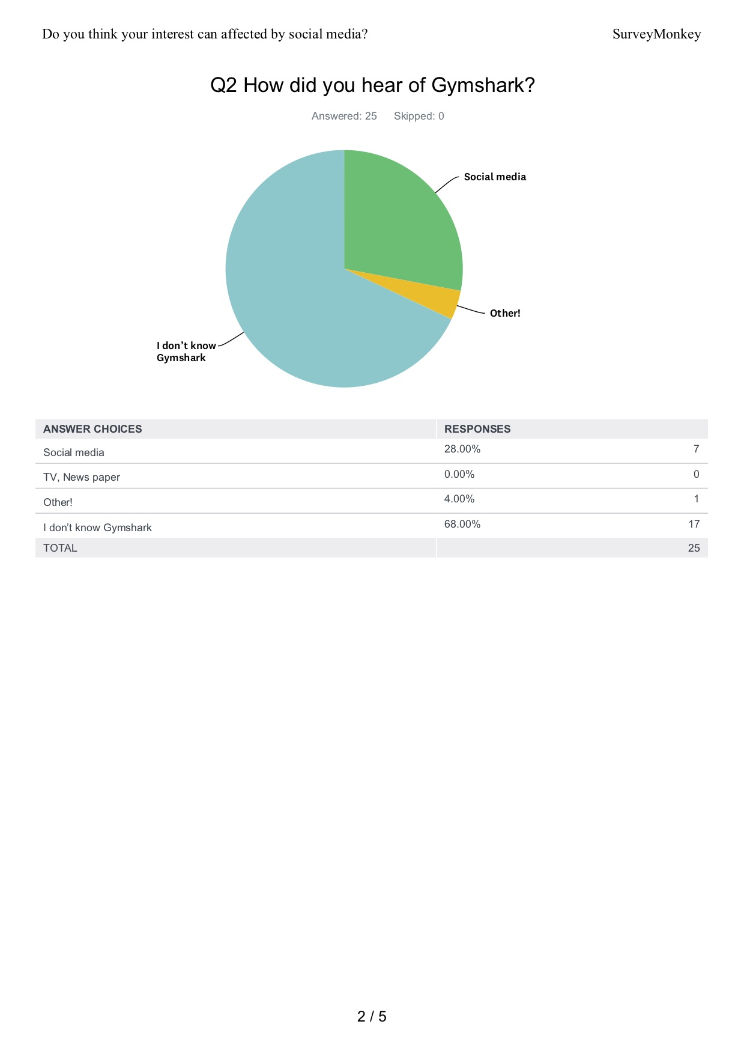
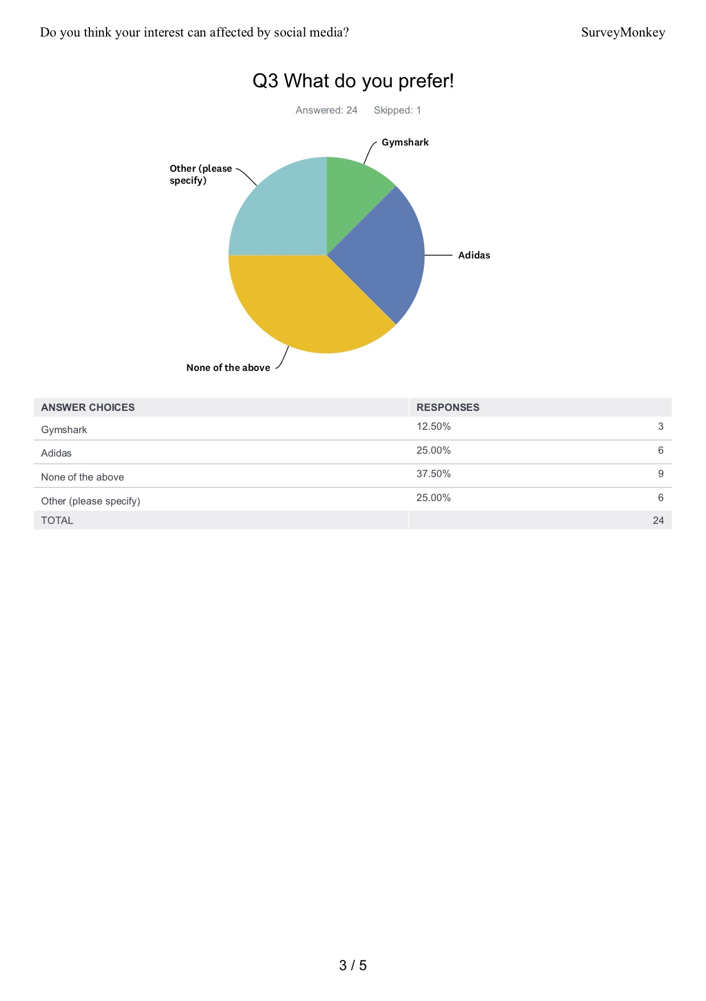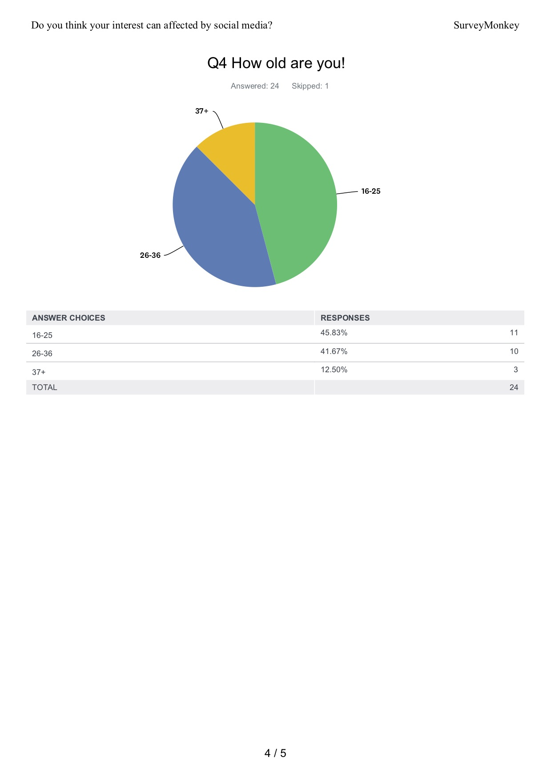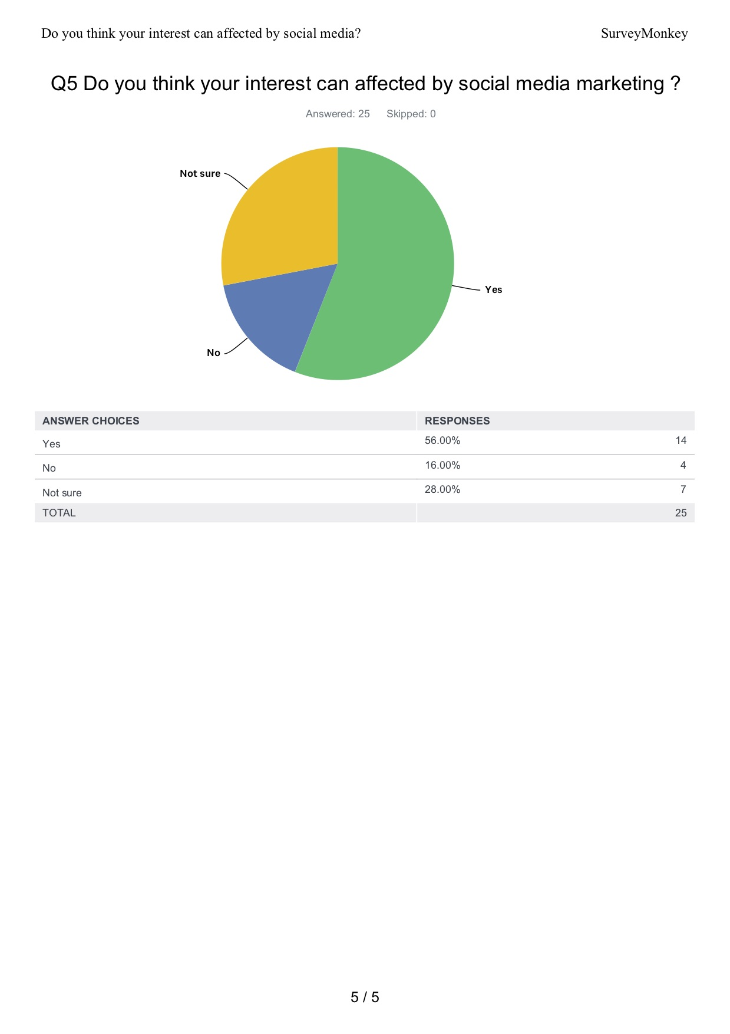

Survey Summery
https://www.surveymonkey.com/results/SM-V56WTHRQV/

