Take off and BoQ

Prepared for:

D. Hughes

Written by:

S. Williams

Date completed:
15th May 2023

Table of Contents
Page
Number
1.0 Executive Summary 3

2.0 Findings 3
2.1 Cost of Gross Internal Floor area for ground floor extension 3
2.2 Cost of Gross Internal Floor area for existing ground floor 3
2.3 Cost of Gross Internal Floor area for existing first floor 3
2.4 Centreline calculations for extension. 4
2.5 Measuring the existing roof tiles. 5
2.6 BoQ information and extra drawing details. 7

3.0 Conclusion 7

4.0 References 7

1.0 Executive summary
This report focuses on doing a take-off for elements of the proposed extension and replacing roof tiles on the existing building. It BoQ is then produced showing an estimate of the external envelope and tiles.
2.0 Findings
2.1 Cost of Gross Internal Floor area for ground floor extension
Ground  Floor | Length  (M) | Width  (M) | Area  ($M^{2}$) | Estimated cost per  ${(M}^{2}$)  £
Section  A | 1.75 | 1.75 | 3.063 | 300.17
Section  B | 7.43 | 1.48 | 10.996 | 1077.61
Section  C | 2.95 | 2.78 | 8.201 | 803.70

Total Gross Internal Floor area for extension = 22.26 $M^{2}$
Total estimated cost for extension = £2182.00
2.2 Cost of Gross Internal Floor area for existing ground floor
Ground  Floor | Length  (M) | Width  (M) | Area  ($M^{2}$) | Estimated cost per  ($M^{2}$)  £
Section  A | 5.45 | 2.35 | 12.808 | 1255.19
Section  B | 1.75 | 1.6 | 2.8 | 274.40

Total Gross Internal Floor area for existing ground floor = 15.608 $M^{2}$
Total estimated cost for existing ground floor = £1530.00
2.3 Cost of Gross Internal Floor area for existing first floor
First  Floor | Length  (M) | Width  (M) | Area  ($M^{2}$) | Estimated cost per  ($M^{2}$)  £
Section  A | 5.45 | 2.35 | 12.808 | 960.60
Section  B | 1.75 | 1.6 | 2.8 | 210.00

Total Gross Internal Floor Area for existing first floor = 15.608 $M^{2}$
Total estimated cost for existing first floor = £1171.00
2.3.1 Notes for client
- The ground floor for the existing build and proposed extension consists of 150mm thick concrete slab with 1 layer of A195 fabric reinforcement that has a cost of £98.00 per $M^{2}$.

- The first floor for the existing build consists of a joisted floor, plasterboard ceiling, skim, emulsion, t&g chipboard, sheet vinyl flooring and painted softwood skirtings that has a cost of £75.00 per $M^{2}$ (AECOM, 2020, p. 185, 189).

2.4 Centreline calculations for extension (see sheet for original calculations)
Internal living space girth (m)
1.475 A
5.725 B
2 / 1.700 C/D
3.400
5.950 E
2.950 F
2.775 G
4.500 H
Total internal girth = 26.775m
2.4.1 Centreline calculations
Inner blockwork
4/2/0.5/0.1 = 0.4
4/2/0.5/0.1 = 0.4
T = 0.8m
Insulation
4/2/0.5/0.0375 = 0.15
4/2/0.5/0.0375 = 0.15
T = 0.3m
Cavity
4/2/0.5/0.015 = 0.06
4/2/0.5/0.015 = 0.06
T = 0.12m
Outer blockwork
4/2/0.5/0.1 = 0.4
4/2/0.5/0.1 = 0.4
T = 0.8m
26.775 + 0.8 + 0.3 + 0.12 + 0.8
Total girth (internal to external) = 28.795m

2.5 Measuring the existing roof tiles.
Roof measurements
Width of roof (including overhang) = 6.6m
Height from eaves to apex = 1.15m
Length of roof = 7.75m
Roof area ($m^{2}$)
2.8 + 0.5 = 3.3m
(run) + (overhang)
= (3.3 x 1.15) x2 = 7.59$m^{2}$
Roof pitch
= 1.15 $÷$3.3 = 0.348 (3 d.p.)
$\tan^{-1}$ (0.348) = 19.19˚
Rafter length
$C^{2}$ = ${3.3}^{2}$ + ${1.15}^{2}$
= 10.89 + 1.3225
= 12.2125
= $√12.2125$
C = 3.49m
2.5.1 Notes for client
- A Welsh slate finish has been selected for the existing roof.
- Sloping per $m^{2}$ = £211.00.
- Estimated price = £1602.00 (AECOM, 2020, p. 190)
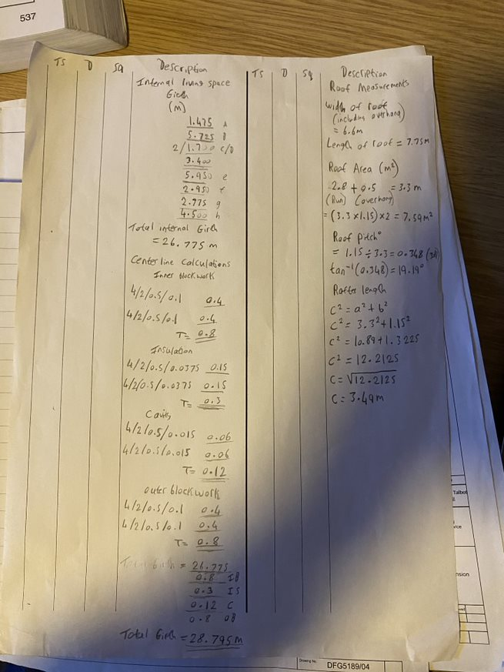

2.6 BoQ information and extra drawing details
See excel spreadsheet for BoQ.
Proposed rear elevation.
Door = 2.05 x 0.9m
Windows = 2/ 1.3 x 0.8
Proposed side elevation (to the right)
Door = 2.05 x 0.9m
Window = 1.3 x 0.8m
Proposed front elevation.
Window = 1.1 x 0.6m
Girth = 28.795m x 2.3m height to soffit
= 66.2285 – 7.47
= 58.7585 + 0.5775
Total wall area = 59.34$m^{2}$
Total area of windows and doors for extension = 7.47$m^{2}$
- Mineral fibre quilt was selected to increase the overall thermal performance of the extension.
3.0 Conclusion
The total estimated cost which includes the gross internal floor area for the extension, the external envelope of the extension and the amount of tiles for the existing build equals £8206.00.
4.0 References
AECOM (2020) SPON’S ARCHITECTS AND BUILDERS PRICE BOOK. 145th edn. Taylor & Francis Group.

