Student Name: Zara Zafar

Student Number: 1605787

Module Title: Financial Management

Lecturer: Jia Miao

Table of contents
Contents
Introduction 3
Part A: 3
Brief history 3
Business model 3
Market place and major competitor 4
Review of major recent events 4
Part B: 5
Calculation of key financial ratios for the past 5 years: 5
Profitability ratios 5
Liquidity ratios 5
Gearing ratios 6
Efficiency ratios 6
Critical evaluation of the ratios calculated: 6
Profitability ratios 6
Liquidity ratios 9
Gearing ratios 10
Efficiency ratios 10
Comparison to major competitor: 11
Recommendation: 15
Part C 15
Project Appraisal: 15
Advantages and shortcomings of different project appraisal techniques: 17
Non-financial factors to be considered: 19
Conclusion 19
References 20

Introduction
The business organisation needs to make different decisions on the daily basis in order to allocate and manage the available resources. The financial resources of the organisation are managed through the financial management. The financial management process involves the planning, unifying, monitoring and directing the financial resources of the organisation. In this report, the different aspects of the financial management are discussed from the view point of Rolls-Royce Holdings plc. There are three parts of the report, in part A the brief history along with its business model and major recent events have been discussed. In part B, various financial ratios along with the analysis and evaluation have been delineated. In part C, the project appraisal techniques are used to evaluate the feasibility of the given projects.

Part A:

Brief history
Rolls-Royce Holdings plc. is a British multinational organisation which was established in 1904 and the organisation was incorporated in February 2011. The headquarter of the organisation is situated in Goodwood, England. The business of electrical and mechanical engineering was first introduced by Henry Royce back in 1884 and it built its first motor vehicle in 1904 and in that year Henry Royce and Charles Rolls established the organisation named Rolls-Royce. Now, the main business of Rolls-Royce Holdings PLC. includes the manufacturing of the aircraft engines, marine propulsion systems, power-generation systems beside the production of the luxury cars (Rolls-royce.com. 2020).

Business model
Rolls-Royce is basically a luxury motor car brand which manufactures aerospace and defence engines as well. The main business model of Rolls-Royce Holdings PLC. can be depicted as manufacturing high-performance engines and luxury cars as per the demand of the customers and providing long-term services to the customers. Rolls-Royce Holdings PLC. is highly committed to the continuous value creation through the research and development, latest technologies, competitive intellectual assets and brand value (Rolls-royce.com. 2020). The characteristics of the business model of Rolls-Royce Holdings PLC. reveals that, the organisation focuses on the standard, customer demand, customisation, reliability, luxury, performance and ultimately pure customer satisfaction.

Market place and major competitor
Rolls-Royce Holdings PLC. has more than 40 engineering projects or programs in order to develop a handsome portfolio of the competitive products and services. However, Rolls-Royce Holdings PLC. operates in four segments mainly- civil aerospace, defence aerospace, marine and power systems. In terms of aerospace engine manufacturing industry, Rolls-Royce Holdings PLC. possesses about 18% of the market share, after CFM International and Pratt & Whitney (Smith, 2020). So, the close competitors in this segment are CFM International, Pratt & Whitney, Bombardier, Honeywell and General Electric. On the other hand, there are many competitors of Rolls-Royce Holdings PLC. in terms of luxury motor car manufacturing segment including Bentley, BMW, Mercedes, Maserati, Jaguar, Aston Martin etc.

Review of major recent events
There are many recent events related to Rolls-Royce Holdings PLC. There is a major improvement of its product Trent 1000 in 2019, which is a high-bypass turbofan engine for the aircraft. The review of the mechanism of this engine provides better certainty for the customers and the investors as well (Results and events, 2020). Rolls-Royce Holdings PLC. participated in the Environmental, Social & Governance (ECG) Event in 2019 where it presented the financial performance over the period. In the Farnborough Air Show, Rolls-Royce Holdings PLC. showed its new design, innovation and development of different aircraft engine models. In 2016-17, there are some changes in the senior management team, including the president, directors and couple of officers (Results and events, 2020).

Part B:

Calculation of key financial ratios for the past 5 years:
The financial ratios are the metrics of measuring the performance and position of the business organisation. As per the requirements, the key financial ratios of Rolls-Royce Holdings PLC. based on the Financial Statements for the years ended 31 December 2019, 2018, 2017, 2016 and 2015 have been calculated below:

Profitability ratios
The profitability ratios of the organisation indicate the ability of the organisation to generate the revenue out of the continuing business operations (Gibson and Frishkoff, 2019). However, the major profitability ratios are as follows-
Ratios | 2019 | 2018 | 2017 | 2016 | 2015
Gross Margin | 5.679 | 7.617 | 19.46 | 20.38 | 23.796
Operating Margin | -5.76 | -7.41 | 7.09 | -0.49 | 10.19
EBIT Margin | -5.76 | -7.41 | 7.09 | -0.49 | 10.19
Net Profit Margin | -7.93 | -15.26 | 25.79 | -26.96 | 0.61
Return on Equity | 39.09 | 227.47 | 68.2 | -216.31 | 1.67
Return on Assets | -4.06 | -7.51 | 14.02 | -15.79 | 0.38
Return on Investment | -84.25 | -86.95 | 43.94 | -79.85 | 1.06

Liquidity ratios
The liquidity ratios measure the ability of the organisation to satisfy its current obligations out of its available liquid assets (Robinson, 2020). However, the major liquidity ratios are calculated below:
Ratios | 2019 | 2018 | 2017 | 2016 | 2015
Current Ratio | 1.07 | 1.13 | 1.33 | 1.34 | 1.48
Quick Ratio | 0.78 | 0.77 | 0.75 | 1.02 | 1.16

Gearing ratios
The gearing ratios indicates the proportion of the debt and equity in the capital structure. However, the gearing ratios are as follows-
Ratios | 2019 | 2018 | 2017 | 2016 | 2015
Debt / Equity Ratio | -1.69 | -4.43 | 0.56 | 1.8 | 0.65
Long-term Debt / Capital | 3.16 | 1.38 | 0.36 | 0.63 | 0.37

Efficiency ratios
The efficiency ratio indicates that, how efficiently the available resources are used in generating the revenue of the organisation. However, the efficiency ratios are as follows:
Ratios | 2019 | 2018 | 2017 | 2016 | 2015
Assets Turnover | 0.51 | 0.49 | 0.54 | 0.58 | 0.61
Inventory Turnover | 3.62 | 3.39 | 3.59 | 3.86 | 3.97
Receivable Turnover | 3.25 | 3.33 | 2.05 | 2.14 | 2.19

Critical evaluation of the ratios calculated:
The above calculated ratios need to be explained, interpreted and evaluated accordingly because the number itself does not represent valuable information for the decision makers. Therefore, the ratios are explained and evaluated based on the available information accordingly.

Profitability ratios
There are basically two types of profitability ratios- margin based ratios and return based ratios. Both types of ratios indicate ability of the organisation to generate the income out of the core business operations (Robinson, 2020).
Ratios | 2019 | 2018 | 2017 | 2016 | 2015
Gross Margin | 5.679 | 7.617 | 19.46 | 20.38 | 23.796
EBIT Margin | -5.76 | -7.41 | 7.09 | -0.49 | 10.19
Net Profit Margin | -7.93 | -15.26 | 25.79 | -26.96 | 0.61

However, three margin-based ratios have been calculated here. Firstly the gross margin is the proportion of the gross profit with respect to sales revenue. It indicates that, how much of the direct costs are attributable to the cost of sales and services. From the above result, it is seen that, the gross profit margin has been decreased over the period, from 2015 to 2019. Over the last five years, this margin has been dropped by 76.14 %.

EBIT margin indicates the earnings before income tax and for Rolls-Royce Holdings PLC., the EBIT margin for last five years are mixed. There are 2 positive figures and 3 negative figures regarding the EBIT margin. However, in 2015, the EBIT margin was positive but in the next year, it becomes slightly negative to -0.49%. In the next year (i.e. 2017), the result is positive again, which means the organisation was able to generate enough earnings to cover all the operating costs before taxes. However, in 2018 and 2019, the EBIT margin becomes negative again.

Net profit involves the residuals from the operating profit after adjusting all the expenses and taxes. The net profit portion is solely by the common stock holders. However, the net profit margin indicates the ability of Rolls-Royce Holdings PLC. to generate the earnings for the shareholders out of sales revenue. The movement of net profit margin over last five years are closely aligned with the EBIT margin since the tax rate fixed normally. Therefore, a mixed result is observed throughout the periods.
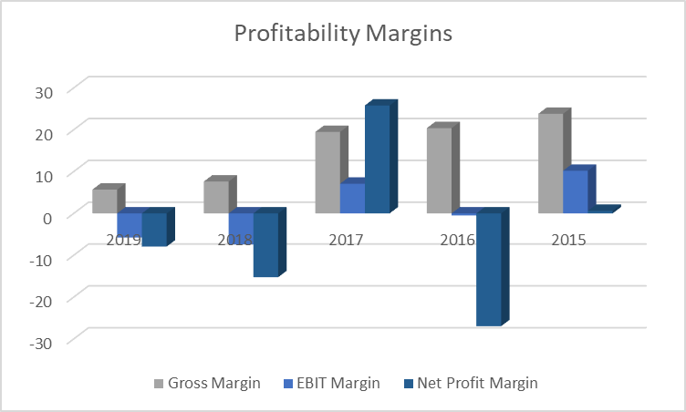
Figure: Comparison of the profitability margins (self-developed)

The above discussions are depicted in the above bar chart comparing the relationship among the gross margin, EBIT margin and net profit margin. Normally, the latter two ratios follow the movement of the gross margin and it happened for all the cases except in 2016 when gross margin is high but EBIT is negative. It incurred due to the increase of the other operating costs in this year.

Ratios | 2019 | 2018 | 2017 | 2016 | 2015
Return on Equity | 39.09 | 227.47 | 68.2 | -216.31 | 1.67
Return on Assets | -4.06 | -7.51 | 14.02 | -15.79 | 0.38
Return on Investment | -84.25 | -86.95 | 43.94 | -79.85 | 1.06

The return-based profitability ratios always compare the net profit with respect to the equity, assets or total capital employed (Gibson and Frishkoff, 2019). However, results of the return-based ratios provide a confusing result in the case of Rolls-Royce Holdings PLC.

The net profit is negative in 2019, 2018 and 2016. On the other hand, it is positive for the ended 2015 and 2017. However, since the returns or net profits are negative in the above-mentioned 3 years, its ratios should be negative as well. However, the return on equity is positive in 2019 and 2018 despite of negative return. Further scrutinisation suggests that, the equity figure in these 2 years are also negative due to negative reserve balances. As a result, due to having negative figures in the nominator and denominator, the results become positive at the end. In the other 3 years, the net profit figures are reflected accordingly.

Return on assets involves the rate of return generated with the invested assets. The return on the asset is negative when the net profit is negative and vice versa (Wahlen, Baginski and Bradshaw, 2014). However, compared to negative return in 2016, Rolls-Royce Holdings PLC. was able to secure a positive 14% return on the assets in the following year which is very impressive. But due to negative profit, the returns on assets in the last 2 years become negative.

Like the return on assets, the return on investment also moves with the profit or loss. The results of return on investment over the period of 5 years shows very dramatic ups and downs, from negative to positive and to negative again. However, the negative figures in the last 2 years indicates that, with respect to huge new capital investment, the expected return was not good. However, the return from the new investment may not come immediately rather it may come in the later periods.

Liquidity ratios
The results from the liquidity ratio are depicted below for explanation:
Ratios | 2019 | 2018 | 2017 | 2016 | 2015
Current Ratio | 1.07 | 1.13 | 1.33 | 1.34 | 1.48
Quick Ratio | 0.78 | 0.77 | 0.75 | 1.02 | 1.16

Two common ratios of liquidity measurement- current ratio and quick ratio have been calculated. The results show that, unlike the profitability ratios, the liquidity ratios are consistent over the periods. These indicate that, there were not huge deviation in the current assets and current liabilities over the considered periods. Though the current ratio decreased gradually, Rolls-Royce Holdings PLC. is perfectly able to maintain its required liquidity position.

Gearing ratios
The capital structure of the organisation plays a very crucial role in the financial performance and different metrics. There are different advantage and disadvantages of the debt and equity in the capital structure of the organisation. The higher the debt to equity ratio, the lower the weighted average cost of capital (Subramanyam, 2014). On the other hand, the excessive amount of debt may increase the risk of the bankruptcy. However, the debt to equity ratio has been decreased over the periods. But in 2018 and 2019, the debt-to-equity ratio becomes negative because of negative reserve in the equity portion of the statement of the financial performance.

Ratios | 2019 | 2018 | 2017 | 2016 | 2015
Debt / Equity Ratio | -1.69 | -4.43 | 0.56 | 1.8 | 0.65
Long-term Debt / Capital | 3.16 | 1.38 | 0.36 | 0.63 | 0.37

In terms of long-term debt to capital ratio, it is observed that, this ratio has been increased significantly in the recent 2 years, particularly in the last year due to new borrowing of the funds.

Efficiency ratios
From the perspective of Rolls-Royce Holdings PLC., three efficiency ratios have been calculated including the assets turnover, inventory turnover and receivable turnover and the results are as follows:

Ratios | 2019 | 2018 | 2017 | 2016 | 2015
Assets Turnover | 0.51 | 0.49 | 0.54 | 0.58 | 0.61
Inventory Turnover | 3.62 | 3.39 | 3.59 | 3.86 | 3.97
Receivable Turnover | 3.25 | 3.33 | 2.05 | 2.14 | 2.19

The assets turnover ratio remains almost same over the period which is between 0.61 to 0.49. The higher asset turnover ratio indicates better efficiencies of the organisation and vice versa. However, from that perspective, the efficiencies of the Rolls-Royce Holdings PLC. have been deceased slightly over the last couple of years.

The result of the inventory turnover is mixed up but on an average, it can be said that, the inventory turnover ratio is also decreasing over the years. Therefore, the efficiencies of the Rolls-Royce Holdings PLC. are decreasing.

Unlike the other two efficiency ratios, the efficiencies of the organisation in terms of receivable turnover has been increased from the perspective of Rolls-Royce Holdings PLC. The higher receivable turnover indicates that, the efficiencies of the liquidity position of the organisation has been improved as a result of the prompt collection of the account receivables.

Comparison to major competitor:
Since Rolls-Royce Holdings PLC. has different business segments, it would be more justifiable to compare the financial metrics with a related industry among different business segments. In connection, the major business segment of aerospace engine manufacturing of Rolls-Royce Holdings PLC. is considered and the related competitor organisations have been considered accordingly. However, the major financial ratios of Rolls-Royce Holdings PLC., General Electric and Honeywell International Inc. have been compared as per the requirements:

The profitability ratios of these three organisations given below:
Ratios | 2019 |  |  | 2018 |  |  | 2017 |  |  |  | 2016 |  |  |  | 2015
 | RR | GE | HI | RR | GE | HI | RR | GE | HI | RR |  | GE | HI | RR |  | GE | HI
Gross Margin | 5.679 | 26.45 | 33.69 | 7.617 | 24.94 | 30.51 | 19.46 | 23.85 | 30.56 | 20.38 |  | 26.63 | 29.57 | 23.796 |  | 29.55 | 30.67
EBIT Margin | -5.76 | 9.76 | 18.66 | -7.41 | -13.39 | 16.03 | 7.09 | 5.86 | 15.55 | -0.49 |  | 10.94 | 15.39 | 10.19 |  | 12.14 | 17.69
Net Profit Margin | -7.93 | -5.71 | 16.74 | -15.26 | -23.5 | 16.13 | 25.79 | -8.98 | 3.81 | -26.96 |  | 5.73 | 12.24 | 0.61 |  | -5.23 | 12.36
Return on Equity | 39.09 | 1.42 | 33.3 | 227.47 | -40.95 | 37.19 | 68.2 | -11.61 | 79.83 | -216.31 |  | 10.53 | 75.94 | 1.67 |  | 1.69 | 76.39
Return on Assets | -4.06 | 0.16 | 10.61 | -7.51 | -6.77 | 11.82 | 14.02 | -2.31 | 2.67 | -15.79 |  | 2.24 | 8.96 | 0.38 |  | 0.34 | 9.82
Return on Investment | -84.25 | 0.44 | 20.89 | -86.95 | -15.01 | 24.28 | 43.94 | -4.69 | 5.43 | -79.85 |  | 4.47 | 15.28 | 1.06 |  | 0.69 | 20.21

In the above table, RR stands for Rolls-Royce Holdings PLC., GE stands for General Electric and HI stands for Honeywell International Inc. For better understanding and quick view of different ratios, the above results are shown in the bar chart:
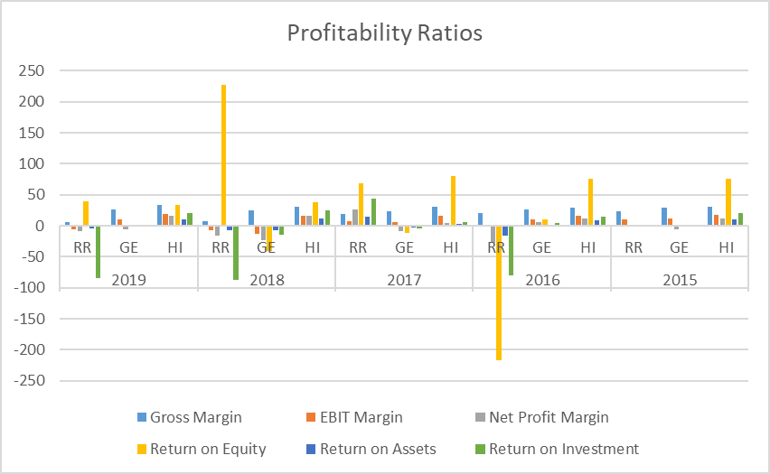
Figure: Comparison of the profitability ratios (self-developed)

From the above figure, on an average, the profitability ratios of Rolls-Royce Holdings PLC. varied significantly over the periods. For instance, the positive and negative returns on equity of Rolls-Royce Holdings PLC. in 2018 and 2016 respectively. Except the negative, the return on equity is the highest among these three organisations. In 2018, not only the profitability ratios of Rolls-Royce Holdings PLC., but also those of General Electric were negative in some cases. However, while the profitability ratios of Rolls-Royce Holdings PLC. are volatile over the periods, those ratios of the other two companies are more consistent over these periods.
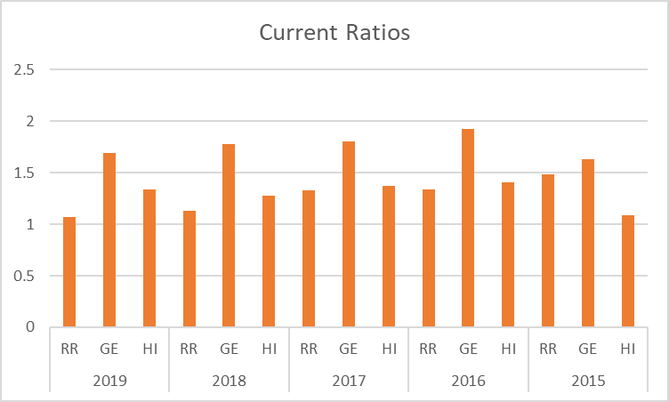
Figure: Comparison of the current ratios (self-developed)

In the above bar chart, the liquidity ratios (i.e. current ratio) of the three companies have been depicted. It is observed that, among the three companies, General Elect has the best liquidity position in terms of current ratio and Rolls-Royce Holdings PLC. has the worst liquidity position among the three.

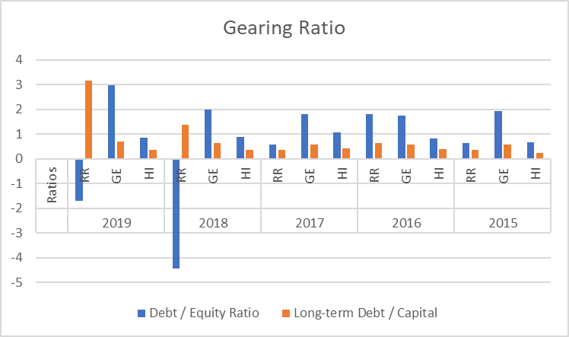
Figure: Comparison of the gearing ratios (self-developed)

From the above bar chart, it is found that, the debt to equity ratio of General Electric is comparatively higher than that of Rolls-Royce Holdings PLC. but this ratio is lowest for Honeywell International Inc. among these three organisations. On the other hand, the long-term debt to capital ratio is comparatively higher for Rolls-Royce Holdings PLC. than that of General Electric. Compared to these two, this ratio is lower for Honeywell International Inc.

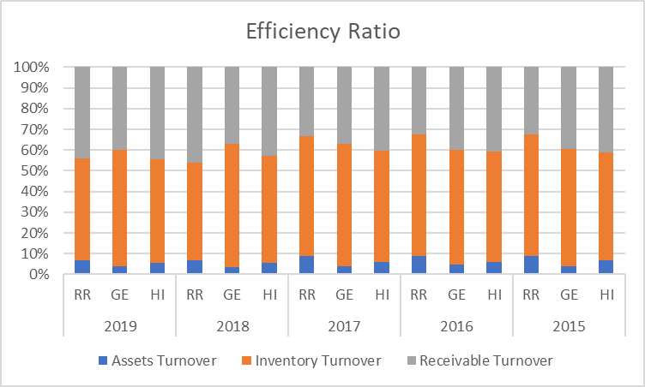
Figure: Comparison of the efficiency ratios (self-developed)

The above chart portrays the efficiency ratios of the selected companies. According to the proposition of the efficiency ratios, the higher the ratios are, the more efficient the organisations are. However, the results from comparable organisations are mixed in these cases because the results are on an average consistent for each organisation. In some cases, General Electric looks more efficient and in some cases Honeywell International Inc. looks more efficient. In some other cases and in some other years, Rolls-Royce Holdings PLC. looks more efficient from the perspective of the given ratios.

Recommendation:
Based on the financial metrics and results, it is found that the financial performance and position of Rolls-Royce Holdings PLC. have been decreased in the recent couple of years. In order to make better financial health of the organisation, the management of Rolls-Royce Holdings PLC. needs to make some strategic decisions on sector or segment basis. For instance, for attracting the new customers, the organisation needs to invest more in the research and development for manufacturing eco-friendly and fuel-efficient products in case of aircraft engine and motor cars. The organisation needs to invest more in different segments to compete with the potential counterparts. For making the most efficient and optimum level of debt to equity ratio, the decision makers of the organisation must work very carefully. Moreover, the liquidity position of the organisation needs to be considered as well at the time of making new investments. The reasons behind the negative profitability should be analysed further and the costs needs to decreased further. In this connection, various models can be customised and used for the purpose of making the organisation more efficient than ever.

Part C
As per the given cashflows of the promising projects, the investment appraisals have been made based on three suggested appraisal techniques.

Project Appraisal:

Payback Period: The payback period can be defined as the shortest possible time within which the initial investment of the project can be recovered (Brigham and Ehrhardt, 2019). However, the payback period of the two projects have been calculated below:

Project A
Year | Cash Flow (£m) | Cumulative Cash Flow (£m)
1 | 10 | 10
2 | 20 | 30
3 | 40 | 60
4 | 55 | 115

For project A, the initial investment is £89 million which is recovered after year 3. So, the payback period will be:

3 years + [(89-60)/55] = 3.53 years

Project B
Year | Cash Flow (£m) | Cumulative Cash Flow (£m)
1 | 25 | 25
2 | 30 | 55
3 | 35 | 85
4 | 40 | 125

For project B, the initial investment is £90 million which is recovered after year 3. So, the payback period will be:
3 years + [(90-85)/55] = 3.09 years

Since, the payback period of project B is lower, the investor should accept the project B.

Net Present Value (NPV): The Net Present Value involves the expected and discounted residuals from the projects after adjusting all the cash inflows and outflows (Lumby and Jones, 2020). However, the NPV of both the projects have been calculated below:

Year | Cash Flow |  | PVIFA (10.50%) | Present Value
Year | Project A | Project B | PVIFA (10.50%) | Project A | Project B
0 | (85) | (90) | 1 | (85) | (90)
1 | 10 | 25 | 0.905 | 9.05 | 22.62
2 | 20 | 30 | 0.819 | 16.38 | 24.57
3 | 40 | 35 | 0.741 | 29.65 | 25.94
4 | 55 | 40 | 0.671 | 36.89 | 26.83
Net Present Value |  |  |  | 6.97 | 9.96

From the above calculation, it is found that the NPV of the project B is higher than that of the project A. Therefore, the management should go for project B.

Accounting Rate of Return (ARR): The Accounting Rate of Return involves the average rate of return with respect to the initial investments (Brigham and Ehrhardt, 2019). However, the ARR of the given projects have been calculated below as per the requirements.
Year | Cash Flow
Year | Project A | Project B
0 | (85) | (90)
1 | 10 | 25
2 | 20 | 30
3 | 40 | 35
4 | 55 | 40
Average Income | 31.25 | 32.5
ARR | 36.76% | 36.11%

Based on the given information, the ARR have been calculated in the above table. As per ARR result, the Accounting Rate of Return of Project A is greater than that of the project B. Therefore, based on these results, the management should go for Project A.

Advantages and shortcomings of different project appraisal techniques:
Payback Period: There are different advantages and disadvantages of the payback period. The payback period is very easy to calculate by the individuals. It provides the results in terms of time required to recover the initial investment. Therefore, the people who actually care about the time would get the results very easily. Again, the person or organisation that is concerned about the liquidity of the project would prefer this project appraisal technique because it helps them to make quick decision (Pandey, 2015).

The main disadvantage of this project appraisal technique is that, it does not consider the time value of money concept. As a result, the true picture of the cash flows cannot be depicted. Another disadvantage of the payback period is that, it does not consider different patterns of the cashflows (Gibson and Frishkoff, 2019). As a result, a project with more cash flows at the later part of the project duration may not be preferred due to slow cash inflows at the beginning part of the project.

Net Present Value: Among the most common project appraisal techniques, the NPV is regarded as the best method of project evaluation. The NPV method considers the time value of the money and as a result the actual cash flows are reflected in the project (Madura, 2015). The results are produced in terms of actual cash flow in the NPV calculation which is helpful for the investor to make the investment decisions. It also considers all the cash flows during the project life time. Therefore, the results are less affected due to different pattern of the cash flows.

There are some disadvantages as well for NPV. The calculation and determination method of the required rate of return or discounting rate is very difficult to calculate because it involves different assumptions and determination of different other factors.

Accounting Rate of Return: This method of the investment appraisal is very easy to calculate and understand by the investor. This method is aligned with the normal accounting records and transactions and thus it can be easily compared with the net profit as per the financial statements (Fridson and Alvarez, 2011). The non-cash expenses like depreciation are considered in this method.

On the other hand, the main disadvantage of this method would be the lack of considering the time value of money (Brigham and Ehrhardt, 2019). The cash flow concepts are ignored in this method. Moreover, the terminal value of the project at the end of the period is not considered in this method.

Non-financial factors to be considered:
There are some non-financial factors which needs to be considered as well at the time of making the investment decision. For instance, the potential demand for the products and supply of the raw materials may not be determined specifically. Therefore, there would be an expectation gap after launching the project. The laws, rules and regulations need to be considered as well at the time of making the investment decisions because the existence and performance of the organisation would be significantly affected by such rules and regulations. The quality and skills of the employees and management team are regarded as the non-financial factors which affect the performance of the investment projects. The market dominance, good brand value, strong customer relationship etc. also affects the investment decision. Innovation and rapid change in the technologies and methodologies may obsolete the existing facilities within very short time. The taste and demand of the customers would be changed as well. Therefore, before making the investment decision, the management of the organisation must consider these issues besides the financial results.

Conclusion
Each and every business decision in the corporate organisation is ultimately a financial decision. In making the prudent, effective and efficient financial decision, there is no alternative to learn and master the financial management. Various perspectives of the financial management have been discussed in this report from the view point of Rolls-Royce Holdings PLC. and given scenario. In making the strategic business decision, it is imperative to master the critical knowledge, expertise and understating of the financial management required in different parts of the business organisations.

References
Belloc, H., 2017. On. Freeport, N.Y.: Books for Libraries Press.
Brigham, E. and Ehrhardt, M., 2019. Financial Management. Mason, OH: Cengage.
Fridson, M.S. and Alvarez, F., 2011. Financial statement analysis: a practitioner's guide (Vol. 597). John Wiley & Sons.
Gibson, C.H. and Frishkoff, P.A., 2019. Financial statement analysis: Using financial accounting information.
Lumby, S. and Jones, C., 2010. Investment Appraisal And Financial Decisions. London: Thomson Learning.
Madura, J., 2012. International Financial Management.
Pandey, I., 2015. Financial Management. New Delhi: Vikas Publishing House PVT LTD.
Robinson, T.R., 2020. International financial statement analysis. John Wiley & Sons.
Rolls-royce.com. 2020. Results And Events. [online] Available at: <https://www.rolls-royce.com/investors/results-and-events.aspx#yr-2019> [Accessed 28 December 2020].
Smith, P., 2020. Aircraft Engine Market Share | T4. [online] T4.ai. Available at: <https://www.t4.ai/industry/aircraft-engine-market-share> [Accessed 28 December 2020].
Subramanyam, K.R., 2014. Financial statement analysis. McGraw Hill Education.
Van Horne, J.C. and Wachowicz, J.M., 2015. Fundamentals of financial management. Pearson Education.
Wahlen, J.M., Baginski, S.P. and Bradshaw, M., 2014. Financial reporting, financial statement analysis and valuation. Nelson Education.

