CONTEMPORARY THEMES IN THE HOTEL AND HOSPITALITY SECTOR
BMIH6001
TOPIC: THE DEEPENING MENTAL HEALTH CRISIS IN THE HOSPITALITY INDUSTRY
STUDENT ID- 22453303
STUDENT NAME- Georgiana Pangonis
Abstract
The UK hospitality sector is grappling with a silent epidemic: a deepening mental health crisis. It's not just individual stress; it's a systemic breakdown fuelled by the current Cost-of-Living Crisis and young workers' "Future Career Anxiety." Imagine a world where smiles mask burnout and suffering, where in 2024 a staggering 76% of hospitality workers face mental health issues, a surge from 56% in 2018.
This study reveals a shift to "systemic survival mode," driven by chronic understaffing and relentless work conditions. Chefs and front-of-house staff endure intense stress and abuse, while political aftershocks from Brexit and rising costs exacerbate the crisis. The Theory of Planned Behaviour highlights cultural barriers preventing help-seeking, despite supportive efforts.
Discover how the industry's culture, economic forces, and tech innovations shape this perfect storm. Can predictive scheduling and wellness programs turn the tide? Uncover the hidden truths, explore the scope of this crisis, and find the path to a sustainable future for hospitality heroes. The evaluation of organisational outcomes, demonstrating that while support programs such as Hospitality Action’s EAP create a positive impact on the performance of this sector, it must develop a range of mental health training initiatives to analyse the current situation of workers and guide them accordingly.

Declaration
I confirm my adherence to academic integrity policies, verifying that I have neither utilised AI in this research and assignment creation nor incorporated any AI-generated content. All supporting evidence, including drafts and notes, is available upon request.

Signed Georgiana Pangonis

Table of Contents
Introduction 4
Literature Review 5
Prevalence and severity of mental health crisis among hospitality workers across distinct roles and settings 5
Identification of individual and occupational risk factors that are strongly associated with poor mental health conditions in the hospitality sector 6
Evaluation of organisational outcomes by introducing support programs due to the mental health problems affecting hospitality workers 7
Theoretical Underpinning 7
Method 8
Data Collection Process 8
Analytical Techniques 8
The Use of Tools for Analysis 9
Theme Impact Analysis 9
Conclusion 13
Recommendation 13
References List 15

Introduction
The hospitality industry is facing a severe, deepening mental health crisis among 1 in 4 people due to lower numbers of staff, long working hours and high pressure. The UK hospitality industry is facing a deepening mental health crisis post-2020, with 76% of workers reporting mental health issues in 2024, up from 56% in 2018 (Edward Waddell, 2026). Around 44% face work-related stress and cost-of-living pressures driven by chronic understaffing. This surge has left over half of employees struggling with workplace under-resourcing.
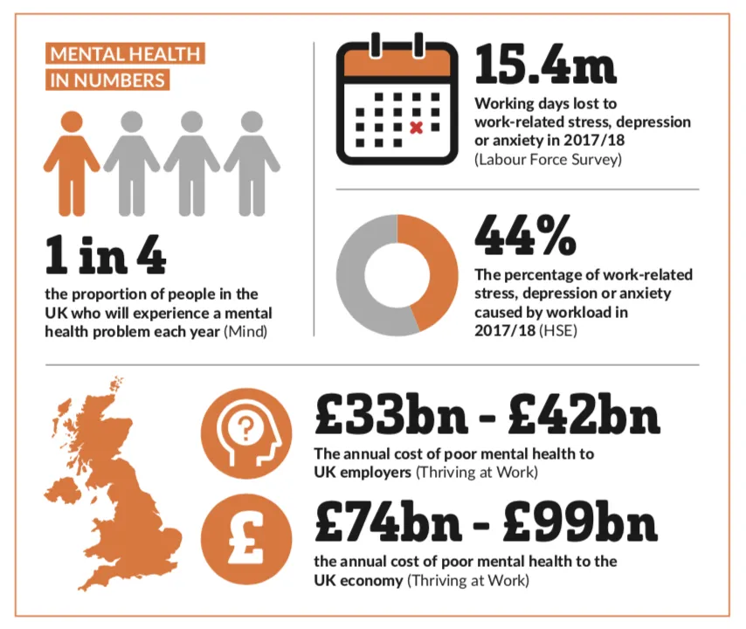
Figure 1: Mental Health Conditions in the UK
(Source: Rahimi, Akgunduz and Bilgihan, 2023)
After analysing this crisis, the UK government introduced a scheme called The Eat Out to Help Out (EOHO Scheme). Under the scheme, the government provided 50% off the cost of food to reduce the cost-of-living crisis among the hospitality staff (Rahimi, Akgunduz and Bilgihan, 2023). However, this is not a significant solution that mitigates the risks of mental stress. Mental health needs to be included in health coverage as this industry recovers from the pandemic. This research aims to examine the scope, causes, and consequences of the progressively worsening mental health crisis among hospitality workers. The objective of this analysis is to identify effective workplace and policy interventions that improve employee well-being, job performance, and retention. The current study is focused on ‘Fear and Depression’ as it triggers Future Career Anxiety for the mental health workers. This contemporary theme is revealing in this industry, as the psychological impact of this crisis negatively creates risk for the workers.

Literature Review

Prevalence and severity of mental health crisis among hospitality workers across distinct roles and settings
The mental health crisis in UK hospitality has shifted from a simmering concern to a full-blown systemic failure. 76% of workers now report mental health challenges, a staggering 20% rise since 2018. This is not merely individual stress, but it is a direct byproduct of an industry built on unsustainable labour practices. By 2025, an alarming 62% of junior employees have come to accept burnout as an inevitable part of the job (Chakrabarti and Chatterjee, 2026). This data highlights a dangerous normalisation of psychological distress at the entry level.
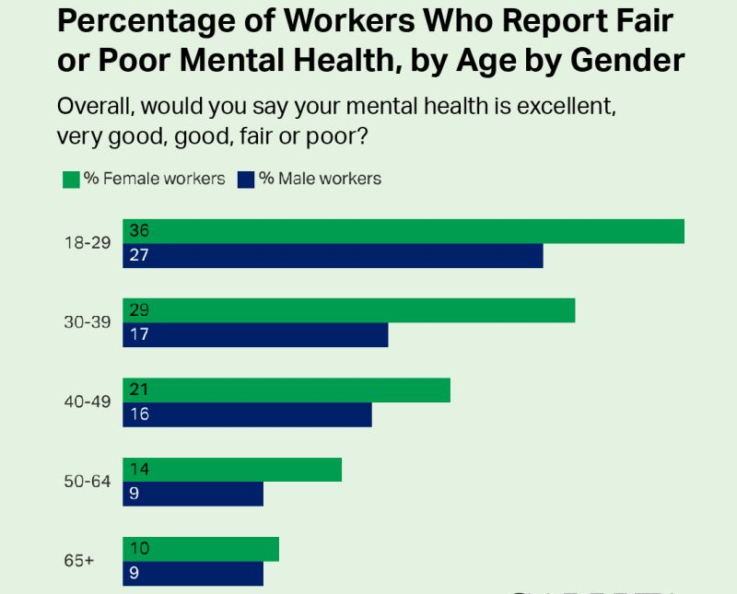
Figure 2: Poor mental Health based on Gender
(Source: CORY SMITH, 2023)
In the age of 18 to 29, 36% of the female workers report poor mental health and 27% male workers reported the same. The severity varies sharply across the roles of the workers in the hospitality sector. 70% of chefs face chronic stress in high-pressure kitchen environments, while 74% of front-of-house staff endure regular verbal abuse from customers, according to World Chefs (2025). On the other hand, 14% of hospitality leaders report poor mental health, cited by James Bayley (2025). More than double the national average, driven by post-pandemic recovery struggles and the cost-of-living crisis. Furthermore, with 57% of teams identifying chronic understaffing as their primary stressor, the sector’s current ‘survival mode’ is actively eroding its workforce. Therefore, without radical structural reform, such as mandatory mental health first aid and predictable scheduling, this action cannot be performed well, and the industry risks losing its most vital assets.

Identification of individual and occupational risk factors that are strongly associated with poor mental health conditions in the hospitality sector
Poor mental health in UK hospitality is driven by a toxic intersection of individual and occupational risk factors. Yet current data suggests that structural, occupational failures are the primary reason for the crisis. Occupational risk factors are increasingly severe, as 57% of workers are dealing with chronic understaffing, and it has surged by 21% from the previous year (Kathrin Cockhill, 2025). In contrast, Aljawarneh et al., (2025) argued that these systemic pressures are often normalised, with 62% of junior staff viewing burnout as an inherent part of the job.
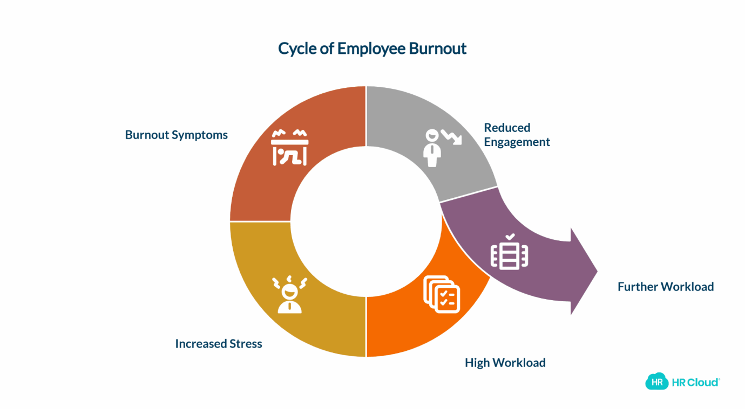
Figure 3: Employee Burnout Cycle
(Source: Aljawarneh et al., 2025)
While individual factors such as financial strain and personal resilience play a passive role, they are often exacerbated by the structural flaws of the hospitality industry. Individual risks are personal and varied, with 18–24-year-olds being most at risk. External shame about seeking help accounts for over 60% of the variance in reported mental health problems (Batabyal and Das, 2019). In contrast, occupational risks are universal to the setting related to irregular long hours, lack of autonomy, and the absence of mental health training. For example, Soho House is an international private members' club headquartered in London. This organisation is accused of its long-term working pressure on its employees (Rooney, 2022). Most of its staff stated that they are often scheduled from 6 pm to 2 am. They work from 4 to 6 PM twice a week. Due to this reason, the occupational risk of long-term work creates mental stress for them.

Evaluation of organisational outcomes by introducing support programs due to the mental health problems affecting hospitality workers
The mental health crisis in UK hospitality has shifted from a hidden struggle to a primary driver of organisational instability. Historically, the industry relied on a ‘culture of persistence’ where high turnover and long hours were accepted as seasonal norms. However, current data reveal a far more severe reality. The belief that prolonged emotional distress diminishes the cognitive capacity of workers to plan is a pervasive belief that their mental health struggles will inevitably hinder long-term professional progression (Cooper and Hall, 2023). This crisis now manifests as a direct economic threat. Mental health is now the third most common reason for work absence in UK hospitality. It is contributing to the £21 billion in annual lost revenue that operators face due to reduced trading hours and staff shortages. Organisational outcomes have deteriorated significantly due to absenteeism, presenteeism, low performance quality of 16% staff, and staff turnover (Dixit, 2020). In the UK hospitality sector, the cycle of fear and depression acts as a critical catalyst for future career anxiety.
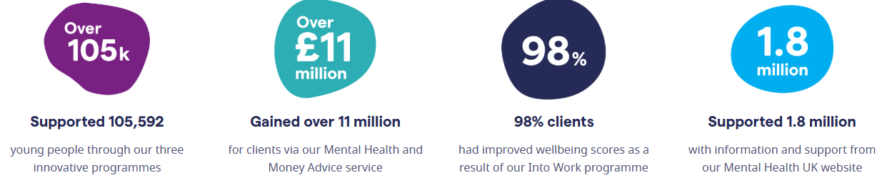
Figure 4: Support Activity by the UK Government
(Source: Mental Health UK, 2025)
In order to overcome this situation, the mental health department of the UK launched three innovative programmes for young people that are supported by over 105 thousand workers (Mental Health UK, 2025). As a result, 98% of the clients had improved well-being scores because of this program.

Theoretical Underpinning
The Theory of Planned Behaviour (TPB)
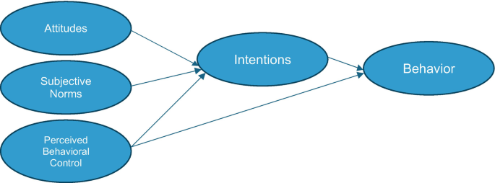
Figure 5: Theory of Planned Behaviour
(Source: Chkoniya, 2021)
TPB posits that the precursor to action is governed by Attitude, Subjective Norms, and Perceived Behavioural Control (Chkoniya, 2021). Workers often possess a negative attitude toward help-seeking, with 60% of the variance in reported issues linked to shame and fear of career damage in UK hospitality (Institute of Hospitality, 2024). Subjective Norms reinforce this silence that helps this industry to shift its culture and ensure fair judgment from peers. Finally, Perceived Behavioural Control is eroded by structural barriers such as chronic understaffing, leaving workers feeling they lack the time or agency to access support despite its necessity. The application of this theory mitigates the perception of workers regarding their beliefs about disclosing stress. They will actively hinder their career progression and develop a deeply negative attitude toward help-seeking.

Method

Data Collection Process
In secondary research, the data collection process focuses on the rigorous gathering of existing evidence from academic databases, government white papers, and industry-specific publications (Wirtz et al., 2022). For hospitality studies, this involves identifying reputable sources such as the Office for National Statistics (ONS) and industry reports. The information is also collected from the UK government's Mental Health report to build a comprehensive view of the current climate of this sector. This method is highly efficient, allowing this research study to observe broad historical shifts such as the transition from pre-pandemic norms to current post-crisis pressures without the logistical constraints of primary surveys.

Analytical Techniques
Thematic impact analysis was used in this research study to analyse a vast range of secondary data related to the research topic and background. In the context of this study, it helped to extract recurring patterns, such as the persistent stigma of silence and the normalisation of burnout. This analytical process is also vital, allowing for the contrast between the separate roles of the hospitality workers. By synthesising these diverse datasets, experts can construct a compelling argument for structural reform (Tribe, 2009). Controversially, it also enhances the risk of subjective bias, which often results in a lack of rigorous and transparent procedures.

The Use of Tools for Analysis

To rigorously evaluate the multifaceted influences on mental health within the hospitality sector, this research employs a PEST analysis framework. This assesses the impact of macro-environmental factors – Political, Economic, Social, and Technological – as they contribute to the ongoing crisis. Furthermore, established sustainability and organizational theories, including the Theory of Planned Behaviour (TPB), are strategically applied to interpret findings and provide a robust foundation for the proposed recommendations, ensuring they are both theoretically sound and practically relevant to the unique challenges of the hospitality industry.

Theme Impact Analysis
Factor | Description | Impact
Political | - The post-Brexit effect continues to restrict the labour supply, directly contributing to the understaffing that fuels worker stress.  - In the UK hospitality election, Labour won a huge landslide victory, taking 412 seats and a 174-seat majority (UK Hospitality, 2026). | Medium
Economic | - The hospitality industry of the UK is facing a severe financial hit from the April 2025 National Insurance Contribution (NIC) hike.  - NIC rate is increased by 13.8% to 15%, and the threshold is lowered from £9,100 to £5,000 (Gov UK, 2026). | High
Social | - According to the Deloitte 2025 Gen Z and Millennial Survey, 89% of young workers now consider a sense of purpose and mental health support as non-negotiable for job satisfaction (Deloitte Insights, 2026).  - Socially, the ‘stigma of silence’ is being challenged by a generation that is 40% more likely to reject a role that shows a lack of commitment. | High
Technological | - New digital platforms in this area allow for smart staffing that anticipates busy shifts using historical data.  - This digital shift is reducing the overworking of staff and developing the areas of mobile-first workforce management.  - Contactless payment in the UK hospitality sector reached 94.6% of all eligible in-store transactions in 2024, enhancing the use of digital-first operation models (Mordor Intelligence, 2026). | High
Table 1: PEST Analysis
From the above table, it can be stated that the UK hospitality industry is currently navigating a crisis where political shifts and economic burdens are colliding to ensure technical development. Following a landslide victory, the Labour government has introduced a transformative legislative agenda, including the Mental Health Bill 2025 and the Employment Rights Bill. This legislative agenda from the political scenario of the UK grants workers day-one rights to flexible working. While these aim to reduce stress, the sector faces an immediate economic squeeze due to the April 2025 National Insurance hike, which lowered the payment threshold to £5,000, and a National Living Wage increase to £12.21 per hour (Gov UK, 2026). At the same time, individuals can adopt coping strategies, such as smart technology that helps them enhance their work speed. They can work out of a 60-hour week or a chronically understaffed shift. Personal factors influence how a worker suffers, and occupational hazards determine that they suffer. It is making industry-wide reform through platforms such as Hospitality Action the only viable solution.
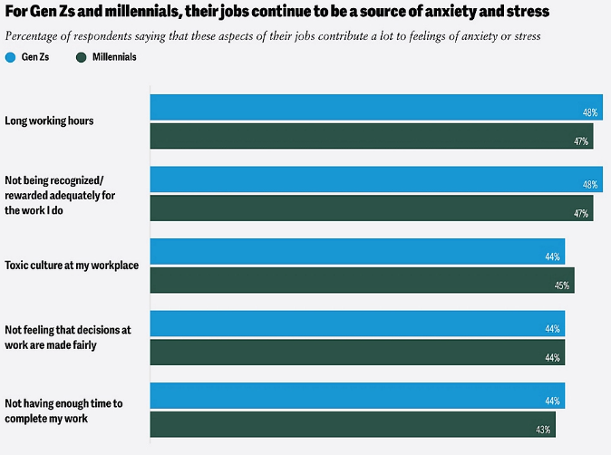
Figure 6: The source of anxiety and depression among Gen Z and Millennials
(Source: Deloitte Insights, 2026)
Socially, Gen Z and Millennials believe that the source of anxiety and stress for them is long working hours and a toxic culture at the workplace. 48% of millennials support long working hours as the main reason for their aversion to being flooded by 47% of millennials. In contrast, the stigma of silence is rapidly eroding 89% of young workers now view mental health support as a non-negotiable benefit (Ahmad, 2024). However, the workforce of the hospitality industry, junior staff, still feels unable to voice concerns. As a result, young employees are now resigning themselves to burnout as an inevitable part of the job. Admittedly, technological integration has moved beyond basic contactless payments to AI-driven Predictive Scheduling (Sharma, Singh and Tyagi, 2024). These platforms use historical data to prevent the overworking of staff during peak hours, creating a more sustainable digital-first operational model.

Theme | Impact | Industry Response | Strengths | Limitation
Prevalence and severity of mental health crisis | The hospitality industry experiences turnover as high as 73.8%, creating operational instability (Blad Consulting, 2025). | The Burnt Chef Project is a non-profit Community Interest Company (CIC) and social enterprise launched in May 2019 by Kris Hall. This organisation provides Free Mental Health support to 8.5 thousand people (The Burnt Chef Project, 2026). | Unlike general mental health charities, they focus exclusively on the hospitality environment, understanding unique triggers such as split shifts and kitchen culture. | As a non-profit, their reach is often limited by funding, and they rely heavily on merchandise sales and corporate sponsorships, which can fluctuate with the economic outcome.
Individual and occupational risk factors for poor mental health conditions | Research shows that 69% of the hospitality workers in the UK are facing a lack of adequate notice period about their schedule changes when shifting their duties. | A prominent UK-based company's response to these mental health challenges can be seen in Premier Inn. This organisation worked with Dr Zoe Williams (Doctor) to regularly check the mental health condition of the workers (Premier Inn, 2026). | Recognising that individual financial stress is a primary driver of poor mental health, their benefits include discounts and emergency financial tools. | This response has limitations, providing mental health training that focuses on preventive care for the systemic staffing caused by macro-economic pressures on the employees.
Table 2: Industry Response to the Issues
From the above table, it can be stated that different industries share different responses to overcome the crisis and support their employees to reduce productivity. Ultimately, by developing the balance between eco-efficiency and profitability, the sector is successfully evolving to meet the transparent, responsible standard of mental health.

Conclusion
The mental health crisis in UK hospitality has shifted from a personal struggle into a profound structural failure, where the normalisation of burnout now threatens the industry's long-term viability. This crisis is fuelled by a toxic intersection of occupational hazards, such as chronic understaffing, irregular hours, and individual risks, including financial insecurity and the persistent ‘stigma of silence'. While initiative-taking company responses and charitable initiatives provide essential support, they often function as reactive measures rather than preventative measures. The hospitality sector must move beyond temporary fixation and commit to systemic reform prioritising workforce wellbeing as a core operational necessity rather than an optional benefit.

Recommendation
Conducting an organisational diagnosis
Improving the mental health of hospitality workers requires a combined approach that integrates personal and proactive self-care with systematic workplace changes. These cumulative strategies will help manage high stress, long hours, and burnout among existing employees. Firstly, leaders and managers of a hospitality firm need to develop a strategic plan to implement an effective workplace wellbeing program (Alexander, 2025). In this regard, conducting an organisational diagnosis is crucial for recognising risk factors and specific employee needs. For example, Kelly’s Cause Foundation provides Mental Health First Aid (MHFA) England training specifically designed for the hospitality sector (Kelly's Cause, 2026). Therefore, to meet these criteria, the organisation can introduce or hire a team of mental well-being psychologists who will incorporate valuable tools into this entire process. It will further help them understand group dynamics and identify factors affecting the mental health of workers. Providing training in stress management and mental wellness equips staff with tools and techniques to manage multiple episodes of stress and helps build resilience. Apart from this, mandatory management training on mental well-being in the hospitality sector is necessary.
Implementation of Predictive Scheduling and Staffing Minimums
The UK hospitality sector needs to adopt Predictive Scheduling and Staffing Minimums to dismantle the attrition loop caused by chronic understaffing. By utilising AI-driven workforce management tools, operators can align with historical demand, ensuring shifts are safely resourced and staff are granted the day-one flexible working rights mandated by the Employment Rights Bill. Furthermore, organisations must bridge the trust gap among the employees and the organisation by formalising mental health support within the management structure. This involves appointing dedicated Mental Health First Aiders at every site and integrating Hospitality Actions EAP services into standard employment contracts. In order to implement the circular economy model, two main suggested areas are reducing workload and finding the most suitable solutions to manage the remaining work (Socaci, 2020). This action helps the industry to combat mental health disclosure from career progression concerns. Finally, the rise of the cost-of-living crisis can be mitigated through the help of these initiatives. Through this combination of technological adoption, legislative compliance, and cultural empathy, the industry moves toward a sustainable future where employee wellness is a core KPI rather than a secondary thought. For instance, Atlas Hotels in the UK is proud to announce its partnership with two leading mental health charities, Mind and SAMH (Scottish Action for Mental Health), which is considered a significant step towards supporting mental health and well-being within the organisation (ATLASHOTELS, 2026). This program helps the normalisation to support its employees with difficult mental health problems.

References List
Ahmad, N. (2024) ‘Sesi 1-Integrating Islamic Religious Perspectives into Mental Health Legislation: A Holistic Approach to Human Rights and Well-being in Brunei Darussalam’, Available at: https://iris.univpm.it/handle/11566/345557
Alexander M. Danzer (2025) Food Waste and Dynamic Inconsistency: A Behavioral Economics Perspective. IZA -Institute of Labor Economics.
Aljawarneh, Y., Al-Bashaireh, A., Albikawi, Z., Alkouri, O., Alrida, N.A., Abuadas, M., Alobaidly, A., Alyileili, M., Alyileili, S., Alyileili, W. and Alhefetti, F. (2025) ‘The influence of occupational stress and job satisfaction on burnout among healthcare workers in the UAE: A cross-sectional study’, Plos one, 20(10), p.e0335430. https://doi.org/10.1371/journal.pone.0335430
ATLASHOTELS (2026) Atlas Hotels announces new charity partnership with Mind and SAMH. Available at: https://atlashotels.co.uk/atlas-hotels-announces-new-charity-partnership-with-mind-and-samh/ (Accessed: 24 January 2026)
Batabyal, D. and Das, D.K. (eds) (2019) Global trends, practices, and challenges in contemporary tourism and hospitality management. Hershey, Pennsylvania: Business Science Reference, an imprint of IGI Global.
Blad Consulting (2025) The one about the silent crisis: employee mental health in modern hospitality. Available at: https://www.baldconsulting.co.uk/the-one-about-the-silent-crisis-employee-mental-health-in-modern-hospitality (Accessed: 25 January 2026).
Chakrabarti, G. and Chatterjea, T. (2026) Emotional Disengagement and Employee Turnover in Workplaces: An Applied Study. Taylor & Francis.
Chkoniya, V. (ed.) (2021) Handbook of research on applied data science and artificial intelligence in business and industry. Hershey, Pennsylvania: IGI Global.
Cooper, C. and Hall, C.M. (2023) Contemporary tourism: an international approach. 5th ed. Oxford: Goodfellow Publishers Limited.
CORY SMITH (2022) Survey finds poor mental health 'a real issue in the American workforce. Available at: https://thenationaldesk.com/news/americas-news-now/mental-health-employees-poor-study-finds-managers-company-culture-depression-anxiety-american-workforce-employment-issue (Accessed: 22 January 2026).
Deloitte Insights (2026) Gen Zs and millennials at work: Pursuing a balance of money, meaning, and well-being. Available at: https://www.deloitte.com/us/en/insights/topics/talent/2025-gen-z-millennial-survey.html (Accessed: 25 January 2026).
Dixit, S.K. (2020) Managing hospitality organisations: achieving excellence in the guest experience (second edition): by Robert C. Ford and Michael C. Sturman, Sage PublicationsInc., 2019, 544
Edward Waddell (2026) Mental health crisis deepens in hospitality sector due to burnout & understaffing. Available at: https://www.publicsectorcatering.co.uk/news/mental-health-crisis-deepens-hospitality-sector-due-burnout-understaffing (Accessed: 22 January 2026).
Gov UK (2026) Changes to the Class 1 National Insurance Contributions Secondary Threshold, the Secondary Class 1 National Insurance contributions rate, and the Employment Allowance from 6 April 2025. Available at: https://www.gov.uk/government/publications/changes-to-the-class-1-national-insurance-contributions-secondary-threshold-the-secondary-class-1-national-insurance-contributions-rate-and-the-empl/changes-to-the-class-1-national-insurance-contributions-secondary-threshold-the-secondary-class-1-national-insurance-contributions-rate-and-the-empl (Accessed: 24 January 2026).
Institute of Hospitality (2024) Mental Health issues on the rise reports Hospitality Action survey. Available at: https://www.instituteofhospitality.org/hospitality-action-survey/ (Accessed: 25 January 2026).
James Bayley (2025) Hospitality’s mental health crisis. Available at: https://www.thedrinksbusiness.com/2025/05/hospitalitys-mental-health-crisis/ (Accessed: 22 January 2026).
Kathrin Cockhill (2025) How AI Can Help Ease the Hospitality Staffing Strain. Available at: https://thehotelmagazine.co.uk/how-ai-can-help-ease-the-hospitality-staffing-strain/ (Accessed: 23 January 2026).
Kelly's Cause (2026) A charity on a mission to create a mentally healthy hospitality industry for all. Available at: https://www.kellyscause.com/ (Accessed: 23 January 2026)
Mental Health UK (2025) Burnout Report 2026.Available at: https://mentalhealth-uk.org/ (Accessed: 24 January 2026).
Mordor Intelligence (2026) United Kingdom Hospitality Market Size & Share Analysis - Growth Trends and Forecast (2026 - 2031). Available at: https://www.mordorintelligence.com/industry-reports/hospitality-industry-in-the-united-kingdom (Accessed: 25 January 2026).
Premier Inn (2026) Together, we are a Force for Good. Available at: https://www.premierinn.com/gb/en/why/force-for-good.html(Accessed: 25 January 2026).
Rahimi, R., Akgunduz, Y. and Bilgihan, A. (2023) ‘Impact of COVID-19 on mental health and career anxiety of hospitality and tourism students in the UK’, Journal of Hospitality and Tourism Insights, 6(2), pp.892-911.Available at: http://dx.doi.org/10.1108/JHTI-05-2021-0129
Rooney (2022) Why Working at Soho House Ain’t As Fun As You Think. Available at: https://runesv4.medium.com/why-working-at-soho-house-aint-h-t-tales-from-a-disgruntled-receptionist-8277b9f8b5c3 (Accessed: 22 January 2026).
Sharma, M., Singh, A.K. and Tyagi, P. (2024) Proceedings of the International Conference on Innovation and Regenerative Trends in Tourism and Hospitality Industry (IRTTHI 2024). 1st ed. Dordrecht: Atlantis Press ZegerKarssen.
Socaci, S.A. (ed.) (2020) Food preservation and waste exploitation. London, England: IntechOpen.
The Burnt Chef Project (2026) BURNING STIGMA OF MENTAL HEALTH IN HOSPITALITY. Available at: https://www.theburntchefproject.com/(Accessed: 25 January 2026).
Tribe J. (2009) Philosophical issues in Tourism. Bristol: Channel View Tourism, Channel View
UK Hospitality (2026) General Election. Available at: https://www.ukhospitality.org.uk/campaigns/general-election/ (Accessed: 24 January 2026).
Wirtz, B.W., Weyerer, J.C., Becker, M. and Müller, W.M. (2022) ‘Open government data: A systematic literature review of empirical research’, Electronic Markets, 32(4), pp.2381-2404. Available at: https://doi.org/10.1007/s12525-022-00582-8
World Chefs (2025) In the Weeds: Why Kitchen Culture Must Change to Safeguard Mental Health & Wellness. Available at: https://worldchefs.org/in-the-weeds-why-kitchen-culture-must-change-to-safeguard-mental-health-wellness/

