Leadership Effectiveness During Digital Transformation: Evidence from UK Technology Firms

Table of Contents
1. Introduction 2
2. Background of the Study 2
2.1 Digital Transformation in UK Technology Firms 2
2.2 Leadership During Organisational Change 3
2.3 Significance of UK Technology Firms in Digital Transformation 4
3. Research Problem and Rationale 4
4. Aim, Objectives and Research Questions 6
5. Literature Review 7
5.1 Leadership Effectiveness 7
5.2 Digital Transformation 7
5.3 Leadership Theories 8
5.4 Leadership and Digital Transformation 9
5.5 Conceptual Framework 10
6. Research Methodology 10
6.1 Research Philosophy and Research Approach 11
6.2 Research Strategy, Design and Sampling 11
6.3 Data Collection and Data Analysis 11
6.4 Validity and Reliability 12
6.5 Ethical Considerations 12
7. Expected Findings 12
8. Conclusion 14
References 15

1. Introduction
The digital transformation strategy is a key priority for organisations to be more competitive, efficient and sustainable in an increasingly technologized world. It deals with the integration of digital technologies in organisational processes, business models and decision-making, putting a fundamental transformation on them, and changing the way organisations generate value and adjust to the market demand (Schilirò, 2024). Organisational transformation is taking place at a rapid pace, affected by the rise of artificial intelligence (AI), cloud computing, automation and data analytics, and are striving to continuously innovate and adapt to meeting the expectations of customers and the growing competitiveness. In the United Kingdom (UK), technology firms are a crucial component of the digital economy, contributing to innovation and investment, and as such, an important setting in which organisational transformation can be considered.
Whilst technology has progressed massively, the ability to make digital transformation decisions doesn't depend entirely on the technology, but on effective leadership in it. Leaders should set the broad course for change and communicate the organisational vision, manage resistance and build the skills of employees needed to make change happen (Musaigwa, 2023). This has resulted in poor leadership being a big factor in unwarranted failures to implementation and in unfavourable employee engagement and alignment in organizations about digital projects, which has made it ‘a critical management issue’. This research aims to explore the effectiveness of leadership in digital transformation in UK technology companies by evaluating the behaviours of leaders, challenges faced, and how those behaviours impact on employee engagement and digital transformation success, both academically and in practice to enrich existing knowledge and insight.

2. Background of the Study

2.1 Digital Transformation in UK Technology Firms
Digital transformation describes the process of leveraging digital technologies strategically across the organization to gain efficiency, innovation and long-term competitiveness. In the UK, the digital sector is a major economic force, generating around £170 billion of gross value added (GVA) for the economy in 2025, or around 7.2% of the national economy. The UK Government also states that there are over 180,000 technology businesses with employment of some 1.8 million, making technology one of the fastest-growing sectors of the country.
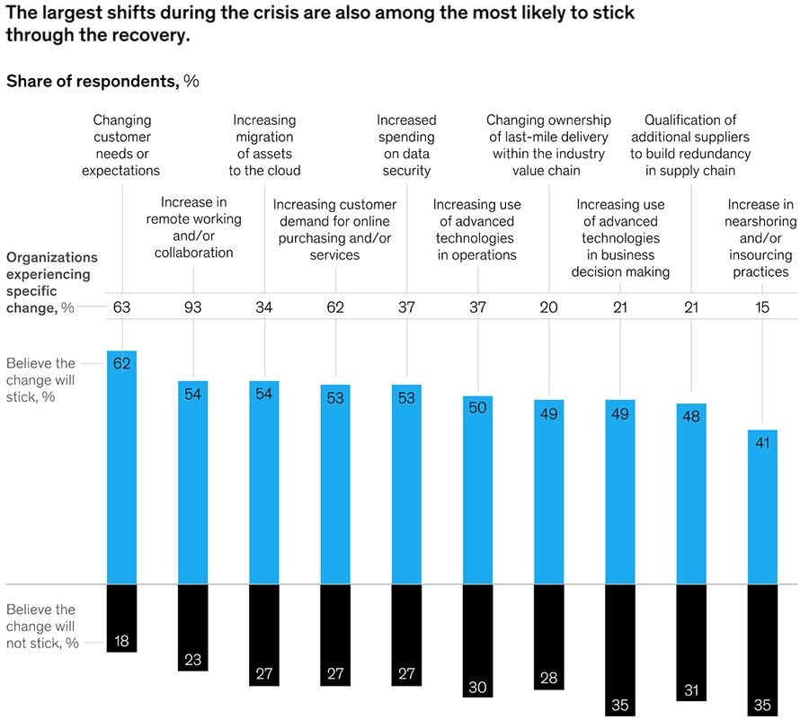
Figure 1 : Covid-19 has accelerated digital transformation by seven years
Source: (Consultancy.uk, 2020)
Investment has ramped up significantly, and over 76% of UK organisations reported digital transformation investments rose after the pandemic, in accordance with Deloitte (2024). Artificial Intelligence makes for a worthwhile investment, as AI will add anywhere from £400 billion to £630 billion to the UK economy by 2035. Adoption of cloud computing has grown considerably too, as more than 89 per cent of UK enterprises are leveraging cloud services this year. At the same time, organisations have been making greater investments in digital resilience due to growing threats around the computer network and doing more work remotely and in a hybrid environment, making collaborative digital platforms more popular.

2.2 Leadership During Organisational Change
As digital transformation has continued, so have the expectations of leaders of organisations, which have moved beyond the traditional hierarchical model and towards those of digital and adaptive management (Tagscherer and Carbon, 2023). Good leaders should not only care about keeping their organizations running effectively in technology uncertainty but also finding ways to raise employee resistance against the technology, continuous innovation and organisational learning. Digital organisations rely on a more collaborative decision-making process, cross-functional working groups and rapid solutions than on central direction. Yet, according to PwC (2024), 61% of UK business leaders indicated the lack of digital skills does not prevent DT as a problem, on the contrary, Deloitte (2024) cited 'cultural resistance and poor leadership' as near 70% of DT projects fail during implementation due to lack of skills, pointing strongly at a lack of leadership within organizations as a significant transformation barrier. Transformational, adaptive and participative leadership styles are therefore gaining growing significance, as they enable these to take place during complex digital change processes, fostering innovation and empowerment of employees, strengthening communication, supporting the development of knowledge and stability of the organisation.

2.3 Significance of UK Technology Firms in Digital Transformation
UK technology companies are well placed as a research context as they are usually faced with fierce competition, with technology evolution and constant innovation, and with high technology input in their workforces (Mandys and Coyle, 2024). The core of their work involves agile working practices, cross-functional collaboration and fast product development and leadership effectiveness is a key factor in their organisation's success. In contrast to traditional industries, technology firms are constantly at a risk of adapting to the new technology in order to keep their employees engaged and innovative in their performance. As a result, the study of leadership effectiveness in digital transformation for technology firms based in the UK can provide good theoretical and practical understanding of how leadership behaviours shape organisational transformation, adaptation and successful digital transformation and organisational sustainable competitive advantage in a digitally seeking world.

3. Research Problem and Rationale
While these companies invest in digital transformation, many technology companies in the UK still struggle to achieve satisfactory results when it comes time to implement, headwomen is the main reason. A global report shows that only 30 per cent of digital transformation projects surface the value the businesses were expecting and 70 per cent do not meet their goals.
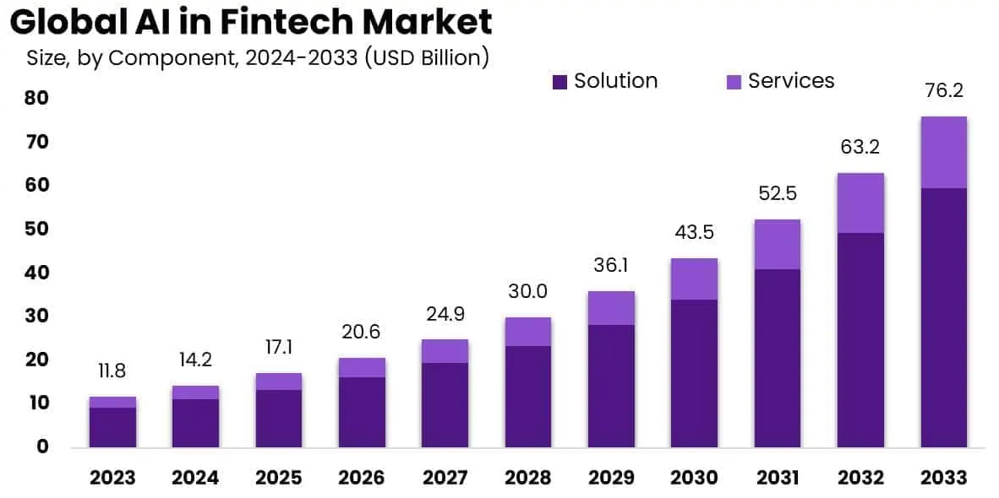
Figure 2 : AI In FinTech Statistics By Usage, Market Size and Facts (2025)
Source: (Electro IQ, 2025)
Moreover, on the monetary side, organisations are expected to spend over US$3.9 trillion on digital transformations from 2024 to 2027, emphasising that although money is essential, it is not enough to drive success (World Bank, 2023). Despite its significance, with the UK IT sector generating more than £170B, contributing to the growth of the UK economy, employing 1.8 million people, many IT businesses face communication problems, employee reluctance, lack of strategic understanding and poor leadership in times of transformation.
While comprehensive research is available on digital technologies, artificial intelligence, automation and innovation, there remains comparatively little focus on the impact of leadership effectiveness as a success factor of digital transformation. However, while technology firms contribute one of the most important and rapidly growing digital economies in Europe, empirical evidence that details the specific performance issues faced by UK technology firms is sparse (Hao, Rasiah and Mustafa, 2026). Thus, there is a substantial gap in the literature and context concerning effective leadership in digital transformation of technology organisations in the UK has yet to be explored. Academically, this study enhances the body of knowledge in the field of leadership and digital transformation by adding insights to leadership effectiveness in digitally transforming organisations. In reality, the results will help UK technology organisations implement our toolkit to effectively lead their organisations, lower employee resistance to change, increase engagement levels, boost adaptability and performance of digital transformation, as well as innovation capability and future competitive advantage (Shonubi, 2025).

4. Aim, Objectives and Research Questions
Aim
The overall aim of this research is to examine the effectiveness of leadership during digital transformation within UK technology firms, recognising leadership as a critical organisational capability that influences successful technological change, employee adaptability and long-term organisational performance.
Objectives
- To examine the concept of leadership effectiveness during digital transformation within UK technology firms.
- To identify leadership behaviours that influence successful digital transformation.
- To analyse the challenges encountered by leaders during digital transformation.
- To evaluate the influence of leadership effectiveness on employee engagement and organisational performance.
- To recommend leadership strategies that enhance digital transformation success within UK technology firms.
Research Questions
- How does leadership effectiveness influence digital transformation within UK technology firms?
- Which leadership behaviours contribute most to successful digital transformation within UK technology firms?
- What leadership challenges affect the successful implementation of digital transformation within UK technology firms?
- How does leadership effectiveness influence employee engagement during digital transformation within UK technology firms?
- What leadership strategies can improve digital transformation success within UK technology firms?

5. Literature Review

5.1 Leadership Effectiveness
Leadership effectiveness is a concept that is broadly understood as the capability of the manager to inspire organisational members to attain organisational goals and objectives in a dynamic business environment. Modern psychographers challenge the ideas of effectiveness to leadership: operational effectiveness, innovation, engagement and organisations' resilience. While the behavioural approaches focus on the observable behaviours of leaders, relational approaches focus on trust, collaboration and employee commitment. Strategic viewpoints, on the other hand, assess effectiveness based on organisational competitiveness and the success of transforming. Research shows that organisations with highly effective leadership outperform competitors 2.4 times and organisations with engaged leadership teams have around 21% higher productivity and 23% higher profitability – highlighting the measurable organizational value of leadership (Power, 2024).

5.2 Digital Transformation
Digital transformation is a holistic organisational change process that incorporates digital into strategic and business planning, operations and customer value creation. Although the word ‘transformation’ is generally linked to technology adoption, the current literature has a strong emphasis on capability of the organisation, innovation and digital maturity. Digital maturity is a factor for how well organizations can use new technologies to their advantage continuously, and the extent to which they are prepared to modify their organization culture and employee skills (Szymon Cyfert et al., 2025).
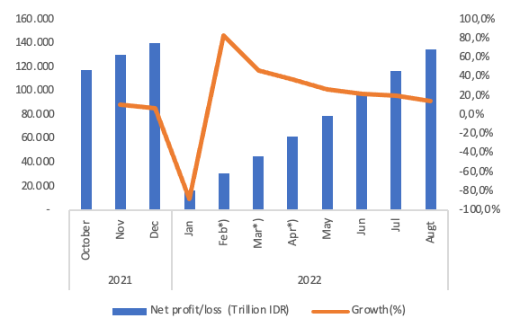
Figure 3 : Digitalization, Emerging Technologies, and Financial Stability
Source: (Ssenyonga, 2022)
By the end of 2027, the investment in digital transformation is expected to grow beyond US$3.9 trillion, globally.At US$3.9 trillion, investment in digital transformation is expected to grow significantly by the end of 2027, in worldwide terms. In addition, it is clear that digital transformation is not just about technology but is directly tied to organisational renewal as evidenced by an additional 23% increase in profitability, 20% improvement in operations and shortened innovation cycles for organisations with high digital maturity.

5.3 Leadership Theories
According to Transformational Leadership Theory, organisational transformation can take place when transformational leaders establish clear visions, convey those visions to employees, promote new ideas and nurture employee willingness to go over and beyond . In digital transformation, transformational leaders help employees move their buy-in and eliminate resistance by communicating and empowering. Every organisation that demonstrates "Transformational Leadership" sees by-roundly 27% higher levels of employee engagement, as well as much better innovation performance. However, some critics state that the theory assumes that no technical problems will arise in an environment where there is charismatic leadership, and bases the theory too much on the concept of digital competencies, which they believe is a myth (Dickson, 2023).
Digital Leadership is an expansion of the theories of leadership provided before, putting technology alongside strategic vision and innovative capabilities. Digital leaders have digital mindsets, they make decisions based on data, they "know" about technology and they promote agile working and ongoing innovation. But, as students suggest, conceptual ambiguity still exists as digital leadership is similar in theory to the concept of transformational leadership and adaptive leadership, which prevents conceptual difference and cannot be distinguished without further empirical investigations in organisational environments that deal with digital technologies.

5.4 Leadership and Digital Transformation
The existing literature highlights the notion that leadership is a key enabler of digitalisation, given that it impacts on innovation, organisational change, employee commitment, communication efficacy and the expansion of digital related skills. Research indicates that culture and lack of leadership, not technology, account for around 70% of digital transformation program failures, and lack of leadership skills is a key challenge for 61% of executives (Cao, Duan and Edwards, 2025). Nevertheless, contradictions remain. Some researchers claim that technological investment is the deciding factor to help reach transformation success, while other researchers believe that leadership behaviours have a more significant impact than the digital infrastructure itself. The inconsistencies highlight the need for more empirical research to investigate leadership effectiveness in UK-based technology firms.

5.5 Conceptual Framework
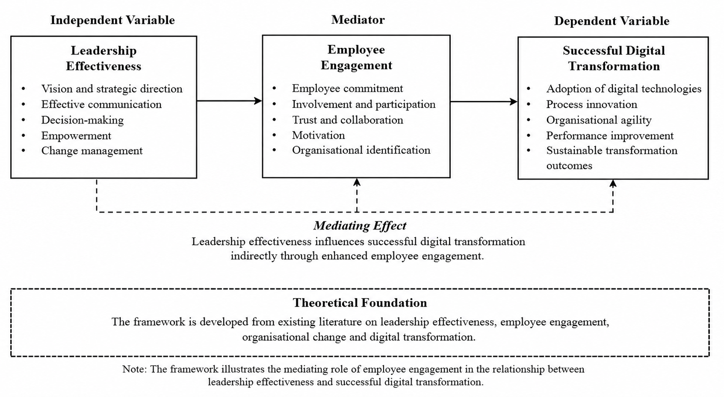
Figure 4 : Conceptual Framework
Source: Selfmade
This study constructs a conceptual framework, basing on previous literature on leadership and organisational change. Employee Engagement serves as the mediating variable, bridging the relationship between Leadership Effectiveness and Successful Digital Transformation, and the former can impact how the latter contributes to employee commitment, organisational agility and the success of digital transformation (Maye, 2026). The rationale for this framework is that employee engagement is boosted when employees are better engaged with the business through more effective leaders, thereby raising the odds of a successful ramp up of digital transformations and improvement in organisational performance. These integrated model beliefs serve as the theoretical base to explore the relationship of leadership effectiveness and employee engagement over digital transformations in the United Kingdom.

6. Research Methodology

6.1 Research Philosophy and Research Approach
This research is positivist since it allows relationships between the effectiveness of leadership, level of employee engagement, and level of digital transformation to be measured objectively. The method is deductive which will test the proposition of the various leadership and organisation change theories with observable evidence. The quantitative analysis helps in hypothesis testing with the help of statistical analysis and reduces the researcher's bias and increases generalisability. Systematic investigation with a statistical verification throughout the entire UK technology firms.

6.2 Research Strategy, Design and Sampling
The research approach is quantitative and the data are collected by means of cross sectional design which aims to record data at a single time. This target audience includes employees in digital transformation within technology companies in the UK as they live the leadership practices first-hand (Sacavém et al., 2025). Due to availability, limited time and resources, convenience sampling will be utilized, but is appropriate for exploratory organisational research. As per recommended sample size for quantitative business studies, sample size of around 150–200 respondents are good enough to get statistically meaningful results and to get multivariate analysis results and also to make the results of the study more representative. This method ensures that there is a good level of feasibility and power for good organisation evidence generation.

6.3 Data Collection and Data Analysis
Primary data will be gathered by taking an online structured questionnaire with a 5-point Likert scale to measure the respondents perception consistently. The questionnaire allows standard responses to be given making it possible to compare different responses objectively. SPSS will be used to analyze the data. The descriptive statistics will summarise the characteristics of the respondents and the distributions of the variables, while the reliability analysis will assess whether there is internal consistency in the instrument used by the respondents. The analysis of variable relationships will be conducted using correlation analysis, and the influence of the variables on successful digital transformation will be obtained from multiple regression analysis.

6.4 Validity and Reliability
The validity and reliability will be improved by doing pilot tests before completing the data collection. Pilot participants will provide feedback that will enhance questions and information quality. The internal consistency will be checked with Cronbach's alpha with alpha> 0.70 being accepted (Hussey et al., 2025). Construct validity will be strengthened to adapt measure items of valid studies for variables to reflect theoretical constructs. Throughout this process, it maintains its credibility, consistency and overall robustness of the measurement process.

6.5 Ethical Considerations
Before the data collecting process, ethical approval will be maintained from the university. No one will be forced to participate and a participant information sheet will be given to respondents, explaining the purpose of the study. The questionnaire is to be completed on-line prior to informed consent of participants. Participants will be able to voluntarily withdraw from the study at any time prior to giving responses without penalty. Obtaining personally identifiable information will be avoided and anonymity and confidentiality will be guaranteed. The study will comply with the UK General Data Protection Regulation (GDPR). All research data will be kept securely on password protected devices and once institutional research data retention period expires, they will be destroyed permanently.

7. Expected Findings
This study is anticipated to have meaningful academic and practical contributions. In terms of academics, it extends the literature on digital leadership with evidence from UK technology companies and bolsters the understanding on the link between leadership effectiveness to employee engagement and digital transformation. The results fill a gap in contemporary research that would be useful to consider in the context. In practice, the research helps technology managers design strategies for effective leadership, create high-performance employee engagement, help make digital transformation programmes successful, and enrich leadership development programmes (Lartey, 2025). Finally, the research provides evidence-based understandings that can be used to increase the organisational ability to adapt, generate innovation, make strategic decisions and the capacity for a sustained competitive advantage in the UK technology organisations that are constantly changing and transforming to embrace digital transformation.
8. Limitations
Limitations of this study are discussed below.This study was faced with certain limitations. First, this study may be limited to the generalisation of the results to all technology companies in the UK, as convenience sampling was used. Second, the cross sectional research study design takes out the participants' perceptions during a single time and isn't able to establish causality. Third, answers to questionnaires are based on self-report and may be subject to response and/or social desirability bias. The number of samples and location of the samples may also be limited due to time or resource constraints. To limit these caveats, validated scales measuring tools will be used, anonymity will be provided to ensure honest responses and results will be analyzed prudently in the study's context.
9.Timeframe
Activity | Jul | Aug | Sep | Oct | Nov
Literature Review | ✓ | ✓
Questionnaire Design |  | ✓
Ethics Approval |  | ✓
Data Collection |  |  | ✓
Data Analysis |  |  |  | ✓
Writing Chapters |  |  |  | ✓ | ✓
Proofreading |  |  |  |  | ✓

8. Conclusion
The proposed study is on how effective leaders are in driving digital change in tech companies in the UK. They aim to investigate the relationship between leadership behaviours and employee engagement, as well as the effectiveness of the digital transformation efforts. A quantitative research style is used to help generate empirical evidence that is reliable, to help fill a gap in the existing literature. The expected conclusions will add to both the knowledge and management practice, giving concrete suggestions for improving effectiveness in leadership. Overall, the study is intended to assist technology organisations to successfully achieve digital transformation and maintain the performance and competitive advantages of the organisations in the long-term.

References
Cao, G., Duan, Y. and Edwards, J.S. (2025). Organizational Culture, Digital Transformation, and Product Innovation. Information & Management, [online] 62(4), p.104135. https://www.sciencedirect.com/journal/information-and-management/vol/62/issue/4
‌‌Consultancy.uk (2020) Covid-19 has accelerated digital transformation by seven years. Available at: https://www.consultancy.uk/news/26372/covid-19-has-accelerated-digital-transformation-by-seven-years (Accessed: 30 June 2026).
Deloitte (2023) Measuring value from digital transformation. Available at: https://www.deloitte.com/uk/en/services/consulting/research/measuring-value-from-digital-transformation.html (Accessed: 30 June 2026).
Dickson, R.K. (2023). Analysis of The Traditional Leadership Theories: A Review of Contemporary Leadership Approaches and Management Effectiveness. Information and Knowledge Management, 13(5). https://doi.org/10.7176/IKM/13-5-02
Electro IQ (2025) AI in FinTech Statistics by Market Size and Trends (2025). Available at: https://electroiq.com/stats/ai-in-fintech-statistics/ (Accessed: 30 June 2026).
Hao, T., Rasiah, R. and Mustafa, S. (2026). Digital Infrastructure, SME E-Commerce, and Economic Growth: Evidence from China’s Platform Economy. Economies, [online] 14(2), p.40. https://doi.org/10.3390/economies14020040
Hussey, I., Alsalti, T., Bosco, F., Elson, M. and Arslan, R. (2025). An Aberrant Abundance of Cronbach’s Alpha Values at .70. Advances in Methods and Practices in Psychological Science, [online] 8(1). https://doi.org/10.1177/25152459241287123
Lartey, S. (2025). The Impact of Technology on Leadership, Management, and Human Resource Practices. [online] ResearchGate. Available at: https://www.researchgate.net/publication/390702290_The_Impact_of_Technology_on_Leadership_Management_and_Human_Resource_Practices.
Maye, C.G. (2026). The Effectiveness of Digital Leadership in Promoting Employee Engagement and Organizational Innovation. OALib, 13(02), pp.1–16. https://doi.org/10.4236/oalib.1113907
Musaigwa, M. (2023). The Role of Leadership in Managing Change. [online] ResearchGate. Available at: https://www.researchgate.net/publication/375562628_The_Role_of_Leadership_in_Managing_Change.
Power, R. (2024) ‘Employees in action: Unlocking profit through an engaged workforce’, Forbes, 21 July. Available at: https://www.forbes.com/sites/rhettpower/2024/07/21/employees-in-action-unlocking-profit-through-an-engaged-workforce/ (Accessed: 27 June 2026).
PricewaterhouseCoopers (PwC) (2024) UK Workforce Hopes and Fears Survey 2024. Available at: https://www.pwc.co.uk/services/human-resource-services/insights/uk-hopes-and-fears-survey/2024.html (Accessed: 30 June 2026).
Qeios article Ssenyonga, S. (2022) Digital leadership: A conceptual perspective on leadership in the digital age. Qeios. Available at: https://www.qeios.com/read/CSTTYQ.2 (Accessed: 30 June 2026).
Sacavém, A., de, A., Santos, Palma-Moreira, A., Belchior-Rocha, H. and Au-Yong-Oliveira, M. (2025). Leading in the Digital Age: The Role of Leadership in Organizational Digital Transformation. Administrative Sciences, 15(2), pp.43–43.https://doi.org/10.3390/admsci15020043?urlappend=%3Futm_source%3Dresearchgate.net%26utm_medium%3Darticle
Schilirò, D. (2024). Digital Transformation and its Impact on Organizations. International Journal of Business and Management, [online] 19(6), p.71. doi:10.5539/ijbm.v19n6p71.https://doi.org/10.5539/ijbm.v19n6p71?urlappend=%3Futm_source%3Dresearchgate.net%26utm_medium%3Darticle
Shonubi, O. (2025). Innovation Challenges of Digital Transformation: Transitioning Legacy to the Future. Sustainable Futures, [online] p.100971. https://doi.org/10.1016/j.sftr.2025.100971
Szymon Cyfert, Wojciech Dyduch, Szumowski, W. and Prause, G. (2025). Are we ready for digital transformation? The role of organizational culture, leadership and competence in building digital advantage. Central European Management Journal. https://doi.org/10.1108/CEMJ-11-2024-0346
Tagscherer, F. and Carbon, C.-C. (2023). Leadership for Successful digitalization: a Literature Review on Companies’ Internal and External Aspects of Digitalization. Sustainable Technology and Entrepreneurship, [online] 2(2), pp.1–15. Available at: https://www.sciencedirect.com/science/article/pii/S2773032823000032.
World Bank (2023). DIGITAL PROGRESS AND TRENDS REPORT. [online] Available at: https://documents1.worldbank.org/curated/en/099031924192524293/pdf/P180107173682d0431bf651fded74199f10.pdf.

