Managing Enterprise in the 21st Century

Business Plan

Skyethiopiatours.com https://skyethiopiatours.com (here)

Submission Date:26/07/2026
Lecturer:Riaz Bhatti

Table of Contents
Group Information 2
Executive Summary 4
Business Concept 5
Business Description 5
Product Description 5
Business Objectives (SMART Objectives) 5
Short-Term Objectives (less than a year) 5
Long-Term Objectives (less than a year) 5
Market Analysis and Marketing Plan 6
Market Analysis (Competitors, Customers, Target Groups) 6
PESTEL Analysis 6
SWOT Analysis 6
Marketing Mix (4Ps) 6
Management Team 6
Management Team and Their Background 7
Organisational Chart 7
Key Milestones 7
Financial Plan (One Year) 7
Sources of Finance 7
Cash Flow Forecast 7
Sales Forecast 7
Cost of Production Forecast 7
Break Even Analysis 7
Operations and Management Plan 7
Production of Good and Service 7
Technology Plan 7
Human Resource Plan 7
Expansion Plan 8
Reference List 8
Appendices: 9

Group information
Name –sky Ethiopia tours
Website - https://skyethiopiatours.com
Industry –tourism and travel service
Location -Addis Abeba Ethiopia and London
Business type-private tour operator
Founder –Asnakew Nega Bizuneh

Executive Summary
Sky Ethiopia Tours is a company that runs tours in the United Kingdom and Ethiopia. We want to show people the culture and history of these places. We also have adventure travel experiences. The people at Sky Ethiopia Tours we hope to get 300 bookings in their year. We want to make a profit that will last. To do this we will use the internet to market work with companies and make sure our customers are incredibly happy, with the service we give from Sky Ethiopia Tours.Sky Ethiopia Tours designs travel experiences that highlight the best of Ethiopia. We handle everything from guided tours and transportation to cultural programs, adventure expeditions, and custom packages—serving both local and international travellers. The company has built a solid digital presence and pushes hard on service quality, with ambitions to become one of Ethiopia's top and most forward-thinking tourism operators. What drives the business is creating safe, genuine, and unforgettable trips. They work closely with hotels, local guides, and tourism organisations to make that happen. Right now, in year one, they're focused on three things: getting the brand out there, keeping customers happy, and smoothing out how they run. Down the road, we planning to add more vehicles to their fleet, develop fresh tour options, and push into other regions.
Business Concepts
Sky Ethiopia Tours is a contemporary, customer-oriented travel agency aimed at connecting traveller with Ethiopia's rich cultural heritage, stunning landscapes, and historical landmarks. As a comprehensive tour operator, it offers tailored travel experiences that include expert guidance, dependable transportation, and personalised itineraries. The company’s primary mission is to provide seamless, safe, and unforgettable journeys for both international and domestic visitors.
Sky Ethiopia Tours stands out by offering flexible and customisable travel options. Rather than relying on fixed packages, it adapts itineraries to meet the specific needs of families, solo traveller's, corporate groups, and adventure enthusiasts. This personalised approach increases customer satisfaction and encourages repeat business. Additionally, the company partners with hotels, local guides, cultural institutions, and transportation providers to guarantee high-quality service throughout the travel process. Safety, professionalism, and cultural authenticity are fundamental to the company’s philosophy. Guides are trained to share exact historical insights, help travellers, and advocate for responsible tourism practices. The business also priorities sustainability by promoting eco-friendly travel habits and supporting local communities.
Business Description
Sky Ethiopia Tours is a contemporary, customer-centric tour operator committed to highlighting Ethiopia's rich cultural heritage, diverse landscapes, and distinctive historical sites for both domestic and international travellers. The company prioritises personalised service, professional tour management, and smooth travel logistics. As an expanding tourism enterprise, Sky Ethiopia Tours strives to establish itself as a reliable provider of high-quality travel experiences, offering safe, well-organised, and culturally immersive tours across Ethiopia. The company's fundamental philosophy centres around delivering outstanding customer service from the initial inquiry to the end of the journey. This encompasses clear communication, dependable transportation, knowledgeable guides, and thoughtfully designed itineraries that highlight Ethiopia's most famous attractions, including Lalibela, the Semien Mountains, the Rift Valley Lakes, and the cultural landmarks of Addis Ababa. Sky Ethiopia Tours also fosters sustainable tourism by supporting local communities, encouraging responsible travel practices, and collaborating with local businesses to enhance the tourism ecosystem

Business Objectives (SMART Objectives)

Short-Term Objectives (less than a year)
- Achieve 300+ bookings within the first 12 months.
- Build partnerships with 10 hotels and 5 local tourism providers.
- Reach 5,000 website visitors per month through digital marketing.
- Maintain a customer satisfaction rating of 4.5/5 or higher.

Long-Term Objectives (More than a year)
- expand Sky Ethiopia Tours’ physical presence by opening international offices in:-
- Addis Ababa (Head Office)
- London (European Market Hub)
- Paris (Optional expansion depending on market demand)
- Increase annual bookings to 1,500+ by year three.
- Grow the fleet to 10 vehicles.
- Establish Sky Ethiopia Tours as a top-rated operator on TripAdvisor and Google.
- Build partnerships with European travel agencies to increase inbound tourism to Ethiopia.
Market Analysis and Marketing Plan
https://skyethiopiatours.com (here)

Market Analysis (Competitors, Customers, Target Groups)

Competitors
• Set up Tour Operators: Companies like Green Land Tours, Ethiopia Travel & Tours, and Semien Image Tour boast strong reputations and established customer loyalty.
• Small Independent Guides: They offer less expensive tours, but they do not have a professional setup, safety protocols, or an online presence.
• International Travel Agencies: They offer packaged tours to Ethiopia but typically lack in-depth local knowledge.
Customers: - International tourists, local travellers, business visitors, diaspora communities
Target groups: -. Adventure travellers, cultural tourists, families, corporate clients
PESTEL Analysis

• Political: Government support for tourism; occasional regional instability.
• Economic: Growing tourism revenue; fluctuating currency exchange rates.
• Social: Rising interest in cultural and adventure travel.
• Technological: Increased use of online booking platforms and digital marketing.
• Environmental: Need for sustainable tourism practices.
• Legal: Licensing requirements for tour operators; safety and insurance regulations.

SWOT Analysis
• Strengths: Strong digital presence, personalised tours, multilingual guides.
• Weaknesses: New brand with limited first customer base.
• Opportunities: Growing tourism sector; demand for authentic experiences.
• Threats: Political instability, global travel disruptions, intense competition.

Marketing Mix (4Ps)
Product
High‑quality tours, transport services, professional guides, and customised packages.
Price
Competitive pricing with flexible packages for different budgets.

Place
Website bookings, social media platforms, hotel partnerships, travel agencies.
Promotion
Social media campaigns
• Google Ads, app
• Travel influencers
• Partnerships with hotels and airlines
• Seasonal discounts

Management Team
• General Manager
• Tour Operations Manager
• Marketing Manager
• Finance Officer
• Customer Service Team.
Management Team and Their role
- General Manager: Oversees strategy, operations, partnerships, and business growth.
- Tour Operations Manager: Manages tour schedules, guides, coordination, and quality control.
- Marketing Manager: Handles digital marketing, branding, promotions, and customer acquisition.
- Finance Officer: Manages budgeting, financial reporting, and cash flow.
- Customer Service Team: Handles bookings, inquiries, complaints, and client support.

Organisational Chart
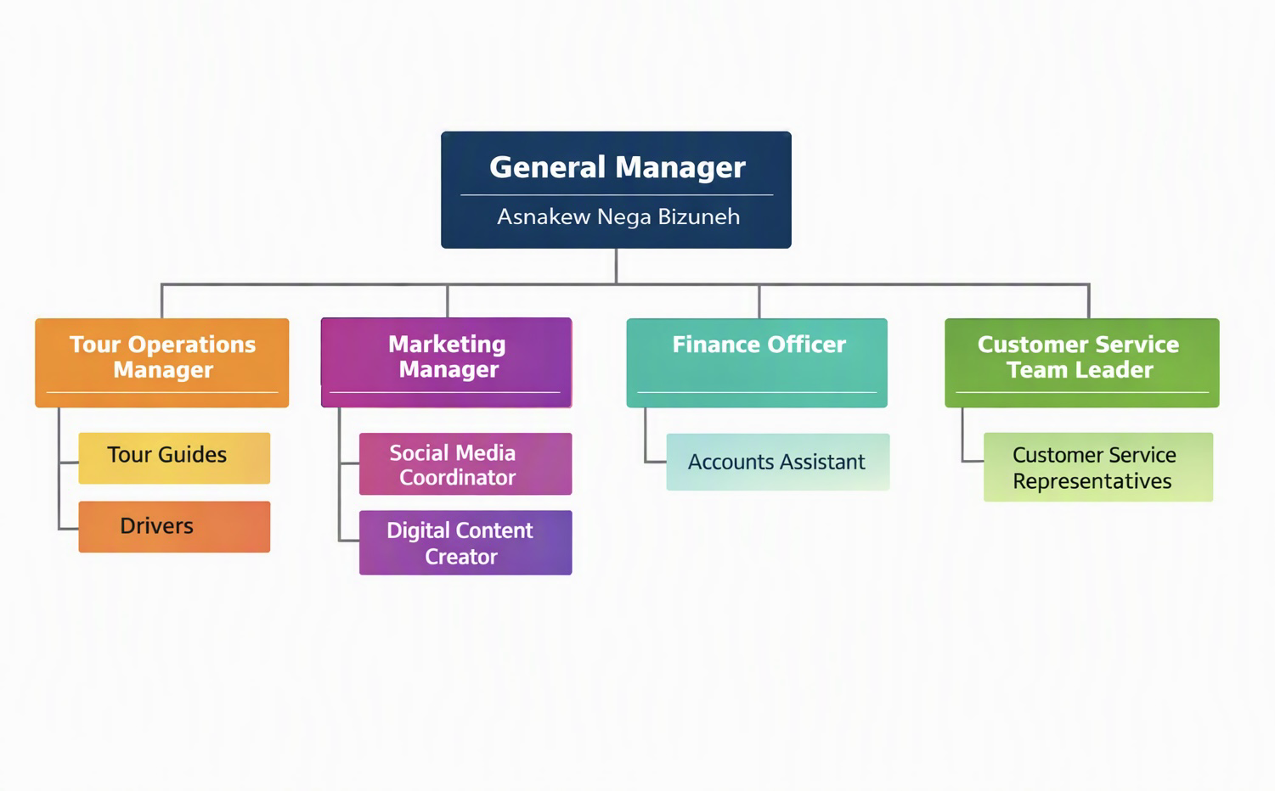

key Milestones
• Business registration finalised
• Website went live
• Initial 10 partnerships formed
• Secured the first 300 bookings
• Expanded fleet to include 5 vehicles
• Opened an international office in London
• Reached top-rated status on TripAdvisor

Financial Plan (One Year)

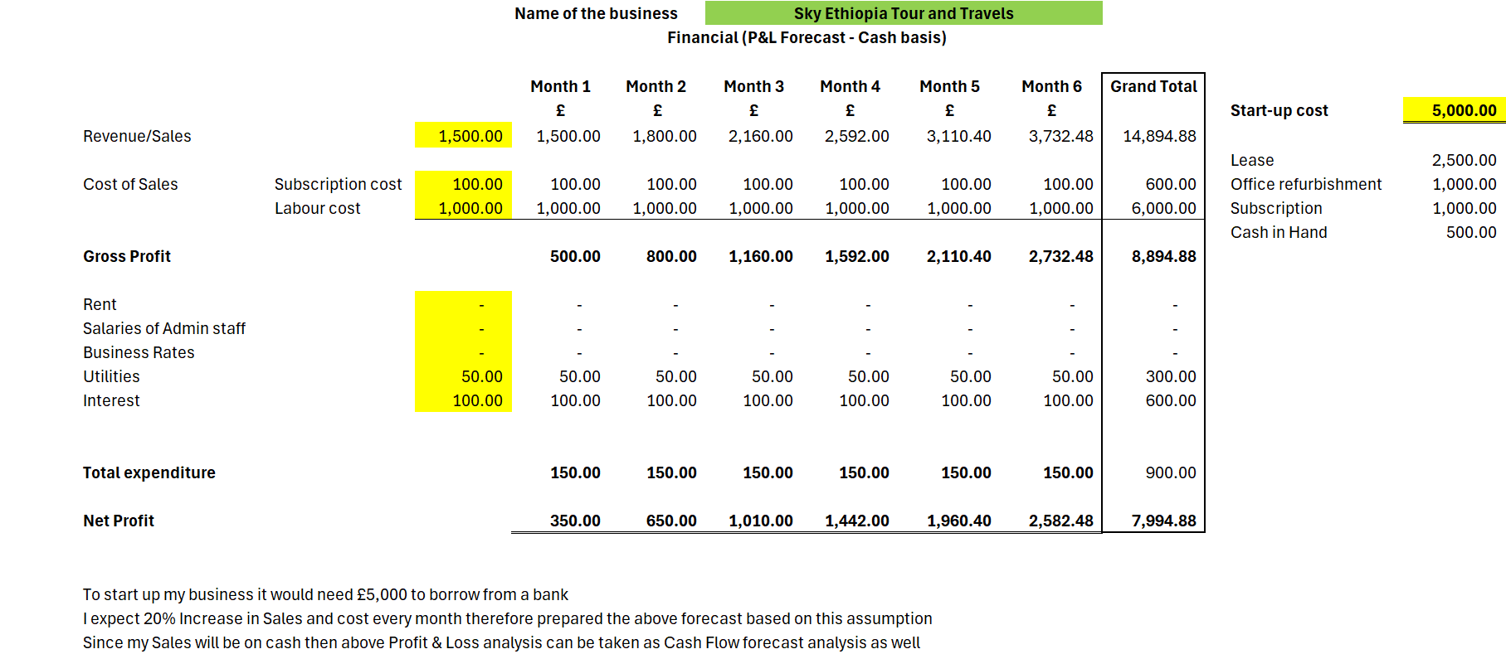

Sources of Finance

Bank loan -5000£
Total finance 5000

Cash Flow Forecast

Sales Forecast
Cost of Production Forecast
Break Even Analysis
Operations and Management Plan
- Website booking system
- Social media marketing
- CRM for customer management
- GPS and communication tools for guides
- Production of Good and Service
- Tour planning
- Transport coordination
- Guide assignment
- Customer communication
- Quality assurance
- Technology Plan

Website booking system
• CRM tools, build app
• Social media marketing
• GPS‑enabled fleet management

Human Resource Plan
Recruitment of guides
• Training programs
• Customer service standards

Expansion Plan
International offices
• New tour destinations
• Larger fleet
• Partnerships with European agencies, Asian and East African

Reference List
- Ethiopian Ministry of Tourism (2023) Tourism Statistics Annual Report. Addis Ababa: Government of Ethiopia.
- World Bank (2023) Ethiopia Tourism (Accessed: 23 July 2026).
- UNWTO (2024) Tourism Market Trends: Africa Edition. Madrid: United Nations World Tourism Organisation.
- Kotler, P., Bowen, J. and Makens, J. (2016) Marketing for Hospitality and Tourism. 7th edn. London: Pearson.
- Porter, M. (2008) The Five Competitive Forces That Shape Strategy. Harvard Business Review, January, pp. 78–93.
- Oxford Business Group (2023) The Report: Ethiopia 2023 – Tourism Overview. (Accessed: 23 July 2026).
- Statista (2024) Inbound Tourism in Ethiopia – Market(Accessed: 23 July 2026).
- TripAdvisor Insights (2024) Traveller Behaviour and Digital Booking Trends. (Accessed: 23 July 2026).
- Google Travel Insights (2024) Global Travel Search Trends. (Accessed: 23 July 2026).
- Pride, W., Hughes, R. and Kapoor, J. (2020) Business. 14th edn. Boston: Cengage Learning
- Appendices:-

