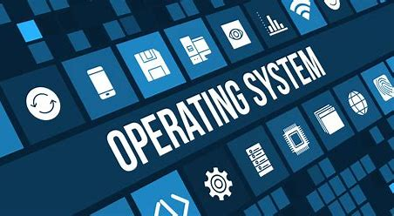
Operating Systems
COMPUTER ARCHITECTURE AND OPERATING SYSTEMS
Ethan Shellem-Prince | 2109509
Table of Contents
Introduction …………………………………………………………………………………… 3
Key Functions of general Operating Systems ………………………………………………… 4
Use of Windows OS CLI Commands ………………………………………………………… 5
Use of Linux OS CLI Commands …………………………………………………………….. 9
Use of Windows OS Scrips …………………………………………………………………… 12
Use of Linux OS Scripts ………………………………………………………………………. 16
Evidence of Engagement with Microsoft Learn Course ………………………………………. 20
References ……………………………………………………………………………………… 21

Introduction
This report will cover the common functions of modern general Operating Systems. As well as documentation of 10 Batch and Linux commands along with evidence and explanation of the reader. Furthermore the report will demonstrate key features within Windows and Linux OS Scripting language with adequate documentation and explanations. The report includes many images of completed scripts that have been run and tested by the author.

Key Functions of general Operating Systems
An Operating System (OS) is a primary software that supports and manages all software on a computer. The Operating System works with the built in hardware and provided services that other applications can use.
As stated in the below article published by the popular programming website ‘Code Academy’ shows the importance of OS.
An operating system makes software development much easier. Without one, a Software Developer would have to know a lot of details about the hardware that the software will run on and — and possibly have to create a different version of the software for each device. [1]

Mobile OS
A Mobile OS is a software that allows all mobile devices (phone, tablets, PCs) to run programmes and applications. The OS typically runs when the device is powered on. The OS allows clean and clear presentation of all applications by displaying them in specific Icons. The Mobile OS can also control cellular and wireless network connectivity as well as phone access.
Network OS
A Network OS is mainly designed to support larger devices such as workstations and PCs. The function of a Network OS is to connect multiple devices onto a network that allows them to transfer and share date safely. The Network OS can also be used to monitor and trouble shoot the network while also configuring and managing certain resources on the network.
Software OS
A Software OS typically runs after being loaded into the computer by an additional program. It is a fundamental component of any Operating System. The main function of Software OS is to manage and allocate the resources on the PC such as memory, CPU time and disk space. This OS also provided a filing system that allows users to store, change and access data on the computers storage.
Embedded OS
A Embedded OS is altered version of a software OS. It is designed to support embedded systems, which are essentially smaller computer systems designed for specific tasks. The primary function of an Embedded OS is to manage the limited resources available on embedded systems, such as memory, processing power, and storage space. It also provides services such as input/output management, device drivers, and network connectivity.
Real Time OS
A Real-Time Operating System (RTOS) is a specialized type of software OS designed to support applications with strict timing requirements The primary function of an RTOS is to manage and schedule tasks within a system to meet specific timing requirements.

Windows OS CLI Commands

- Get-Process
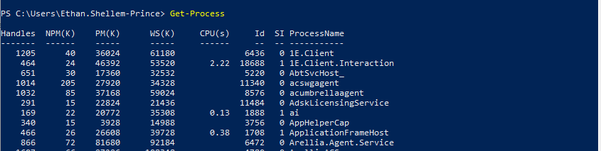
The ‘Get-Process’ commands allows users to view information about the processes that run on their computer. The command includes many different properties for each process, this includes, Process ID, memory usage and CPU.

- Clear-Content
The ‘Clear-Content’ command allows the user to remove the contents of a file but retain the item itself. This can be used to remove contents out of a text file but keep the actual file in place.

- Get-Help
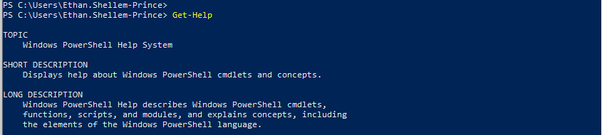
The ‘Get-Help’ command is widely used by all PowerShell users. The command allows quick access to key information required to work with and run all available comments. The command also allows you to narrow the search down. For example, to search for help on the Get-Process command simple input the below:
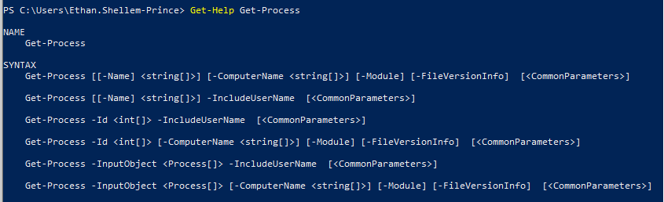
The following statement is from the PowerShell help website. The statement reads,
‘You can run the help command on almost every PowerShell command, provided that the third-party modules include the help resources. The most common way to use the help command is by calling Get-Help with the name of the command you wish to look up.’ [2]
This statement shows how the Get-Help command can be used to find specific help on problems you may face.

- Get-Service
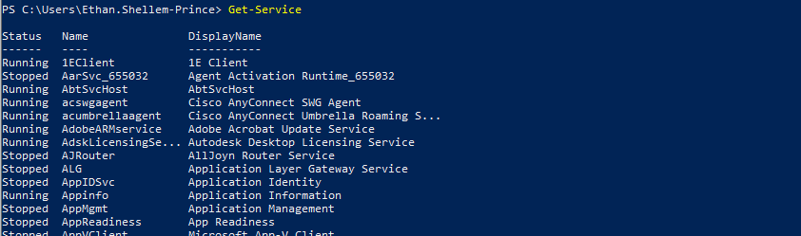
The ‘Get-Service’ command allows users to understand the different services that are installed on the system. Furthermore, if you require to know if a specific service is installed you can input the command ‘Name-Switch’ and the name of the service. This will allow windows to specifically search foe the state of the service.

- Checkpoint-Computer
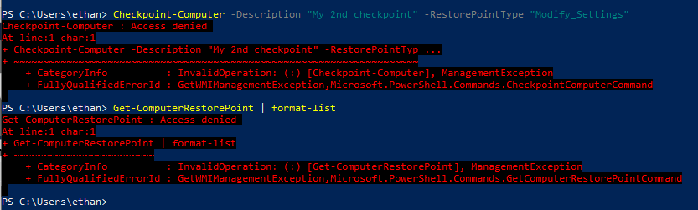
The command ‘Checkpoint-Checker’ allows users to make a checkpoint on the machine This would be very helpful if you are running a test or program that could cause problems soon. This command is used widely by PowerShell users.

- CD
The ‘CD’ command allows you to move between different directories. The CD command is followed up with the directory you want to move into, for example if you wanted to move into your Desktop, use the below command:

- LS
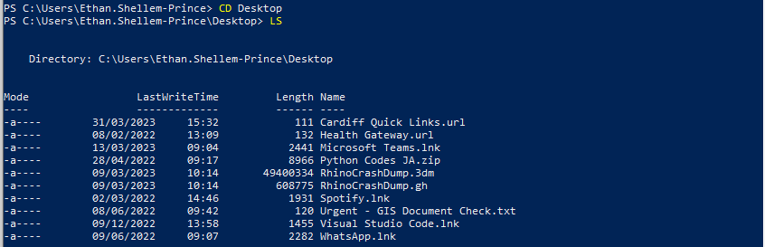
Following the input of a new directory the LS command allows users to list the contents of that specific directory.

- Get-ChildItem
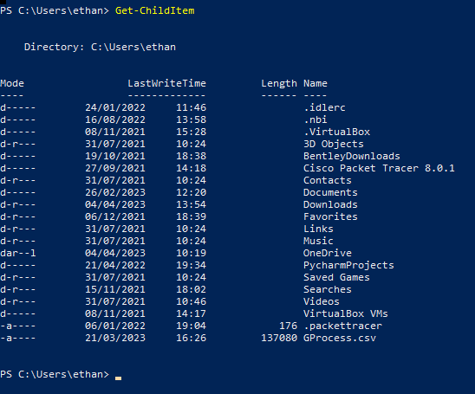
The ‘Get-ChildItem’ command allows the user to retrieve a list of all files and subdirectories within a specified directory. In this case the directory is ‘C:\Users\ethan’ so this command has listed all of the items within this area. Further more the command can be used to recursively search for files and directories in specified directory and all its sub folders. This can be done by adding in the command ‘-Recurse’.

- Get-EventLog
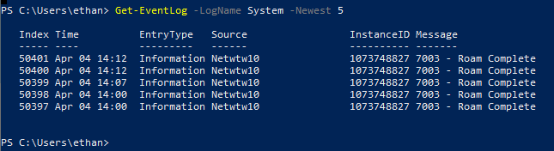
The command above allows users to see previous events that have taken place on the computer, the command above looks at the previous 5 events on the machine. To clear all previous events the command ‘Clear-EventLog’ can be used.

- “Enter Any Text here”
This simple command is used to enter any amount of string text. This command is used widely to set notes and instructions of different PowerShell scripts. The simple use of “” at the start and end of a string will print on the next line.

Use of Linux OS CLI commands
The below statement explains what a Linux Operating system is generally used for,
Just like Windows, iOS, and Mac OS, Linux is an operating system. In fact, one of the most popular platforms on the planet, Android, is powered by the Linux operating system. An operating system is software that manages all of the hardware resources associated with your desktop or laptop. To put it simply, the operating system manages the communication between your software and your hardware. Without the operating system (OS), the software wouldn’t function. [3]

- whoami
This basic Linux commands simply allows users to check their username. This command will print the username of the logged in account. This may be used to ensure the Linux server is logged into your account.

- clear
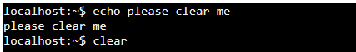
The clear command simply allows the Linux window to be cleared of all previous entries. As shown below after the use of ‘clear’ the window defaults back to clear.
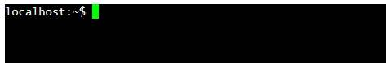

- pwd
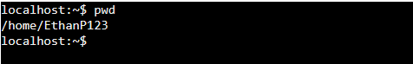
The ‘pwd’ command prints the current working directory with the full path starting from the root/. This command is widely used by Linux system administrators.

- ls -l
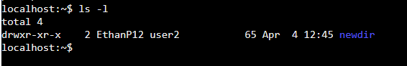
This command lists all of the files and sub-files in the directory aswell as additional fine information. The additional information can be used to see when it was created aswell as the size of the file.
- mkdir directoryname
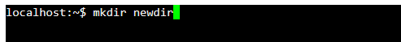
The mkdir command allows users to create new directory. In the example above I have created the directory ‘newdir’. A new directory is the same as a new folder, it is used to organise and control different files.

- cd directoryname
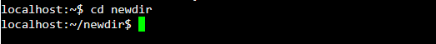
This command allows the user to enter into the directory that have created with the ‘mkdir’ command. After entering the directory the user can then create and amend any files in the folder.

- touch newfile.txt
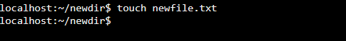
This command is to create a new file within the new directory. In this example we have created a .txt file named ‘newfile’. The user can create many different files using this command.

- chmod +rwx newfile.txt
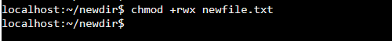
This command adds all permissions for the user/owner of the file. This will allow the user to amend the contents of the files while adding and removing data if needed.

- ‘echo “This text is being added into my file” >> newfile.txt’
The command above allows the user to add specific text into the file they previously created. In this case the text ‘This text is being added into my file’ would be printed within the .txt file

- rm-R newdir
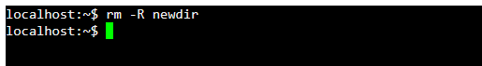
This command is used to remove directory’s as well as all files within. This command would be very useful when cleaning out working areas. This command does not permanently delete the file from the system so it can be recovered if needed.

Use of Windows OS scripts
In this section of the document I will be displaying 10 different Bat scripts that can be used in the windows command prompt. I will be creating these scripts in the application, Notepad++. These scripts can then be executed in PowerShell by reading in the file.
The following statement explains how a basic shell scripting process works,
Shell scripts contain ASCII text and are written using a text editor, word processor or graphical user interface (GUI). The content of the script is a series of commands in a language that can be interpreted by the shell. Functions that shell scripts support include loops, variables, if/then/else statements, arrays and shortcuts. Once complete, the file is saved typically with a .txt or .sh extension and in a location that the shell can access. [4]

- Echo
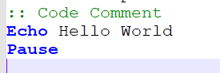
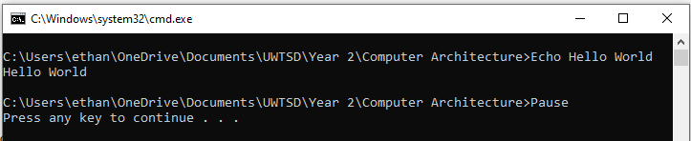
Like many other programming languages, the Echo command can also be used when writing .bat scripts. The command allows users to print any text that would like. The Echo command can also print any set variables that the script has.

- Variables
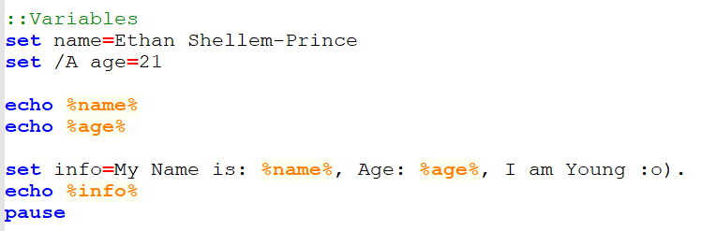
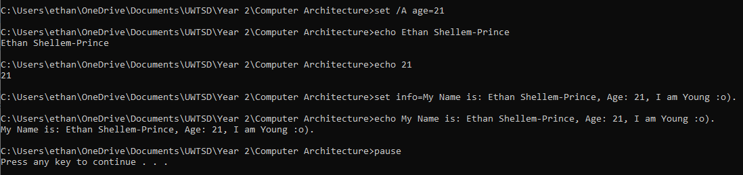
The script above includes different variables including ‘name’ and ‘age’. The user is prompted to input there name and age, using the set command. The echo command is then used to print out the variables in a formed sentence.

- Simple Math
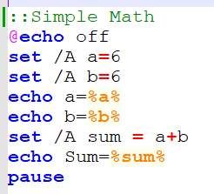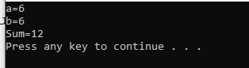
.bat scripts have the power to create math equations using the built in math functions. The simple equation above simply adds the value of A with the value of B together then outputs the sum. The image on the right simple shows the two values within PowerShell with the output as the sum. This makes it easier for the user to read.

- Goto
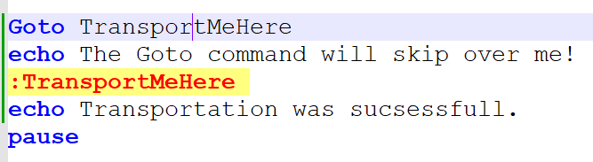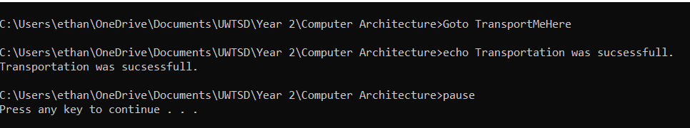
The Goto Command allows users to skip over code if needed. As the script above demonstrates, line 2 is skipped over. This is due to ‘TransportMeHere’ command I have used. The command is regularly used by programmers when they want to test certain parts of the code.

- If Else Statements
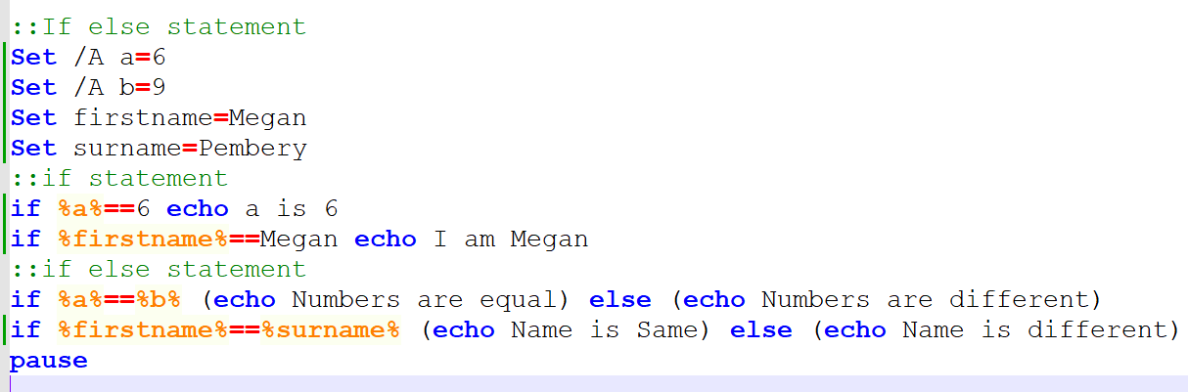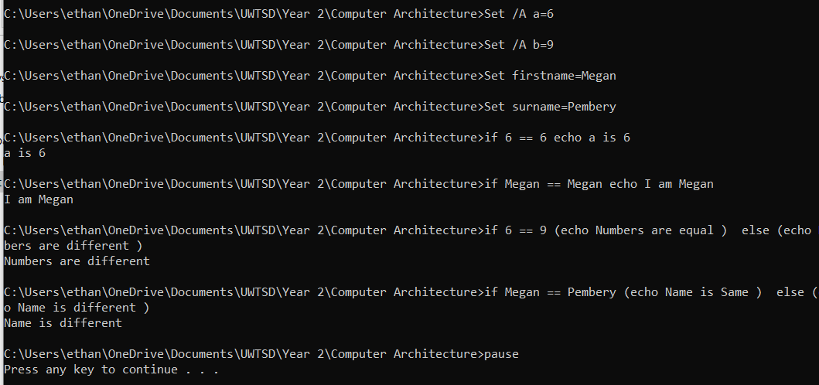
The if and if else statement can be used to set more than one statement at once. The script above states if the numbers input at the start match the numbers from the previous math equation (6) print, ‘a is 6’. This same principle is used for the first name, if the first name matches ‘Megan’ print ‘I am Megan’.

- For Loops
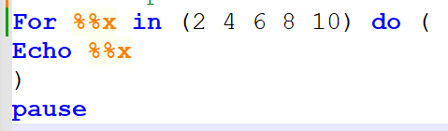
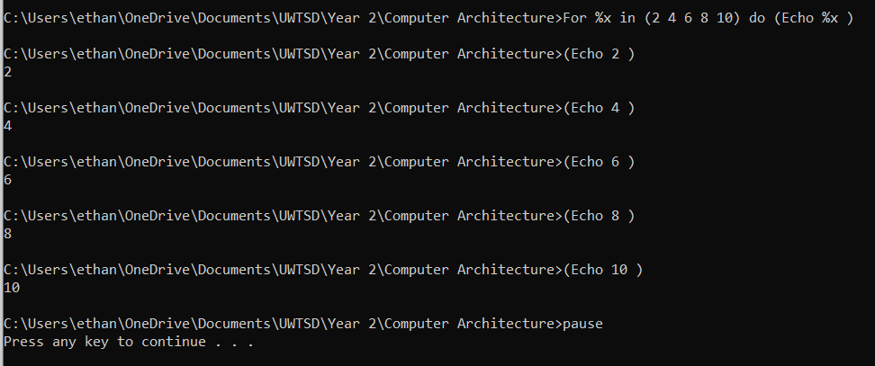
Simple Foor Loops are very simple to use, the script above clearly shows that the user must input the values for the loop. The echo command is then used to print all loop values one by one separately. The use of loops can be very useful to prints lists such as attendance.

- Loops with Lower and Upper Limits
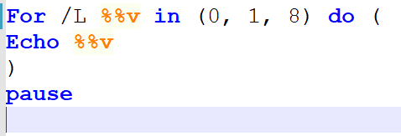
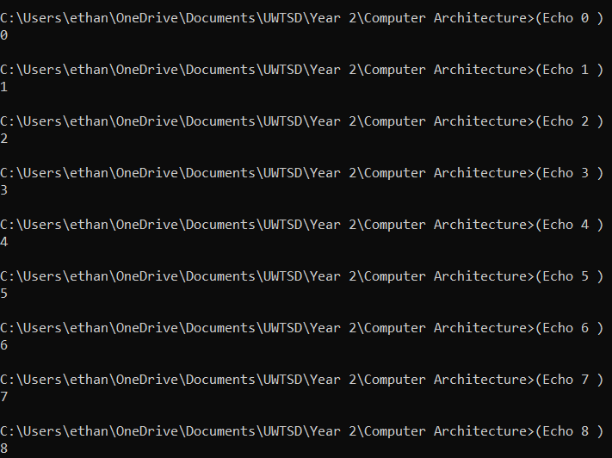
The loop above has upper and lower limits. In the script the values (0, 1, 8) all correspond to rules. Number 0 means the number the loop should start counting at. Number 1 tells the script to count up in values of 1. Then the value 8 means end the loop once the count has hit 8.

Use of Linux OS Scripting
In this section of the document I will be displaying 10 different bash scripts. I will be creating the scripts in the website replit.com.

- Printing out text
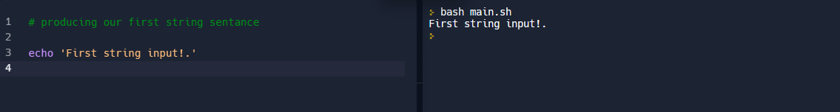
The use of the ‘echo’ command is widely used within the coding world. The echo command is a built-in command that is used to display text on screen. Although this may be simple, the echo command is used above to show that bash is similar to many other software’s such as Python.

- Variables
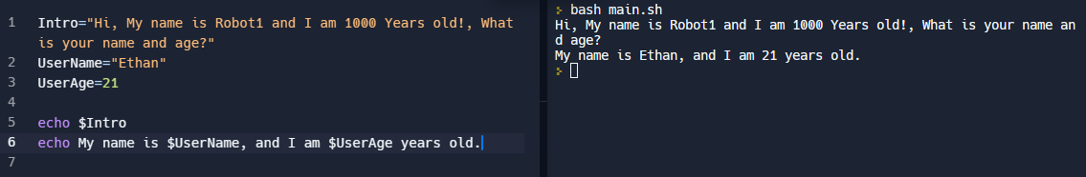
In the script above there are 3 simple variables and amended them to produce a small conversation. The variables above are, Intro, Name and Age. The echo statement allows the variables to be used to string together a short conversation.

- Simple Math (+, - , *, /)
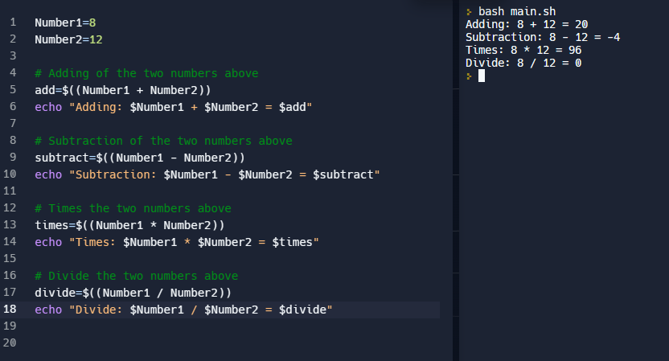
In the script above I have demonstrated the use of all 4 basic math equations. Bash has built in properties that allow the use of the math symbols (+, -, *, /) to be used when creating scripts. Due to Number1 and Number2 being variables, if those values change all of the equations would update to suit.

- If Statement
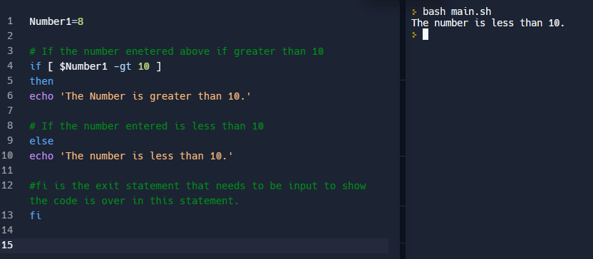
The script above shows the use of a simple If statement. The script reads, if the number 8 is greater than 10 then print out ‘The Number is greater than 10.’ Else if it is smaller print out ‘The Number is less than 10.’

- If-Else Statement
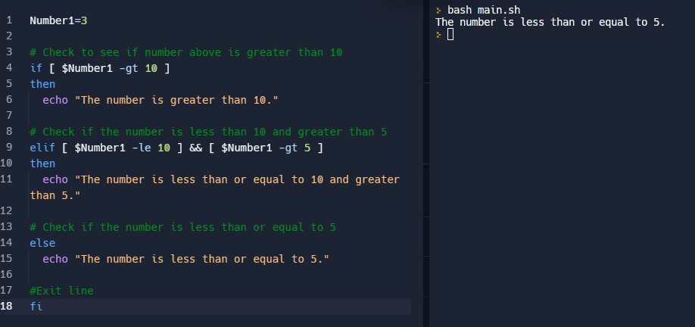
The script above has an elif statement added into it. This allows there to be secondary if statements within the code. If the first if statement is not true, the code will be moved down to the secondary statement which in this case is the elif. If not true it will then move down to the final statement. In this case the number 3 is less than or equal to 5.

- Loops
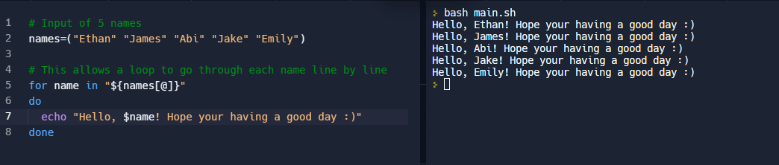
The script above shows a simple loop variable being used to say hello to the 5 names I have entered in the names variable. The @ symbol is used in the for loop to separate the array into separate elements. This allows the code to say hello to each name separately. To end the for loop the command ‘done’ has been used to tell the script that is the end of the loop.

- Loops with a range
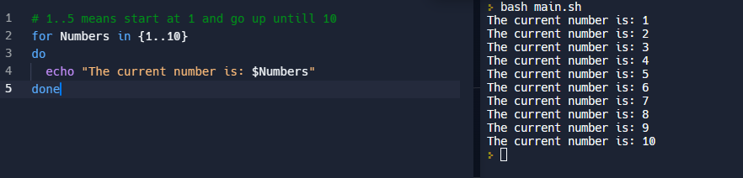
The script above demonstrates how a simple for loop with a range works. The loop counts up from 1 to 10 while printing ‘The current number is:’ at each step. The range can be set to any numbers if needed and the counter can also be changed to count up in different values if needed.

- Arrays
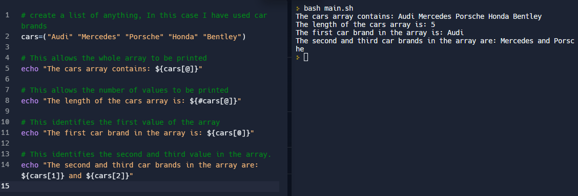
In the script above we can see that 5 values have been inputted into an array function. The echo statements pics on different information from the list. The first being the whole array being printed at once. The second being the length of the array, the third identifying the first value in the array. Finally the last 2 lines are identifying the second and third items in the array.

- Return Functions
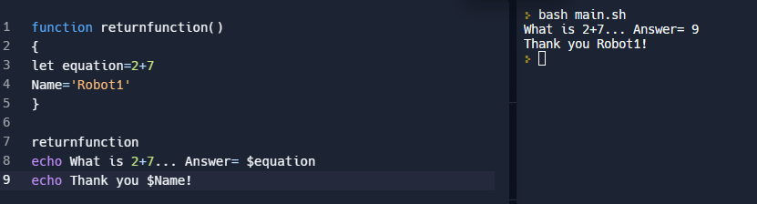
The above script shows how a simple return function can be used. The return function allows users to create a separate function at the top of the script and call on it when needed. Many larger scripts have lots of functions that are called upon at different points.

- Adding text styles to the text
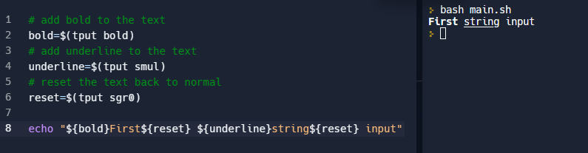
The script above shows how the use of text styles can be added to any string of text. The script includes Bold, Underline and reset. The reset command allows the string to be reset back to its original settings. This may come in usefully if the user wants to highlight certain parts of the output more than others

Evidence of Engagement with Microsoft Learn course
Course: Automate administrative tasks by using PowerShell
Units 1-7:

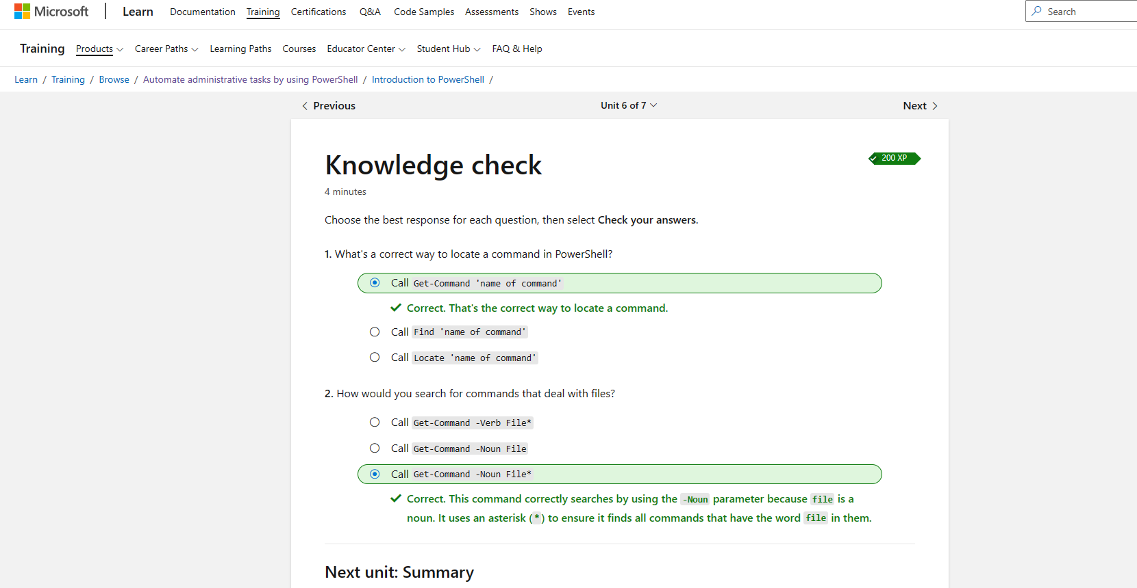
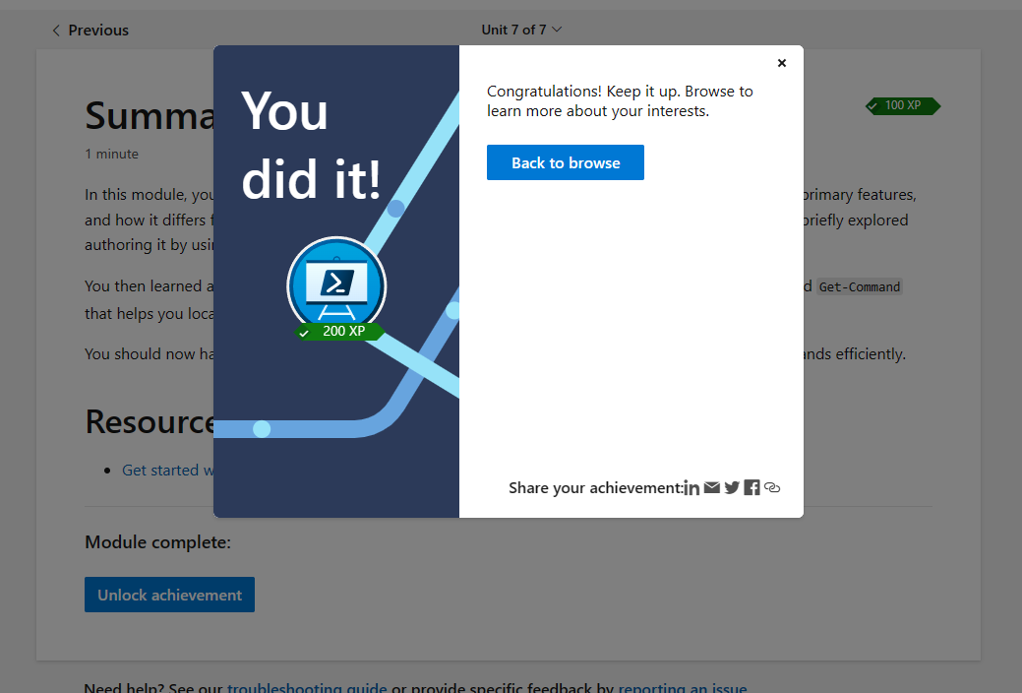

References

[1] | S. Miller, “What is an Operating System?,” 24 02 2023. [Online]. Available: https://www.codecademy.com/resources/blog/operating-system/. [Accessed 01 04 2023].
[2] | P. SIngh, “PowerShell Basics: How to use Powershell Help?,” 2 06 2021. [Online]. Available: https://parveensingh.com/powershell-get-help/#:~:text=PowerShell%20Get-Help%20cmdlet%20provides%20a%20rich%20set%20of,information%20about%20what%20the%20command%20is%20all%20about.. [Accessed 01 04 2023].
[3] | Linux.com, “What is Linux?,” 06 04 2022. [Online]. Available: https://www.linux.com/what-is-linux/. [Accessed 01 04 2023].
[4] | Tech Target Contributor, “Data Center ops, Monitoring and management,” 17 05 2021. [Online]. Available: https://www.techtarget.com/searchdatacenter/definition/shell-script#:~:text=A%20few%20examples%20of%20applications%20shell%20scripts%20can,6%20Executing%20routine%20backups.%207%20Monitoring%20a%20system.. [Accessed 01 04 2023].

