Component 2 - Individual Report

Student Name: ALIN FLORIN CARARE

Student Number: 2246440

Lecturer Name: Dr Yousuf Kamal

LCBB4006_BIRM
Academic Skills

Table of Content
INTRODUCTION 3
MAIN BODY 3
CONCLUSION 7
REFLECTIVE STATEMENT 8
REFERENCES 11
APPENDIX 13

Table of figures
Figure 1: Pomodoro technique 5
Figure 2: Tuckman's team theory 8
Figure 3: Gibbs Reflective Cycle 9

INTRODUCTION
Academic skills are some of the abilities or habits that can help students in succeeding through their academic learning (Stanley et al., 2018). These skills help in making a student the master of their settings in terms of literacy or any other technical subject that they undertake in their learning. Several types of traits are considered to be necessary for the aspect of academic learning. These skills are essential for the learners as this help in improving the ability to learn and understand by taking immersive actions & interacting with tutors. Learners are facing several types of issues in their modern-day learning practices (Granziera et al., 2022). This problem includes team working and time management as one of the main aspects of working and learning in the places. These are some of the significant issues that are faced by students in the period of their academic learning. Majorly these skills play an essential role in the progression and development of an individual as these traits are intertwined with the lots of different skills that are required by a person in various aspects of their daily life, including in both phases, professional as well as personal. Some of the essential skills that are required by an individual to work on development in their university are time management, critical thinking, motivation, cooperation and technical skills.
The essay based on academic skills is conducted to understand the concept that can help a student become a successful graduate. It will cover the points of concern by including in the team working and time management. The essay will be showing about the meaning of the various concepts by incorporating several types of critical theories that can help a student to grow and strengthen their pace over the topics of concern. The importance of the issues will also be covered within the essay. It will also discuss how these topics can help individuals' performance in several ways. Further, a reflective statement will be presented in the essay by using Gibb's reflection model. It will be discussing the learning experience through the academic writing module.

MAIN BODY
The concept of time management is one of the critical factors that is to be covered by every individual in their personal as well as professional lives. This is the ability to make use of time effectively and in productive ways, especially at work, to accomplish daily goals (Stevens et al., 2019). Time management is the coordination of tasks and other activities that can assist an individual in maximizing their effectiveness. It includes the process of organizing and planning the concept, that is, how the work is to be accomplished by dividing the time in proper manners between different activities. It is the process of consciously planning and controlling time spent on specific tasks to increase efficiency. The technique can help in using time in an effective manner by planning proper operation over several types of activities, including academic learning activities and management of personal tasks. This area of practice works with the appropriate kinds of end goal that shows helps in controlling the proper types of accomplishment of the job by managing things with less effort and stress. Practising and developing adequate time management skills through the year of academic settings and university period can help an individual have several benefits that can help them with appropriate development. The benefits of time management are the achievement of goals on a fast basis and fasten up of processes (Costa et al., 2018). It also provides the ability to perform more precisely in a short span of time and by providing more time for other tasks.
It can help avoid one of the most modern problems that can be found in every university student: procrastination. By preventing this problem, it can also help in reducing the pain of stress in the students. There are several theories that can be used to strengthen the time management skills of university students in their academic settings.

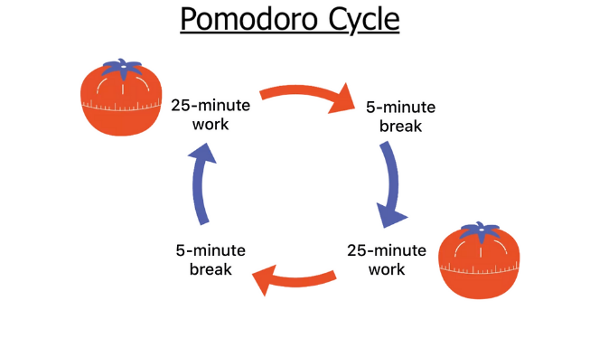
Figure 1: Pomodoro technique
(Source: Theavmtheory, 2023)
One of the best theories for effective time management is the Pomodoro technique theory, which is stated from the above image (May et al., 2022). It works on the basis of different steps that, are like choosing a task, setting a timer for 25 minutes and working on that task until the timer goes off. Further, it includes the steps after the timer turns off; the student must check the time on paper. The individual has to take a short break, and after four, Pomodoro students have to take an extended break to reduce their stress. For example, a student has to go to a music lecture, but at the same time, one has to complete their leftover project. Thus, by using time management skills in an effective manner, one can accomplish both tasks by meeting them on time by dividing them in the required form and, after completing both tasks, taking a long break. This can allow them to be productive and take over several functions by managing appropriate timings in other ways. Time management's importance is much higher than how it is being taken. Time management places several different types of the critical aspect for every other individual in general, as well as specific terms.
In general, time management skills are essential as it helps in reducing stress and help in prioritising the time for every individual task that has to be accomplished on a single day. Using practical time management skills can help an average individual perform their daily task on time and bring out proper results by prioritising efforts over different tasks. This can become one of the most critical skills for individuals in accomplishing their daily goals by providing them with success in their personal and work life. Managing time by prioritising it over different tasks can help increase the ability to be productive and helps in feeling less stressed (Lacerenza et al., 2018). For individuals, time management skills work as lifesaving hacks for maintaining their operational capabilities and providing them with the chance to improve their efficiency and overall performance by maintaining a work-life balance. This skill is essential for individuals to have appropriate types of development through increasing one’s efficiency at the workplace and making them provide better quality through their work.
Moreover, time management is also an essential activity for the students as it helps them in managing it properly and enables them to prioritize tasks. This way, university students are able to understand how much time they have to give to each task as per its requirements. It is also essential for the students as this helps university students to prepare well for their exams in organized ways by focusing more on their development by inclusively managing their daily life on the go (Hawkins, 2021). For example, the student has to cover an essential lesson for tomorrow's lecture but also has to go to the football match organized by the college in the evening. Thus, the student can now make use of the time management skill and primarily manage the time for accomplishing both the tasks.
As inclusive of time management, there is another concept of team working that is of utmost priority for learners. Teamwork is done by bringing several people together to work on accomplishing a common goal (Hadfield et al., 2018). This goal can be from the professional or the personal aspect of working. It is a collaborative effort of the group to achieve a common goal by completing the task most effectively and efficiently. Several characteristics define shared goals, interdependence, stability, boundedness, and the ability to manage internal processes. One of the basic requirements for effective teamwork is to have an appropriate team. The team can be built of at least two or more members that can effectively accomplish the common goal. A group of individuals that are working as a team on a specific task could have the ability to leverage the straightforward use of resources. The elements that strengthen teamwork are communication, time management, problem-solving, listening, collaboration, leadership and critical thinking. For example, a task is given to a university student for working on a business management project in a group. Thus, this can be accomplished, and the proper results can be bought out by working with proper collaboration with every group member and making every single task be divided among the group member as per their strengths and capabilities. Teamwork does not just include working on a task with a similar goal but also includes proper types of collaborative working with the group members by understanding each other in appropriate terms.
Working in a team is essential in several ways, and it provides the individual to have appropriate types of working and provides them with appropriate types of problem-solving capabilities that lead them towards better outcomes. Thus, this can leverage them with several advantages, including improved efficiency for working over the task. It can also give the group members proper time management by working correctly, reducing stress, and allowing the leader and teammates to generate new ideas and solutions for their problems (Daft and Marcic, 2022). This is important for the students and helps them by boosting their morale for operating in the team by providing them with better motivation to accomplish the goal by having proper types of working over the same goal. For example, a group is being formed in the University for presenting a group presentation on human resource management. The student showed keen interest in this to work on a new topic. This made the students form a group and being motivated by new working opportunities allowed them to work collaboratively with team members and produce proper work in their presentations. By working in a team, one can share proper types of ideas and deliver proper types of development of their self as well as their team. This can assist them with the proper types of the opportunities in their professional future to fit in with diverse team management.
Moreover, for formulating proper types of teams in the workplace or the university, several frameworks are imposed that can help bring in proper team management and operations. Tuckman’s model can be utilized by university students for working on team development and facilitating proper operations (Griffin, 2021). This framework is on the basis of different stages.
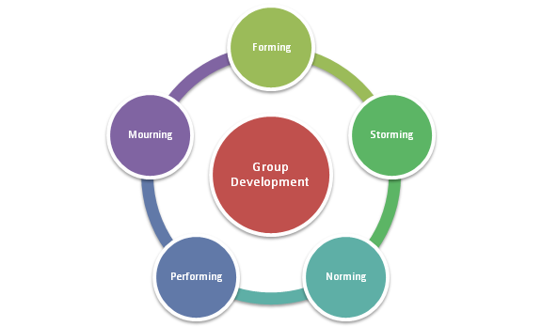
Figure 2: Tuckman's team theory
(Source: Mspguide, 2023)
The stages of this framework include forming, storming, norming, performing and adjourning that are stated from the above image. This can help the learners to determine how best work can be done by understanding several stages of team development. For example, the project is assigned to the learners, and they have to work in a group of 5 members. Thus, they can use this framework and utilize different stages to accomplish this project properly. This can help the learners in the University for Getting started in the form of a team by knowing each other in proper terms. It can help them resolve any conflict properly and facilitate smooth operations. Making use of this can help the students in sharing information in the required manner with the group members and accomplish proper working conditions.

CONCLUSION
The above essay, based on academic skills, has concluded with the concept that can help the individuals get successful graduates in their academic settings. The essay has included the concept of the team working and time management, which is one of the integral parts of the academic settings of learners. It has shown the proper meaning of teamwork and time management. Further theories and frameworks have also been included in the essay by including the importance of the covered concept in the above essay. It has shown Tuckman's framework and Pomodoro's time management technique theory. Several examples are presented in the essay by discussing how working on these issues can improve the performance of the student in their timings of university learning. It has shown how working on the aspect of time management and team working can benefit the student in their learning during the period of an academic setting.

REFLECTIVE STATEMENT
As per the above essay, I would like to share my experience in completing the above essay. I would be using the Gibbs reflective model for completing my experience sharing on the issues of time management and teamwork. This is the framework that works on a cyclical basis by including several steps that include description, feelings, evaluation, analysis, conclusion and action plan. The further elaboration of my experience sharing is as under:
Description: I would like to describe that in the growing modern world, where technology is being used at its full potential, things are getting done quickly. I would say that understanding the proper meaning of time management and team working was one of the best things I have done in this essay by choosing these topics to complete this assessment. It can be described that time management is one of the appropriate abilities to accomplish things on scheduled periods. Altogether as per the proper working based on the time there is the other aspect which is team working. This is the ability to work with other people in the group and accomplish the work on time (Qizi, 2020).

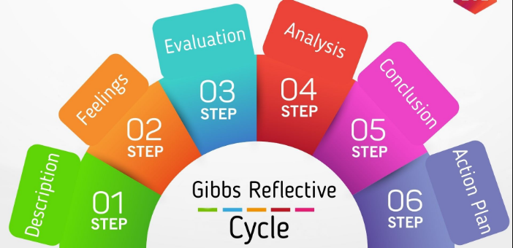
Figure 3: Gibbs Reflective Cycle
(Source: Marketing91, 2023)

Feelings: Throughout my work on this assessment, the factors of time management and teamwork operate together. This has also made me feel that for a university student like me, developing these skill areas is paramount for scaling the greater chances of employability. Completing my essay made me work on finding out the importance of this aspect in general and for the student. This has included the factors that for an average individual, time management is the skill that includes the proper development opportunities for better succession in the personal life. Furthermore, as for the student, this aspect can provide the proper development opportunity to grow and develop as a well-versed graduate that would be welcomed by everyone for working in their firm in terms of employability.
Evaluation: This assessment made me evaluate that working on developing academic skills can make a student far ahead compared to their official institutional colleagues. This can make them have appropriate types of development to succeed in their graduation life. Furthermore, the things at the time of completing the project worked in my direction, and I quickly understood all the relevant information that I required to complete this project, and I did my work in proper terms. I evaluated that the efforts that I put into completing this project were very efficient for me, and all the things worked adequately for completing the things on time.
Analysis: By the time I was progressing through my operations in the assessment, several things were analysed by me. Things started to work in my way as I have given all my efforts to complete this project. Throughout this situation, things have made sense as per the completion of the project by inculcating the fundamental values of the things in the operations that are required. This also helped in founding the actual importance that is levied behind the concepts that can help me in bringing proper results in my future terms. This has helped me gain appropriate knowledge in researching and analysing the information to complete the project correctly. It has given me an understanding of the things necessary for covering the various aspects of learning.
Conclusion: Further, I would like to conclude that working on this project was successful regarding my university assessment. I also cultivated the values that are essential for the development of these skills. Working on this project has helped me understand the actual formulation of the information appropriately and enhanced my writing capabilities for improving my grammatical working skills. If I had more time for this project, I could highlight proper values that can determine my skills and ability in the project. Moreover, formulating an action plan can help develop these skills properly by allowing me to present myself adequately in my future projects.

Action plan:
Skills | Resources | Actions | Time taken
Time management | To-do list, right tools and a proper plan (Luthans and Doh, 2018). | By conducting time audits and formulating a proper to-do list, I would be able to develop more of these skills with ease, and this can provide me to have properly completion of the project on time. | 3 weeks
Team working | Collaboration tools, innovation and proper understanding of surroundings (Jiang and Chen, 2018). | By inculcating the values of team working, I would be able to understand my teammates in better ways, and this can help me in working freely by assigning proper tasks to my mates as per their capabilities. | 4 weeks

REFERENCES
Costa, A.C., Fulmer, C.A. and Anderson, N.R., 2018. Trust in work teams: An integrative review, multilevel model, and future directions. Journal of Organizational Behavior, 39(2), pp.169-184.
Daft, R.L. and Marcic, D., 2022. Understanding management. Cengage Learning.
Granziera, H., Liem, G.A.D., Chong, W.H., Martin, A.J., Collie, R.J., Bishop, M. and Tynan, L., 2022. The role of teachers' instrumental and emotional support in students' academic buoyancy, engagement, and academic skills: A study of high school and elementary school students in different national contexts. Learning and instruction, 80, p.101619.
Griffin, R.W., 2021. Management. Cengage Learning.
Hadfield, J., Megill, C., Bell, S.M., Huddleston, J., Potter, B., Callender, C., Sagulenko, P., Bedford, T. and Neher, R.A., 2018. Nextstrain: real-time tracking of pathogen evolution. 34(23), pp.4121-4123.
Hawkins, P., 2021. Leadership team coaching: Developing collective transformational leadership. Kogan Page Publishers.
Jiang, Y. and Chen, C.C., 2018. Integrating knowledge activities for team innovation: Effects of transformational leadership. Journal of Management, 44(5), pp.1819-1847.
Lacerenza, C.N., Marlow, S.L., Tannenbaum, S.I. and Salas, E., 2018. Team development interventions: Evidence-based approaches for improving teamwork. 73(4), p.517.
Luthans, F. and Doh, J.P., 2018. International management: Culture, strategy, and behavior. McGraw-Hill.
Marketing91, 2023. Gibbs Reflective Cycle [Online] Available Through <https://shorturl.at/evAHN> [Accessed on 14 July 2023]
May, R.J., Tyndall, I., McTiernan, A., Roderique‐Davies, G. and McLoughlin, S., 2022. The impact of the SMART program on cognitive and academic skills: A systematic review and meta‐analysis. British Journal of Educational Technology, 53(5), pp.1244-1261.
Mspguide, 2023. Tuckman's team theory [Online] Available Through <https://shorturl.at/fioCK> [Accessed on 14 July 2023]
Qizi, K.N.U., 2020. Soft skills development in higher education. Universal Journal of Educational Research, 8(5), pp.1916-1925.
Stanley, C.R., Belisle, J. and Dixon, M.R., 2018. Equivalence‐based instruction of academic skills: Application to adolescents with autism. Journal of Applied Behavior Analysis, 51(2), pp.352-359.
Stevens, A.E., Hartung, C.M., Shelton, C.R., LaCount, P.A. and Heaney, A., 2019. The effects of a brief organization, time management, and planning intervention for at-risk college freshmen. Evidence-Based Practice in Child and Adolescent Mental Health, 4(2), pp.202-218.
Theavmtheory, 2023. Pomodoro technique [Online] Available Through <https://shorturl.at/lrtJL> [Accessed on 14 July 2023]

APPENDIX

