STUDENT NAME: Cezar Apetrei
STUDENT ID: 2015925
TITLE- PROBLEM SOLVING AND DECISION MAKING

Executive Summary
The assignment is based on problem solving and decision making process. The report has been made on the given case study of UK. According to report, the employees do not have proper health conditions due to work related stress problems. The report carries information related to problem, proper solution for it and measures to have proper decision making. Also, the report mentions about the impact of problem on organisation and employees.

Table of Contents
INTRODUCTION 4
Company of choice 4
Solving problems 4
The effect of the problems on workers 5
The effects of the issue on institutions 5
Evaluation of reason and impact 5
Evaluation of the current reason and impact 6
Evaluation of reason and impact is essential 6
Pestle analysis 6
Making decisions 7
SUGGESTIVE SOLUTIONS As Well as its APPROPRIATENESS 7
Plan for implementing the solution 7
CONCLUSION 8
REFERENCES 9

TASK 2 Final Report

INTRODUCTION
The tension in the Great Britain is the subject of the article. Workers in the current world are under a lot of worry over their wellbeing. Inside firms, there's really fierce rivalry, which strains workers, and whenever events got out of hand, it has lengthy term consequences for a person. As a result, among most dangerous sort of medical condition, according to the research study, is tied to job. The particular research will concentrate on the mass of the English populace's money troubles. In addition, the young face greater work-related pressure than that of the boomer generation. The projected issue was work-related pressure, with service quality being the most difficult industry for individuals. As a consequence of this whole, the number of individuals admitted to treatment centres has increased, with chest discomfort seems to be the most prevalent form of stressful symptoms. As a result, job pressure arises as a result of an individual's inability to meet the firm's and economy's standards. Stress may affect everyone at any stage of an organisation, and that it's the leading cause of disease and bad circumstances, according to the given scenario. The report has been stated that workplace stress is related to peers and seniors pressure and in absence of colleagues support. In UK, the overwhelming numerous of people will identify that there is no control to have on work and it became a biggest cause of individual and employees stress. If workplace stress will not be channelized and controlled, it will create unreliable issues. The problem of employees who are running through the stress of professional and daily life which affects their health conditions hazardously. Stress is considered different to all people, as it is significant to address the stress differently

Company of choice
The research analysis focuses on Great Britain companies. ThirdWay Organization was recruited to assess the issue of job strain and its impact on people as well as the firm. The ThirdWay Organization is a rapidly expanding architectural firm in the United Kingdom. The organization works with clients to develop buildings and corporate offices depending on unique ideas. The ThirdWay Organization is a company that aims to improve the assessment of resolving conflicts. As a result, it takes a customer-centric process to create innovative work areas and structures for customers. The organization employed unique and youthful architects who are aiming to make a name for themselves in the structural and development business.

Solving problems
The process of declaring a trouble, establishing the cause of the dilemma, discovering solutions, and applying solutions is referred to as conflict resolution. As a result, issue resolving enables for the identification and use of opportunities in the corporate ecosystem, as well as the management of the long term.

The effect of the problems on workers
According to the research study, complicated challenges have a broad influence on personnel. Any difficulty that arises in the organization disrupts the general functioning of the workforce. The research also discusses the impact of job pressure on workers. Excessive attention to workplace dangers may have an impact on workers' actual quality and also workplace happiness. There's several types of job pressure, including logistical, economic, client relations, interpersonal, and health-related pressure. Workers are required to meet organizational goals as well as stressful situations. Workers at UK firms have been known to suffer from harmful illnesses as a result of job pressure. Occupational stress lowers job satisfaction and drags people back from their pathway to victory. In addition, numerous workers are compelled to abandon their occupations owing to poor health and emotional distress. As a result, viable measures are required to prevent job pressure in the UK.

The effects of the issue on institutions
Heavy workloads, intense job pressure, job instability, and disagreements among employers and workers are just a few of the numerous reasons of job pressure. Since a result, it is critical for companies to monitor worker health, as job research supports illnesses and has an impact on staff health. As a result of job pressure, the company faces several issues. Staff having to work inefficiently have a higher incidence of absence at workplace. Workers are unable to execute at a high level, which results in low time management and significant staffing levels. As a result, it raises the number of sick days, incidents, and event documents filed by the firm.

Evaluation of reason and impact
Reason and effects research is a technique and method for identifying and resolving all possible reasons of a problem, implying that the individual can analyze and solve the causative factors from the outset rather than having the problem repeating itself.

Evaluation of the current reason and impact
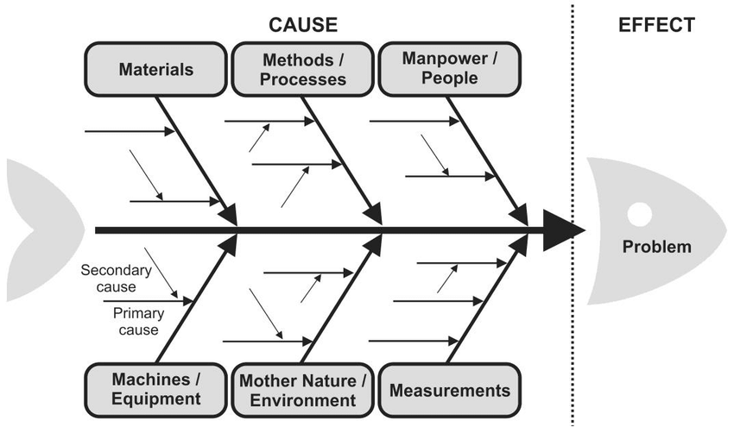
According to the information in the given scenario, the causes and effects evaluation shows that the majority of workers, both men and women, have already been experiencing job-related tension as a result of the current dynamics and excessive production job stress. Furthermore, this has been estimated that 35% of males and females are dealing with challenges that contribute to unproductive functioning and have an impact on staff health. Individuals living with the disease, psychological toll, or chest discomfort as a result of job pressures are being admitted in large numbers to British medical centers.

Evaluation of reason and impact is essential
The reason and impact assessment will assist the organization in comprehending that an impact might be caused by a variety of factors. There is a visual representation of the action and reaction connection. Organizations may assist in identifying areas for growth and achievement.

Pestle analysis
PESTEL model is a methodology that is used by firm strategists to examine and analyze aspects that have an effect on the business, such as macro and micro environmental elements. As a result, the PESTEL analytical method, which is also utilized in SWOT evaluation, may be utilized to identify the firm's strength and vulnerabilities. Politically, ecological, societal, technical, financial, and legal issues all influence the company processes, according to the PESTEL research tool. Furthermore, all of these aspects are analyzed in order to discover the variables that affects company so that appropriate steps may be done.

Making decisions
Identifying an option, gathering data, and considering the possible approaches to the resolution are all steps in the judgment procedure. Organizations make advantage of the judgment procedure by adopting steps that might lead to careful, meaningful conclusions by arranging correct data and discussing possibilities. Furthermore, judgement call improves the whole company and assists administration in choosing the right path that benefit personnel. The modern life has been filled with the change, complicated relationships, uncertainty, long workdays and urgent deadlines. The development of skills related to problem-solving of work stress will assist to make life more manageable from all challenges which are obtained in future. It is considered a procedure of identifying the stressors and strategies to be created for management of work for them.

SUGGESTIVE SOLUTIONS As Well as its APPROPRIATENESS
Workers behavior and productivity may be improved even more by encouraging and rewarding them. Workers must also feel appreciated and strive to attain the organization's aims and aspirations, therefore the working atmosphere must be attractive and non-biased. Managing the workflow, creating different job activities, or conducting standard supervision to keep an eye on the workers is one of the best ways to reduce job pressure. It will assist to plan for preventing from future problem related to work stress that have been affected the health dangerously. Be sure about the decision to be taken in aspect of problem solving to be quite important for individuals and employees to live life stress-free

Plan for implementing the solution
The following is the ideal process strategy for the particular issue:
1. STEP 1: Recognize the Decisions - Recognizing the Decisions Pertaining to the Issue is the initial stage in the execution strategy. As a result, according to the given scenario, the job issue may be solved by restructuring the workflow or establishing differing work activities. The suggested method would be successful in solving the problem.
2. STEP 2: Obtain data- the 2nd stage would be to obtain appropriate details. Furthermore, according to the given scenario, strategies to assist workers release pressure would be obtained. As a result, the elements that cause job difficulties would be collected in order to identify a solution.
3. STEP 3: Determine the options—optional approaches to the choice that may be implemented if the choice doesn't really prove to be beneficial to the organization.
4. STEP 4: Evaluating the Proofs- The 4th step is evaluating the proofs regarding the issue in order to make an informed choice. Furthermore, gathering proofs of remedies such that the finest from them may be picked.
5. STEP 5: Selecting From Options - The 5th stage is to select the finest and most efficient approach from those studied, so that it may be applied to give answers to workers. As a result, according to the British case analysis, the ideal option would be to arrange the workflow, establish numerous working initiatives, and perform consistent supervision to keep an eye on the personnel.
6. STEP 6: putting the plan into practice – in this stage, the plan is implemented such that the outcomes could be reviewed. After creating numerous working initiatives and executing consistent supervision to keep an eye on the workers, administration may assess the success of their decisions.
7. STEP 7: Analyze the established choice and its repercussions- In this stage, the established choice is examined in order to collect input and solve issues for possible impacts.

CONCLUSION
The given report has made on the information related to solving problems and the decision making processes in the business organizations. The given report has made on the case study of organizations in UK. The problem which has observed in the organizations of UK are mostly of stress of work which eventually results in the inefficient work and reduced effectiveness of the companies. In addition to this, the work stress is also resulting in the sickness of most of the people such as chest pain. The number of patients is also increasing in UK due to increased stress. The given report was designed to find the solutions of the problems in UK in order to take the proper decision.

REFERENCES
Caprì, T., Martino, G., Giannatiempo, S., Semino, M. and Fabio, R.A., 2019. Attention, problem solving and decision making in adult subjects with ADHD. Journal of Clinical & Developmental Psychology, 1(1).
Yusal, Y., Suhandi, A., Setiawan, W. and Kaniawati, I., 2021. The Effectiveness of Collaborative Problem-solving Using Decision-making Problems to Improve the Pre-service Physics Teachers’ Critical Thinking Skills. Jurnal Pendidikan Fisika, 9(2), pp.107-116.
Christodoulou, A. and Cullinane, K., 2019. Identifying the main opportunities and challenges from the implementation of a port energy management system: A SWOT/PESTLE analysis. Sustainability, 11(21), p.6046.
Huijts, T. and Kolster, R., 2021. Excellence programmes in higher education: selection of students, effects on students, and the broader impact on higher education institutions. European Journal of Higher Education, 11(1), pp.4-12.
Hong, M.J. and Oah, S., 2020. Effects of Shiftwork on Workers' Safety and Health: The Mediation Effect of WLB. Journal of the Korean Society of Safety, 35(5), pp.66-73.

