Name: Malachi Smith
Program of Study: Photography in the arts (BA)
Lecturer: Paul Duerinckx
Approx: 2000 words

Illustration list
Fig. 1. Eugène Atget / Berenice Abbott, The El, 2nd and 3rd Avenue Lines, Bowery and Division Street, Manhattan (Metropolitan Museum of Art, n.d.).
Fig. 2. Antoine d’Agata, Insomnia, Cairo, Egypt, 1999 (Magnum Photos, 1999).
Fig. 3. Antoine d’Agata, Photographer Profile (Magnum Photos, n.d.).
Fig. 4. Dolorès Marat, La Panne, New York, 1996 (Howard Greenberg Gallery, 1996).
Fig. 5. Robert Doisneau, Be-bop men cave, Vieux Colombier, 1951 (Robert Doisneau, 1951).

Question 2
“It is useless and tedious to represent what exists because nothing that exists satisfies me…. I prefer the monsters of my fantasy to what is positively trivial.” Baudelaire, Salon Review (1859). Is Baudelaire’s position defensible given the case lens-based art forms make to ‘represent what exists’? Or, from a contemporary perspective, do the ‘monsters of fantasy’ still allow artists to engage with ‘what exists’ creatively?

“Photography is a way of finding meaning in the world.” (Sontag, 1977) Art helps us navigate and process the world around us, as well as sharing how our minds and thoughts look and feel. Photography is no exception to this.

Photography is using what exists to show the mind of the artist and how they view the world. To be able to show the environment around in a way that shows creativity in itself is a way of showing how one can be creative while using the real world, which in a sense is what photography is.

What exists is in a whole; boring, which is why artwork exists in the first place, expressing oneself in itself is an artform that cannot be already displayed in the world, or can it? Nature is quite a vast thing, saying, ‘nothing that exists satisfies me’ is discrediting everything ever, Baudelaire is displaying a lack of creativity, not even that, just blatant disregard of life in itself. Passion to show and create is an extension of what already is.
The passion of life and to exist is what makes us create, to explore how we feel, to be able to try to comprehend what possesses us to do anything at all in itself is an endless spiral of an existential flame that burns the soul.

It is completely inexcusable to say that absolutely everything is unsatisfying, you would have to actively avoid finding joy in life to find nothing satisfying. The most basic photography and stereotyped photograph, taking out a camera and pointing it at the sunset, creates an ironically dull and lifeless image, purely because so many people feel the need to capture the beauty of the changing scenery being witnessed and the image created does not nearly capture the complexity of the solar event and how it feels to be reminded of the absurdity of everyday life.
The dullness in the photo comes from how surface the thought of pulling out a phone and taking a picture, a picture of the sky is, there in itself is an astronomical beauty in it, just no effort or life has been put into the work. The work in itself is an afterthought, most people taking a picture of a sunset do not care for the image but think the idea that they could have had been even a small bit inspired enough to stop looking at the event to take out their phone is enough. That could be the problem that Baudelaire is having.
Of course capturing a sunset, because of the over abundance of people trying to truly capture it, an actual artist's photograph of the sun set would need to be unbelievably incredible to be able to escape the cliché because of how much of a first though it is, which is known to the artist, it’s trying to re-invent the wheel, cavemen captured it, it’s nothing new.

“The camera makes strange what is banal.” (Burgin, 1982). With awareness and understanding, what is known as normal and boring can become something creative with enough care. Composition and timing, waiting for the right moment for something to balance out the scene before you, or moving around an environment in a way not intended can help make a new look on something seemingly worthless to someone who doesn't try to look.
Architectural photography; documenting surrounding buildings, as a genre by now should have beaten into the ground by how many photographs have been taken, by many famous photographers, but somehow, just the act of being able to look up and see a composition in the lines of a building and how they balance with the scenery of a street is an easy task, upon trying to capture an image like that is a different matter however. To be able to capture such a simple idea, requires a lot of thought and skill to have an image that does satisfy.
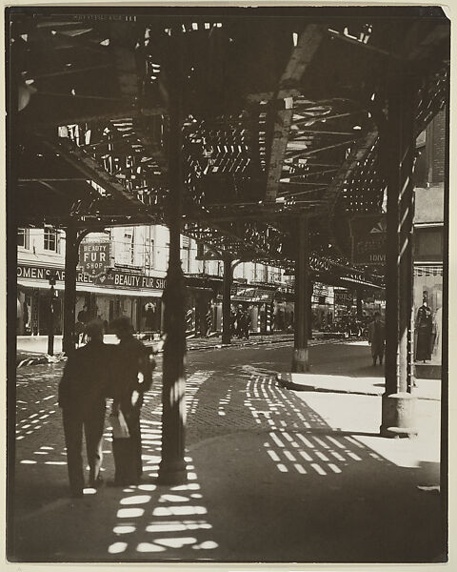

Fig. 1.
‘Berenice Abbott’s New York street photography, showing framing of a railroad above a walkway with a few people in the street, noticeable shadow figures blending in with the metal and poles as well as the shadows they are creating. Shops are in the distance as the metal bars of the train lines bend and weave around the roads above. The composition utilises the support beams of the tracks to balance the image perfectly with five bars spaced out. The bar on the middle left is shown slightly more middle of the frame giving space to the people standing there. “It was downright dangerous to document New York… but it was very important to get exactly the right position to make the photograph work.” (Abbott, cited in The Metropolitan Museum of Art, n.d.)
This work demonstrates how intent in showing an environment can transform what exists though vision, capturing the balanced symmetry of objects in a space that were not originally designed to be viewed in that way. Order can always be found in chaos, and vice versa, which is what this work represents, by revealing details not documented by others, going out of her way to find different compositions not yet realised or cared for by a passer by.
“Every image embodies a way of seeing.” (Berger, 1972). It is just as much as a look into a photographer as any other artist, it shows what they see or even how they want to see the world around them. Engaging with what exists creativity is what makes a photographer an artist.

Creative fantasy can be shown within what exists. Digital and analogue manipulation and edits of photographic work demonstrate how play with the visual and creative world can collide into one, using aspects of the real world and bringing new ideas into what it could look like if it were true. Using studios and set up lights can be used to create an idea, a scene that has never been seen before in real life, the augmentation of real life can help artists make visualisations of their world to show to others. This helps artist to be able to express themselves fully in a real space, making it come to life.
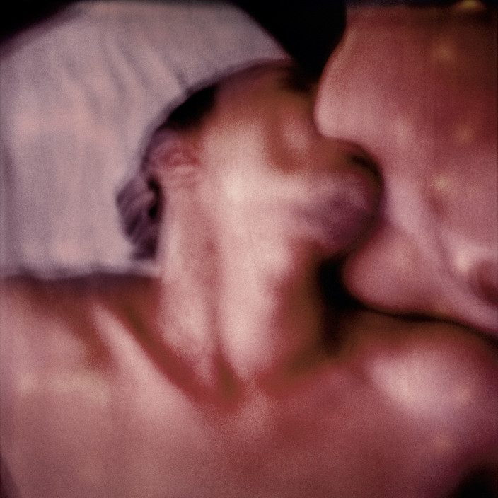
Fig. 2.

A blurred close up of a man and woman. The image shows emotions of lust and the deep desire to feel. The burred effect adds to this as it makes it seem more desperate to feel as if it’s a struggle that is being fought for. “It’s not how a photographer looks at the world that is important. It’s their intimate relationship with it.” (D’Agata, Magnum Photos, n.d.) D’Agata’s work directly challenges Baudelaire’s claim that reality is positively trivial. His work comes from one’s most extreme experiences, sharing depictions of waste and decay as well as addiction, sex, and violence. By pushing real experiences into more abstract versions of themselves, the work shows, not monsters of fantasies, but the very real and ‘intimate relationship with it.’ His relationship with his work is the same as his relation to the emotions and experiences themselves, they just represent and display them for others to see, to understand.

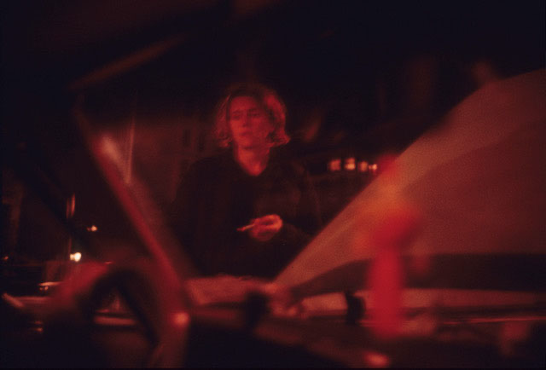
Fig. 3.

Story telling in photography, showing imagined scenes through images, lighting sets.
The ‘monsters of fantasy’ are also shown through scenes created for images, telling stories though single frames.

The image shows a model standing outside a car, cigarette in hand, with her head up, but looking down in an almost defeated manner. The photo is taken from inside the car looking out the front window and past the open bonnet of the car. With that context I can only assume that the car has broken down, and the moment captured shows the defeat of the fact. The composition of image shows the car surrounding the model, filling up the frame this way helps us understand how trapped into the moment she is. The red lighting in the image turns the photograph from a documentary image of a moment in time, to a dream like scene with story.

“Truth is inseparable from the act of interpretation.” (Tagg, 1988). These artists show how fantasy and truth are not opposites; they just look deeper into truth itself, understanding oneself though a real idea made visually real. This blurs the line between documentation of themselves and imaginations of their work, as whatever we do or create it will always represent a part of ourselves, no matter how detached or fully submerged we are from it. What we experience is always changed and warped by our own emotions and realities that we create for ourselves.
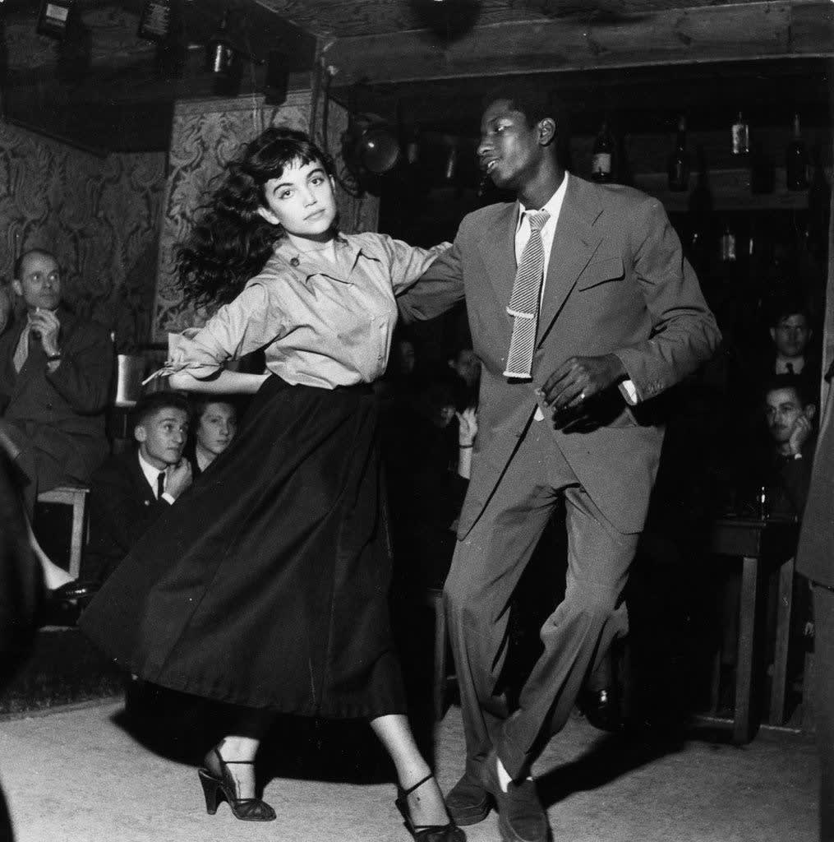
Fig. 4.
This monochrome photograph by Robert Doisneau, shows a snapshot of a couple dancing, with the woman on the left looking at the camera as if they noticed the photo Doisneau was taking as it was happening. She still is completely consumed by the moment even when noticing the camera. The man dancing with her posing with his tie swaying the same direction as their movement. The swinging movement shows the life in the photograph and setts the rest of the scene, with the light abound theme acting as a spotlight.
Dancing in itself is an expression of oneself, we are just seeing a portion of it, a shared art between those in the image, captured by a photographer inspired and seeing opportunity in the moment and composing the moment perfectly to get the right moment to show the life and beauty in the moment.

Capturing real moments, art cannot create accurately to show real emotions of others, it would be the artists interpretation of what happened, instead with photography it is fully up to the viewers to decide from what they understand about their world.
Moments in real life are so short lived that freezing light itself is truly the only way of capturing its truest form.

Baudelaire believed that the real world was too mundane to inspire true art, and that the only internal mind and fantasy that it can create was the only thing that could hold true value. Photography contradicts this conclusion entirely, as it shapes and transforms the viewers perception of the every day. Lens based artwork demonstrates and documents a vast range of human struggle and emotion as well as the environments that surround us. Reality is not just a fact of life in art, it is something to build into whatever the artist wants. Ordinary places can hold hundreds of stories, encounters, potential for meaning and stories to be told, wether that is through people standing closely on a walkway or the way human design and buildings interact with each other.
Fantasy is not abandoned by the use of lens based work, it adds to it, showing truths of moments and the mind that are not visible unless the moment is captured to truly be observed and appreciated. Artist like D’Agata, Marat, Abbott and Doisneau prove that there are different layers of the humanity that can be explored though photography.
Baudelaire’s original though is however understandable from its moment in history. Photography was a new technology, copying what it sees, threatening the traditional notions of art and how it was created for most of history. But like any tool, it can be used in a vast variety of ways. Today this perspective is no longer defensible as we have found a way to represent ourselves within what is ‘positively trivial.’ Representing what exists is in no way tedious in the modern day, it all depends on the artist in how trivial the final work is and what they pour into it. Like any other form of art.

References

Abbott, B. (cited in The Metropolitan Museum of Art) (n.d.) Berenice Abbott’s New York. Available at: https://www.metmuseum.org/exhibitions/berenice-abbott
Baudelaire, C. (1859) ‘The Salon of 1859’, in Baudelaire, C. (1964) The Mirror of Art. London: Phaidon.
Berger, J. (1972) Ways of Seeing. London: Penguin.
Burgin, V. (1982) Thinking Photography. London: Macmillan.
Howard Greenberg Gallery (1996) DOLORÈS MARAT, LA PANNE, NEW YORK. Available at: https://www.howardgreenberg.com/artists/dolores-marat
Magnum Photos (1999) Insomnia, Cairo, Egypt. Available at: https://www.magnumphotos.com/arts-culture/antoine-dagata-insomnia/
Magnum Photos (n.d.) Antoine d’Agata Photographer Profile. Available at: https://www.magnumphotos.com/photographer/antoine-dagata/
Robert Doisneau (1951) Be-bop men cave, Vieux Colombier. Available at: https://www.robert-doisneau.com/en/robert-doisneau/portfolios/1885,paris-st-germain-des-pres.htm
Sontag, S. (1977) On Photography. New York: Farrar, Straus and Giroux.
Tagg, J. (1988) The Burden of Representation: Essays on Photographies and Histories. London: Macmillan.

