
Freshwater Conservation YR 3 25/11/2020
1.- What happens when a stream, lake or a reservoir receives an amount of pollution?
a) input – output relationship
b) mass balance
scenario 1…..Known as conservative as there is no change.

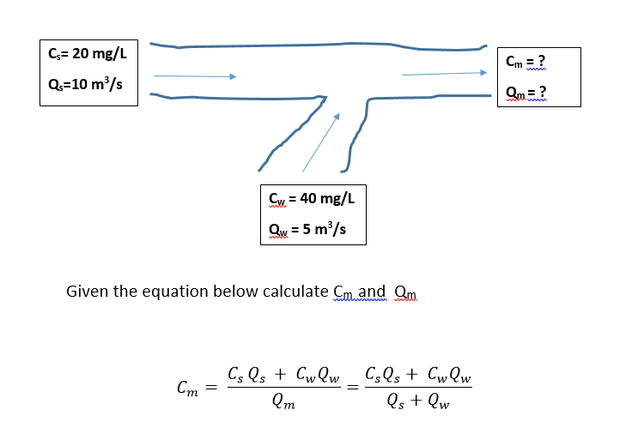

Scenario 2….known as non-conservative



