

Course: Business management
Module name: Data Handling & Business Intelligence
Module code: LCBB5000
Lecturer: Xavier Matieni
Title of report: The importance of Business Intelligence Trends and its impact on the business
Student: Stanimira Nikolova Nikolova
ID Number: 2118452

TABLE OF CONTENT
Introduction………………………………………………………………………...page 3
Business Intelligence and its importance……………………………………… page 3
Artificial Intelligence………………………………………………………………page 3
POWER Business Intelligence …………………………………………………..page 4
SaaS and Cloud Adoption …………………………………………………………page 4
Mobility Business Intelligence………………………………………………......page 5
Data literacy………………………………………………………………………page 6
Conclusion………………………………………………………………………...page 6
Reference list………………………………………………………………………page 8

Introduction
Business Intelligence Trends are extremely important nowadays as data never stop, and neither does business. Business Intelligence is more essential now than ever before for enterprises as to make data-informed decisions. Business trends are typically new ways that businesses hope to improve their performance or achieve their goals among their competitors as to stay competitive and sustainable. This report will analyse the importance of Business Intelligence trends in the industry which also helps the employees up-to-date with the latest market trends and established business goals for the company’s benefit that affect the business environment.
Business Intelligence and its importance
Maheshwari and Anil (2015) point out that Business intelligence can help business to stay ahead of competitors and makes them more flexible and adaptive to business shift. Mobile devices can display and work with data, and Business Intelligence is a full set of information technology (IT) explanations that includes tools for analysing, gathering, and reporting information to the users about the performance of the organization and its environment. These IT solutions are in the middle of the most highly prioritized solutions for investment. Business Intelligence tools generate data about purchases, sales, and expenses from multiple locations and time limits. Analysing this data can help sales professionals to keep track of what their existing customers are buying and can help design better product bundles, promotion plans, and store layouts, which lead to a better-performing business (Maheshwari and Anil 2015 p.3)
Artificial Intelligence
According to Elsevier (2020, p2201-2206) highlights Artificial Intelligence technology's potential for business opportunities and economic transformations, enabling big data patterns, analytics, and improved product design. It impacts industries like cybersecurity, business intelligence, and healthcare, offering insights into investments and data availability. Experlu (2023) points out that Artificial Intelligence enhances financial institutions by improving customer service, fraud detection, cost reduction, saving, loan management, and decision-making through machine and deep learning.

Artificial Intelligence impacts banks, traditional services, and job loss, potentially causing missed opportunities and affecting trustworthiness. (Experlu,2023). Therefore, Artificial Intelligence can enhance customer service in financial institutions, such as fraud detection, leading to satisfied customers, loyalty, and repeat purchases. This satisfaction boosts trust, employee performance, organizational commitment, and profitability, as ethical practices contribute to long-term success for your organisation. AI cannot replace human beings as AI is also invented by humans and knowledge can be applied by humans. Please refer to Appendix 1, as an example of how AI increase in productivity in selected economies.
POWER Business Intelligence
Smetana (2020) states that Power Business Intelligence is a user-friendly analytics tool that uses cloud-based apps to run reports and analyse data. It connects to trading data and uses machine learning for better decision-making. Power BI offers six key benefits for the finance sector such as simple data access, quick trends detection, Artificial Intelligence-driven machine learning, and easy data visualizations. It also offers intuitive UX, Microsoft Office suite features, and security features for client confidentiality and compliance. Analytics and business intelligence are also essential for surviving in the data-driven economy. With the help of Power BI, financial firms as an example, may change their company's historical data for improved performance thanks to its simple, intuitive features and automated machine learning. CFI Team (2020) states that no matter how big the firm is or how complex its data is, this programme offers great financial data management services with no limitations on the reporting of financial data.
Therefore, Power Business Intelligence is crucial for finance, optimizing financial performance, maximizing objectives, increasing efficiency, competitiveness, and risk management in the data-driven economy. In all business settings finance is important as it allows the business to plan for the future by enabling informed decisions on how to allocate resources, and where to save and spend to reach the short, medium and long-term goals of the business.
SaaS and Cloud Adoption
Balfour (2020) Software as a Service (SaaS) has been in use for 20 years, providing cloud-based subscription-based access to software applications. Companies pay a subscription fee for a defined period, allowing employees to access programs from a central cloud using an internet browser. SaaS offers speed, accessibility, cost, end-of-use, and ease of updating on various operating systems. It is cheaper, expandable, and enables small businesses to access software previously only accessible to large companies. Covid 19 accelerates digital change, driving industry adoption by companies like pharma, emphasizing data security through trusted service providers. SaaS platforms streamline processes across suppliers and stakeholders, addressing environmental, social, and governance concerns (Balfour,2020). Therefore, SaaS is a valuable Business Intelligence solution for pharmaceutical companies, enhancing medication delivery to society, it is responsible and reliable which leads to achieving objectives with increased output which is the main key to every successful business.
Mobility Business Intelligence
McGuigan (2023) points out that Mobility Business Intelligence refers to the ability to perform and access Business Intelligence-related data analysis on tablet or mobile devices as it makes it easier to display business metrics and dashboards to the users. Mobile BI can help improve the decision-making process, increase productivity, and boost your business. Mobile BI offers accessibility to data from anywhere, improving productivity and decision-making. However, screen sizes and web pages can vary, so developers should ensure content rendering is suitable for mobile devices when creating reports and data visualizations (McGuigan, 2023)
Oza (2022) states that mobile app development grows very quickly and enables companies to meet customer demand across various industries. A mobile application can benefit businesses by improving their capabilities and enhancing their overall potential. Application for travel and tourism is now widely applied all over the world and businesses are growing with the help of famous app developers to increase their brand recognition. With these applications, travellers may plan their trips, which provides quick and effective solutions. A hotel room can be booked, buy airline tickets, weather notifications, a petrol station, a shopping centre and so on with these innovative capabilities (Oza,2022) Therefore, mobile business intelligence and app have a great advantage in travel and tourism as an example as they increase their brand recognition. This enables travellers to make better-decision anywhere and provide social responsibility which can increase customer satisfaction and increase profitability in their specific business.
Data Literacy
Tableau Software (2003-2023) states that Data literacy is crucial for individuals and businesses, as 87% of employees consider it essential for daily operations. However, only 40% feel adequately trained, resulting in data-induced procrastination. A data literacy culture improves decision-making, employee satisfaction, and customer experience. Non-technical skills like critical thinking and domain knowledge are essential, while technical skills like data analysis and visualization are crucial. Addressing challenges like employee resistance, skills gaps, and data governance is essential for fostering a data culture. Organizations should align leadership metrics, build data sources, grow value through targeted use cases, and promote widespread data discovery to achieve goals (Tableau Software ,2003-2023). Talent (2023) states that education is beginning to understand the importance of implementing data analytics throughout their organisation as it can benefit students such as critical thinking communication skills, empowerment over personal data by understanding their own data and acting based on trusted information with data-driven decision-making skills. All these can help students to communicate and understand diverse types of data and put them on a path to success in any career as Data Literacy is an essential life skill (Talent,2023) Therefore, Date Literacy enables an organisation to use data effectively to drive desired business outcomes which also have a great positive impact on society. This provides responsibility and trust which can contribute to long-term success and customer satisfaction, enabling educational improvement for example.
Conclusion
Businesses must implement Business Intelligence trends for significant opportunities and economic transformation. Business Intelligence trends can be used to identify trends and patterns in data sets, making predictions about future events more accurate and can help understand customer needs and expectations by providing clear insights into how existing customers think and act. Therefore, social changes need to be considered to better plan for marketing campaigns in order to achieve an advertising goal that can translate into sales or impact. Consumer spending and satisfying their needs is important not only for the business but consumer spending is able to drive much of the economy.

Reference list:

CFI Team (2020) Power BI-Uses in Finance [Online] Available at:
https://corporatefinanceinstitute.com/resources/business-intelligence/power-bi-uses-in-finance/
(Accessed: 14 July 2023)

McGuigan, C (2023) What is mobile BI& Why is it important? [Online] Available at:
https://www.revealbi.io/blog/mobile-business-intelligence-bi (Accessed: 10 July 2023)

Elsevier (2020) Artificial Intelligence in Business: From Research and Innovation to Market Deployment [Online] Available at:

https://pdf.sciencedirectassets.com/280203/1-s2.0-S1877050920X00056/1-s2.0-S1877050920307389/main.pdf?X-Amz-Security-Token=IQoJb3JpZ2luX2VjEDoaCXVzLWVhc3QtMSJHMEUCIQDWCWdLw3UvEATpK1pDpEDZqPafo7zw7gBZ1w5w%2BMwOSQIgO8K6khL%2B2Q%2BH2IgRAxGE%2Fbo0DAH7yh23dlJUrWGlABMqvAUIov%2F%2F%2F%2F%2F%2F%2F%2F%2F%2FARAFGgwwNTkwMDM1NDY4NjUiDHYcEwFzh4RM2d%2BPkiqQBdEqL%2FGtqxRjZ4kLOqEC8C1dL0f0Z5lB8zgNNRBJ5s3P7yvoWok3%2FpofoJROmTiB2fI4BUfPtG4ez8kRf%2Fzfuv0M3MOr1ExJxDwmBM%2B4snWJQLHxrV9Eu3xeSSJsWXTtStP2J8tsi0DRC3%2F41ii0V4Hay0UtAkfvCZAkrefOZJoNon9h2IS16ZZbtjp8Q3qtKOhm6aPkpEVPrQ4johFVh2CckLRSWFqVSyLODjlnjpgbKn%2F0cMz3Ac9Bx5LsU749TGUoIcIv6lbQ15FaaPyYaN8Cnmj4bl4NTOeRv6QaRe9OpZ7U43h5ho5KXkO5FdjAU%2BGw50viTy%2BmSzWkGxbkVIG4QPiZ6BELy5v1IEk%2Bb7rA1%2FbnKMjjmgnuhxTLF1YlQibKf3j8P21EdxCguuap2TjpHBTfkwr66nreJUOjOCA92zxUNNQTLu45T88cpMtvBmFlq1ZAmTp2jKMd9UBJds2CxDTMIPK7xO4pE0LrckMq0vgvrV5tj62LRBHcwKsvI0GRXo6oW69gKmec8WG75AE%2BD77WsY9lzVX3RIDMjhg0uoEKqcQuzgV%2FwoQcjFyinpEGNzWN%2Fvy8GZODFL44vm1FjHagEKVEu6g7ofo8vquuCrle%2BcGl7C7CSkuL3V4gXtKDtgPVjOdqSYBe4Ph08RQMMSn%2BuAjucgv9xL1dca23q7eWucIZC2wghQY8q6ikd3SGCqw3CWjMULQaHiPotp68frDidO2OYCBjpdjEyI1C8JT5C09frtoj8NWz3%2B6%2BHGRRnjSXZqhl2cW%2FKQyB9%2BOIT2aQZ8Bu416BCNxRZfWZ3wNTbOOqetXBACAGCwEbpRZk5um7lipiSeiRpzeQgHjexfuXo7qO%2Fm8TRiq8V%2FvUMJe1%2BqQGOrEBV4932keluYhqS4AQU8jya90p5hrrlE3NQAsGm5V0dlIkcWofrZSwQNNN31ogpwFU%2FLMnC7wTuRjs6M%2FZagZ8XuNXzwk0zBmbNZmEJ%2FMIvxf1E1qN4QeZ61PH3pwrGpxC0FLHe7qQtpcVt1B44em5l6jn%2FOjbFGc45Vk5kR%2FugK0jvzVzfIxh65mHbLBqiT%2BC3zAZEQJSxN4pQsvAxzd975uaDRw6vIf5%2B4Z8hvalxU3Z&X-Amz-Algorithm=AWS4-HMAC-SHA256&X-Amz-Date=20230630T094025Z&X-Amz-SignedHeaders=host&X-Amz-Expires=300&X-Amz-Credential=ASIAQ3PHCVTYVAMW4XI4%2F20230630%2Fus-east-1%2Fs3%2Faws4_request&X-Amz-Signature=b8b6494d7348831771c9f01f925b79c4d62e95da7e8c445729c72618ee25dbe7&hash=2d220335f17ca6e694702143e1e2ef936a40f2af8b157afd29a6c0674401ee72&host=68042c943591013ac2b2430a89b270f6af2c76d8dfd086a07176afe7c76c2c61&pii=S1877050920307389&tid=spdf-90ee3930-3f65-40ec-b535-5e4e3d985ead&sid=10fc01c95ae76943ed6b5a8-24a61f5cf02agxrqb&type=client&tsoh=d3d3LnNjaWVuY2VkaXJlY3QuY29t&ua=1d045605075252525a5d55&rr=7df572994b9d888b&cc=gb
(Accessed: 10 July 2023)

Experlu (2023) AI for Finance Industry: Advantages and Disadvantages [Online] Available at:
https://www.experlu.co.uk/blog/ai-for-finance-industry/ (Accessed: 18 July 2023)

Balfour, H (2020) How can software as a Service drive collaboration and success in pharma? [Online] Available at:
https://www.europeanpharmaceuticalreview.com/article/134197/how-can-software-as-a-service-drive-collaboration-and-success-in-pharma/
(Accessed: 16 July 2023)

Oza, H (2022) Which industries profit the most from Mobile app development and how? [Online] Available at:
https://www.hyperlinkinfosystem.co.uk/blog/which-industries-profit-the-most-from-mobile-app-development-and-how (Accessed: 17 July 2023)

Maheshwari and Anil, K (2015) Business Intelligence and data mining, Business express Press, New York

Smetana, D (2020) What is Power BI used for? BI and analytics in finance [Online] Available at:
https://www.chalkline.tech/blog/what-is-power-bi-used-for (Accessed: 14 July 2023)

Tableau Software (2003-2023) Data literacy explained: Definition, importance, examples, and more [Online] Available at:
https://www.tableau.com/data-insights/data-literacy/what-is (Accessed: 10 July 2023)

Talent (2023) Data literacy in education: Understanding the benefits, advantages, and barriers [Online] Available at:
https://www.talend.com/resources/data-literacy-benefits-education/
(Accessed: 17 July 2023)

https://www.pinterest.co.uk/pin/253186810290573945/ snimkata

Appendix 1

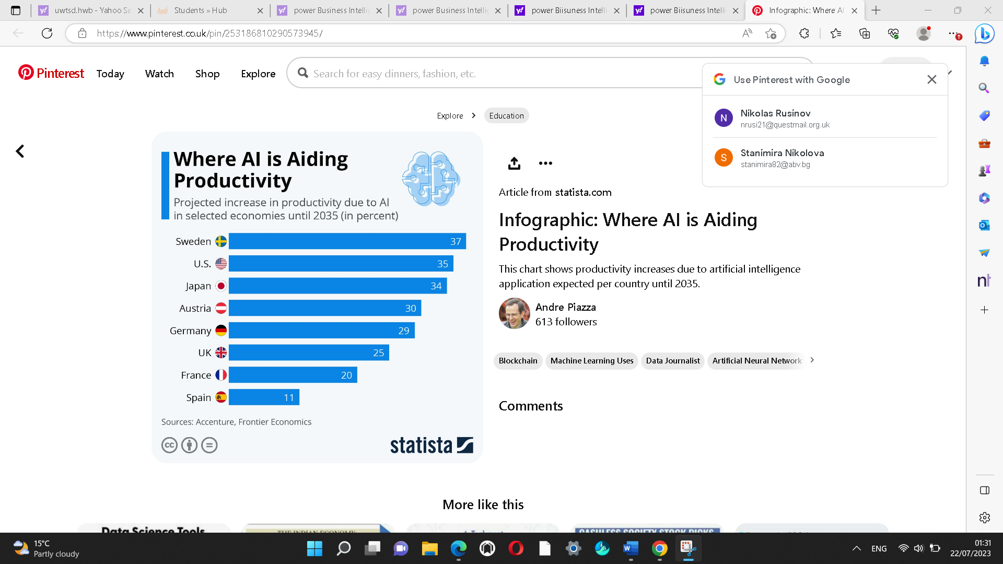
AI Productivity

