STRATEGIC ANALYSIS OF NIKE INC.

Stefan Gheorghe-2024473

The Global Business Environment – LCBB 4005
Dr. Rexon Nting
University of Wales Trinity Saint David
03.05.2021

Table of Contents

1. Introduction 3
2. PESTLE Analysis - Nike Inc. 3
3. Opportunities and Challenges 7
4. Conclusion 9
5. References 11
6. Appendix 13

STRATEGIC ANALYSIS OF NIKE INC.

1. Introduction
Every company, from small to multinational corporations, are subject to pressures from various external factors that they cannot control. It is critical to understand what forces are affecting us and take appropriate measures as well as devise long-term strategies. To adapt to the constantly changing business environment, companies use some specific tools that analyses information about factors and conditions outside and inside the company. The business environment analysis tools help us to identify our internal strengths and weaknesses, as well as the external opportunities and threats that affect the company. It aids us in making decisions about our short-term objectives and for our long-term strategies, and how to optimally use the company resources. We should systematically perform environmental analysis to maximise the strengths, minimise the weaknesses, take advantage of the opportunities and diffuse the threats so we can survive and grow our company.
In this essay, we will perform an analysis of Nike Inc. and explain some of the major forces that have affected them during the COVID-19 world pandemic. We will also assess the opportunities and threats that the pandemic has presented and explain how they tried to adapt to the changing business environment.

2. PESTLE Analysis - Nike Inc.
The business environment, as seen in figure 1, consists of different levels that influence the company. The external environment comprises of a wide range of influences like political, economic, social, technological, legal, and environmental factors, also known as PESTLE, that affect business activity in a variety of ways (Worthington, 2006).
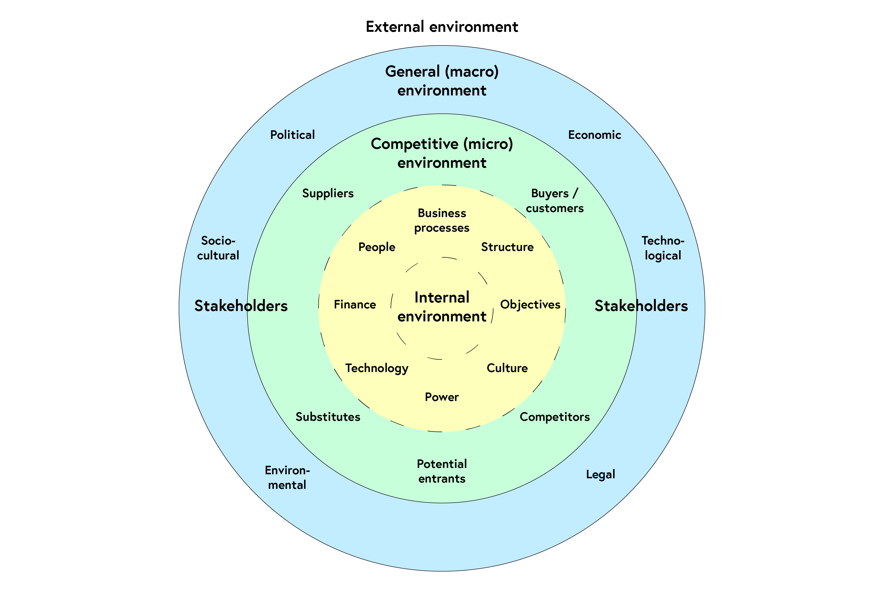
Fig.1 Source: (Coventry University, 2020)
Nike Inc. is a multinational company that is engaged in designing, manufacturing, and selling of owned brands that includes Nike, Converse, and Jordan. In 2020, its global revenue was 37.4 billion dollars, a 4.58% drop than 2019 (Appendix 1), of which footwear accounted for 66% of the revenue, 31% for apparel and 3% for equipment (Appendix 2). The COVID-19 pandemic has impacted Nike Inc. and all the companies around the world, changing the business environment and the consumer behaviour.
Next, we will analyse the macro-environment of Nike Inc. by applying the PESTLE framework to determine what major forces have shaped their business environment and the decisions taken. When analysing the political environment, we must consider the involvement level that the government has in a country and the political exposure presented by various organisations, to determine what opportunities and threats they pose. As an international company, Nike Inc. must consider the various taxes and tariffs imposed by the countries where it operates. The United States represents the core market for the company (Appendix 3), and it pays as much as 25% in tariffs on the goods produced in foreign countries. As the trade tensions between U.S. and China has escalated in 2019, Donald Trump, former president of U.S.A., threatened to increase the tariffs on Chinese goods, including all types of footwear by 10%. Nike Inc. and another 173 companies signed an opened letter, addressed to the president, and asked him to reconsider his tariffs on the shoes produced in China (Williams & Loh, 2019). Nike Inc. has 107 factories located in China, which represents about 19% of their finished goods factories (Appendix 4) and the tariffs change would affect the company in a limited way. Nike Inc. solution to the political powers has been the geographically diversity of its supply chain, by expanding its manufacturing sites in various countries. Also, during the world pandemic the governments have taken measures to protect its citizens by imposing lockdowns and forcing all non-essential businesses to temporarily close their stores.
Like every company, Nike Inc. is vulnerable to a downturn in the economy. During the pandemic, the global revenue has dropped as physical stores across the world were closed and the foreign direct investment has also dropped by 38% in 2020 compared to 2019 with the top three destination countries being China, U.S.A., and India (Appendix 5), where the company is focusing their efforts to gain more market share. To counter the effects of the pandemic Nike Inc. has intensified its efforts to increase their presence in Ecommerce and adapt to the new forced customer behaviour.
The social environment can have at least two impacts on companies. First, they can influence the nature of supply and demand by the demographics of a country, by geographical locations, by cultural attitudes or by the distribution of wealth and lifestyles. Secondly, the social environment can have significant implications for innovativeness, power, and effectiveness by the way of organisational networks (Whittington, et al., 2020). At Nike Inc., the social factors have allowed them to analyse the patterns of consumer behaviour and early adapt their products to the culture changes. In their main market of U.S., they have created products that appeal to the consumers and were related to popular sports, like basketball. Knowing their customers, they capitalized on the early trends by partnering with iconic players like Michael Jordan, which contributed to the rise of a sneakerhead culture and global development. During the pandemic, Nike Inc. has encouraged their customers to do their disrupted day to day activities from home, by creating online campaigns, that reinforces the message to “Play inside, play for the world” (Nike Inc., 2020). Socially the company has always tried to reflect their customers values and beliefs.
Technological factors play a very important role for every company and allows them to create new products or improve the existing ones by innovation. Nike Inc. has a dedicated research and development department that produces multiple innovative and market leading products. One of their best examples of this is the Nike Fit, which uses technological data to scan the customers feet and find the best size for them (Nike Inc., 2019). During the pandemic, technology played an important role, not only for Nike Inc. but for all companies that wanted to adapt and survive the uncertain times. Investments had to be made to increase the presence of online shopping and customer interaction.
The legal factor investigates the effects that laws and regulations have regarding the business environment. Nike Inc. has been involved in many legal battles, most of them against competitors, over patent infringements and designs. With the rise of athletic footwear market, the competition has increased, and the company tries to protect its design patents by legal court actions. Opportunities and threats can be considered when expanding the operations to developing countries by means of consumer laws or health and safety regulations. This can improve the brand image and reputation but can also increase labour costs where the company operates. The pandemic had governments issue health and safety regulations to protect employees and to help stop the spread of the virus in the workplaces, so companies were obligated to provide personal protective equipment and keep the two-metre rule within.
The environmental factor has always been an issue with the fashion industry. The pandemic has increased the need for sustainable activities and expectancy from customers that the companies involved should reduce their carbon footprint, take action to reduce waste and pollution and to preserve the environment for future generations. Nike Inc. has pledged to take appropriate measures to reduce the impact that their activity has on the environment by 2025. There is also the opportunity brought by the expanding environmental laws to create and improve environmental and sustainability programs that will increase brand awareness and consciousness.

3. Opportunities and Challenges
The COVID-19 pandemic presented many companies with opportunities and challenges within their business environment. To better formulate strategies, we can perform a SWOT analysis that will provide a general summary of the internal Strengths and Weaknesses and the Opportunities and Threats of the external environment (Whittington, et al., 2020). In figure 2 below, we summarize the SWOT analysis perform on Nike Inc. that will provide the framework for some strategies adopted by the company.
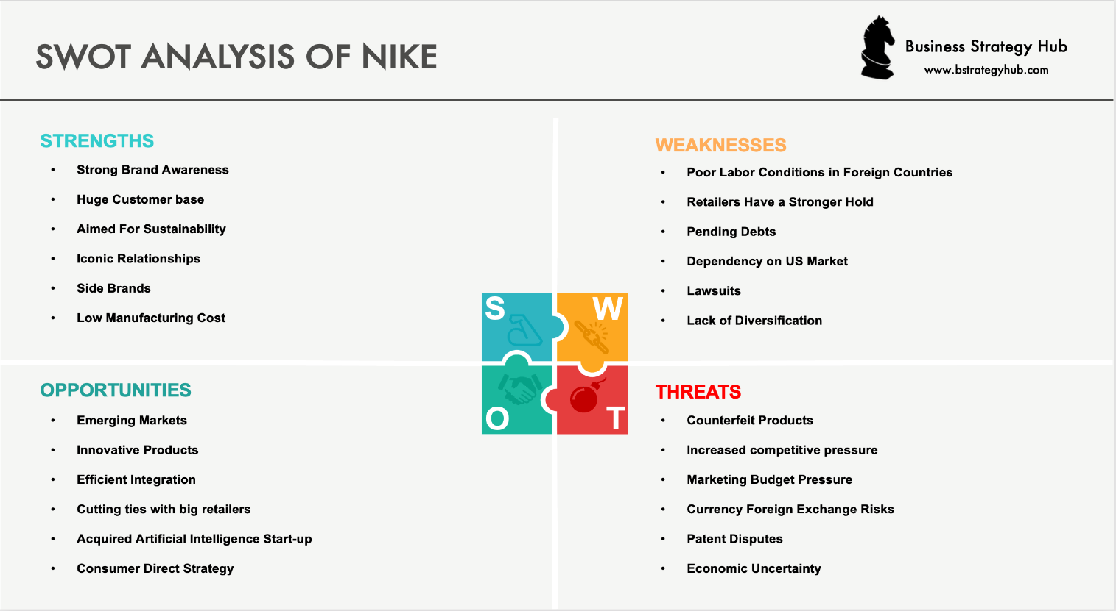
Fig.2 Source: (Business Strategy Hub, 2020)
Considering the pandemic, Nike Inc. has taken some strategic decisions that have helped them to endure during this challenging times. As a response to the temporary close of most of their physical stores, made by world governments, they have boosted their digital strategy and its direct sales efforts. As people were forced to stay at home during lockdown, Nike Inc. has encouraged them to “play inside” and “play for the world” and delivered new ways to interact using digital content and platforms for free (Nike Inc., 2021). They have created a library of digital workouts and resources using the Nike App, Nike Training Club App and Nike Running Club App. They have also initiated a livestream workout available for free on the Nike YouTube channel, and partnered with known sport celebrities like Lebron James or Cristiano Ronaldo, to create the Living Room Cup, which allows users to take part in challenges set by those athletes. All these efforts have been done to connect with its customers and keep the company and brand awareness active (Gilliland, 2020). In January 2020, John Donahoe was appointed Chief Executive Officer at Nike Inc. and brought with him a vast experience in digital commerce, which would help the company to focus more on digital business and subsequently close their physical stores.
Developed markets like the United States are more stable and allows the company to slowly grow, while emerging markets like China offers an opportunity for a more rapid growth but also for a threat of competitors presence and the risk of rising labour costs. Nike Inc. can capture a larger market share by focusing on product innovation and technological improvements of their products.
A major threat factor is represented by the deterioration in economic conditions in the main market of U.S. and in the global market. The company may have reduced consumer demands as these seek to decrease their spending, and other factors like the rise of unemployment rate, volatility in the financial markets or disruption of the distribution centres can affect the performance of the company and cannot be controlled.
Due to the global decline in economy, there is the risk of counterfeit products to appear, which are cheaper, and which can affect the brand imagine as customers might feel dissatisfied with the low quality of products. Nike Inc. originality depends on a new technology called RFID, that stands for Radio Frequency Identification Technology, and which uses a tiny radio part embedded in tags to automatically identify and track all its footwear and most of its apparel products (Silver, 2021).
Considering the vast financial resources, Nike Inc. can acquire small or medium companies and new technology that will give it a competitive advantage. In 2019 the company has acquired a predictive analytics platform called Celect, by which they hope to reduce the out-of-stock rates and run into fewer situations where demand comes unplanned. A better control of inventories will allow Nike Inc. to have goods in their warehouses that are not overflowing and decrease operational costs (Thomas, 2019). This platform will also allow the expanse of its online sales capabilities and the prediction of consumer shopping behaviour.
Considering the pandemic, Nike Inc. had challenges on satisfying customer demands because of the problems occurred in the supply chain. Some factories were forced to stop their operations, while containers were blocked due to the congestion in ports. This were again factors that the company had no power to control but affected their revenue.

4. Conclusion
As a conclusion to the above points covered, we can say that the world pandemic has adversely affected the business environment and changed the consumer behaviour. Every company and individuals had to adapt to the new regulations put in place by governments for social protection. Companies had to make difficult strategic decisions to take advantage of the opportunities presented and face the new threats of the changing business environment. Just like in nature, those that have adapted to the new environment have survived and continue to operate forward under the changing trends in the market. Nike Inc. has showed promising growth globally and should capitalize on the good brand image created while considering the social responsibility, sustainable consumption, and the environmental awareness that their customers are expecting. The company has the strengths needed to support its global leadership in the sports footwear, apparel and equipment and should look more closely at the concerns regarding competition, labour practices, imitation, and patent protection. They should also collaborate with government agencies to address patent protection issues (Kissinger, 2017).

5. References
Business Strategy Hub, 2020. Nike SWOT Analysis 2021. [Online]
Available at: https://bstrategyhub.com/swot-analysis-of-nike-nike-swot-analysis/
[Accessed 01 05 2021].
Coventry University, 2020. Future Learn. [Online]
Available at: https://www.futurelearn.com/info/courses/managing-company-culture/0/steps/216760
[Accessed 28 04 2021].
Gilliland, N., 2020. Econsultancy. [Online]
Available at: https://econsultancy.com/how-nike-is-striking-the-right-tone-with-its-response-to-covid-19/
[Accessed 03 05 2021].
Kissinger, D., 2017. Nike Inc. SWOT Analysis & Recommendations. [Online]
Available at: http://panmore.com/nike-inc-swot-analysis-recommendations
[Accessed 03 05 2021].
Map Data, 2020. Manufacturing Map. [Online]
Available at: http://manufacturingmap.nikeinc.com/#
[Accessed 29 04 2021].
Nike Inc., 2019. Nike News. [Online]
Available at: https://news.nike.com/news/nike-fit-digital-foot-measurement-tool
[Accessed 01 05 2021].
Nike Inc., 2020. Nike News. [Online]
Available at: https://news.nike.com/news/nike-play-inside-play-for-the-world
[Accessed 01 05 2021].
Nike Inc., 2021. COVID-19 Response Efforts. [Online]
Available at: https://purpose.nike.com/covid-19-response-efforts
[Accessed 03 05 2021].
Nike Inc., 2021. Investors Annual Reports. [Online]
Available at: https://investors.nike.com/investors/news-events-and-reports/default.aspx
[Accessed 28 04 2021].
Organisation for Economic Co-operation and Development, 2021. OECD. [Online]
Available at: https://www.oecd.org/investment/statistics.htm
[Accessed 01 05 2021].
Sabanoglu, T., 2021. Nike Revenue Worldwide. [Online]
Available at: https://www.statista.com/statistics/241692/nikes-sales-by-region-since-2007/
[Accessed 30 04 2021].
Sabanoglu, T., 2021. Statista. [Online]
Available at: https://www.statista.com/statistics/412760/nike-global-revenue-share-by-product/#statisticContainer
[Accessed 28 04 2021].
Silver, S., 2021. Financial Management. [Online]
Available at: https://www.fm-magazine.com/news/2021/jan/coronavirus-supply-chain-disruptions-kelloggs-nike-hp.html
[Accessed 03 05 2021].
Thomas, L., 2019. CNBC. [Online]
Available at: https://www.cnbc.com/2019/08/06/nike-acquires-ai-platform-celect-hoping-to-predict-shopping-behavior.html
[Accessed 03 05 2021].
Whittington, R. et al., 2020. Exploring Strategy: Text and Cases. 12th ed. Harlow: Pearson.
Williams, E. N. & Loh, T., 2019. Industry Week. [Online]
Available at: https://www.industryweek.com/the-economy/article/22027628/nike-adidas-call-tariffs-catastrophic-in-letter-to-trump
[Accessed 29 04 2021].
Worthington, I., 2006. The Business Environment. 5th ed. Harlow: Pearson.

6. Appendix
Appendix 1
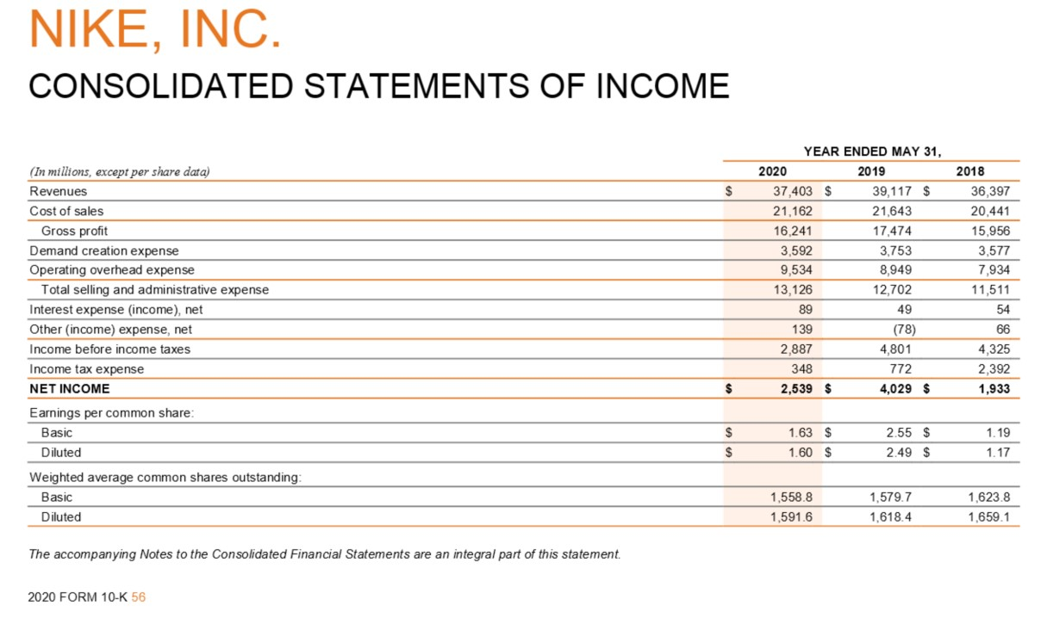
Source: (Nike Inc., 2021)
Appendix 2
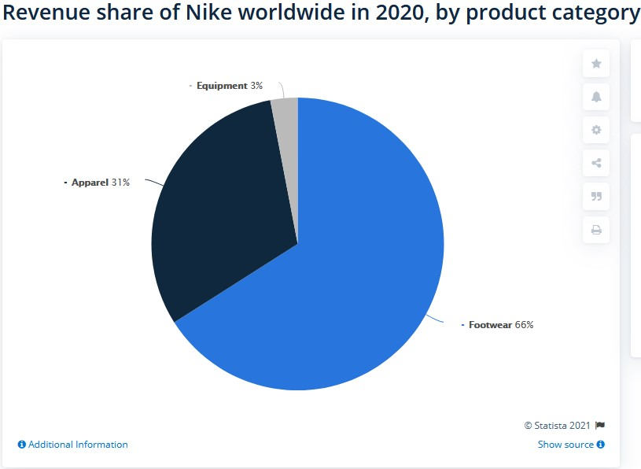
Source: (Sabanoglu, 2021)
Appendix 3
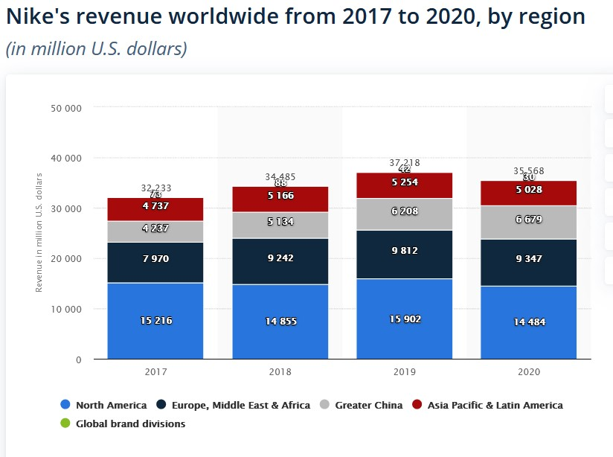
Source: (Sabanoglu, 2021)
Appendix 4
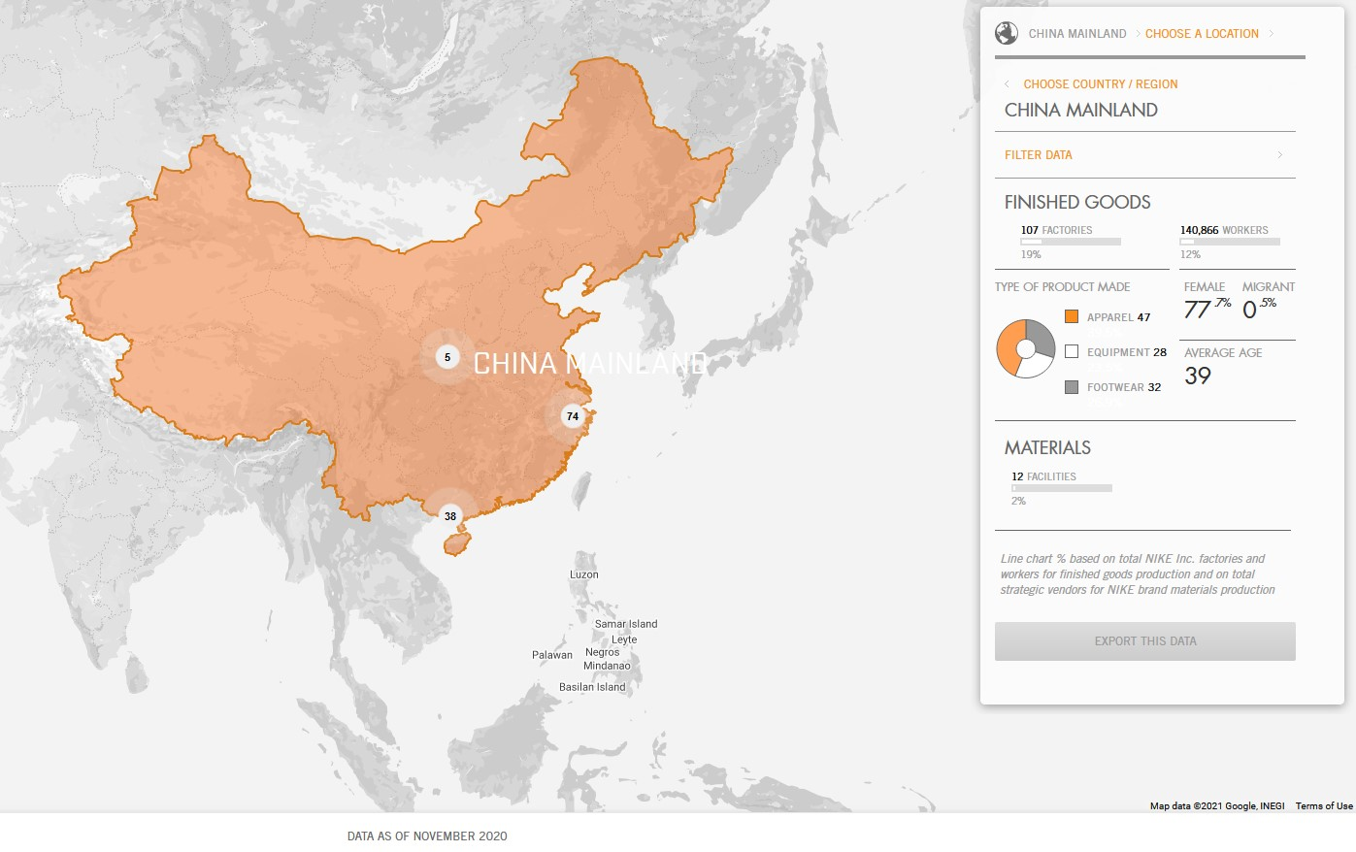
Source: (Map Data, 2020)
Appendix 5
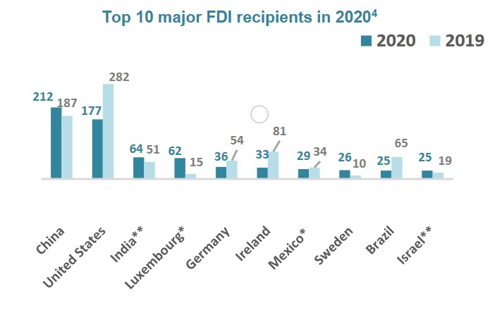
Source: (Organisation for Economic Co-operation and Development, 2021)

