
The Grand Hotel Budget Planner

Student Name: Muhammad Ali
Student ID:2021588
Module: Financial Management for Hotel Industry
Lecturer: Christopher Wilkin
Module Code: BMIH5007

Contents
- .Introduction ……………………………………………………………………………………………………………………..2
- Analysis of GHrand Hotel Budget Planner ………………………………………..
- Importance of budgeting 4
- Understanding of incremental budgeting 4
- Activity based Budgeting 5
- Value proposition based 5
- .Zero based budgeting 6
- Conclusion 8
- Reference List 9
- Executive Summary 12

Introduction

Every year bosses in a business plan future budget to carry out day to day business. Almost the budget remains the same unless there isn’t any internal or external factor after the decision making. Internal factor could be the loss of business and external is economic activities overall. Budgeting plays an important role in order to run business smoothly. Budget reflects how the plan is working and where it needs to be amended. Forecasting in budget help to chieve the targets set by the bosses.
Grand Hotel is situated in London, the hotel is also having restaurant facilities and a mini bar too. Given the detailed entries an over few of the cash flow and monthly income is presented as below with the help of Excel sheet. These predictions are based on zero based budgeting.

Analysis of Grand hotel budget planner
Preparing budget planner or cash flow forecast, we have to sort the records of estimated cash inflows and the real spendings. Below are complete entries catalogued and recorded for a final analysis for the hotel’s coming financial year.
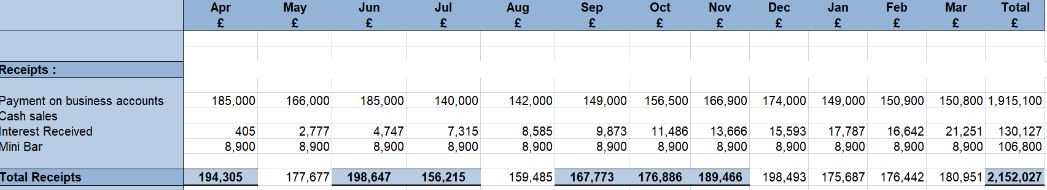
Entries:
First section of Table 1 shows the overall receipts the hotel is expected to receive in coming fiscal year. All the entries are monthly, and this part also have the payments section with interest accumulated with closing balance of previous month.
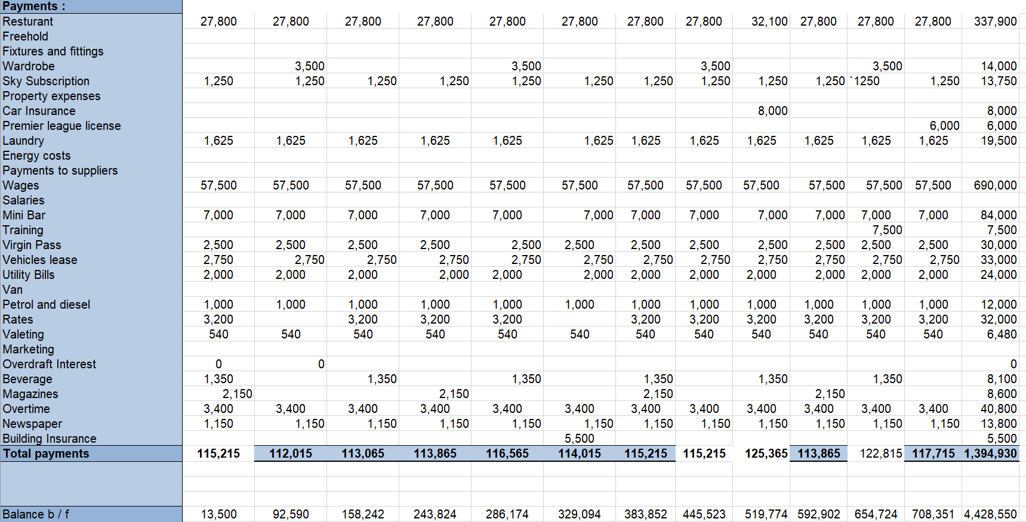

Table 2

Second section of the Table 2 indicates the entries of the predicted expenditures. These expenditures are recorded according to the previous year’s record. The entries include the fixed and variable costs.
Overall business is doing well and does not need any stimulated budgeting. The net cash flow is consistent and monthly expenditures are less than the revenue generated each month. Net cash flow is increasing every quarter.
At the end of the year the balance brought forward from the previous year is around 9 times higher. This show the business is doing well and have potential to grow. The growth and revenue can be generated more when a proper marketing strategy adopted. There should be around 5% of the revenue be spent on marketing in order to increase business.

Importance of budgeting
A budget is a list of objectives containing every single segment of the proﬁt and loss from high to low. For example, it will involve the marketing expenditure but typically it separates more into minor units too.
For any Hotel Manager creating a budget is probably the most significant part of the job. He should be aware of internal and external factors while planning budget. He has his own limitations wherever he can use existing resources and relies on predictions too. It is vital to the overall success of the hotel as they manage spending, encourage workforce to attain income goals and tell managers of the week areas so that could be handled in time.
Budgeting is like walking in the dark never knowing what is waiting ahead. There are no rights or wrongs at the time of creation as nobody can see the future. That said, experience and practice of budget-writing will begin to identify unrealistic predictions of hotel revenue and gives the ability to predict and work to realistic proﬁt margins.
Budgeting is "still regarded as an organizational imperative if costs are to be controlled and financial performance to be achieved" (Frow et al., 2010, p. 445).
De wall et al, (2011) mentions that budgeting is still regarded as an organizational imperative and there is little empirical evidence that organizations alter their existing budgeting practices
In recent years numerous alternatives for the budgeting process have been introduced. The most frequently encountered alternatives are activity-based budgeting, zero-based budgeting, rolling budgets and forecasts, profit planning, and beyond budgeting (Neely et al., 2002)

2,2 Understanding of incremental budgeting
This kind of budgeting is a mere modification to the existing budget plan. In other words, incremental budgeting starts with the existing budget and increases or deducts increments from those sums to create new spending figures. It is often considered the most conservative approach among all budgeting methods.

Activity based Budgeting
Activity-based budgeting is a budgeting approach where actions are comprehensively evaluated to forecast.
Budget is a significant part of planning and implementation. There are certain targets that needs to be achieved through proper forecasting. They define the targeted plans and the necessary measures to achieve them. The budget is a measurable representation of financial status. It depicts the aims and approaches of the business, and can also be used to use the budget in the control of those goals and strategies and control is the process of setting standards and compare the actual performance with the scheme and address the deviations between them (Mwakibasa, 2013)
Anulika (2012,) is of the view that traditional budget approaches are insufficient to meet the demands of modern companies with multiple activities and large services they provide. They need advanced and sophisticated budget methodologies. Activity based budgeting is considered a realistic approach and is a derivative of Activity based costing. Barfield et al, (2003) explained it as a planning approach that applies cost factors to estimate the levels and costs of activities necessary to provide a quantitative and qualitative balance of production.

Value proposition based
Value proposition budgeting is also known as priority-based budgeting, includes scrutinising and justifying a company’s expenditure for a particular period. In its essence, value proposition budgeting objectives are to uncover where a company should use capital based on how much profit each amount earns back.

Value-based budgeting is mostly based on the previous predictions that generated the profit. In simple if previous prediction led to high profit, then the same will continue to occur if conditions are similar.

Given that fiscal prediction is a precedence — or, nonetheless, it should be — it’s vital to run precise budgets to make certain steady progress. If a business is in not doing well, it is highly important where and how to spend capital to yield more profit. Value based budgeting is an ideal tactic as it helps focus on the crucial expenditures. It keeps engaged and helps to get rid of excessive spending and drives growth.

Zero based budgeting
Zero based budgeting is a technique that requires departmental managers to propose and justify their entire budget for the year. It is a planning system that assumes the starting point for each year is no budget, rather than the traditional method of using the previous year’s budget as the baseline
Zero-based is a budgeting technique where every expenditure is justified each time a new timeframe begins. (Kagan, Brock, & Rathburn, 2022) Zero-based budgeting starts with the point of a "zero base," and each function in an organization is examined to determine its requirements and expenses. The budgets are then constructed based on what is required to cover the next period regardless of whether the budget is greater or less than the prior one. (Anaplan, 2021)
Originating in the 1970’s as the brainchild of Texas Instruments accounting manager Peter Pyhrr, zero-based budgeting quickly gained popularity among federal, state and local governments, with a significant number of jurisdictions having seen its adoption. (Mukdad Ibrahim,2019).
Zero-based budgeting always requires a periodic review. The difference between zero based budget and incremental is that the former relies on the previous year’s planning while predicting next year’s budget. This makes things easier the budget planning by using the last year budget as a starting point,
Zero based budgeting always works in real time keeping in view the trends and economic situation. This helps budget planner when to flex the arms and when to take a risk-free decision. In these kinds of budget there is always a margin to learn lesson from the mistakes made previously.
The use of zero-based budgeting is considered as a substitute to incremental budgeting methods. This allows managers to get rid of any excessive expenditures that are irrelevant. To develop a flexible budget company often use zero based budgeting methods. With this budget managers can find out the exact income and expenditure at any time.

How budgeting control can support sustainability
Sustainable development can become steps to achieve profitability for any business. In order to curtail the challenges of sustainability, businesses need to work on a model where they could find opportunities and threats. The more sustainable a business is the more helpful for the society and in economic terms too. Sustainability should be a strategic priority pf the business. According to Baumgartner and Ebner, 2010 p. 78) with the recognition of sustainability as a strategic priority, there has been effort to extend the frameworks utilised to support strategic decision-making.
Business always focusses on profit-oriented strategies. Sustainability and development in an organization are focus of any business. If a business generates more profit that secures the future of the business.
When it comes to decision making forecasting becomes a priority. Yilmaz (2018) states that based on these expectations and forecasts, it is possible to create a scenario. If the scenario includes financial matters, it means the budget has been created that helps to stimulate the business sustainability.

Conclusion

The report is mostly of two kinds of the budgeting that are the conventional budgeting and the zero-based budgeting. Conventional budgeting is based on the previous year planned by bosses. However, the zero-based budget method established on zero and managers must modify their fiscal needs. It isn’t easy to adopt any specific method for budgeting as there are different variables involved when it comes to budget planning.

Reference List

- Anaplan. (2021, February 15). The ultimate guide to zero-based budgeting (ZBB). Retrieved June 27, 2022, from anaplan.com: https://www.anaplan.com/blog/zbb
- Anulika, U. (2012). The role of budgeting in managerial planning and control: A case study of Guinness Nigeria Plc Benin, Edo State and Nigerian Breweries Plc Ama, Enugu State. A project submitted in partial fulfilment of the requirement for the award of Master of Business Administration (MBA) in management department of management, faculty of business administration, University of Nigeria, Enugu Campus, 17 - 27.
- De Wall et,al ,2011 Journal of Accounting & Organizational Change; Bradford Vol. 7, Iss. 4, (2011)
- Frow, N., Marginson, D. and Ogden, S. (2010), "Continuous budgeting: reconciling budget flexibility with budgetary control", Accounting, Organizations and Society, Vol. 35 No. 4, pp. 444-61.
- Horngren, C., Datar, S., & Rajan, M. (2012). Cost accounting managerial emphases, (14th edition). Prentice Hall, 146.
- (Anaplan, 2021)
- Mwakibasa, E. (2013), https://www-proquest-com.ezproxy.uwtsd.ac.uk/docview/2679344510?pq-origsite=primo&accountid=130472

- Neely, A., Sutcliff, M. and Heyns, H. (2002), Driving Value through Strategic Planning and Budgeting, Research Report, Cranfield School of Management and Accenture, Cranfield.

- Rupert J. Baumgartne Mwakibasa, E. (2013), https://www-proquest-com.ezproxy.uwtsd.ac.uk/docview/2679344510?pq-origsite=primo&accountid=130472

- Value Proposition Budgeting (VPB): A Step-by-Step Guide — Relay (relayfi.coValue Proposition Budgeting (VPB): A Step-by-Step Guide — Relay (relayfi.com)
- m)

- What is Incremental Budgeting? - Overview, Advantages, Disadvantages (interobservers.com) Value Proposition Budgeting (VPB): A Step-by-Step Guide — Relay (relayfi.com)

- Zero-based budgeting - Oxford Reference

4.Appendix Budget Calculations

Executive Summary

Preparing budget planner or cash flow forecast, we have to sort the records of estimated cash inflows and the real spendings. Below are complete entries catalogued and recorded for a final analysis for the hotel’s coming financial year.
Entries:
First section of Table 1 shows the overall receipts the hotel is expected to receive in coming fiscal year. All the entries are monthly, and this part also have the payments section with interest accumulated with closing balance of previous month.

Table 2
Second section of the Table 2 indicates the entries of the predicted expenditures. These expenditures are recorded according to the previous year’s record. The entries include the fixed and variable costs.

