  Component One: Student Journal (learning log) 750 words +/- 10%  Contribution to Overall Module Assessment: 25% | Student No: | 2235531
 | Module Title: | Operating Hotel Facilities
 | Module Code: | BMIH4006
 | Lecturer: | Neil Dyer
Reflection

The learning log reflects the overall experience with the help of Kolb's learning cycle (Vince, 2022).

Concrete Experience:
During my internship at Premier Inn Stevenage North, I actively participated in the Housekeeping team, which afforded me a practical opportunity to explore the operational dimensions involved in upholding a superior level of cleanliness within a hotel setting. Engaging in duties such as the maintenance of room cleanliness, administration of linen, and adherence to hygiene rules provided me with the opportunity to fully engage with the operational aspects of the Housekeeping department (Rohaeni et al., 2021).

Reflective Observation:
Upon thorough examination of the Kolb Learning Cycle, my process of reflective observation has revealed the progressive development of my talents within the Housekeeping team (Watson et al., 2019). The initial struggles underscored the significance of adaptation as the team successfully managed high occupancy times and unanticipated maintenance problems. The team's overall effectiveness was strongly influenced by my capacity to adjust in response to these problems. This particular stage of the Kolb Learning Cycle also compelled me to evaluate my personal abilities inside the realm of household management (Vince, 2022). Throughout the duration of my internship, I observed a noticeable enhancement in my capacity to concentrate on intricate details.

Abstract Conceptualisation:
Upon doing an analysis of adaptability from a theoretical standpoint, I identified correlations with the Cynefin framework. This framework underscores the importance of tailoring management strategies according to the complexity inherent in a particular situation. In the context of the hotel industry, characterised by a multitude of uncertainties, the adoption of the principles outlined in the Cynefin framework has become imperative (Singh et al., 2019). This approach sheds light on the notion that adaptability is not solely an individual characteristic but rather a strategic skill that is integrated into management theories. Upon careful reflection of my tenure within the Housekeeping team, I have discerned a set of crucial abilities that are important for achieving success in my particular role. These skills encompass adaptability, robust collaboration, unwavering focus, and effective teamwork.

Active Experimentation:
Drawing inspiration from these valuable ideas, I actively engaged in experimental endeavours aimed at augmenting my adaptability. I facilitated interdepartmental partnerships, engaging in team-building activities designed to replicate high-stress situations. The active participation in this endeavour not only enhanced my ability to effectively address and resolve issues (Jubaedah et al., 2019), but also cultivated a sense of cooperation and teamwork among the members of the Housekeeping team.

Connecting Skills, Experience, and Theoretical Principles by Using the KOLB Learning Cycle

Concrete Experience:
Upon introspection of my personal journey, I have identified two prominent characteristics that have significantly contributed to my success: good communication and adaptability. The hotel industry is recognised for its dynamic nature, characterised by rapid and frequent changes in various conditions (Alcalde-González et al., 2021). During my tenure at Premier Inn Stevenage North, I encountered a diverse range of situations, including effectively handling a sudden surge in guest arrivals and promptly resolving unforeseen maintenance concerns, which underscored the importance of adaptability and efficiency.

Reflective Observation:
Upon introspection of my own adaptability, I established a correlation with theoretical frameworks such as VUCA (Volatility, Uncertainty, Complexity, Ambiguity), a notion extensively employed in the field of management research (Rohaeni et al., 2021). The hotel sector, characterised by its inherent volatility, uncertainty, complexity, and ambiguity, aligns with the VUCA paradigm. This correlation facilitated my comprehension that adaptability is not solely an individual characteristic but rather a valued talent rooted in management ideas. In relation to the significance of communication, I conducted an in-depth exploration of the concept of transactional communication, which is a paradigm that underscores the value of transmitting messages that are clear, succinct, and devoid of ambiguity.

Abstract Conceptualisation:
Expanding upon this correlation, an examination was conducted into the theoretical foundations of service quality. The SERVQUAL approach places significant emphasis on various dimensions of service quality, including tangibles, reliability, responsiveness, assurance, and empathy (Prima, 2022). My encounter with the Housekeeping team served to strengthen the significance of these values (Islam, 2020). The presence of tangible factors, such as the level of cleanliness in rooms, was found to have a direct impact on guest satisfaction. Additionally, the attributes of reliability and responsiveness were identified as essential in satisfying the expectations of guests.

Active Experimentation:
By using these theoretical ideas, I actively participated in cross-functional training sessions aimed at comprehending the interdependence among different departments inside the hotel. Not only did this experience strengthen my adaptability, but it also improved my capacity to contribute to a seamless and high-quality guest experience (Espellita and Maravilla Jr, 2019). By recognising the significance of responsiveness, I ensured expeditious communication with the front desk in the event of any concerns, enhancing the efficacy of the resolution procedure.

Component Two: Housekeeping cleaning checklist
Contribution to Overall Module Assessment: 25%

Checklist Tasks | Turnaround date | Turnaround date
Change and make beds with fresh linens
Ensure pillows are fluffed and neatly arranged.
Wipe down and sanitise all surfaces.
Dust furniture and decorative items
Vacuum carpets or mop hard floors

Pay special attention to corners and edges.
Clean and disinfect sinks, countertops, and fixtures
Scrub and sanitise the toilet bowl, seat, and surrounding areas.
Restock toiletries and towels as needed
Wipe down mirrors for a streak-free shine.
Clean windows and sills
Ensure curtains or blinds are dust-free
Dust and clean TV screens
Wipe down remote controls and other electronic devices.
Empty and replace trash liners
Proper disposal of trash in designated areas
Dust and clean light fixtures

Replace any burnt-out bulbs.
Check and clean HVAC controls.
Remove any cobwebs or dust buildup.
Neatly organise and clean inside closets.
Check for any items left by guests.
Dust and clean artwork or decorative items
Ensure all items are properly aligned.
Add a pleasant fragrance if part of the hotel's protocol.
Ensure a fresh and inviting aroma.

Based on your completed checklist, you will need to write 500 words in essay format discussing the following:
- How will you ensure that the rooms are cleaned to brand standards?
- What measures would you introduce to improve team effectiveness?
- Why would you consider your checklist to be the most effective?

Introduction

Maintaining a pristine and welcoming environment in guest rooms is paramount to ensuring guest satisfaction and upholding brand standards in the hospitality industry (Verma and Singh, 2020). The previously crafted checklist serves as a comprehensive guide for housekeeping teams, focusing particularly on room cleaning. This essay includes the strategies for achieving brand-standard cleanliness, measures to enhance team effectiveness, and an exploration of why the provided checklist is deemed highly effective.

Discussion

Ensuring Brand-Standard Cleanliness
To ensure that rooms are consistently cleaned to brand standards, a multifaceted approach is necessary. Firstly, rigorous training sessions will be implemented for new and existing team members. These sessions will encompass the proper use of cleaning tools, adherence to the checklist, and an in-depth understanding of brand cleanliness expectations (Vijaya, et al., 2020). The incorporation of visual aids, simulations, and practical exercises will be employed to enhance the exchange of knowledge. Furthermore, the implementation of regular quality inspections will have a significant impact. The implementation of periodic inspections led by designated team leaders or supervisors will ensure that every room complies with the defined criteria. These assessments will not just ascertain locations that require enhancement but also function as occasions for constructive critique and ongoing advancement.

Measures to Improve Team Effectiveness

To enhance team effectiveness, a collaborative and communicative culture will be fostered. Regular team meetings will be conducted to discuss challenges, share best practices, and disseminate important information. This platform will also serve as an avenue for team members to voice concerns or suggest improvements, creating a sense of ownership and shared responsibility (Batten et al., 2023). Cross-training initiatives will be introduced to broaden the skill set of team members. While specialisation in certain tasks is crucial, having a basic understanding of other roles within the housekeeping department promotes flexibility. This not only mitigates potential bottlenecks in operations but also instils a sense of camaraderie as team members gain insights into each other's responsibilities.

In addition, the implementation of a recognition and rewards program will incentivise exemplary performance. Acknowledging and rewarding team members who consistently meet or exceed cleanliness standards will instil a positive work environment and motivate others to strive for excellence (Huang et al., 2022). This recognition can take various forms, from verbal praise during team meetings to tangible rewards or incentives.

The Effectiveness of the Checklist
The checklist provided earlier is considered highly effective for several reasons. First and foremost, the simplicity of the system enables straightforward comprehension and execution, hence diminishing the probability of mistakes. Although functioning as a comprehensive manual, the checklist also permits customisation according to distinct space categories (Torres and Zhang, 2022). The implementation of this adaptable approach guarantees consistent adherence to brand standards even in diverse situations. This effectively adjusts the ever-changing dynamics of the hospitality industry.

Summary
In brief, to attain brand-consistent cleanliness in the guest room requires an effective approach encompassing comprehensive training, regular quality assessments, and a dedication to incorporating guest input. By employing these tactics and utilising the checklist as a reference, a housekeeping crew may regularly achieve exemplary cleanliness standards that fit with the brand's expectations.
Component 3: Training Presentation

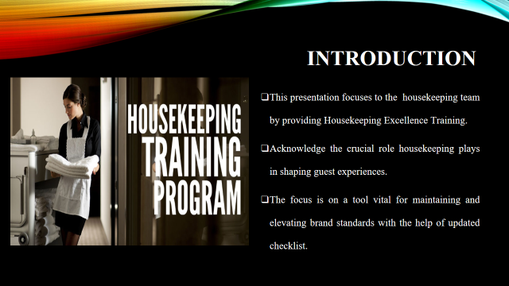
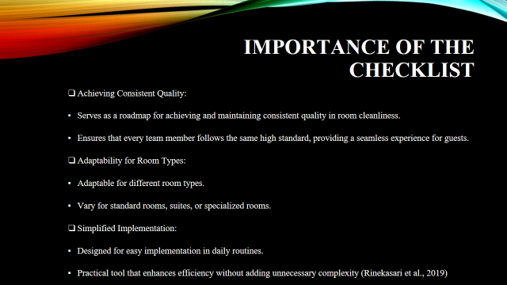
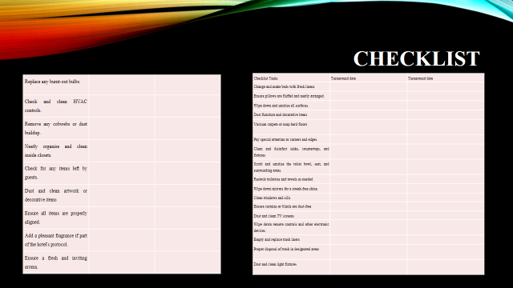
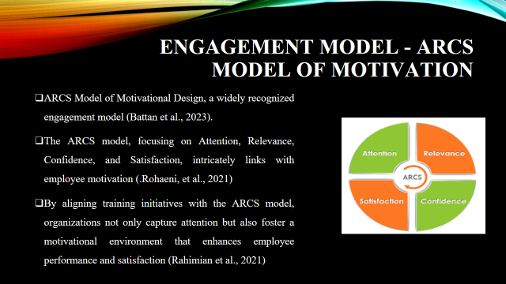

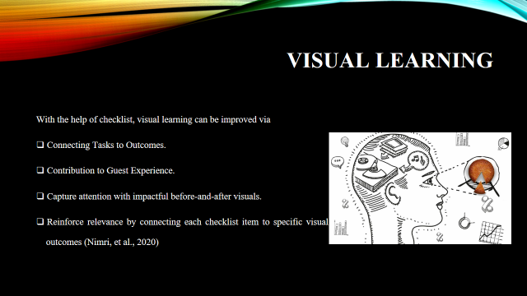
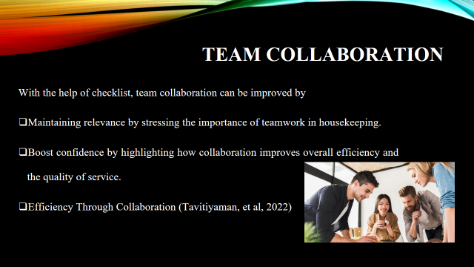
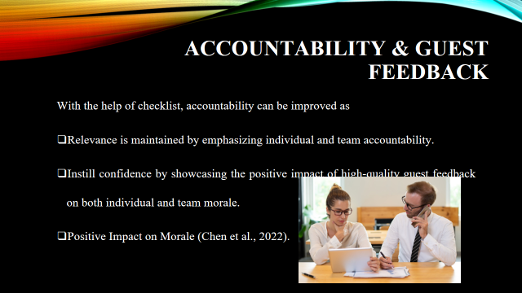
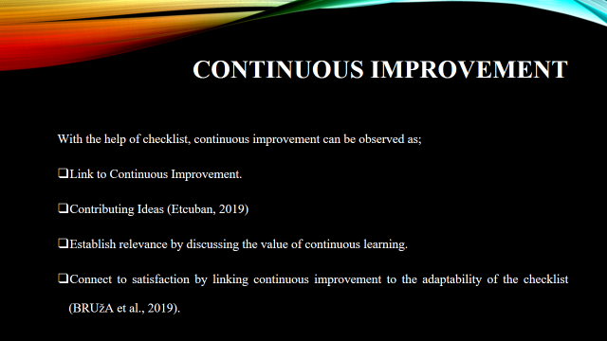
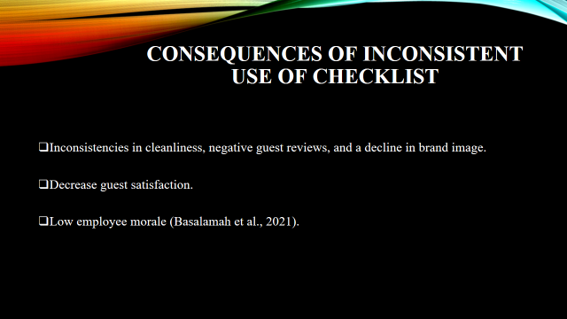
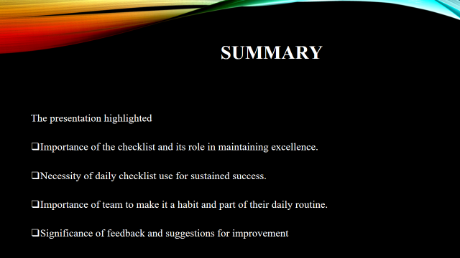
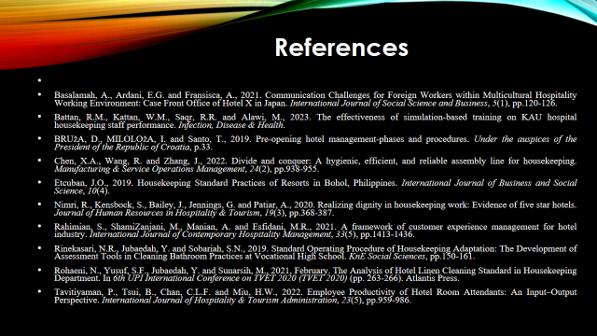

References
Alcalde-González, V., Mozo, A.G. and Bustos, A.V., 2021. No clean rooms, no hotel business: Subversion tactics in Las Kellys’ struggle for dignity in hotel housekeeping. Annals of Tourism Research, 91, p.103315.
Basalamah, A., Ardani, E.G. and Fransisca, A., 2021. Communication Challenges for Foreign Workers within Multicultural Hospitality Working Environment: Case Front Office of Hotel X in Japan. International Journal of Social Science and Business, 5(1), pp.120-126.
Battan, R.M., Kattan, W.M., Saqr, R.R. and Alawi, M., 2023. The effectiveness of simulation-based training on KAU hospital housekeeping staff performance. Infection, Disease & Health.
BRUžA, D., MILOLOžA, I. and Santo, T., 2019. Pre-opening hotel management-phases and procedures. Under the auspices of the President of the Republic of Croatia, p.33.
Chen, X.A., Wang, R. and Zhang, J., 2022. Divide and conquer: A hygienic, efficient, and reliable assembly line for housekeeping. Manufacturing & Service Operations Management, 24(2), pp.938-955.
Espellita, S. and Maravilla Jr, V.S., 2019. Employable skills for hospitality graduates as perceived among hotel supervisors in Cebu City. Journal of Economics and Business, 2(2).
Etcuban, J.O., 2019. Housekeeping Standard Practices of Resorts in Bohol, Philippines. International Journal of Business and Social Science, 10(4).
Huang, S., Liang, L.J. and Choi, H.C., 2022. How We Failed in Context: A Text-Mining Approach to Understanding Hotel Service Failures. Sustainability, 14(5), p.2675.
Islam, M.T.,(2020) Skill Deficiency among Hotel Management Students. Employability Skills and Competencies of working Professionals: Curriculum and Emerging Trends, p.197.
Jubaedah, Y., Rinekasari, N.R. and Rohaeni, N., 2019, December. Job Performance Apprenticeship in Housekeeping Department: An Implementation of Competency-Based Assessment Model. In 1st Vocational Education International Conference (VEIC 2019) (pp. 246-251). Atlantis Press.
Nimri, R., Kensbock, S., Bailey, J., Jennings, G. and Patiar, A., 2020. Realizing dignity in housekeeping work: Evidence of five star hotels. Journal of Human Resources in Hospitality & Tourism, 19(3), pp.368-387.
Prima, S., 2022. A study of the perception of the importance of English language skills among Indonesian hotel employees. J-SHMIC: Journal of English for Academic, 9(1), pp.73-86.
Rahimian, S., ShamiZanjani, M., Manian, A. and Esfidani, M.R., 2021. A framework of customer experience management for hotel industry. International Journal of Contemporary Hospitality Management, 33(5), pp.1413-1436.
Rinekasari, N.R., Jubaedah, Y. and Sobariah, S.N., 2019. Standard Operating Procedure of Housekeeping Adaptation: The Development of Assessment Tools in Cleaning Bathroom Practices at Vocational High School. KnE Social Sciences, pp.150-161.
Rohaeni, N., Yusuf, S.F., Jubaedah, Y. and Sunarsih, M., 2021, February. The Analysis of Hotel Linen Cleaning Standard in Housekeeping Department. In 6th UPI International Conference on TVET 2020 (TVET 2020) (pp. 263-266). Atlantis Press.
Singh, S.V., Ranjan, R., Verma, A. and Bharadwaj, R., 2019. HOSPITALITY EDUCATION CURRICULUM EFFICACY: A STUDENT PERSPECTIVE. AVAHAN: A Journal on Hospitality &Tourism, 7(1).
Tavitiyaman, P., Tsui, B., Chan, C.L.F. and Miu, H.W., 2022. Employee Productivity of Hotel Room Attendants: An Input–Output Perspective. International Journal of Hospitality & Tourism Administration, 23(5), pp.959-986.
Torres, E.N. and Zhang, T., 2022. Customer Service Marketing: Managing the Customer Experience. Taylor & Francis.
Verma, P. and Singh, M.,(2020) Sustainable Housekeeping Practices in Hotels: A Review of Trends in Sustainability Practices Performed By Housekeeping Staff. Hospitality and Tourism Emerging Practices in Human Resource Management, p.79.
Vijaya, R., Sharma, A., Daga, A. and Gopichandran, L., 2020. Effectiveness of structured training programme on infection control measures among housekeeping workers in selected intensive care units at tertiary hospitals. JoNSP, 10, pp.51-56.
Vince, R., 2022. Reflections on “behind and beyond Kolb’s learning cycle”. Journal of Management Education, 46(6), pp.983-989.
Watson, M.K., Pelkey, J., Noyes, C. and Rodgers, M.O., 2019. Using Kolb’s learning cycle to improve student sustainability knowledge. Sustainability, 11(17), p.4602.

