WEEK 5 (week beginning October 30)
Reconstructing a Nation: From Civil War to Empire
In Focus:
Narratives of Slavery and Freedom

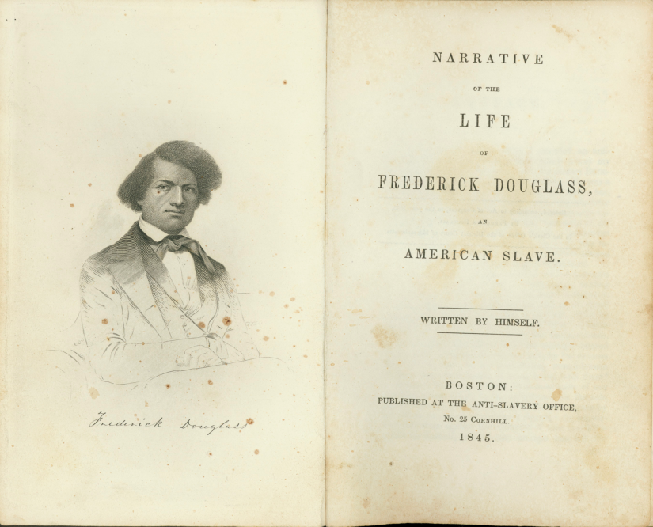

This week explores how the United States was transformed by the American Civil War and its aftermath. We begin with a detailed examination of Southern slave society, as seen through the eyes of Frederick Douglass. We then chart key events that occurred during the Civil War, and the subsequent eras commonly referred to as the ‘Reconstruction’ years and ‘the Gilded Age,’ concentrating on far-reaching consequence of legislation passed by the Federal government during the Civil War in relation to, first, the rights of African Americans and, second, supporting the development of free market industrial capitalism. Here, we will chart the United States’ emergence as an industrial superpower, and how this was accompanied by an ideology of progress espoused by the ‘Robber Baron’ elite which helped legitimate both the conquest of the West and (after the 1898 Spanish-American War) the United States' new-found status as a pancontinental empire.

- Reading and preparation:
Required readings:
- Frederick Douglass, Narrative of the Life of Frederick Douglass, an American Slave (1845), chapters 1, 2, 6, 7, 10 and 11,

Recommended background reading:
Below is a list of relevant chapters from books, of which copies are available in the UWTSD Lampeter library.
- George B, Tindall and David Emory Shi, America: A Narrative History (New York: WW Norton & Co, 2010), chapters 15–18.
- Eric Foner, Give Me Liberty! An American History (New York: WW Norton & Co, 2014), chapters 11, 13–15.
- Malcolm Bradbury and Howard Temperley, eds. Introduction to American Studies (London: Longman, 1998), chapters 4, 7.

- Background information:
The ‘in focus’ session concentrates on a famous memoir by Frederick Douglass. The memoir is short and very readable, so students may find it possible to read the book in its entirety – although six key chapters have been assigned as required reading. Below is a biographical sketch of Douglass from The Heath Anthology of American Literature.

Frederick Douglass (1818–1895)
Abolitionist, women’s rights advocate, journalist and newspaper editor, social reformer and race leader, Frederick Douglass was unquestionably one of the most prominent black leaders of the nineteenth century and one of the most eloquent orators in American public life.
Frederick Augustus Washington Bailey was born a slave in Talbot County, Maryland in February 1818. His mother, Harriet Bailey, was a slave; his father, Douglass suspected, was probably Aaron Anthony, the general plantation superintendent for the Lloyd plantation, where Douglass spent his early childhood. A sensitive and intelligent child, Douglass was quick to observe the horrors and routine injustices of slavery and his passion for black liberation and women’s rights was undoubtedly fueled by his early observations and experiences on the Lloyd plantation. When Douglass was eight years old, he was sent to Baltimore to live with and work for the Auld family. There he learned an important lesson about the relationship of reading and writing to a liberated consciousness. In the face of the adamant opposition of the Aulds to his receiving even the most elementary instruction, Douglass, through a series of ruses, slowly and painstakingly taught himself the rudiments of reading and writing.
Another step towards his liberation occurred at the age of sixteen, when he was hired out to Edward Covey, a notorious “Negro breaker.” For the first time Douglass, who had until this point lived as either a house- or urban slave, became a field hand and, for the first time in his life, he was regularly whipped and his spirit almost broken. Douglass’s decision to physically defend himself against Covey’s brutality—a central moment in his 1845 Narrative—was a turning point in his life as a slave and the final rehearsal for his escape from bondage. In 1838, Douglass escaped from slavery in Baltimore to pursue his vision of freedom in the North. In New York City he married Anna Murray, a free black woman from Baltimore who had been instrumental in his escape; Douglass and his bride then made their way to New Bedford, Massachusetts, in search of a new life. Typical of many former slaves who had decisively broken away from the shackles of slavery, Douglass renamed himself shortly after he arrived in the North, choosing as his own the name of the hero of Sir Walter Scott’s novel The Lady of the Lake.
In early 1839, Douglass purchased his first copy of William Lloyd Garrison’s radical abolitionist newspaper, the Liberator—the initial step towards his transformation into an abolitionist leader. He read the Liberator religiously, began to attend anti-slavery meetings in the local black community and, by 1841, had emerged as an eloquent leader of the black people in New Bedford. Later that year, Douglass was electrified when he heard Garrison speak for the first time and decided to attend an anti-slavery convention at Nantucket, where Garrison was scheduled to speak again. It was at that meeting on August 12, 1841, that Douglass was encouraged to address the audience. In spite of his embarrassment, Douglass stood up and offered a very moving account of his experiences as a slave. Douglass addressed the convention again that evening and, when the meeting was over, John A. Collins, general agent of the Massachusetts Anti-Slavery Society, asked Douglass to join them as an agent. After some soul-searching, Douglass agreed. From that point on, Douglass committed his life to, in his words, the “great work” of abolition and black liberation.
Douglass’s public career unfolded in several distinct phases. Between 1841 and 1845, he lectured extensively on the anti-slavery circuit. When he published his Narrative in 1845, it was so explicit in its details that it exposed him to the risks of capture and re-enslavement. He fled to England and spent the years between 1845 and 1847 lecturing and promoting the anti-slavery cause throughout the British Isles. His English friends raised the money which allowed Douglass to purchase his freedom and to publish his own journal.
When Douglass returned to the United States, he broke with William Lloyd Garrison, who was then advocating that New England secede from the United States—a strategy which, in Douglass’s view, would allow slavery to flourish in the South unchallenged. Ultimately, Douglass came to differ with Garrisonian abolitionists on a number of other issues as well, including the usefulness of electoral politics and the centrality of non-resistance—indeed, Douglass became a supporter of John Brown’s direct attacks on the slave power. Douglass moved to Rochester, New York, in 1847, where he established his newspaper, The North Star (later renamed Frederick Douglass’ Paper) and vigorously resumed his efforts on behalf of the abolitionist movement. He also became a participant in the first women’s rights conventions in 1848, at Seneca Falls and at Rochester.
Although his despair over the bleak condition of blacks during the 1850s led him to briefly consider emigration to another country as a solution, Douglass welcomed the outbreak of the Civil War as the moment in which the long-awaited opportunity for black emancipation and elevation had arrived. During the war, he functioned as a public spokesman for the position that this conflict should be seen as a war of emancipation and, along with Sojourner Truth, urged Abraham Lincoln to enlist blacks in the Union army. When Lincoln yielded to these demands in 1862, Douglass was at the forefront in urging blacks to join the army to fight for their freedom. Between 1865 and his death in 1895, Douglass continued to function as one of the most prominent black spokesmen in the country and as a political leader in the Republican Party. He served as U.S. Marshal of the District of Columbia (1877–1881), Recorder of Deeds for the District of Columbia (1881–1886) and chargé d’affaires for Santo Domingo and minister to Haiti (1889–1891). He also completed the third and final of his autobiographical writings, The Life and Times of Frederick Douglass (1892).
Frederick Douglass’s life, politics, and writings are inextricably linked. His first speeches were moving and powerful evocations of his experiences as a slave and, in his early public appearances, he was often presented as a showpiece for major abolitionist lectures. “Give us the facts,” he was told by John Collins, “we will take care of the philosophy.” As Douglass grew more confident of his speaking abilities, however, he increasingly chafed under these guidelines, and he began to expand the scope of his speeches, incorporating larger issues and elaborating his own philosophy. His mentors became concerned that Douglass’s eloquence would undermine his authenticity as a former slave, and Collins even urged him to sprinkle his speech with a little plantation language to maintain his credibility with his audiences. To dispel growing public doubts about his experiences as a slave, Douglass spent the winter of 1844 to 1845 writing an account of his experiences. Narrative of the Life of Frederick Douglass, An American Slave, Written by Himself appeared in May, 1845, with a preface by William Lloyd Garrison and an introductory letter by Wendell Phillips. Douglass’s narrative was an instant popular success. In the first five months 4,500 copies were sold and, over the next several years, editions appeared in England, Ireland, France, and Germany.
One of the reasons for the popular appeal of Douglass’s Narrative would certainly be the skill with which he appropriated the language and symbolism of American middle-class culture and religion to denounce the evils of slavery and racism. Unlike David Walker, for example, whose Appeal was addressed to the black community and issued dire warnings of America’s impending doom, Douglass’s Narrative excoriated American society for its lapses at the same time that it affirmed its original promise. In this respect, as William L. Andrews has pointed out, Douglass’s Narrative is a kind of American jeremiad. Throughout his autobiography, Douglass blends his personal experiences as a slave with sharp attacks on the inequities of slavery and racism. And he appropriates the rhetoric of the jeremiad to distinguish between true and false Americans and Christians, between those who would affirm the dream and those who would destroy it. In the process, particularly by appropriating the rhetoric and symbols of Christianity, Douglass establishes a convincing case for himself as a lonely outcast in his own land and, more importantly, as a prophet ordained to warn American society against perversity and error. Against the backdrop of his relationship with the abolitionist movement, Douglass’s Narrative can also be read as a step towards the declaration of his literary and political independence—the first step towards his ultimate break with the Garrisonians and his long and extraordinary public career.

- Questions to consider:
Douglass, Narrative
- Douglass opens his Narrative by telling readers that he is troubled by not knowing when he was born. Why do you think slave owners kept slaves ignorant about their birthdays and parentage?

- What does Douglass list as some of the most important the turning points in his life, and why? Do these change his perceptions of slavery and freedom?

- What virtues, attributes or phenomena does Douglass associate with freedom? In what sorts of activities does he think a slave might engage in order to become free? Is freedom defined by legal or moral arguments?

- Several times in his Narrative, Douglass expresses his view that slavery is bad for both whites and blacks. In what ways does he suggest that slavery detrimental to the South and to southerners?

- What is your opinion of Douglass as a writer? Do you find his style effective and why? Is he a persuasive writer?

