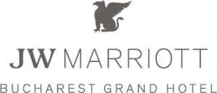

JW Marriott Bucharest Grand Hotel
Consultancy Report

Student name: Cristian Paveliuc

Student ID: 2110402
Company name: VICRIS Consultancy

Contents
Executive summary 3
Introduction 4
Analysis 4
PESTLE Analysis 6
TOWS Analysis 8
The Star Model 9
Recommendations and Change Management 12
Action Plan 14
Conclusion 14
Reference list: 15

Executive summary
The hospitality sector is a vital element of the national economy. It offers a variety of services such as lodging establishment, dining service transportation and accommodation, recreational activities. Hotel Marriott is a respected and widely recognised company in the business. The report described several challenges and solutions to maximise profit while maintaining customers and employees satisfaction.
As the fastest expanding industry, there are several factors that may have an influence on the hospitality business. According to the research, employees and customers are missing out on fundamental services that other hotels in the brand give on a global scale. The hotel requires significant improvements and investment in its operations. As a result, its development and stability are based on effective operational management in all sectors and surrounds. For example, the report clearly defines all of the important parts of pestle analysis, demonstrating all of the factors that have an effect on the Hotel Marriott market. Furthermore, the TOWS analysis of Marriott Hotel is used to evaluate the property's external threats and opportunities in order to determine the level of an opportunity it must maintain in a competitive market, accomplish customer demand, implement sustainable operations, and identify a number of opportunities that might be conducted to accomplish high profitability and growth. In brief, present four elements but ultimately encompass all the beneficial and adverse points' by expressing the organization's difficulties and opportunities. Hotel Marriott from Bucharest faces issues regarding employee retention and competition. Unlike the rest of the Marriott Hotels, this property does not offer loyalty programmes to their customers, therefore competition is inevitable. The loyalty programme will lessen complexity and attract more clients to the business. Political, economic, and legal variables are beyond the control of organisations, consequently they must adhere to all government demands in order to have a long-term presence in the market. Implementing legal requirements and focusing on integrating different cultural components will establish an enjoyable place to work for employees while also maintaining an excellent reputation. Also the Star Model was used to observe the organization's business strategies and value offerings over time. It recognises the organization's need to evolve throughout time in regard to adjustments in planning, market pressures, or other elements of the marketplace as a whole. As a result, it considers formal organisation as a continuous development difficulty. Following an evaluation of the hotel's difficulties through research, an action plan was developed to identify the issues, solutions, and time required for achieving the goal.

Introduction
The purpose of this report is to examine all of the elements and environments that influence Marriott Hotel's hospitality services. This industry contributes significantly to the nation's financial stability and development.
Inaugurated in November 2000, the JW Marriott Bucharest Grand Hotel is located in close proximity to one of the most representative monuments in the city - the Palace of the Parliament and just a few minutes away from other tourist attractions. It is located in The Grand building, where there are offices and also The Grand Avenue, an area with brand shopping stores. (The Grand, 2023)
In the spring of 2004, the Marriott hotel in Bucharest was promoted to a superior brand of the hotel chain - JW Marriott - located between the five-star standard and the luxury one.The hotel in Bucharest was the first in Europe included in this category of the Marriott chain. The criteria that were the basis of this decision were the interior architecture and the quality of the services. (The Grand, 2023)
The hotel has the highest standards of services, intended for both business and tourism purposes, through 402: 2 Presidential Apartments (Cotroceni and Parliament) 21 Apartments (8 Executive, 6 Senator, 2 Business, 5 Family), 244 Deluxe Rooms (benefit from spacious bathrooms with separate bathtub and shower),45 Grand Superior Rooms,32 Executive Rooms,58 Grand Executive Rooms, 8 Rooms for people with physical disabilities, a Spa centre and health club, a shopping gallery and a casino. (The Grand, 2023)
VICRIS is the consultancy film which will help the hospitality company to overcome the challenges. The consulting film assists the businesses with cost-cutting, software system implementation, strategic planning, and marketing strategy creation and execution.
The main challenges that will be discuss in this report are competition, the staff training and retention and the absence of the loyalty programmes. For the analysis of the issues there will be used several frameworks such as PESTLE analysis, TOWS analysis and the STAR Model framework. The PESTEL analysis is an approach for assessing the operational environment an organisation works. Political, economic, social, technical, environmental, and legal aspects are represented by this framework. (50MINUTES.COM, 2015)
The TOWS matrix is an outline for developing, evaluating, selecting, and gaining admission to business approaches. It represents threats, opportunities, weaknesses and strengths, and. In practise, the distinction between SWOT and TOWS is that SWOT addresses the internal context (strengths and weaknesses), whereas a TOWS matrix assessment concentrates on the external setting (opportunities and threats). (Moslem, 2022)
The Star Model for organisational layout provides the basis for a company's choices regarding design. The structure is composed of a set of conceptual principles that could be controlled by company and impact employee conduct. Regulations are a resource executives learn to use in order to successfully influence their organisations' actions and decisions. (Galbraith, 2023)

Analysis
The issue that will be analysed first is staff retention. People working in tourism, gastronomy, and Hospitality industry in Romania earn between £416.27 and £877.98 gross pay (highest average) including the bonuses. Also, the salaries are calculated based on the education level, experience and job position. (Paylab, 2023)
According to Paylab, men earn 21.1% more than women, and also the age and education level can influence the minimum salary. (Paylab, 2023)
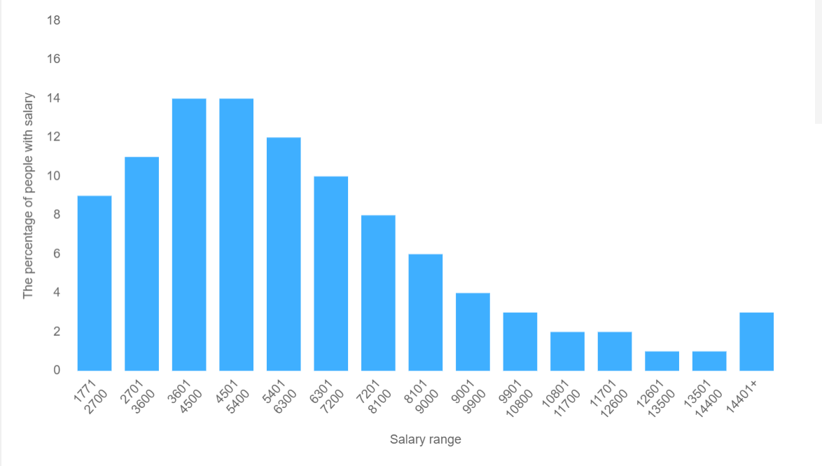
Fig. 1 Distribution of employees in Romania into salary brackets in RON
(Source: Paylab, 2023)
As it can be seen in Fig 1., there is a population of 8% that have their salary 1771 lei, £311.85. This can be a minimum salary depending of age, job position, experience and education level. (Paylab, 2023)
According to the HR Manager, in the hotel industry, the difference is not made by salaries, but by bonuses and development opportunities. A waiter cannot reach a salary 400 euros, but taking into account the tips received, he can reach this threshold. Also, another sector where bonuses make a difference is sales. Depending on the established targets or the organization of events, employees in this sector benefit from a series of benefits depending on their fulfilment and exceeding. (Camelia Buburuz, 2023)
Also she stated that in recent years, there have been situations in which there were people who returned and stayed, but also people who came worked for a period and then chose to leave again.
Like salary expectations, there are candidates who ask for more. However, they become aware that they cannot have the same expectations as abroad. Many accept the situation and become aware that they can evolve from one position to another and earn more in the long term. (Camelia Buburuz, 2023)
According to Michael Armstrong, the tourism and hospitality business is steadily expanding, accounting for 6.1% of worldwide GDP. However, it also faces staff and guest loss as a result of natural disasters such as pandemics, economic downturn, and increasing pricing. (Armstrong, 2020)
Aside from organisational growth and progress, the success of a business is also dependent on its employees. For success in this market, companies must improve staff retention tactics to reduce employee turnover. (Armstrong, 2020)
According to the Marriott Hotel website, the company offer discounts and benefits for travel, bonuses and recommendations, but also the opportunity to be promoted, mentorship and
training. (Marriott
Careers, 2023)
The employees are constantly coming and leaving, and this is affecting the company’s success. The causes of employees leaving are mainly financial. According to the feedback from the employees, the disadvantages are the salary compared to the job description, the manager’s attitude is strict. (Undelucram, 2023)

PESTLE Analysis
A PESTLE analysis is an organisational framework that also serves as a diagnostic tool. The results of the study will assist in understanding outside variables that might affect strategy and influence company decisions. (CIPD,2023)
Political
The political factor plays a significant impact, particularly on an entire country or city's economy. The primary goal of the hotel is to attract in as many guests as it can by providing them with amenities like facilities. Since the hotel business and municipal management are tightly associated, the hotel can only "survive" in comparison to its competitors with the backing and assistance of the city hall. (Pernice, 2023) The political factors that impact the hospitality industry in Romania are the international relationships with other countries, also the wars can impact the international air transport and travelling. (Consiliul Europen, 2023)
Economic
The economic aspect comprises a number of significant elements, including taxes, inflation, economic growth, currency rates, income levels, population consuming levels, and prices of administered programmes. According to a news article, from January 2024 the employees will pay more taxes. Moreover, the company will be impacted because the delivery of sugar and beverage tax will be increased from 9% to 19% (Bihoreanul, 2023) Currently, the inflation is 8,1%, according to Euronews. (Euronews, 2023)
Social
In order for a hotel to continue operating and expand, social factors are crucial. The hospitality industry is improving its methods in order to attract more clients. For example, more vegan and vegetarian cuisine alternatives will be available in hotels. A survey made by Booking.com states that hoteliers have observed an increase in the number of clients requesting food alternatives that are produced responsibly and locally. (Euronews, 2023) This year, artificial intelligence has become a popular issue in travel, with tourists using ChatGPT to organise their itineraries and compare airfares. (Euronews, 2023) Customers are increasingly making purchases online as a result of the rise of social media and e-commerce. Considering younger customers are more inclined than the elderly to make purchases online, Marriott International has to comprehend the demographic differences in online purchasing habits. When developing marketing and communication strategies, it is critical to consider the increasing usage of mobile devices and social media platforms. (Digital Travel, 2023)
It is the organization's obligation to increase customer satisfaction while enhancing their overall experience with service. It is the organization's responsibility to resolve customer concerns and reply to their questions. Hotel Marriott is experiencing difficulty managing feedback from clients since they take long hold times to respond to their concerns. They also fail to respond to customer concerns through their social media pages.In an effort to improve their sustainability over time and continue to function, businesses have to control client complaints while attending to their comments. (Undelucram,2023)

Technological
Because of the degree of technology, technological considerations are of particular importance, and the Marriott hotel follows this rhythm of development and change, continually incorporating the new technologies required for the efficient operation of the hotel's operations. As a 5-star hotel with well-implemented administration, all sanitary standards and conventions, as well as technology, are properly adhered to. According to their website, the ballroom has top-tier technology, and the most recent technology is accessible for all sorts of corporate conferences and meetings. (Marriott, 2023)
Environmental
Because of increased awareness of the environment and changing climatic conditions, environmental analysis has become an important component of PESTEL analysis. Different marketplaces have their own set of environmental standards, laws, and regulations. Bucharest is one of Europe's most polluted cities, and it is in infringement procedures with the European Commission for regularly exceeding the levels of fine moving particles in the air, as well as for failing to monitor air quality in accordance with the law. (Aerlive, 2023) Also according to the hotel website, there are electric car charging stations in the parking lot for the guests. (Marriott, 2023) Also the camping is a new growing technique that people adopt in order to sustain the environment and to reduce expenses. (Martiny, 2023)
Legal
The legal factors that impact the company, are the travel regulations, border control and policies for both tourists and goods. Legal standards must be followed, involving laws for equal treatment and the elimination of cultural disparities in hotels. Marriott promotes all laws by addressing its employees and clients with respect and honesty. The minimum salary and hour regulation is having a detrimental impact since Marriott is primarily concerned with income instead of expense. Also the Economy Minister in Romania, stated that there should me laws and regerminations for people who offer their homes through Airbnb platform, such as statistics and news. (Zamfir, 2023)
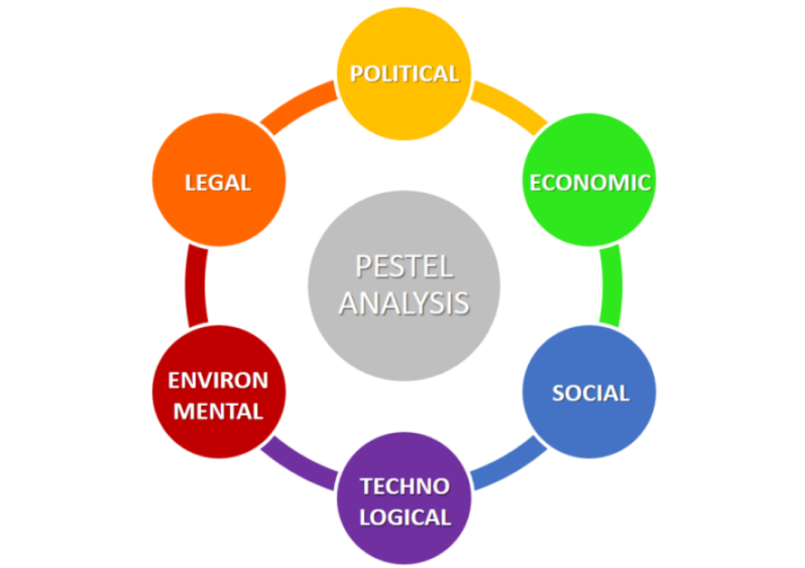
Fig. 2 PESTEL Analysis
(Source: Business-to-you, 2023)

TOWS Analysis
The TOWS matrix is a framework for developing, evaluation, selection, and implementing business methods. It addresses more on the external factors such as threats and opportunities as it can be seen in the Fig 3.
Threats
The biggest threat for Marriot Hotel in Bucharest is the competition. There are 13 hotels with 5 stars. According to Booking.com the first place is held by The Marmorosch Bucharest, Autograph Collection and JW Marriott Bucharest Grand Hotel is on the 5th position. (Booking.com, 2023) Another advantage that the competition has is the green space. Because Marriott’s location is not centred like its competitors, the location doesn’t have parks or natural attractions. Another threat that Marriott is facing is staff turnover and the challenge in replacing them with a similarly competent workforce.
Opportunities
One of the opportunities Marriott Hotel has, is attending job fairs. In Romania there are periodically organised job fairs, especially at the universities. (Euronews, 2023) There are universities with modules such as Business Administration, Management and many other that could provide industries, many capable and top students. Another opportunity for the company would be changing the price currency. At the moment the prices are based on the national currency but converting into euros, could increase the profit of the business. Another opportunity would be developing connections with local governments - secured discounted pricing for events.
Weaknesses
One of the hotel’s weaknesses is the location. It is located far from the city centre, the attractions and also the airport. Also, the services are addressed mainly to business people and the absence of the loyalty programme. Another weakness is the low-income during winter and summer.
Strengths
One of the hotel’s strengths is that it provides a variety of services, including accommodation, a full package of business or personal events, catering, restaurants, a casino, and Grand Avenue, a ground-floor shopping centre where guests can explore and purchase from international brands. (Marriot, 2023) Other strengths are the variety of restaurants and bars, elegant and spacious rooms, the modern and complex management organisation. (Marriott, 2023)

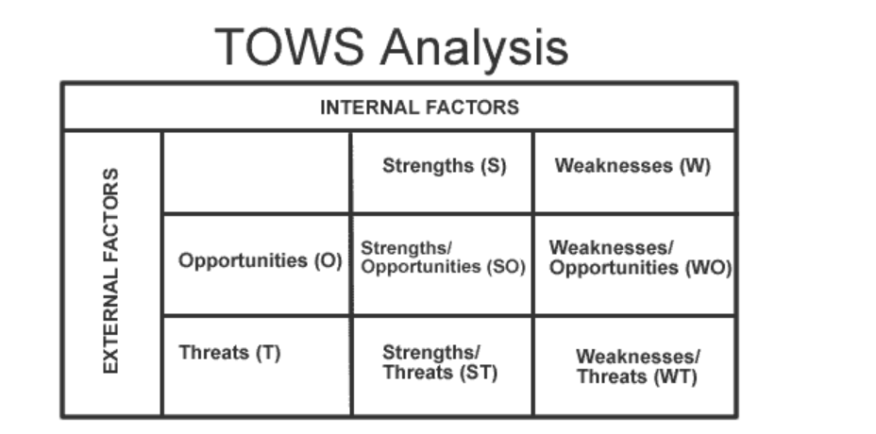
Fig3. TOWS Analysis
(Source: Marketing Teacher, 2023)

The Star Model
Jay Galbraith's Star Model assists businesses to establish the organisation required to maintain an organization's business strategies and value offerings over time. It recognises the organization's need to evolve throughout time in regard to adjustments in planning, market pressures, or other elements of the marketplace as a whole. As a result, it considers formal organisation as a continuous development difficulty. (Garner, 2015)
The Star Model comprises of five components that need to be integrated and coordinated in order to properly influence the company's actions and conduct: Strategy, Structure, Processes, Rewards, and People. The business model is positioned in the centre of the star as a "centre of power" that connects the five sectors. Decisions concerning the business model have an influence on execution in all five areas. (Galbraith, 2002)
The initial stage is strategy, which states the course of action. The second factor is structure, which affects where decision-making authority is located. The third category is processes, which deal with the movement of data and are used to address technological innovations. The fourth category is incentives and reward systems, which impact employees motivation to succeed and meet organisational goals. The fifth area of the model consists of people-related, which impact often define employees' perspectives and talents. (Galbraith, 2002)
Strategy
Strategy is a business's successful recipe. The business's plan of action outlines the goals and targets that need to be reached, as well as the values and missions to be achieved; it establishes the business's core orientation. The strategy specifies the goods or services that are to be delivered, the sectors that will be targeted, and the benefit that should be offered to customers. It also identifies possible grounds of differentiation. (Galbraith, 2002)
Marriott Hotel Bucharest’s mission is to thrive through in delivering excellence through all the actions and manifestations. The business considers that the ethical and considerate attitude of all acts performed, accomplished with unparalleled safety and efficiency, in constant communication with social and environmental changes, provides the finest circumstances for expression and sustainable development. In regard to this, the hotel has installed a contemporary system of solar panels on the roof of The Grand building to ensure that a portion of the power consumed comes from renewable sources. The Grand works continuously with Concordia, one of Romania's most active humanitarian organisations, to assist children and young people from disadvantaged households. (The Grand, 2023)
Structure
The structure of authority and control in a company is determined by its structure. Structure principles are divided into four categories: specialisation, shape, power distribution and departmentalization. The type and quantity of job specialisations employed in completing the task are referred to as specialisation. Many employees in every division, flat organisational structures with few levels result. The vertical component of power distribution pertains to the traditional concerns of consolidation or decentralisation. It refers to the unilateral change of authority to the organisation addressing directly with the problems vital to its goal. Departmentalization serves as the foundation for the formation of units at all tiers of the organisation. Operations, items, workflow processes, markets, consumers, and location are the typical parameters on which divisions are built. In a matrix system, multiple dimensions may submit to an identical manager at the same level. (Galbraith, 2002)
The Bucharest Marriott staff has more than 500 employees who work in the following departments, each of them being led by a manager directly subordinate to the general manager: Food & Beverage Department, Financial department, HR, Sales and Marketing department, technical department and Rooms and service department.
Process
Communication and decision-making procedures flow through the structure of the business; if structure is regarded of as the organization's anatomy, processes are its physiology or operating. Management procedures are equally vertical and horizontal in nature. (Galbraith, 2002)
Rewards
The objective of the reward system is to connect the employee's plans with the desired objectives of the organisation. It serves as encouragement and motivation to complete the strategic plan. The organization's incentive system establishes regulations that govern pay, promotions, incentives, share of profits, options for stocks, and other benefits. This domain is undergoing significant transformation, especially since it promotes lateral activities. Pay-for-skill wage practises, as well as team incentives or gainsharing schemes, are currently being used by businesses. There is also a growing trend of providing nonmonetary benefits such as appreciation or difficult tasks. (Galbraith, 2002)

According to the Star Model, in order to impact the strategic plan, the reward system must be compatible with its foundation and activities. Reward systems are only successful when combined with other design decisions to produce a cohesive package. (Galbraith, 2002)
Marriott provides an atmosphere whereby every employee may develop and create a long-term career. All the company accomplishes is based on the organisation's ethos of "putting people first." Every day, the job requires continuous learning, cooperation, and a friendly environment. (The Grand, 2023)
In terms of compensation and other work benefits Marriott provides competitive salaries and perks to all associates, which vary by function and location: competitive advantages (which may differ by nation depending on employment laws and practises). Discounts on international chain hotel rooms; Food and beverage discounts, as well as discounts in hotel gift shops worldwide. (The Grand, 2023)
People
This domain manages human resource policy pertaining to recruiting, selection, movement, training, and advancement. Human resource policies, when implemented correctly, develop the abilities necessary by the company's approach and structure, providing the skills and attitudes necessary to accomplish the selected path. These policies, like the policy decisions in the other domains, operate optimally when they are aligned with the various linking design areas. (Galbraith, 2002)
At Marriott Bucharest performance evaluation is carried out on a regular basis using verification forms, the results of which show how each employee accomplished his obligations.
The initial assessment is performed three months after employment; if the employee receives the qualities "excellent," "very good," and "good," it indicates that the trial period has finished, and he will continue to work in the hotel. If the qualifications are "needs improvement" or "unsatisfactory," the employee will be let go permanently. After the initial trial period, a verification will be performed after the first 6 months, followed by reviews every year, generally at the end of the year, so that the employee obtains a bonus based on the results. (JW Marriott, 2023)
The main considerations during these evaluations are work productivity, the level of professionalism with which the employee fulfils his duties, the client orientation, comprehension of the work performed, the capacity to work in a team and adjust to changes, initiative, active involvement in achieving general company objectives, written and verbal communication ability, employee cleanliness and personal hygiene. (JW Marriott, 2023)
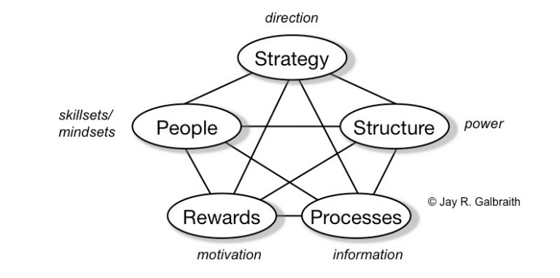

Fig. 4 The Star Model
(Source: Galbraith, 2002)

Recommendations and Change Management
Marriott hotels have to strengthen their management practises in order for them to accurately represent the company's goals and regulations. The negative aspects that need better strategies are the strict regulations, competition strategies, employees retention and loyalty programmes for customers. (Rue, 2016) It is accurate that implementing stringent regulations and providing instruction will lead to immediate achievement and minimise errors. However, excessive of everything is dangerous, therefore Hotel Marriott is overly rigid with its staff and its standards of conduct. Employees feel demotivated and uncomfortable as a result of committing a single error and nervous about jeopardising their position.
As a result, it is detrimental to Marriott's future growth. Because employees are the most important aspect of any business, the employee turnover percentage must be consistently minimal in order to retain Marriott's reputation. Employees must be given the flexibility and authority to make decisions that encourage creativity and fresh concepts within the company. (Undelucram, 2023)
Increased competitiveness is the most detrimental aspect for the Hotel Marriott. Hotel companies such as Sheraton, Intercontinental, Ramada, and Radisson are setting up strong competition in terms of hotel expenses, cuisine, and accommodation, which are popular among travellers. This constituted an obstacle for Hotel Marriott to develop innovative and current tactics by giving exceptional services that the competition can't offered (Sharma, 2020). As a result, competition is required to addressed by conducting continual studies on rivals' behaviour and developing a counter-strategies that might reduce their share of the marketplace.
Employee retention
A first step in retaining the employees is developing a plan for career development. The corporation has responsibility for initiating and maintaining career development happens. The company's tasks are particularly to create and provide career opportunities inside the organisation to its personnel. The organisation should thoroughly educate staff on various career pathways in order for them to attain their professional ambitions. Human resource employees are normally in charge of maintaining this information up to date when new positions develop and previous ones are gradually taken out. Human resource professionals should work together with both employees and their supervisors to ensure that precise data is communicated and that the connections between different career pathways are recognised. (Rue, 2016) Career counselling is also an appropriate method to help employees to persue their career within organisation. Expert counselling is a procedure that connects the many stages of the growth process. An employee's direct manager, an HR consultant, or an assortment of the two may provide career counselling. In most circumstances, having the direct manager undertake counselling with proper involvement from HR experts is preferred. The direct manager often has practical experience, is familiar with the firm, and may provide a realistic assessment of organisational prospects. (Rue, 2016) Companies should embrace a fresh approach to management which enables them to oversee their staff effectively while also inspiring them to work effectively. These methods of management allow Marriott hotels accomplish the objectives of their business as well as the needs of its employees. Since it promotes creative approaches, executives should allow workers to share their ideas in the workplace.
Rewards are another method of employee retention. The system of free enterprise is predicated on the idea that incentives should be based on performance. This link between compensation and performance is desired not just at the organisational or commercial level, but additionally at the person's level. The fundamental premise is that personnel will be engaged if they feel their efforts will result in the intended rewards. However, many formalised awards granted by organisations are not performance-related. This group of rewards, which includes paid vacation, insurance plans, and paid holidays, is nearly generally chosen by organisational affiliation and experience rather than achievement. (Rue, 2016)
Marriott Hotels should provide outstanding training to its employees to help them manage a range of workplace difficulties. These challenges include increasing personnel turnover, providing a friendly environment, and meeting health and safety demands. Personnel productivity and effectiveness enhance as does staff engagement as a consequence of this education and growth. Throughout this training, the company helps personnel embrace rigorousness in a positive way, encouraging them to increase their efficiency. (Su, and Chen, 2020)
Competition within an industry can be influenced significantly by an individual firm's participation in franchising. Considering the services business is not consistent, the impact of franchising on industry competitiveness may vary depending on business-specific variables. (Sun, 2018) Because of the amount of capital required and the environment of work carried out by franchisees in the hospitality industry, the connections between franchising and each of the three aspects of competition may have various degrees of significance, or even separate valences, when compared to other service industries. (Sun, 2018) The level of competition within all industries influences the number of goods and services in the market and indicates the magnitude of the business environment within that industry. (Sun, 2018)

Action Plan

Number | Problem | Solution | Desired outcome | Time scale | Completion date | Planned Budget
1 | Employee retention | Offering career development, promotions, incentives and rewards. Reviewing their performance and increase salaries. | Employee engagement as well as job fulfilment, better business results, increased customers satisfaction | 5 months | April 2023 | £30000
2 | Competition | Businesses utilise a variety of technologies and software to enhance their activities. Improve marketing strategies and price adjustments. | Customers overflow, positive feedback from the customers, gaining awards based on the services provided. | 7 months | June 2023 | £50000
3 | Loyalty programmes | Implementing loyalty programmes and benefits for customers. | This solution would increase the profit. Opportunity to gain more customers and competitive advantage. | 3 months | February 2023 | £5000

Conclusion
To conclude it is vital for hospitality businesses to identify organisational difficulties in order to increase its productivity and importance. This research discusses the environmental and internal factors that determine an organization's performance. According to this report, the employees are a key factor in the hotel sector, this key helping to grow the country's economy and provide benefits to the organisation. The business is facing a number of challenges as a result of personnel turnover and competitiveness. It is important for the organisation to have a strategy for managing employees and to establish new strategies for customer satisfaction. Future possibilities are being studied in collaboration with this company in order to acquire advantages in competition while achieving greater achievement. In addition, the company applies a variety of regulatory tactics to assist customers obtain better results and becoming more successful in the industry. The needs of consumers are evolving, generating new concerns for the hotel business. Clients nowadays expect leisure networks, internet access for free, and an excellent experience. As a result of these evolving demands, companies are under demand to provide superior services for clients in order to compete in their sector. Visitors expect an environment that is clean and secure, which contributes to the establishment of confidence amongst the firm and its clientele. This affects matters for Marriott Hotel and consequently boosts the cost of conducting enterprise. Companies are experiencing difficulties as their sector becomes increasingly competitive. To overcome these difficulties and distinguish their offering from the services provided by competitors in the market, organisations can utilise a range of customer service tactics. Clients may anticipate an immediate reaction to any difficulties or inquiries they may have. (Lee,. and Oh, 2019) Social networking engagement, sufficient safety and health measures, concierge service, and a clean atmosphere all boost client contentment, thereby improving customer loyalty to the brand. Responding promptly to customer concerns improve the business's reputation in the thoughts of its customers although additionally offering them with a competitive edge.
On this instance, the consultant company appreciates the opportunity provided by Marriott to conduct this research. It was designed to draw attention to the challenges that Marriott is now facing, and the agency attempted to give a long-term solution that could be implemented in the shortest period of time.

Reference list:
The Grand, 2023, JW Marriott Bucharest Grand Hotel, Available at: https://thegrand.ro/jw-marriott [Accessed on 16 November 2023]
Savari, M., Amghani, M., 2022, SWOT-FAHP-TOWS analysis for adaptation strategies development among small-scale farmers in drought conditions, International Journal of Disaster Risk Reduction, Volume 67, ISSN 2212-4209, Available at: https://doi.org/10.1016/j.ijdrr.2021.102695. pag 11
50MINUTES.COM, 2015, PESTLE Analysis: Prepare the best strategies in advance, Primento Publishing, EPUB Available at: https://www-vlebooks-com.ezproxy.uwtsd.ac.uk/Product/Index/856158?page=0&startBookmarkId=-1
Galbraith Management Consultants, 2023, Star Model, Available at: https://www.jaygalbraith.com/services/star-model
Paylab, 2023, Salaries in the category: Tourism, Gastronomy, Hotel Business, Available at: https://www.paylab.ro/en/salaryinfo/tourism-gastronomy-hotel-business[ Accessed on 15 November 2023]
Wall Street, 2023, HR Manager Marriott: Bonusurile fac diferenta in industria hoteliera, Available at: https://www.wall-street.ro/slideshow/Careers/40650/HR-Manager-Marriott-Bonusurile-fac-diferenta-in-industria-hoteliera.html?full#gref [Accessed on 9 November 2023]
Marriott Careers, 2023, ÎNCEPE-ȚI CĂLĂTORIA PROFESIONALĂ ALĂTURI DE LIDERUL #1 ÎN OSPITALITATE LA NIVEL GLOBAL, Avallabile at: https://marriottcariere.ro/
Unde Lucram, 2023, JW Marriott Bucharest Grand Hotel, Available at: https://www.undelucram.ro/evaluari-jw-marriott-totul-despre-mediul-de-lucru-interviu-216?page=3
Armstrong, M. and Taylor, S. (2020) Armstrong’s Handbook of Human Resource Management Practice. [BibliU version] 15th ed. London, Kogan Page.
CIPD, 2023, PESTLE analysis, Available at: https://www.cipd.org/uk/knowledge/factsheets/pestle-analysis-factsheet/
European Parliament, 2023, Turismul, Available at: https://www.europarl.europa.eu/factsheets/ro/sheet/126/turismul
Consiliul European, 2023, Impactul invadării Ucrainei de către Rusia asupra piețelor: răspunsul UE, Available at: https://www.consilium.europa.eu/ro/policies/eu-response-ukraine-invasion/impact-of-russia-s-invasion-of-ukraine-on-the-markets-eu-response/
Bihoreanul, 2023, S-a promulgat legea privind creșterea taxelor. Ce modificări vor avea loc și începând de când, Available at: https://www.ebihoreanul.ro/stiri/s-a-promulgat-legea-privind-cresterea-taxelor-ce-modificari-vor-avea-loc-si-incepand-de-cand-182204.html
Hughes, R. 2023, Want to stay at a sustainable hotel? These European countries have the most according to booking.com, Available at: https://www.euronews.com/travel/2023/10/24/want-to-stay-at-a-sustainable-hotel-these-european-countries-have-the-most-according-to-bo
Digital Travel, 2023, The Role of Social Media in Tourism Marketing, Available at: https://digitaltravelapac.wbresearch.com/blog/social-media-in-tourism-marketing
Marriott, 2023, JW Marriott Bucharest Grand Hotel, Available at: https://www.marriott.com/en-us/hotels/buhro-jw-marriott-bucharest-grand-hotel/events/
Martiny, J., 2023, Influenţează războiul şi schimbările climatice turismul?, Available at: https://www.dw.com/ro/coronavirus-r%C4%83zboi-schimb%C4%83ri-climatice-ce-impact-au-toate-acestea-asupra-turismului/a-64314065
Zamfir, C., 2023, Românii care fac un ban din închirieri pe AirBnB și Booking „ar trebui supuși” unor reglementări privind datele statistice - strategie propusă de Ministerul Economiei, Available at: https://www.startupcafe.ro/taxe/romanii-care-fac-bani-inchirieri-airbnb-booking-reglementari-strategie-ministerul-economiei
Marketing Teacher, 2023, TOWS Analysis, Available at: https://www.marketingteacher.com/tows-analysis/
Booking.com, 2023, JR Marriott Bucharest Grand Hotel, Available at: https://www.booking.com/searchresults.ro.html?aid=356980&label=gog235jc-1DCAMYyAEowAE4vgNIIFgDaFCIAQGYASC4ARfIAQzYAQPoAQH4AQKIAgGoAgO4AsjI2qoGwAIB0gIkYTU4ZjUwNjMtNmEyMC00NjA4LWFjYzktODM5YjNjMGYxMDBl2AIE4AIB&sid=995e9c4f47121a9c651f2658a34bd462&city=-1153951;nflt=sth%253D110;pptfromtl=58;src=theme_landing_city
Euronews, 2023, PoliJOBS 2023 a început. Zeci de companii prezintă ofertele de angajare pentru tinerii studenți, Available at: https://www.euronews.ro/articole/polijobs-2023-politehnica-bucuresti-locuri-de-munca
Business to you, 2023, IMG, Scanning the Environment: PESTEL Analysis, Available at: https://www.business-to-you.com/scanning-the-environment-pestel-analysis/
The Grand, 2023, About Us, Available at: https://thegrand.ro/despre
Marriott, 2023, Târgul de Joburi, Available at: https://jwmarriottcariere.ro/
Galbraith, J., 2002, The Start Model, Available at: https://www.jaygalbraith.com/images/pdfs/StarModel.pdf
Rue, L., 2016, Human Resource Management, 11e, McGraw-Hill Education, New York pag. 305
Kyung-A. Sun, Seoki Lee, 2018, Effects of franchising on industry competition: The moderating role of the hospitality industry, Volume 68, Pages 80-88, ISSN 0278-4319, https://doi.org/10.1016/j.ijhm.2017.10.002.
Lee, S.A. and Oh, H., 2019. Anthropomorphism and its implications for hotel advertising brands. Journal of Business Research.
Kotter, J (2012). Leading change. Harvard Business Review Press.

