DS 1 Template

My Screenshots/Photos
- Please add 4–6 screenshots or photos of your digital life.
- You can use your phone or laptop.
- For each screenshot, write one or two sentences explaining what it shows.

Screenshot/Photo 1
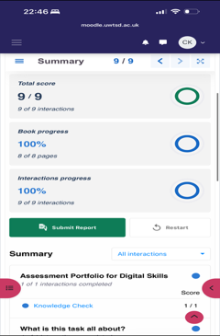
This screenshot shows my moodle activity . I use the moodle to access my university course materials , complete activities and keep track of my studies .

Screenshot/Photo 2
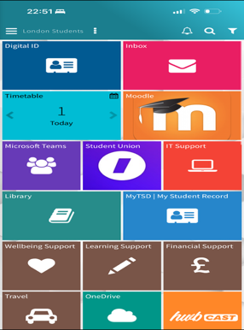
This ss shows my UWTSD Hwb. I use it to access Moodle , my timetable , emails and other university services .

Screenshot/Photo 3
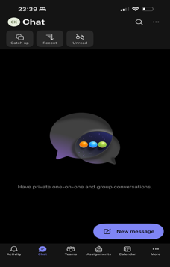
This ss shows Microsoft Teams . I use teams to communicate , check assignments and keep up with my university activities .

Screenshot/Photo 4
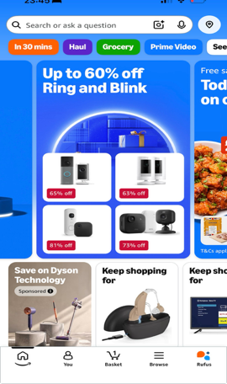
This ss shows Amazon , which I use for online shopping .
I use it to search for products compare prices and buy things I need .

Screenshot/Photo 5
[Insert Photo/Screenshot below]

[Write what this shows of your digital life]

Screenshot/Photo 6
[Insert Photo/Screenshot below]
[Write what this shows of your digital life]

My Short Reflection
- Write 5–8 simple sentences about your digital life.
- You can use the sentence starters below if helpful.
I use digital tools every day for my studies and personal life .
I use Moodle to access my course materials and complete my university work .
I also use Microsoft Teams to communicate and check my university activities. I use online shopping apps such as Amazon in my daily life .
I feel confident using basic digital tools , but I still have more to learn.
I want to improve my digital skills and become more confident
I hope this module will help me use digital tools more effectively.

Sentence starters
- I use digital tools to …
- I feel confident when I …
- I want to improve …
- I often use these tools: …
- I sometimes feel nervous about …
- I hope this module will help me …
- Digital skills are important for me because …
You can write more if you want.

Submission Checklist
Before you submit, please check:
​​​ ☐ I added 4–6 screenshots
☐ I wrote short sentences for each screenshot
☐ I wrote my short reflection
☐ My work is my own
☐ My file opens correctly
​​☐ My file opens correctly

