Hotel Handbook for Intercultural Competence

Student no: 2014605
Name: Aurelia Nae
Module: Cultural Awareness
Module code: BMIH5003
Lecturer : Mike Davies

Contents

Executive Summary
Contents Page
Introduction
County A: Romania
Country B: Japan
Hotel Handbook ( do’s & don’ts)
Conclusion

Executive Summary

Introduction
In an increasingly global world, to know the cultural differences between countries are essential skills in Hospitality Industry for various reasons like establishing and maintaining work culture in order to promote elevated levels of output in an organization. Cultural competence encourages the acknowledgement and acceptance of differences in appearance, behaviour and culture. By recognising and understanding different values shaped by our diverse cultural background we allow our self to develop successful personal and professional relationships.
According to Hofstede (1980) , culture is the minds collective programming that distinguishes between one category of people and members of one group from another. This initial analysis of studied people who worked for IBM in more than 50 countries and identified systematic differences in national cultures on four primary dimensions: power distance, uncertainty avoidance , individualism versus collectivism and masculinity versus femininity. The original theory proposed four dimensions and a bit later co-authors and Hofstede (1984) identified a new fifth dimension named long-term orientation versus short-term orientation to life, to cover aspects of values not discussed in the original paradigm and a sixth dimension (2010) indulgence versus self-restraint.
So, this report will focus on the application of the Hofstede Model on to give a general overview and understanding of other cultures , what to expect and to behave towards peoples from other countries.
Country A: Romania
The InterContinental Bucharest is the first five star hotel to be built in the Romania capital and the highest hotel in town with a landmark of heritage and comfort. Romania is a country in south-eastern European, with the majority of its inhabitants are ethnic Romania. Romania society has changed in recent decades due to the impact of socio-political processes and economic and is increasingly culturally oriented towards Western Europe. Population of Romanians are known for being warm, hospitable, animated, with a good sense of humour, religious (Orthodox) and places great importance on family networks and values. Also, Romania have a strong tradition of folk which includes dance, folk music, ceramics, embroidery and wood carving .
The research of Romania culture through the lens of the Hofstede model it shows that:
- The high scorer of 90 on Power Distance means that employees of all departments accept a hierarchical order in which everybody has a place and which needs no further justification; ;
- The scores of 90 of dimension Uncertainty Avoidance define that employees high preference is avoiding uncertainty and have an inner urge to be busy and work hard, precision and punctuality are the norm and security is an important element in individual motivation;
- The scores of 30 of dimension Individualism means that employees are having individualistic behaviour and have good bonding and comes out of difficult situations easily;
- Romania scores 42 means that the dimension Masculinity versus Femininity is considered a relatively Feminine society and focus is on working in order to live. Moreover, they are more expectations from the female employees;
- The intermediate score of 52 on The Long Term Orientation describes that culture encourage thrift and efforts in modern education as a way to prepare for future and employees to plan for long time when they are planning for future;
- With a very low score of 20, Romanian culture on the Indulgence dimension is one of Restraint and employees from all departments must follow strict norms.
Romania versus Japan
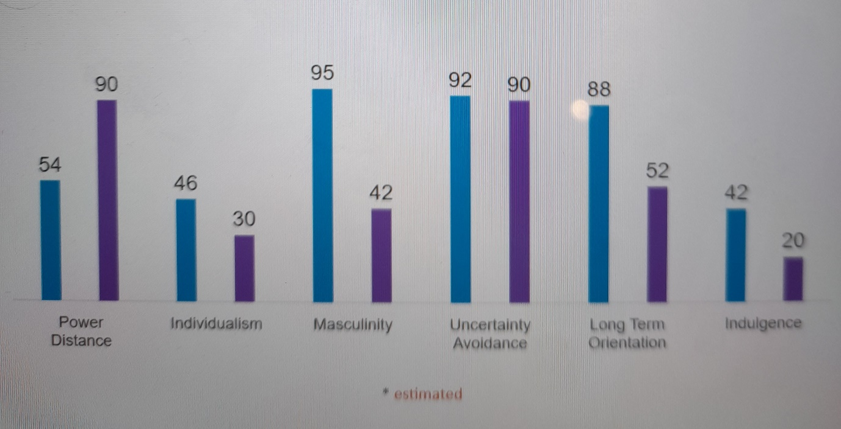
Hofstede Insights (2021)

Country B: Japan
Japan has a multifaced culture such us the traditions dating back for thousands of years with influences from Buddhism and Shinto religion and a society in a continual state of fast change, with continually shifting trends and fashions and technological progress . Manners are very important and people greet each other by bowing. There are strict rules regarding indoor manners like shoes are taken off when entering in most of the restaurants, temples and historic buildings. Chopsticks are used to eat instead of cutlery and it’s polite to say thank you for the meal and never tip. Also, for special events and festivals people wear the traditional ethic garments like kimonos and western clothing is worn in day to day life.
The research of Japan culture through the lens of the Hofstede model it shows that:
- Power distance score of 54 define that Japan is a borderline hierarchical society and employees are always conscious of their hierarchical position in any social setting and act accordingly;
- The dimension Uncertainty Avoidance Japan scores 92 means that is one of the most uncertainty avoiding countries on society glob due to the fact that in Japan are earthquakes every day ;
- Japan scores 46 on the Individualism dimension and an explanation of this score is that Japanese society does not have extended family system which forms a base of more collectivistic societies and the family name and asset was inherited from father to the eldest son ;
- At a score of 95, Japan is one of the most Masculine societies in the world. On the expression of Masculinity in Japan we see a severe competition between teams and drive for excellence;
- At 88 Japan scores as one of the most Long Term Orientation oriented societies. Japanese see their life as a very short moment in a long history of mankind ( do your best in your life time and that is all you can do) ;
- The score of 42 in Indulgence dimension means that people have a tendency to cynicism and pessimism and their actions are restrained by social norms.
Hotel Handbook

Do’s | Don’ts
For al departments : in Romania, greetings consist of a direct eye contact, a firm handshake and the appropriate greeting for the time of day . | For all departments: in Japan, people don’t greet with a handshake and eye contact and greet by bowing.
For all departments: in Romania address people using formal title as Mr/Mrs followed by the surname. | For all departments: in Japan, don’t address people using formal title and address by their last names plus the suffix San.
For all departments: in Japan, bowing or nodding your head is also done when apologizing or thanking someone. | For all departments: don’t bowing or nodding your head when you apologize or thank a client from Romania.
For all departments: pointing at people is considered rude in Romania and pointing at things it is ok. | For all departments: pointing at people or things is considered rude in Japan.
For all departments: in Romania , direct eye contact is expected and is also normal for people’s eyes to wander a little during conversation. | For all departments: in Japan, making eye contact with another person during conversation is considered rude.

Conclusion
The research of Romania and Japan culture using Hofstede model it shows that are differences between countries and help us to understand and manage them by creating a Hotel Handbook with basis of differences in value and beliefs regarding work goals. By studying and resolving the cultural issue an organization keep its employees in a joyful mood and increase revenue. Moreover, in the present scenario when the world changed due to post pandemic worldwide study of cultural diversity requires to maintain harmony among employees team work and with out studying previous work cultures of employees may result in disengaged employees.

