

Programme: Master of Business Administration
Module: International Marketing (Principles & Practices)
Module code: LCMB7026
Word count: 5191
Lecturer : Dian Mayasari (Birmingham)
Student Name : Sifat Al Galib
Student ID: 2438313
Submission Date- 27/03/2026

Table of Contents
SECTION 1: COMPARATIVE REPORT
1.0 Introduction…………………………………………………………………….. 3
2.0 Comparative Analysis of the Macroenvironment (PESTEL)…………… 3-6
2.1 Political Factors
2.2 Economic Factors
2.3 Social Factors
2.4 Technological Factors
2.5 Environmental Factors
2.6 Legal Factors
3.0 STP and International Marketing Mix (7Ps) Analysis……………………. 6-11
3.1 Segmentation, Targeting and Positioning (STP)
3.2 Marketing Mix (7Ps)
3.2.1 Product
3.2.2 Price
3.2.3 Place
3.2.4 Promotion
3.2.5 People
3.2.6 Process
3.2.7 Physical Evidence
4.0 Directional Development Strategy in Bangladesh……………………….. 11-13
5.0 Ethical Issues in Zara’s Marketing Mix…………………………………….. 13-14
5.1 Supply Chain Ethics
5.2 Environmental Ethics
5.3 Cultural and Marketing Ethics
5.4 Pricing Ethics
6.0 Recommendations…………………………………………………………….. 14-16
7.0 Conclusion……………………………………………………………………… 16
SECTION 2: REFLECTIVE ACCOUNT
1.0 Description……………………………………………………………………… 16
2.0 Feelings………………………………………………………………………….. 17
3.0 Evaluation……………………………………………………………………….. 17-18
4.0 Analysis………………………………………………………………………….. 18
5.0 Conclusion………………………………………………………………………. 19
6.0 Action Plan………………………………………………………………………. 19
Reference List.……………………………………………………………………… 19-23

SECTION 1: COMPARATIVE REPORT
1.0 Introduction
Zara, the mother brand of the Spanish multinational conglomerate Inditex was established in 1975 by Amancio Ortega and Rosalia Mera in A Coruna, Spain. With a market presence of 96 countries and more than 1,800 stores worldwide, it has revenues of more than EUR23 billion each year which places it as the largest fast-fashion retailer in the world (Inditex, 2024). The model adopted by Zara, speed of designing to store, verticalization and runway inspired fashion at affordable prices has revolutionized the way retailing is done globally (Ghemawat and Nueno, 2006). This report provides a comparison between the marketing strategies of Zara in the United Kingdom, which is a mature market, and the Bangladesh, an emerging economy in the retail sector. It considers the 7ps framework, the use of PESTEL and STP analysis to determine how it adapts, ethical issues and future strategy.

2.0 Comparative Analysis of Macroenvironment: PESTEL Framework.
2.1 Political Factors
The United Kingdom is a stable democratic system, though, Brexit orchestrated trade and regulation uncertainties to impact supply chains and EU alignment (Dhingra et al., 2017). In the case of Zara, whose mother company, Inditex, is located in Spain, Brexit imposed higher tariffs, customs inspections, and administrative expenses on imported goods into the EU (Business of Fashion, 2021). That said, the UK is competitive because of its clear jurisdiction and robust regulatory safeguards (Hollensen, 2020). Although Bangladesh is a parliamentary democracy, the nation is vulnerable to political unrest such as hartals and intra-party political unrest between the Awami League and the Bangladesh Nationalist Party (BNP), which is likely to upset business confidence (World Bank, 2023a). Nevertheless, the stimulatory strategies of investment, export-processing zones, and incentives related to the garment sector stimulate the growth, yet retail FDI is still constrained, and franchising is preferred (Rahman and Khondker, 2020; Siddiqui, 2021).
2.2 Economic Factors
UK is a high-income country, the GDP per capita stands at around $46,000 and the fashion business in the UK is worth £62 billion (World Bank, 2023b; Statista, 2023a). Nonetheless, the consumer price sensitivity has risen due to inflation and also due to the cost-of-living crisis that occurred after 2022 (Office for National Statistics, 2023). Bangladesh, on the other hand, has had an average annual growth of over 6% and its urban middle-income group is growing, despite the fact that GDP per capita is still much lower at about 2,688 (World Bank, 2023b; International Monetary Fund, 2023). However, the price sensitivity of the consumers in Bangladesh is considerably lower compared with the UK consumers (Khanna and Palepu, 2010; Hossain and Rahman, 2022).
In the case of Zara Bangladesh, this provides an opportunity and threat. The expansion of the urban middle-income is an obvious market opportunity of an aspirational global fashion brand, but low purchasing power and high price elasticity limit the penetration of the mass market, implying that the realistic strategic focus of Zara is the upper-middle-class and confident urban consumer.
2.3 Social Factors
The fashion consumption, brand perception, and marketing strategy are greatly influenced by social and cultural dynamics.
Consumer Behaviour in the UK:
British shoppers have become fashion savvy and they exist in a very competitive retail sector comprising of high-street retailers like Primark, H&M and Next, as well as luxury brands like Burberry and Alexander Mcqueen. The characteristics of the market include the short-term cycles of trends, high levels of e-commerce choices, and increase in sustainability awareness (Mintel, 2023). This environment is close to the positioning of Zara, which is affordable luxury (Caro and Martinez-de-Albeniz, 2015). UK has a high score regarding individualism (89), which focuses on self-expression and taste of any kind in the acquisition (Hofstede Insights, 2024). An uncertainty avoidance score of (35) is rather low, meaning that it is open to experimentation (De Mooij, 2019). Following the pandemic, e-commerce is about a quarter of all retail sales in the UK (Office for National Statistics, 2023). Instagram, Tik Tok and Pinterest are the social media websites that impact younger consumers greatly (Statista, 2023b).
Bangladesh Consumer Behaviour:
The domestic fashion retail industry in Bangladesh is not so advanced and is characterized by domestic brands and tailoring (Siddiqui, 2021). Though, Dhaka is experiencing urbanisation and income growth which are driving demand in organised retail (Hossain and Rahman, 2022). According to Hofstede data, power distance is high (80) and individualism is low (20) which indicates collectivist decision making behavior (Hofstede Insights, 2024). Family and community norms determine the purchasing decisions (De Mooij, 2019). The expectations of modesty which are influenced by Islamic values (around 90% of the population is Muslim (Bangladesh Bureau of Statistics, 2022)) influence the suitability of products (Aziz and Afzal, 2021). Though Instagram, Facebook, and YouTube are already growing more influential on younger consumers, the conflict between international fashion dreams and domestic traditions brings a complicated market situation into persistence (Rahman and Khondker, 2020).
Hofstede's Dimensions — A Comparative Summary:
Dimension | UK | Bangladesh
Power Distance | 35 (Low) | 80 (High)
Individualism | 89 (High) | 20 (Low/Collectivist)
Masculinity | 66 (High) | 55 (Moderate)
Uncertainty Avoidance | 35 (Low) | 60 (Moderate-High)
Long-Term Orientation | 51 (Moderate) | 47 (Moderate)
Indulgence | 69 (High) | 20 (Restrained)
(Source: Hofstede Insights, 2024)
The consumer behaviours of the UK market are more impulsive, and the consumer behaviours of the Bangladeshi market emphasise social affiliation and long-term worth (De Mooij, 2019).
2.4 Technological Factors
UK penetration of the internet is estimated at 97% and has a very high level of digital infrastructure that covers advanced e-commerce ecosystems (Statista, 2023b). To improve the online shopping experience, Zara UK has engaged in digital integration, providing online shopping, click-and-collect, online-to-store returns, and an app with augmented reality (AR) capabilities to increase the shopping experience in the store (Inditex, 2024).
The internet penetration in Bangladesh had reached approximately 40 percent in 2023, and it was mainly brought on by the cheap mobile data and 4G connectivity (Bangladesh Telecommunication Regulatory Commission, 2023). E-commerce websites like Daraz are on the rise, as well as local, up-and-coming e-tailers (Hossain and Rahman, 2022). Nevertheless, online payment applications are not as developed, and cash-on-delivery has been leading (Siddiqui, 2021). Zara will have to, therefore, be flexible towards reduced digital maturity and logistical restrictions.
2.5 Environmental Factors
The UK has heightened environmental awareness, especially, after the 2019 report of the Environmental Audit Committee on the environmental impact of fashion (House of Commons Environmental Audit Committee, 2019). Inditex also launched its own collection named Join Life and committed to ultimately being sustainable by the year 2025 (Inditex, 2024). However, the model of disposability of fast fashion is criticized (Fletcher, 2014).
In Bangladesh, the issues related to environmental concerns concern primarily the problems of garment production like pollution and dangerous working conditions (Clean Clothes Campaign, 2023). What is lacking is the sustainability awareness among consumers on a relatively low level (Aziz and Afzal, 2021).
2.6 Legal Factors
The UK possesses high legal regulations in the Consumer Rights Act 2015, ASA regulations, and UK GDPR (Information Commissioner's Office, 2023). The Consumer Rights Protection Act 2009 exists in Bangladesh but is not strictly enforced (Siddiqui, 2021). The level of intellectual property protection is lower, and the threat of counterfeit still exists (World Intellectual Property Organization, 2022).

3.0 Analysis in STP and International Marketing mix (7ps) comparison.
3.1 Segmentation, Targeting, and Positioning (STP).
Segmentation:
In the UK, Zara makes use of psychographic and demographic segmentation as it targets young professionals (20-35) who are fashion-sensitive, teenagers who are fashion conscious and middle-income families where the product is based on the trend (Lopez and Fan, 2009). It has also created a sustainability-oriented segment, which shows the increasing awareness of the environment (Mintel, 2023). The geographic segmentation is not that high, because Zara has a national presence with large physical stores and e-commerce network.
In Bangladesh, it is a more income-based and geographical segmentation. The core market will include urban high-end and middle-income consumers in Dhaka and Chittagong, where the purchasing power and the retail infrastructure are more robust (Hossain and Rahman, 2022). Zara targets aspirational buyers aged between 18-35 years who relate global brands to the status and trendiness (Aziz and Afzal, 2021).
Targeting:
Zara in the UK uses differentiated targeting through the sub-brands of Zara Women, Zara Man, Zara Kids and Zara Home (Inditex, 2024). It has an elastic appeal to the fashion-conscious middle market interested in the runway-inspired designs at affordable rates (Caro and Martinez-de-Albeniz, 2015).
In Bangladesh, Zara is using a narrow targeting strategy with its customers being the urban elite and upper-middle class. It is a good niche as it targets a niche with adequate economic strength and global orientation because of premium relative pricing (Siddiqui, 2021).
Positioning:
Zara is established as an affordable, trend-following retailer between the very low-end and the high-end high-street stores in the UK (Tokatli, 2008; Lopez and Fan, 2009). Zara also occupies a more aspirational and status-based role in Bangladesh, which is more of an affordable luxury in the country because of economic differentials and global brand quality (Aziz and Afzal, 2021).

3.2 International marketing mix (7Ps).
3.2.1 Product
The product philosophy of Zara is based on its world-renowned model of fast-fashion, which includes short design cycles, high turnover (twice per week in most of the markets), and a broad assortment of trend-driven items of clothing, accessories, and footwear (Ghemawat and Nueno, 2006).
Zara has a limited amount of adaptation in the UK where it sells its entire global line. The collections are based on the runway trends around the world and are designed by Zara design teams in A Coruna, where the product collections reflect the British fashion desires which are quite similar to the trends in Western Europe (Lopez and Fan, 2009). The effects of the temperate climate in the UK are that seasonal ranges will provide heavier items in winter, and lighter items in summer.
In Bangladesh, it is more important to adapt products. The cultural norms of modesty affect Zara collection as it focuses on longer dresses, covered models, and less provocative designs (Aziz and Afzal, 2021). The climate factors influence the choice to use lightweight and breathable materials and shoes appropriate in rainy weather because Bangladesh has a hot and humid climate that is susceptible to monsoons (Hossain and Rahman, 2022). There is also a difference in taste in colour: the consumers in Bangladesh tend to prefer bright and decorative designs, and it would have to be re-evaluated to align with the minimalist European colour palette, which is prominent in Zara (De Mooij, 2019). Local body proportions are also adapted to sizing (Siddiqui, 2021). This strategy represents the example of adaptation as a part of standardisation, where a global product architecture is preserved, but other factors are modified to fit local cultures, climatic and physical conditions (Vrontis and Thrassou, 2007).
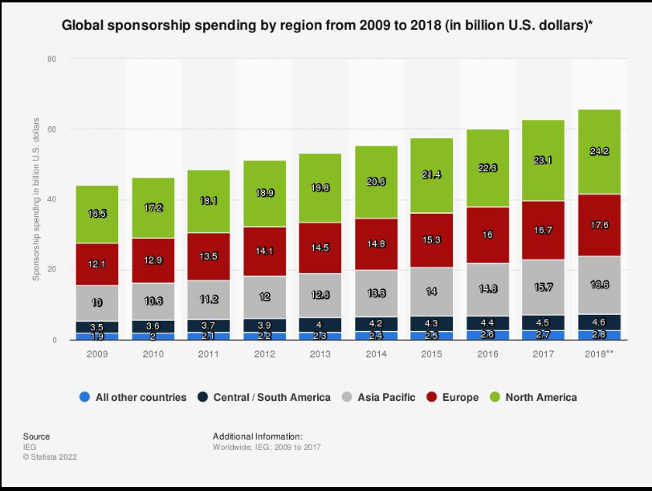
Soure: Baker (2016)
3.2.2 Price
On a global scale, the pricing method utilized by Zara is market-based, which places the company in a competitive position at the same time retaining its brand image (Inditex, 2024). Zara has a middle position in the UK high street, higher than the low-cost stores like Primark or H&M, but lower than higher end stores like Reiss and AllSaints. Dresses cost £30-£60, coats £80-£150 (Zara UK, 2024) which serves as evidence of the Zara, the democratic fashion, positioning.
In Bangladesh, the prices of Zara are similar or a little higher than the UK ones taking into consideration the costs of imports. A £40 dress in the UK can be sold between BDT 5,000 and BDT 7,000 (£35-50), which is equal to 15-25% of average wages in the formal sector (BDT 20,000-30,000) (£140-210) (Bangladesh Bureau of Statistics, 2022; Siddiqui, 2021). Zara is thereby considered to be a high quality brand, which is only affordable to internally higher-income earners. Limited-stock model minimises intensive discounting, which was a successful strategy in both markets, but end-of-season sales in Bangladesh can appeal to a wider aspirational customer group (Caro and Martinez-de-Albeniz, 2015).

3.2.3 Place (Distribution)
Zara has 65 outlets in the UK in shopping centre and high-street areas (Inditex, 2024). The flagship stores like the Oxford street and the Regent street in London are big format multi-storey brand displays. Zara UK also provides a well-developed e-commerce service in which next-day delivery, free returns, click-and-collect, and built-in stock visibility have been integrated, which is a sign of highly developed omnichannel integration (Zara UK, 2024).
Zara is a franchisee in Bangladesh with outlets located in the high-end malls of Dhaka such as Jamuna Future Park and Bashundhara City (Siddiqui, 2021). Numbers of the stores are low, which is indicative of the underdeveloped modern retail industry and a tight-knit high-income consumer market. Local e-commerce is less established because of logistical issues, such as traffic jams, disjointed addresses, and cash-on-delivery preference as a limitation and an initiative to adopt (Hossain and Rahman, 2022).
3.2.4 Promotion
The promotion of Zara as a global company is adopted in the least possible manner, the company spends approximately 0.3% of its revenue on traditional advertising. It is emphasized on prime store locations, word-of-mouth, store design as well as visual merchandising (Ghemawat and Nueno, 2006; Lopez and Fan, 2009).
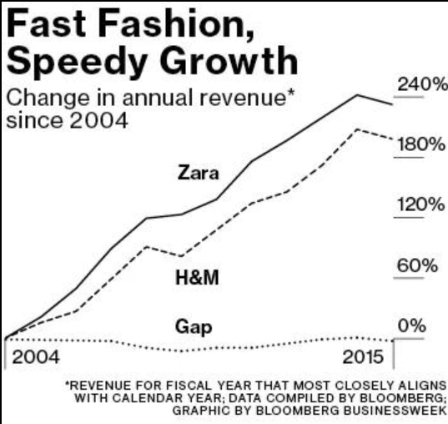
Source: VISUA
This strategy is effective in the UK: stores are used as the constant advert with the help of the organic social media promotion of bloggers and influencers in the Tik Tok and Instagram (Mintel, 2023). New arrivals and limited collections are communicated via email marketing, the Zara app, and the updates on the website. This is in line with British consumer preference to subtle branding (De Mooij, 2019).
Other countries such as Bangladesh have minimal advertising, yet brand awareness is more important to the new market. The visibility is based on social media such as Facebook and Instagram, with the help of local influencers and celebrity promotion (Rahman and Khondker, 2020; Aziz and Afzal, 2021). Cultural events like Eid can also be done as local promotions by franchise partners (Aziz and Afzal, 2021).

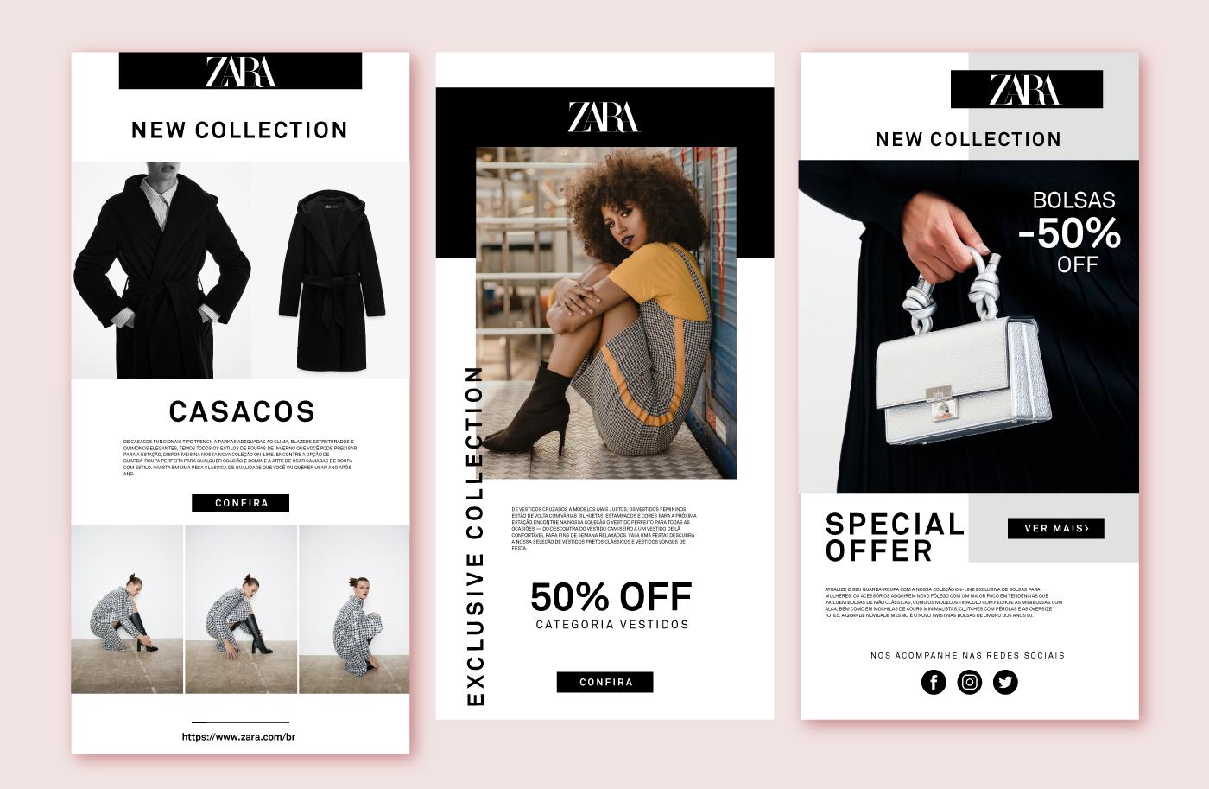
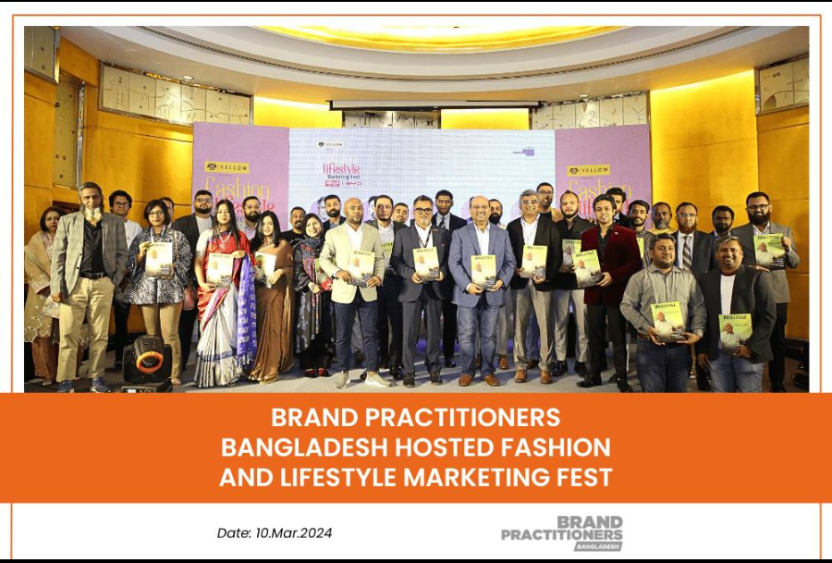
3.2.5 People
Its UK Zara stores have knowledgeable personnel that do not overstep or pressurize but instead reflect the expectations of British customers to browse at their own pace (Jobber and Ellis-Chadwick, 2020). The training of employees is within the scope of product knowledge, customer service, and visual merchandising (Inditex, 2024).
In Bangladesh, employees need to fit in a culture of high power-distance and collectivism. Customers would want a more personalised advice especially in luxury foreign outlets (Hofstede Insights, 2024). Employees must observe cultural values, such as modesty, and adjust to decisions related to purchasing by the family (De Mooij, 2019). Bilingualism in both English and Bengali is significant to effective communication.

3.2.6 Process
UK procedures are efficient and based on technology: self-service checkout, RFID stock-finding, online tracking, automated returns, and loyalty features that integrate into the app improve the customer experience (Inditex, 2024). The turnover of stocks is fast, which promotes returning (Caro and Martinez-de-Albeniz, 2015).
The processes in Bangladesh need to be localized. The ways of payment also lean towards the use of cash, fitting room etiquette and queues management is different and staff interaction is more accentuated to facilitate group decision-making (Siddiqui, 2021).

3.2.7 Physical Evidence
The store design of Zara across the world reflects the contemporary European style of fashion: straight lines, light, neutral colors, and high-level styles of visual selling (Lopez and Fan, 2009).
The stores in the UK are based on the international template, and the flagship stores offer high-quality brand experiences. The arrangements direct the customers on the journey of the fashionable looks using mannequins that are styled and through lighting that highlights the textures and colours.
Modern malls in Bangladesh imitate the world design and offer a dreamy atmosphere as opposed to local retail space (Siddiqui, 2021). The location of the Mall also has an impact on physical evidence of the brand, which indicates modernity and exclusivity (Hossain and Rahman, 2022). The packaging and signage and store looks are all globally consistent, and this strengthens the brand identity of the developing market.
4.0 Zara in Bangladesh Directional Development Strategy.
The strategy of developing directionally in Bangladesh of Zara can be evaluated through the Growth Matrix of Ansoff (Ansoff, 1957) and the Uppsala internationalisation model (Johanson and Vahlne, 1977; 2009).
Ansoff's Matrix Application:
Zara entering Bangladesh is a market development strategy which is the introduction of its already existing fast-fashion product range in a new geographic market (Ansoff, 1957). Although the core concept of the product is global, cultural and climatic variations, such as small-fashion goods, lightweight material, and colour schemes that are popular in the region have been applied to the Bangladesh market, which can be seen as the incremental-level product innovation (Johnson et al., 2017). This is a blend of market development and a selective adaptation of the products which concurs with the observation of Doyle (2008) that successful entry into markets with a different culture demands simultaneous changes in the products offered.

Mode of Entry:
Zara made an entry into Bangladesh as a franchise with a local partner, a typical fashion brand entry mode to a market where there is regulatory complexity, cultural distance, or logistical issues (Root, 1994; Hollensen, 2020). Franchising can enable Zara to utilise the expertise of the partner in the market, connections with the mall operators and government, and logistical capabilities at the same time maintaining branding, product mix and store design (Ghemawat and Nueno, 2006). Conversely, the stores of Zara in the UK are run out of an Inditex-oriented operation, which implies less market risk, increased familiarity, and more substantial market size, which warrant wholly-owned operations (Johanson and Vahlne, 2009).

Uppsala Model Application:
The Uppsala model assumes that companies internationalise in stages, initially focusing on psychical proximate markets and then increasing to further distant markets with a gain in experience (Johanson and Vahlne, 1977). The same path was taken by Zara whose initial move was to expand in Europe, and then in Latin America and then further Asian and African markets (Lopez and Fan, 2009). Bangladesh was penetrated through franchise, and it has a large cultural, linguistic, economic, and institutional difference with Spain, which is in agreement with the model that low-commitment modes are recommended in high-uncertainty markets (Johanson and Vahlne, 2009). Another advantage of Zara is the previous experience of sourcing in Bangladesh in the garment industry, which gives good background knowledge about the entry stage (Tokatli, 2008).
This will become the direction of strategy in the future:
The probable future plan of Zara in Bangladesh entails:
Penetration in the market: Reaching out to more cities (Dhaka, Chittagong) and strengthening e-commerce (Johnson et al., 2017).
Geographic expansion: Tapping into the secondary cities such as Sylhet and Rajshahi once the purchasing power and retail infrastructure has developed (Hossain and Rahman, 2022).
Product development: Introducing additional Bangladesh-centric collections, such as modest-fashion collections and Eid capsule collections, to increase the local market appeal (Aziz and Afzal, 2021).

5.0 Marketing Mix Ethical Issues in Zara.
Ethical aspects of the operations in Zara are relevant both in the UK and Bangladesh, but the problems are expressed differently and are especially severe in Bangladesh.
5.1 Ethics in the Bangladesh Supply Chain.
The garments industry in Bangladesh, a source of numerous fashion brands worldwide, such as Zara, had experienced serious industrial disasters, and the most recent one, the Rana Plaza, destroyed over 1,100 employees in 2013, revealing the systemic failures in safety, building standards, and corporate responsibility (Reinecke and Donaghey, 2015). Although there was no direct connection between Zara and Rana Plaza, Inditex signed the legally binding Accord on Fire and Building Safety in Bangladesh to change the factory conditions (Accord on Fire and Building Safety in Bangladesh, 2013).
Although they have been improved, there are still ethical issues, including low wages, extra-long working hours, and a lack of union rights (Clean Clothes Campaign, 2023). The current minimum wage is BDT 12,500 (£87) which is not enough to live dignifiedly (Human Rights Watch, 2023). The fast-fashion concept of Zara, which is based on the principles of quick production and minimal costs, generates constant ethical discussions about the possibility of integrating it with the principles of fair labour practices (Fletcher, 2014; Crane and Matten, 2020).

5.2 Environmental Ethics
The system of regular collection rotation and impulse buying used in Zara is one of the causes of environmental problems, such as textile waste, water wastes, and carbon emissions (House of Commons Environmental Audit Committee, 2019). Zara reacts in the UK by the range of sustainability actions called Join Life, recycling bins, and the pledge of the circular economy (Inditex, 2024). Critics state that these programs are minimal, as there is a fundamental conflict between sustainability and disposable fashion (Fletcher, 2014). Production externalities to local communities in Bangladesh include environmental effects due to water pollution during dyeing, chemical waste, and manufacturing processes that use more energy (Clean Clothes Campaign, 2023).

5.3 Ethics of Culture, Ethics of Marketing.
The Western fast fashion is being promoted aggressively in Bangladesh, and there is an ethical issue of cultural homogenisation and the loss of local textile traditions, such as muslin weaving, jamdani saris, and nakshi kantha embroidery (Klein, 2000; Siddiqui, 2021). Zara is a fashion signifier with global presence, which adds to stressors on such artisanal activities, and makes one wonder how corporate responsibility should manage the maintenance of cultural diversity at the local level (Crane and Matten, 2020).
5.4 Pricing Ethics
Aspirational pricing in Bangladesh renders Zara products very expensive to the majority of consumers, and it puts into question the nurturing of exclusivity in low-income countries. Even though the segmentation is commercially legitimate, the opponents claim that marketing of unaffordable luxury products may lead to the increased social anxiety and flawed consumption aspirations (Schor, 2004). Conversely, the pricing of Zara in the UK is widely available and so, this ethical concern does not stand out.

6.0 Recommendations
According to the analysis, the following are the recommendations that can be made on the international marketing strategies of Zara:
6.1 Improve Ethical supply chain practice in Bangladesh.
Further measures that Zara should take in addition to the Bangladesh Accord is total compliance with the supply chain, i.e. public supplier lists, frequent third party audits with published outcomes and investing in living wage programs (Reinecke and Donaghey, 2015). The collaboration with such organisations as the Fair Wear Foundation might help enhance the accountability and credibility (Crane and Matten, 2020). Good ethics are a strategic consideration since Bangladesh is both a sourcing location and a consumer market.
6.2 Design a Separate Modest-Fashion Line.
Zara must develop a modest-fashion sub-brand or capsule collection that would be related to the local taste, but the design of the products would be in cooperation with Bangladeshi customers and designers (Aziz and Afzal, 2021). This would overcome the gaps in cultural adaptation and access the global modest-fashion market, estimated at nearly 311 billion (Thomson Reuters, 2022).
6.3 Invest in the E-Commerce Infrastructure in Bangladesh.
As the usage of internet and smartphones increases, Zara must create a strong, localised e-commerce service with support in Bengali language, mobile first architecture, cash-on-delivery, and co-operation with local logistics companies to deliver in last miles (Hossain and Rahman, 2022). This would help it reach further than the high-end malls and enlarge the market size to be reached.
6.4 Enhance UK Sustainability Communication.
Zara needs to make sustainability reporting transparent and audited by independent auditors, and introduce take-back or resale programs to illustrate practical circularity initiatives, combat consumer scepticism and greenwashing issues (House of Commons Environmental Audit Committee, 2019; Fletcher, 2014).
6.5 Leverage local partnerships and cultural heritage
Limited-edition collections with jamdani or nakshi kantha patterns would be a sign of cultural respect and would differentiate the brand and create positive associations through collaboration with local artisans (Siddiqui, 2021).
6.6 Bangladesh Pricing Strategy Adaptation.
Implementation of tiered pricing and entry-level items that are easy to access especially basics may expand customer base yet will not affect the brand equity. High sourcing is local and minimized supply chain can aid in minimizing the premiums of import costs (Caro and Martinez-de-Albeniz, 2015).
7.0 Conclusion
Zara international marketing strategy balances the global standardisation with local adaptation. In the UK, it lives as a mainstream, mid-market brand and in Bangladesh as aspirational and premium due to economic, cultural and regulatory variations. The PESTEL and STP analyses point to social and cultural forces as important causes of strategy adjustment. In all 7Ps, there should be a major change in product, price, promotion, people, and process to match expectations of the local. The entry of Zara into Bangladesh is based on the market development approach through franchising, and this is in line with the Uppsala model of high-distance market. Ethical issues such as labour practices, environmental sustainability and cultural impact are still a burning issue. Some of the recommendations aim at keeping up with the competitive environment and at the same time working on these ethical imperatives to achieve sustainable international development.

SECTION 2: REFLECTIVE ACCOUNT
Reflective Account Gibbs Reflective Cycle (1988)
Description
This reflective report is about a research, analysis and writing of a comparative report on Zara and its international marketing strategy in Bangladesh and in the United Kingdom. The task involved employing the scientific method of using scholarly constructs, such as PESTEL, STP, the 7Ps, and the Matrix provided by Ansoff to examine a global fashion brand with presence in two opposite markets. The report also incorporated a moral analysis of the activities at Zara and recommendations on the strategic advice in each market. The process of the research took place during several weeks and presupposed work with a great variety of sources, such as academic journal articles, textbooks, industry reports, corporate publications, government statistics, and authoritative media sources, which made it possible to use the evidence-based analytical approach and conduct an academically rigorous study.
Feelings
Initially, I had a feeling of excitement and fear. I was actually interested in the analysis of Zara, which is a brand that I know as a consumer, and I was curious about such a task as comparing two much different markets one of which (the UK) was familiar, and the other one (Bangladesh) was a bit less familiar. Nonetheless, I also was nervous about the scope of the assignment, which required skills in using various analytical frameworks, cultural literacy, and how to combine various sources into a logical academic argument.
Of particular concern to me was my fear of the Bangladesh market. I also felt worried about accidentally being guilty of stereotyping or having uninformed generalisation of the Bangladeshi consumer behaviour. This is one of the reasons why I decided to use primary sources, including the data on cultural dimensions provided by Hofstede, publications of Bangladesh Bureau of Statistics, and scholarly studies on consumer culture in South Asia (De Mooij, 2019; Aziz and Afzal, 2021) instead of using shallow secondary descriptions.
My confidence increased as the study continued and trends were drawn. I found it intellectually stimulating and inspiring to relate theoretical knowledge to practical brand choices, e.g. the relationship between the collectivism dimension of Hofstede and the necessity of Zara to provide more customised in-store service in Bangladesh.
Evaluation
My approach had a number of strengths. A PESTEL analysis was used as a structured macro-level basis that was the logical basis of other STP and 7Ps analysis. This top-down strategy, which was advised by Hollensen (2020), made sure that the discussion on the marketing mix was based on the contextual understanding as opposed to being used in isolation.
The ethical analysis part was challenging and complete. The study of the Rana Plaza disaster and its continued ramifications on the Zara supply chain in Bangladesh made me deal with some unpleasant actualities about the fast-fashion sector, such as the discrepancy between the rhetoric of corporate sustainability and its practical realization (Fletcher, 2014). The critical response added to the analytical richness of the report and promoted the subtle consideration of the ethical role of global brands.
It was also possible to identify areas of improvement. My first mistake was underestimating the challenge of finding solid and up-to-date academic content that directly deals with the operations of Zara in Bangladesh. The information at hand was mostly journalistic or anecdotal and it needed good triangulation in order to be credible. Reflectively, a literature search in terms of databases like Business Source Complete, Emerald Insight and Google Scholar done in the beginning would have been more effective. The initial versions of the 7ps section were too much descriptive and did not provide enough critical comparison. It required massive revisions to make sure that every item was truly comparative, and did not merely compare the differences between the markets but also the strategic meaning.

Analysis
The PESTEL and the 7Ps as theoretical frameworks are priceless in terms of their organization and completeness, yet have issue when used as a robot (Johnson et al., 2017). The actual analytical worth was found in the discovery of interrelations or connections e.g. the collectivist culture of Bangladesh (social factor) into the in-store service expectations (people element of 7Ps), which consequently affects the staffing models and selection of franchise partners (process and place).
The Uppsala model also helped me to better understand the notion of psychic distance (Johanson and Vahlne, 1977). The UK and Bangladesh have a significant difference in terms of language, religion, level of income, regulatory environment, and cultural values. It is not only academic but a key ingredient that facilitates international marketing to realise such differences. The experiential learning cycle (1984) by Kolb would be the most appropriate way to describe my experience: after getting the concrete experience reading about Rana Plaza, I observed the human cost of fast fashion reflected, then the abstract conceptualisation of the structural tension in the business model of Zara, the active experimentation when formulating ethical recommendations.
Conclusion
This assignment has made a great contribution to my knowledge on the practical side of international marketing. I now understand that successful global marketing goes beyond the translation of a domestic strategy; it involves reconsidering assumptions that exist about consumers, culture and value in a given market. These complexities were brought out by the comparative approach which involved the analysis of one brand in two very different markets. I also came to understand more the ethical aspect of global fashion marketing as it is frequently not that business success and ethical responsibility go hand in hand but must be carefully balanced.
Action Plan
Moving forward, I will:
- Conduct more systematic literature searches earlier on in subsequent academic work by consulting databases like Business Source Complete, Emerald Insight and Google Scholar, in order to have more credible and strong evidence to base my arguments on initially.
- Become more analytical in school and in career situations by constantly posing the question of why? and "so what?" when analyzing business contexts, which would enable me to make judgments that are more strategic instead of merely defining problems.
- Apply the international marketing knowledge gained during this assessment to my future career and daily decision-making process by applying frameworks like PESTEL, STP and Hofstede in analysing the difference in markets, consumer behaviour and ethical aspects in the context of actual business through, as well as enhancing my everyday consumption of foreign brands.
Reference List
Accord on Fire and Building Safety in Bangladesh (2013) The Bangladesh Accord. Available at: https://bangladeshaccord.org (Accessed: 20 March 2025).
Ansoff, H.I. (1957) 'Strategies for diversification', Harvard Business Review, 35(5), pp. 113–124.
Aziz, S. and Afzal, M.N.I. (2021) 'Consumer perceptions of international fashion brands in Bangladesh: A qualitative exploration', South Asian Journal of Business Studies, 10(2), pp. 198–215.
Bangladesh Bureau of Statistics (2022) Statistical Yearbook of Bangladesh 2022. Dhaka: Ministry of Planning, Government of Bangladesh.
Bangladesh Telecommunication Regulatory Commission (2023) Annual Report 2022–2023. Dhaka: BTRC.
Business of Fashion (2021) 'How Brexit is reshaping UK fashion retail supply chains', The Business of Fashion, 15 February. Available at: https://www.businessoffashion.com (Accessed: 18 March 2025).
Caro, F. and Martínez-de-Albéniz, V. (2015) 'Fast fashion: Business model overview and research opportunities', in Agrawal, N. and Smith, S.A. (eds.) Retail supply chain management. 2nd edn. New York: Springer, pp. 237–264.
Clean Clothes Campaign (2023) Fashioning justice: Towards living wages in the global garment industry. Amsterdam: Clean Clothes Campaign.
Crane, A. and Matten, D. (2020) Business ethics: Managing corporate citizenship and sustainability in the age of globalization. 5th edn. Oxford: Oxford University Press.
De Mooij, M. (2019) Consumer behavior and culture: Consequences for global marketing and advertising. 3rd edn. London: Sage Publications.
Dhingra, S., Huang, H., Ottaviano, G., Pessoa, J.P., Sampson, T. and Van Reenen, J. (2017) 'The costs and benefits of leaving the EU: Trade effects', Economic Policy, 32(92), pp. 651–705.
Doyle, P. (2008) Value-based marketing: Marketing strategies for corporate growth and shareholder value. 2nd edn. Chichester: John Wiley & Sons.
Fletcher, K. (2014) Sustainable fashion and textiles: Design journeys. 2nd edn. London: Routledge.
Ghemawat, P. (2007) Redefining global strategy: Crossing borders in a world where differences still matter. Boston: Harvard Business School Press.
Ghemawat, P. and Nueno, J.L. (2006) ZARA: Fast fashion. Harvard Business School Case 703-497. Boston: Harvard Business School Publishing.
Gibbs, G. (1988) Learning by doing: A guide to teaching and learning methods. Oxford: Further Education Unit, Oxford Polytechnic.
Hofstede Insights (2024) Country comparison tool. Available at: https://www.hofstede-insights.com/country-comparison/ (Accessed: 20 March 2025).
Hollensen, S. (2020) Global marketing. 8th edn. Harlow: Pearson Education.
Hossain, M.K. and Rahman, S. (2022) 'The emergence of modern retail in Bangladesh: Trends, challenges and opportunities', International Journal of Retail and Distribution Management, 50(6), pp. 701–720.
House of Commons Environmental Audit Committee (2019) Fixing fashion: Clothing consumption and sustainability. HC 1952. London: House of Commons.
Human Rights Watch (2023) "Paying for a bus ticket and dying to make clothes": The deadly cost of fashion. New York: Human Rights Watch.
Inditex (2024) Annual Report 2023. Arteixo: Industria de Diseño Textil, S.A.
Information Commissioner's Office (2023) Guide to the UK General Data Protection Regulation (UK GDPR). Available at: https://ico.org.uk (Accessed: 19 March 2025).
International Monetary Fund (2023) World Economic Outlook: Bangladesh. Washington, DC: IMF.
Jobber, D. and Ellis-Chadwick, F. (2020) Principles and practice of marketing. 9th edn. London: McGraw-Hill Education.
Johanson, J. and Vahlne, J.-E. (1977) 'The internationalization process of the firm: A model of knowledge development and increasing foreign market commitments', Journal of International Business Studies, 8(1), pp. 23–32.
Johanson, J. and Vahlne, J.-E. (2009) 'The Uppsala internationalization process model revisited: From liability of foreignness to liability of outsidership', Journal of International Business Studies, 40(9), pp. 1411–1431.
Johnson, G., Whittington, R., Scholes, K., Angwin, D. and Regnér, P. (2017) Exploring strategy: Text and cases. 11th edn. Harlow: Pearson Education.
Khanna, T. and Palepu, K.G. (2010) Winning in emerging markets: A road map for strategy and execution. Boston: Harvard Business Press.
Klein, N. (2000) No logo: Taking aim at the brand bullies. London: Flamingo.
Kolb, D.A. (1984) Experiential learning: Experience as the source of learning and development. Englewood Cliffs, NJ: Prentice Hall.
Lopez, C. and Fan, Y. (2009) 'Internationalisation of the Spanish fashion brand Zara', Journal of Fashion Marketing and Management, 13(2), pp. 279–296.
Mintel (2023) Fashion retailing — UK — 2023. London: Mintel Group Ltd.
Office for National Statistics (2023) Retail sales, Great Britain: 2023. Available at: https://www.ons.gov.uk (Accessed: 18 March 2025).
Rahman, M.M. and Khondker, H.H. (2020) 'Digitisation and changing consumer culture in Bangladesh', Asian Journal of Social Science, 48(3–4), pp. 296–318.
Reinecke, J. and Donaghey, J. (2015) 'After Rana Plaza: Building coalitional power for labour rights between unions and (consumption-based) social movement organisations', Organization, 22(5), pp. 720–740.
Root, F.R. (1994) Entry strategies for international markets. Revised edn. San Francisco: Jossey-Bass.
Schor, J.B. (2004) Born to buy: The commercialized child and the new consumer culture. New York: Scribner.
Siddiqui, K. (2021) 'International fashion retail in Bangladesh: Market dynamics and strategic challenges', Journal of International Consumer Marketing, 33(4), pp. 412–430.
Statista (2023a) Revenue of the apparel market in the United Kingdom. Available at: https://www.statista.com (Accessed: 18 March 2025).
Statista (2023b) Digital market outlook: United Kingdom. Available at: https://www.statista.com (Accessed: 19 March 2025).
Thomson Reuters (2022) State of the global Islamic economy report 2022. Dubai: DinarStandard.
Tokatli, N. (2008) 'Global sourcing: Insights from the global clothing industry — the case of Zara, a fast fashion retailer', Journal of Economic Geography, 8(1), pp. 21–38.
Vrontis, D. and Thrassou, A. (2007) 'Adaptation vs. standardisation in international marketing — the country-of-origin effect', Innovative Marketing, 3(4), pp. 7–21.
World Bank (2023a) Bangladesh development update: Recovery and resilience. Washington, DC: World Bank.
World Bank (2023b) World development indicators. Available at: https://data.worldbank.org (Accessed: 18 March 2025).
World Intellectual Property Organization (2022) World intellectual property indicators 2022. Geneva: WIPO.
Zara UK (2024) Zara United Kingdom. Available at: https://www.zara.com/uk/ (Accessed: 20 March 2025).
VISUA (no date) The role of Visual-AI in sports sponsorship measurement & valuation. Available at: https://visua.com/white-paper/sports-sponsorship-measurement-with-computer-vision-whitepaper (Accessed: 26 March 2026).
Baker, S. (2016) Zara’s recipe for success: More data, fewer bosses. Bloomberg. Available at: https://www.bloomberg.com/news/articles/2016-11-23/zara-s-recipe-for-success-more-data-fewer-bosses (Accessed: 26 March 2026).

