Joseph Luke Harris
Introduction to Web and Database Concepts
ACCA4023

Table of Contents
Context Diagram 2
Level 0 DFD 3
Entity Relationship Diagram 4
3NF 5
Suitable Tables Created 6
Suitable Fields Created 6
Suitable Foreign Keys Created 7
Suitable Relationships Created 7
Database matches user requirements 8
Additional database tools used 9
Create a query 10

Context Diagram

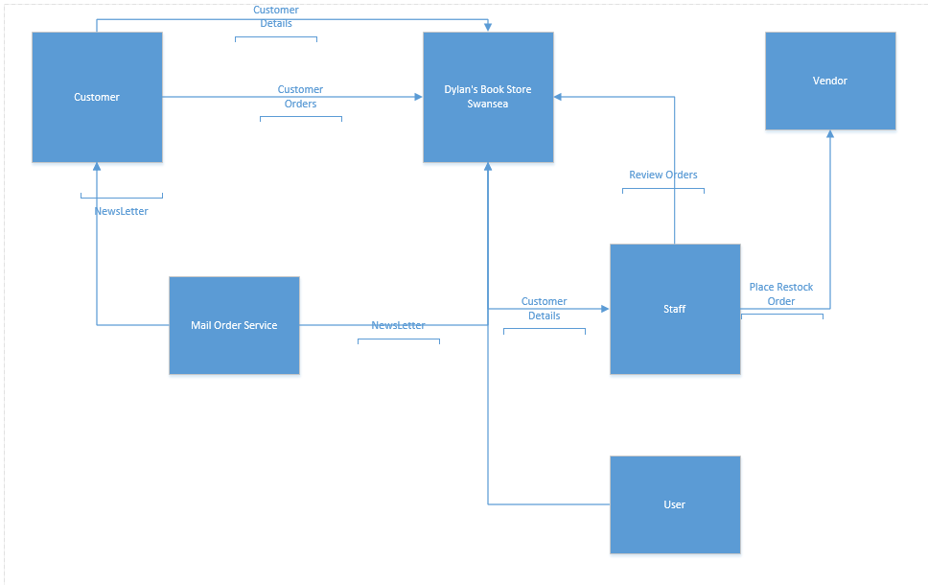

Above is my context diagram which I will use to create the Database for Dylan’s book store Swansea. I will based my database off this diagram and follow the one to one and one to many relationships outline above. By starting off with this context diagram I can build the foundation of a successful database by using this diagram as a checklist to make sure I have covered all areas to make the database work successfully. By using this diagram I was able to create relationships within my database and have a working database which fits the client’s needs. Below you will see the relationships created based off this context diagram.
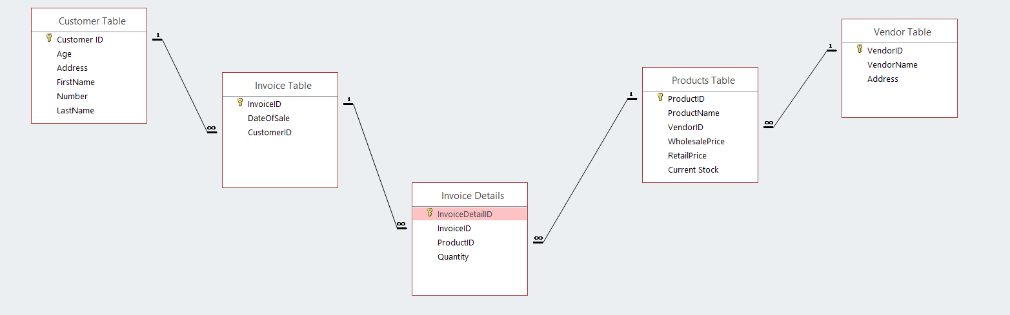

Level 0 DFD
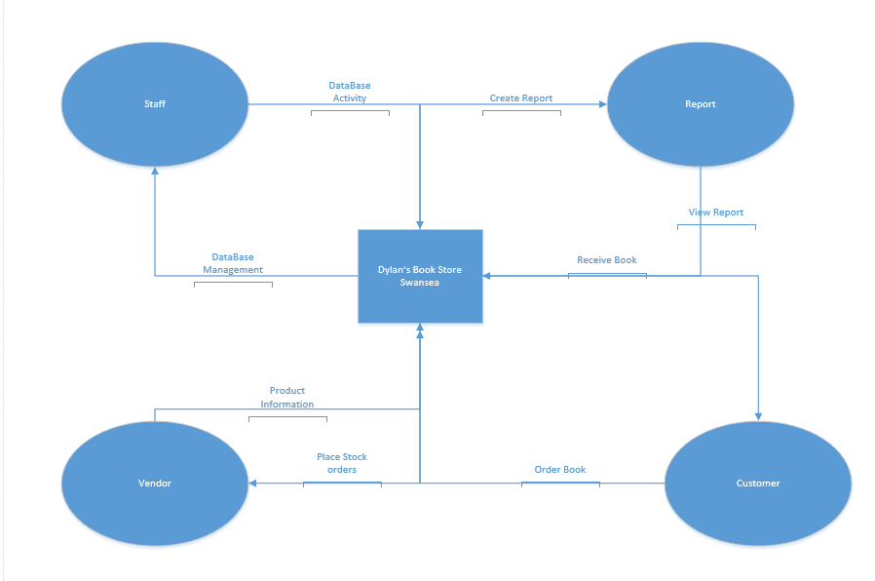
In the above image I have created a logic view for a level 0 DFD. Within the logical view I have demonstrated how Dylan’s book store Swansea will run via the database. The level 0 DFD shows how each section works and how it links back to the store. For example, the store can request a report and then receive a report.

Entity Relationship Diagram
Name | Description | Attributes | Relationships
tblCustomer | The table data refers to Customer Details | CustomerID,Age, Address, Firstname, Lastname, Number | One-to-Many with tblInvoice
tblInvoice | The table data refers to Invoice | InvoiceID, DateofSale, Customer ID | One-to-Many with tblInvoiceDetails
tblInvoiceDetails | The table data refers to Invoice Details | InvoiceDetailID, InvoiceID, ProductID, Quantity | One-to-Many with tblInvoice & tblproducts .
tblproducts | The table data refers to Product Details | ProductID, ProductName, VendorID, WholesalePrice, Retailprice, CurrentStock | One-to-Many with tblVendorID
tblVendorTable | The table refers to VendorTable | VendorID, VendorName, Address | One-to-Many with ProductsID

3NF
CustomerID, Age, Address, Firstname, LastName, Number
InvoiceID, CustomerID, Dateofsale
InvoiceDetailID, InvoiceID, ProductID, Quantity
ProductID, Vendor ID, ProductName, WholesalePrice, RetailPrice, CurrentStock
VendorID, VendorName, Address

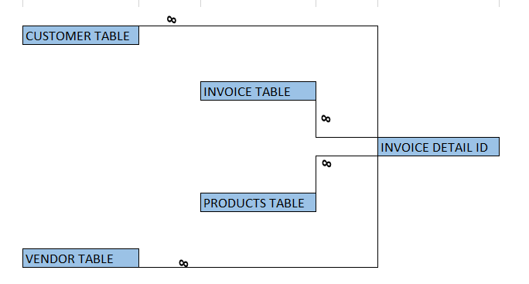

Suitable Tables Created
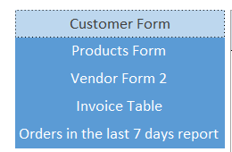
I was asked by the client to create a database with suitable forms included. The requirements stated I needed a Customer page to insert and delete data for customers. A Page to view current stock for books. A Page for the Vendor to place orders and an invoice table to view invoices for old and ongoing customer orders.

Suitable Fields Created

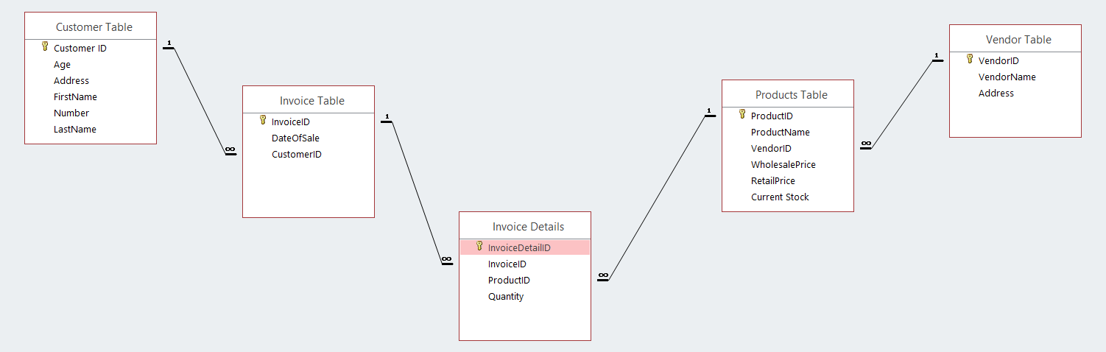
In order to make my database fit for purpose I need to create suitable fields for each table. As you can see above I have included a screenshot from my relationships diagram to show all the tables and fields included clearly.

Suitable Foreign Keys Created
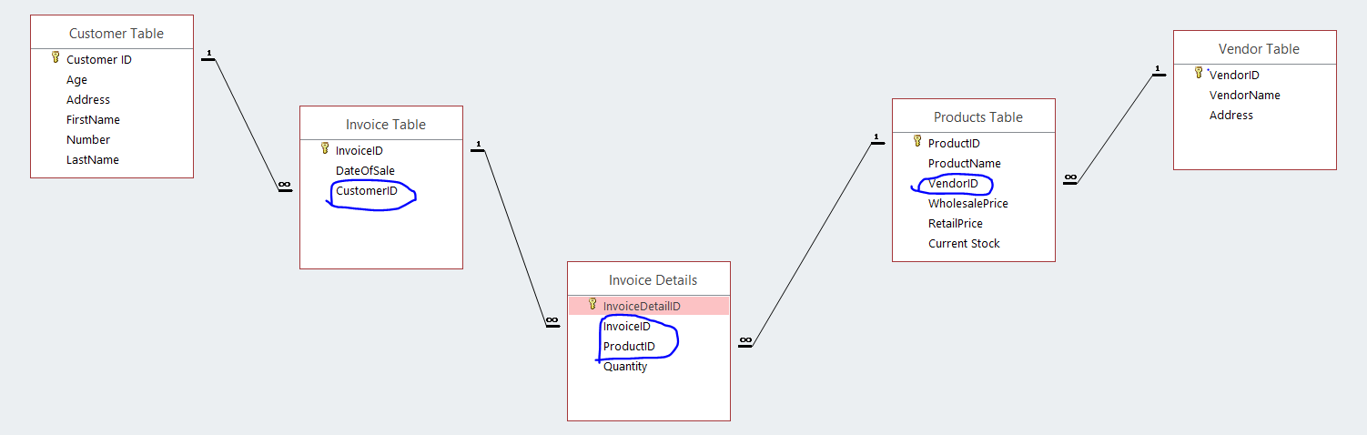
When creating my database I needed to link my tables together in order to have Reports and access orders with ease. To do this I needed create a foreign key within my relationships to link the tables together so my data in each field links together using the primary id which is located in the other fields using a form wizard to create these links.

Suitable Relationships Created

When creating my relationships I followed my context diagram and level 0 DFD alongside my 3NF. By doing this I was able to create relationships between my database fields which will allow me to now create forms which can create orders and review orders made.

Database matches user requirements

When creating this database I had to follow a set of requirements which I have done. Firstly, I needed to create a database based on a book shop in Swansea where staff can User has the ability to add or delete information from any table.
User should be able to view, on screen, Book stock, orders and customer details.
User should be able to view ongoing customer orders.
User should be able to query the system and print out relevant reports.

Further to this, the database needed to be menu driven.

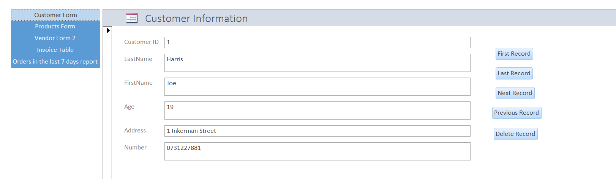
As you can see I have created a menu driven database where the user can use buttons to add and delete records and also navigate through the database. The user can also view the database data without being able to access the behind the scenes imbedded code. Furthermore, when the database loads the Navigation page opens instantly. Users can also add data and save new data to the database using the forms provided and buttons included to save or delete any information added.

Additional database tools used

When creating the database I wanted to have a sub total enabled on my invoice form. To do this I needed to include imbedded code into my forms. Here is an example, of the code I used.
By doing this code every time a customer adds an item or deletes an item from the invoice then the total price would change at the bottom of the form.

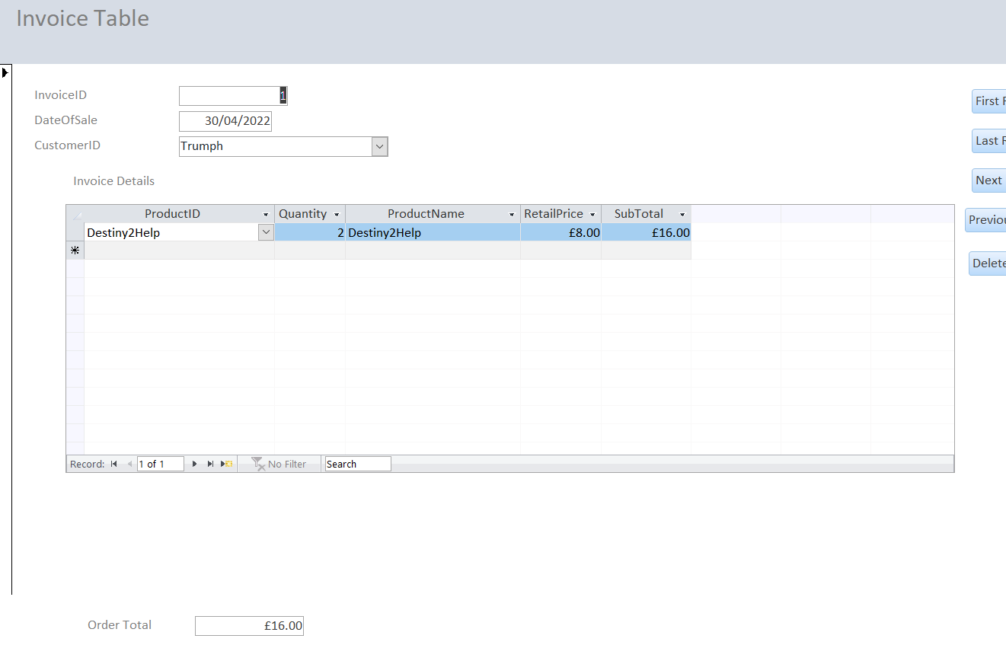
As you can see the total currently sits at £16.00 however, when I add an item the form automatically updates the total price.
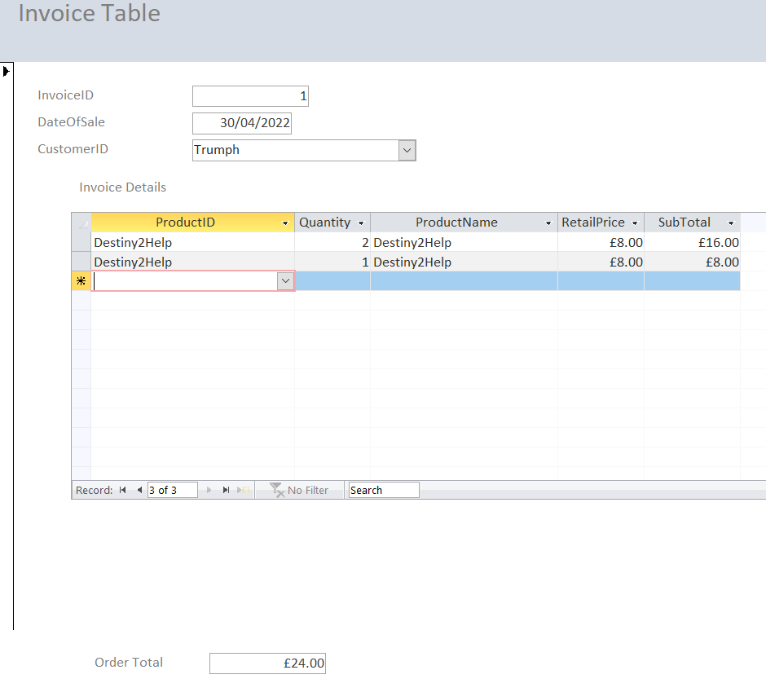

Create a query

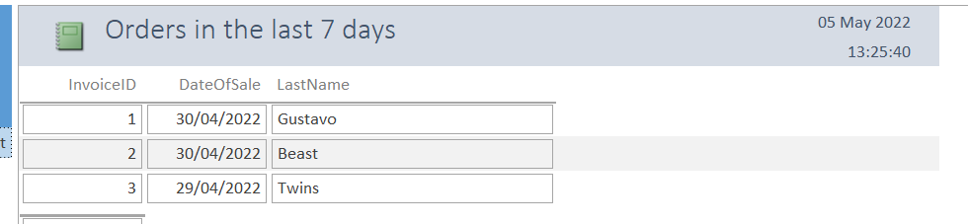

I was able to produce a report showing orders placed in the last 7 days by using a macro query.

