

Postgraduate/Distance Learning
Assignment coversheet & feedback form

THIS SHEET MUST BE THE FIRST PAGE OF THE ASSIGNMENT YOU ARE SUBMITTING (DO NOT SEND AS A SEPARATE FILE)

For completion by the student:
Student Name: Sintija Barakat

Student University Email: 1706722@student.uwtsd.ac.uk
Module code: HPCA7002  Module title: Researching Contemporary Cosmologies Module | Student ID number:  1706722 |  |  | Educational support needs:  Yes/No
Assignment title: Research Project in Contemporary Cosmology

Assignment due date: 10th August, 2020
This assignment is for the 1st 2nd 3rd 4th 5th 6th module of the degree
I confirm that this is my original work and that I have adhered to the University policy on plagiarism.
Signed Sintija Barakat……………………………………………………………
Email submission:if you are submitting this form via email, please tick this box □
(as a substitute for your signature) to confirm that you agree to the above declaration.
Assignment Mark
1st Marker’s Provisional mark
2nd Marker’s/Moderator’s provisional mark
External Examiner’s mark (if relevant)
Final Mark

NB. All marks are provisional until confirmed by the Final Examination Board.

For completion by Marker 1 :
Comments:

Marker’s signature: |  |  | Date:
For completion by Marker 2/Moderator:

Comments:

Marker’s Signature: |  | Date:
External Examiner’s comments (if relevant)

External Examiner’s Signature: |  | Date:

Introduction.

The aim of this research is to examine the beliefs of astrologers and examine elements of their practice in the context of their belief system, and personal cosmologies – how it synthesizes with astrologer’s inside and outside world. This project examines Nicholas Campion’s and Freya Mathews ideas about people’s personal cosmologies, beliefs and how cosmology is reflected in their lives and how they fit into cosmology. These ideas will be examined amongst a group of Latvian astrologers by exploring their beliefs and practices and answering the research question ‘Do Latvian astrologers believe in the Latvian deities and why?’ Latvian astrologers were chosen from different Latvian astrology schools. The methodology used qualitative and quantitative research approaches. Semi structured interviews and questionnaires were conducted online via Skype and Google Forms.

Within the aspects of human society and culture, the term cosmology in the modern world plays an integral part in human lives. Nicholas Campion describes cosmology as a ‘meaning system’ which ‘deals with mythic narratives, ways of seeing the sky, and the manner in which human beings locate themselves in space and time’ and also ‘looks at magic, ritual, and the actions that people take to negotiate destiny and find meaning in the stars’. But Freya Mathews asserts that, ‘Cosmologies are not of course pulled out of the air to suit the convenience of the communities to which they are attached. They are conditioned by many and various historical, environmental, technological, psychological and social factors. A flourishing community is likely to evolve a bright, self-affirming cosmology, and a languishing community is likely to see the world in darker shades… A good cosmology, in other words, is good for its adherents’. Such notions can highlight people’s personal cosmologies, their beliefs and attitudes towards life.

Methodology.
This research use both qualitative and quantitative methodologies. For quantitative research, the questionnaire collected data of ‘the opinions and attitudes of some groups of people’. In this case a group of Latvian astrologers (22 participants) from different astrology schools. This is a useful method to investigate the ideas of other scholars, for instance Nicholas Campion’s and Freya Mathews’ views on personal cosmologies. In the Questionnaire all participants were ‘asked the same question in, as far as possible, the same circumstances…to enable the researcher not only to describe, but also to compare, to relate one characteristics to another and to demonstrate that certain features exist in certain categories’. All participants took an online questionnaire on Google Forms, which was most likely filled out from home or school settings. This questionnaire ensures fairness as everyone was able to answer the same questions which were collected by a researcher. Participant questionnaire responses provided the answers to the main questions ‘What?’, ‘How?’ and ‘Do you believe…?’.
Qualitative research is another method to collect data from the research participants. One of the basic uses of the qualitative research is ‘…for exploring new topics or to understand complex issues; for explaining people’s beliefs and behaviour; and identifying the social or cultural norms of a culture or society’. Therefore, qualitative research is the best method for this project to address beliefs of the Latvian astrologers through their opinions, feelings and thoughts. The interviews by qualitative research can provide the researcher with an answer to the question– ‘Why?’. According to Hennink, Hutter and Bailey, ‘Qualitative research is most suitable for addressing ‘why’ questions to explain and understand issues or ‘how’ questions that describe processes and behaviour’. For instance: Why do Latvian astrologers believe in Latvian deities? On top of the questionnaires, interviews allowed the researcher to understand and put into words participants personal beliefs. As Bell explains, ‘…the interview can yield rich material and can often put flesh on the bones of questionnaire responses.’ Which is another advantage of qualitative research as it goes deeper on subject exploration and comprehension. This project particularly focusses on semi structured interviews as it gives a slight openness to the interview. The structure of this kind of interview kept space for additional questions where needed. Interviews were conducted online through Skype. For the interview participants - Latvian astrologers were chosen from two Latvian astrology schools, namely Baltic astrology school and Andra Racha astrology school. All four participating astrologers are tutors with many years of practice and advanced knowledge of astrology, therefore with great experience and a wide perspective regarding cosmologies.

This project focusses on Monique Hennink’s, Inge Hutter’s and Ajay Bailey’s definition and approaches of ‘insider’. As this research is seen from an insider’s perspective, and as I position myself as an insider by being Latvian, an astrologer and student of one of the same astrology schools as the questioned participants - astrologers. For instance, one of the interviewees – Participant-3, addressed the researcher (me) during the interview with a direct insider perspective: ‘…you have left now, but anyway you are from here, you have this vibration inside - we live in a fantastic land’. Participant-3 addressed me as an insider – Latvian. Where I used to live, where I am from. Therefore, she still considers me as one of their own. I am still Latvian in passport and in heart – that is where the energy comes from. Or perhaps, Participant-3 meant that ‘vibration’ in me is the root of nationality, culture and belonging – the part of identity or energy which will always remain within me. Similarly, Participant-4 used the word ‘our’ to describe our belonging to an inside group that we both belong to. As he explains the ‘…tradition of our Latvians and ancestors…’.
Participant-2 in interview also used insider perspective but in a different sense. Different inside perspective was used, in this case it was astrology. As he explained, …astrology if you study it, then you should get it…’. In this case, I am considered as an insider due to practicing astrology. I am being recognized as someone who would understand astrology concepts and philosophy. However, ideologies, philosophies and approaches of the astrology schools can sometimes be distinct from each other, especially if they practice a different tradition of astrology. In a similar way Participant-1 used astrology as an insider perspective, as she explained ‘Our sun is masculine…’. Interestingly, she used insider perspective on astrology rather than being Latvian. Perhaps, because she feels more connected to me through the astrology school that we both represent. These are only assumptions of insider perspectives, that were presented through the interviews. However, researchers are never purely insider or outsider. Therefore, this project is balanced between subjectivity and objectivity.

Research is based on an insider’s point of view of an interpretive approach that focuses on a ‘Verstehen’ concept. That is, to research participant experiences in their normal and cultural living settings and comprehend life from their own point of view, by using participant expressions and words. This research also met the emic perspectives which are drawn to ‘…the insider’s point of view, the insider’s perceptions, beliefs, and meaning system. It thus reflects the cultural meaning that people attach to certain facts, events, or experiences.’ Which helped to gain in-depth understanding of the research group perspectives.

Personal cosmologies – belief in the Latvian deities.
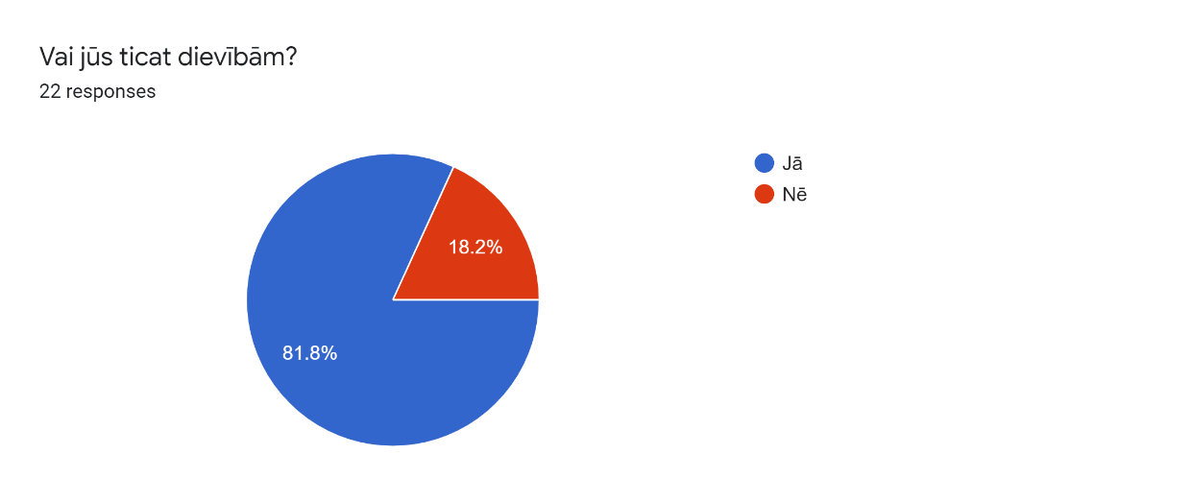
Do Latvian astrologers believe in the Latvian deities? This qualitative research question involves people’s personal cosmologies and their beliefs in it. As Freya Mathews states, ‘Cosmologies may include not only ordinary concrete items such as material objects, but also forces, fields, minds, spirits, even deities, since all these entities are capable of being actual, of constituting an actual world’. Therefore Latvian deities also fit into this definition, as they exist in Latvian culture. In the questionnaire Latvian astrologers were asked if they believe in the deities, all twenty-two respondents answered this question from which only four (18,2%) answered ‘no’. The rest of the respondents answered with – yes (81.8%). Participant answers can be seen in the chart in figure 1. The exact same results are shown in a different question - Do you believe in heavenly deities? As the same respondents answered repeatedly with ‘yes’ or ‘no’. It would suggest that those who believe in deities in general also believe in heavenly deities. However, in the following question respondents were asked to specify deities they believe in; the results indicated that only ten respondents specified that they believe in heavenly deities, and ten – believe in Latvian deities only. Heavenly deities such as ‘god’, ‘sun’, ‘planets’, ‘Pērkons’, ‘Auseklis’. Despite the fact that eighteen respondents answered that they believe in heavenly deities. Where did the other eight responses of belief in heavenly deity disappear to? Perhaps in other answers in which the direct answer was not specified. Those answers included ‘spirits’, ‘each deity has a certain energy and there are many’, and ‘I believe that there are forces outside the physical world, but I do not name them in any way’, and ‘I believe in the principle of all deities in general, because behind each deity there is a deeper archetypal philosophy that does not belong to a particular nationality’.
Figure 1 Question number ten results - target group - Latvian astrologers revealing if they believe in deities. Chart obteined from Google Forms, 2020.
In additional to the questionnaires, semi structured interviews provided a deeper look into participant beliefs in Latvian deities, as Bell would say ‘flesh on the bones’. All four interviewees talked about their belief in deities in a very distinctive way. Thus Participant-2 described his belief in deities as an experience, as he states ‘I have no belief, I have experience that it is effective enough. In his opinion, belief in Latvian deities – is missing something, for instance a system; as he states ‘I am a person who needs to see complete systemicism’. In a different way, Participant-3 who explained her belief as ‘to know’, as she states:
…As belief, in energies that exist outside of me, - I don't have to believe them. I know they exist! I do not worship as deities, but I know that there are energies that are related to destiny, mentality, perception, and understanding of life.
In Participant-3’s perception, Latvian deities are seen on a deeper level, as she senses them as energies that have their own vibrations, and which respond to something specific, for instance ‘destiny’. By contrast, the other two participants, namely Participant-1 and Participant-4, believe in Latvian Deities and their belief in a way which is similar to each others. Thus, Participant-1 states:
...I believe in the deities themselves, but I understand that in each of them, looking at different nations separately, we have also embedded some historical heritage of our own, national identity, or consciousness, or nation’s historical heritage.
Participant-1 talked about her belief in Latvian deities as something that comes from a primal source and has been changed. That these deities have been adapted to Latvian culture and folk. Similarly Participant-4 believes that all deities come from the same source. As he explains:
Deities that are well known in the Baltics and Latvia – they are international... For example, the planet Jupiter is considered as a deity responsible for the happiness. For Latvians he is known as ‘Pērkons’, for Russians ‘Перýн’, for Lithuanians ‘Perkūnas’. That is, practically, we can say that there is a single star religion in all nations, and it received only modifications.
The concept of star religion is noted also by the German philosopher Bernulf Kanitcheider, as he suggested, ‘Astrology…must be seen in its origins as a religion based on the stars.’ However, Mathews explains that cultures always create stories in order to take into account ‘the origin and nature of the universe’. Therefore one can argue, this worldview can be seen as a religion based on the stars, or not.
There are also symbols and rituals in Latvia that are associated with Latvian deities. In questionnaires Latvian astrologers were asked if they practice any rituals or use any deity symbols in their daily lives. The minority of participants answered ‘no’ to both questions. However, the majority of participants had an opinion on this. Thus, six out of twenty participants use symbols with a defined purpose, but did not specify if they are Latvian deity symbols; another six use specific Latvian deity symbols, such as ‘Jumis’, Auseklis’, ‘Austras koks’ and Latvian symbols of god and the sun, plus many more. Every Latvian deity has their own specific symbol with a specific meaning, for example protection and welfare. Therefore, rituals can be practiced regarding specific Latvian deities or cycle of the year, where deities are also involved. According to Campion, rituals are part of the cosmology that finds meaning in it. For example, two participants practice rituals in Latvian midsummer fest also known as ‘Jāņi’; other two are practicing fire rituals; or other two practice chanting a Latvian verse. Participant-2 noted that he also practices Latvian rituals, including fire, chanting, midsummer, and many more, as he explains ‘If I practice rituals at all, then they are most strongly Latvian…’.

Belief in deities from astrology lence.
Latvian astrologers were asked if their perception of astrology had been influenced by their belief in Latvian deities? In the questionnaire eighteen participants out of twenty-two, provided answers on this question. Most responses were answered with ‘no’ and the rest with ‘could not say’. However, all interviewees gave a rich answer on this question and drew a similar pattern to the sun and the moon between astrology teachings and Latvian culture. For example, in astrology teaching the sun and the moon have their gender which is typical form the astrology point of view. Namely, sun is masculine and moon is feminin. On the contrary, in Latvian culture the sun is feminin and the moon is masculine. As Participant-3 explains:

The sun, for Latvians is like a mother - a giver of life; the moon is masculine. But it is not for nothing that the Latvian nation is considered a mother nation. We have a mother tongue and a fatherland…. But life is created by a woman. Maybe that is why we have feminine sun. Although astrologically this might not be correct.
Participant-3 acknowledges both gender ways of the sun and the moon, from the astrological and Latvian culture perspectives. However, other participants might not be so acceptable with both ways. For instance, Participant-1’s extended interest and practice in Greek mythology brought her to accept only one way of thinking about the sun and the moon, regarding gender; although Participant-1 has her fixed way of seeing deities, she also recognizes planets on a higher energy where the gender of planes does not exist, and this revelation is human reflection. As she explained:
On the other hand, if we take it in such an even higher principle... then from the point of view of the earth we attributed this feminine or masculine to them. But in reality, the planets already have that absolute energy. Because there is no more feminine or masculine in space.
But if the question is looked at from a wider perspective then it can also provide wider answers. For example Participant-2 responded, that he is grateful to astrology for his path to faith. By contrast, Participant-3 feels that astrology gave her ‘confirmation of world unity’, she believes that astrology and Latvian deities complement each other. But Participant-3 explains, that in Latvian literature, in Latvian folk songs, also known as ‘dainas,’ are a complete reflection of Latvian astrology. Thus, in Latvian folk songs, as she continues ‘the sun gave a chamomile and the moon gave a leash’ with which to ride. So, this structure of the universe, somewhere, is like heaven …it is not like a deity, it is like a world order’. It has been said that these ‘dainas’ are phenomenological and date back over a thousand years; they are Latvian heritage as all recorded Latvian culture can be found in folklore, – ‘collective wisdom and beliefs of the Latvians’ ancient tribal ancestors.’ Some Latvians in these ‘dainas’ find a deeper, cosmological meaning, as Participant-3 did. In the questionnaire, one participant commented that ‘Every folk song has some code in it and its own wisdom. I chant them as mantras in different life situations.’ This comment was an answer to the question about rituals regarding to deities, if they practice any. Similarly, in the questionnaire, in a question about the deity role in an astrologers’ life, one participant commented that ‘…words, verse that protect, it is a set that forms the Latvian identity, in it you can feel the strength of the nation, your own strength.’ Another participant commented ‘…I keep track of the Sun's annual calendar as part of my culture’. According to Mathews, ‘…culture must generate to the questions of identity, origin and destiny if its members are to exercise their agency in any kind of sustained and consistent fashion’. From this one can surmise that Latvian deities are embodied in astrology, in some aspects of Latvian culture and acknowledged by Latvian astrologers where their identities were constantly shaped.
The question – Why do you believe in Latvian deities? Was answered in the questionnaire and shows largest the breakthrough. Twelve participants (60%) out of twenty answered that their belief is built on a personal belief. Which points to Campion’s and Mathew’s notions about personal cosmologies. The second largest breakthrough is cultural belonging, and third is family and ancestry related. This is another strong indicator of Latvian astrologer belief that Latvian deities are closely connected to culture, ancestry, and identity. Participant answers can be seen in the chart in figure 2. 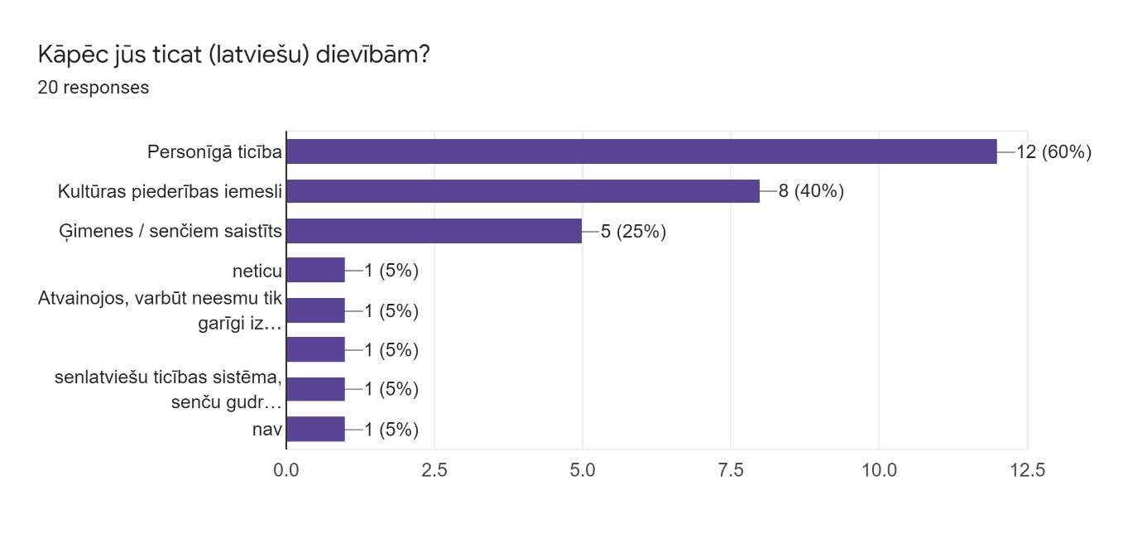
Figure 2 Question number fourteen results, target group - Latvian astrologers revealing the answers about why they believe Latvian deities. Chart obtained from Google Forms, 2020.

Outside factors in a personal belief.
There are numerous reasons that influence people’s beliefs about this world and beyond. As Freya Mathews points out ‘Cosmologies…. are conditioned by many and various… factors’. Figure 3 shows the results of outside factors that influence Latvian astrologers’ personal cosmologies. The largest breakdowns of an outside factors in a personal cosmologies are environmental and historical, both have been selected by ten participants (47, 6%). The second largest breakdowns are social and psychological, which are also selected in an equal number of participants – eight (38,1%).
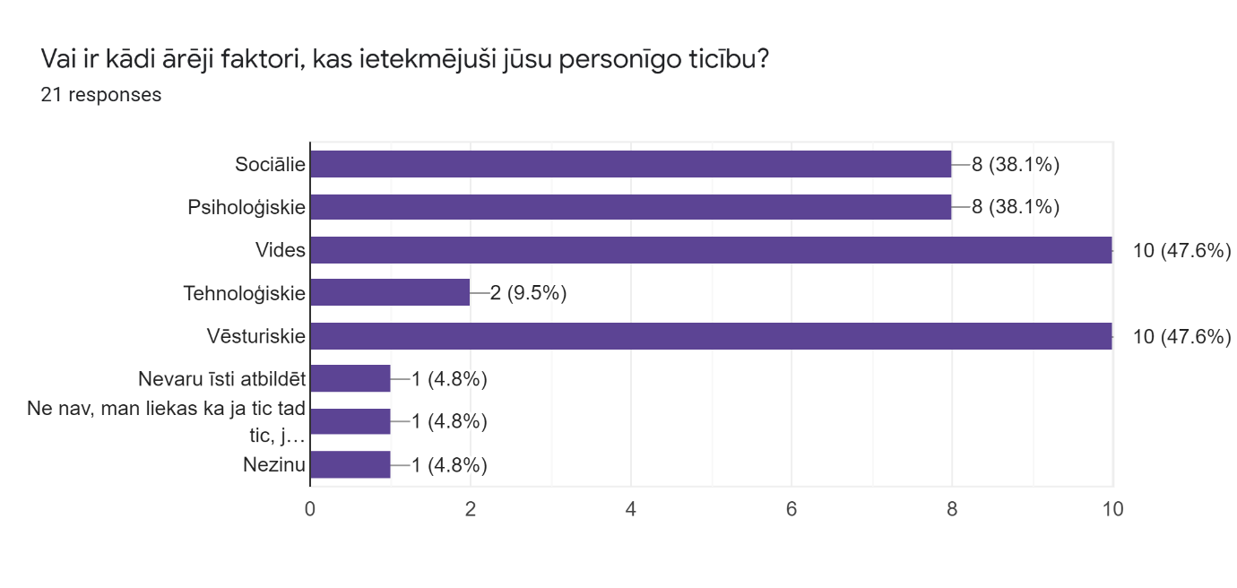
Figure 3 Question number fourteen results, target group - Latvian astrologers revealing the answers about the outside factors that influenced their cosmologies. Chart obtained from Google Forms, 2020.

In interviews, Participant-1 related her personal belief being conditioned by social and psychological factors. However she describes these influences in her own words, as she explains, ‘It is some natural result of the individual development of the perception of the mind’. For instance Participant-3 indicated that
Basically, everything has worked in some way... It is not possible to separate specifically. They have compleated each other... from one has been one information - from social, connection with people; historical is another option. All this has formed some kind of my worldview, in which there are certain Latvian energies, Latvian... either deities, if you call them like that? Which also exist!
Participant-4 commented on the question from a different view, that is strongly influenced by someone else. Thus, he pointed out that
The main thing that influenced me was, of course, the theosophical movement, the works of Blavatsky, practically, and the works of Roerich’s. This is Agni Yoga. Everything else has little effect. Everything else are little additional factors. The main thing is worldview.
All interviewees worldviews are rather positive. As Freya Mathews states ‘good cosmology… is good for its adherents’.

Personal cosmologies – belief about the Universe and Cosmos

In the interviews and questionnaires participants were asked about their personal belief in cosmos and the way it works in their perception about the universe. Participants were answering precisely the question do they believe in cosmic order. The answers provided with ‘yes’ or ‘no’ shown in the chart in figure 4. This chart shows that twenty-one participants out of twenty-two responded ‘yes’ to this question, where only one participant does not believe in the cosmic order.

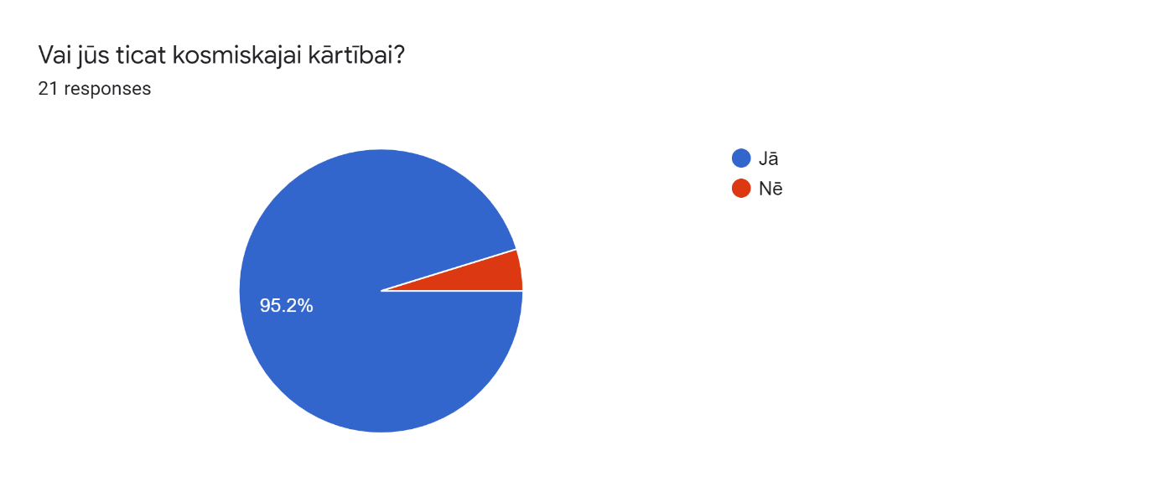
Figure 4 Question number twenty-one, target group - Latvian astrologers revealing answers about their belief in cosmic order. Chart obtained from Google Forms, 2020.
Additionally, the chart in figure 5 indicates participant belief about the universe. If it is benign, hostile, or neutral in their opinion. Twelve participants (54.5%) of twenty-two made the largest breakdown by answering that the universe in their opinion is neutral. The second largest breakthrough shown by seven participants (31,8%) answering – benign. This sentiment can be named ‘cosmophiles’, as Campion represents it as those ‘who believe that the cosmos is essentially good’. None of the participants think that the universe is hostile, or in other words, none of the participants were ‘cosmophobes’. However participants had a chance to use their own answers in the free opening. Namely, one participant thinks that the universe is rather a god, another thinks that everything is in balance, and another thinks it is both – good and evil. As Mathew points out ‘A flourishing community is likely to evolve a bright, self-affirming cosmology…’

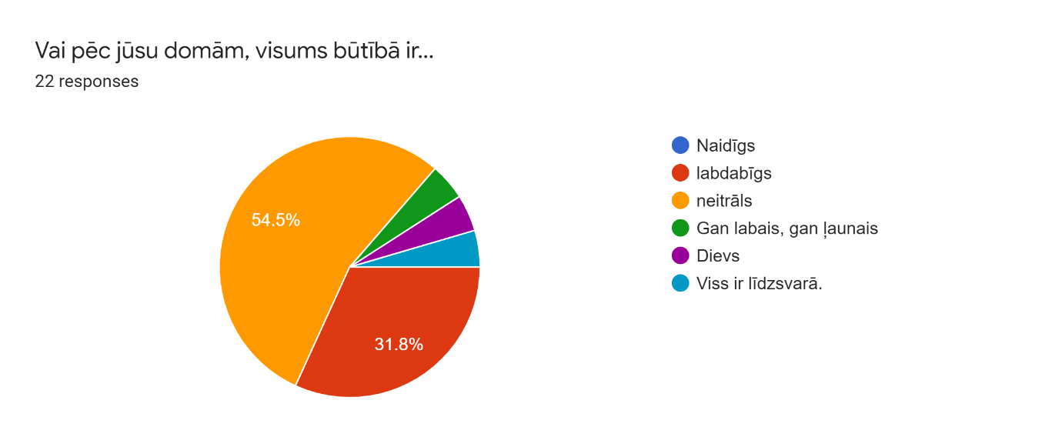
Figure5 Question number twenty-tree, target group - Latvian astrologers revealing answer about their belief about the Universe. Chart obtained from Google Forms, 2020.
The question about the cosmos and how it works was also answered by participants from the interview. Participant-4 notes that:

Cosmos is like a living organism. A living organism permeated with all these influences… It is a unified system. And we are a small part of this single system, a single living organism.

Participant-4 explained his view of cosmic order, how it functions and where we stand in it. He also mentions that he takes the cosmogony from Blavatsky, from The Secret Doctrine. Therefore his cosmology is strongly influenced by someone else, by something else. On the contrary, Participant-3 developed her own believe, from her own perception about the universe. As she explains

In the summer in the countryside, in the middle of the day, I lay down in bed and in the sunlight, such small, small dust flew into the room. And I realized that it is the whole universe, it is maybe part… That every dust that flies in that air is one galaxy. And that in one branch that dust has our solar system. And that that solar system has such a planet - the earth. And that we live on this earth. And I saw it, as if in great chaos, the great order that is… We are in order, in a big, big structure ... I saw the model of the universe, the whole big universe. And with that, my opinion changed… I do not worry anymore about the small things in life.

By developing her own vision about the cosmos and universe. Her vision is rather positive, like the other research participants. As Mathew would point out ‘A flourishing community is likely to evolve a bright, self-affirming cosmology…’

Conclusion
The research data indicates that most Latvian astrologers, in fact, do believe in Latvian deities. Semi structured interviews and questionnaires pointed out that to some extent astrologer views on the concepts of deities and beliefs varied. However, the majority of astrologers find themselves to believe in Latvian deities of different sorts, practice their rituals and use their symbols. On the other hand, a minority of this group of astrologers did not believe, practice, or use anything related to Latvian deities, or they were not sure about something. This reflects Mathews and Campion’s notions on personal belief. Latvian astrologers also drew some insights on the connection between astrology and Latvian deities. Additionally, this research also revealed, that for Latvian astrologers their identity and culture are equally important. As Latvian deities are embedded in their cultural heritage, their cosmology is mostly positive and good. It indicates Mathews notion on thriving community. The Latvian astrologers’ belief was influenced not only by astrology and their culture, but also by other factors, such as environment and history, and many more. These factors serve as additional information on their belief that would point out why Latvian astrologers do believe in the Latvian deities.

Bibliography

Bell, Judith, ‘Doing your research project’, (Open University Press, Berkshire, 2010).

Campion, Nicholas, Astrology and Cosmology in the World’s religions, (New York and London: New York University Press, 2012).

Hennink, Monique, Hutter, Inge and Bailey, Ajay, ‘Qualitative research methods’, (Los Angeles; London; New Delhi; Singapore; Washington DC, SAGE Publications Inc., 2011).

Mathews, Freya, The Ecological Self. (Routledge, 2012).

Moser and Kalton, 1971:1 in Judith Bell, ‘Doing your research project’, (Open University Press, Berkshire, 2010).

Kanitscheider, Bernulf, ‘A Philosopher Looks at Astrology’, Interdisciplinary Science Reviews 16, no. 3 (1991):259, in Nicholas Campion, Astrology and Cosmology in the World’s religions, New York and London: New York University Press, 2012).

Appendix 1

Questionnaire

- Do you consent for the data in the questionnaire to be used for the purpose of my research project? Please check the box if you agree. ☐

Part One: General information
- Male ☐
Female ☐
- Age ____

- What is your level of interest in astrology?
Student ☐
Tutor ☐
Other ____________

- How many years have you been studying/practicing astrology? _________

- In which astrology school do you study or teach?
Baltijas astroloģijas skola (Baltic astrology school) ☐
Andra Rača astroloģijas skola (Andra Rača astrology school) ☐
Other ____________

- What tradition of astrology do you practice/study?
Traditional ☐
Hamburg School of Astrology ☐
Psychological astrology ☐
Vedic ☐
Other_________________

- What is your level of education? (Please tick more than one box if more than one answer applies.)
Secondary school ☐
University ☐
Post-graduate ☐
Professional training ☐
Other_________________

- In terms of religious affiliation, how would you describe yourself now?
Member of an organised religious institution or group ☐ (If so, which?) ___________
Spiritual but not conventionally religious ☐
Agnostic ☐
Atheist ☐
Other ________________

PART TWO: Information about belief in the Latvian deities?

- Do you believe in deities?
Yes ☐
No ☐

- Do you believe in Latvian deities?
Yes ☐
No ☐

- What are the deities you believe in? (Please write more than one if more than one answer applies.) _________________

- Why do you believe in (Latvian) deities? (Please tick more than one box if more than one answer applies.)
Personal belief ☐
Cultural reasons ☐
Family/Ancestry related ☐
Other _______________

- Are there any outside factors that has influenced your personal beliefs? (Please tick more than one box if more than one answer applies.)
Social ☐
Psychological ☐
Environmental ☐
Technological ☐
Historical ☐
Other _______________

- Has your religious or spiritual outlook been influenced by your study of astrology?
Yes ☐
No ☐

    - If so, how? ______________________________________________

- Has your religious or spiritual outlook been influenced by your belief in Latvian deities?
Yes ☐
No ☐

    - If so, how? ______________________________________________

- Has your perception of astrology been influenced by your belief in Latvian deities?
Yes ☐
No ☐

    - If so, how? _________________________________

- Does Latvian deities play any role in your life?
Yes ☐
No ☐

    - If so, for example? ___________________________________

- Do you practice any rituals regarding to deities you believe in?
Yes ☐
No ☐

    - If so, for example? _____________________

- Do you use any symbols of deities in your daily life?
Yes ☐
No ☐

    - If yes, which? _____________________________

    - And why? _____________________________

- Do you believe in cosmic order?
Yes ☐
No ☐

- Do you believe in universal purpose or patterns?
Yes ☐
No ☐

- Do you believe the universe is essentially:
hostile ☐
benign ☐
neutral ☐
Other _________________

Nicholas Campion, Astrology and Cosmology in the World’s religions, New York and London: New York University Press, 2012), Loc 48.
Freya Mathews, The ecological self, (London: Routage, 1991), p. 109.
Moser and Kalton, 1971:1 in J. Bell, ‘Doing your research project’, (Open University Press, Berkshire, 2010), p. 11.
Judith Bell, ‘Doing your research project’, (Open University Press, Berkshire, 2010), p. 161.
Monique Hennink, Inge Hutter and Ajay Bailey ‘Qualitative research methods’, (Los Angeles; London; New Delhi; Singapore; Washington DC, SAGE Publications Inc., 2011), p. 10.
Monique Hennink, Inge Hutter and Ajay Bailey ‘Qualitative research methods’, (Los Angeles; London; New Delhi; Singapore; Washington DC, SAGE Publications Inc., 2011), p. 10.
Judith Bell, ‘Doing your research project’, p. 161.
Translated from original language – Latvian. ‘Baltijas astroloģijas skola’ = Baltic astrology school, and ‘Andra Rača astroloģijas skola’ = Andra Racha astrology school.
Monique Hennink, Inge Hutter and Ajay Bailey ‘Qualitative research methods’, (Los Angeles; London; New Delhi; Singapore; Washington DC, SAGE Publications Inc., 2011), p. 18.
Participant-3, Interview number 3, 8th July 2020, the interview was conducted in Latvian language. Original transcription ‘Mēs dzīvojam, vispar nu...- tu tagad aizbrauci, bet vienalga tu esi no šejienes, tevī tā vibrācija ir ieksā, - mēs dzīvojam fantastiskā zemē’.
Participant-4, Interview number 4, 16th July 2020, the interview was conducted in Russian language. Original transcription ‘традиция наших латышей и предков’.
Participant-2, Interview number 2, 8th July 2020, the interview was conducted in Latvian language. Original transcription,’...astroloģija, ja jūs viņu studējat, tad jums vajadzētu pie ta nonākt...’.
Participant-1, Interview number 1, 4th July 2020, the interview was conducted in Latvian language. Original transcription, ‘Mums saule ir vīrietis…’.
Monique Hennink, Inge Hutter and Ajay Bailey ‘Qualitative research methods’,), p. 18.
Monique Hennink, Inge Hutter and Ajay Bailey ‘Qualitative research methods’, p. 18.
Freya Mathews, The ecological self, (London: Routage, 1991), Loc 213.
Google Forms Questionnaire, question number 10, The chart question and answers are in Latvian. Jā = Yes, Nē = No (translation into English).
Google Forms Questionnaire, question number 11.
Google Forms Questionnaire, question number 12.
Google Forms Questionnaire, question number 12, The chart question and answers are in Latvian. Translation is in the same order as original text. All tree: ‘Dievs’, ‘dieviņš’, ‘tētis’ are ‘god’ in English translation, ‘saule’ = sun, ‘planētas’ = planets. ‘Pērkons’, ‘Auseklis’ are Latvian heavenly deities.
Google Forms Questionnaire, question number 12.
Google Forms Questionnaire, question number 12, The chart question and answers are in Latvian. Translation is in the same order as original text: ‘Gari‘, ‚Katra dievība ir noteikta enerģija un to ir daudz.‘, ‚Ticu, ka eksistē spēki ārpus fiziskās pasaules, bet nenosaucu tos nekādi.’, ‘Ticu visām dievību principam kopumā, jo aiz katras dievības ir dziļāka arhetipiska filozofija, kurai nav piederiba konkrētai nacionalitātei.’
Judith Bell, ‘Doing your research project’, p. 161.
Participant-2, Interview number 2, 8th July 2020, the interview was conducted in Latvian language. Original transcription: ‘Man nav ticība, man ir pieredze, ka tas ir pietiekami efektīvi’.
Participant-2, Interview number 2, 8th July 2020, the interview was conducted in Latvian language. Original transcription: ‘Esmu cilvēks, kuram vajag redzēt pilnīgi sistēmismu’.
Participant-3, Interview number 3, 8th July 2020, the interview was conducted in Latvian language. Original transcription: ‘Kā ticību, kā tādām enerģijām, kas pastāv ārpus manis, tām man nav jātic. Es zinu, ka viņas ir!... nepielūdzu kā dievības, bet es zinu, ka ir tādas enerģijas, kas saistītas gan ar likteni, gan ar mentalitāi, uztveri, un dzīves izpratni’.
Participant-1, Interview number 1, 4th July 2020, the interview was conducted in Latvian language. Original transcription: ‘…es ticu pašām dievībām, bet es saprotu ka katrā no tām, skatoties dažādās tautās atsevisķi, mēs vēl esam pielikuši iekšā kaut kādu savu, nacionālās identitātes, vai apziņas, vai tautas vēsturisko mantojumu’.
Participant-4, Interview number 4, 16th July 2020, the interview was conducted in Russian language. Pronunciation: ‘Pērkons’ (perkons), ‘Перýн’ (Perun), ‘Perkūnas’ (Perkoonas). Original transcription: ‘...Божества, который известны в Балтии и Латвии – они интернациональные’. ‘Допустим, планета Юпитер считается Божеством, отвечающим за счастье, у латышей он будет Пэркон, значит, у русских будет Перун, у литовцев Перконс. Т.е. практически, можно сказать, что есть единая звёздная религия во всех народах и она получила только модификации’.
Bernulf Kanitscheider, ‘A Philosopher Looks at Astrology’, Interdisciplinary Science Reviews 16, no. 3 (1991):259, in Nicholas Campion, Astrology and Cosmology in the World’s religions, New York and London: New York University Press, 2012), Loc 441.
Freya Mathews, The ecological self, Loc 232.
Google Forms Questionnaire, question number 19 and 20.
Google Forms Questionnaire, question number 20.
Nicholas Campion, Astrology and Cosmology in the World’s religions, Loc 48.
Google Forms Questionnaire, question number 19.
Participant-2, Interview number 2, 8th July 2020, the interview was conducted in Latvian language. Original transcription: ‘Ja es vispār piekopju rituālus, tad tie ir stipri vairāk latviski…’.
Google Forms Questionnaire, question number 17.
Participant-3, Interview number 3, 8th July 2020, the interview was conducted in Latvian language. Original transcription: ‘Saule, latviešiem ir kā māte – dzīvības devēja; mēness ir vīriešu dzimtē. Bet ne pa velti latviešu tautu uzkata par mātes tautu. Mums ir mātes valoda un tēvu zeme. Bet dzīvību rada sieviete. Tāpēc varbūt ir mums saule, kā sieviešu dzimtes pārstāve. Lai gan astroloģiski tas varbūt nebūtu pareizi’.
Participant-1, Interview number 1, 4th July 2020, the interview was conducted in Latvian language.
Participant-1, Interview number 1, 4th July 2020, the interview was conducted in Latvian language. Original transcription: ‘No otras puses atkal ja mēs ņemam tādā vēl augstākā principā – tas mēs no zemes viedokļa viņām piedēvējām šo sievišķo vai vīrišķo. Bet patiesībā planētās jau ir tā absolūtā enerģija. Jo kosmosā jau nav ne sievišķais, ne vīrišķais’.
Participant-2, Interview number 2, 8th July 2020.
Participant-3, Interview number 3, 8th July 2020, the interview was conducted in Latvian language. Original transcription, ‘apstiprinajums pasaules vienotībai’.
Participant-3, Interview number 3, 8th July 2020.
Participant-3, Interview number 3, 8th July 2020, the interview was conducted in Latvian language. Original transcription: ‘saule deva kumeliņu un mēness deva pavadiņu’ ar ko jāt. Tātad šī visuma uzbuve, kaut kur, kā debesu …viņa nav kā dievība, viņa ir kā pasaules kārtība’.
Ministry of Foreign Affairs of the Republic of Latvia, Latvian culture, Last accessed [9.08.2020] https://www.mfa.gov.lv/data/visit/14-latvian%20culture.pdf
Google Forms Questionnaire, question number 19, The chart question and answers are in Latvian. Original transcription: ‘Kātrā tautasdziesmā ir kāds kods un sava gudrība. Skaitu tās kā mantras dažādās dzīves situācijās’.
Google Forms Questionnaire, question number 18, The chart question and answers are in Latvian. Original transcription: vārdi, skaitāmpanti, kas aizsargā, tas ir kopums kas veido latvisko identitāti, tajā var just tautas spēku, savu spēku.’
Google Forms Questionnaire, question number 18, The chart question and answers are in Latvian. Original transcription: ‘…sekoju līdzi Saules gada kalendārs, kas ir daļa no manas kultūras.’
Freya Mathews, The ecological self, Loc 831.
Freya Mathews, The ecological self, (London: Routage, 1991), Loc 251
The chart question and answers are in Latvian. ‘Sociālie’ = Social, ‘Psiholoģiskie’ = Psychological, ‘Vides’ = Environmental, ‘Technoloģiskie’ = Technological, ‘Vēsturiskie’ = Historical. More than one answer was possible to select if more than one applied.
Google Forms Questionnaire, question number 14.
Google Forms Questionnaire, question number 14.
Participant-1, Interview number 1, 4th July 2020.
Participant-1, Interview number 1, 4th July 2020, the interview was conducted in Latvian language. Original transcription: ‘Tas ir kaut kāds individuālais attīstības prāta uztveres dabiskais iznākums.’.
Participant-3, Interview number 3, 8th July 2020, the interview was conducted in Latvian language. Original transcription: ‘Būtībā viss kaut kā kompleksi ir nostrādājis... Konkrēti attdalīt nevar. Viens otru ir papildinājis... no viena ir bijis viena informācija - no sociāliem, saitēm ar cilvēkiem; vēsturiskie ir otra opcija. Tas viss ir veidojis kaut kādu manu pasaules uzskatu, kurā ir noteiktas latviešu enerģijas, latviešu – vai dievības, tā viņas varētu nosaukt? Kuras arī eksistē!’
Participant-4, Interview number 4, 16th July 2020, the interview was conducted in Russian language. Original transcription: ‘На меня главное, что повлияло – это, конечно, теософское движение, труды Блаватской, практически, и, труды Рерихов. Это Агни-йога. Всё остальное – это мало влияет. Всё остальное – это маленькие дополнительные факторы. Главное – миропонимание.’
Freya Mathews, The ecological self, (London: Routage, 1991), Loc 258.
Google Forms Questionnaire, question number 21, The chart question and answers are in Latvian. Translation is in the same order as original text. Jā = Yes, Nē = No (translation into English).
Google Forms Questionnaire, question number 23, The chart question and answers are in Latvian. Translation is in the same order as original text. ‘Naidīgs’ = hostile, ‘Labvēlīgs’ = benign, ‘Neitrāls’ = neutral, ‘gan labais, gan ļaunais’ = both good and evil, ‘Dievs’ = god, ‘viss ir līdzsvarā’ = everything is in balance.
Nicholas Campion, Astrology and Cosmology in the World’s religions, Loc 111.
Nicholas Campion, Astrology and Cosmology in the World’s religions, Loc 111.
Google Forms Questionnaire, question number 23.
Freya Mathews, The ecological self, (London: Routage, 1991), Loc 251.
Participant-4, Interview number 4, 16th July 2020, the interview was conducted in Russian language. Original transcription – ‘Космос – это как живой организм. Живой организм, пронизанный вот этими всеми влияниями… Это единая система. А мы маленькая часть вот этой единой системы, единого живого организма’.
Participant-4, Interview number 4, 16th July 2020.
Participant-3, Interview number 3, 8th July 2020, the interview was conducted in Latvian language. Original transcription: ‘Vasarā laukos, dienas vidū, es guļu gultā un saules gaismā telpā ienāca tādi mazi, mazi putekļi. Un es sapratu, ka tas ir viss Visums, tā varbūt ir daļa… Ka katrs puteklis, kas lido tajā gaisā, ir viena galaktika. Un ka vienā zarā putekļiem ir mūsu Saules sistēma. Un ka šai Saules sistēmai ir tāda planēta - zeme. Un ka mēs dzīvojam uz šīs zemes. Un es redzēju, it kā lielā haosā, lielajā kārtībā, kāda ir… Mēs esam kārtībā, lielā, lielā struktūrā ... Es redzēju Visuma modeli, visu lielo Visumu. Un līdz ar to mans viedoklis mainījās… Es vairs neuztraucos par dzīves sīkumiem.’
Freya Mathews, The ecological self, (London: Routage, 1991), Loc 213.
This questionnaire is based on Liz Greene’s questionnaire from her paper ‘Mystical experiences among astrologers’, [Culture and Cosmos 13:2 (2009), pp. 3-32].

