Introduction to Web and Database Concepts

  - Umair Umair 2528414

Database Implementation for AutoPark Management System

Contents
1. Introduction 2
1.1 Background 3
1.2 Scenario Overview 3
1.3 Report Objective 4
2. Scenario Analysis 4
2.1 Existing Business Problems 4
2.2 Functional Requirements 5
2.3 Main Entities 6
2.4 Relationships 6
3. ERD 7
4. Data Structure Development 8
5. Normalisation Compliance 9
First Normal Form (1NF) 9
Second Normal Form (2NF) 10
Third Normal Form (3NF) 10
6. Sample Data Population 10
7. Query Development 14
Query 1: Available Parking Slots 14
Query 2: Vehicles Currently Parked 15
Query 3: Customer Booking History 16
Query 4: Daily Revenue 17
Query 5: Parking Site Occupancy 18
Query 6: Pending Payments 19
8. Validation and Testing 20
9. Design Reflection 21
10. Conclusion 22
References 23

1. Introduction

1.1 Background
Database Management Systems (DBMS) are essential tools in today's businesses that offer a structured and efficient way of storing, handling and retrieving vast quantities of data. Manual record-keeping systems are prone to inefficiency as organisations grow, with the data being duplicated, error-prone and hard to manage. The relational database system resolves these problems by structuring data into tables of related data where data is held in both tables is related by primary and foreign key, ensuring the consistency and integrity of data. Furthermore, database systems provide greater advantages in repetitive tasks, data quality and reduce data duplication, and enable faster information retrieval [1]. The features enable organizations to generate timely reports and make informed operational and strategic decisions using accurate and up-to-date information.

1.2 Scenario Overview
The AutoPark Management System is a city based parking service, which manages several parking locations in the city. The current system uses 100% manual data entry to store customer data, vehicle data, parking slot assignments, booking history, and payment transactions. This conventional method has led to many inaccuracies in recording data, information lost, wasted parking space use and time lost in tracking vehicles and revenue. To address these challenges, the organisation plans to use a centralized Microsoft Access database to store customer and vehicle data, assign parking spaces, log bookings, process payments and produce management reports that will help with the day-to-day management of parking stations and vehicles.

1.3 Report Objective
This report will focus on the main goal of designing and developing a solution using the Relational Database Management System (RDBMS) with Microsoft Access for the AutoPark Management System. The proposed database will strive to replace the manual record keeping systems with an integrated and automated information management system that will improve the accuracy of information, reduce manual mistakes and increase operational efficiencies. This database will assist in the real-time management of parking sites, parking slots, customers, vehicles, bookings, and payment transactions while allowing management to create meaningful reports of parking occupancy, revenue performance, and all activities to inform decision making.

2. Scenario Analysis

2.1 Existing Business Problems
The current AutoPark Management System uses manual record-keeping methods to cater to the daily parking needs of the various sites it operates. The paper-based data system is prone to human error and data inconsistencies, capturing customer information, vehicle details, parking plot assignment, reservations, and payment transactions. In addition, staff have a challenge of knowing at the moment where parking is available, resulting in parking being underutilized and service delays. Manual system also causes report generation to be time-consuming, making it difficult for management to track occupancy rate, revenues and operational efficiency [2]. These obstacles underscore the importance of using a centralized relational database system that will facilitate accurate data handling, streamline data quality management and enable prompt decision-making.

2.2 Functional Requirements
2.1 Functional Requirements of the AutoPark Management System
Requirement | Description
Register Parking Sites | Record details about each parking location, such as its location, parking capacity and contact details.
Register Parking Slots | Record individual parking slots, their type, status, and associated parking site.
Register Customers | Maintain complete information about customers, including personal and contact information.
Register Vehicles | Store vehicle information that is associated to the respective customer's (owner) vehicle, such as registration number and vehicle specification.
Record Bookings | Record vehicle entry and exit times, allocated parking slots, and booking status.
Record Payments | Capture payment information such as payment amount, payment date, payment method, payment status.
Track Parking Slot Occupancy | Keep track of slot availability and occupancy to optimise parking space usage.
Generate Management Reports | Create reports of parking occupancy, customer activity, booking history and revenue to aid in operational decisions.

2.3 Main Entities
The database can be segmented into 6 entities which can be used to manage AutoPark Management System. The ParkingSite entity has information about each individual parking site including SiteID (Primary Key), SiteName, Location, TotalSlots, and ContactNumber. Each parking site is associated with a number of parking spaces (parkslots) with entity ParkingSlot. ParkingSlot contains SlotID (Primary Key), SiteID (Foreign Key), SlotNumber, SlotType and Status to indicate whether a parking space is available or not.
With regards to the Customer entity, CustomerID (Primary Key), FirstName, LastName, Phone, Email, and Address are the customer information that is stored in it. Vehicle information is stored separately in the Vehicle entity, with attributes VehicleID (Primary Key), CustomerID (Foreign Key), RegistrationNumber, VehicleType, Make, Model and Colour, since one customer can own several vehicles. All the parking activities are captured into the Booking entity, which contains BookingID (Primary Key), VehicleID (Foreign Key), SlotID (Foreign Key), EntryTime, ExitTime and BookingStatus. Last but not least, financial transactions are stored in the Payment entity with PaymentID (Primary Key), BookingID (Foreign Key), Amount, PaymentDate, PaymentMethod, PaymentStatus to have the complete and accurate records of all payments made by every customer.

2.4 Relationships
The database is structured in a relational database and has one to one, one to many and many to many relationships with referential integrity. A ParkingSite has many ParkingSlots (1:M). Likewise, Customer is related to Vehicle many-to-many (M:N) as many vehicles can be registered to one Customer. A Vehicle may have many Bookings, and a ParkingSlot may have multiple Bookings at different times, thus offering one to many (1:M) relationships. Finally, one Payment will be associated with each Booking, thus establishing a One to One (1:1) relationship, meaning that every time a car is parked, there will be exactly one Payment record.
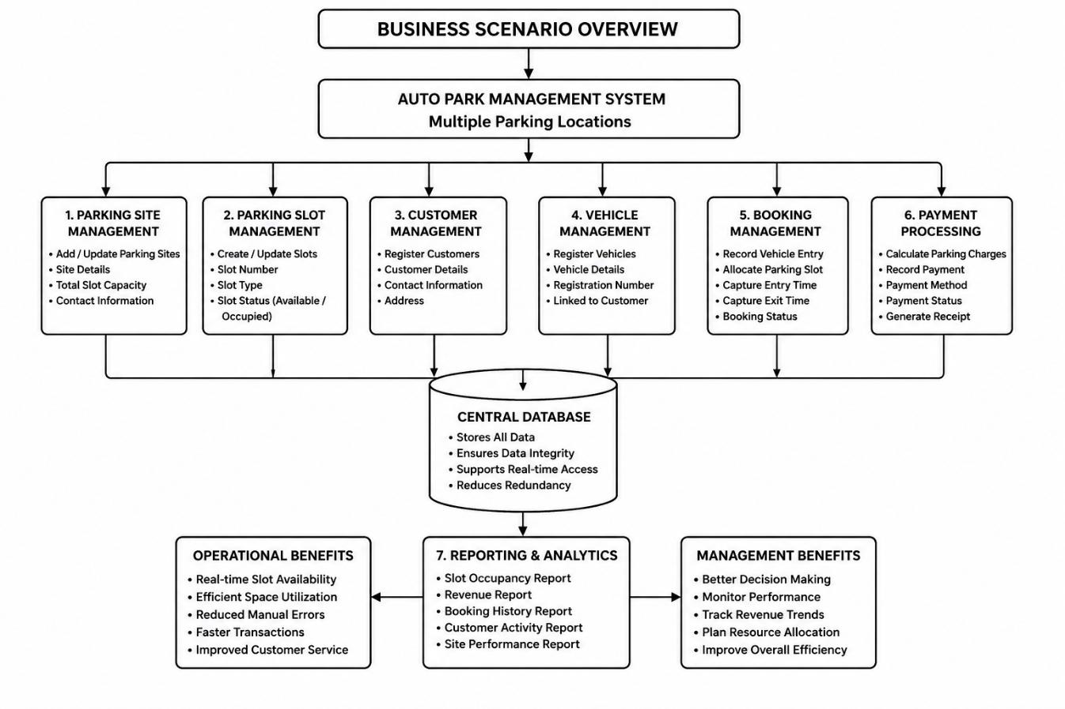

3. ERD
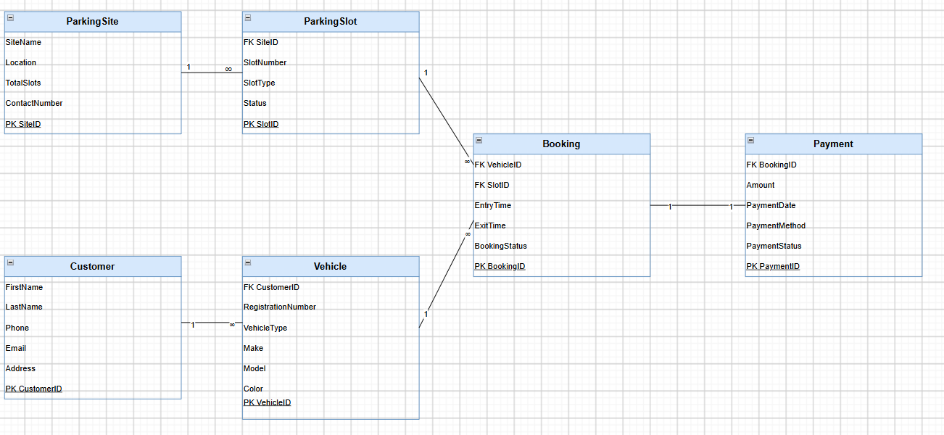
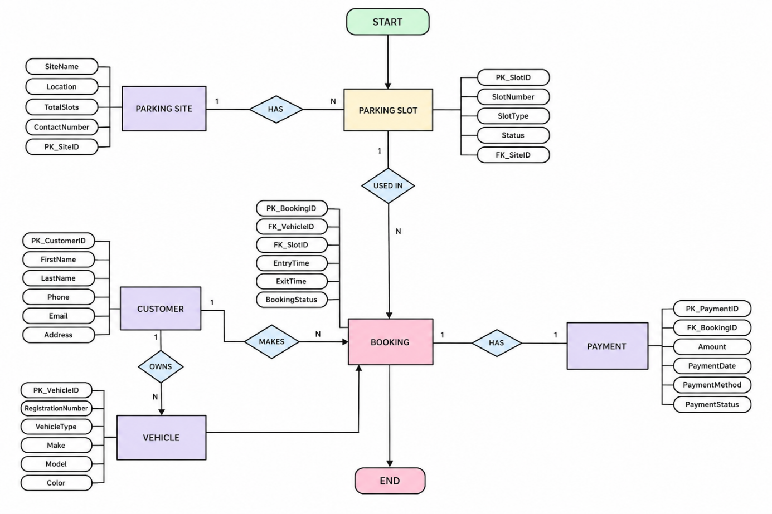

4. Data Structure Development
This AutoPark database was designed in Microsoft Access with six related tables. The ParkingSite table is based on the AutoNumber data type for SiteID, this is the primary key of the table, and is required field with validation; and has the following required field data types: Short Text for SiteName, Short Text for Location, Short Text for TotalSlots and a required field with validation Number for ContactNumber. The primary key for the ParkingSlot table is SlotID and the Number foreign key is SiteID, SlotNumber, SlotType and Status are used to denote each parking space and only accept a Status of either Available or Occupied.
The Customer table stores names, phone numbers, email addresses, addresses and required fields are marked. The Vehicle table relates each vehicle to a customer using the CustomerID field this is not unique, so the data will not be duplicated and the RegistrationNumber field has a unique index to ensure it is not duplicated. The Booking table contains foreign keys to cars and time slots, entry time, exit time, and booking status. The Payment table contains currency amounts, dates, payment methods and statuses.
A primary key can be used to detect the presence of duplicate records, validation rules can be used to help ensure that data is accurate and reliable, and required fields are important for consistency and reliability, and unique indexes can help to detect and prevent duplicate records [3].

5. Normalisation Compliance
Normalisation is a systematic technique used in the design of a database to prevent data redundancy, update anomaly and data integrity problem by organizing data into well-defined tables. Each piece of information is stored just once in the database, relationships are established between tables through primary keys and foreign keys and the overall decrease in data will make the database easier to maintain and more efficient to query. The AutoPark Management System database is “normalised” to Third Normal Form (3NF), which ensures that the operational data is stored efficiently, consistently and accurately.

First Normal Form (1NF)
The information contained in the database is in the First Normal Form (1NF): No repeating groups or more values in the same column. For example, the Vehicle table contains two attributes Make and Model rather than one attribute for both. Similarly, each customer has only one phone number, one email address in each record; an attribute is not divisible into smaller parts and no record in the table has more than one primary key by which it can be uniquely identified.

Second Normal Form (2NF)
The database is in Second Normal Form (2NF), which means that no data is stored that depends on more than one primary key. Since each table is given a primary key of just one column, there are no partial dependencies in any of the tables. In the Booking table, for example, the attributes EntryTime, ExitTime and BookingStatus are entirely dependent on BookingID. Similarly, there is no partial dependency because the details of the vehicle only rely on the VehicleID whereas Customer information only relies on CustomerID.

Third Normal Form (3NF)
The database is also in Third Normal Form (3NF) as there are no transitive dependencies between non-key attributes. Each non-key attribute is only influenced by the primary key, not by another non-key attribute. The columns in the Customer table (Phone and Email) are not mutually dependent, but dependent on the CustomerID. Likewise, the payment information only depends upon PaymentID and the parking slot information only depends upon SlotID. This not only reduces data redundancy but also makes database maintenance easier and ensures data consistency. Hence, AutoPark Management System database is completely in third normal form (3NF).

6. Sample Data Population
For testing the functionality of the AutoPark Management System database five realistic records were inserted into each table. The sample data contains common parking operations such as several parking sites, available slots, registered customers, customer's vehicles, parking bookings and completed payments. Each record can guarantee that the foreign key value equals the primary key value that exists in related tables, thus maintaining referential integrity [4]. The sample transactions simulate real world scenarios including a customer registering a car, parking at a site, assigning an available parking spot, making a parking booking and paying the parking fee when they leave. This representative data set allows for detailed testing of relations, queries, reports and validation rules, and can prove that the database will meet the operational needs of the AutoPark Management System.
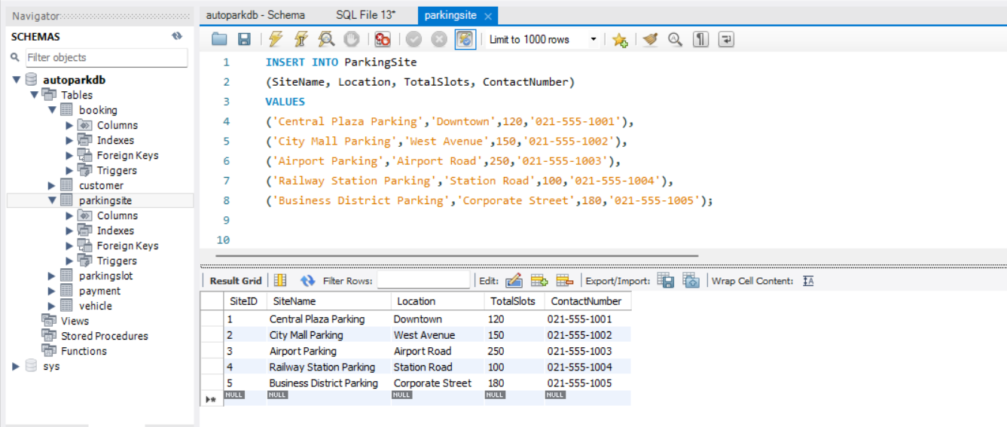

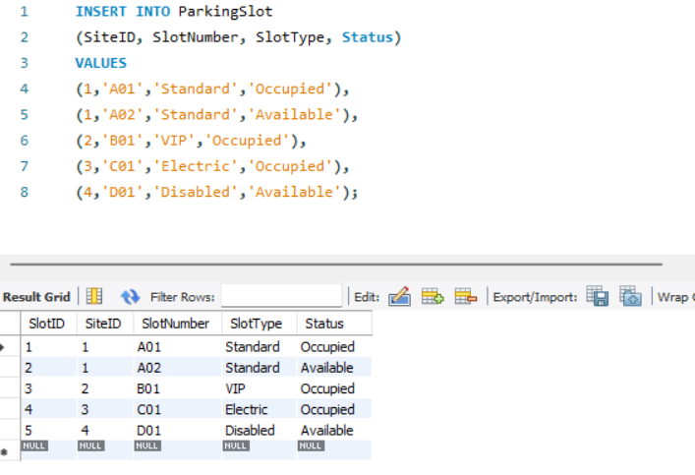
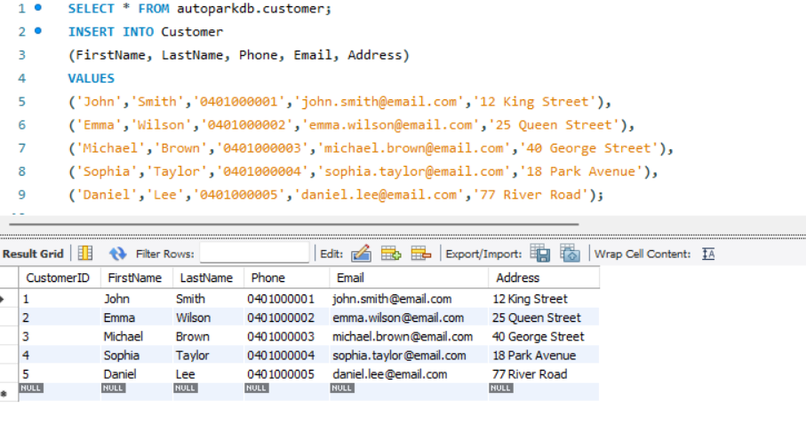
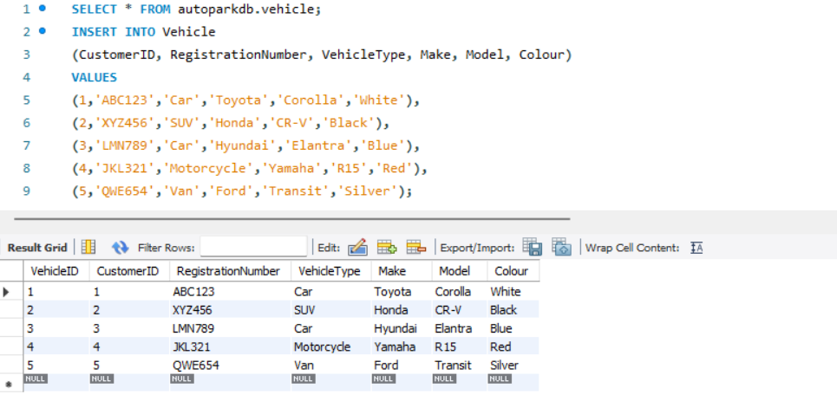
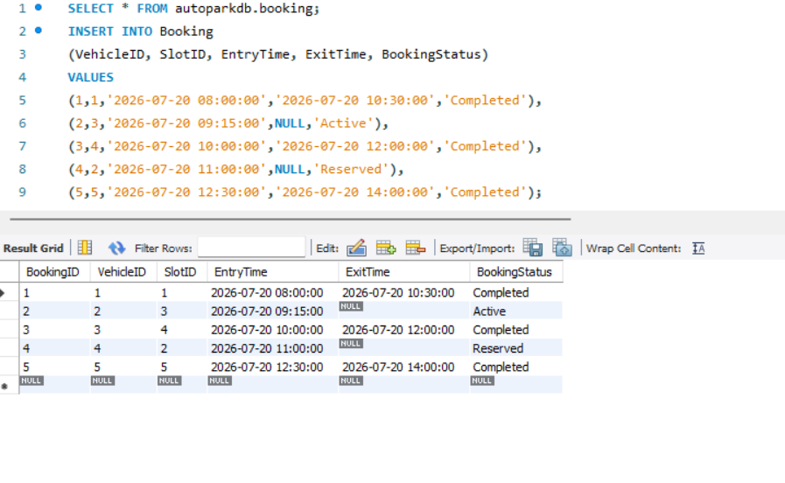
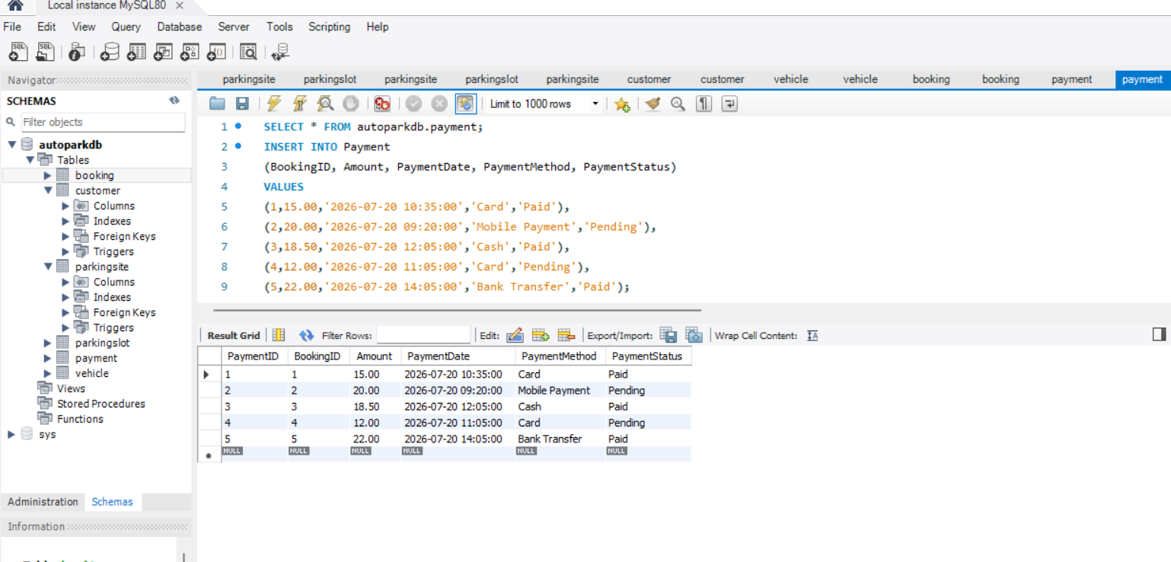

7. Query Development
These are some of the SQL statements that can be used to track parking availability, vehicle movements, customer activity, revenue generation, occupancy, and payment status. These queries help provide operational information which can help optimise the use of parking space, provide better service to the customer and help to review the performance of the business.

Query 1: Available Parking Slots
Purpose: Show all parking spaces that are available to make a vehicle booking.
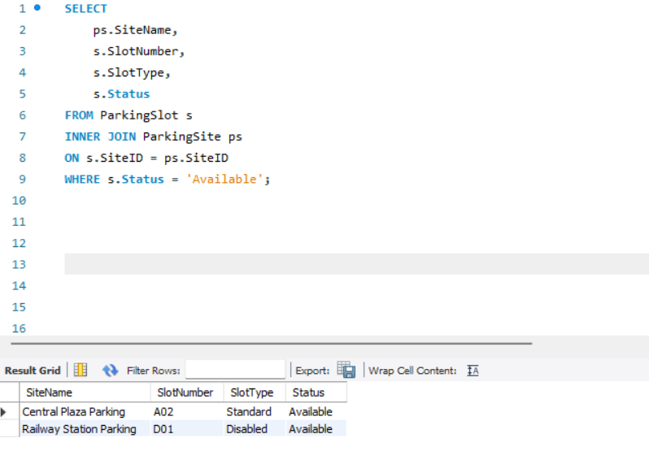

Query 2: Vehicles Currently Parked
Purpose: Show all the cars which have a current parking booking.
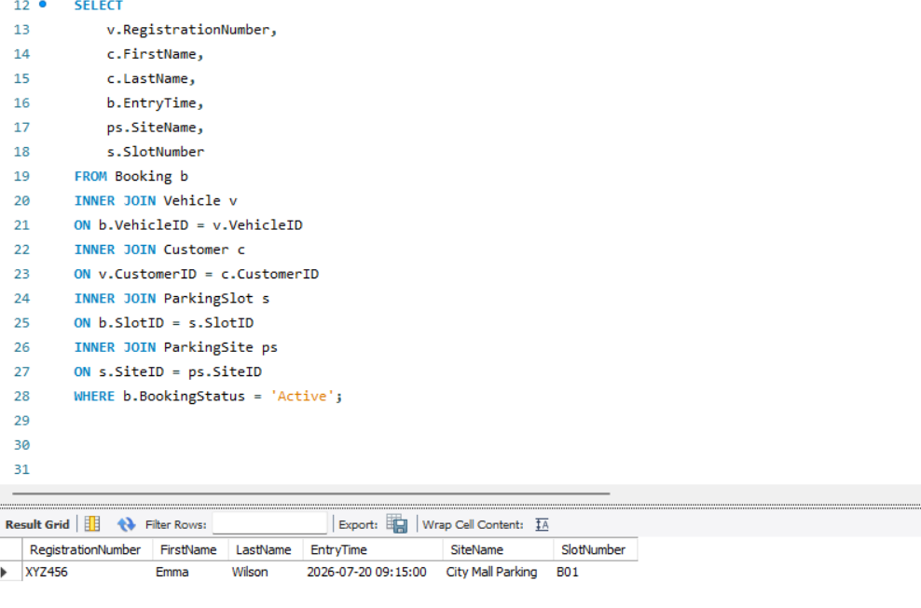

Query 3: Customer Booking History
Purpose: Returns all bookings for a specific Customer.
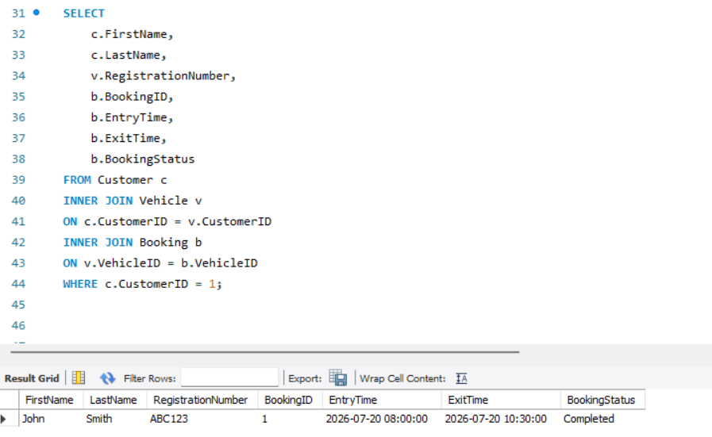

Query 4: Daily Revenue
Purpose: Calculates the total revenue collected for each payment date.
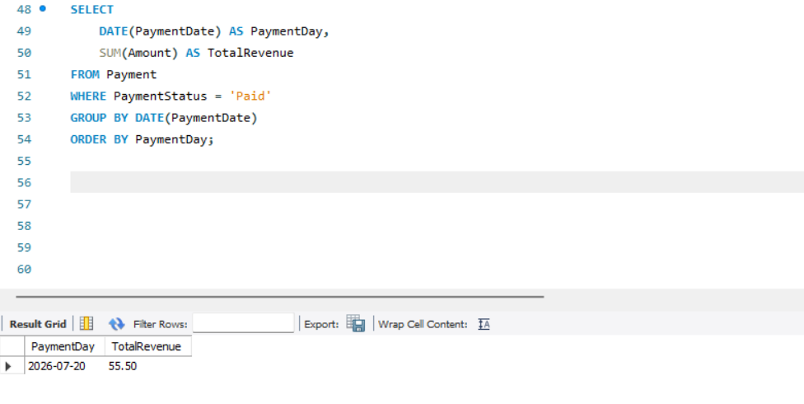

Query 5: Parking Site Occupancy
Purpose: Displays the number of occupied parking slots at each parking site.
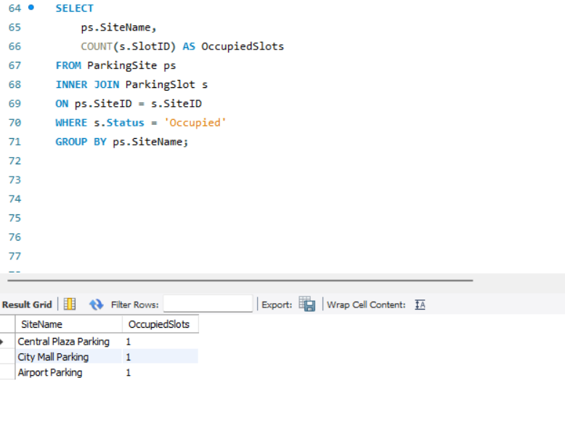

Query 6: Pending Payments
Purpose: Displays all bookings with outstanding or unpaid parking fees.
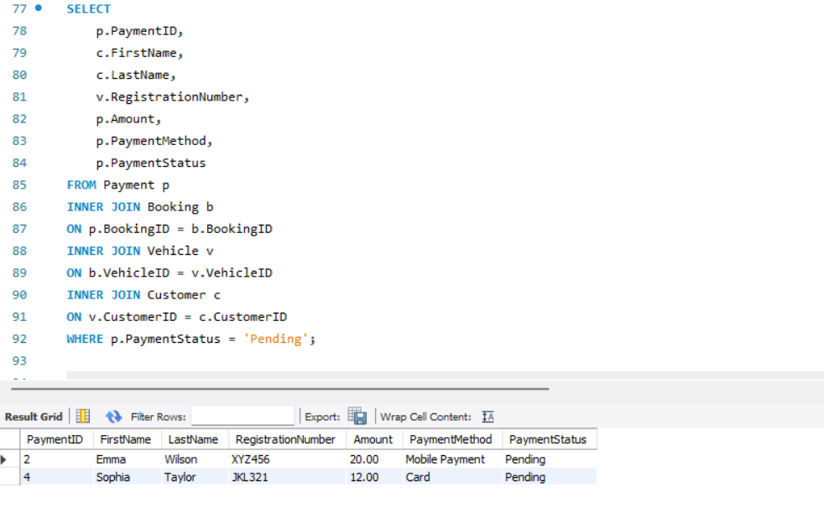

8. Validation and Testing
The AutoPark Management System was tested to ensure that all tables, relationships, validation rules and queries worked as per functional requirements. The test data consisting of valid and invalid data was inserted into the database to test if errors would be identified. Prevented incomplete customer records and prevented duplicate vehicle registration numbers with required fields and unique constraints. Foreign-key constraints even disallowed the creation of bookings without any existing vehicles or parking slots. Lastly, the daily revenue question was matched with the revenue amount calculated manually from the payment records to check for accuracy.
Table 8.1: Validation and Testing Results
Test Case | Test Input or Action | Expected Result | Outcome
Duplicate registration number | Insert an existing registration number into the Vehicle table | Record rejected because the registration number must be unique | Pass
Missing customer name | Leave FirstName or LastName empty | Validation error generated because the field is required | Pass
Invalid payment amount | Enter a negative payment amount | Record rejected by the payment validation rule | Pass
Booking without vehicle | Enter a booking without a valid VehicleID | Booking not allowed | Pass
Invalid foreign key | Enter a non-existent SlotID or CustomerID | Record prevented by referential integrity | Pass
Revenue query | Run the daily revenue query | Query returns the correct total of paid transactions | Pass
The testing confirmed that validation rules, required fields, unique indexes, and referential integrity protect data accuracy and prevent invalid or orphaned records.

9. Design Reflection
Microsoft Access was chosen because it offers a user-friendly interface for building relational tables, establishing relationships, adding data, writing queries and creating reports without needing to know any complicated programming languages. The six entities - ParkingSite, ParkingSlot, Customer, Vehicle, Booking, Payment - were enough as they constitute the major operational activities and data requirements of AutoPark. The separation of these entities also helped to minimize duplication and normalization [5].
Several issues arose during the development process, such as fixing the relationship issues, making sure that the foreign keys are compatible with the primary keys, debugging multiple-table queries, and applying correct validation rules. Solutions were sought by repeatedly testing and tweaking the table structures. Additional enhancements might include online booking, QR entry, a customer mobile app, automated gate barriers, access to a cloud-based database storage, integration of live sensors, and dashboard analytics for occupancy and revenue monitoring.

10. Conclusion
Autopark Management System database was successfully designed, which solved the problem of manual record keeping and used a structured relational database. The system facilitates the effective monitoring of customers, vehicles, bookings, parking slots, payments, etc. and makes sure that data is accurate, without duplication and real-time [6]. Its queries and reports give management more information on occupancy, income and performance. Validation rules makes it more reliable, referential integrity further adds to that reliability, and the scalable design gives a robust base for future digital parking technologies and organisations.

References
[1] M. A. Sahraei, “Design and implementation of a smart parking system with real-time slot detection and automated gate access,” *Technologies*, vol. 13, no. 11, Art. no. 503, 2025, doi: 10.3390/technologies13110503

[2] V. Dragu, E. A. Roman, M. A. Roşca, F. C. Oprea, A.-B. Mironescu, and O. M. Dinu, “Integrated information system for parking facilities operations and management,” *Systems*, vol. 13, no. 9, Art. no. 769, 2025, doi: 10.3390/systems13090769.

[3] J. S. Olmos Medina, J. G. Maradey Lázaro, A. Rassõlkin, and H. González Acuña, “An overview of autonomous parking systems: Strategies, challenges, and future directions,” *Sensors*, vol. 25, no. 14, Art. no. 4328, 2025, doi: 10.3390/s25144328.

[4] M. U. Ramzan, U. Ali, S. H. A. Naqvi, Z. Aslam, Tehseen, H. Ali, and M. Faheem, “Enhancing vehicle entrance and parking management: Deep learning solutions for efficiency and security,” in *Proc. 25th Int. Multi Topic Conf. (INMIC)*, Lahore, Pakistan, 2023. [Online]. Available: https://ieeexplore.ieee.org/document/10403227 Accessed: Jul. 20, 2026.

[5] Y. Zhao, “Automatic parking planning control method based on improved A* algorithm,” *arXiv* preprint arXiv:2406.15429, 2024. [Online]. Available: https://arxiv.org/abs/2406.15429 Accessed: Jul. 20, 2026.

[6] A. Singh, A. K. Singh, A. Srivastava, and A. K. Jaiswal, “Smart parking system and database creation,” *International Journal of Novel Research and Development (IJNRD)*, vol. 9, no. 2, pp. 143–145, Feb. 2024. [Online]. Available: https://ijnrd.org/papers/IJNRD2402143.pdf Accessed: Jul. 20, 2026.

