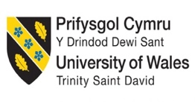

1913799@student.uwtsd.ac.uk

Workplace Culture and its impact on Organizational Efficiency

module

(BMSW5105)

By rares albei

Uju Ugochukwu

Table of Contents
Introduction 2
Political & Economic factors: 2
Social Factors 3
Technological factors: 3
Environment Factors 3
Legal factors: 3
Key factors: 4
Production: 4
Marketing: 5
Sales: 5
Culture web: 5
Ethical Dilemma 6
References : 9
Appendix Interview 10

Introduction

In this assignment we will discuss about Tesco as a company, we will use the Pestel analysis to have a better understand of what’s happening inside Tesco, will define the concept of Pestel and breakout in political, economic, social technological, environment and legal, for a better understanding.
In the second part of the assignment
We will define the cultural web the meaning of cultural web and, we will talk about McKenzie’s 7s cultural web scheme following that after I created an appendix that includes an interview based on questions from the cultural web
Last part of the assignment we will discuss about ethical dilemma for our chosen company in our case Tesco, we will explain the meaning of ethical dilemma and identify 2 ethical dilemmas in our chosen company.

According to Katz D and `Kahn an organization it is based on organizational structure including formal policies, rewards, and penalties. The authors they affirm that personal attributes of an employee can determine the employees to act or behave in a certain way with their motive and values.
As we learn on previous module every organization apply a reward strategy scheme for next few years. In other words, Organizations develop a reward system that include processes and different practices to ensure the employees are motivated to achieve a specific goal that can benefit both ways the organization and employees. The meaning of organisation refers to: a collection of people, who are involved in working towards a mission and vision in the pursuit of the company's goals

“Tesco Pestel analysis PESTEL is a framework that can be used to analyse how external political, economic, social, technological, environmental, and legal factors effect trail management”

Political & Economic factors:

Tesco it is one of the biggest supermarket chains in all Europe. The company start his expanding in early 1990 in Europe in countries like Poland, Czech Republic, Republic of Ireland, Hungary, Slovakia, and outside of the Europe in countries like Japan South Korea Taiwan Recently Turkey, and now `Tesco it is negotiating with China for their expansion, they plan to open there a supermarket chain.
For such an important supermarket chain Brexits plays an important role both political and economically, so we can place Brexit in both categories of the Pestel Analysis.
After research we found that Tesco they closed or gave up almost 2000 stores from 2020 (6,993 Stores) after Brexit and the Pandemic situation.
Brexit force Tesco to close several stores and to fire a certain number of employees because of uncertainty environment. The Brexit process delays importing and exporting goods inside or outside EU, and the prices rise for UK costumers as almost 80% food items in Tesco stores are provided from EU, causing a major impact on increasing the prices from 3% up to 6%.

The Pandemic situations in some ways help Tesco, last tow years they registered huge profits from sales. The misinformation helped them a lot, people panicked starting to buy unnecessary things and stock up on products such as frozen food, toilet paper, soap, hand sanitizer etc. In fact, the pandemic situation brought profit in their pocket up to 1.3 billion pounds and 360 million in 2020.However Tesco was forced to closed small shops and focused on big distribution centre which create a higher rate of unemployed. Still early but the specialist predicts major changes in the economic system in next few months.

Social Factors

Often little things can make the biggest difference between feeling welcome and included or not. Tesco adopt an inclusion strategy leaded by curiosity, deliberately seeking out difference, being open to change and challenge. We can referee here at the Muslim society, the company use and provide halal meat and label for the Muslim community, and, they imported Polish, Romanian, Indian and Chinese products for their customers.
The company it is up to date with Vegan product as it seems to be the new trend in 2021.This Vegan trend is on the upside based on food made from plants, and Tesco estimate that this trend will increase by 300% until 2025.Based on multicultural market the company depends on the influence that the community have and the power of purchasing of those costumers.

Technological factors:

As we all know we live in technology Era and the company understand this since the beginning. Before the pandemic situations Tesco already offer the costumer the change to order food online and deliver the food as well, but in the pandemic time they invest and develop this process, making easier for costumer. Because of social distancing and all the regulations imposed by Covid situation they launch mobile apps where you can order food, different delivery services, barcode scanning, online grocery’s platforms where you can track your delivery, online vouchers, online discount for NHS and Tesco colleagues. For example, in certain days they offer 20% discount for NHS personnel and key workers around they UK. By understanding the situation not only they did survive, but they manage to make huge profits.

Environment Factors:

From my personal experience I can tell that Tesco it is one of the biggest Organization in terms of recycling, as an employee part of my job was to make sure that we recycle almost everything. Special local designated areas for cardboard and shrink-wrap. Also, they develop the biggest redistribution scheme in other words they create a scheme where all the food surplus it is donated daily to community like local charity’s, people who can’t provide food for themselves community groups. The company implement a new type of fuel, natural based on food waste and household waste as well and this type of fuel reduce NOx up to 90% making the company one of the safest when it comes to the environment.

Legal factors:

Obviously operating worldwide Tesco stores must meet the Laws and Regulations for every country where they have stores. As we all know all the big Organizations tries to put a monopoly in the field in which it operates but Brexit change somehow this situation for Tesco. Obviously because of EU Law and regulations all the Tesco stores outside the UK can’t merge with other small companies to impose a monopoly on the specific market, but now because UK it’s outside of EU this law can’t be applicable for Tesco in UK, however they must meet the UK Law and Regulations.
Operating in a multicultural country like UK they must respect and be against employee discrimination, gender, and age. They also must provide equal payment between male and female personnel. As a company they must treat all the employees equal and give them the same chances regardless their color skin, religion, gender, or sexual orientation.

Key factors:

Structure organization at Tesco has been very successful until now, and I believe that it is one of the most important key factors to succeed in a business environment. They’ve been visionaries and they expand to all continents in the world.

“The divisional structure occurs when departments are grouped together based on organizational outputs. The divisional structure is sometimes called a product structure or profit center. Most large companies have separate divisions that use different technologies or serve different customers. People within each division have more product focus, accountability, and flexibility than would be the case if they were part of a huge functional structure.”

Production:
Tesco doesn’t produce only food like most big stores in EU, they also provide mobile telephone services, in competition with big brands like Vodafone, they have their own network wherever you can choose your own plan or Sim only and the costumer could choose between brand such as Samsung, iPhone, Huawei, Google, etc. Tesco it’s also having they own Bank, called Tesco Bank where people can make insurance car, they can access credits, mortgages. They also provide a department of clothing from where clients can choose between kids clothing, women’s, and men’s clothing even school uniforms. Overall, the production system they’ve adopt works well for them as a company.

Marketing:
This structure allows Tesco to prosper in business marketing. The company creates in South Africa their own wine product and sale in UK and around the world, they use different and new technologies to make one of the finest wines on the market in all Europe.
Marketing department of Tesco from Asian division manage in 2011 to offer customers the opportunity to take a virtual tour of stores in South Korea which lead to a considerable increase in new memberships by 76% and online sales increased by 130%, becoming the No1 store in online sales in South Korea.

Sales:
From this point of view in last few years Tesco has a big advantage, understanding the customer needs and finding the best and easiest way to satisfy the costumer in Online areas. Basically, people responsible with sales based in online create and develop Tesco website in a way that it’s easy to access, to navigate, easy to find the correct product which you need. In Today’s world the costumers need is crucial in this process, obviously they want to be able to navigate easy and at the same time to go from one section to another with just a click, they don’t like to search for products, that’s way Tesco updated the website long time ago with search button.
IT department designers highlighted the main categories to be easier to spot it, and you will find absolutely every necessary information about the category you selected.
Visually the website it’s well balanced in term of effects or advertising, On Tesco homepage the costumer will find fresh products, products available with discounts and all promotions available on the site, also the logo company it’s very easy to spot it in the left-hand area.

Culture web:

“The McKinsey 7S Model was developed in the early 1980s by Tom Peters and Robert Waterman, two consultants working at the McKinsey& Company consulting firm and has been used to analyse over 70 large organizations, since then. The model was created as a recognizable and easily remembered model in business. The seven variables, which the authors termed “levers” all beginning with the letter “S” include “structure”, “strategy”, “systems”, “skills”, “style”, “staff”, and “shared values/ superordinate goals”

“According to Alvesson (2013), culture is central to everything in organizational life, and the behaviour of the members is guided by values, ideas and beliefs that are accepted within their organization.”

Strategy represents all actions made by a company as a response to all changes in external environment.

Structure means basically the organisation of the company, how the company has been organization including teams and departments and who’s reporting to whom.

Systems: the systems consist of all information needed to get the job done, in other words represent the information that support first 2 steps above strategy and structure

Style we can admit two components: Code of conduct representing by the values establish by senior employees and beliefs develop in time

Staff involve people all Human Resources and HR management as well related to process of recruiting, the reward system, socialisation process training areas.

Skills competences of employees to achieve the company goal

Shared values all the staff implicated direct or indirect in this process understand the organisation targets, objective, values, and the success of the organisation as well

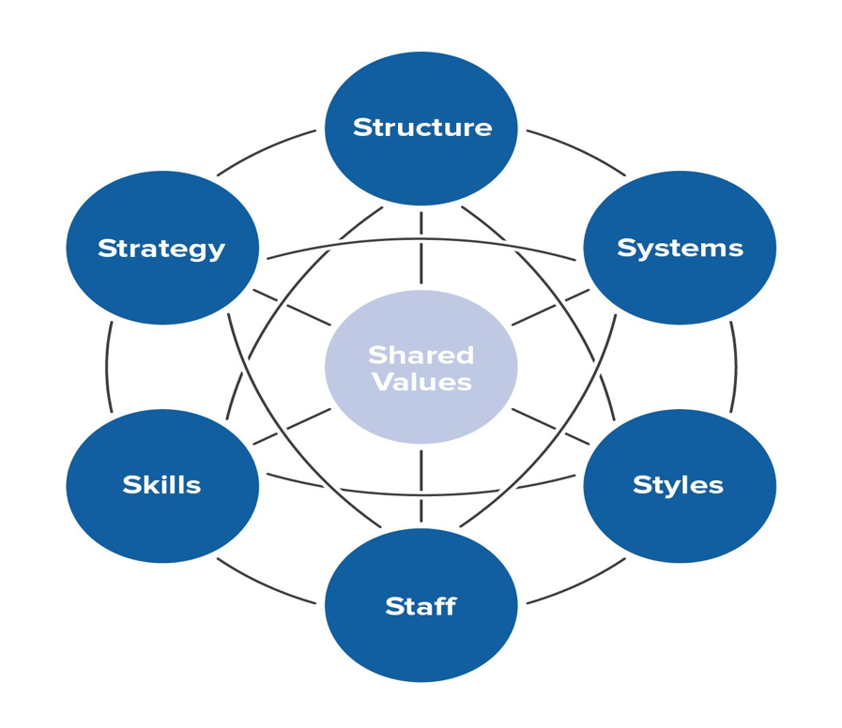

Ethical Dilemma

“In general, an ethical dilemma is a complex situation a person (business) faces in which a decision must be made about the adequate action to be taken Harrison, 2005. A dilemma may derive from the conflict between the rightness or wrongness of the actions and the goodness or badness of the consequences of the actions. In other words, doing what is morally right apparently results in a bad outcome and doing what is morally wrong seems to lead to better effects. From another perspective, an ethical dilemma is a conflict between at least two ethical principles both of which could lead to an equally good or equally bad outcome “

The name of ethical dilemma it’s given by the specialists that impute to companies or businesspeople to do everything that is correct or fair or equitable for both sides even if they are not legally or institutionally correct or in accordance with the company's policy. In this process of liberalization of the world economy, the business environment has undergone and is undergoing rapid changes with new corporate responsibility and moral obligations corporation or business. In other words, considering these changes in business world of this process of liberalization it is very important the moral character of multiculturalism that already exist and operates world-wide in all international markets.
An example could be the different approach between Europe and Middle East related to morality and ethics
when we refer to the employment of staff in Europe being considered illegal to work if you are a minor while in the middle east this rule does not exist. indeed, in eastern Europe this rule of morality is not applied by all countries

The most important changes are closely related to the liberalization process. As a result of this process, debates and debates of ideological origin are born. revolt against this process because they do not believe that this globalization is economically beneficial, causes economic instability and causes inequality between other countries and individuals. On the other hand, there are economic analysts who support the process of globalization as having very successful positive economic effects. Without fear of error, we mention that the process of globalization has been, and still is in our days and probably will still be in next few years useful for removing impediments and barriers to transporting goods, services, and capital, reducing the costs of transport, and expanding new technical technology and new economic skills and knowledge.
We must not forget and pay attention to one of the basic rules of global liberalisation. Firstly, the economic system should not be restricted for international competitors and all the international markets can develop to be more efficient adopting this rule or this conduit of morality and ethics

Companies who are operating worldwide must meet the Laws and Regulations for every country where they have business. Respecting the imposed laws and regulations, the business ethics process will start immediately where the law allows them, following that the ethical principles of the business will be established by strategies in which we ensure that we respect the environment and do not harm the environment, culture and customers. we can develop and technologies these areas This meaning strengthens and develops the need for moral and ethical values in business. Lately, the concept of sustainable development has gained a greater aptitude, encompassing both economic and social aspects while discussing the issues of ethics and morality in the business environment. Sustainable development also considers ecological, economic, and social phenomena, being at the same time a concept related to environmental protection.

Approaching economic strategies from the perspective of sustainable development also has implications for business ethics which has been structured by economists such as Kenneth Arrow, Herman Daly, and David Pearce on several levels: economic, social, moral, and ethical. Thus, the responsibility of management must produce and market the products that ensure the economic success of the company. From a social perspective, the most important concerns are related to the establishment of more equitable relations between rich consumers in developed countries and poor people in developing countries, as well as to the development of equitable relations between urban and rural population, between men and women. The concept of sustainable development also has implications for the process of ethics and morality in trade. These ethical implications can be generated by certain marketing techniques that create ethical problems such as the closure of factories, the manufacture of products that cause non-compliance with pollution rules, etc.

Cultural values are especially important in the way people understand how to do business. Many elements of culture show a special influence on business behaviour, so that understanding and knowing the set of values of culture influences partnerships and / or competition.

Conclusion : this assignment it is structured on 3 parts , in first part of the assignment we have an introduction for a better understanding of what are we going to talk about .Our chosen company it is Tesco and we’ll understand better how the company works by reading the Pestel analysis , in the second part of the assignment we’ve describe and define de Culture Web we’ve got an appendix as well for this part of the assignment and for last part of our work we will discuss about ethical dilemma. will Define the ethical dilemma, and discuss the importance of globalisation advantages and disadvantages, what the companies need to do if they want to work abroad and develop their business world-wide and economical strategies as well.

References :

Anand, N., and Richard L. Daft. "What is the right organization design?." Leading organizations: Perspectives for a new era(2007): 307-322. Fosher, Holly. Understanding the Marketing and Management of trails using PESTEL Analysis. Diss. University of New Hampshire, 2018.

Alshaher, Ali Abdul-Fattah. "The McKinsey 7S model framework for e-learning system readiness assessment." International Journal of Advances in Engineering & Technology 6.5 (2013): 1948

www.youtube.com. (n.d.). Tesco Homeplus Virtual Subway Store in South Korea. [online] Available at: https://www.youtube.com/watch?v=fGaVFRzTTP4&t=143s [Accessed 13 Jul. 2021].

Doherty, O. and Stephens, S. (2020) ‘The cultural web, higher education and work-based learning’, Industry and Higher Education, 34(5), pp. 330–341. doi: 10.1177/0950422219879614.

Tota, Ikbale, and Hidajet Shehu. "The dilemma of business ethics." Procedia Economics and Finance 3 (2012): 555-559.

Crane, A. and Matten, D. (2007). Business ethics : managing corporate citizenship and sustainability in the age of globalization. Oxford: Oxford Univ. Press.

Appendix Interview

My name is Marcelo I’m a manager at Tesco, I’ve been working for Tesco since 2015, in this time I get the full-time job afterword’s Tesco give me the opportunity to apply for a co-ordinator job I’ve Benn doing this for 3 years now, I did my placement at Fenny Lock for 8 months where basically our team open the warehouse, hire personnel, train them for specific jobs. AT THE MOMENT I’m despatch in Middleton where we open another warehouse, 20 minutes far from Manchester as a landmark and I’m so excited to take it again from scratch and make something significant for society, we will create workplaces, we will be able to support our Stores and that make me happy.

What core beliefs do stories reflect?

As you can see on the club card it says, “every little help makes a big difference”, so our Core Purpose and Values are trust of course, caring for customers and colleagues as well, innovation, empathy and collaboration.

What do train programme emphasis?

Well, is Inspiring great performance, our training it’s based on 26 weeks with an evaluation within 4 weeks 12 weeks and finally 26.

What is mostly monitored/controlled?

What we monitored every day it’s the performance of our employees (objectives and targets), our job it’s to make sure that our staff meet the targets and objective. We have our own system of monitoring, we give feedback, we put safety first and we try to do everything with a smile.

Are there particular symbols which denote the organisation?

Our logo, I mean from 1960 Tesco it’s using colour red for the name of the company, and it’s obvious, I think Tesco keep it simple but efficient.

How is power distributed in organisation?

Oh, basically Tesco follows hierarchical organisational structure, everyone knows what he needs to do I can’t speak for other colleagues, but currently we know our role and the company make sure they “distribute” if you like the work in many parts to make sure the work will be more efficient.

