Therapy Assistant Practitioner:
Demonstrating Practice Logbook



This logbook was completed by:

Mentor’s name: ……Holly Jacobs Mentor’s signature: …Hjacobs…………………… Date: …13/02/2026

Learner’s name: ……Rosheena Thomas……. Learners’ signature: ……RLThomas Date: …11/02/2026….

The content page includes a list of evidence to be collected as part of your portfolio:

- Log of supporting documents: | Details to include (including criteria): | Date of completion: | Mentors signature: | Appendix / page
- An observation of your practice | A supporting document from your mentor of your compliance with person centred practice (1.2 & 4.3). | 01/12/2025 | Hjacobs | Appendix 1 / Page 3
- Evidence of reading and learning related to role | A minimum of 2 examples of your engagement with researching and learning on topics related to your role (8.4). | 11/02/2026  11/02/2026  03/02/2026 | Hjacobs | Appendix 2 / page 5
- Log of a wide range of assessments. | A minimum of three anonymised assessments completed by you, demonstrating a range of skills and tools (1.2). | 01/12/2025  02/12/2025  02/12/2026 | Hjacobs | Appendix 3/ Pages 6-8
- Copy of a recent Personal Development Appraisal Review (PDAR). | A copy of the most recent PDAR document completed with supervisor / mentor (8.1 & 8.3). | 06/11/2025 | Hjacobs | Appendix 4/ Page 9-10
- Copies of your recent supervision records. | A minimum of two supervision records, demonstrating attendance and contribution to supervision and agreement to actions (4.2). | 20/01/2025  28/01/2026 | Hjacobs | Appendix 5/ Page 11-12
- A copy of a risk assessments you have undertaken | A formal or informal risk assessment that you have completed. This can be a case note entry, DATIX, incident report or an assessment completed due to risks (such as a falls risk assessment) (4.3) | 03/02/2026 | Hjacobs | Appendix 6/ Page 13
- Examples of any training you have participated in or delivered | A minimum of five examples of evidence that you attended or delivered training within the last 12 months (8.4). | 21/01/2026  04/02/2026  11/02/2026  04/02/2026  12/02/2026 | Hjacobs | Appendix 7 / Page 14-18
- Evidence of your compliance with mandatory training | A minimum of 5 examples of your mandatory training compliance over the past 12 month (4.1). | 11/02/2026 | Hjacobs | Appendix 8/ Page 19
***The following pages are where you can start to include your evidence:
Appendix 1 (to be completed by your mentor) - Supporting document:
Give a brief description of your relationship with the learner and a typical activity that you have overseen the learner complete:
I am a band 6 Occupational therapist in Rosh’s team, myself and Rosh work together closely. I asked Rosh to support me during this assessment as I value her calm and polite manner when assessing patients , especially those who have a learning disability. Rosh has an approachable manner and was able to adapt the terminology and use words appropriate for the patient’s learning age. Due to Rosh’s experience with a variety of patients with differing cognitive challenges she pointed out the patient having a communication pack which supported with patient’s engagement with the assessment. Rosh was able to carry out a conversation with the patient and gather all appropriate information to support the initial assessment. Rosh was polite and professional with the LD Nurse who was present for part of the assessment and made sure to introduce herself and role. Rosh made sure the patient was always included during the conversation and asked inquisitive questions about patient’s interests e.g her favourite colour/ her pets.
Does the learner demonstrate the following performance in their day to day practice: | - Yes | - No | - N/A | Signature
- Person-Centred Practice
- Actively listens to patients/carers to understand goals and concerns | / |  |  | C.Morgan
- Adapts communication style to meet patient needs (such as cognitive, language, sensory) | / |  |  | C.Morgan
- Respects patient dignity, respect, and personal preferences | / |  |  | C.Morgan
- Involves patients in decision making and provides clear explanations | / |  |  | C.Morgan
2. Professionalism & Accountability |  |  |  | C.Morgan
- Arrives prepared, punctual, and appropriately presented for the clinical task. | / |  |  | C.Morgan
- Follows organisational policies, procedures, and scope of practice | / |  |  | C.Morgan
- Accurately reports and escalates clinical concerns to qualified therapists | / |  |  | C.Morgan
- Accepts responsibility for actions and learns from feedback | / |  |  | C.Morgan
- Maintains appropriate boundaries and therapeutic relationships | / |  |  | C.Morgan
3. Safe & Competent Clinical Practice
- Delivers treatment sessions as prescribed by supervising clinicians | / |  |  | C.Morgan
- Demonstrates safe handling, mobility, and equipment use | / |  |  | C.Morgan
- Uses standardized assessments correctly and ethically | / |  |  | C.Morgan
- Identifies and reports risks (falls, safeguarding, deterioration, environmental hazards) | / |  |  | C.Morgan
- Documents interventions and outcomes accurately and timely | / |  |  | C.Morgan

Appendix 2- These are reading examples and research around my job role.
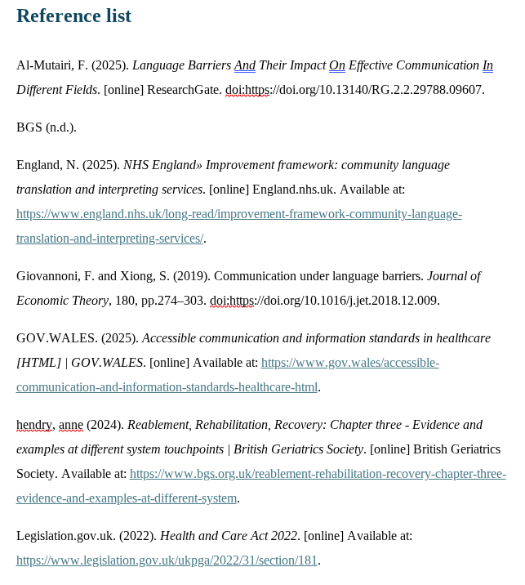

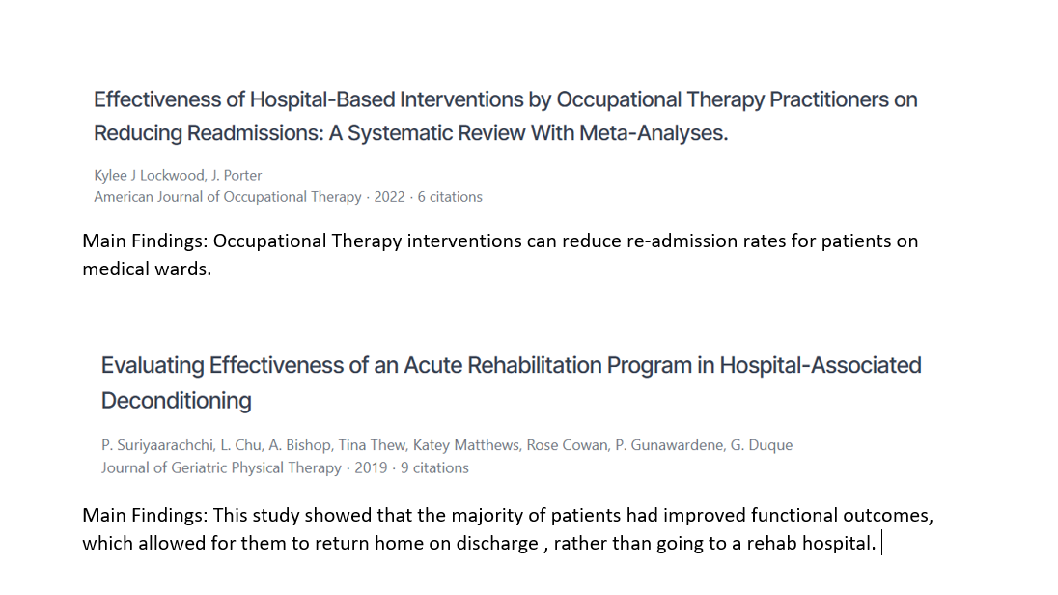

Appendix 3 -
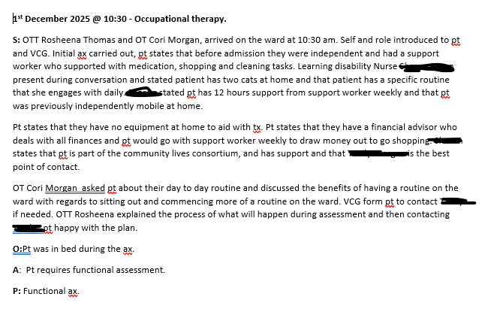

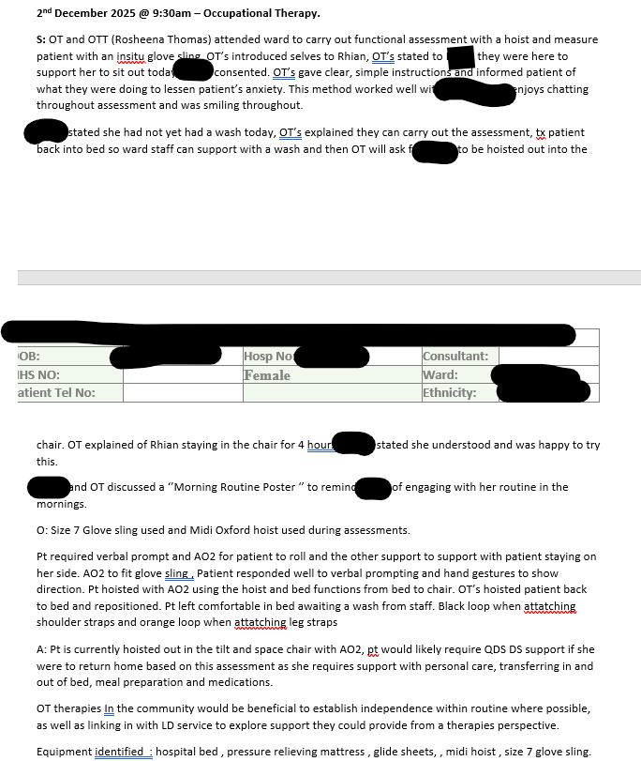

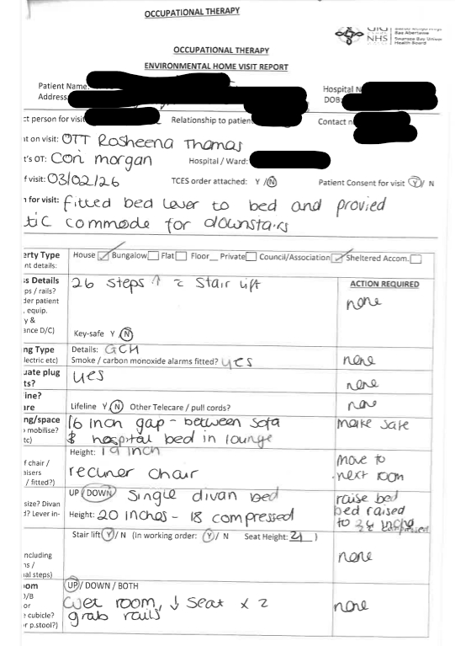

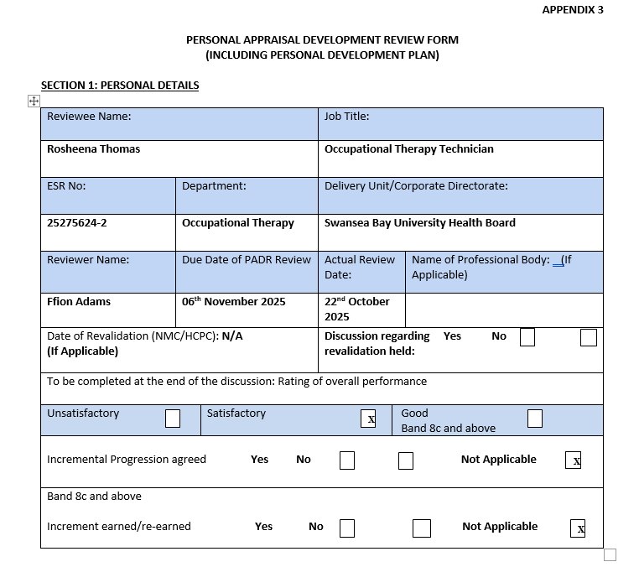
Appendix 4

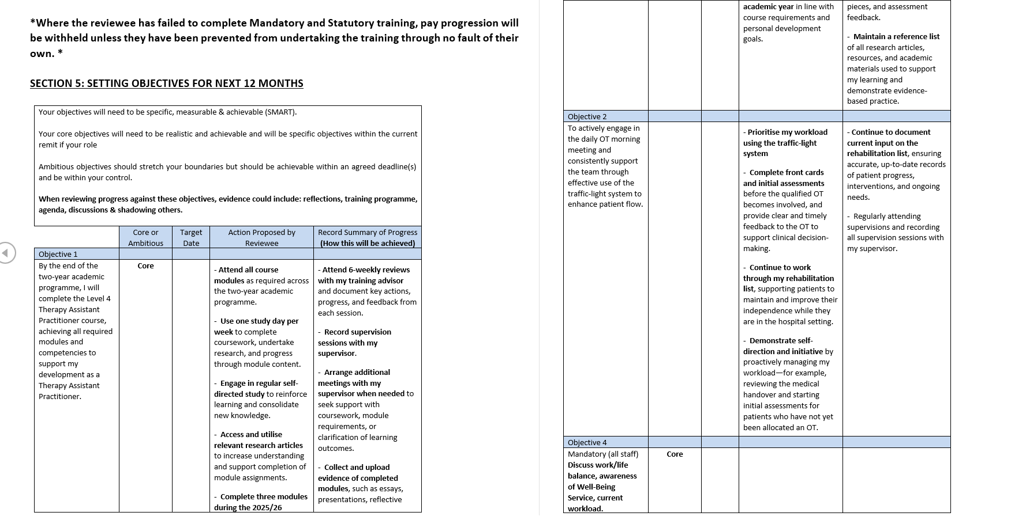

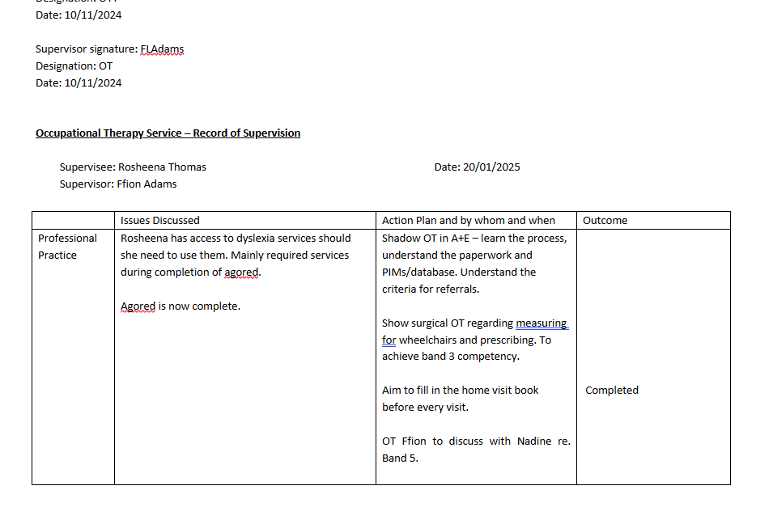
Appendix 5

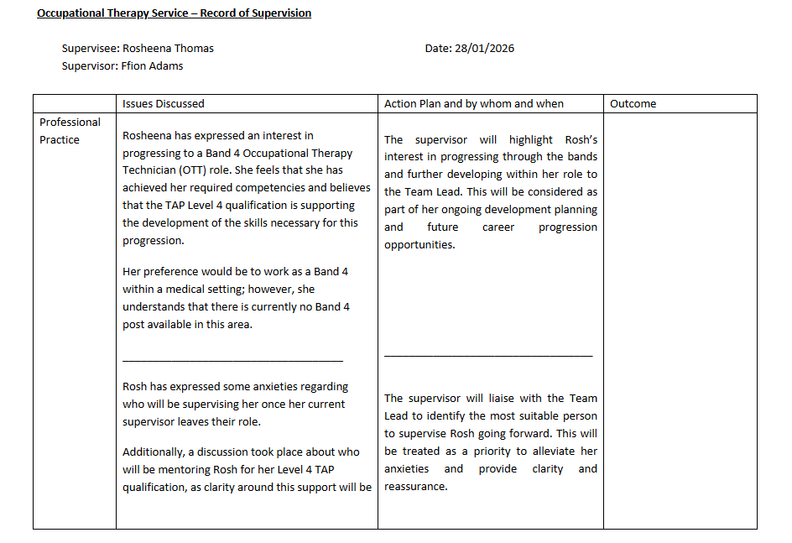

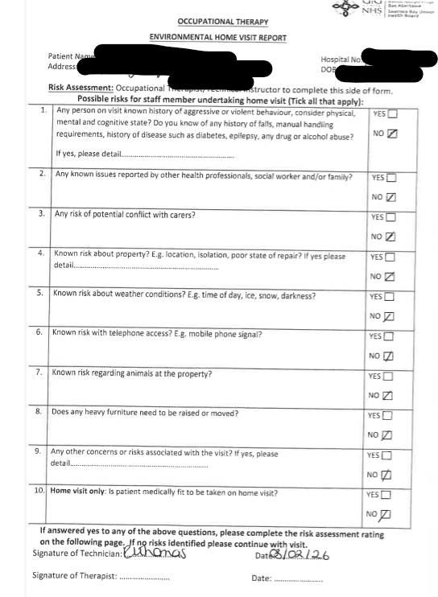

Appendix 7
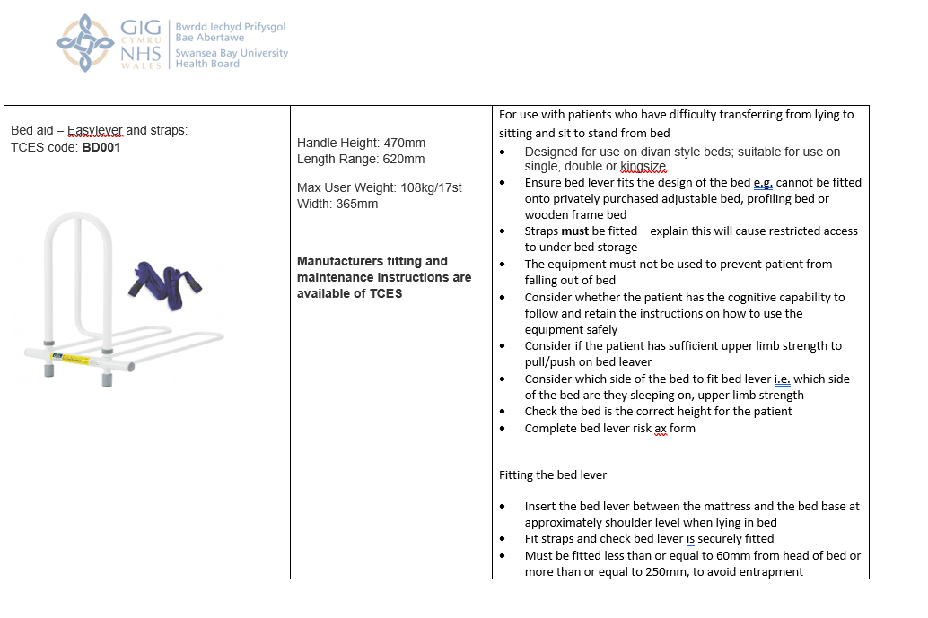
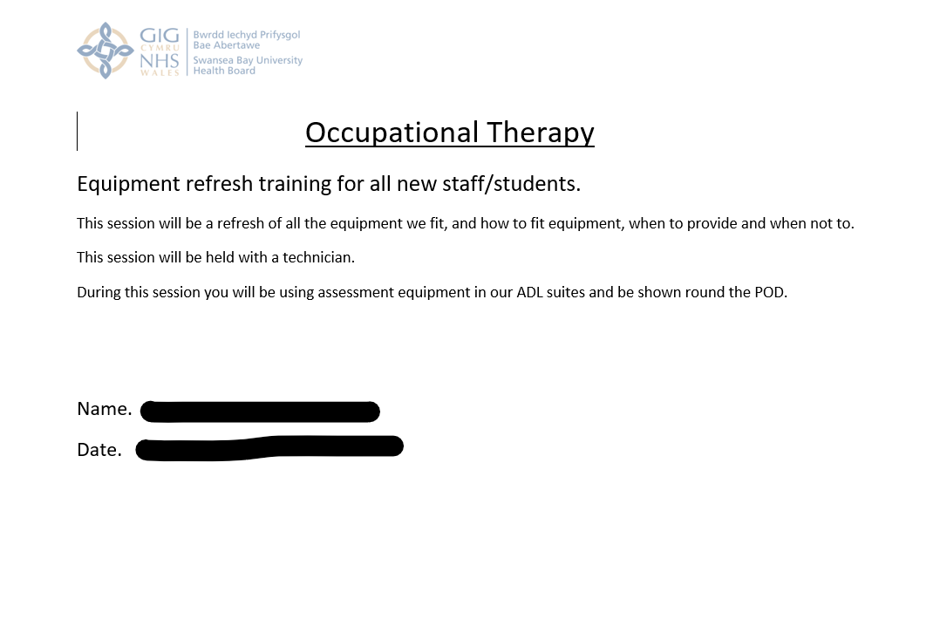

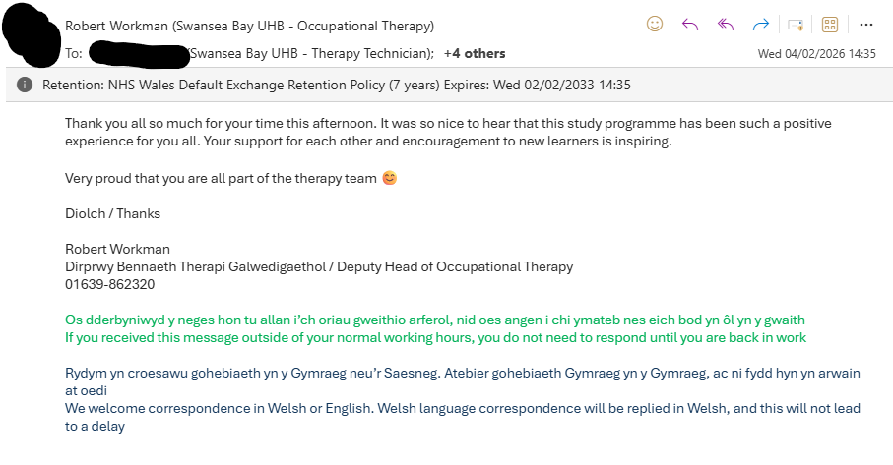

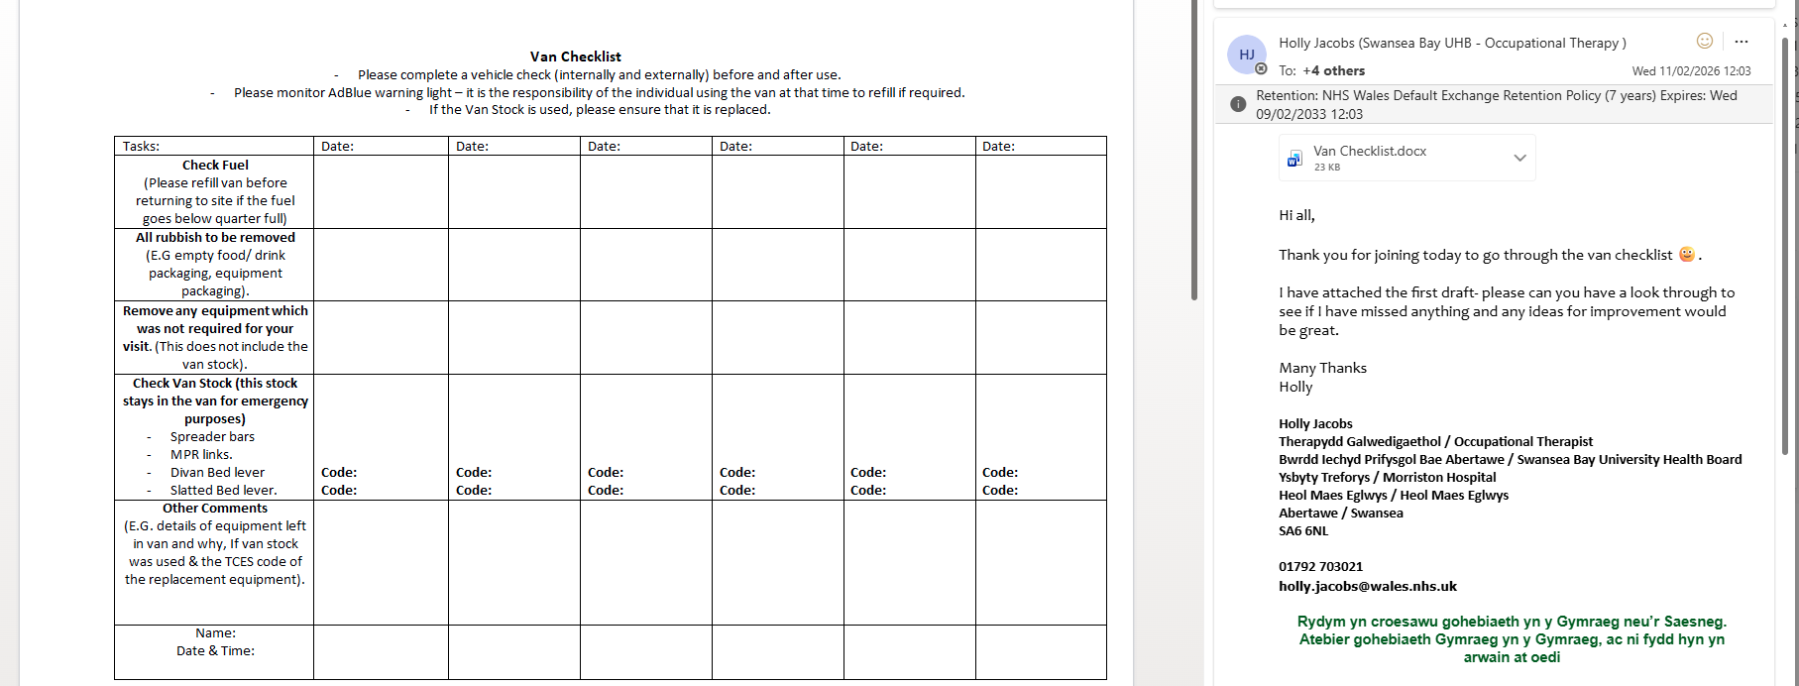

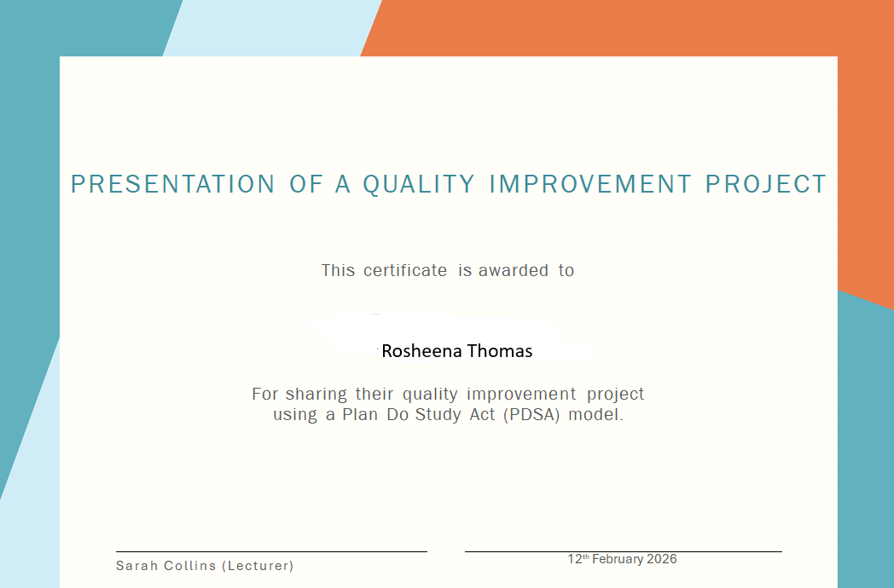

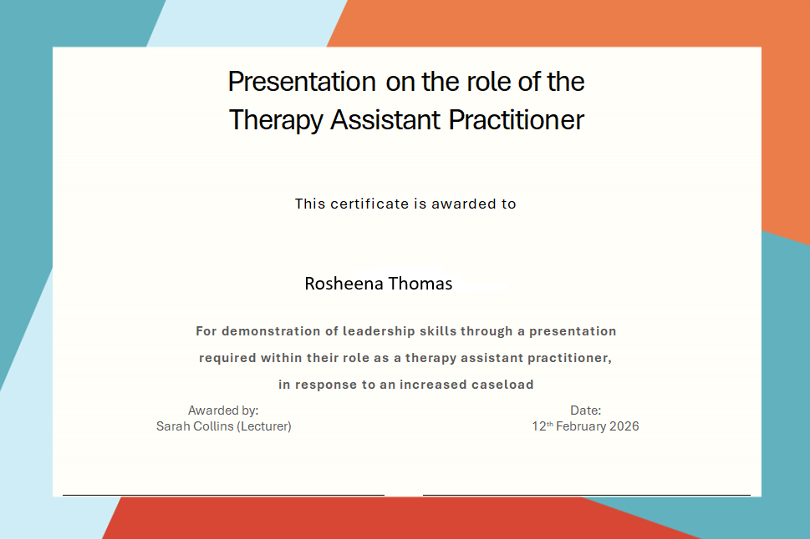

Appendix 8


