Synthesize a solution to a potential real-life scenario
Author: Steven Moore
(1801309)
Network and Cybersecurity Essentials
(ACCA4024)
School of Applied Computing Wales Institute of Science and Art Date of submission: 29/12/2020

Table of Contents
Network 3
Devices 3
Threats 3
Poor Communication 3
Compromised Devices 4
Unsecure Networks 4
Malicious Apps 4
Mitigation 4
Poor Communication 4
Compromised Devices 4
Unsecure Networks 4
Design and Implementation 5
Weak points 5
Policy 5
Access points 5
Tools 5
Example attack 5
Type of Attack 5
Implementation 6
Network 6
Scenario 6
Guide 6
Outcome 8
Mitigation Strategies and Recommendation 8
Policy 8

  - Introduction
This is a discussion of Che-Si, a construction-based company, and their network. This will include the type of network, threats, an example attack and mitigation options.

Network
Che-Si is a construction-based company which uses a large WAN to connect their offices from all over the world. WAN meaning wide area network which is commonly used to connect multiple LANs (Local area networks) together. Che-Si currently allow their staff, clients, and vendors to access their network from any device and any network. This is commonly referred to as bring your own device or BYOD.

Devices
Bring your own devices can include any device which can connect to a network such as: smartphones, laptops, and tablets. 90% of workers in the US use their own smartphone whilst at work, according to digitalguardian.com [1].
As mentioned previously Che-Si also allow people to connect to the company’s network from any network. Meaning desktop PCs may also be used to remotely connect to the network from public networks. Because of these policies Che-Si will store personal or sensitive data from its staff, clients, and vendors. This data is at risk of being stolen, encrypted, or destroyed.

Threats
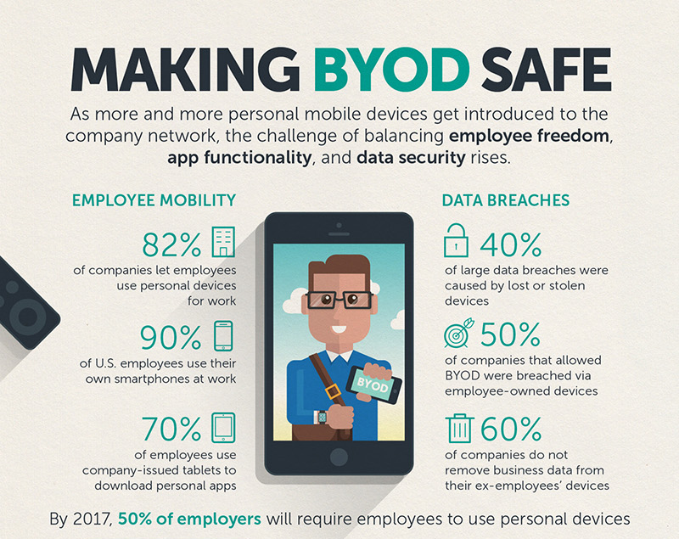
Due to Che-Si’s cyber security policies the network is at risk from a large range of attacks. For example, [2] According to trendmicro.com 40% - 60% of large data breaches are caused by compromised personal devices. Compromised devices include lost, stolen or hacked personal devices such as smart phones and laptops.
There are four main cyber threats concerned with BYOD policies according to ccbtechnology.com [3]. These are:
- Poor communication of BYOD policies.
- Compromised devices.
- Unsecure networks.
- Malicious Apps.

Poor Communication
Poor communication of a company’s BYOD security policy is one of the most dangerous threats as it opens the network to all kinds of attacks.

Compromised Devices
As mentioned previously 40% – 60% of large data breaches are caused by stolen personal devices of employees. These devices not only contain the personal information of the owner but also contain sensitive data that may put the entire company at risk. Such as private conversations, access to databases etc.

Unsecure Networks
Unsecure networks refer to public Wi-Fi which anyone can connect to. This makes it very easy to intercept and view any data being sent over the network by Che Si employees. This is known as snooping or packet sniffing.

Malicious Apps
Without a proper security policy many employees may unknowingly download malicious applications onto their smart phones. These apps can gain access to private or sensitive data stored on the device.

Mitigation

Poor Communication
According to Jamey Heary [4], a senior director at Cisco. Creating a clear and easy to understand BYOD security policy is the best solution to security threats from BYOD. A good BYOD policy should layout the employee’s rights and responsibilities. It should also define rules of what is deemed acceptable device / network use. Employees should also be made aware of what procedure to follow if a device is stolen or compromised.

Compromised Devices
When dealing with lost or stolen devices most companies use mobile device management software or better known as MDM. MDMs can be used to secure devices by enforcing company policies onto a device. An MDM can also be used to remotely wipe a device if it is lost or stolen.
According to the national cyber security centre, which is a British government organisation, there is no clear best all-rounder MDM [5]. The most popular MDMs according to ITPro.co.uk [6] are: Cisco Meraki, IBM MaaS360, and Hexnode MDM.

Unsecure Networks
The best way to mitigate the threat of unsecure networks is to not use them. This could be enforced through company policy. Another solution is to use a company VPN or virtual private network.
[7] Cisco offer a more advanced automated security solution called Cisco identity services engine. This software is used to automatically segment networks so specific users, devices and network access points can only access specific parts of a network. Increasing security on the entire network by restricting access based on who the user is, what device they are using and where they are connecting from.

Design and Implementation
This section is an example of an attack which could be carried out in the Che-Si company network. It will include vulnerabilities, attack demonstration, implementation, and the outcome.

Weak points
Che-Si biggest weak point in the network is its policies relating to personal devices and access points to their network.

Policy
For example, right now anyone can gain access to the entire Che-Si network if they are a customer, staff, or a vendor. The person accessing the network can even do it remotely from home. Someone with malicious intent would only have to do some basic human engineering to gain access to the network by posing as one of those people.

Access points
Another weak point involves the use of unsecure networks to connect to the Che-Si network remotely. For example, an employee may use public Wi-Fi on a train, in a Coffee shop etc. Someone with malicious intent can easily use tools such as Wireshark to steal usernames, passwords and webpages sent over the network.

Tools
Wireshark is a packet sniffing tool which is usually used by network administrators to isolate and troubleshoot problems on a network. It can also be used to spy on communications and capture sensitive data such as usernames and passwords [8].

Example attack
For this example attack on the Che-Si company network, the author will be demonstrating a packet sniffer attack using Wireshark and Packet Tracer. Wireshark is a free tool which was discussed under the weak points section in this report. Packet Tracer is a tool used to build and simulate a network.

Type of Attack
A packet sniffer attack is where an attacker will monitor or capture all network traffic between two devices. Any data or “packets” sent between these devices can be intercepted by the attacker. Once captured the packets can be analysed. Any data sent in plain text can be read by the attacker without the need of decryption or any other tools.
This data could include usernames, passwords and even the webpages being accessed by the victim. For this example attack, the author will be targeting traffic involving HTTP communications. The attack demonstration involves an employee using public Wi-Fi to connect to Che-Si.com.

Implementation
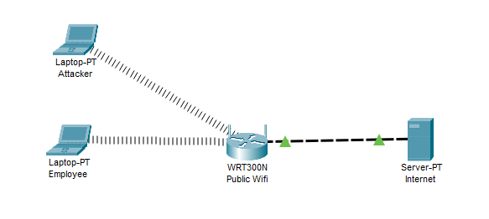
The author is using packet tracer to simulate the attack. This can be seen in the screenshot below:

Network
This is a simulation of a public Wi-Fi network. As seen on the left there are two devices connected to this network. The first being the attacker (Laptop -PT Attacker) and the second being the employee (Laptop -PT Employee). Both devices are connected wirelessly to a wireless access point (WRT300N Public Wi-Fi). The wireless access point is connected to a server simulating the internet (Server-PT Internet).

Scenario
When the employee connects to this public open Wi-Fi network their connection is being broadcasted wirelessly without any encryption. Meaning any data packets sent over this connection can be captured and reassembled into text, websites, videos, and images.

Guide
Wireshark is a tool which can do just that. All the attacker needs to do is boot Wireshark whilst connected to the public Wi-Fi, select the right network interface within Wireshark. The next step is to record or to capture data packets passing through the network. To do this the attacker just needs to click start capture in Wireshark. The example below is captured packets from where a user on a network has visited an unsecure HTTP website [9].
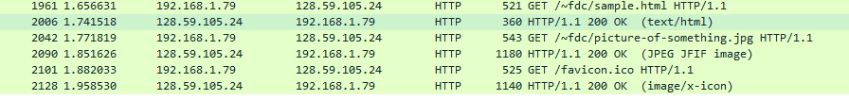
Any data such as passwords, usernames, images or even the webpage itself can be captured, exported, and viewed by the attacker. This can all be done within Wireshark by using this method, File - Export object - HTTP - save the target webpage. The output of this can be see below including the site’s raw html code which can be used to reconstruct the full site and its layout.
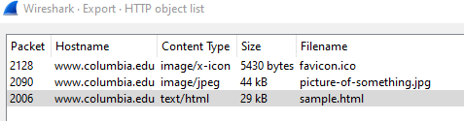
Export screen in Wireshark.

Captured files and raw html code.
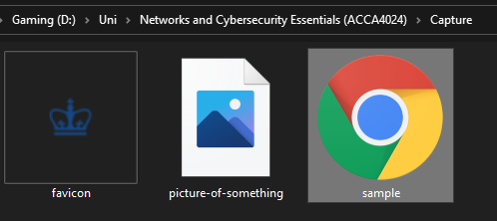

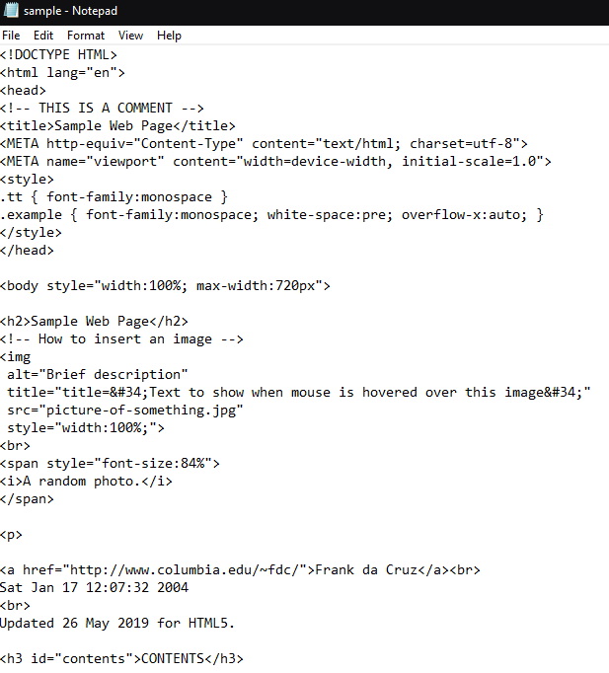

Outcome
The potential outcome of using this method to attack the Che-Si network is huge. It could lead to stolen personal data of employees. It can capture websites, images and text viewed by the employee. It can also capture emails, usernames, and passwords.
Stolen credentials can lead to unauthorised access to the entire Che-Si network allowing attackers to steal data, deploy other attacks and even take the whole network offline. Attackers could even deploy ransomware where they encrypt any data on the network so that it becomes unusable. Usually, the attackers are willing to decrypt the data but at a ransom, hence the name ransomware. One infamous example of ransomware is “WannaCry”. Where in October of 2018 it was deployed in the NHS network where it cost 19 million pounds of output and 73 million in IT costs according to the BBC [10].

Mitigation Strategies and Recommendation
In this section the author will discuss different strategies and recommendations to avoid the threats and attacks discussed in this report.

Policy
Che-Si should allow its employees to use their own devices whilst at work, however the employees should also be trained to recognise threats and how to react to them. Company policy should also define acceptable/unacceptable use of its network. For example:
- No access to personal communication or leisure activities such as playing games or online shopping.
- No access to specific websites containing unrelated or inappropriate content.
- Do not allow users to download unauthorised applications.
- A List of allowed applications
Policies relating to BYOD (bring your own device) should be clear and enforceable. For example, Che-Si should block its employees from accessing their network from public Wi-Fi. Che-Si could enforce something like this with the use of a tool such as Cisco identity services. This is discussed in “unsecure networks” under the “mitigation” section of this report.
The other issue with BYOD is the fact these devices can be compromised, either by being stolen or infected with malware. The best method of mitigating this is to enforce use of an MDM (Mobile Device Management). This would allow Che-Si to control what applications can and cannot be installed on the employee’s personal device. It could also allow the employee to wipe their device if it is lost or stolen. More information on MDMs can be found in the “mitigation” section under “compromised devices” in this report.
An example policy for BYOD may look something like this:
- All personal devices must be password protected.
- Device must automatically lock itself after being idle.
- Rooted or jailbroken devices are forbidden from accessing the network.
- Employees are forbidden from downloading any unapproved applications (See list of approved / unapproved applications).
- Employees access to company network is restricted based on employee user rights.
- Employee’s device may be remotely wiped if the device is lost, or employee leaves the company, or employee breaches policy.
Based on these policies and recommendations the example attack the author performed would not be possible due to the restricted access to the Che-Si network. However, the employee’s personal data may still be vulnerable which could lead to black mail, which may lead to a potential attack against Che-Si. To avoid this all employees should have access to a company VPN which could encrypt any data sent over public networks.
  - Conclusion
In conclusion Che-Si currently have a weak security policy when it comes to their cyber security. Anyone can access their network from any device and any network. The main recommendation is to introduce a new security policy and training to Che-Si employees. Introduction of tools such as MDMs and Cisco Identity services would be the best solution to most BYOD threats.

  - Bibliography
[1]"The Ultimate Guide to BYOD Security: Overcoming Challenges, Creating Effective Policies, and Mitigating Risks to Maximize Benefits", Digital Guardian, 2020. [Online]. Available: https://digitalguardian.com/blog/ultimate-guide-byod-security-overcoming-challenges-creating-effective-policies-and-mitigating . [Accessed: 19- Dec- 2020].
[2]Documents.trendmicro.com, 2020. [Online]. Available: https://documents.trendmicro.com/assets/infographics/making-byod-safe.jpg . [Accessed: 19- Dec- 2020].
[3]"BYOD: Addressing the 5 biggest security risks | CCB Technology", CCB Technology, 2020. [Online]. Available: https://ccbtechnology.com/byod-5-biggest-security-risks/ . [Accessed: 19- Dec- 2020].
[4]A. Heary, Cisco ISE for BYOD and Secure Unified Access, 2nd Edition. [Online] Available: https://www.google.co.uk/books/edition/Cisco_ISE_for_BYOD_and_Secure_Unified_Ac/0tvX-awrJlQC?hl=en&gbpv=0&kptab=overview Cisco Press, 2017.
[5]"NCSC IT: MDM products - which one is best?", Ncsc.gov.uk, 2020. [Online]. Available: https://www.ncsc.gov.uk/blog-post/ncsc-it-mdm-products-which-one-best-1 . [Accessed: 23- Dec- 2020].
[6]Itpro.co.uk, 2020. [Online]. Available: https://www.itpro.co.uk/mobile/29775/best-mdm-solutions . [Accessed: 23- Dec- 2020].
[7]P. Services and N. Segmentation, "Cisco Identity Services Engine", Cisco, 2020. [Online]. Available: https://www.cisco.com/c/en_uk/products/security/identity-services-engine/index.html . [Accessed: 23- Dec- 2020].
[8]"Wireshark · Go Deep.", Wireshark.org, 2020. [Online]. Available: https://www.wireshark.org/ . [Accessed: 27- Dec- 2020]
[9]"Sample Web Page", Columbia.edu, 2020. [Online]. Available: http://www.columbia.edu/~fdc/sample.html . [Accessed: 28- Dec- 2020]
[10]"NHS 'could have prevented' WannaCry ransomware attack", BBC News, 2020. [Online]. Available: https://www.bbc.co.uk/news/technology-41753022 . [Accessed: 28- Dec- 2020]

