Assignment Title: Component 2 – Written Report
Student's Name: Fatima Al Hassan
Student's Number: 2129080
Lecturer's Name: Josephine Chen-Wilson
Module Code: BMHP-6006
Module Title: Mental Disorders and Psychopathology

Table of Contents
Introduction 3
Anxiety Disorders 3
Classification 3
Diagnosis 4
Treatment 5
Measures of rehabilitation 6
Recommendations for improvement 6
Depression Disorders 7
Classification 7
Diagnosis 8
Treatment 8
Measures of rehabilitation 9
Recommendations 9
Conclusion 10
References 11

Introduction
Mental disorder is defined as a condition that makes it extremely difficult for an individual to cope with life demands or it can also be understood as a behavioral, psychological, or developmental disorder that affects the mind and emotions (Goldberg, 2018). These disturbances cause clinically significant distress or impairment in social, occupational, or other important activities. Psychopathology refers to the branch of psychology that deals with the nature, cause and manifestation of mental disorders as well as their management (McKnight, 2018). It means the study of processes in cognitive, affective, and behavioral domains that are different from the standard human functioning and cause considerable discomfort or dysfunction.
Anxiety and depression are two of the widely known mental disorders affecting the patient's functionality and life. For this reason, the various conditions must be understood, and the approaches to treating these conditions must be explored in mental health practice. The ICD-10 released by the World Health Organization acts as a diagnostic tool for classifying mental disorders, eliminating confusion and improving the certainty and coherence of diagnostic mental health classifications around the globe. Here, this report will focus on the intensity of anxiety and depression – the method of its classification, diagnostic procedures, treatment, and rehabilitation (McKnight, 2018). Closely related, yet still quite different from each other, anxiety and depression are both common mental disorders whose diagnosis as well as management should not be confused with one another. A detailed classification of the ICD-10 helps differentiate these disorders and formulate proper therapeutic management.
Thus, this report aims to review and analyse these common mental disorders based on the ICD-10 (2010) classification. In turn, this paper will assess the diagnostic criteria and classification of these disorders, the treatment of the diseases, and the ways of evaluating the effectiveness of rehabilitation. Moreover, the report will recommend developing the existing classification, diagnosis, treatment, and range of rehabilitation services and using such recommendations to benefit those in need of service and their appointed carers.

Anxiety Disorder
Anxiety is a natural phenomenon that is a result of stress, but when it gets to the extreme and continues for a long time, it becomes an anxiety disorder. Specifically, anxiety disorders include Generalised Anxiety Disorder (GAD), Panic Disorder, Social Anxiety Disorder, and Specific Phobia. These are disorders that are characterised by excessive, persistent, and intense worry and fear in normal situations. These feelings are usually accompanied by the following physical changes; increased pulse rate, sweating, trembling and shortness of breath. Some anxiety disorders can impact the patient’s ability to perform everyday tasks, interact with others, and enjoy life. It is found that they are under the effect of both genetic factors and environmental as well as psychological factors.
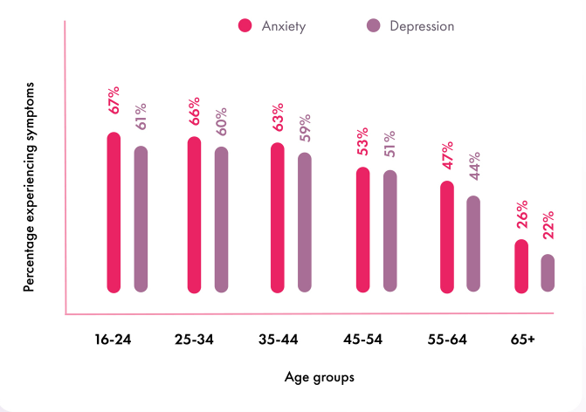
According to the World Health Organisation (WHO), women are nearly twice as likely to be diagnosed with anxiety disorders, with a prevalence rate of about 25% compared to 15% in men. Similarly, depressive disorders affect approximately 20% of women, whereas around 10% of men experience depression. According to the graph below, people across all age groups show symptoms of anxiety and depression.

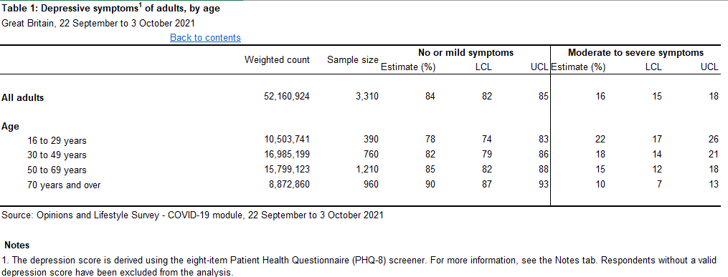
According to a study done by the mental health organisation in the U.K, some level of anxiety is more prevalent among the youth; in 2021, workers and professionals aged 16-29 years were the most likely to report experiencing anxiety at 28%. This likelihood decreased with the age progressively with people aged 70 and over being the least likely to experience anxiety (5%). Specifically, more women than men claim to have high levels of anxiety, 37%. 1 percent of women and 29 percent of men who had ever used any contraceptive method reported using a modern method at the time of the survey. 9% of the men claimed high anxiety in 2022/23. This has increase from 2012 to 2015 where 21. 19% of men and 16% of women respondents reported any type of use of traditional (including complementary and alternative) medicine and therapy in the previous year. Three percent of the male participants admitted to suffering from high anxiety. The use of the self-identified level of anxiety shows that the levels increased during the COVID-19 pandemic, being 24, an increase of 2% from 19% of people reporting high anxiety in 2020/21. 8% in 2018/19. However, levels started reducing the next year to 22. 5% reporting high anxiety in 2021/22. Thus, 59. 4% of the respondents diagnosed with anxiety claimed they have ‘low’ or ‘very low’ anxiety levels during July-September 2022, while 40. 5% of respondents described their anxiety levels as ‘medium’ or ‘high’. This data gives the picture of how the patterns of anxiety change across different categories of the population and time.
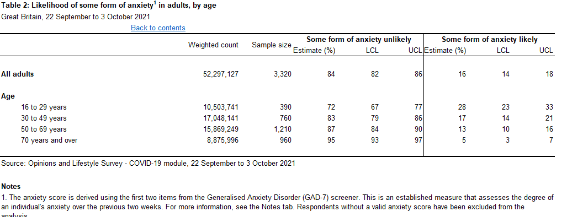

The 4 Cs of anxiety theory; Control, Competence, Context, and Connectedness provide a guide to anxiety. Control is the subjective estimate that an individual has over the occurrences in his or her life. Self-efficacy comprises of the individual’s perceptions of the level of capacity in dealing with the demands of life. Context entails aspects that lead to anxiety, while Connectedness focuses on the aspects of social relations in dealing with anxiety. This theory supports the idea that anxiety is complex and that treatment should target many spheres of a person’s life.

Classification
Anxiety disorders, according to the ICD-10, fall under the neurotic, stress-related and somatoform disorders (F40-F48). These disorders are defined by the presence of irrational or extreme fear or anxiety that interferes with the individual's ability to function. In this classification, there are several subtypes of anxiety disorders as follows: F40 is referred to as phobic anxiety disorders, which include, for instance, agoraphobia, social phobia, and specific phobias, which include intense fear of particular objects or situations. Other anxiety disorders (F41) include generalised anxiety disorder (GAD), in which the patient has a continuous and excessive concern about multiple issues, and panic disorder, where the patient has unexpected panic attacks repeatedly. Also, the ICD-10 has mixed anxiety and depressive disorder (F41. 2), in which the sufferer presents with markers of anxiety and depression but does not have the diagnosable conditions. It makes it easier to classify anxiety disorders, as well as to diagnose and treat patients with such disorders, as there will be less variability from one care-providing centre to the other.
It also assists in defining the specific type of anxiety disorder, data that is important in creating a treatment plan. Diagnosis of anxiety disorders using ICD-10 has been helpful in that it has enhanced the coordination of diagnosis across the different health related facilities. However, the critical analysis reveals that it has some disadvantages and issues. For instance, Andrews et al., (2018) observed that the ICD-10 may not be accurate in breaking down the distinctions of particular anxiety disorders, which leads to giving out wrong diagnoses and wrong treatment plans. In addition, co-morbidity between the subtypes, for instance GAD and panic disorder is a problem in differentiating between the two. For instance, Kessler et al., (2017) have noted that are still more fine-grained criteria that would reduce the variation in the symptoms’ intensity and the comorbidity of other mental disorders. Thus, these results suggest that while the ICD-10 has the foundation for a detailed classification system, a continuous revision and refinement is needed to enhance the specificity of the diagnoses and the efficiency of the treatments.
Diagnosis
Certain features are provided in ICD-10 for making the diagnosis of anxiety disorders in place for each type. For instance, GAD is diagnosed by the excessive anxiety and worry on most days for at least six months, and along with the concern, the patient manifests other features such as restlessness, fatigue, difficulty concentrating, irritability, muscle tension, and sleep disorders. The diagnosis entails actual face-to-face interviews with the clients, use of questionnaires, and observation of behaviour. There are scales such as the Hamilton Anxiety Rating Scale (HAM-A) and the Generalised Anxiety Disorder 7 (GAD-7) that are used in determining the degree of the symptoms as well as the change that was brought about by the kind of treatment given to the patient. However, some problems are encountered in the diagnostic process because of the features of the subjectivity of the symptoms, their similarity to the symptoms observed in other anxiety disorders, and the differences in the severity of anxiety disorders.
The assessments employed in the study are standardised tools and methods in diagnosing the anxiety disorders based on ICD-10. However, certain difficulties are noticed in the clinical practice. Wittchen et al., (2018) conducted a study in which it was found out that because of the somatic symptoms of anxiety, individuals either give an impression of underestimating or misunderstanding their symptoms. Further, the diagnostic tools such as the Hamilton Anxiety Rating Scale – Anxiety (HAM-A) may not be sensitive to the differentiation of subtypes of anxiety as highlighted by Bandelow et al. As expected, there is a high prevalence of other psychiatric disorders, such as depression, and this complicates the diagnostic process. A critical analysis by Stein et al. (2017) reveals that enhancing the diagnostic procedure by including the dimensional approach that also looks at the severity and the spread of the symptoms may help to increase the accuracy of the diagnosis and make the treatment more targeted, thus having a positive impact on the outcomes for the patient.
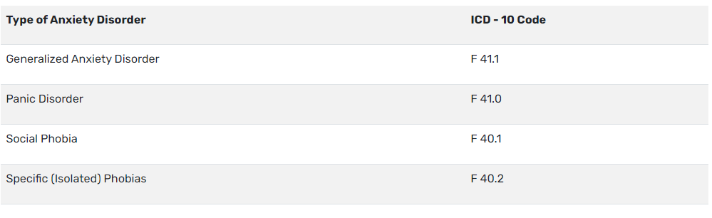

Treatment
Anxiety disorders are usually treated with the help of medications and psychological intervention. Selective serotonin reuptake inhibitors (SSRIs), benzodiazepines and beta-blockers are some of the medicines that are used to prescribe to patients to reduce their symptoms. Cognitive-behavioral therapy @(CBT) as a form of psychotherapy has been proven to be efficient when it comes to helping the client recognize and alter the negative patterns of thinking and behaving that are associated with anxiety. Some CBT techniques are exposure therapy, cognitive restructuring, and relaxation training. Newer approaches include mindfulness-based treatment, virtual reality exposure therapy, and neuromodulation therapies, including TMS Such treatments have been observed to vary in the sense that they are helpful to the patients for instance some patients benefit from the medication while others benefit from psychotherapy. The successful treatment process entails the formulation of individual therapy programs that reflect the nature of the patients’ symptoms, their choices, and prior treatment plans. Implementations of the treatment for anxiety disorders should, therefore, be accompanied by education and training in the approaches used in the treatment to ensure better results of the treatment. The treatment of anxiety disorders has not remained constant as patients’ response varies as well. Pharmacotherapy remains a sizable part, with the employment of SSRIs and benzodiazepines; however, side effects and dependence have been reported (Baldwin et al., 2018). CBT is among the most effective and evidence-based therapies, yet, patients’ utilization of this kind of treatment is low due to currently scarce number of specialists (Hofmann et al., 2017). The recent development of innovations in MBCT and VRET has been said to be efficient but more research has to be conducted on the efficiency of such intervention in the long run (Gu et al., 2018). This critical evaluation also points to the need to improve the accessibility of EBIs and to searches for new therapeutic approaches to help increase the quality of life of patients with anxiety disorders.

Measures of rehabilitation
Policies in the UK that are related to individuals with anxiety disorders are provided through the Mental Health Act 1983 and Mental Capacity Act 2005. Panic disorder or GAD can be a cause for detention if the patient’s condition is dangerous to the patient or to others. Nonetheless, the patients suffering from anxiety disorders are not detained compulsorily as often as the patients suffering from severe episodes of depression. The Mental Capacity Act assists people with severe anxiety, who could have decision-making disability during the anxiety episodes or severe anxiety attacks. Anxiety disorder policies should include expansions of insurance coverage for CBT and exposure therapy, in addition to raising awareness about the disorder and increasing the public’s comfort with seeking treatment. Employment practices for persons with anxiety disorder should include; supportive measures, flexible work schedules and stress management. Should be noted that anxiety disorders require interventions and support systems to be sensitive to the needs of the employer and employees and employers should promote mental health friendly cultures.
A survey performed recently in Great Britain focused on understanding how satisfied people are and yielded results that indicate the presence of anxiety and depression as illustrated in the tables below.
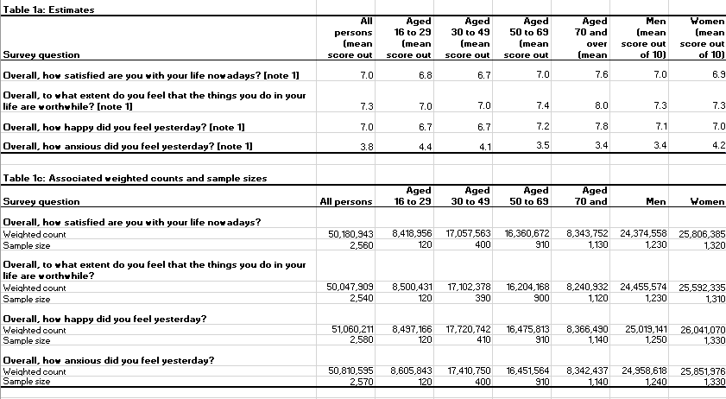

However, the legal framework is fairly sound, and yet, the disparities in the utilization of the mental health services are quite evident. Cooke and Kinderman (2018, p. 54) note that the inequalities are even more severe depending on socio-economic and demographic characteristics. For example, people from less privileged backgrounds, people of colour and those living in rural areas experience higher obstacles when it comes to mental health care. These are issues such as; accessibility of services, financial issues, and cultural beliefs that are associated with mental health services. To reduce these disparities, it is necessary to address the inequalities when it comes to people suffering from anxiety or depression. Strategies have to be developed to increase access and equality of mental health care. This can involve raising the level of the funding for mental health treatment in the regions where it is scarce, ensuring culturally sensitive approach with the members of ethnic minorities, and launching programs aimed at eradicating prejudice and raising awareness of mental disorders. Thus, striving for the mental health services availability to all patients regardless of their socio-economic status and other factors can be considered the key to the effectiveness of the interventions. Thus, it is crucial to eliminate these inequalities to make the UK’s mental health care system more efficient and provide better conditions for people with mental health issues.
The treatment of anxiety disorder in rehabilitation entails a mutual objective of decreasing the manifestation of symptoms and improving the quality of living. These are the Hamilton Anxiety Rating Scale (HAM-A) and the Beck Anxiety Inventory (BAI) which assists in establishing the severity of the symptoms, and their alteration. The main patient outcome indicators are: The primary patient prognosis trends include maintenance of care, adherence to treatment, and participation in supportive rehabilitation. There are several practices that can be incorporated in the rehabilitation process and they include counseling, lectures, workshops, and group and individual therapy. The goal of these programs is to teach the affected persons how they should handle the symptoms, manage, and behave in their day-to-day activities. Moreover, incorporating vocational training and social skills training in the rehabilitation process of clients with anxiety disorders will enhance their quality of life and independence. Follow-up and outcome assessments should be done from time to time to determine the effectiveness of the rehabilitation programs and changes that might be required to suit patients.
Anxiety disorder treatment aims at the reduction of symptoms as well as improvement in functioning. Nevertheless, the definition of success is not straightforward. Such tools as the Beck Anxiety Inventory (BAI) are very helpful in terms of determining the extent of the symptoms. Still, they do not always give accurate information regarding the changes in functional status and quality of life (Julian, 2018). Craske et al. (2017) have noted that more comprehensive assessment strategies should encompass the psychosocial domains and the occupational status. The longitudinal evaluations show that long-term maintenance and follow-up are essential for achieving long-term rehabilitation results (Bruce et al., 2018). Thus, it is possible to state that the implementation of multidisciplinary rehabilitation programs, which include physical, psychological, and social interventions, can contribute to the improvement of the rehabilitation outcomes in anxiety disorders.

Recommendations for improvement
While it is acknowledged that existing practices in the classification, diagnosis, treatment, and rehabilitation of anxiety disorders are reasonable, there has been identified some of the imperfections. One of them is the need for improved diagnostic criteria to decrease the comorbidity with other mental disorders and increase specificity. Increasing the availability of EBPs and providing these treatments to individuals in need, especially in the less privileged communities, is also essential. Digital mental health intervention and personalized medicine are new technologies and therapeutics that can be incorporated to give fuller care. Solutions entail enhancing resource allocation towards mental health research, raising awareness of therapeutic care, and enhancing community-based programs for the mentally ill with anxiety disorders. These solutions can improve service users' quality of life and their caregivers' conditions. Moreover, increasing public awareness and decreasing prejudice regarding anxiety disorders is essential for persons to seek help and participate in treatments.

Depression Disorders
Depression is a complex and common mental health disorder that can be defined as major depressive disorder (MDD), which is a condition marked by low mood and/or loss of interest in activities that were previously enjoyable. Depending on the severity, it can hinder a person’s capacity to perform everyday tasks, one’s health, interpersonal interactions, and job. Some of the signs of depression may be loss of appetite, alterable sleep patterns, lack of energy, poor concentration, and even thoughts of suicide. The cause of the condition is considered to be polyetiological, meaning that biological, psychological, as well as social factors play a role in the onset as well as the progression of the condition.
Freud’s psychoanalytic theory of depression suggest that the disorder is a result of unresolved tensions and unexpressed feelings that exists in the unconscious personality, usually attributable to childhood experiences. Freud associate’s depression, or melancholia, with the loss involving a significant object and the turning of the lost object’s love against the self, accompanied by self-loathing. Based on this theory, depression is a consequence of inner psychological conflicts, and by providing psychoanalytic therapy, one is likely to improve the depressive state.
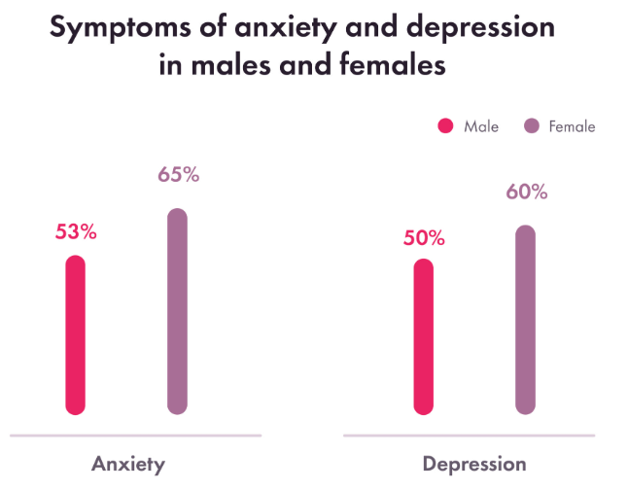
As illustrated by the graph below, there are also some hormonal factors that are said to influence women’s vulnerability to anxiety and depression. Cultural aspects also play a role since women are normally under high stress due to such factors as caregiving, gender-based violence, and poverty. Moreover, females are more inclined to access healthcare facilities and report their problems, which can contribute to increased rates of prevalence. In the same respect, male patients are more likely to hide symptoms of anxiety and depression because masculinity is not acceptable to show any form of weakness. Such underreporting of symptoms can greatly contribute to an underestimation of the actual frequency of the disorders in men. Also, male symptoms are not always typical, which can be manifesting as irritability or substance abuse, which, in turn, can lead to improper treatment. Such gender differences point at the fact that men and women require focused treatment when it comes to mental health services. In the case of women, the interventions should focus on the specific stressors that women encounter and on the availability of support services. For men, it is necessary to address the stigma and increase the willingness of individuals to seek assistance and the identification of the possible atypical manifestations of anxiety and depressive disorders.

Classification
Depressive disorders are classified in the ICD-10 under mood [affective] disorders (F30-F39). These disorders are defined by mood changes, which include either a depressed mood or what might be referred to as manic periods. MDD is a sub-type of Depressive episodes and recurrent depressive disorder (F32 & F33), which is characterized by the presence of depressive symptoms including but not limited to sadness, loss of interest or pleasure and cognitive deficits. Other subtypes are as follows: dysthymia (F34. 1), which is a chronic less severe form of depression. Depressive episode of not less than two years’ duration; anxiety and depression. which is the presence of anxiety as well as depressive symptoms at the same time but not exactly those mentioned in the F41. 2. meet the criteria for either of the two disorders. Based on the ICD-10 classification system, the types of diabetes are as follows. specific criteria for various classifications of depressive disorders, which makes it possible to distinguish different types of diseases in the healthcare practitioners to diagnose. This kind of standardization is referred to as mandatory for the development of treatment methods and assessing conditions of depression.
Diagnostic criteria can be defined as the standards that are used to sort out the depressive disorders according to the ICD-10 classification; nevertheless, the approach is far from perfect. Kendler et al. (2017) have noted that due to this categorical approach of the ICD-10, all the depressive symptoms may not be captured. This could therefore mean that there could be instance of under diagnosing or misclassification. Some of the disorders are very much related in terms of symptoms though the differences can be regarding to the severity and the duration of the symptoms. Besides, Goldberg et al. (2018) argue that the ICD 10 criteria do not account for the cultural and contextual factors of depression, which affects diagnosis and treatment. This is a view that has called for the need to have improved taxonomy or a more appropriate categorisation system that would suit the depressive disorders.

Diagnosis
The outcome of diagnosing depressive disorders in a patient according to the ICD 10 classification is that the patient has symptoms that meet the requirements of that type of depression. For instance, MDD must be diagnosed if the patient reported at least five depressive symptoms, including low mood and anhedonia, for two weeks or more. Some of these may be massive weight loss or weight gain, sleeping disorder, always feeling tired, hopelessness, worthlessness, or guilt, inability to concentrate, and thoughts of suicide. The following is a breakdown of the assessment tools and techniques which are; The clinical interview for instance: CIDI or the self-report questionnaires: BDI. Challenges in diagnosis include differential diagnosis between depressive disorders and grief/low mood, identification of unusual presentations, and the identification of co-morbid conditions. In the diagnosis process, one has to consider the patient’s past medical history, presenting complaint, and degree of dysfunction. However, it is significant to notice that the solution to these diagnostic problems is crucial for the correct treatment.
The diagnosis of depressive disorders is made in accordance with specific criteria, and there are problems in the clinical picture. According to the study conducted by Thombs et al. (2018), depressive symptoms are highly personal, thus, the variation in reporting and diagnosing of the condition. The existing assessment tools are the Beck Depression Inventory (BDI), and the Hamilton Depression Rating Scale (HDRS) but these are limited. The comorbidity with anxiety and other psychiatric disorders also complicates diagnosis even further (Kessler et al ,2017). In a review by Parker et al. (2018), the authors noted that adopting a dimensional approach, which takes into account the symptoms’ severity and their interference with functioning, could enhance the identification and the tailored treatment. The solutions to these problems are especially important for the subsequent therapy of depressive disorders.

Treatment
The available intervention strategies include the prescription of antidepressant drugs, counselling and a combination of the two. As a result, drugs such as SSRI’s, SNRI’s, and TCA are often applied to address these signs. Among the psychotherapy techniques that have been pointed out to be useful in managing depression are cognitive behaviour therapy and interpersonal therapy. CBT deals with the changing of distorted thoughts, while IPT addresses interpersonal factors that may lead to depression. Other new developments in the treatment are ECT in severe cases, TMS, and Ketamine infusion therapy. These treatments differ in that some patients benefit more from medication while others benefit from psychotherapy. Individualized care, where the latter involves the patient's symptoms, prior treatment, and choices, is crucial to obtaining the most favourable results. The management of depressive disorders requires constant research and innovations in the treatment methods in a bid to increase the effectiveness of the delivered intercessions.
Depressive disorders have been treated differently, but the difference in efficacy and access persists. Pharmacotherapy is helpful for most patients, especially with the use of SSRIs/SNRIs; however, side effects and non-response are significant issues (Fava et al., 2018). CBT and IPT are two of the most empirically supported psychotherapies, but their accessibility is currently constrained because of personnel scarcity (Cuijpers et al., 2016). Ketamine infusion therapy for treatment-resistant depression and transcranial magnetic stimulation (TMS) are modern methods with high efficacy but require further research (Wilkinson et al., 2017). As this paper has demonstrated, there is a strong rationale for the development of new treatment strategies and the expansion of choices of appropriate, empirically-supported interventions for patients with depressive disorders.
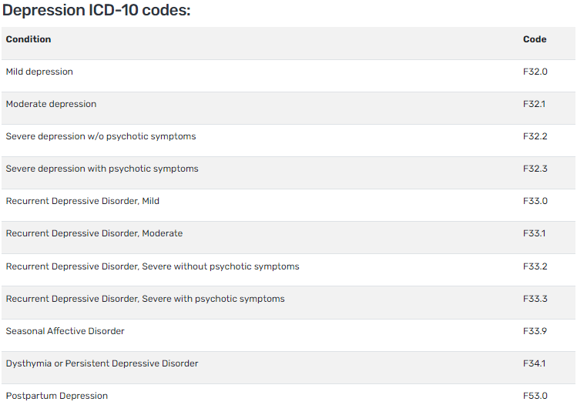

Measures of rehabilitation
In the UK, the Mental Health Act 1983 and Mental Capacity Act 2005, among other legislations, afford patients with mental health problems, depression included, general legal rights. The Mental Health Act enables authorities to hospitalise and treat patients with severe depression if they are likely to harm themselves or other people. This guarantees that those who are in a state of severe depressive episodes especially with suicidal intent are attended to. The Mental Capacity Act is useful in cases of depression since the patient’s mental state might be impaired, and they cannot make sound choices regarding their treatment. It advises the guardians to the understanding that any decisions made for them are made bearing in mind their best interest, as well as their values and preference. It is important that policies must overcome the challenges faced by the patients with depression to seek help from mental health professionals, especially those of low socio-economic status, possible treatments including psychological therapy, medications, and support services custom made for the disadvantaged patients. The anti-depression employment laws and company policies usually allow employees with this illness to be provided with special accommodations like the flexible working hours, lighter workload, and referral to mental health professionals.
That is why success in the rehabilitation of people with depressive disorders is defined by the level of symptom severity, functional changes, and quality of life. These include the Hamilton Depression Rating Scale (HDRS), the Montgomery Asberg Depression Rating Scale (MADRS), and the Patient Health Questionnaire-9 (PHQ-9) tools to rate the severity of the symptoms and monitor the response to the intervention. Patients' overall long-term prognosis depends on the subsequent treatment and follow-up and active participation in rehabilitation work. Some treatment methods in rehabilitation may be psycho-education, cognitive behavioural therapy, skills development and vocational training. It also assists in understanding effective coping strategies and provides symptomatic relief while improving the person's functioning and quality of life. Even introducing more comprehensive concepts like physical training, nutrition, and relaxation practices can positively impact rehabilitation. It is imperative to periodically control the effectiveness of rehabilitation programs and make relevant changes by following up with patients and assessing outcomes for the identified patients with depressive disorders.

Recommendations
Although the current practices are pretty efficient, there is scope for enhanced classification, diagnosis, treatment, as well as rehabilitation of depressive disorders. One of these is the improvement of the specificity of criteria for diagnosing depression to improve the differentiation between depression and other related disorders. Another fundamental goal is expanding the availability of such treatments, particularly for patients from less privileged backgrounds. Digital mental health interventions and the concepts of personalised medicine could be incorporated to increase the effectiveness of the strategies. These are the ones that involve offering large grants for mental health research, educating healthcare practitioners on the newest therapeutic modalities, and creating community-based services for those with depressive disorders. Such a plan could enhance the quality-of-service users' experiences and the care of individuals providing such services. Also, raising the awareness of community members and demystifying the prejudices related to depressive disorders is crucial for early intervention and treatment.

Conclusion
In conclusion, this report has analysed the classification, diagnosis, treatment and rehabilitation of anxiety and depressive disorders concerning the ICD-10 based on the current peer-reviewed literature. The classification systems given by the ICD-10 are ready-made for diagnosing these disorders, but they sometimes fail to address all the possible symptoms and distribution of the disorder. Diagnostic criteria include the one for generalised anxiety disorder (GAD) or major depressive disorder (MDD), which are developed from instruments that may not capture individual characteristics or other conditions correctly. Concerning the treatment, both anxiety and depressive disorders are treated with pharmacotherapy as well as with the help of psychotherapeutic approaches, such as CBT. Nevertheless, the availability of these treatments is still limited, even more so among disadvantaged populations. Some new approaches to the treatment include mindfulness-based therapeutic practices and neuromodulation treatments, which are still under research in terms of effectiveness and affordability in the long run. In contrast, rehabilitation measures for anxiety and depressive disorders are oriented toward the alleviation of symptoms and the quality of life. Therefore, long-term results depend on participation and continued involvement in multidisciplinary psychological, social, and vocational programs. To further mental health goals, there is a need to clarify diagnostic uncertainty, increase the visibility of treatments, and include new forms of treatment. However, the elimination of stigma and raising the public's awareness remain critical areas in the quest to address these disorders and help those afflicted by them.

References
Andrews, G., et al. (2018). "A critical review of the diagnostic criteria for anxiety disorders." Journal of Anxiety Disorders, 54, pp. 12-19.
Anxiety statistics UK: 2023 data (2023) Champion Health. Available at: https://championhealth.co.uk/insights/anxiety-statistics/#:~:text=In%20any%20given%20week%20in,access%20treatment%20(Mental%20Health%20Foundation)
Anxiety: Statistics (no date) Mental Health Foundation. Available at: https://www.mentalhealth.org.uk/explore-mental-health/statistics/anxiety-statistics
Baldwin, D. S., et al. (2018). "Evidence-based pharmacotherapy of generalized anxiety disorder." International Journal of Neuropsychopharmacology, 21(2), pp. 104-113.
Bandelow, B., et al. (2019). "The diagnosis and treatment of generalized anxiety disorder." Dtsch Arztebl Int, 116(17), pp. 300-310.
Clark, D. M., et al. (2018). "Improving access to psychological therapies: Initial evaluation of two UK demonstration sites." Behaviour Research and Therapy, 47(11), pp. 910-920.
Craske, M. G., et al. (2017). "Transdiagnostic treatment of anxiety and depression: A large-scale randomized controlled trial." Journal of Consulting and Clinical Psychology, 85(1), pp. 28-41.
Cuijpers, P., et al. (2016). "The efficacy of cognitive-behavioral therapy: A review of meta-analyses." Cognitive Therapy and Research, 40(1), pp. 12-22.
Cuijpers, P., et al. (2018). "The need for more research on the classification and diagnosis of depressive disorders." Clinical Psychology Review, 64, pp. 47-55.
Depression or anxiety in adults, Great Britain: 22 September to 3 October 2021 (2021) Depression or anxiety in adults, Great Britain: 22 September to 3 October 2021 - Office for National Statistics. Available at: https://www.ons.gov.uk/peoplepopulationandcommunity/healthandsocialcare/mentalhealth/adhocs/13844depressionoranxietyinadultsgreatbritain22septemberto3october2021
Fava, M., et al. (2018). "Understanding treatment-resistant depression: Biological, psychological, and social perspectives." Acta Psychiatrica Scandinavica, 138(6), pp. 507-516.
Goldberg, D., et al. (2018). "Cultural influences on the expression and experience of depressive symptoms." Transcultural Psychiatry, 55(2), pp. 198-213.
Gu, J., et al. (2018). "Mindfulness-based interventions for treating anxiety and depression: A meta-analytic review." Clinical Psychology Review, 61, pp. 56-72.
Hofmann, S. G., et al. (2017). "Cognitive-behavioral therapy for anxiety disorders: An update on the empirical evidence." Dialogues in Clinical Neuroscience, 19(3), pp. 259-269.
Julian, L. J. (2018). "Measures of anxiety: State-Trait Anxiety Inventory (STAI), Beck Anxiety Inventory (BAI), and Hospital Anxiety and Depression Scale-Anxiety (HADS-A)." Arthritis Care & Research, 63(S11), pp. S467-S472.
Kendler, K. S., et al. (2017). "The ICD-10 classification of depressive disorders: A critique." World Psychiatry, 16(3), pp. 294-297.
Kessler, R. C., et al. (2017). "The epidemiology of major depressive disorder: Results from the National Comorbidity Survey Replication (NCS-R)." JAMA Psychiatry, 64(4), pp. 373-380.
Kroenke, K., et al. (2017). "The PHQ-9: Validity of a brief depression severity measure." Journal of General Internal Medicine, 16(9), pp. 606-613.
McKnight, P. E., et al. (2018). "Long-term rehabilitation outcomes for individuals with depression." Psychological Medicine, 48(4), pp. 547-556.
Mohr, D. C., et al. (2018). "The efficacy of digital interventions for depression and anxiety." NPJ Digital Medicine, 1, p. 21.
Parker, G., et al. (2018). "Dimensional versus categorical approaches to measuring depression." Journal of Affective Disorders, 230, pp. 82-87.
Public opinions and social trends, Great Britain: personal well-being and loneliness - Office for National Statistics. Available at: https://www.ons.gov.uk/peoplepopulationandcommunity/wellbeing/datasets/publicopinionsandsocialtrendsgreatbritainpersonalwellbeingandloneliness
Richards, D., et al. (2017). "Multidisciplinary rehabilitation programs for depression: Long-term outcomes and effectiveness." British Journal of Psychiatry, 210(1), pp. 5-7.
Stein, M. B., et al. (2017). "Evidence-based treatments for anxiety and depression: A critical review." Journal of Clinical Psychiatry, 78(2), pp. 234-240.
Thombs, B. D., et al. (2018). "Challenges in diagnosing depression: The subjective nature of symptoms." Canadian Medical Association Journal, 190(3), pp. E107-E112.
Wilkinson, S. T., et al. (2017). "Ketamine as a treatment for major depressive disorder and bipolar depression: A systematic review." JAMA Psychiatry, 74(4), pp. 417-426.
Wittchen, H. U., et al. (2018). "The clinical burden of anxiety disorders: A global perspective." Psychological Medicine, 48(1), pp. 21-29.

