
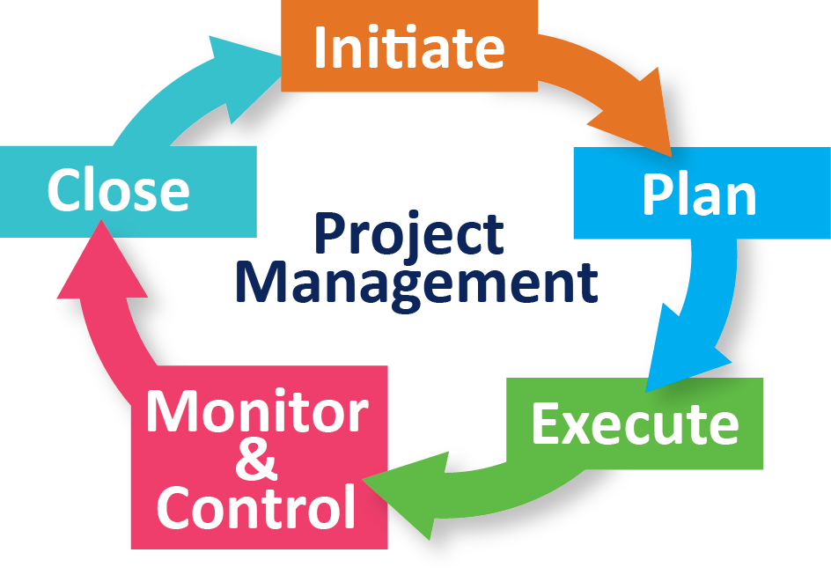

Name: Francisco Mojica
Student ID#: 1817539
Module Name: Managing Projects in the Organization
Module Code: BMSW 5104
TABLE OF CONTENTS

- Introduction
- Chosen Organization Background
- Project tool
III.1 First tool Project Libre
III.2 Estimating Algorithm
III.3 Summary on Tools
- Project and Plan
IV.1 Plan
IV.2 Project Breakdown – Work Breakdown Structure
IV.3 Timing Estimates
IV.4 Cost and Resource Breakdown Structure
IV.5Network Design
- Critical Analysis of the Ability to Manage a Project
- Conclusion and Recommendations
- References

- Introduction
A restaurant, a coffee shop or maybe a bar are just some of the businesses that encourage people to go in, that is why extending the newly opened coffee shop inside the hotel I am working, is a project that first came to my mind. The project’s success depends on the way the project managing is done and carried out by selecting the right path to perform using the different tools and techniques to create an effective process. This report aims to perform the capability and knowledge of a project manager within the workplace. Choosing this kind of project is just like thinking of what is best for my future.

Methods for project management range from traditional to innovative, which is chosen to manage a project depends on the details of the project, its complexity, the relevant laws and other factors. Most can be used in many fields, but some techniques are traditionally used in specific fields of activities or that have been developed specifically for specific fields. These are the techniques most used in project management (Rew et al., 2020). The simplest traditional technique is sometimes best used to accomplish a project.
Another purpose of this report is to assess critically the functionality of the project management within the organization, which includes developing a future work plan, evaluating the tasks to be performed, allocating resources, providing feedback to staff and controlling quality and deadlines. Different tools and techniques will be discussed and used in report to evaluate the ability with the purpose of understanding the different factors to manage a project.
To use all the tools and techniques in my project will enable me as a project manager to enhance my knowledge and skills to be able to meet the target and expectation of the management.
- Chosen Organization and Background
The Lime Tree Hotel is a 25-bedroom bed and breakfast Boutique situated in the area of Belgravia, London. It is set in a pair of graded II listed Georgian townhouse and is a family-run business for 30 years. An elegant townhouse hotel in the heart of a beautiful and most exclusive neighborhoods. It offers a relaxing accommodation with lovely rooms and fantastic breakfast and a great location to explore all the attraction of central London.
. It is now opening its new venture which is called The Buttery, a coffee shop and an extension of the usual dining room of the bed and breakfast hotel.
Coffee shop extension of this new venture is the best project that is chosen to manage. Being close to a coach station is a big advantage for this project and business. Open not only for the hotel guests but to the public.

Project tools
Project management tools are tools and techniques have a wide selection which can be used to support a project manager in managing and making effective decisions during the life process of the project. Many dynamic tasks are required to be tackled in a very short time frame, although it is typically considered in the world of business. Building understanding will result more exceptional quality of project outcome (Hajjani et al., 2010).
The program and some software packages also have been chosen and common in the area of project management in engineering due to its wide and huge enhancement in the technology of the computer. Practically, the use of spreadsheet in MS excel is a famous tool to be used in building the management models and to take up risk analysis for more projects to help the individual as a group to organize their work effectively and accomplish the tasks and projects. The term generally has to do with the project management software that can be purchased (Kezner, 2019).
Gantt Chart
According to Kpvida (2008), it is a type of bar chart that demonstrates the schedule of the project from the start to finish dates of the terminal and summary elements of the project. It contains the work breakdown structure of the project. Several Gantt charts also show the dependency relationships between activities. This may be used toto show current schedule starts using percent-complete shadings and a vertical. In 1896, Karol Adamiecki, develop the first Gantt chart called harmonogram, but he did not publish the chart until 1931 and in that case, his works were published in Polish and Russian languages.
The chart now carries the name of Henry Gantt (1861-1919), who planned his chart around the years 1910-1915. Personal computers relived the creation and elaborated Gantt charts in the 1980’s. The applications of the desktop were mainly calculated for the managers and schedulers of the project. It has been a regular feature of web-based applications in the late 1990’s and early 2000. Gant chart became a regular technique for representing the phases and activities of a project.
According to Pellerin & Perrier (2018), PERT is a management tool of a project which is used to estimate the actual time it consumes to finish a project realistically, and it represents the technique of program evaluation. PERT charts are tools used in project planning in a project, to make easier for all the members of the team to plan and join forces in the execution of work. PERT is a critical way, and both are used to illustrate the scheme and work on the project. It was created in the 1950’s to support the creation weapons and defense projects for the UK Navy. However, with PERT, a person does three different time calculations for a project, firstly a person estimates the shortest time each task can have, secondly the most convenient time, and lastly the longest duration of tasks when things are not planned. A fixed end date recalculates PERT because it is not normally possible to change the contractor’s hours (Boovtev, 2016).
PRINCE2 is a short project in a controlled environment, and it is a method based on project management. The UK government mainly uses it, but it is also common in the private sector in England and around the world. The main functions of PRINCE2 focus on business motivation, determine the organizational structure of the project management team and use a product-based strategy according to (Hinde, 2018). Emphasis is placed on the flexible division of the project into controllable and controllable phases. PRINCE2 ensures good project resource management and can manage business risks and projects more effectively (Siegelaub, 2017). The Gantt chart is a widely used and popular project management tool that provides a visual view of what features to perform and when. Gantt maps are great for tracking project plans because they help a person see the interdependence of tasks, especially when one task is the result of completing another task (Lientz & Rea, 2016). They can also be used to view progress, resources, constraints, and other relevant planning information.

III.1 First tool Libre Project
ProjectLibre is considered as one of the tools for an open source which intends to update and to build up a software as a substitute to business software. It is a free software but is compatible with any other software used in project management and continues to grow according to the project libre team. This is a guide that gives a person an overview of the basic features of ProjectLibre. The goal is to explain how a person can easily use this program; this is not an explanation for the method of project management.

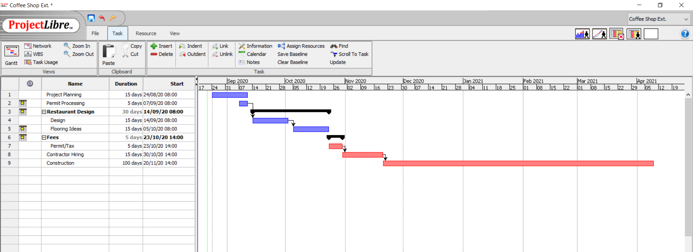

III.2 Estimating algorithms
It is also called a mathematical algorithm which is used to estimate the cost of a particular project. The model’s results are important and essential to get the approval in order to proceed and are included in the business plans financial planning and other budgets. Its design process itself requires not only professionalism but also knowledge and experience in many cases, creativity and intuition of the developers (Guerra et al., 2019).
An algorithm is used as a software product to support accounting and decision-making processes in a project management.
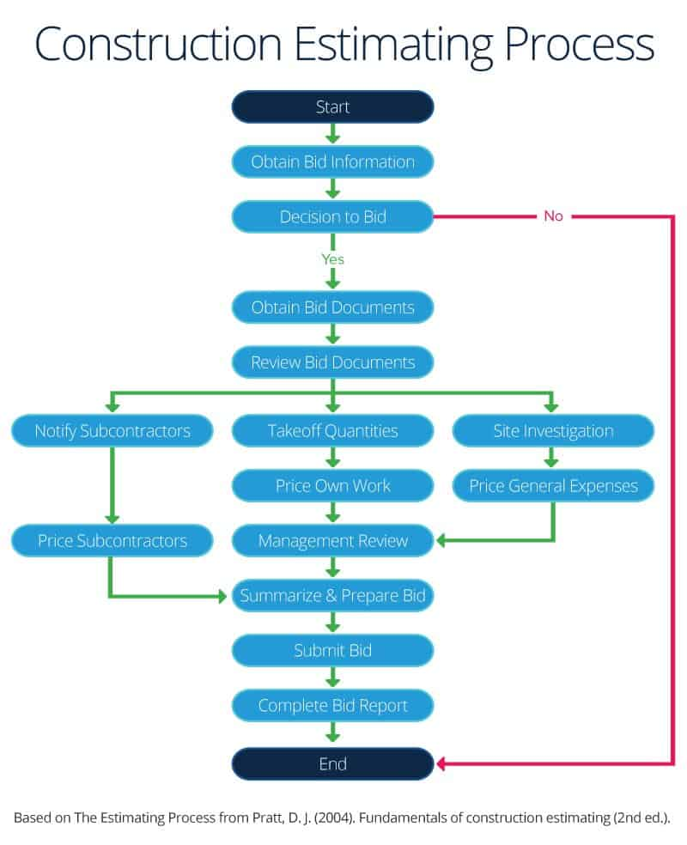

III.3 Summary of Tools
Different software management tools help in the project management and these teams meet customer requirements and the agreed time, budget and scope concepts according to (Anantatmula & Rad, 2018). However, there are many options available, in choosing the right project management and may be confusing, and people may not know where to start. But with the use of these different tools and techniques, managing a project will make is easier for the project manager to supervise and to achieve a good outcome and to meet the expectation of the management. Online project software is mostly used by many small and medium-sized businesses in every industry now. These types of software use cloud-based technology and are provided by application companies such as Software and Service (SaaS) (Guerra et al., 2019).

Project and Plan
The project is the construction of an extension of a coffee shop, called The Buttery, inside the Lime Tree hotel, where it is currently serving as a bed and breakfast hotel.
The project team will consist of the following:
- Project Manager
- Engineers
- Technicians
- Builders
- Electrician
- Plumbers
- Painters
Everyone in the team will have the roles and responsibilities assigned to them to meet the targets and expectation of the management. It is expected to encounter risks and problems during the process, but with the good management and use of different tools and techniques discussed above, a great outcome of the project will be achieved. If each of the team consider the good communication and proper use of the tool, the project will be finished on time.
Risk management of a project is a science and art to identify, analyze and respond to risk which main process is to plan and identify risk management. Analyzing the qualitative and quantitative risks must be performed, while to control the risk, a quick response to the risk should be planned. Controlling the risk is done through executing the risk management process. It is usually overlooked but risk management helps to minimize the negative ana maximize the positive. According to Enhassi & Abumosa (2008), risk management is a medial issue in the planning and management of any venture, construction industry is subject to extra risk and uncertainty than any other industries.
The industry of construction has modified suddenly every now and then from the past years since 2010, all the risks and doubts were faced than before. When things went wrong most consumers were engaged expectedly in legal action. It has always been the risk in construction that were the focus of attention because of the lost outrun associated with construction projects. If the risk occurs, it is defined as an uncertain event or circumstance which has negative or positive effect on the project purpose.

IV.1 Plan
A time to have a face to face communications with each member of the team should be planned by the project manager, as well as the stakeholders and other consumers who are incorporated in the said project. These type of communication sessions must be set in motion ahead of time. The time can be limited but should be regular, for example, in a weekly basis. These communication barriers will be removed by conducting a meeting to help the project manager to resolve all the potential problems. help protect project manager to sort out possible worries. According to Dow (2008), face to face assembly will strengthen the connection and confidence and will enhance every individual in the group. Provider-based job distribution clearly shows the relationship between the start of a project, like, products, results or services and the scope, and all the works that need to be done. Figure 3 is an example of a WBS with a breakdown for the construction of coffee shop.
Based on conceptual advices, the theoretical background for the planning process and communication planning framework is protected and communication must be arranged. The basic questions for efficient communications are answered by the project managers throughout the planning procedure. Stakeholder’s identification and analysis based on the lessons learned information must be done. The communication between stakeholders are g good required, and lastly, the list of project information should be communicated showing good methods and the time frame will be distributed as a ground for project communication pattern.
Measurement instruments should be improved and needs to plan on how to get communication and feedback success. Every element of the process is a normal stage of a project. The elements on the level 2 are the commitment which are distinctive to each stage (Cooper & Sommer, 2018). No matter what type of WBS, all low levels can be delivered. Note that the elements of the different parts have the same name. Phase-based WBS requires that work related to different objects be divided into individual work for each level. A list that describes the work for each object must be created.

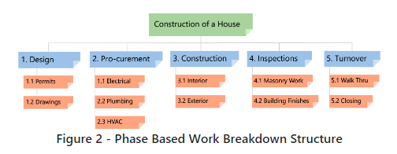

IV.2 Project breakdown - WBS
The normal productivity technique which is used to build the tasks more achievable and attainable is to break the work into a compact job. In most projects, the structure of the work breakdown (WBS) is an instrument that makes use of the method or approach and is one of the most essential document of project management. It is a single handedly merged scope, cost and schedule baseline to make sure a project plans are in the position. A well-developed work breakdown structure describes expected outcome instead actions which are planned. The outcome are the required goals of a task, such a result, product and service and can mainly predict (Chong et al., 2017). The Work Breakdown Structure is designed to provide a common understanding of the scope of the project. The work breakdown structure is a scale illustration of the work that needs to be done to complete the commitment to the project (Greer et al., 2018). Each level in the work breakdown structure provides a progressively detailed category of the project. The accuracy of the inventories is so hard to estimate, but with a well-planned work breakdown structure, adding components to any activities are easier.
A fine work breakdown structure is clearly one that makes the task more attainable, each project is different each project manager is different, and each work breakdown structure is different. A correct WBS is the one that best suits to the question. Work breakdown structure can be easily understood and described and the assessment of the time it takes to complete the project can be evaluated against the required sources. WBS can be measurable as it can measure the progress, when it started and when it will finish. It is flexible enough to add and remove workloads to fit in the work breakdown structure.
Deliverable-based work breakdown structure understandably demonstrates the connection between the project deliverables, (for example, products, services, or results) and the scope (like work to be implemented).

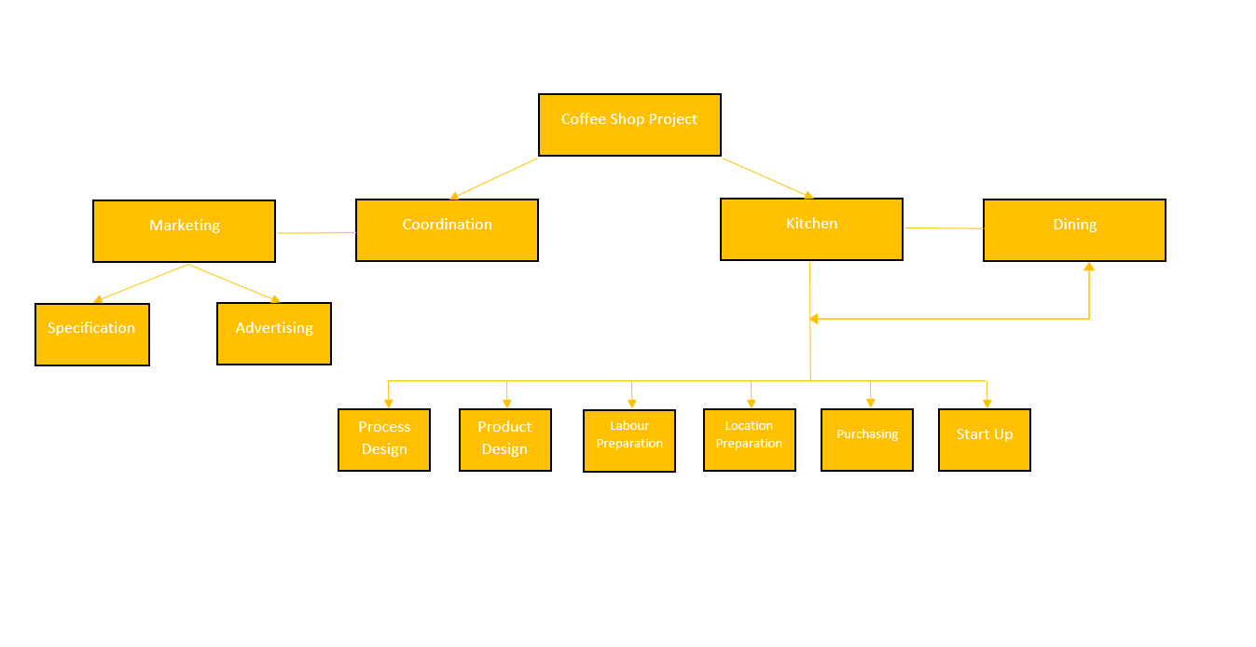
IV.3 Timing estimates
The project manager has participated in the work breakdown structure. The team representation creates enthusiasm and responsibility for the project. WBS provides the basis for the mission (Chong, 2017). The exact task is assigned to a specific team member who is responsible for performing it. WBS enables work-based control and monitoring. This way, one
measures the progress and makes sure the project is delivered on time. Work breakdown structure extremely simplifies the process of project evaluation. It offers the following advantages over other rating techniques. WBS associates and identifies all the work that needs to be done on the project, that is why freeing up less work is necessary to deliver the requested results of the project by reviewing the WBS with project owners (Kezner, 2018). WBS leads to more accurate cost and schedule calculations which will definitely assist in managing a project
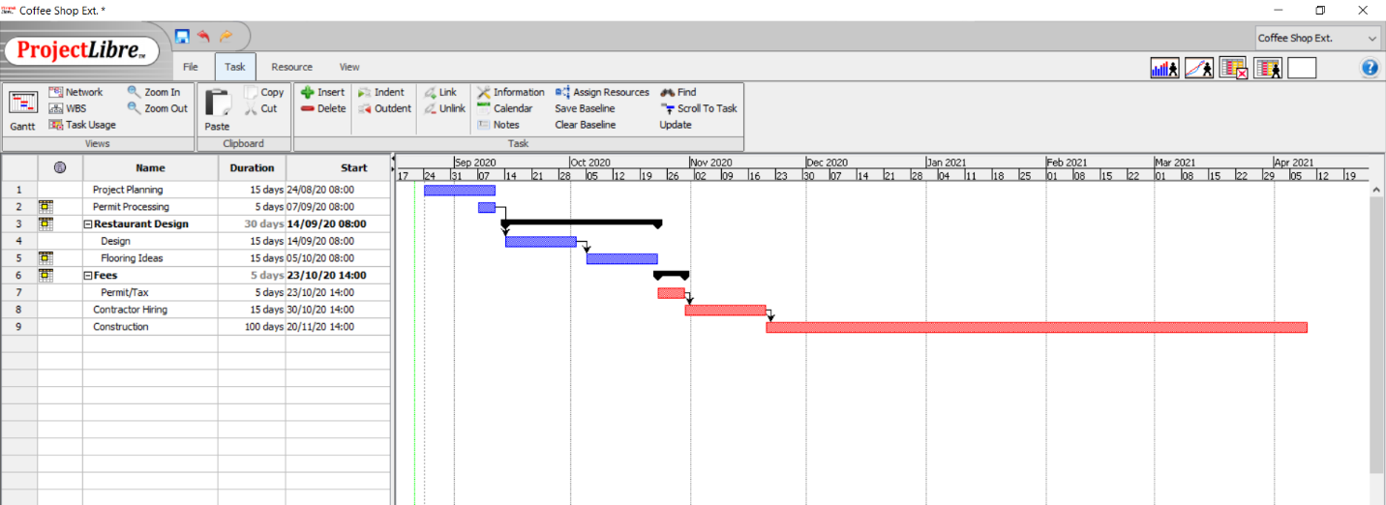
easily.

IV.4 Costs and Resource breakdown structure
A cost-breakdown structure (CBS) is a group classification structure that represents the various costs of a project. The cost-sharing structure represents the cost of the elements and components of the combination structure, such as WBS (Steenkamp, et al., 2019). Dutch statistics are important tool for the management and financial characteristic of all projects and provide a framework for the implementation of cost management measures. Statistics Netherlands is involved in handling and dealing with the financial aspects of all projects. This is the planning structure that financial controller uses to prepare budgets and perform various and different financial calculations, for example, final estimate, implementation costs, discrepancy and value of benefits (Chong, 2017). Most project tools, including project management, planning, and ERP, are normally missing in the cost-sharing structure. The resource allocation structure is a list of measures and resources that are needed to manage a project. The roles are divided and typed that usually includes the people needed and involved in completion of the project (Wilson et al., 2017). It covers however, everything a person and member of the team spend on the project, including people, project management tools, equipment, machines, materials, and even fees and licenses. The structure of the resource allocation is also more impressive as it is a categorized diagram that authorize and acknowledge the project manager to arrange the resources and see their solidity and firmness. According to Kezner (2018), resource breakdown structure is a report about the budget because a complete list of resources makes it easy to quote and estimate the cost and value of the project. Another way to keep a personal budget complete and intact ideally rather than spending it independently for transparency.
Resource breakdown structure (RBS) is a document of a project management which supplies a disintegration of categorized resources by classification and type. The RBS introduces all resources that will depend upon to finish the task except monetary resources. The person in-charge for producing resource breakdown structure is the project manager who will collect input from others on the team.
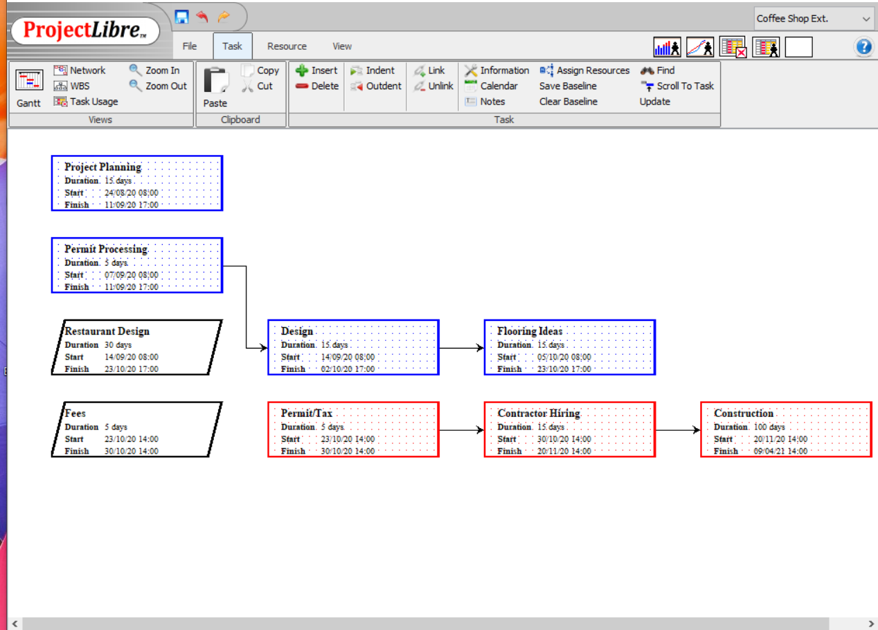
When we are creating a resource breakdown structure, we calculate the resource needed for each activity. The input collected from the list of activity resource calendars, planned schedule management, risk registers, estimate of activity cost, factors of the environment and the process assets of the organization. The important planning step of a project is estimating the cost where resource breakdown structure is most convenient. Whatever work that requires accomplishment can be done with the help of RBS, and it will help the measures we require for the work to be performed.

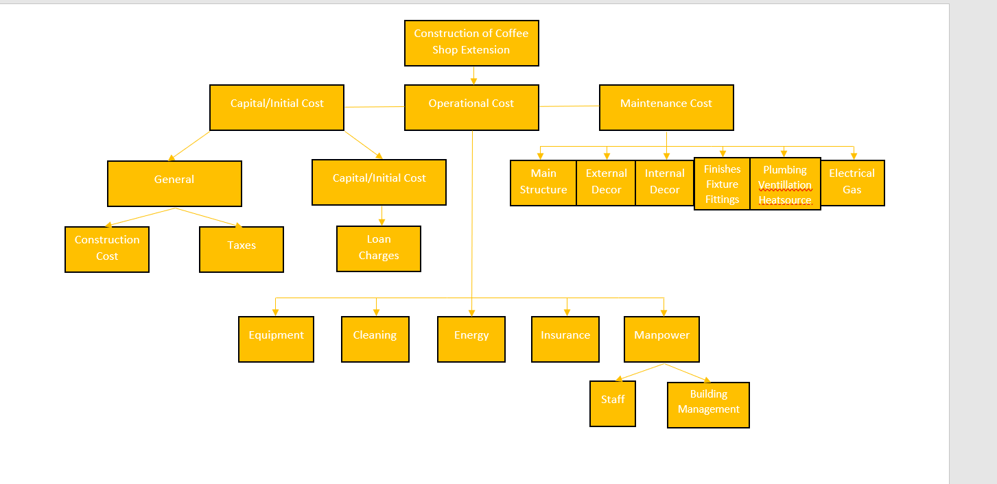

IV.5 Network Diagram
A network diagram is a visual likeness and representation of the process workflow of the project. A composition diagram that displays or shows the roles and responsibilities, that describe the time frame and to be able to know or the order in which the work is done so that a plan is a way to predict or foresee the progress and to track every phase and step of a project until it is finished (Wilson, et al., 2017). Most project managers make use of an online map to track the project to follow the development of each target object. Network diagram is exceptionally practical and useful and to have a better understanding of the visually delivered information. For the team members, network diagrams enhance efficiency and escalate project productivity. Another importance of the network plan is that it outlines and describes the extent and scope of the project. The bridging map accumulates and gathers all projects and activities.
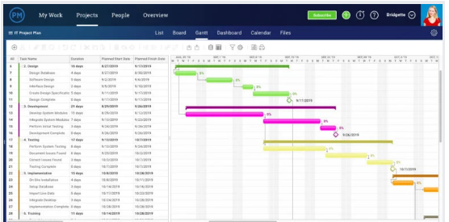
Figure 6 Project Network diagram (Source: Wilson et al., 2017)

Analyse the ability to manage critical projects
The skills that are used in project management are all relevant in managing a project. Project management skills helped my technical skills and the knowledge of the techniques and tools is compulsory to prosper and to make good at different tasks of the projects.
Professional knowledge with regards to project management can be compared with difficult skill as well as with technical functionality, I understand that I need to prioritize the necessary task to make sure that I am capable to develop and grow with regards to the important and essential project management skills so that I can move on to the other skills such as technical and communicational skills. The ability to make decisions that is relevant to improve the management was also essential. Every design on the work breakdown structure helped me to pay attention on every stage of the process. Overall, project management is a technical job that needs to be well planned.

Conclusion and Recommendations
Project management is a broad field of work because it has a variety of project management tools and techniques that enable a person to analyse and manage the project they want effectively. Project communication for instance, is a critical key to competency, which enhance the bridge between the stakeholders and the task team. At the same time, the project also manages on certain dependencies and important factors to achieve the desired results. This is due to the limited resources and time since the start of the project, as well as the fact that a person does not have to spend valuable resources on equipment and supplies that may not be available when someone presents them the work that needs to be done. The project manager should always plan and confirm the dates with all employees before spending any income in a low area full of resources but no work.
Project manager should give much consideration to the enhancement of the matrix techniques to plan communication, particularly protect the communication matrix. Management plan must made in accordance to the abstract structure of communication plan. According to the whole information, communication plans should cover the different aspect to make sure it is successful (Dow,2008).
Project management tools and techniques determine the process and how a project always depends on the tools that implement these techniques and help people achieve the great results. According to Kezner (2009), cited in Risk Management in Building Projects: Owner's Perspective, communication is a process of supervision to the transfer of information in most directions, which can be formal or informal. The project management depends on the project competence of the project manager in managing communications. Efficient project communications assume that the correct information is converted to the right addressee at the right time. These prerequisites are all important for the project success.

- References
Anantatmula, V. S., & Rad, P. (2018, July 24). Role of Organizational Management Maturity Factors on Project Process. Engineering Management Journal, 30(3), 165-178.
Boovtev, S. (2016). Development of Methodology for Time Management of Construction Projects. 2(62).
Chong, A., Ch'ng, E., Liu, M., & Li, B. (2017). Predicting Consumer Product Demands via Big Data: The Roles of Online Promotional Marketing and Online Reviews. International Journal of Production Research, 55(17), 5142-5156.
Cooper, R. G., & Sommer, A. F. (2018). Agile-State-Gate for Manufacturers: Changing the Way New Products are Developed Integrating Agile Project Management Methods into a State-Gate System Offers Both Challenges and Opportunities. Research Technology Management, 61(2), 17-26.
Dow. (2008). cited in Risk Management in Building Projects: Owner's Perpective. The Islamic University Journal.
Enhassi, A., & Abumosa, J. (2008). Risk Management in Building Projects: Owner's Perspective. The Islamic University Journal (Series of Natural Studies and Engineering, 16(1), 95-123. Retrieved from https://www.edu.ps/ara/research
Forbes. (2011). cited in Degree Project in Project Management and Operational Development. Retrieved from https://www.diva-portal.org
Greer, L., de Jong, B., Schouten, M., & Dannals, J. (2018). Why and When Hierarchy Impacts Team Effectiveness: A Meta: Analaytic Integration. The Journal of Applied Psychology, 103(6), 591-613.
Guerra, B. C., Bakchan, A., Leite, F., & Faust, K. (2019, March 15). BIM-Based Automated Construction Waste Estimation Algorithm: The Case of Concrete Drywall Waste Streams. Waste Management, 87, 825-832.
Hajjani, Mufeed, Denton, Paul, & Jackson. (2010). The Effectiveness of Using Project Management Tools and Techniques for Delivering Projects. in Future Technologies in Computing and Engineering: Proceedings of Computing and Engineering Annual Researcher's Conference, 124-129. Retrieved from https://www.core.ac.uk
Hinde, D. (2018). Prince2 Study Guide: 2017 Update (2nd ed.). John Wiley & Sons.
Kezner, H. (2009). cited in Risk Management in Building Projects: Owner's Perspective.
Kezner, H. (2018, May 15). Project Management Best Practices: Achieving Global Excellence.
Kezner, H. (2019, February 22). Using the Project Management Maturity Model: Strategic Planning for Project Management.
Kpvida. (2008, August 25). What is Gantt Chart? Retrieved August 25, 2008, from Kpvida's weblog: https://www.kpvida.wordpress.com
Lientz, B., & Rea, K. (2016, September 17). Breakthrough Technology Project Management Knowledge.
Pellerin, R., & Perrier, N. (2018). A Review of Methods , Techniques and Tools for Project Planning and Control. International Journal of Production Research, 57(7), 2166-2178.
Planning Project communications. (2015). Retrieved from Degree Project in Project Management and Operational Management: https://www.diva-portal.org
PMI. (2013). cited in Degree Project in Project Management and Operational Development. Retrieved from https://www.diva-portal.org
Rew, L., Cauvin, S., Cengiz, A., Pretorious, K., & Johnson, K. (2020). Application of Management Tools and Techniques to support Nusrsing Intervention Research. Nursing Outlook.
Siegelaub, J. M. (2017). How Prince2 Complement the PMBOK Guide and your PMP.
Steenkamp, A., Alawdah, A., Almasrio, o., Gai, k., Khattan, N., Swaby, C., & Abaas, R. (2019, October 31). Enterprise Architecture Specification Case Study. Journal of Information Systems Education, 24(2), 3.
Team, P. L. (2012, September 29). The Project Libre Documentation. Retrieved from htpps://www.projectlibre.com/wiki/projectlibre-documentation
Wilson, G., Bryan, J., Cranston, K., Kitzes, J., Nederbragt, L., & Teal, T. (2017). Good Enough Practices in Scientific Computing. PLoS Computational Biology, 13(6).

