BA(Hons) Business Management

DATA HANDLING & BUSINESS INTELLIGENCE
LCBB5000

Student Name: Krisztina Pocsik
Student Number: 2115263
Lecturer Name: Amitave Banik

Table of Contents
Part 1: Excel 3
1.1 Decline in the value of profit or sales over the years 3
1.2 Use of Excel for pre-processing data 11
1.3 Use of Excel for analyzing the data 12
1.4 Use of Excel for visualizing the data 13
Part 2: SPSS 14
2.1 Number of people who like ice cream vanilla 14
2.2 Number of students, those are male and female 16
2.3 Participants Median and mean who like strawberry and chocolate ice cream flavour 18
2.4 K-Means clustering 19
2.5 Data mining and text mining methods 20
2.5.1 Data mining methods 20
2.5.2 Text mining methods 20
2.6 Disadvantages and advantages of Excel and SPSS usage 20
2.6.1 SPSS advantage 20
2.6.2 Disadvantages of SPSS 21
2.6.3 Advantages of Excel 21
2.6.4 Disadvantages of Excel 21
Reference list 23
Appendices 24

Part 1: Excel

1.1 Decline in the value of profit or sales over the years
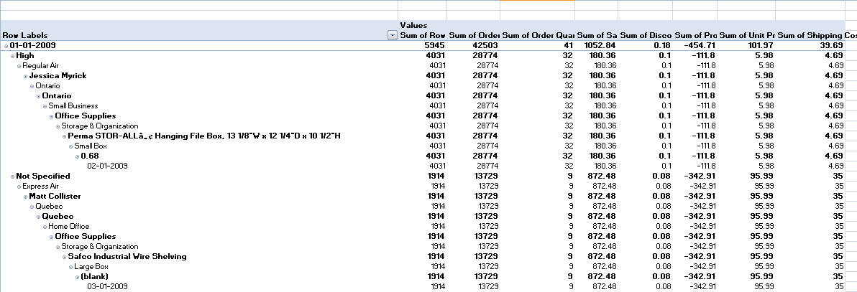
Figure 1: Value of profit and sales on 1.1.2009
(Source: In Ms Excel self created)
The above figure demonstrates the value of profit and sales on 1.1.2009. The value of the profit this year is -454.71 and the value of sales is 1052.84.
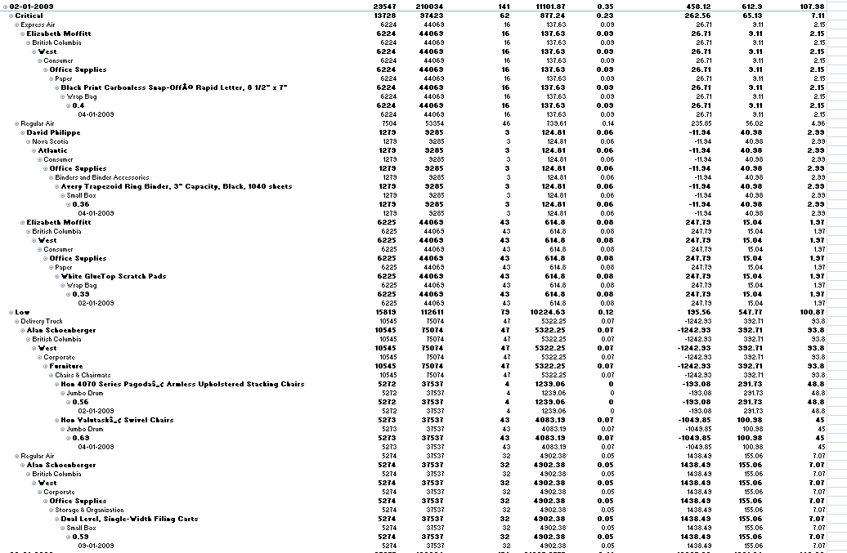
Figure 2: Value of profit and sales on 2.1.2009
(Source: In Ms Excel self created)
The above figure demonstrates the value of profit and sales on 2.1.2009. The value of sales this year is 11101.87 and the value of profit is 458.12.
From the first figure to the second figure, the value of profit has increased, but the value of sales is also increased.
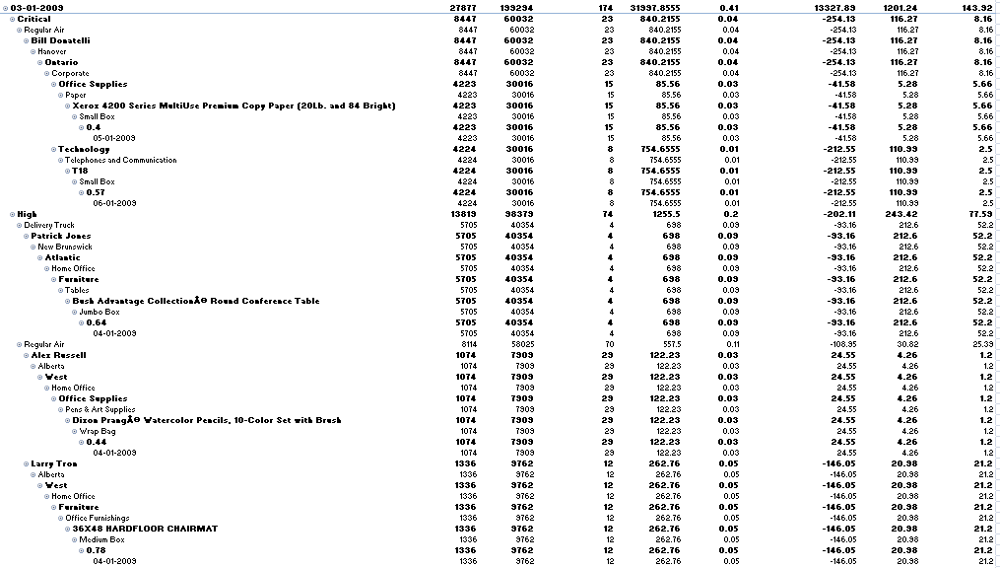
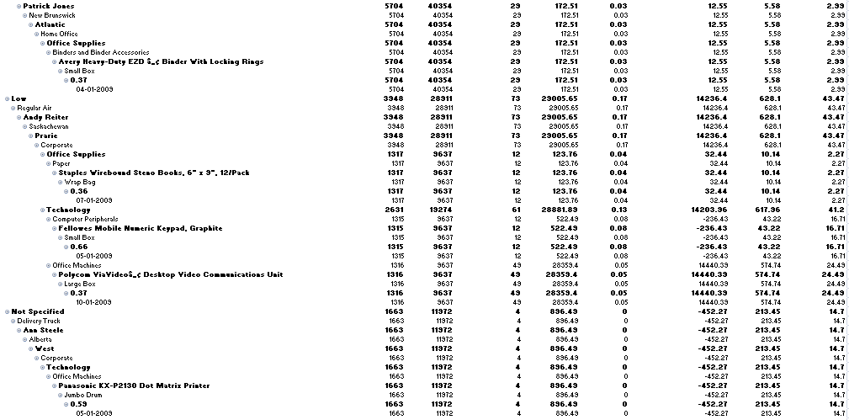
Figure 3: Value of profit and sales on 3.1.2009
(Source: In Ms Excel self created)

The figure that is presented above demonstrates the value of profit and sales on 3.1.2009. On this date, the value of the sales has increased up to 31997.8555 and the value of the profit also increased up to 13327.89.
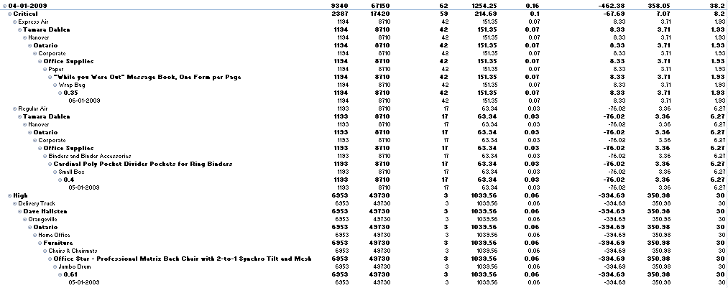
Figure 4: Value of profit and sales on 4.1.2009
(Source: In Ms Excel self created)
The above figure demonstrates the value of profit and sales on 4.1.2009. In this value of sales gets declined up to 1254.25 and the value of profit is determined as -462.38. In this regard, the value of the profit had also declined.
On 5.1.2009 the sales value increased to 33734.404 and the profit value is determined at 3320.39.
On 6.1.2009 the value of the sales declined, to 35525.7985, and the value profit is determined as -11310.46 (Angles et al. 2020). 7.1.2009 is the date when the value of the sales increased to 52140.3085, but the profit amount got declined to -2314.21.
8.1.2009 is the date when the value of the sales is determined as 22216.35 and this is the declined figure of sales than the previous date. The value of profit is 3335.45 and this figure of profit is the increased profit than the previous date.

On 1.1.2010 the sales are 4801.74 and the profit of this company was 669.98. On 2.1.2010 the sales is 17636.668 and the profit of this company was 696.63. The date 3.1.2010 is the date when the value of sales is 33551.35, and the profit was 7193.32. On 4.1.2010 the value of the sales is 7939.47 and the value of the profit is -775.35 (Chen et al. 2019). On 5.1.2010 the sales value is 4505.832 and the profit of this company is 411.32. On 6.1.2010 the sales of this company are 775.08 and the profit of this company is -77.09. The sales value on 7.1.2010 is 7569.09 and the profit of this company is 895.59. From 1.1.2010 to 7.1.2010 it is noticed that there is noticed constant ups and downs in the sales value and in the value of profit. On some dates, it is going up and on some dates, it is going down.
From 1.1.2010 to 2.1.2010 there is noticed an increase in the value of the sales from 4801.74 to 17636.668 and in the value of profit, there are noticed an increase also from 669.98 to 696.63. From 2.1.2010 to 3.1.2010 there is noticed a decrease in the value of sales from 17636.668 to 33551.35 and in the value of profit, there is noticed an increase from 696.63 to 7193.32. In the date from 3.1.2010 to 4.1.2010, there is noticed an increase in the value of sales from 33551.35 to 7939.47, and in the value of profit, there is noticed also a decrease from 7193.32 to -775.35. From 4.1.2010 to 5.1.2010 there is noticed a decrease in the value of sales from 7939.47 to 4505.832 and in the value of profit, there is also noticed a major decrease from -775.35 to -77.09. From 5.1.2010 to 6.1.2010 there is noticed a decrease in the value of sales from 4505.832 to 775.08 and in the value of profit, and there is noticed an increase in the value of profit from 411.32 to -77.09. In the date, 6.1.2010 to 7.1.2010 there is noticed an increase in the value of sales from 775.08 to 7569.09, and the value of profit got increased from -77.09 to -895.59.

On 6.1.2011 the value of the sales is 21138.15 and the value of the profit was 2490.85. On 7.1.2011 the sales value is 5636.6525 and the value of the profit is -1672.1. From 1.1.2011 to 7.1.2011 again there noticed constant ups and downs in the value of sales and in the value of profit. On some dates, the sales value is going up and on the majority of dates, it is going down. The value of the profit on some dates is going up and on some dates, it is going negative also.
From 1.1.2012 to 2.1.2012 there is noticed an increase in the value of the sales from 2144.58 to 13370.47 and in the value of profit, there is noticed an increase also from 203 to 342.35. From 2.1.2011 to 3.1.2011 there is noticed a decrease in the value of sales from 13370.47 to 4612.8315 and in the value of profit, there is noticed an increase from 342.35 to 1255.98. In the date from 3.1.2011 to 4.1.2011, there is noticed an increase in the value of sales from 4612.8315 to 22396.6605, and in the value of profit, there is noticed also an increase from 1255.98 to 5732.07. From 4.1.2011 to 5.1.2011 there is noticed a decrease in the value of sales from 22396.6605 to 1029.47 and in the value of profit, there is also noticed a major decrease from 5732.07 to -8.12 (Belhadi et al. 2019). From 5.1.2011 to 6.1.2011 there is noticed an increase in the value of sales from 1029.47 to 21138.15 and in the value of profit, and there is noticed an increase in the value of profit from -8.12 to 2490.85. The date, 6.1.2011 to 7.1.2011 there is noticed an increase in the value of sales from 21138.15 to 5636.6525, and the value of profit got decreased from 2490.85 to -1672.1.

From 1.1.2012 to 7.1.2012 in the value of sales, there are noticed constant ups and downs. On the majority of dates the value of sales, there is noticed the rise and on some dates, there are noticed a decline in the value of sales. On the value profit on some dates, there is noticed a rise and on some dates, there is noticed a decline in the value of profit and even the value of the profit goes negative also.

Now using the if function, the value of the sales and profit are going to be determined in each year
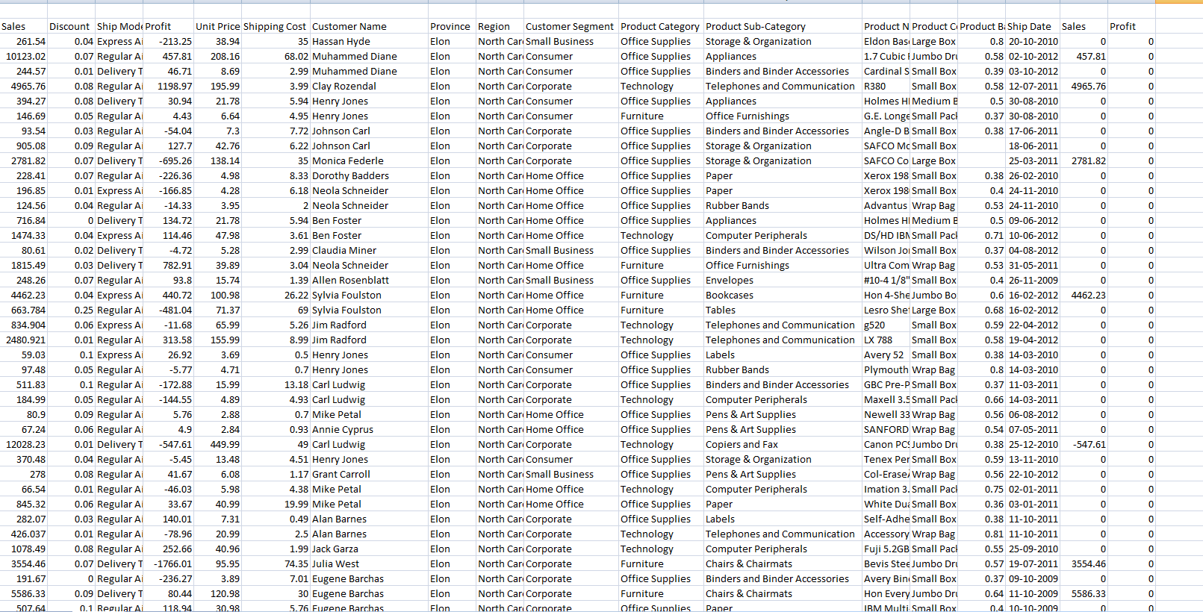
Figure 5: Value of profit and sales
(Source: In Ms Excel self created)
The figure that is presented above on that figure for determining the value of sales and the value of profit, the if function is used.

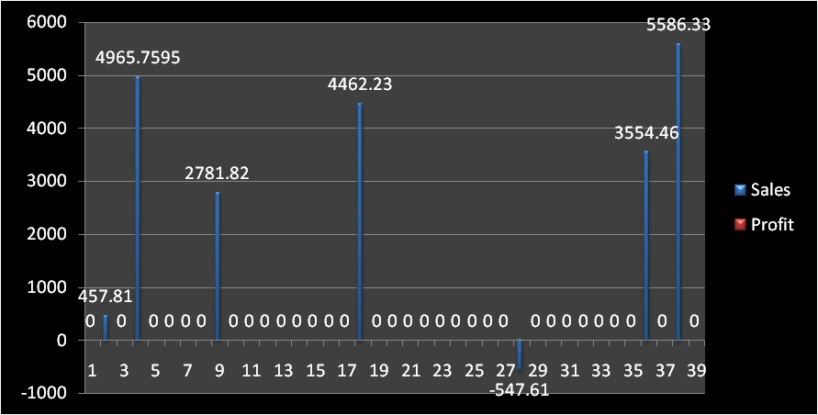
Figure 6: Value of sales and profit from the bar chart
(Source: In MS Excel self created)
The figure above is the graph chart of the sales figure and the profit value that is determined using the if function. The red color is the value of profit and the blue color is the value of sales. The value of sales from the figure above is 457.810, 4965.7595, 2781.82, 4462.23, 3554.46, and 5586.33.

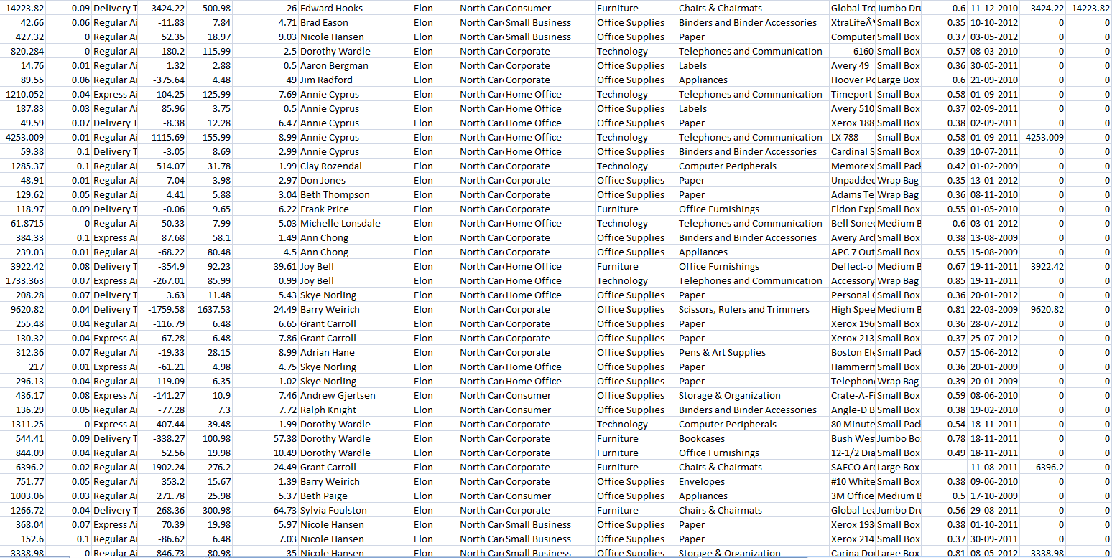
Figure 7: Value of sales and profit
(Source: In MS Excel self created)
The figure that is presented above on that figure for determining the value of sales and the value of profit the if function is used.
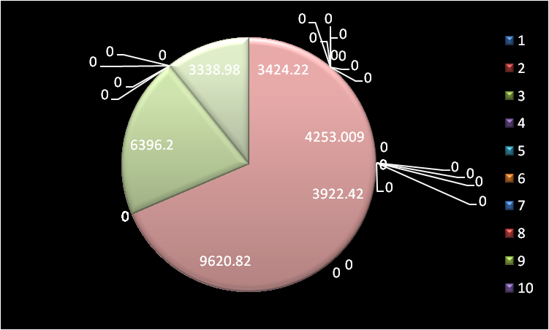
Figure 8: Value of sales and profit from pie chart
(Source: In MS Excel self created)
The above figure is the Pie Chart of the Sales value and profit value using the IF function. The value of sales is determined as 9620.82, 3922.42, 4523.009, and 3424.22. The value of profit determined from the above figure is 6396.2 and 3338.98.
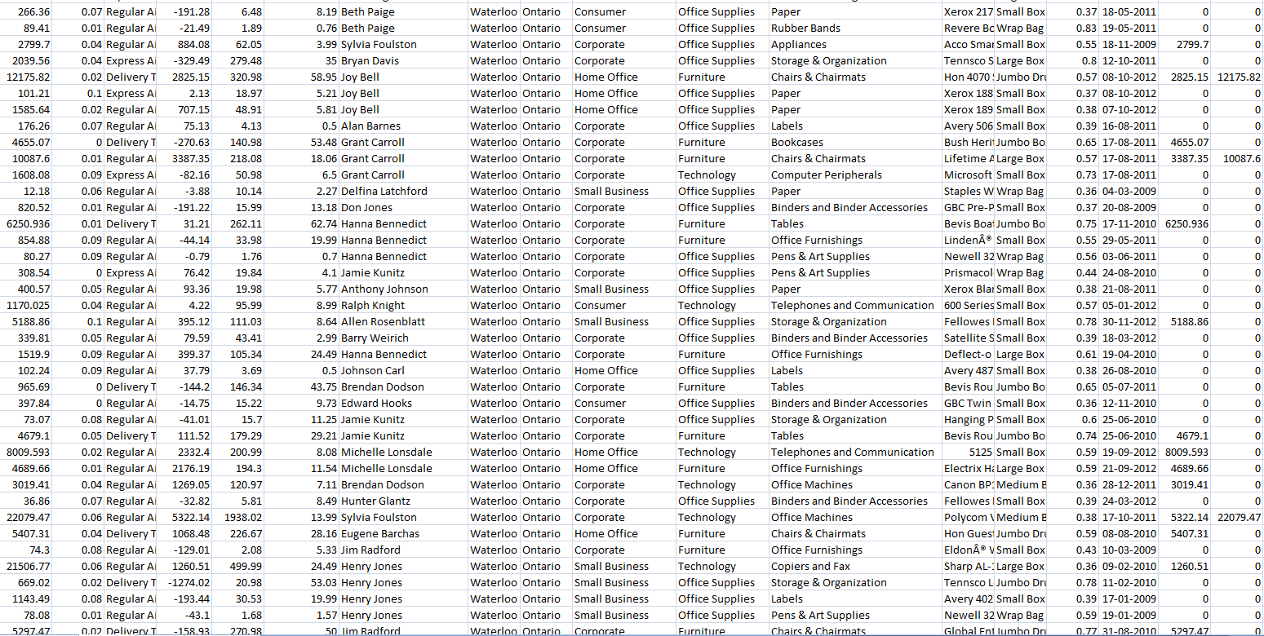
Figure 9: Value of sales and profit
(Source: In MS Excel self created)

The figure that is presented above on that figure, for determining the value of sales and the value of profit, the if function is used.

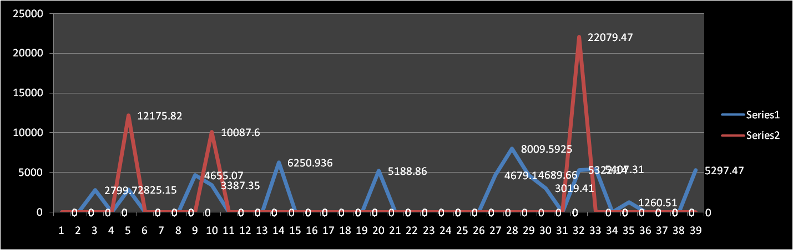
Figure 10: Value of sales and profit from Line chart
(Source: In MS Excel self created)
The figure above is the line chart from which, using the If the function, the values of the profit and the values of the sales are determined. The value of the profit is 12175.82, 10087.6, and 22079.47. The value of the sales is 2799.7, 2825.15, 4655.07, 3387.35, 6250.936, 5188.86, 8009.5925, 4679.1, 4689.66, 3019.41, 1260.51 and 5407.31.
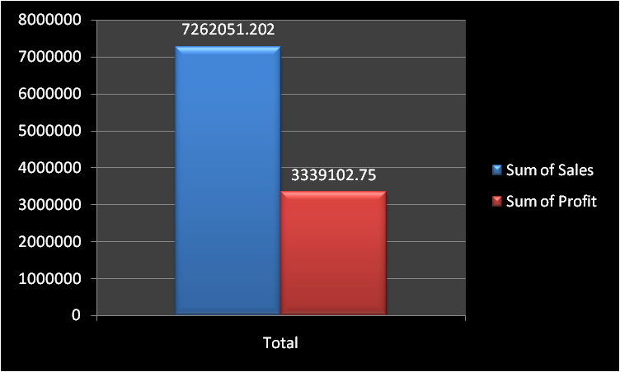
Figure 11: Value of sum of sales and profit in pivot chart
(Source: In MS Excel self created)

The figure that is presented above is the Pivot table figure where in red colour the sum of profit is determined and in blue color the sum of sales is determined. The value of the sum of sales is 7262051.202 and the value of the sum of profit is 3339102.75 over the years.

1.2 Use of Excel for pre-processing data

Figure 12: Use of Excel for pre-processing data
(Source: In MS word self created)

For the pre-processing of data, the use of Excel is done by using the if function, count if function if error function, left and right function, etc.

1.3 Use of Excel for analyzing the data

Figure 13: Use of Excel for analyzing the data
(Source: In MS word self created)
Through a natural query of language when understanding is developed regarding the data that is empowered through the data analysis in Excel. Without writing the complicated formulas when regarding the data, the questions are asked at the time properly in Excel analysis of data is done.

1.4 Use of Excel for visualizing the data

Figure 14: Use of Excel for visualizing the data
(Source: In MS word self created)
Through the organized spreadsheet creation in Excel, the visualization of data is crafted. The final data set and labels are included in it. After regarding the visuals, the data that are going to be included are being highlighted. After that, the chary type that is required to be included is chosen from the insert menu.

Part 2: SPSS

2.1 Number of people who like ice cream vanilla
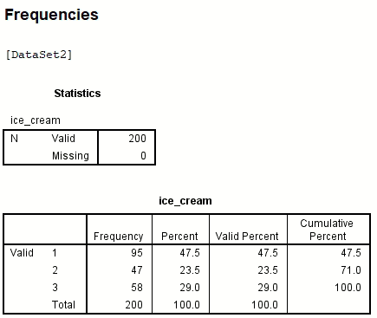
Figure 15: Number of people who like ice cream vanilla
(Source: In SPSS self created)

The people number who likes ice cream whose flavor is vanilla is 95. Regarding the percentage, the number is 47.5%, the valid percentage is 47.5%, and the cumulative percentage happened for the vanilla ice cream terms of percentage is 47.5%
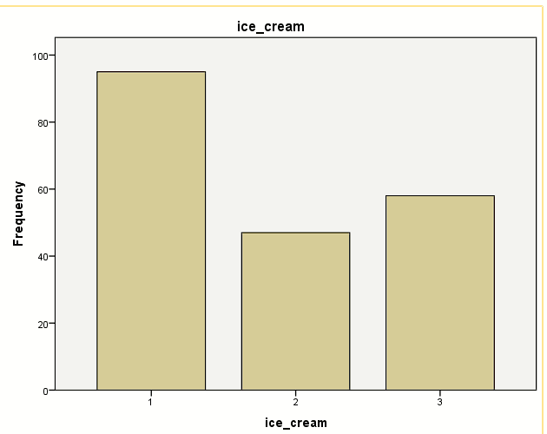
Figure 16: Number of people who like ice cream vanilla
(Source: In SPSS self created)
The figure is presented above is the figure regarding the participant who likes the vanilla flavor ice cream. It is notable from the above figure that most flavour of ice cream that is liked by many students is related to the Vanilla flavour.

2.2 Number of students, those are male and female
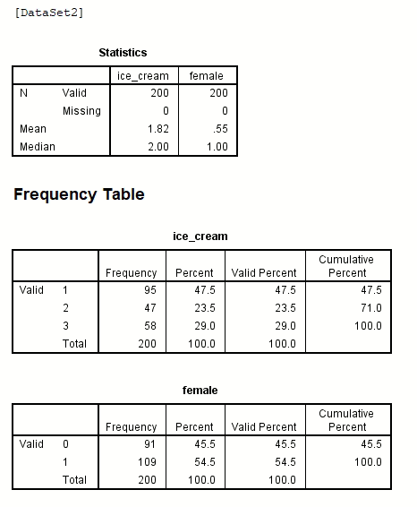
Figure 17: Number of students, those are male and female
(Source: In SPSS self created)
The students' number, regarding female and male, is 91 those who are female and 109 those who are male. The total number of students in this regard is 200. In this regard, the number of females is higher than the male population. The percentage of the male population is 45.5% and the percentage of the female population is 54.5%. The valid percentage of males is 45.5 and the females' valid percentage is “54.5”. The females' percentage that is cumulative is “100.0” and the males' percentage that is cumulative is 45.5.
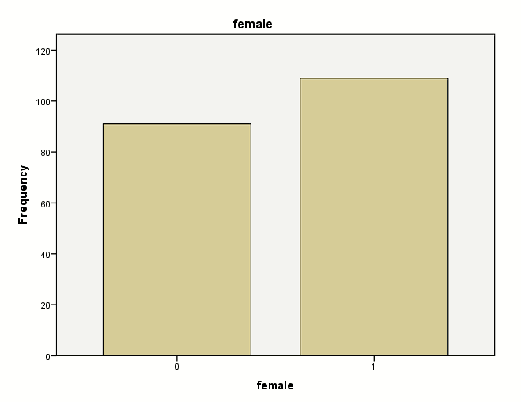
Figure 18: Number of students, those are male and female
(Source: In SPSS self created)
The figure that is presented above is regarding the students’ number that is female and the student's number is who are female. In the above figure, the data regarding it is presented in the form of a bar chart (Ahmad et al. 2021).

2.3 Participants Median and mean who like strawberry and chocolate ice cream flavour
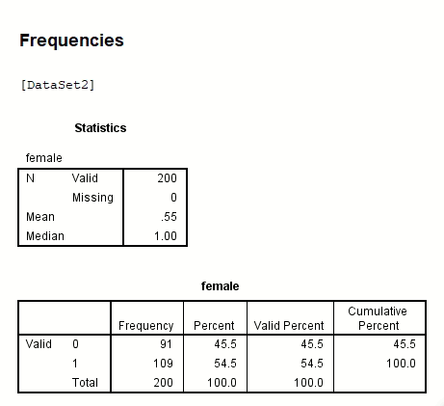
Figure 19: Participants Median and mean who like strawberry and chocolate ice cream flavour
(Source: In SPSS self created)
The participants' median and mean, those who like strawberry and chocolate ice cream, are mentioned here. The mean value in this regard is 0.55 and the median value in this regard is 1.00 (Ul et al. 2019).
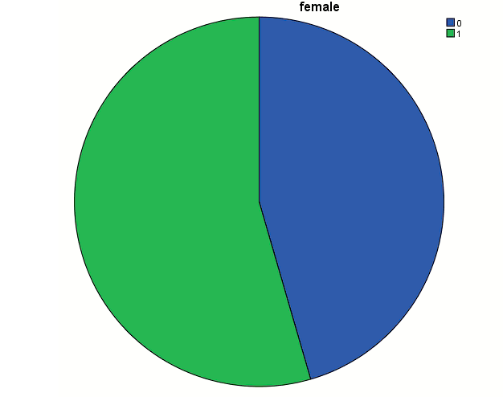
Figure 20: Participants Median and mean who like strawberry and chocolate ice cream flavour
(Source: In SPSS self created)
The figure that is presented above is the figure related to the median and mean participants' values who like ice cream strawberries and chocolate. The total students' number in this regard are present around 200.

2.4 K-Means clustering
The ID number clusters in this regard are 1 in the number 1 stage and in the number 2 stage, it is 200. The number of females clustered in the first stage is 1 and in the second stage, it is 0. Regarding a good deal of ice cream clusters, the first stage is 2 and the second stage is 1. The number of videos clustered in the first stage is 39 and 2nd stage is 66. The puzzle number in the number one stage is 41 and in the second stage, this number is 66 (Galetsi and Katsaliaki, 2020). The change in cluster centres in the first stage is, 50617 and in the second stage is 53.305. It happened in iteration 1. In interaction 2 in the first stage the change in the cluster is 0.000 and in the second stage is 0.000 because in the centres of clusters, a number of small changes are achieved by achieving the convergence. The 0.000 is the maximum absolute coordinate change for any centre. The number 2 is the current iteration. Between the initial centers, the minimum distance is 202.378 [Referred to appendix 3].

The ID cluster number in the first half is 50 and in the second half is 150. In the first half, the female cluster is number 1 and in the second half, this number is 1. The ice cream number cluster in the first half is 2 and in the second half is also 2. After determining the final cluster center the value of ANOVA is determined. For the purpose of descriptive nature, the F tests are used because for the difference maximization the cluster usage is chosen among the cases in different clusters. The correction has not been made on a significant level, those are observed for this and in form of a test of the hypothesis, it cannot be interrupted because in this mean of clusters are equal. For determining the ANOVA the value of mean square and df is determined for cluster and error and for the value of F and sig is also derived [Referred to appendix 1].

The figure that is presented above is regarding the case number in every cluster. In the first cluster the case number is 98000 and in the 2nd cluster cases, the number is 102000. The valid number in this regard is 200000 and the missing value is 0.000 [Referred to appendix 2].

2.5 Data mining and text mining methods

Data mining methods
The common data mining methods are “clustering, association, data cleaning, data visualization, classification, machine learning, prediction, neural networks, warehousing of data, and detection of the outlier”.
Among many data mining methods, the method of clustering is a major data mining method among all the methods.

Text mining methods
The common text-mining methods are extraction of the information, retrieval of the information, categorizing of the information, clustering of the information, and summarization of the information.

2.6 Disadvantages and advantages of Excel and SPSS usage

SPSS advantage
- Fast and reliable answers are offered through the SPSS.
- Useful graphs and tables are generated through it, and it is also dynamic (Božič and Dimovski, 2019).
- A lot of people can access the SPSS and a variety of languages in a wider range of languages are used in this software.
- The management of data happens in this software effectively.
- In terms of using this software, a lot of effort is not required.
- The qualitative data and quantitative data for both are determined in this software.

Disadvantages of SPSS
- For the analysis of large data, the SPSS is not useful, and it is the limitation of the SPSS.
- For the students, the purchase of SPSS will be very much expensive.
- For the exploitation of the feature, that is available, the involvement of added training is required very much.
- The feature of the graph is simple in Microsoft Excel, but it is not simple in the SPSS.

Advantages of Excel
- The layout regarding the data is provided through Microsoft Excel.
- For the rearrangement of data and reformatting of data, this software is very much easy to use.
- With the charts and graphs, the analysis and the processing of the data are done.
- The conditional formatting is done through Microsoft Excel (Bordeleau et al. 2018).
- The connectivity and sharing are done easily through Microsoft Excel (Cheng et al. 2020).
- The patterns and trends are analyzed and identified in amounts of data that are present in a large format.

Disadvantages of Excel
- The lack of security and control is noticed in Excel.
- Error from humans is prone to happen in Excel.
- Regarding consolidation, Excel is very hard.
- For the agile practices of business, Excel is not suitable at all.
- Quick decisions cannot be made through excel (Azeroual and Theel, 2019).
- For the collaborative work, the design of Excel is done.
- In terms of testing and troubleshooting, the use of Excel is very much difficult.
- The fraud and corruption, and the vulnerability in Excel, are noticed (Ahmad et al. 2020).
- Advanced rules of pricing are difficult to be managed in Excel.
- For agile practices of business, the unfit nature is noticed in Excel effectively.

Reference list
Journal
Ahmad, S., Miskon, S., Alabdan, R. and Tlili, I., 2020. Towards sustainable textile and apparel industry: Exploring the role of business intelligence systems in the era of industry 4.0. Sustainability, 12(7), p.2632.
Ahmad, T., Zhang, D., Huang, C., Zhang, H., Dai, N., Song, Y. and Chen, H., 2021. Artificial intelligence in sustainable energy industry: Status Quo, challenges and opportunities. Journal of Cleaner Production, 289, p.125834.
Angles, R., Antal, J.B., Averbuch, A., Birler, A., Boncz, P., Búr, M., Erling, O., Gubichev, A., Haprian, V., Kaufmann, M. and Pey, J.L.L., 2020. The LDBC social network benchmark. arXiv preprint arXiv:2001.02299.
Azeroual, O. and Theel, H., 2019. The effects of using business intelligence systems on an excellence management and decision-making process by start-up companies: A case study. arXiv preprint arXiv:1901.10555.
Belhadi, A., Zkik, K., Cherrafi, A. and Sha'ri, M.Y., 2019. Understanding big data analytics for manufacturing processes: insights from literature review and multiple case studies. Computers & Industrial Engineering, 137, p.106099.
Bordeleau, F.E., Mosconi, E. and Santa-Eulalia, L.A., 2018, January. Business Intelligence in Industry 4.0: State of the art and research opportunities. In Proceedings of the 51st Hawaii international conference on system sciences.
Božič, K. and Dimovski, V., 2019. Business intelligence and analytics use, innovation ambidexterity, and firm performance: A dynamic capabilities perspective. The Journal of Strategic Information Systems, 28(4), p.101578.
Chen, L., Koutris, P. and Kumar, A., 2019, June. Towards model-based pricing for machine learning in a data marketplace. In Proceedings of the 2019 International Conference on Management of Data (pp. 1535-1552).
Cheng, C., Zhong, H. and Cao, L., 2020. Facilitating speed of internationalization: The roles of business intelligence and organizational agility. Journal of Business Research, 110, pp.95-103.
Galetsi, P. and Katsaliaki, K., 2020. A review of the literature on big data analytics in healthcare. Journal of the Operational Research Society, 71(10), pp.1511-1529.

Appendices
appendix 1: Final Cluster Centers
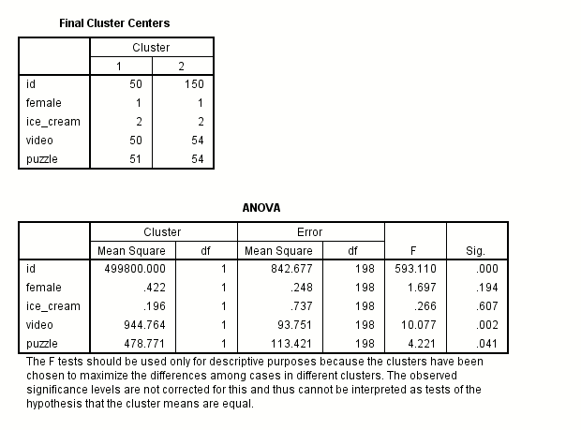
(Source: In SPSS self created)

Appendix 2: Number of cases in each cluster
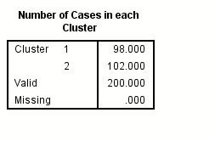
(Source: In SPSS self created)

Appendix 3: Quick cluster
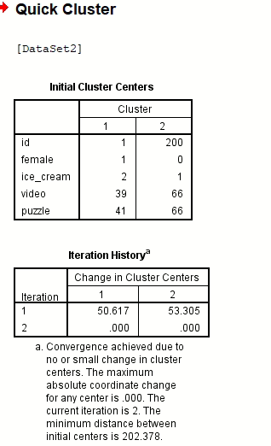
(Source: In SPSS self created)

