Throughout this project I want to create an inspiring body of work, which
helps demonstrate the meaning and symbolism of flowers rather than
their initial natural beauty. I aim to achieve this by creating an interiors collection,
which highlights the vibrancy and joy that flowers can bring, as well as showing their softer, more romantic perspective. To achieve this, I will look into medias such as watercolour and ink to create soft flowing florals to emulate their delicacy. I want to create an interior collection which can span from soft to hard textiles, including
experimenting with working on a variety of surfaces to help bring a juxtaposition
within my collection. Some of the initial inspiration for this collection came from a visit I took to the Saatchi Gallery in April to visit the ‘Flowers, Flora in Contemporary Art and Culture’ where I got to experience a deep insight into how florals have been used throughout time and have created such cultural significance.

Working Practices

I like to include flowers in most of my work. This has been something I have done since I can remember. I have always liked the variety you can get when drawing flowers, due to the huge range of florals. I enjoy drawing from life and find that even when drawing the same species of flower, each flower is unique in its size, shade, angle and degree of bloom or wilt. Drawing one flower will never be the same as another flower.

Continuing with my floral theme, I am moving towards going deeper into
symbolism rather than focusing on just the look of the flower and the obvious
meaning. I want to continue to take inspiration from florals as they can enhance
living space and making it more enjoyable. “Biophilic Design seeks to incorporate natural elements into interior spaces, recognizing the deep human need for connection with the natural world”(Alma de Luce, 2024). This quote shows that having a connection with nature is so important also helps highlight the strong juxtaposition between our relationship with nature as we carve it in our lives through design and art, however forget to cherish it in its natural environment. Biophilia is the innate connection humans have with the natural world. This is what I believe is one of the many driving forces behind the constant desire to have nature in our designs/homes. The need for biophilia in our homes helps show the true contact with nature we hold, that is hard to replicate through design. “Humanity is exalted not because we are so far above other living creatures, but because knowing them well elevates the very concept of life” (Wilson, 1984 p.22). Our understanding of the natural world i feels runs along side our innate desire to have biophilla in our homes.

As a designer who feels influenced by the natural world, I would like to use this
opportunity of my degree show to help create work which highlights my desire for
this, to further enhance my portfolio allowing me to show my best work and passion to future employers.
Narrative and Theme
The narrative of my collection will be about the language of flowers, including hidden meanings, and messages. This will require a deeper look at symbolism of certain flowers, acknowledging that different cultures have different meanings of flowers. For example, carnations in western culture mean deep love and purity (depending on the colour), however in Korean culture they are used to help predict the fortune of young girls. This project will focus on the western context and the cliche and stereotypes of flowers, my personal connection with flowers and how they have been used through time.

I am personally interested in exploring the meaning of florals as I feel they are seen only as a way of expressing love. I wanted to show how there are so many different deeper meanings and how flowers create their own language through their symbolism. Some of my inspiration for this came from looking into songs and poems about flowers and realizing they are used as a way to express different emotions without physically saying the words. The song ‘I could be a Florist’ by Olivia Dean, could be seen as a metaphor for being a caring person, as it highlights how giving flowers shows someone cares. The verse that stuck with me is:

“‘If you need to tell 'em, "Sorry" (sorry, my fault, it's okay)
Then I'll have the right bouquet (right bouquet)
When words don't come so easy (ah), believe me, you need these
They know what just to say (I-I-I-I love you)’” (Dean, 2023)

I found this verse perfectly encapsulates the meaning of giving / receiving flowers as not only are they a gift which already has good connotations, they have a universal unspoken language within them. Songs are particularly helpful as audio and visual go hand in hand so taking inspiration from the inner picture the song is painting could possibly be a starting point to a few of my designs. Especially as there are so many songs both new and old that mention florals within them “ I can buy myself flowers” (Cyrus, 2023). Flowers by Miley Cyrus is another example as it uses the act of buying herself flowers to help demonstrate how she can be independent.

From looking into how the language of florals originated I looked at how it was significant in periods of history, such as the Victorian era where florals played a huge role in society through art, literature and other aspects. “...at the heart of the Victorians' love of flowers was their strong and direct connection with nature, much more so and in quite a different way than our connection today” (Kirkby, 2011 p.4). The Victorian era brought the growth of the industrial revolution and this lead to increased travel and trade with places less known helping bring new variations of flowers to Britain.

Kirkby (2011) says that “...western language of flowers, an intricate system of floral symbolism in which each flower is assigned a specific meaning, is thought to have been inspired by the Turkish custom of selam – a method of communicating through flowers and other objects” (p.4). Having this almost alphabet-like category system makes it easier to quickly find the basic meanings of the florals, allowing you to make a bouquet that can have a whole conversation without saying a single word. “...selem as a method of communication between lovers in which it was possible to send messages ‘without ever inking your fingers’, and gave examples of their meanings” (Kirkby, 2011 p.5). The quote in italics embodies the idea I am trying to show throughout this collection with the idea that flowers can say much more than people think without even writing or physically saying a word. With this love for florals and their ability to put meaning to them they were able to create unique ways of communicating through the florals. Much like the Georgian ‘language of the fan’ which was a way of communicating though the different position in with a lady held her fan "The primary use of the fan between lovers would have been as a much less explicit means of flirtation, accompanied by longing looks, fluttering eyelashes and loving glances," (Gorman, 2025), this form of coding was much like with Victorians and florals with them arranging their bouquets.

For this project, I will also look into cliches and stereotypes within the meaning of gifting flowers, with flowers like carnations having split opinions on them. Although pretty, carnations are perceived as cheap and easily purchased from local shops, making them less desirable and tarnishing their reputation. This also links with the idea of ‘garage flowers’ which are seen as embarrassing, as they are brought with ‘less thought’ and are often associated with last minute apologies. These two examples along with many others help show how modern culture has helped evolve the language of florals and their meanings throughout society. This shows everyone's unique habits and practices they unconsciously link to florals. Fake flowers are another branch of cliches around florals, as they are desired for the fact they do not die, but also contradict themselves by trying to replicate nature in a synthetic way which could never compare to the real beauty of florals.
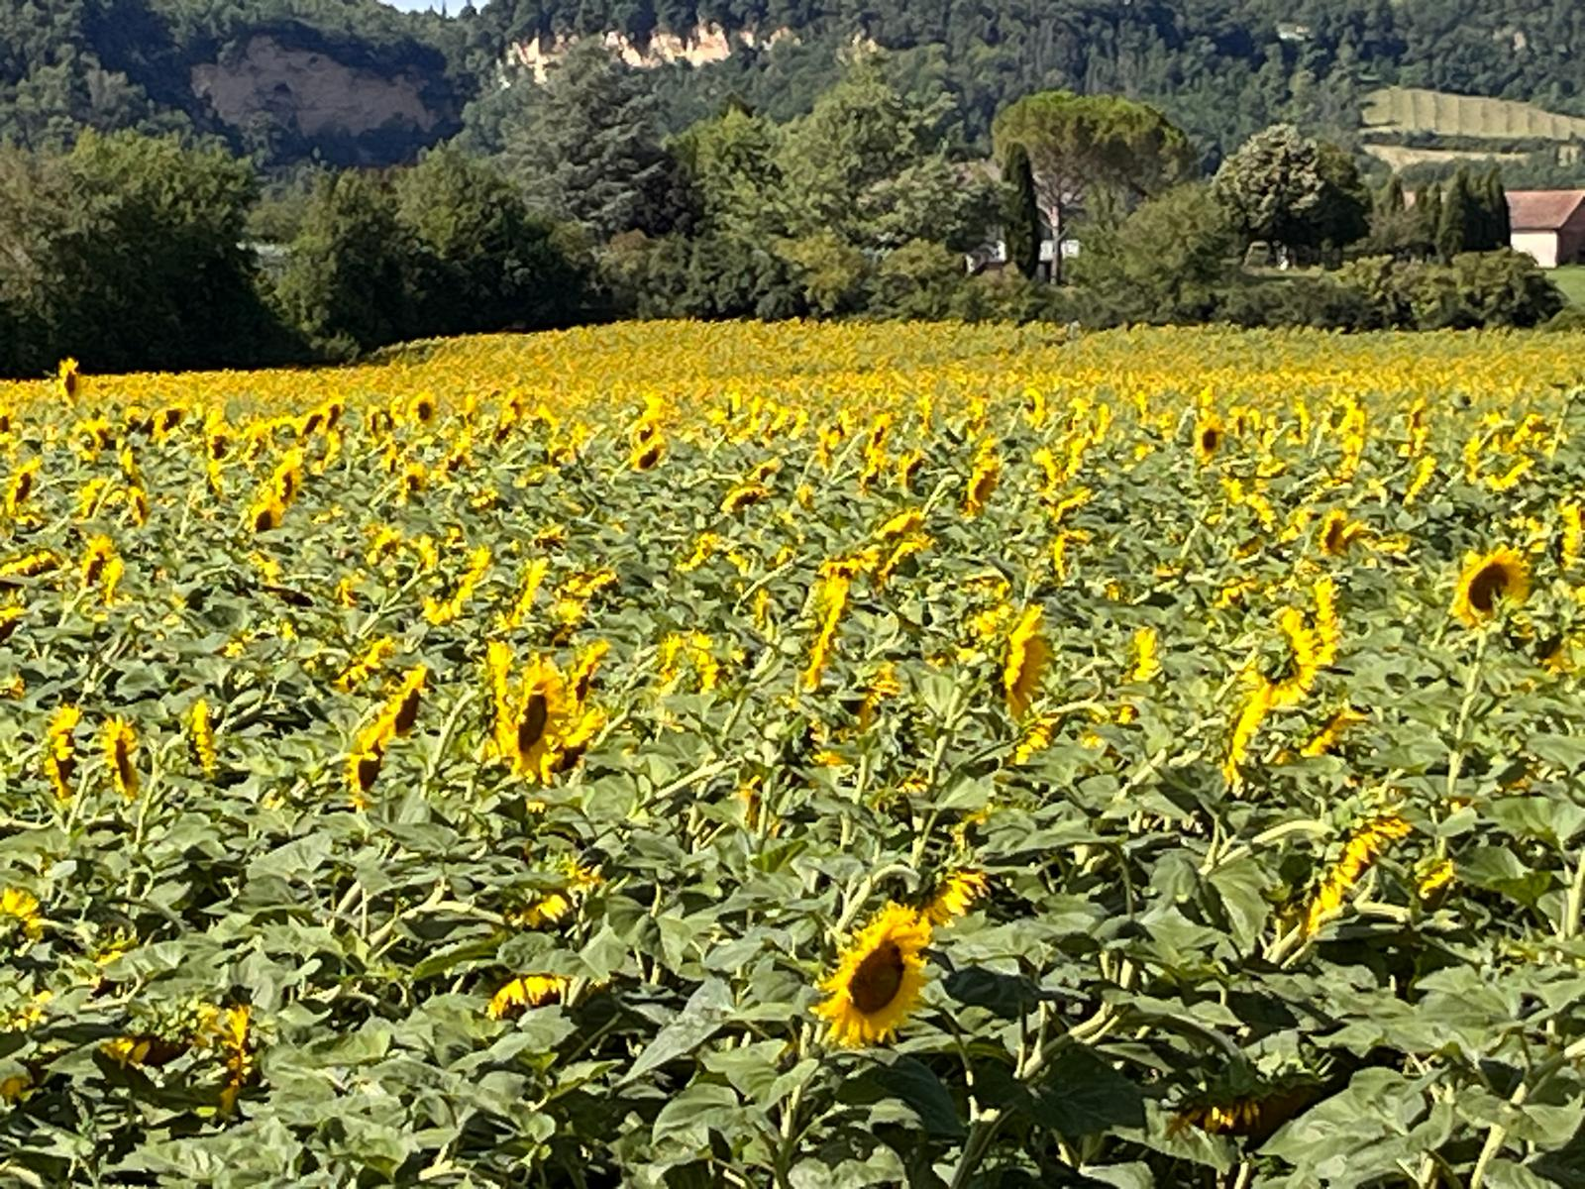
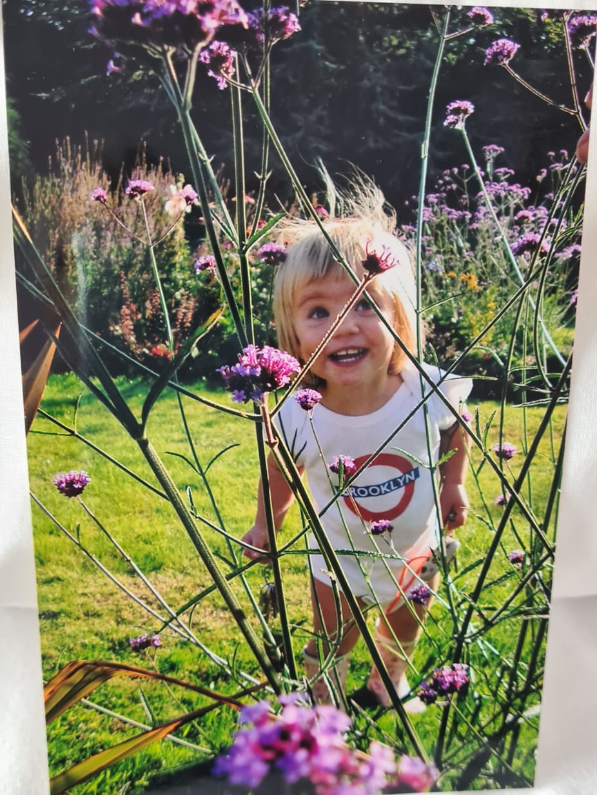
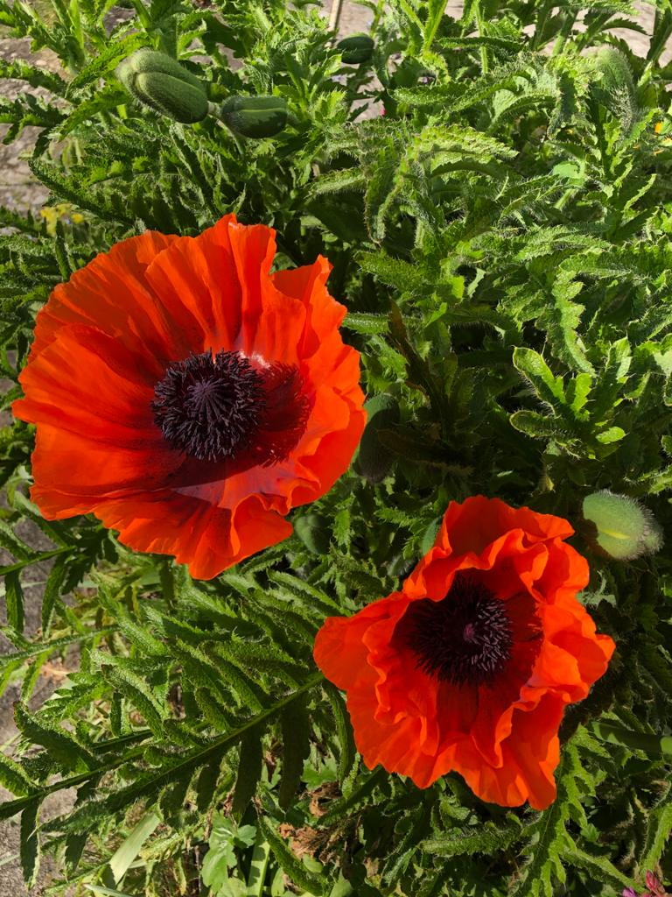
Figure.1 Figure.2 Figure.3
Flowers can also be deeply personal to everyone and although there is a set language of flowers through books. Everyone has their own personal connotations on certain flowers depending on their life experience. A sign on the wall at Saatchi reads: “Every watershed moment in our lives seemingly involves flowers as potent symbols of meaning”. As part of this collection I also want to look into my own personal connections with flowers. To me although poppies mean remembrance, peace and sleep. I always associate them with childhood memories of my garden and when we used to have huge plate sized poppies that no matter how much you cut them back every year they would always seem to double in numbers(Fig.1). I always associate sunflowers with France as they remind me of feeling carefree, as when on holiday there were always what felt like millions lining the fields (Fig.2) and Verbena to me means the perfect spot for playing hide and seek in my Grandparents' garden(Fig.3). Using these memories I can use them as strong starting points for design enquiries, I can use this story telling as a starting point of creating this collection.

There are also many stories that link back to florals that help to show how their presence has transcended time. Myths like the one of ‘The Origin of Hyacinths’ where it is said that a young Spartan hero (Hyacinth) chose the suitor of Apollo much to other Gods disgust. One day they were playing discus and Zephyrus (God of the West Wind) blew a gust of wind out of jealousy, blowing the discus at Hyacinth's head and killing him. Apollo was so distraught he refused to let Hades (God of the underworld) take Hyacinth’s soul; he transformed it into a flower and called it Hyacinth. This myth then led to the Hyacinth having a strong cultural significance within Ancient Greece, as it was the catalyst to the three day Spartan festival Hyacinthia. This included mourning rights to young Hyacinth's death and the celebration of his rebirth through the flower. The Romans too had strong spiritual connections with flowers, having Flora the goddess of flowers, spring, and fertility - who I feel embodied the feeling of biophilia. From looking into these myths I am able to make connections with the modern meanings of flowers and where they came to fruition; like how red tulips mean undying love which is taken from the Persian Legend of ‘Farhad and the Princess Shirin’. Farhad fell for the Princess but was not of royal blood so could not marry her, so he was sent by the King (did not want him to succeed) to cut a passage through mountains to create a stream that would flow through the Palace. As the King found out he was close to completing, he sent Farhad a message that the Princess died from a sudden illness. Overcome with grief, he threw himself from the mountain and as his blood fell each drop became a blood red tulip symbolising his pure and undying love.

Context and audience + Materiality, Methodology and Process
In this collection I will be designing for interiors. This is an area I am most passionate about and want to focus mainly on in my future career as a designer. Within an interiors context, I would like to investigate design for both soft and hard surfaces, having focused on kitchen and living areas. The main audience will be adults in their late 20s to early 40s. Many will be furnishing their first home and want a modern collection to embellish their living areas, whether that be living rooms with soft furnishings and wallpapers or kitchen’s/ bathrooms with tiles. The collection will look homely and inviting.
I will start working with certain materials as part of the experimentation process
and work out which materials are the most successful. In previous work, I found where I feel comfortable and would like to continue with these methods. These
include UV printing and laser engraving, as well as traditional screen printing and digital printing. I will do some more experimentation but will concentrate in these areas.

Critical Perspectives

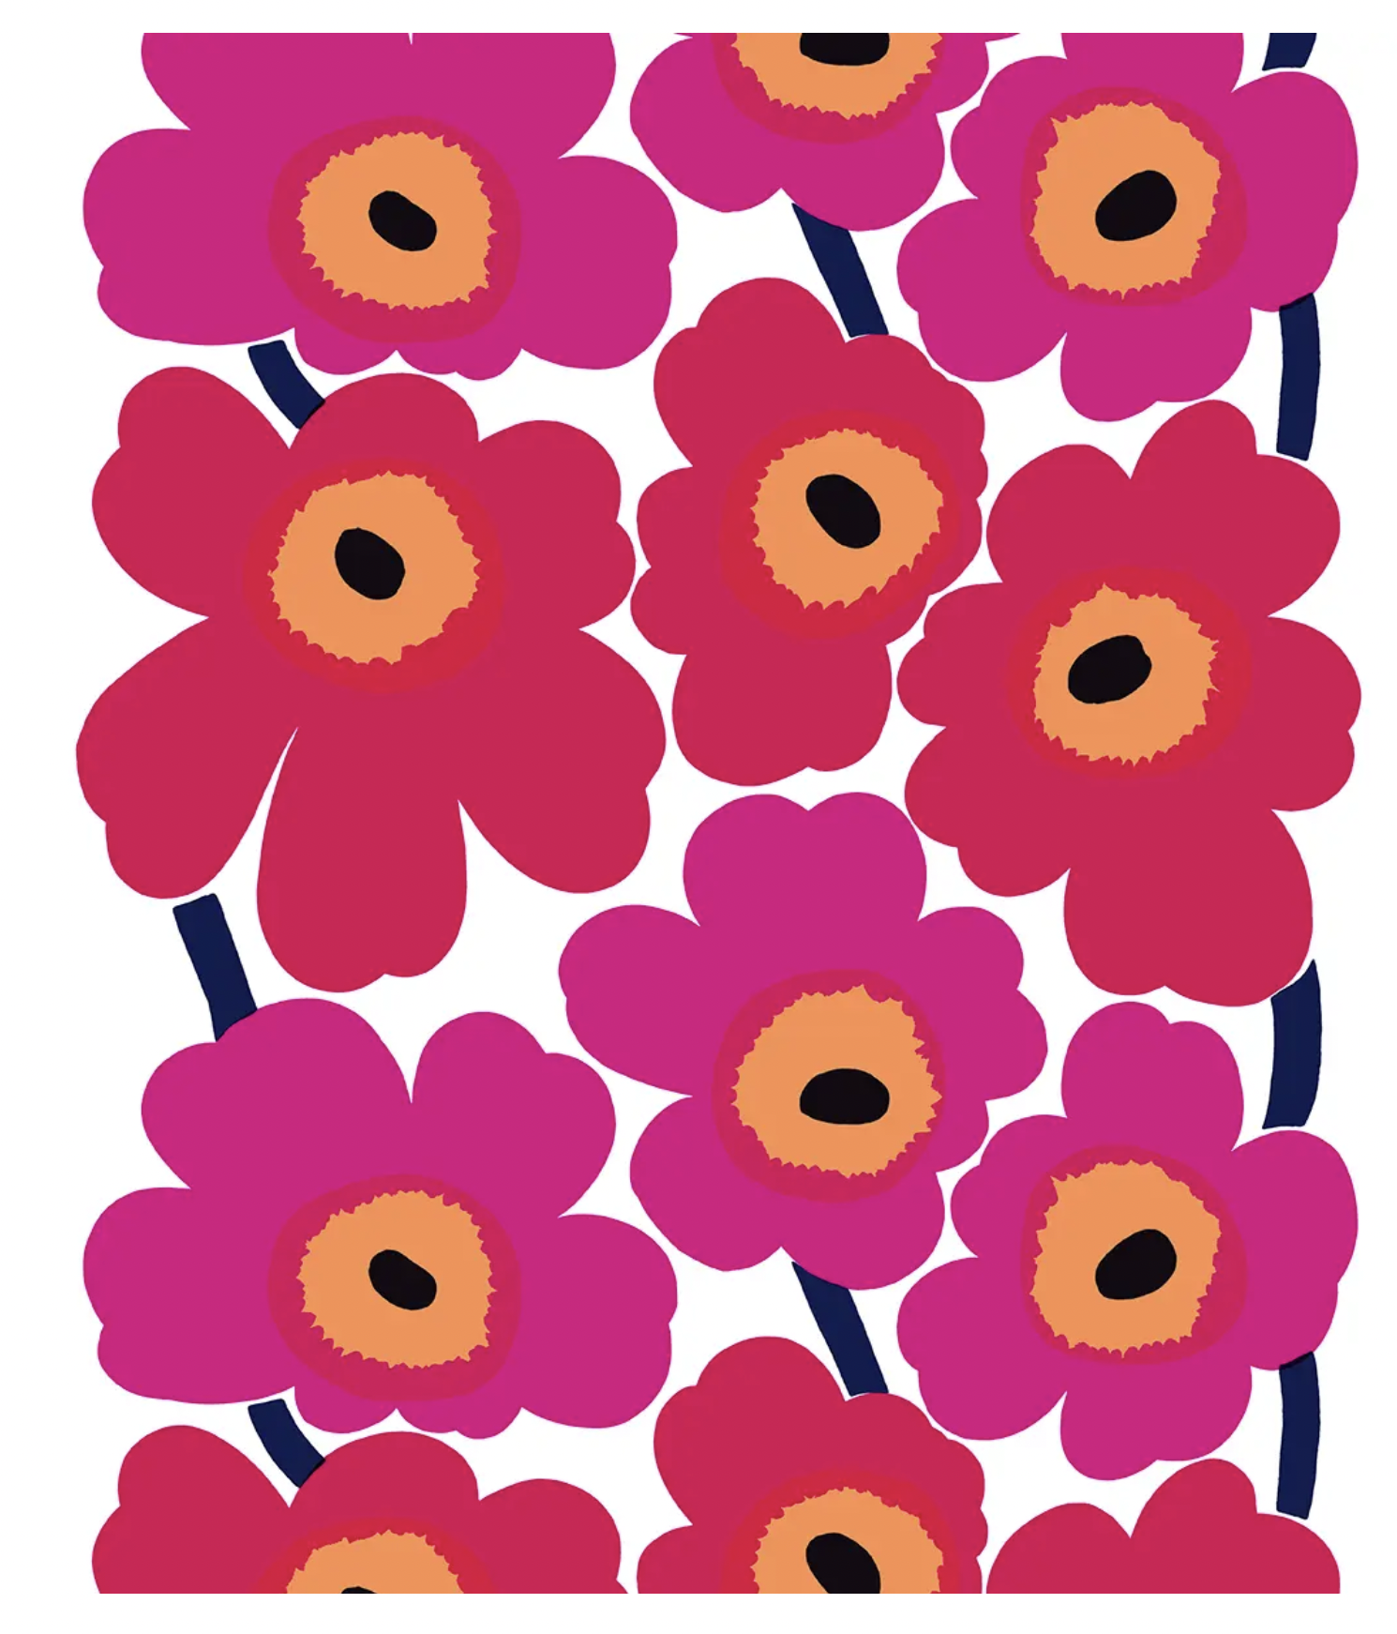Figure. 4
Visual language plays a huge factor in design, from the shapes to the colour each detail can change the whole feel of the design. With this collection I will be conscious of visual language as the message I want to portray focuses on the unspoken language. “Flowers bring an element of natures dynamism into the more static context of the man-made world…While the static nature of the objects around us engenders comfort and predictability, it also drains away our connection to the vibrancy of the earth” (Fetell Lee, 2018 p.287). Fetell Lee highlights how having the ability to create natural change within the home is so important especially when it is shown by flowers which have been recognised to bring an expanse of joy to many. “No flowers in the world seems dim, dystopian- not dead, exactly, but not fully alive either” (Fetell Lee, 2018 p.284) This quote also helps to show how as humans we have come accustomed to constantly seeing flowers even if we are not actively seeking them out. From visiting the Saatchi Gallery for the ‘Flowers, Flora in Contemporary Art and Culture’ exhibition I noticed artists like Marimekko, Faye Bridgwater and Rita Fennell who all use bold striking, stylised florals in their work, compared to the work of designers such as William Morris and Sanderson Design who focus on much more traditional design and techniques with more subtle florals. “It is quite understandable that artists have been drawn to flora as a subject of discipline. Flowers are amongst the most beautiful and vibrant of natural phenomena observable. At a purely aesthetic level, theyrepresent a challenge to all artists to reproduce. Yet, almost all artists recognise the futility of trying to compare with nature directly” (Saatchi, 2025). All of these artists use their own visual language to display their work to different audiences, who each have unique feelings towards the designs. Marimekko most well known for their Unikko print (Fig.4) (celebrated 60 years of this pattern in 2023), which embodies the whole brand's identity “The unmistakable Marimekko prints have always been worn as bold badges of positivity and personal empowerment. Our lifelong mission is to bring colour and joy into lives and homes everywhere and encourage people to be happy as they are” (Marimekko, 2025). The print was revolutionary to the brand as before this print they had not released any floral designs, as it was said the founder Armi Ratia had claimed flowers were so beautiful and unique that they would not be well represented in patterns. The pattern was new and unique, cutting through what had been seen before in fashion and interior by using bright bold florals to make statements unlike the more muted smaller patterns that were all the rage in the 50s. Not only was this pattern cutting edge in its initial release it has also stood the test of time as it is still used as one of their main prints synonymous with the brand.

Florals are a recurring theme in design, especially in interiors for several reasons. “A growing body of research is proving that exposure to nature can exert a significant impact on people's physical and mental health, performance, and wellbeing” (Kellert, 2018 p.9). Not only do they have improved psychological benefits, they have also proved to be timeless, have deeply varied symbolism through many cultures and highlight the importance of biophilia with humans' basic need to connect with nature.

Vision
As the language of florals is so vast, I have decided to split my collection down into three sub collections that I feel best embody this theme. I wanted to look at different aspects of the theme, making sure I covered a wide scope. This will include exploring personal experiences, myths and stories to show how the language of florals has transcended time and the cliche and stereotypical to show how even in the mundane we are communicating with flowers without realising. Through the personal collection, I want to explore my memories with flowers and the way they have subconsciously played a part in my life and when reflecting on memories have their own personal meanings to me. Looking at myths and legends, I want to show how flowers have been part of storytelling before they made their way into modern design. Looking into cliches I want to highlight how Western culture and capitalism have taken away some of the meaningful beauty - making them so accessible and ‘every day’ that it takes away some of the value.
I am very ambitious to achieve my goals in the future, however I often find my own mind gets in the way of my confidence for my work and my nerves prohibit me from outwardly expressing my ambition towards designing and the future. To help combat this I have looked into the idea of ‘inner chimp’. “The premise of Dr Peters’ ‘inner chimp’ is built on an understanding of neurophysiology and human behaviour ......... Dr Peters argues that it is important to know our emotions and instincts and to allow them free rein when they work productively, but to manage them when they are destructive. He argues that managing our impulsive, emotional chimps is one of the biggest factors that determine how successful we are” (Kay, 2013 p.11). By utilising the opportunities available to me at university I have been able to slowly speak more confidently about my work and intend to keep practicing the skill of public speaking to help give me the best opportunities when looking for jobs in the future.
I am still working on finding my unique style but having an adaptable style will make
me more marketable for collaborating with other designers or working for a design
house. This is my ambition for the near future after graduating. I would love to work
for a commercial design house such as Laura Ashley, Habitat or even broaden my
scope by looking at companies such as Kip and CO who are based in Australia.
To help achieve this goal, I will have to create a strong portfolio to help market myself as a Designer.

My success in the Major Project will be measured by having a collection of work that feels cohesive and I am proud of and want to show to potential employers. It will also be a measure of success to see my watercolour and ink work transferred onto other materials and still be close to their original high quality. I want the meaning behind my work to be understood by others yet be thought provoking and allow others to make their own connections.

Conclusion
Bibliography:
Alma de Luce (2024) The influence of nature on interior design. [online] Available at: https://www.almadeluce.com/blog/the-influence-of-nature-on-interior-design/.[Accessed 28 Nov 2025]
Cyrus, M. (2023) Flowers [song] Columbia Records
Dean, O. (2023) I could be a florist [song] Universal Music Operations Limited
Fetell Lee, I. (2018). Joyful: the surprising power of ordinary things to create extraordinary happiness. Little Brown Spark.
Gorman, M. (2025). Beyond words: The 200-year-old hidden languages of dating. [online], Available at: https://www.bbc.co.uk/future/article/20250703-the-200-year-old-hidden-languages-of-dating [Accessed 30 Nov. 2025].
Kay, J (2013). Nursing Management (through 2013); Nursing Vol 20 (4) pp.11
Kellert, S.R. (2018). Nature by Design: The practice of biophilic design. Yale University Press.
Kirkby, M. (2011). Language of Flowers: a Miscellany. Pan Macmillan.
Marimekko (2025). Our story | Marimekko. [online] Available at: https://www.marimekko.com/us_en/m/our-world/our-story. [Accessed 8 Nov 2025]
Saatchi (2025) Gallery visit 16th April 2025, London
Wilson, E.O. (1984). Biophilia. Harvard University Press.

List of Figures:
Figure 1: Personal Photo, Iranian poppies, (date?)
Figure 2:Personal Photo, Field of Sunflowers, Saint Lattier, (date?)
Figure 3:Personal Photo, Me hiding in Verbena, Welshpool,(date?)
Figure 4:https://www.nordicfusion.com.au/products/unikko-fabric-red?srsltid=AfmBOopntWuaf36XikCo6kHARogdooDEhqZQMXYuKsHjy2HXAY-Ob5_3

