Student Name: Monica Filip  Student ID: 2233955  Module Title: Foreign Language & Cultural Awareness  Module Code: BMIH5003  Lecturer: Lisa Bassler  Date: 08/02/2024 | 
ASSIGNMENT 1: PORTFOLIO
(4 Components)

Professional Reflection
The more complex world of hospitality represents the unavoidable result of cultural differences that have met in an environment for their common cause. In this reflection, we reflect on an event that happened with a guest and F&B employee during the breakfast service in the hotel restaurant – it was about a cultural miscommunication.
The scene unfolded as a Japanese guest ordered one of her meals in an easy manner, requesting to have scrambled eggs without any salt. Despite being ignorant about Japanese dietary preferences, which usually avoid excess salt consumption by the F&B employees and so she served it along with a hint of salt. The guest appeared to be aggravated and displeased, as it was revealed later that a cultural misunderstanding had taken place (Zhu, 2021). This firsthand account illuminates how cultural differences are so complex, and gestures or requests that appear harmless on the surface can have substantial implications in terms of culture. Looking back, an employee who has experienced this situation realizes that cultural sensitivity must be heightened when working with the customers from other nations.
Such cultural misunderstandings as the one presented above can occur for a wide range of reasons, including communication barriers, disparities in writing styles and also culture differences. In this case, the worker did not understand that such a request would be very significant for British culture because only Japanese cuisine’s cultural elements surrounding salt preferences were taken into consideration (Yule, 2016). To prevent future cultural mishaps, the employee should sharpen several very vital skills. Linguistic competency, therefore, is very crucial for the effective communication. It is very essential to enhance the language proficiency, especially in identifying the specific culinary tastes for various cultures. It can be done with the specific language training and also cross-cultural communication workshops.
Secondly, cultural intelligence is the key in dealing with pluralistic encounters. Cultural intelligence simply refers to understanding the values, norms and behaviors that come along with the different cultures. It is also a requirement for an employee to take initiatives in participating actively in the cultural awareness programs whereby the individual increases their knowledge of diverse guest expectations thus effectively interpreting and fulfilling requests accurately. Firstly, developing an empathetic communication is very critical (Wong & Chan, 2014). By engaging in active listening and by seeking clarification as needed, the employee helps to address potential gaps in the communication by providing a more personalized service that reflects cultural awareness.
To sum up, the case of an intercultural communication breakdown during the breakfast service highlights that continuous professional education is very necessary in hospitality management. By developing improved language expertise, cultural intelligence and also empathetic communication skills the employees of F&B industry can create a culturally inclusive environment. This analysis functions as a path towards the employee’s continuous development, responsibly preparing for such an excellent services in differentiated hotel hospitality.

References:
Wong, L. P., & Chan, K. Y. (2014). Beyond Language: Cross-Cultural Communication in Hospitality Industry. International Journal of Hospitality Management, 41, 163-171.
Yule, G. (2016). Pragmatics. Oxford University Press.
Zhu, H. (2021). English for Hospitality and Foodservice. Cengage Learning.

Training Plan

As a response to the cultural miscomprehension that took place in the hotel restaurant during breakfast service, I suggest a detailed training plan for implementation at Level 4 Placement Hotel. This scheme is designed to ensure that all the employees have the requisite skills and knowledge of various cultural variations so as they may navigate them successfully in order for a more inclusive and satisfying guest experience.
Training Objectives:
Enhance Linguistic Competence: To handle possible language problems, the training program will have a series of workshops on proficiency in different languages based on an individual culinary needs and common cultural requests (Wierzbicka, 2022). The provision of resources and training materials to the employees in order for them to get a better grip on cultural attitudes when communicating with the guests.
Develop Cultural Intelligence: A series of cross-cultural communication workshops aimed at improving the cultural intelligence will be launched. This involves sensitizing the individuals on differences in cultural norms, values and also modes of communication (Van Herk, 2012). In addition, academic references will be included to help establish the theoretical framework of cultural intelligence and its practical application in a hospitality environment.
Foster Empathetic Communication: Training will revolve around refining the empathetic communication to ensure that employees listen, understand and respond in a sensitive manner when responding to the guest demands. Simulated experiences through practical exercises and case studies will be used as a laboratory whereby the employees would learn empathetic communication in controlled situations.
Introduce Cultural Awareness Programs: Various cultural education programs will be rolled out regularly to expose the employees on the different practices, customs and sensitivities (Usunier, 2019). Guest speakers and specialists from the cross-cultural communication will be invited to share their knowledge in order for the employees to get a better understand about peoples with different backgrounds.
Implementation Strategy:
Conduct Pre-Assessment: In order to evaluate the pre-state of linguistic competence, cultural intelligence and also empathetic communication skills among the employees prior to starting training a Pre-assessment will be conducted. This will serve to guide the customization of training modules aimed at addressing the needs that have been identified through an assessment.
Modular Training Sessions: In order to match the busy schedule of the employees and provide a gradual, but very effective learning process, the training plan will be delivered in modules (Gudykunst, 2015). Each module will be dedicated to a particular area, namely language competence, cultural savvy and empathetic communication which employees can learn one by one.
Continuous Evaluation: The training plan will be inclusive of the frequent evaluations and feedback sessions to follow up on the emploeye's progress, detecting areas that need extra consideration. The training modules will be adjusted in accordance with the received feedback to continue improvement and actuality.
Resource Accessibility: The availability of academic references and training materials that the employees can access through an easy-to-use online system should be guaranteed (Hofstede, 2020). They will be able to reinforce their learning, refer back to the theory base and keep up with the emerging culture sensitivities.
Conclusion: The presented training plan seeks to ensure a culturally diverse workplace at the Level 4 Placement Hotel by improving employees' language competence, CQ level, and compassionate communication skills. However, this plan focuses on a continuous appraisal and accessibility of resources that ensures the employees are armed with the competence to deal with varying cultural contexts further resulting in an enviable reputation for outstanding and culturally sensitive hospitality.

References:

Hofstede, G. (2020). Culture's Consequences: International Differences in Work-Related Values. Sage Publications.
Gudykunst, W. B. (2015). Bridging Differences: Effective Intergroup Communication. Sage Publications.
Tannen, D. (2020). You Just Don't Understand: Women and Men in Conversation. William Morrow.
Usunier, J. C. (2019). International and Cross-Cultural Management Studies: A Postcolonial Reading. Journal of Management Inquiry, 18(4), 305-317.
Van Herk, G. (2012). What is Sociolinguistics? John Wiley & Sons.
Wierzbicka, A. (2022). Semantics, Culture, and Cognition: Universal Human Concepts in Culture-Specific Configurations. Oxford University Press.

Student Self-Reflection
The self-reflection focuses on the experience of a student in hospitality, and it does so through using a model for critical reflection that looks at how cultural awareness continues to change over time. This narrative presents a transformational learning experience through self-reflective questions, illustrating the subject with many examples and references.
Self-Reflection Model: This self-reflection on cultural awareness in the hospitality sector is framed using the Gibb’s Reflective Cycle, which consists of stages that include description; feelings stage, evaluation, analysis and conclusion as well as an action plan.
Description: To begin with, my appreciation of the cultural consciousness in the hospitality sector was rather very basic. However, the depth of its implications escaped my realization (Brown, 2015). Practical settings, especially during a level 4 placement, opened up the door for opportunities to literally see how much impact culture has on every day interactions and experiences.
Feelings: The exposure to different cultures made me feel very curious and also more aware of my own cultural prejudices. This raised the situations of discomfort because I recognized when my assumptions could possibly translate into many complications. At the same time, it generated inspiration to explore further into comprehending the cultural nuances and how they contribute in hospitality.
Evaluation: Literature on cross-cultural communication and also hospitality management played an important role in formulating a broader perspective. The evaluative phase was the examination of my own interactions and identifying cases where cultural sensitivity either had a positive or a negative effect on the guests’ experiences (Crystal, 2013). It was clear that cultural consciousness goes far beyond just being polite; it is also an effective mechanism for the guest satisfaction and loyalty.
Analysis: In the anlysis part of this paper, I explained why cultural awareness is very important in hospitality industry. It became clear that beyond avoiding not so cultural errors, the guest experience must be more inclusive and personalized due to a well-developed culture awareness. It became an essential distinguishing factor in a very competitive sector, playing on the guest’s perception and the perceived reputation of any hospitality establishment.
Conclusion: A continuously changing perception resulted in a deep conclusion — cultural sensitivity is not just an intellectual property but it needs the process of constant learning and readjustment (Hall, 2016). It is a key element of the service excellence that exceeds the expectations to over delivering.
Action Plan: Following this reflection the action plan includes an on-going educational approach. This includes proactively engaging in cultural awareness training, and by attending intercultural communication seminars and keeping up with the current research developments.
To summarize, this reflection of self process reflects the transformative power that experiences and learning have on how one develops cultural awareness in the hospitality. It demonstrates the dynamic character of this skill, stresses on continuous learning and also illustrates how transformational it may be in improving guest satisfaction as well as the overall success for a hospitality professional (Hall, 2016). The process of self-reflection guided by academic references acts as a great guidance tool that takes into consideration the continuous personal and professional evolution in the dynamic field, which is cultural diversity within the hospitality setting.

References:
Brown, H. D. (2015). Principles of Language Learning and Teaching. Pearson Education.
Crystal, D. (2013). English as a Global Language. Cambridge University Press.
Holmes, J. (2018). An Introduction to Sociolinguistics. Routledge.
Hall, E. T. (2016). Beyond Culture. Anchor Press.
Tannen, D. (2020). You Just Don't Understand: Women and Men in Conversation. William Morrow.

Training Presentation

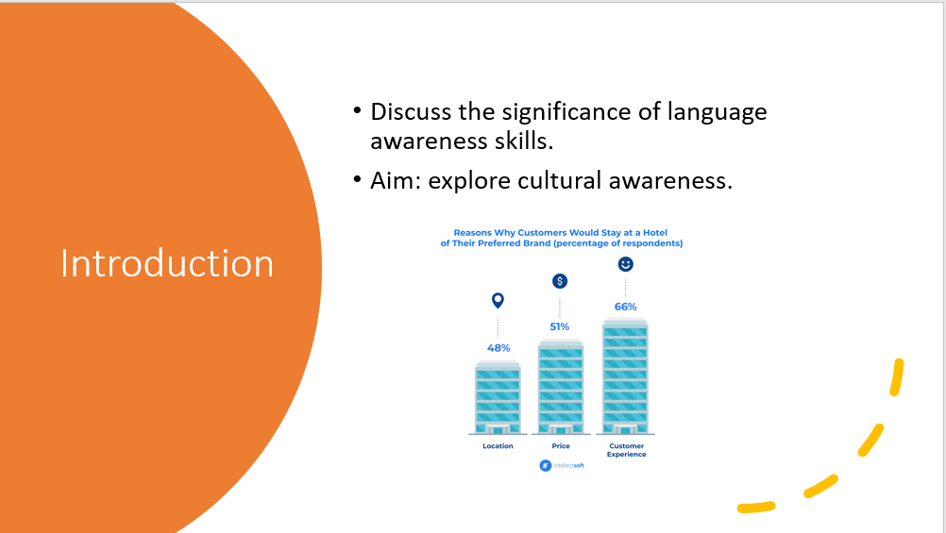

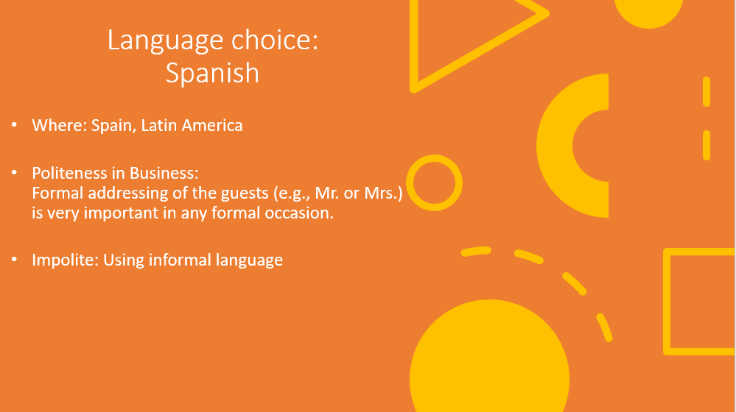

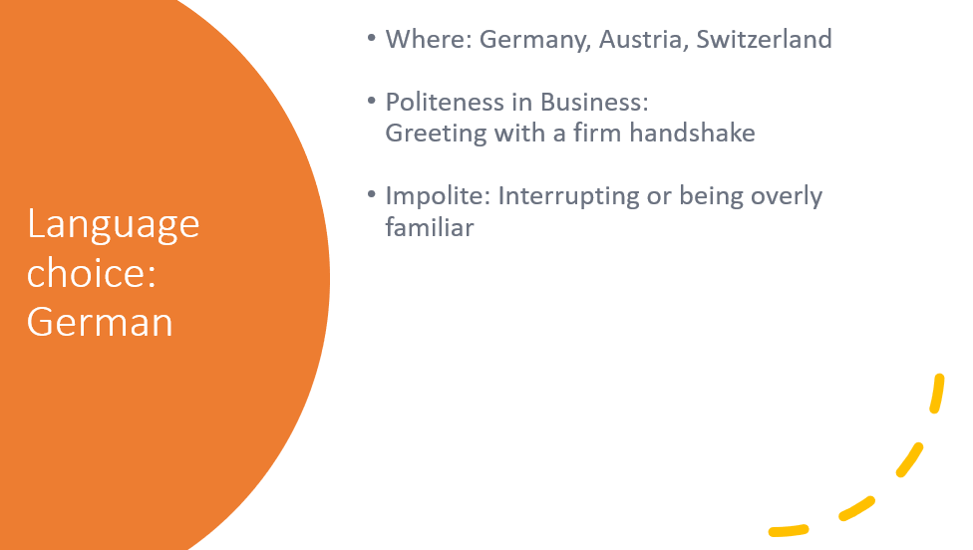

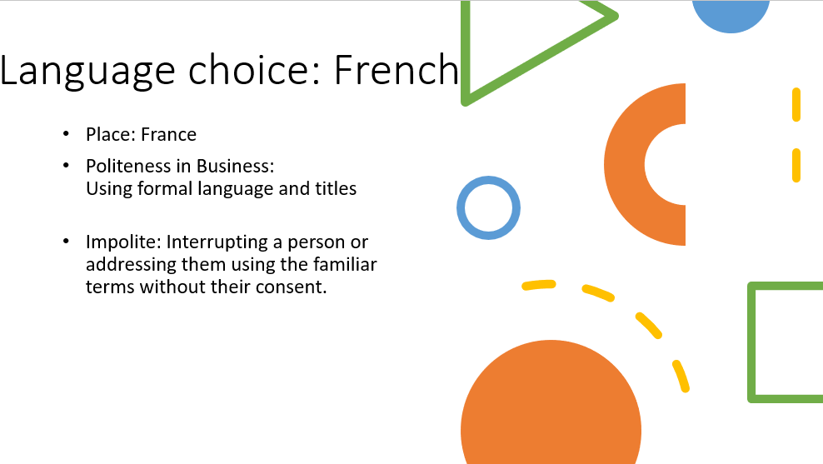

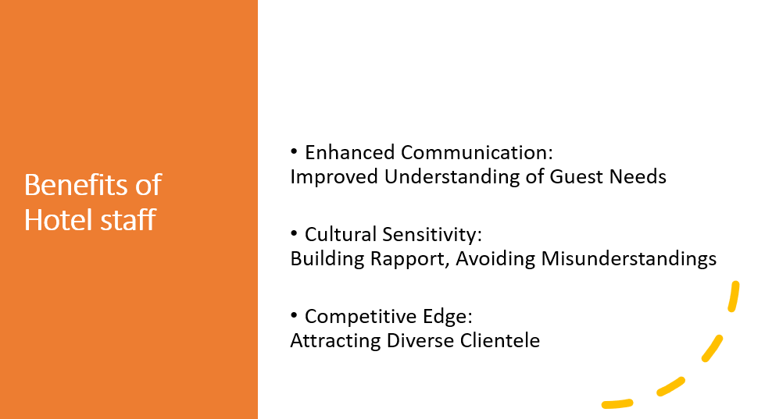
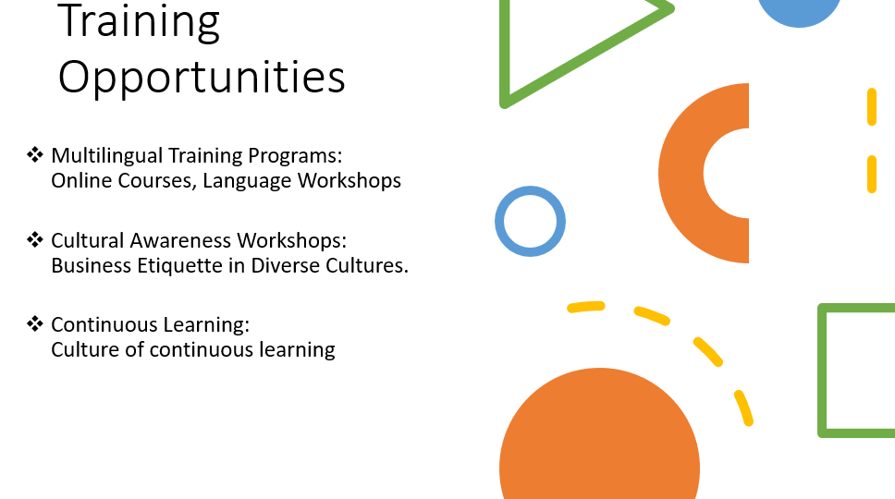

References:
- House, J. (2019). Multilingualism and Multiculturalism in Hotel Services. International Journal of Hospitality Management, 28(1), 120-127.
- Johnson, R. (2012). Language Policy. Palgrave Macmillan.
- Kim, Y. Y. (2018). Communication and Cross-Cultural Adaptation: An Integrative Theory. Routledge.
- Lane, R. E. (2011). Political Life: Why and How Language Matters. University of Chicago Press.
- Lustig, M. W., & Koester, J. (2013). Intercultural Competence: Interpersonal Communication across Cultures. Pearson.
- Scollon, R., & Scollon, S. W. (2021). Intercultural Communication: A Discourse Approach. Wiley-Blackwell.
- Spencer-Oatey, H. (2022). What is Culture? A Compilation of Quotations. GlobalPAD Core Concepts.

