Research Methods

The relationship between levels of sensation seeking and the likelihood of engaging in risky driving behaviours


This study attempted to thoroughly investigate the possible relationship between sensation, seeking and the possibility of the engagement in risky driving behaviours. Each university participant was required to complete two consecutive questionnaires, the first in relation to risky driving behaviours with questions such as ‘drive whilst listening to loud music and follow very closely behind slow drivers’, and the second with relation to sensation seeking with questions such as ‘I would like to explore strange places and I like wild parties’. The results from the participants aided the study. Before the study had taken place, it was hypothesised that the higher levels of sensation seeking would be in relation with the engagement of risky driving behaviours.

Introduction

The relationship between sensation seeking and the likelihood of engaging in risky driving behaviours will aim to support the evidence and results based around the study. The aim of this study was to determine whether the participants involved had any relations between both risky driving behaviours and impulsivity. The definition of impulsivity is “deals with one’s controls over one’s thoughts and behaviours” (Barratt, 1972). As an example, those who show increasing signs of impulsivity, may be unable to control their immediate reactions in certain situations and as a result may possibly find themselves facing consequences. Risky driving behaviours can be described in various ways such as aggressive driving for example. Research has suggested that angry drivers are more likely to engage in aggressive driving behaviours and are less likely to be involved in non-aggressive driving behaviours such as not wearing a seat belt, driving over the speed limit etc. (“Deffenbacher et al., in press; Deffenbacher et al,. 2003a, 2003b, Deffenbacher et al 2000, 2001”). According to empirical literature, there is a clear relationship between impulsivity/sensation seeking and risky driving behaviours. The first clear identical relation would be the lack of premeditation which is the likelihood to think/plan prior to an event and the negative urgency that mirrors the likelihood to act impulsively whilst experiencing negative situations. Another relation could be due to the lack of perseverance which displays the continuous attempt of persisting with tasks/situations until they are completed. A recent study conducted by Jonah, Thiessen and Au Yeung (2001) suggested that individuals with high levels of sensation seeking were extremely likely to drive faster in the most common driving situations such as on the motorway for example. It has been hypothesised that there will be a positive relationship between both sensation seeking and risky driving behaviours.

Method

Participants

During the relationship between sensation seeking and the likelihood of engaging in risky driving behaviours task included 26 participants, involving 5 males and 21 females. The participants were recruited via email that had been forwarded to each participant including all the relevant information about the study and requesting their participation. The ages ranged between 18 years old up to 60 years old (M=27.58 SD= 11.13). Each participant was also asked if they held a fully official UK driving licence before they participated in the study.

Design

The analysis being used during this study was a questionnaire method and the study involved was ‘within subjects’ due to the results of the study being derived using a group orientated method and the participants were exposed to the conditions in the study. As a result, the levels of SS and RDB were being measure on a scale of 0-4 in the RDB questionnaire and from 1-5 in the SS questionnaire. This study was a correlation study and the variables of the study included sensation seeking/impulsivity and risky driving behaviours.

Materials

Before this correlation study took place, each participant was given a consent form containing all the relevant information about the study, and included data such as the age range, gender, and if they did or did not hold a full official UK driving license. It indicated that the study would consist of two online questionnaires in relation with SS and RDB. This form also allowed each participant to not participate in the study. The SS questionnaire (appendix B Stephenson,M. T., et al,. 2003) included 8 questions and allowed participants to score each question ranging from strongly disagree (1), disagree (2), neither disagree or agree (3), agree (4), strongly agree (5). The RDB questionnaire (appendix A Ivers, R., et al., (2009) included 14 questions allowing participants to score each question ranging from never (0), hardly ever (1), sometimes (2), often (3), very often (4).

Procedure

Before the study could take place, each participant was requested to complete a study consent form (appendix D) which stated exactly what the participants needed to know about the study, also stating that any participant would be able to withdraw themselves from the study at any time and seek advice before or after the study had taken place if deemed necessary. It also stated that each participant’s result would be collected in addition to the Data protection act. Each participant then needed to complete two separate questionnaires with one in relation with risky driving behaviours and the other in relation with sensation seeking. There were 14 questions included in the risky driving behaviour questionnaire (appendix A Ivers, R., et al., (2009) and the answers available varied from never, hardly ever, sometimes, often, and very often and the scoring system ranged from 0 (never) to 4 (very often). These questions were based around poor driving habits. The sensation seeking questionnaire (appendix B Stephenson,M. T., et al,. 2003) included 8 questions ranging from 1 (strongly disagree) to 5 (strongly agree). These questions were based around how the participants felt themselves in relation to the 8 questions. Once each participant completed both questionnaires, their scores were calculated and provided an accurate answer as to whether there is a relationship between sensation seeking and risky driving behaviours. After the correlation study had been completed, each participant involved was giving a debrief information form (appendix C). This form displayed the aim and focus behind the study in relation with whether there is a relationship between SS and RDB, and also included the researchers contact details.

Results
A correlation study was formed to determine whether or not there is any relation between both sensation seeking and risky driving behaviours. After the study had been completed, the results showed that there is a weak negative correlation between sensation seeking and risky driving behaviours. As a result, the findings from the study were deemed to be non-significant with no correlation. r= -0.08, n= 26, p < .05 (appendix D). This concludes that the original hypothesis that there is a relationship between sensation seeking and risky driving behaviours would now be rejected.

Discussion

The correlation between sensation seeking and risky driving behaviours study was conducted to determine whether there was a relationship between the two variables and was performed via two online questionnaires. Prior to other studies showing that there is a relationship between the two variables, it had been hypothesised that this study would have a similar result. This would have been as a result of the participants scoring their answers highly levels of SS and RDB in both questionnaires. However, the study indicated that the participants scored low in both the SS and RDB questionnaires.
In relation with all study’s and experiments conducted, individuals will always find limitations with the study. An example of a limitation within this study could be that not every participant involved in the study held a full official UK driving license which decreases their knowledge of the questions asked of them. As a result, this may have possibly had a major effect on the results of the study. Another limitation of the study may be concerning the number of participants involved in the study. As appose to previous studies such as Dahlen, Martin, Ragan and Kuhlman (2005) which included 224 participants whereas this study which only included 26 participants, may be seen to have more effective results due to the number of participants involved. If both limitations were excluded from the study, the results may have been significantly different.

Reference List

- (Barratt, 1972)

- “Deffenbacher et al., in press; Deffenbacher et al,. 2003a, 2003b, Deffenbacher et al 2000, 2001”

- Ivers, R., et al., (2009

- Jonah, Thiessen and Au Yeung (2001)

- Stephenson,M. T., et al,. (2003)

Appendices A

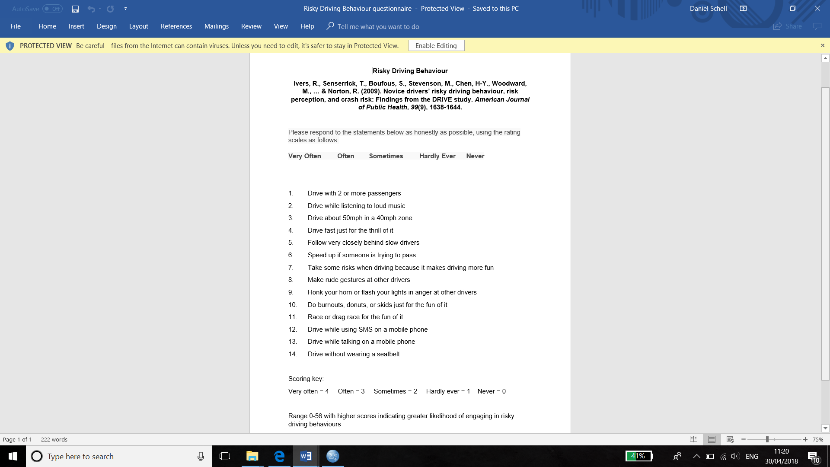

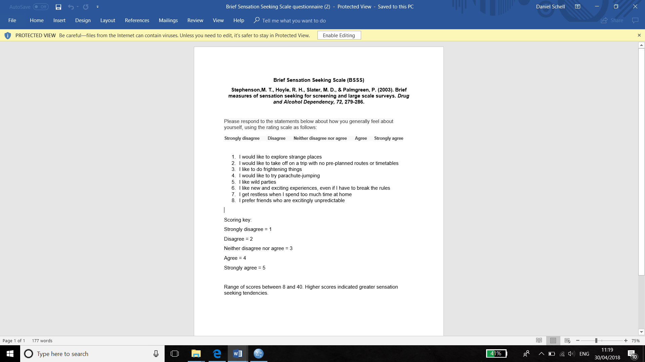
Appendices B

Appendices C

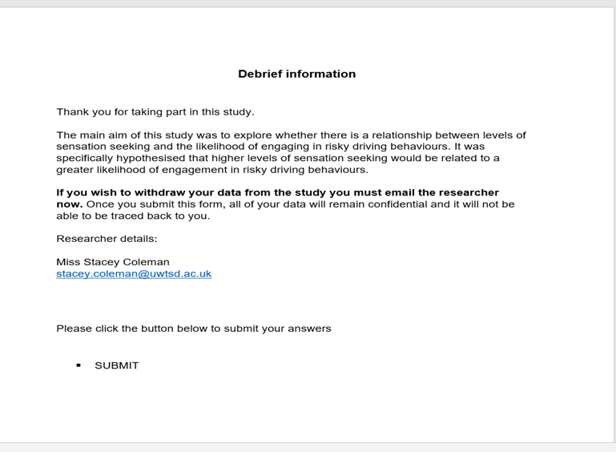

Appendices D

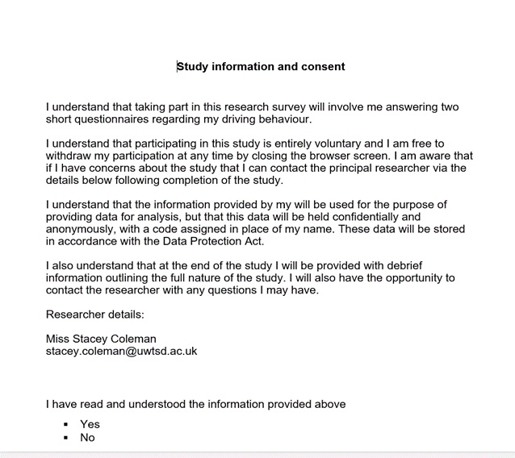

Appendices E

Correlations
 |  | TotalRDB | TotalSS
TotalRDB | Pearson Correlation | 1 | -.076
TotalRDB | Sig. (2-tailed) |  | .712
TotalRDB | N | 26 | 26
TotalSS | Pearson Correlation | -.076 | 1
TotalSS | Sig. (2-tailed) | .712
TotalSS | N | 26 | 26

Descriptive Statistics
 | Mean | Std. Deviation | N
TotalRDB | 14.5769 | 7.88504 | 26
TotalSS | 25.8846 | 4.49290 | 26

Gender
 |  | Frequency | Percent | Valid Percent | Cumulative Percent
Valid | 1.00 | 5 | 19.2 | 19.2 | 19.2
Valid | 2.00 | 21 | 80.8 | 80.8 | 100.0
Valid | Total | 26 | 100.0 | 100.0

Descriptive Statistics
 | N | Minimum | Maximum | Mean | Std. Deviation
Age | 26 | 18.00 | 60.00 | 27.5769 | 11.13256
Valid N (listwise) | 26

