

Task 1 – Reading Task Template
Upload your photo of your A3 in-class notes here:
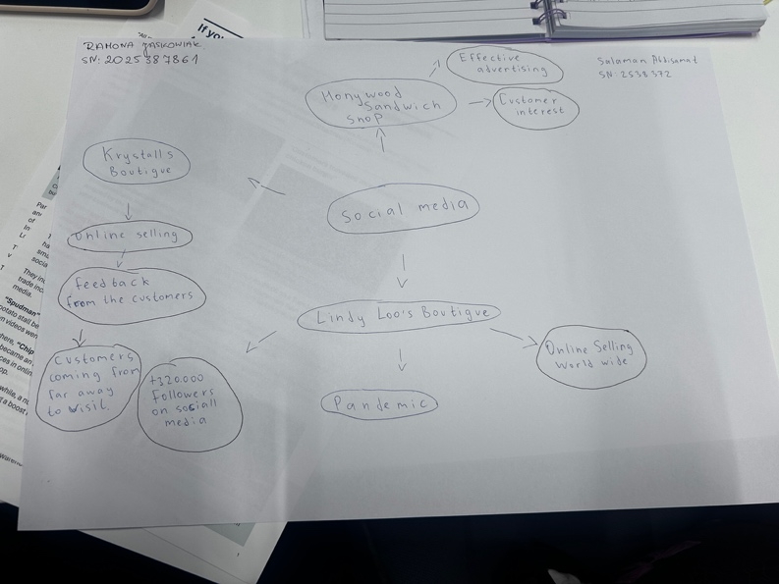

1. Answer these questions using the sentence starters below
a. What is the main idea of the text?
The main idea is that social media helps boost a small business popularity.
b. What are two key points?
One key point is its content posted by its customers that has boosted its bottom line.
Another key point is according to the governments business worldwide are using instagram to reach customers.
c. What part of the text did you find most important? Why?
The most important part is showing how social media can change the popularity of businesses.
d. Was anything unclear or difficult to understand?
I was not sure about the text as I have difficulties speaking English but it has gotten better.
e. How did your group help you understand the text better?
My group helped me by understanding the text and the main point.
3. One sentence reflection
Question: What did you find challenging about this task?
The hardest part was finding the key points.

