Ways of Perceiving – Nature v Nurture

When asked to create a gallery exhibition, I decided to focus on the debate of ‘nature v nurture and how they challenge each other today. The exhibition will have included work from multiple mediums including Art, Photography, Installation and Poetry to enhance societies a posing view on the topic in question. The work featured in the exhibition includes a series of composite portraiture images by philosopher Francis Galton and an installation by the London Team lab that looks at humanities relationship and interaction with the natural world. Within the exhibition I decided to place great attention on a poem by Gary Davidson that focus a lot on nature and nurture through human genes and their experiences in the world. I also decided to concentrate on a piece of Art by Matt Collishaw that challenges the intricate controversy between the origin and evolution of the world. Finally, I felt that an image by photographer Maria Konstanse Bruun that looks at “self” and the connection of “self” would work well with my topic nature and nurture.

I decided on the theme of Nature v Nurture as I found the social outlook on the topic fascinating due to its many different viewpoints. This topic has sparked up debates not only in science, but culture and philosophy. Nature v Nurture is the question of whether human behaviour, personality and culture Is determined by a person’s genes and who their family are (nature) or determined by life experiences and situations (nurture). “The real issue isn’t the nature versus nurture, but how nature and nurture interplay to produce the diversities and uniformities of human nature” (Caton, 2005), Carlton is suggesting that it’s not one or the other, but both combined that makes us who we are as people genetically. I agree with his statement as I think both oppositions have an impact and shape us as people, physically and mentally they shape us into who we are.

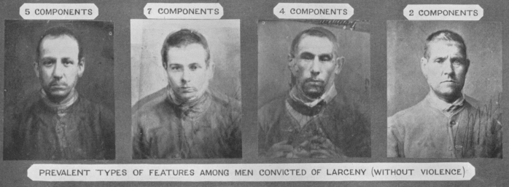

For my exhibition, I’ve chosen artists that look at the theme through different perspectives and express it with their own individual style.
Firstly, I have chosen Francis Galton’s composite portraiture as he was very much more on the side of nature and thought that the DNA and genotype that you are born with determined who you would be as a person. “Galton was convinced that intellectual ability was largely inherited and that the tendency for “genius” to run in families was the outcome of a natural superiority” (McLeod, 2018) To try and prove this, he spent many years making composite portraiture of people with similar character traits such as a ‘criminal’ and ‘Jewish’. I chose to include his portraiture of the criminal type in my exhibition as they are the portraiture that intrigued me the most, as they look at a character trait that is a personal choice. In my opinion, no one is technically born a criminal, but you can be born into a certain religion for example. I will display multiple images from his composite portraiture as a collage on one of the gallery walls.

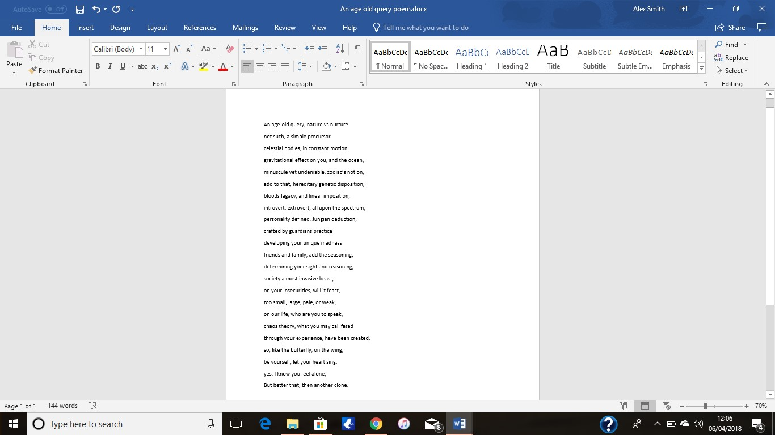

Following this, I included a poem by Gary Davison. The poem will be blown up to A1 size and placed on the far back wall of the gallery, I chose this poem as he represented nature and nurture in an obvious yet beautifully descriptive way. He shined both sides of the argument and used them against each other to depict the different sides to humanity, as though our experiences in the natural world combined with our genetics both make up what we are as humans, making us all individually unique.

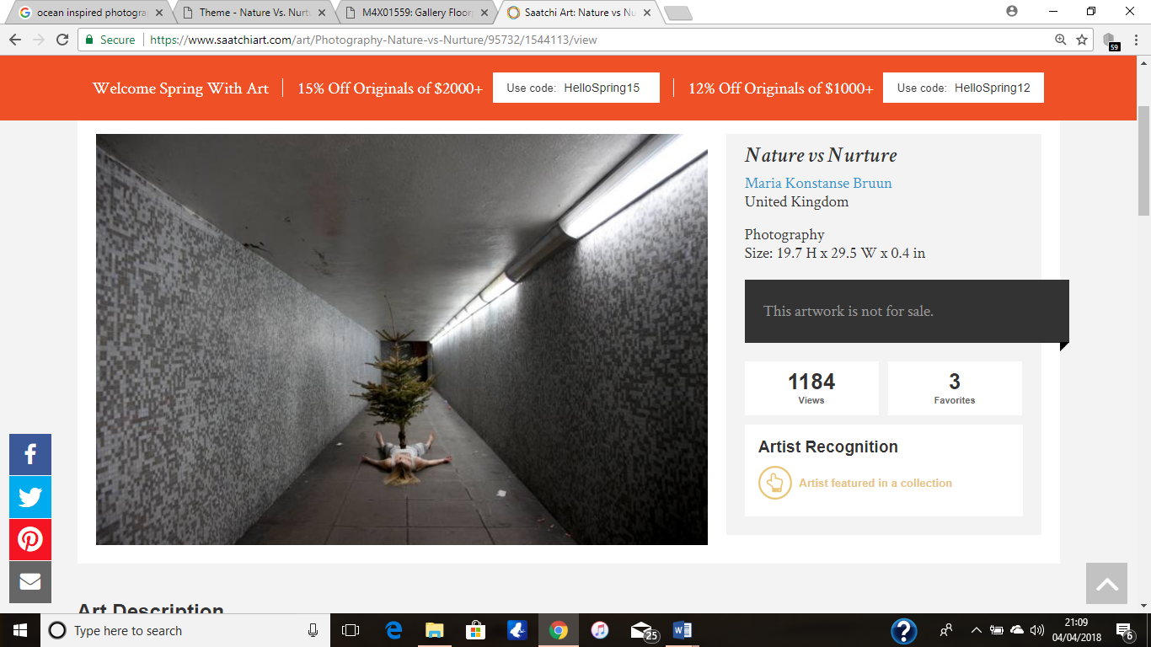

Maria Konstanse Bruun’s psychological approach to nature v nurture in this image fascinated me. Through her way of challenging a person’s sense of self, she is trying to express that we as humans are made up of what beliefs and attributes we have. Brunn suggests that we are initially what we think we are in our heads. For me, this questions how our ever-changing world and the circumstances in and around us are shaping us and making us grow as people. Brunn has represented this through a tree growing from the body referring to the environmental world subconsciously becoming part of our DNA as we adapt to our surroundings. She has created a narrative between self and the natural world combining us together as one.

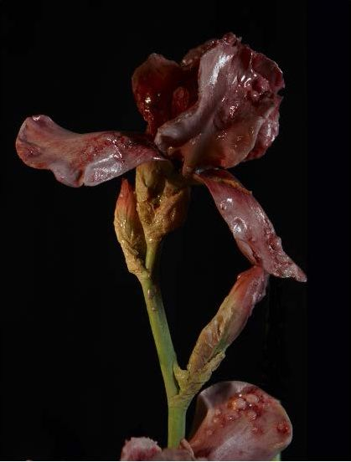

Venal muse by Matt Collishaw was heavily inspired by French poet Baudelaire's ‘Les Fleurs du Mal’ which is a book that touches upon themes of decadence and eroticism through poetry, due to the flowers flesh like appearance it makes a strong connection between human nature and environmental nurture. “They are reflections on the depraved state of modern, media-saturated culture and the spectra of genetic manipulation” (Matcollishaw.com, 2018) This piece looks at how our surroundings and the natural world have suffered changes and damages that humans have forced upon it through science. It’s elegant yet dark look catches the observer’s attention while bringing awareness, the way human flesh is shaped as a flower expresses not only the power we have over nature but the power that nature has over us. This image Is perfect for my exhibition, for its ability to draw the viewer in and think about the topic in question but in an intriguingly elegant way.
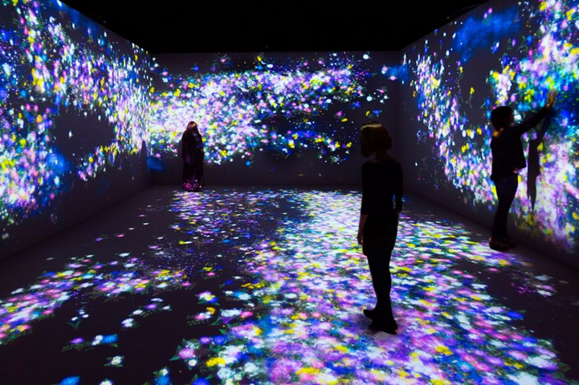

Finally, I will feature an installation by the “London technologist collective team Lab”. This will be displayed in a room of its own as I want it to be a statement piece of the exhibition, The work itself expresses humanity’s sensitive relationship with nature as a whole.
My chosen piece creates a digital eco-system consisting of flowers and butterflies, and how the actions of one’s self affect within the seasonal cycles in nature, by making certain physical movements or just by standing still. Visitors of the piece can create stands within the natural flow making new patterns. This is so they are 100% unique and can never be replicated, linking it within our own individual experiences as humans that cannot be replicated by anyone and how we play big roles in the survival of each other’s lives. As Alex Jordan describes: ‘the boundary between nature’s work and the work of humans was unclear. In other words, nature and humans are not antagonistic concepts, but rather, a pleasant nature is an eco-system that also includes the work of humans’ (Jordan, 2018) This piece allows you to engage not only physically but mentally also. My favorite part of this piece is that it makes you think of the disturbances not only we cause on the world, but it equally causes on us.

I've included a labelled diagram of my gallery exhibition and the layout of the work, i did this to give a more visual viewing so you don't have to picture it in your head it makes the exhibit seem more alive.
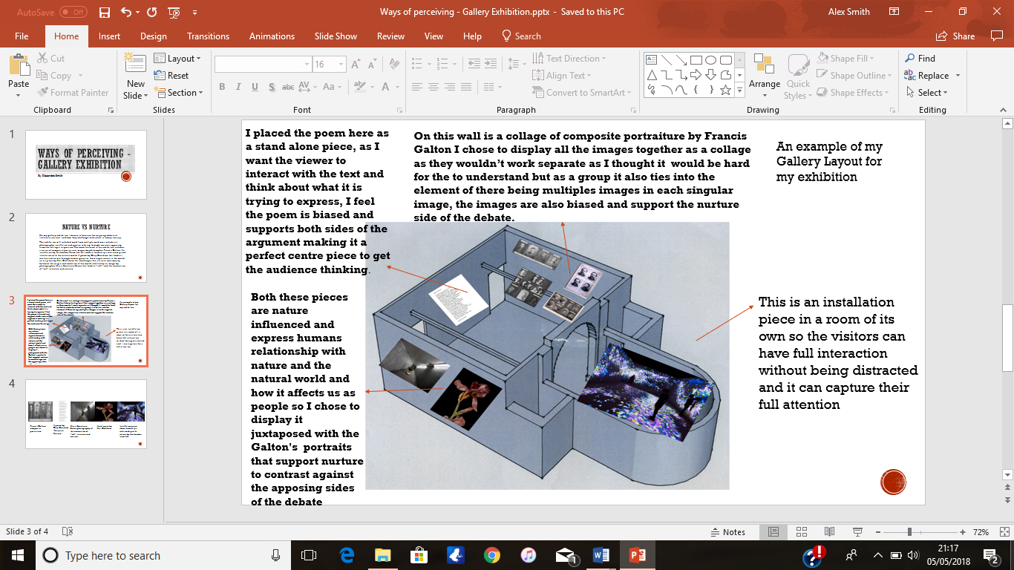

Bibliography
Carlton, H. (2005). Nature via Nurture: Genes, Experience, and What Makes Us Human Matt Ridley (2003). New York: HarperCollins. 328pp, Twin Research and Human Genetics, 8(06), pp.664-666. (Accessed 6 Apr.2018)

Jordan, A. (2018). Nature versus nurture. [online] Nature versus nurture | LS:N Global. Available at: https://www.lsnglobal.com/news/article/18156/nature-versus-nurture [Accessed 7 Apr. 2018].

McLeod, S. (2018). Nature Nurture in Psychology | Simply Psychology. [online] Simplypsychology.org. https://www.simplypsychology.org/naturevsnurture.html [Accessed 6 Apr. 2018].

Matcollishaw.com. (2018). The Venal Muse · Mat Collishaw. [online] https://matcollishaw.com/works/the-venal-muse/ [Accessed 6 Apr. 2018].

