
Application of automation in wastewater treatment


April 4, 2025
University of Wales Trinity Saint David

Control & Automation
ACMA5001
2117931
AI Acknowledgement

I confirm that I have not used any AI tools in the research and creation of this assignment. I confirm that I have not presented any AI generated materials as my own work.

Executive Summary/Abstract
The purpose of this report is to investigate the use of Instrumentation, Control and Automation (ICA). ICA is widely used in wastewater treatment for many reasons and in a wide variety of roles. A wastewater treatment facility requires persistent monitoring, the process involved in the treatment of wastewater is highly important to ensure it is handled and treated safely. This is for the purpose of human safety but also the safety of the natural environment and ecosystems.
In this report ICA technology would be investigated in the wastewater treatment process. Initially research into the background of wastewater treatment was carried out, this dates back many years and many cities had drainage systems in place however did not have any treatment facilities. Not having these wastewater treatment facilities caused illness and unpleasant living conditions with one event being named ‘The great stink of London’. As years passed wastewater treatment improved, from wastewater flowing into the natural watercourses, technologies improved so that it could be broken down and treated, where as these days wastewater treatment facilities use a combination of different process to treat wastewater to ensure it is not only safe for humans but it is also safe for the natural resources and ecosystems.
A investigation into some of the equipment used in the treatment process was carried out, control systems for the treatment of wastewater has grown in complexity and the application has increased. With the technology advancement, certain technologies are becoming cheaper, require less power and space, so are being implemented into a system. A look into sensors was carried out, there being numerous different varieties of sensors, for different applications and monitoring purposes. Actuators and what role they play in the wastewater treatment process was investigated, actuators monitor and receive signals and then convert these signals into mechanical motion. Process controllers were also investigated these form part of an automated system and can regulate the flow in the system or control the treatment of chemicals.
Regulations and standards of the wastewater treatment industry was researched and a look into the future technology advancement that the wastewater treatment industry could be seeing in years to come. One of the advancements being the use of AI technology. This technology could be used in several applications in the industry including real time monitoring, helping companies with the data produced by the treatment plant. It could also be used as a maintenance tool, for performing a health check of the system, or for training purposes, to train workers in the use of equipment at the plant which would give efficient and effective training.

Table of Contents
1 Table Of Figures 5
2 Introduction 6
2.1 Background 6
2.2 Purpose Of This Report 6
3 Literature Review and Research 7
3.1 How ICA Technology Was Adopted From A Historical Context. 7
3.2 Sensors 7
3.3 Process Controllers 10
3.4 Actuators 11
3.5 Regulations And Standards 12
3.6 Advanced Technology 13
4 Discussion 14
5 Conclusion 15
6 References 16
7 Bibliography 18

Table Of Figures

Figure 1 pH Sensors (Archer, 2021) 8
Figure 2 ABM's Non-Contact Radar Level Sensors (ABM, ND) 9
Figure 3 ABM's Non-Contact Radar Level Sensors (ABM, ND) 9
Figure 4 Explosion Proof Radar Level Sensor R-EXP (ABM,ND) 10
Figure 5 NanoTron Dual Timer Controller -F2 (Cannon Water Technologies inc, ND). 10
Figure 6 Group 42 Linear Actuators - Model 42-109 (BECK Electric Actuators, ND) 11

Introduction

This report will investigate the application of automation in wastewater treatment. Initially background research of wastewater treatment carried out and then specifically the application of Instrumentation, Control and Automation (ICA) to wastewater treatment. Exploration into various parts of automation, such as sensors, process controllers, and actuators. Regulations and standards that need to be adhered to will be examined and some of the recent advances in technology that is being applied to this industry.

Background

The history of wastewater dates back many years, and many ancient cities had drainage systems but mainly to carry rainwater away from roofs and pavements ( Nathanson.J, Ambukkar.A, 2025). According to (Association of Directors of Public Health, 2023) initially in the 1800s there was an unwillingness to develop proper sanitation systems. However following an outbreak of Typhus in 1838, this sparked for the development of a drainage system, as an enquiry highlighted a link between poor sanitation and the spread of disease. In 1858 ‘The Great Stink of London’ happened. Hot temperatures from the summer months caused an unbearable stench from the open sewer system The River Thames, from this it was realised the development of a modern sewage system was required (Association of Directors of Public Health, 2023). Sewage has links to transmission of infectious diseases and John Snow’s work in 1854 linking the Cholera epidemic to contaminated water showed this (Association of Directors of Public Health, 2023). In Liverpool in 1848 the development of a sewage system first began, and upon completion, the life expectancy in the city which had been 19 more than doubled (Association of Directors of Public Health, 2023).

Purpose Of This Report

The purpose of this report is to investigate the application of ICA to waste water treatment and how technology was adopted. Research into sensors, process controllers and actuators and the autonomously of wastewater treatment and recent advanced technology being applied to this industry.

Literature Review and Research

How ICA Technology Was Adopted From A Historical Context.

Wastewater treatment has moved on from many years of development, early days wastewater was allowed to flow in natural watercourses, rivers, lakes, oceans (Niv, 2022). This progressed to removing solid waste from sewage. The 20th century then saw technologies that could remove bacteria and other harmful contaminants. The advancement of activated sludge process in the 1930s used bacteria to break down organic matter. Nowadays wastewater treatment plants use a combination of physical, chemical, biological processes to remove a wide range of pollutants from sewage. Aswell as protecting human health wastewater treatment plants also protect natural resources and ecosystems with plants that use a combination of processes (Niv, 2022).
Part of the treatment process uses control systems. Control systems are interconnections of elements and devices for a desired purpose (Dorf. R, Bishop. R, 2022, p.30). The application of control systems has grown in number and complexity due to computer systems becoming cheaper, and requiring less power and space. Sensors and actuators have also experienced similar advancement to more capability in smaller packages (Dorf. R , Bishop. R, 2022, p.30).
The implementation of control systems is becoming more automated, with more resources readily available, and access to moderately inexpensive computers, sensors and actuators. (Dorf. R , Bishop. R, 2022, p.30). Automation involves the use of technology to control and monitor processes without much human interaction and can be used in a variety of different areas when it comes to sewage treatment (PARAS Hydrotech, ND).

Sensors

According to (Dorf. R , Bishop. R, 2022, p.30) a sensor is a device that provides a measurement of a desired external signal. (PARAS Hydrotech, ND) indicates that sensors can gather real time information about plant operations allowing decisions to be based off data gathered. Sensors help data collection and analysis. At a water treatment plant there are many types of sensors, and just one sensor would not be adequate to monitor water quality (Nagda, ND). (Archer, 2021) states that sensors are key because they give plant operators data on the core variables.
Some of the sensors that may be used are:
Conductivity Sensors- these monitor the conductivity of water, the higher the conductivity the poorer the water quality (Nagda, ND).
pH sensors – measure the pH of the water, quality water requires a controlled level of pH, valves are installed in the systems to redirect water if the pH levels changes to an alarming level. (Nagda, ND).
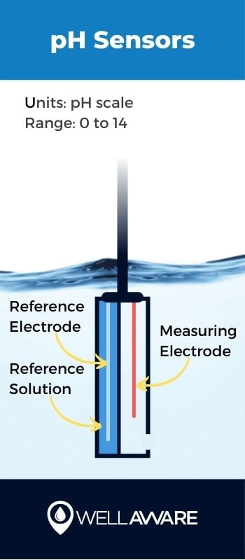
Figure 1 pH Sensors (Archer, 2021)

ORP sensors – oxidation reduction potential - the ability of water to reduce other chemical substances, low OPR can mean high chances of contaminated bacteria developing (Nagda, ND).
Turbidity Sensors- scatter light through water to see if there are any particles present. It is the visual properties of water. Clean water has less or nil amount of particles. (Nagda, ND).
Dissolved Oxygen sensors- measuring the amount of oxygen in the water (Nagda, ND).
Figure 2,3,4 show a radar level sensor which proved to be helpful in resolving challenges at a wastewater treatment plant according to (ABM, ND).

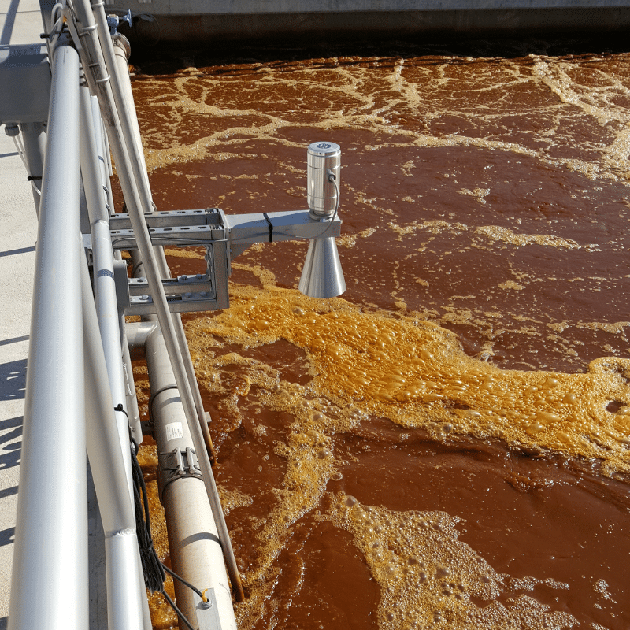
Figure 2 ABM's Non-Contact Radar Level Sensors (ABM, ND)
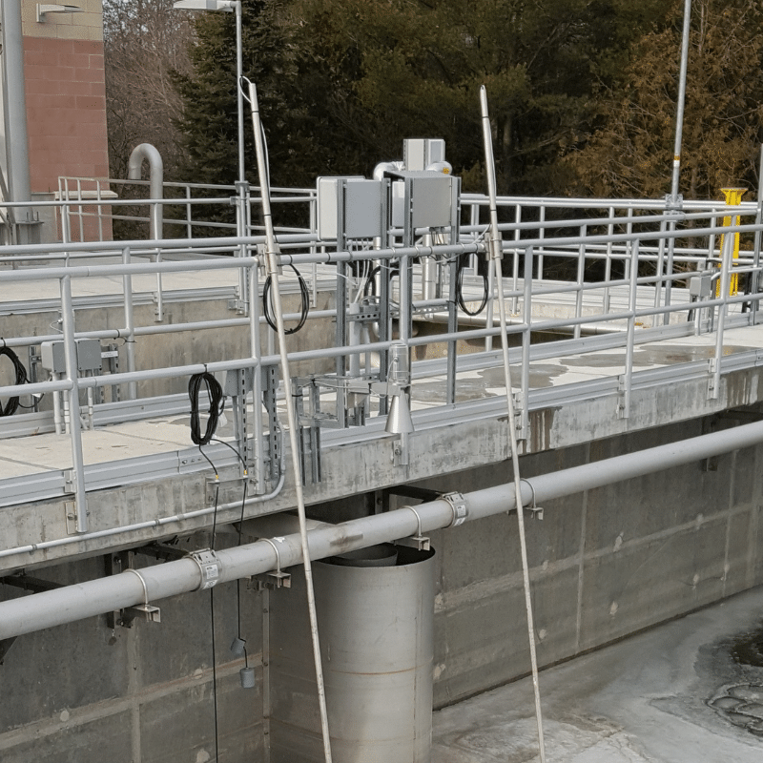

Figure 3 ABM's Non-Contact Radar Level Sensors (ABM, ND)

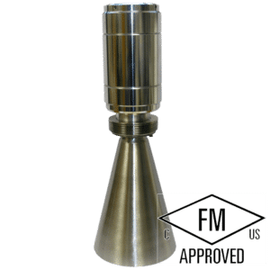
Figure 4 Explosion Proof Radar Level Sensor R-EXP (ABM,ND)

Process Controllers

Process controllers can be defined as automated systems. These automated systems can be used to carry out many different tasks, in wastewater treatment these automated systems can consist of regulating the flow of wastewater, controlling the treatment of chemicals and monitoring the performance of the treatment being performed (PARAS Hydrotech, ND). This summary of process controllers is similar to (Black. P , 2019) description a process controller suggesting that process controllers are used to automatically control the environment when a product is created. This ensures improved quality and efficiency of the system (Black. P , 2019).
The use of process controllers can help monitor a system and is important to the efficiency of a water treatment process (Cannon Water Technologies inc, ND). Monitoring keeps various parts of the process under control.
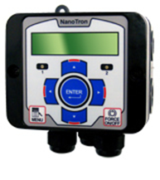
Figure 5 NanoTron Dual Timer Controller -F2 (Cannon Water Technologies inc, ND).
Figure 5 is an Advantage Controls NanoTron Dual Timer Controller-F2 . This NanoTron controller has the ability to adapt to a variety of applications and its dual selectable timers are constructed to automate the addition of various chemicals or activate other devices with a relay output (Cannon Water Technologies inc, ND).
Part of an automated system may be made up of alarms, which can detect abnormal conditions. Timers can be used to control timings of events, such as activating pumps or dosing systems (PARAS Hydrotech, ND).

Actuators

According to (Dorf. R , Bishop. R, 2022) P.30 an actuator is a device used by the control system to adjust or change the environment. The use of actuators has played an important role in the wastewater treatment industry. They have been used in various areas, some of which include water treatment plants, pumping stations and sewage works. Actuators make up part of a control system, and are connected to consoles which monitor the system. When an actuator receives a signal from the system it converts the signal into mechanical motion. Actuators consist of a motor which drives a worm gearbox, providing the torque needed to move a valve. Actuators convert a signal into a rotary or linear movement, this movement can be used to open or close a valve or change the direction of flow to the requirement of the system. Electronic actuators can use their own intellect to control valves (Sully. I, 2008). As actuators are an important part of the running of wastewater treatment plants, its important that they are reliable, and breakdowns and maintenance are minimal so it is important to have an actuator with the correct motor and gear train. Beck actuators are designed around a magnet synchronous motor that will not over overheat or burn out. With more reliable equipment this has the positive effect of less maintenance required (WaterWorld, 2019).
(Sully. I, 2008) expresses that actuators play an important part in the wastewater treatment industry while (Proactuator,2023) suggests that electric actuators are the most commonly used type in water management systems, they can be controlled remotely and can be automated, making them suitable for water management systems. Whilst (Shoaib.S , 2022) indicates that the wastewater industry is actuator-intensive and equipment used to control flow is frequently used on wastewater sites.
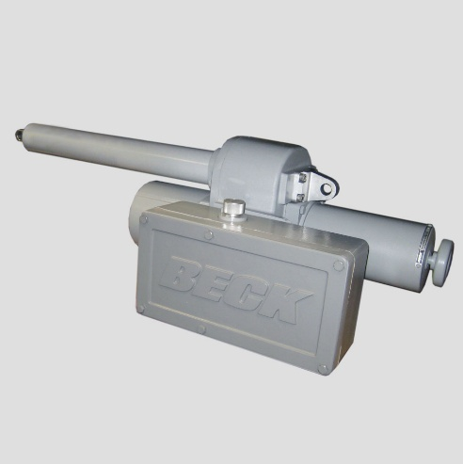
Figure 6 Group 42 Linear Actuators - Model 42-109 (BECK Electric Actuators, ND)

Figure 6 shows a BECK electric actuator, the Group 42 modulating drives are equipped with a control module, that controls the position of the drive according to the input signal (BECK Electric Actuators, ND).

Regulations And Standards

There are many regulations and standards when it comes to wastewater treatment, (Water For Life From Southern Water, ND) states that legislation for the standard of wastewater treatment is found in the EC Urban Wastewater Treatment Directive. This directive is the minimum standards that must be applied. As a minimum a secondary biological treatment process is required for all wastewater treatment, (Water For Life From Southern Water, ND).
Some of the regulations consist of the below
Environmental permitting regulations – companies handling wastewater require permits outlining conditions for discharge and treatment (Gold Lawyers, ND).
Water Industry Act 1991- Provides legal framework for the water industry in the UK. These include wastewater collection, treatment and disposal (Gold Lawyers, ND).
Environmental Protection Act 1990 – sets out responsibilities for businesses and individuals managing and disposing of waste, and wastewater (Gold Lawyers, ND).

In each country of the UK different agencies implement the legislation of wastewater.
England – The environment agency
Wales – Natural Resources Wales
Scotland – The Scottish environment protection agency
Northen Ireland – The Northern Ireland Environment agency
(TRICEL, Generations Of Innovation, ND)

(©Crown Copyright, 2002) also states that to ensure protection of the environment The Environment Agency, the Scottish Environment Protection Agency and the Environment and Heritage Service of the Department of the Environment for Northern Ireland are the environmental regulators of the water industry for the UK. They regulate discharges from wastewater treatment works and combined sewer overflows.

Advanced Technology

One of the advancements in technologies in this sector has come from Onunda. Onunda is a sustainable wastewater management solution, that removes land waste, microplastics and chemicals from wastewater. HTC (Hydrothermal carbonization), drying and gasification processes are used to maximise the extraction of value from sewage, and prevent discharge of pollutants back into the environment (Onunda, 2024).
The use of AI (Artificial Intelligence) could be used in the wastewater treatment processes which could be an advancement of technology in the industry, it is still in early stages however but has the potential to develop.
One of the ways it may advance is through real-time process monitoring, as periodic monitoring can be ineffective in fast paced environments. It could help companies make sense of the date produced by their treatment plant.
AI could be used as a predictive approach to maintenance by performing a remote health check of the system. This would replace an engineer visiting in person, saving time, reducing emissions and allowing the engineer to support those who require help more urgently. The use of AI could also be used for training purposes, by using AI with virtual reality, workforces can be trained efficiently and effectively, learning how their wastewater treatment plant works and what to do in an emergency. Repair tasks could also be learnt. AI can also be used to gather data from various plants and improve wastewater treatment understanding and help develop new technologies over time (Richard,2023).

Discussion

From earlier findings of the history of wastewater treatment, the advancement in processes and technology has changed the outlook on wastewater treatment for the better. From there being illness in the past to now not only improving water treatment for public health but also for natural surroundings and ecosystems. The use of technology now monitors systems continuously and allows for it to be done autonomously. Some of the benefits of an automated system could come in the form of
Strengths-
Continuous monitoring
Efficiency
Accuracy
Instant response to signals
Less labour intensive with automation
Disadvantages-
Initial cost to purchase equipment
Initial setup of equipment
Still require someone to monitor system
Maintenance cost of routine works or breakdowns
Although there are advantages and disadvantages to technology. Technology in this use seems to and hopefully continues to improve the wastewater treatment process.

Conclusion

The purpose of this report was to investigate the Application of ICA to wastewater treatment and how technology was adopted. Initially the history of wastewater treatment was investigated and found that over many years wastewater treatment has developed from the origins of it flowing into natural watercourses, river lakes and oceans, to removing solid waste, with the progression of removing bacteria and harmful contaminants. Current methods using a combination of processes to remove a wide range of pollutants which not only protect human health but also protect natural resources and ecosystems.
Investigation was done on how sites use control systems, these control systems are now becoming more automated due to several factors, such as there are more resources available, computers, sensors and actuators are becoming relatively cheaper and require less power and space, they can control and monitor processes without much human interaction, and so potentially making a process system more efficient. Process controllers in these automated systems can control the flow of wastewater and control the treatment of chemicals. Research into sensors was carried out and found there was many different sensors that could be used in the wastewater treatment facility as sensors can gather real time information about plant operations and with so many different types, they can be used for a variety of monitoring activities. Actuators also play a part in wastewater treatment, again being used in a variety of areas and make up part of the control system. When a signal is received it can turn a signal into mechanical motion. The advanced technology for the future of wastewater treatment could be the use of AI technology, it could be used for real time monitoring, analysing data produced and could be used as a predictive approach to maintenance and be used for training purposes.

References

ABM, (ND) ‘Case Study: Wastewater Level Monitoring’ Available at: https://abmsensor.com/case-study-wastewater-level-monitoring/ Accessed on 15/4/2025
Archer, C (2021) ‘How to measure water quality in wastewater treatment plant controls’ Available at: https://blog.wellaware.us/blog/how-to-measure-water-quality-in-wastewater-treatment-plant-controls Accessed on: 13/4/2025
Association of Directors of Public Health, (2023) ‘The history of decontaminating our water’ Available at: https://www.adph.org.uk/resources/the-history-of-decontaminating-our-water/ Accessed on: 13/4/2025
BECK Electric Actuators, (ND) ‘GROUP 42 LINEAR ACTUATORS MODEL 42-109’ Available at: https://haroldbeck.com/products/model-42-109/?_gl=1*6mish9*_gcl_au*MTk4OTM3OTA2OC4xNzQ0NzI4MTEy*_ga*MTQzMTY0NTIwOS4xNzQ0NzI4MTEy*_ga_J6N7XVLENX*MTc0NDcyODExMi4xLjEuMTc0NDcyODI2Ny4wLjAuMA..*_ga_98QK8SSB4J*MTc0NDcyODExMi4xLjEuMTc0NDcyODI2Ny4wLjAuMA.. Accessed on: 15/4/2025
Black. P , (2019) ‘Process Control – Everything You Need To Know’ Available at: https://www.processindustryinformer.com/process-control-everything-you-need-to-know/ Accessed on: 15/4/2025
Cannon Water Technologies inc, (ND) ‘Water Treatment Controllers’ Available at: https://cannonwater.com/water-treatment-equipment/water-treatment-controllers/ Accessed on: 15/4/2025
©Crown Copyright, (2002) ‘Sewage Treatment in the UK UK Implementation of the EC Urban Waste Water Treatment Directive’ Published by the Department for Environment, Food and Rural Affairs. Printed in the UK, March 2002 Available at: https://assets.publishing.service.gov.uk/government/uploads/system/uploads/attachment_data/file/69582/pb6655-uk-sewage-treatment-020424.pdf Accessed on: 15/4/2025
Dorf. R , Bishop. R, (2022) ‘Modern Control Systems’ Fourteenth edition Pearson education limited Harlow United Kingdom P.30
Gold Lawyers, (ND) ‘Legislation for Wastewater in the UK: Key Regulations and Requirements’ Available at: https://abogadosgold.com/ordinance/what-is-the-legislation-for-wastewater-in-the-uk/ Accessed on: 15/4/2025
Nagda, (ND) ‘Various Types of Sensors used in Water Treatment Plant’ Available at: https://instrumentationtools.com/various-types-of-sensors-used-in-water-treatment-plant/ Accessed on: 13/4/2025
Nathanson. J, Ambukkar. A, (2025) ‘wastewater treatment’ Available at: https://www.britannica.com/technology/wastewater-treatment Accessed on:13/4/2025
Niv, (2022) ‘A Brief History Of Wastewater Treatment and How It Changed’ Available at: https://aguateam.com/history-wastewater-treatment/ Accessed on: 13/4/2025
Onunda, (2024) ‘How does the Onunda technology work?’ Available at: https://onunda.com/newsroom/how-does-the-onunda-technology-work#:~:text=Onunda%20is%20a%20sustainable%20wastewater%20management%20solution%20that,sustainable%20source%20of%20clean%20energy%20and%20nutrient-rich%20fertiliser. Accessed on: 15/4/2025
PARAS Hydrotech, (ND) ‘Automation in Sewage Treatment Plants: A Step Towards Efficiency and Reliability’ Available at: https://parashydrotech.com/blog-post/automation-in-sewage-treatment-plants-a-step-towards-efficiency-and-reliability/ Accessed on: 13/4/2025
Proactuator,(2023) ‘The Power of Actuators in Water Management: A Comprehensive Guide’ Available at: https://www.proactuator.com/the-power-of-actuators-in-water-management-a-comprehensive-guide/ Accessed on: 15/4/2025
Richard, (2023) ‘How AI is Revolutionising Industrial Wastewater Treatment’ Available at: https://latwater.com/how-ai-is-revolutionising-industrial-wastewater-treatment/ Accessed on: 15/4/2025
Shoaib.S , (2022) ‘Valve Automation in Wastewater Applications, How actuators play a role in stages of flow control.’ Available at: https://www.pumpsandsystems.com/valve-automation-wastewater-applications Accessed on: 15/4/2025
Sully. I, (2008) ‘Actuators’ Essential Role in the Water Industry’ Available at: https://www.waterworld.com/wastewater-treatment/article/16202394/actuators-essential-role-in-the-water-industry Accessed on: 15/4/2025
WaterWorld, (2019) ‘Extending the Actuator Life Cycle’ Available at: https://www.waterworld.com/wastewater-treatment/article/14039791/extending-the-actuator-life-cycle Accessed on: 15/4/2025

TRICEL, Generations Of Innovation, (ND) ‘Wastewater Legislation In The UK’ Available at: https://tricel.co.uk/sewage-treatment/wastewater-legislation/ Accessed on: 15/4/2025
Water For Life From Southern Water, (ND) ‘Environmental Regulations’ Available at: https://www.southernwater.co.uk/about-us/environmental-performance/protecting-and-improving-our-environment/environmental-regulations/#:~:text=Legislation%20for%20the%20standard%20of%20wastewater%20treatment%20is,secondary%20%E2%80%9Cbiological%E2%80%9D%20treatment%20process%20for%20all%20wastewater%20treatment. Accessed on: 15/4/2025

Bibliography

Nise, Norman S. (2019) ‘Control Systems Engineering’ Eighth edition. Hoboken, NJ : Wiley

