Distributed Intelligence Systems
A Simple Token Based Distributed Network
Ethan Reynolds
2406303

B.Eng. (Hons) in Electrical and Electronic Engineering
Level 5
University of Wales Trinity Saint David, Swansea
01/05/2025

Table Of Contents
1. Research 4
1.1. Point-to-Point Transmission System 4
1.1.1. Real-World Application: 4
1.1.2. Advantages: 4
1.1.3. Disadvantages: 4
1.2. Point-To-Multipoint Transmission System 5
1.2.1. Real-World Application: 5
1.2.2. Advantages 5
1.2.3. Disadvantages 6
1.3. Multi-Master Transmission System 6
1.3.1. Real-World Application 6
1.3.2. Advantages: 6
1.3.3. Disadvantages: 7
1.4. Research Findings 8
2. Design 9
2.1. Microcontroller Selection 9
2.2. Communication Architecture 9
2.3. Lighting Implementation 10
2.4. Proteus Schematic 10
2.5. Design Considerations 10
3. Development 11
3.1. Master Microcontroller Program 12
3.2. Slave Microcontroller Program 15
3.3. Code Structure and Documentation 15
3.4. Integration and Testing in Proteus 16
4. Analysis 19
4.1. Program Operation and Interaction 19
4.2. Operational Flow Chart 20
4.3. Quality and Safety Considerations 20
5. Conclusion 20
References 21

Table Of Figures
Figure 1 - A Point-To-Point Transmission System [21] 4
Figure 2 - A Point-To-Multipoint Transmission System [21] 6
Figure 3 - Multi-Master Transmission System [22] 7
Figure 4 - System Comparison Table 8
Figure 5 - Proteus Full Circuit Design 9
Figure 6 - Master PIC Code Lines 1-50 12
Figure 7 - Master PIC Code Lines 51-100 13
Figure 8 - Master PIC Code Lines 101-115 14
Figure 9 - Slave PIC Lines 1-26 15
Figure 10 - Brake Light LED Active 16
Figure 11 - Fog Light LED Active 17
Figure 12 - Indicator Light LED Active 17
Figure 13 - Reverse Light LED Active 18
Figure 14 - Fog and Reverse Light LEDs Active 18
Figure 15 - All Lights LEDs Active 19
Figure 16 - Operational Flowchart 20

Research

Point-to-Point Transmission System
A point-to-point transmission system creates a direct link between just two devices, usually a transmitter and a receiver. This setup dedicates the entire communication channel to those two nodes, which helps achieve fast and reliable data transfer without interference from other devices [1].
Because of its simplicity, point-to-point communication makes network design and troubleshooting much easier, as each message travels over a known and predictable path [2]. In automotive systems, for example, it is often used to connect a microcontroller directly to an actuator or sensor where dependable, real-time communication is essential [3].
However, while this method is highly effective for small setups, it becomes less practical as more devices are added. Managing multiple direct links can quickly increase system complexity and cost.
While point-to-point systems are ideal for simple setups, larger and more complex systems often require more scalable solutions such as point-to-multipoint communication.

Real-World Application:
Point-to-point systems are often found in anti-lock braking systems (ABS), where an electronic control unit (ECU) communicates directly with individual wheel speed sensors [4].

Advantages:
- High reliability and low latency due to a dedicated communication link [1].
- Simple system architecture, making troubleshooting and maintenance straightforward [2].
- Predictable timing and minimal interference from other network traffic [3].
- Minimal protocol overhead, conserving microcontroller resources [5].

Disadvantages:
- Poor scalability as adding more devices requires new dedicated links [4].
- Increased cabling complexity, leading to higher installation costs [1].
- Difficulties in implementing redundancy without significantly increasing wiring [6].
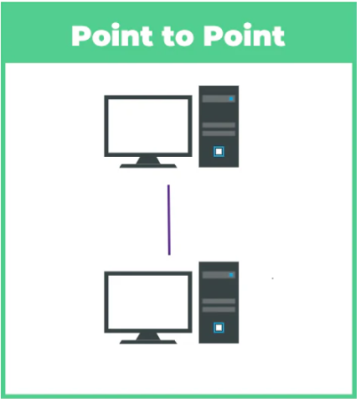
Figure 1 - A Point-To-Point Transmission System [21]

Point-To-Multipoint Transmission System
A point-to-multipoint transmission system connects one transmitter to several receivers over a shared communication medium. In such systems, the transmitter can address individual receivers directly or send broadcast messages that all devices can process [5].
This configuration is commonly used when a single controller needs to manage several components, such as operating a vehicle's rear lights from a central control unit.
Point-to-multipoint systems significantly reduce wiring complexity and are scalable, allowing for easier expansion and lower system costs [7].
However, since many devices share the same communication channel, collision avoidance mechanisms such as addressing, token passing, or time-scheduled transmissions must be used to maintain reliable communication [8].

Real-World Application:
Modern automotive lighting systems often use a point-to-multipoint structure, where a control unit sends messages to multiple light modules (brake lights, indicators, fog lights) [9].

Advantages
- Reduced cabling requirements and material costs compared to point-to-point setups [5].
- Scalability allows easy addition of new devices with minimal infrastructure changes [7].
- Centralized control enhances system coordination and simplifies upgrades [9].
- Efficient use of the communication channel through structured addressing [8].

Disadvantages
- Risk of data collisions without careful communication management [5].
- Shared medium can cause communication congestion under high network load [6].
- Requires more complex addressing and timing strategies [8].
- Potential latency increases when multiple devices attempt simultaneous communication [7].
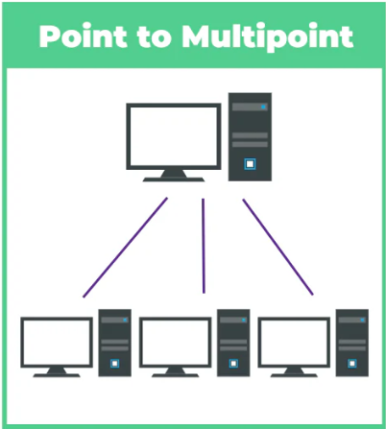
Figure 2 - A Point-To-Multipoint Transmission System [21]

Multi-Master Transmission System
A multi-master transmission system enables multiple devices within a network to initiate communication independently, without relying on a single controlling device [8].
Each node can function both as a sender and receiver, improving flexibility and enhancing system resilience [9]. Arbitration methods must be used to resolve conflicts when two or more devices attempt to send messages simultaneously [10].
One of the best-known examples is the Controller Area Network (CAN) bus, where multiple modules like braking, steering, and engine systems share information across the same communication bus [11].

Real-World Application
The CAN bus in vehicles enables engine management systems, transmission controls, and safety systems like airbags to communicate dynamically without a central master controller [11].

Advantages:
- High flexibility, allowing any node to initiate communication as needed [9].
- Increased fault tolerance with no central point of failure [11].
- Well-suited for complex and distributed systems, such as modern vehicle networks [10].
- Priority-based arbitration ensures critical messages are transmitted first, enhancing system safety [11].

Disadvantages:
- More complex protocol design and collision handling required [8].
- Higher system design and integration costs due to added complexity [9].
- Requires more powerful microcontrollers capable of managing bus arbitration [10].
- Minor transmission delays may occur in heavily loaded networks [11].
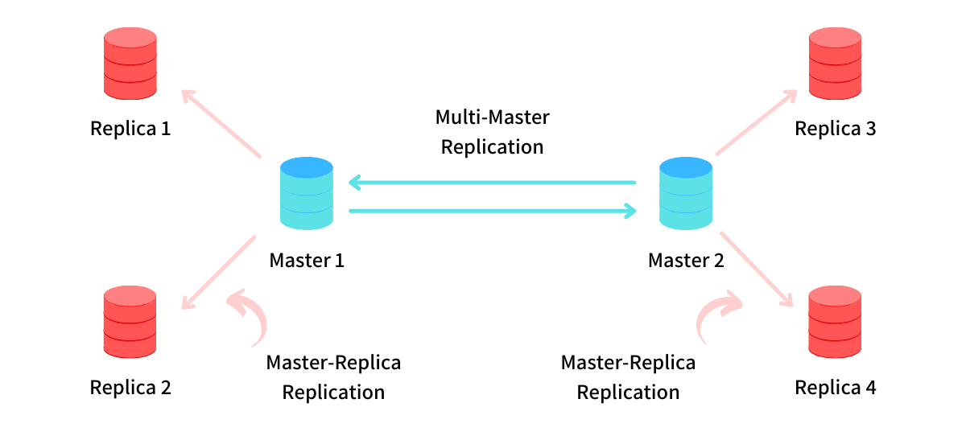
Figure 3 - Multi-Master Transmission System [22]

Transmission System | Real-World Example | Advantages | Disadvantages
Point-to-Point | ABS system communication between ECU and individual wheel sensors [4] | - High reliability and low latency [1]  - Simple troubleshooting and maintenance [2]  - Minimal interference [3]- Low protocol overhead [5] | - Poor scalability [4]  - High cabling and installation costs [1]  - Difficult redundancy without complex wiring [6]
Point-to-Multipoint | Central lighting control unit sending commands to multiple LED modules [9] | - Reduced wiring and material costs [5]  - Easy expansion and upgrades [7]  - Centralized control [9]  - Efficient communication with structured addressing [8] | - Risk of data collisions [5]  - Possible congestion under heavy load [6]  - Requires careful timing management [8]  - Latency risks with high traffic [7]
Multi-Master | CAN bus connecting ECU, transmission, and safety systems [11] | - Flexible communication between devices [9]  - No single point of failure [11]  - Supports complex distributed networks [10]  - Priority handling of critical messages [11] | - Complex design and arbitration required [8]  - Higher initial system cost [9]  - Requires more powerful microcontrollers [10]  - Small transmission delays possible [11]
Figure 4 - System Comparison Table

Research Findings
Understanding the characteristics, advantages, and limitations of point-to-point, point-to-multipoint, and multi-master transmission systems is critical when designing distributed microcontroller networks. Each approach offers specific benefits depending on system complexity, scalability needs, and reliability requirements. Selecting the appropriate communication structure at the design stage enables better system performance, futureproofing, and alignment with quality management and continuous improvement goals in engineering practice.

Design
This section outlines the selection, configuration, and rationale behind the design of a multi-processor microcontroller system developed using Proteus. The system was constructed to simulate a distributed control network for vehicle rear lighting, utilizing a master-slave configuration based on UART communication. The complete system design is presented below, as shown in Figure 5.
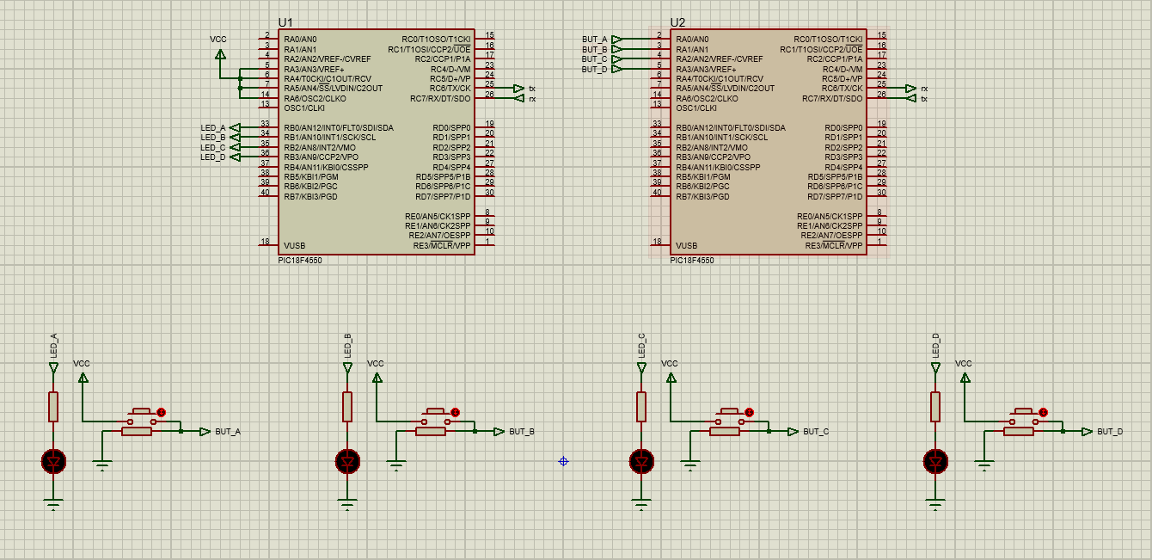
Figure 5 - Proteus Full Circuit Design

Microcontroller Selection
The PIC18F4550 was selected for both the master and slave units due to its availability in the Proteus component library, built-in UART support, and sufficient digital I/O pins for managing both inputs and outputs. The decision to use the same device on both ends allows for code reusability and consistent hardware behavior, reducing design complexity during development and testing.
The master microcontroller is configured to read four user input buttons representing driver-triggered actions. These inputs are encoded and transmitted via UART to the slave device, which decodes the received command and activates the appropriate lighting function. The use of PIC18 devices supports low-power operation, stable clock control, and accurate timing, making them suitable for real-time vehicle control systems [12].

Communication Architecture
A point-to-point UART communication channel was established between the two microcontrollers, forming a unidirectional command path from the master to the slave. This structure simplifies data transmission and eliminates the need for addressing logic, making it well suited to a simple vehicle lighting controller.
Token-based logic was implemented to simulate basic communication. Each button press triggers a unique token (for example, 'A', 'B', 'C', or 'D'), which the master transmits over the UART line. The slave continuously monitors its UART receive pin, interprets the token, and activates the relevant output pin controlling the associated light.
This approach supports modular expansion if required — additional lights or features can be introduced by adding new tokens and corresponding logic, without modifying the communication structure. This aligns with best practices for scalable embedded systems design [13].

Lighting Implementation
The system simulates four rear corner vehicle lights, each with its own behavioural logic designed to reflect realistic vehicle functions:
Brake Light (Button A / LED A): This light operates in a momentary configuration it illuminates only while the button is actively pressed. Once released, the LED turns off. This represents traditional brake light behaviour, where the light is controlled by the physical pressure on the brake pedal [14].
Fog Light (Button B / LED B): The fog light operates in a latching mode. A single press of the button turns the LED on, and the light remains illuminated until the button is pressed again to toggle it off. This mirrors how fog lights typically require manual activation and deactivation for visibility safety [15].
Indicator Light (Button C / LED C): The indicator simulates timed flashing. When the button is pressed, the LED flashes on and off for a duration of approximately five seconds before automatically turning off. This introduces basic timed control logic similar to automotive indicators, which flash periodically for lane change signalling or hazard indication [16].
Reverse Light (Button D / LED D): Like the fog light, this light toggles between on and off states with each button press. This models a situation where reverse activation might be managed by a state-aware control module simulating a gear selector signal [14].

Proteus Schematic
The system was designed in Proteus using the following core components:
- Two PIC18F4550 microcontrollers (U1 as master, U2 as slave).
- Four pushbuttons connected to the master to simulate user actions.
- Four LEDs connected to the slave to represent individual vehicle lights.
- Series resistors to limit current for buttons and LEDs.
- UART connection linking TX of U1 to RX of U2.
Each input is processed via polling or interrupt-driven code on the master, which triggers UART transmission. The slave waits for a valid UART character and responds by setting its output pins high or low to control the LEDs.

Design Considerations
Several factors were considered to ensure system reliability and alignment with good design practice:
- Simplicity: Using only two microcontrollers and a direct UART connection reduces wiring and timing complications.
- Modularity: The separation of control logic (master) and output execution (slave) enables easier updates or feature additions.
- Reliability: UART offers robust serial communication with low overhead, suitable for small-scale distributed control networks.
- Maintainability: Using common microcontrollers and standard logic simplifies debugging and potential future upgrades.
The system was simulated under normal and rapid input conditions to confirm consistent response and robustness. This reflects quality management strategies where testing, traceability, and modularity support long-term system performance and reliability [15].

Development
This section outlines the development of firmware for both the master and slave PIC18F4550 microcontrollers, focusing on code structure, functional logic, and how each element supports the correct operation of a rear vehicle lighting system.

Master Microcontroller Program
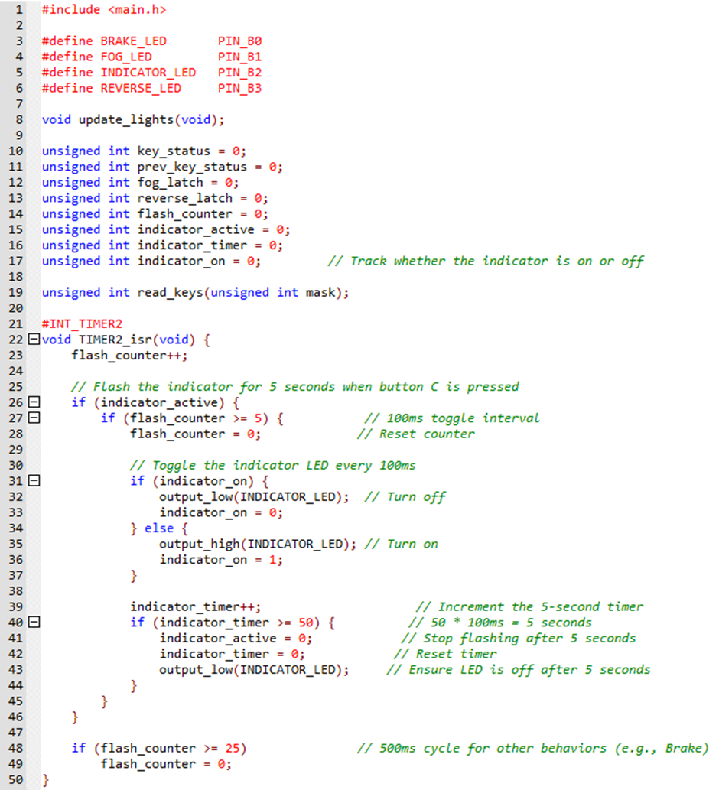
Figure 6 - Master PIC Code Lines 1-50
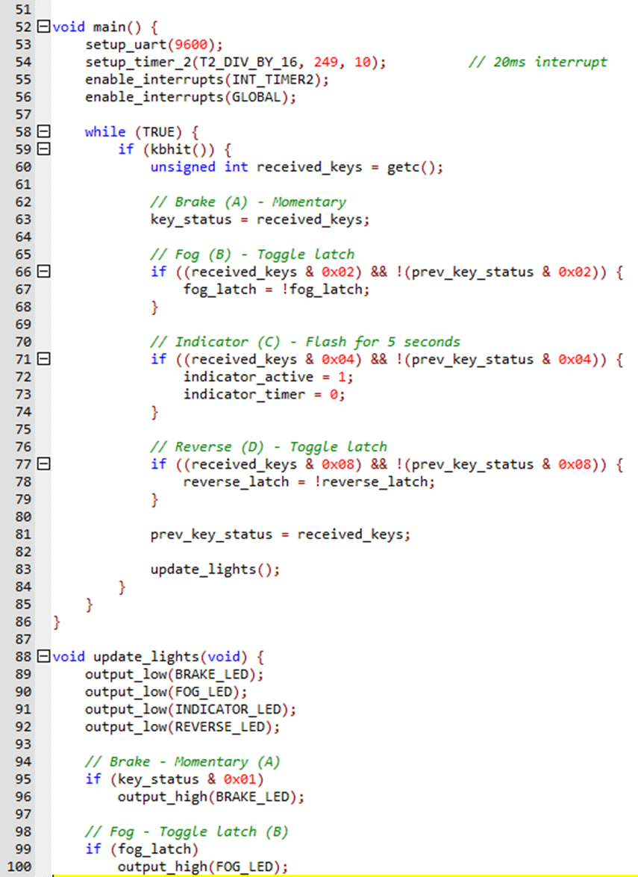
Figure 7 - Master PIC Code Lines 51-100
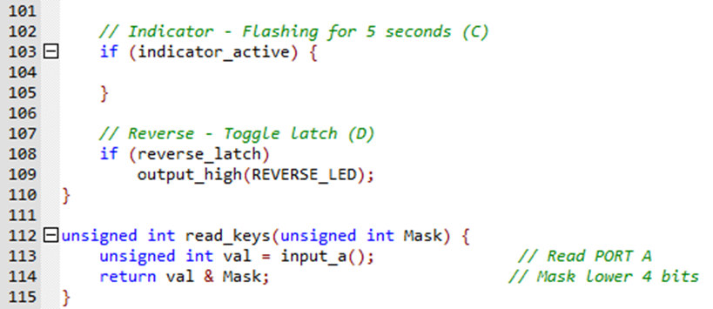
Figure 8 - Master PIC Code Lines 101-115
The master microcontroller listens continuously for UART transmissions and decodes the incoming byte to determine the appropriate lighting actions. Each of the four lights responds to its input in a different way, reflecting real vehicle behaviour.
The brake light is activated while the input is high and turns off as soon as the signal is released, representing momentary control [17]. The fog and reverse lights are toggled using latch variables that retain their state until another press is received, simulating typical manual light control logic [18]. The indicator light is triggered for a five-second flashing sequence, blinking on and off at 100-millisecond intervals. This is managed by a timing routine based on an internal interrupt, which tracks duration without blocking the rest of the system.
To ensure smooth operation, the program uses a 20-millisecond interrupt to manage timing-sensitive operations such as flashing. A central output update function resets all lights before reactivating any required based on current logic states. This structure simplifies code and prevents pin conflicts or unintended outputs [19].

Slave Microcontroller Program
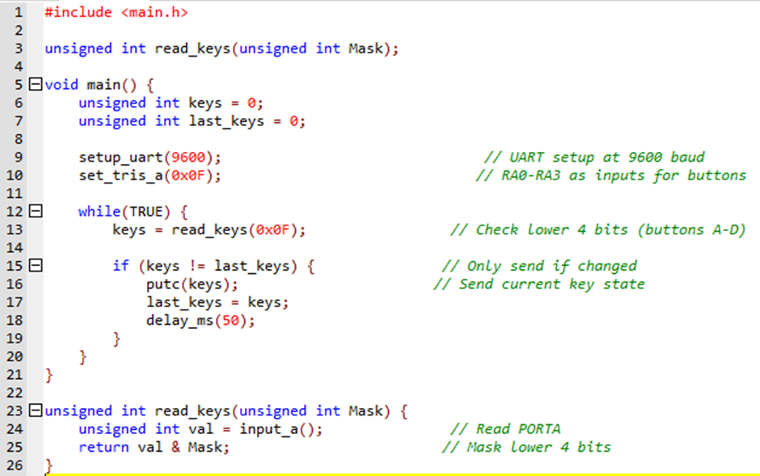
Figure 9 - Slave PIC Lines 1-26
The slave microcontroller is responsible for reading four physical inputs that simulate rear vehicle actions. These inputs are provided by pushbuttons connected to digital input pins on the controller. The system monitors the button states and detects when any input changes. When a difference is found, a compact 4-bit value is generated and sent over UART at a baud rate of 9600. This method of encoding and transmitting the state allows multiple controls to be represented in a single byte, reducing traffic and simplifying communication [18].
To prevent redundant UART traffic, the slave only transmits data when the input state changes. A short delay is added to stabilise the input reading and account for mechanical switch bounce. The logic assigns one bit per input, corresponding to the brake, fog, indicator, and reverse lights, enabling clear decoding on the master side [19].

Code Structure and Documentation
The firmware is written with modular structure and future adaptability in mind. Functions are used to separate logic for readability, and variable names are chosen to reflect their purpose clearly. Inline comments document the main operations, particularly where latching, timing, or communication occurs.
Symbolic constants define hardware pin mappings, improving maintainability and making the program adaptable to hardware changes. The compact and well-commented code base allows for efficient troubleshooting and expansion, such as adding new inputs or outputs [17].

Integration and Testing in Proteus
The final programs were simulated in Proteus, where button inputs on the slave side were tested in various sequences to verify reliable response. UART communication between the microcontrollers performed consistently, with each light behaving as expected. The brake light responded immediately to input changes, while the fog and reverse lights held their toggled states between presses. The indicator successfully flashed for the full five-second duration and then turned off automatically.
System stability was confirmed by observing the virtual terminal and LED status indicators within Proteus. The interrupt-driven timing system performed accurately, and no erratic behaviour was noted during extended simulation. The test process validated both the communication and control logic, ensuring the system matched the real-world rear lighting behaviour of a vehicle [18], [19].
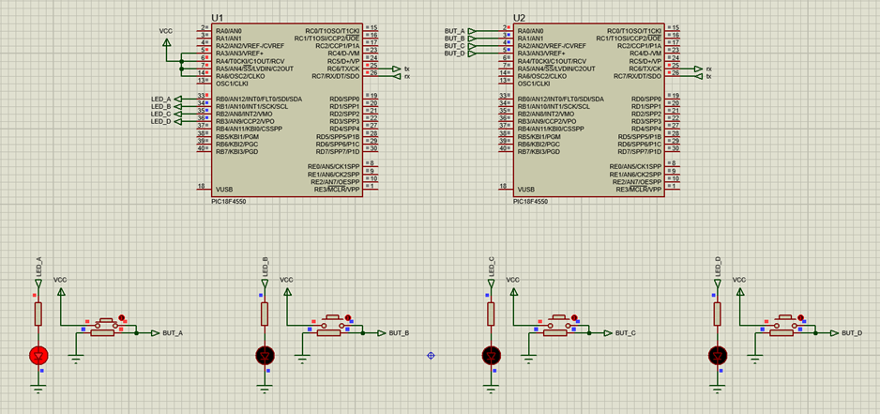
Figure 10 - Brake Light LED Active

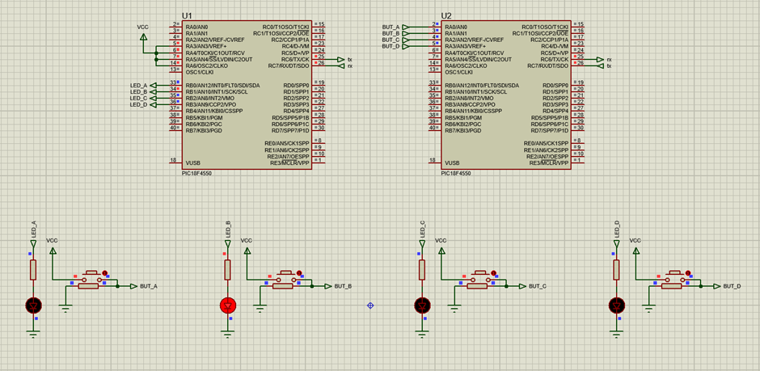
Figure 11 - Fog Light LED Active

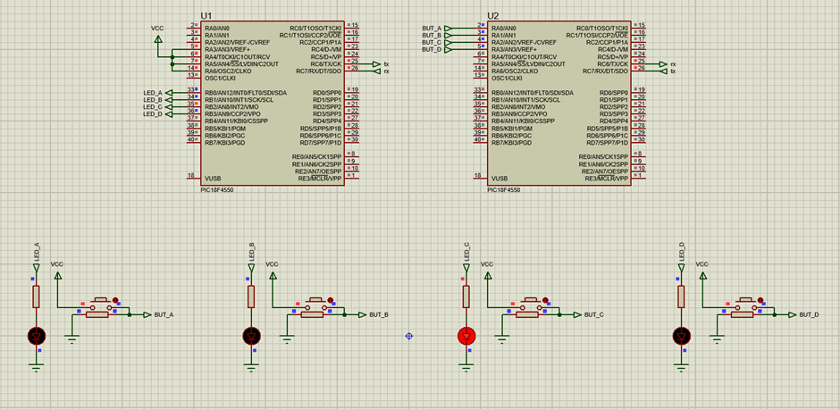
Figure 12 - Indicator Light LED Active
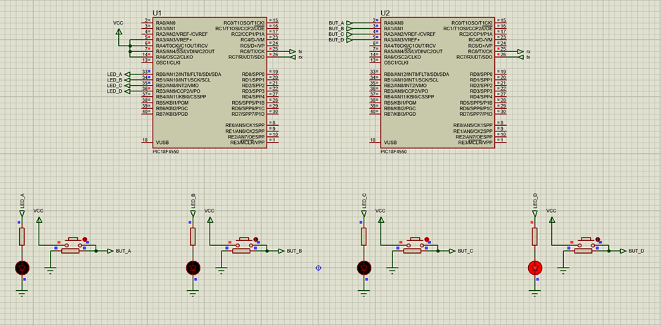
Figure 13 - Reverse Light LED Active
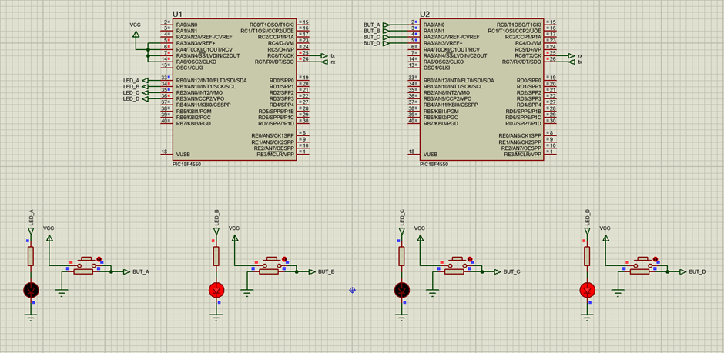
Figure 14 - Fog and Reverse Light LEDs Active
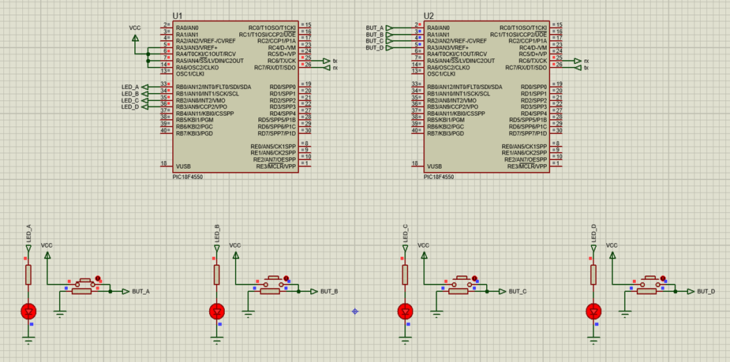
Figure 15 - All Lights LEDs Active

Analysis
This section evaluates the runtime operation of the master and slave programs in the distributed lighting system. It also presents a flowchart illustrating the real-time interaction between devices and explains how engineering quality and safety practices can support the long-term development of such systems.

Program Operation and Interaction
The rear lighting control system is structured around direct serial communication between two PIC18F4550 microcontrollers. The slave continuously checks the state of four pushbuttons, each representing a different rear vehicle light. When a button press is detected or released, the slave encodes the input into a single byte using bitwise logic and sends it to the master via UART.
The master microcontroller receives this encoded byte and decodes it to determine which lighting functions to activate. The brake light is momentary, illuminating only while the button is held. The fog and reverse lights use a toggle mechanism, staying on or off depending on their previous state. The indicator light follows a timed flashing sequence that lasts for five seconds with consistent on and off intervals. An internal interrupt ensures smooth timing and allows other operations to continue without interference.
This separation of sensing and control logic provides modularity. The slave handles all input while the master manages outputs and timing, which allows for easier scaling and system updates. The program flow is structured to ensure accurate decoding, fast response, and consistent LED output based on user input.

Operational Flow Chart
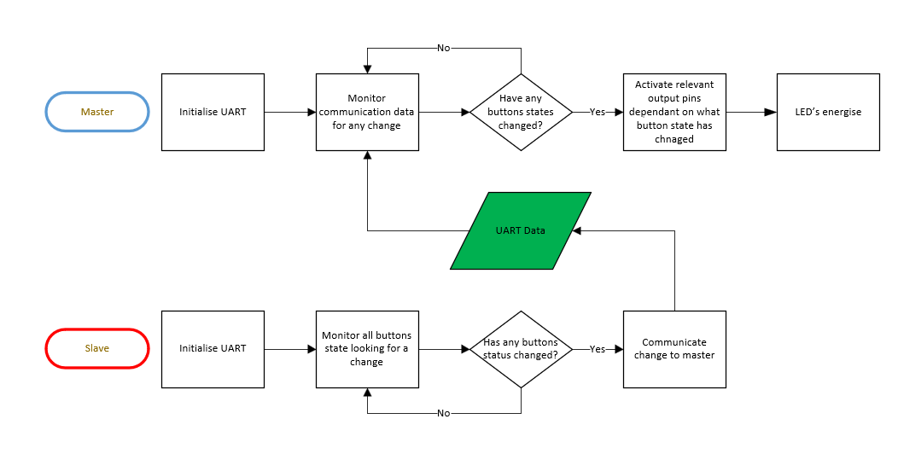
Figure 16 - Operational Flowchart

Quality and Safety Considerations
Embedding principles of quality management into this system ensures that performance remains consistent and maintainable. From code to communication design, quality is reinforced by using clear structures, dedicated functions, and logic separation. The use of symbolic constants, timed interrupts, and UART protocols supports clarity, accuracy, and adaptability.
Continuous improvement is supported through simulation and iterative development. As the system evolves, enhancements such as bi-directional communication or additional sensors could be integrated without disrupting the core structure. By using modular firmware and standard communication approaches, future changes can be applied in a controlled and traceable manner.
In vehicle lighting systems, safety is critical. Rear lights are essential for driver signalling and road visibility. Ensuring that brake, fog, and indicator lights behave correctly always reduces risk to both the vehicle operator and other road users. This system was designed with those priorities in mind and tested to confirm reliable function even during rapid input or repeated state changes.
Compliance with industry safety standards such as ISO 26262 highlights the importance of consistent system behaviour and fault resistance. Although this project is academic, applying these principles helps align its design with the standards expected in professional automotive systems [20].

Conclusion
This assignment has demonstrated the successful design, development, and simulation of a distributed microcontroller system that replicates the rear lighting functions of a vehicle. Using two PIC18F4550 microcontrollers, the system separates user input and light control through a master and slave communication model. The master processes encoded UART data and applies varied control logic, including momentary, toggle, and timed responses.
The project was implemented using the Proteus simulation environment, with accurate behavioural modelling and live testing of input and output interactions. Each lighting function was designed to mirror a real-world application, and system responsiveness was validated under dynamic conditions.
In addition to meeting functional requirements, the system was developed with a focus on modularity, maintainability, and quality. The use of structured code and clear communication protocols supports future development and aligns with safety-focused design practices. This approach lays a strong foundation for expanding into more complex vehicle systems or integrating with automotive safety standards in future work.

References
[1] W. Stallings, Data and Computer Communications, 10th ed., Pearson, 2014.
[2] R. Tocci, N. Widmer, and G. Moss, Digital Systems: Principles and Applications, 12th ed., Pearson, 2016.
[3] D. Smith, Introduction to Automotive Electronics, Butterworth-Heinemann, 2019.
[4] R. Bosch GmbH, Electronic Stability Program (ESP) and ABS Systems Overview, Robert Bosch GmbH, 2018.
[5] J. F. Kurose and K. W. Ross, Computer Networking: A Top-Down Approach, 7th ed., Pearson, 2017.
[6] A. S. Tanenbaum and D. J. Wetherall, Computer Networks, 5th ed., Pearson, 2011.
[7] J. G. Proakis and M. Salehi, Communication Systems Engineering, 2nd ed., Pearson, 2001.
[8] R. Bosch GmbH, CAN Specification Version 2.0, Robert Bosch GmbH, 1991.
[9] Texas Instruments, Automotive Lighting Control Using CAN and LIN Networks, Application Note, 2019.
[10] M. Farsi, K. Ratcliff, and M. Barbosa, An Introduction to CAN Bus, Elsevier, 2004.
[11] T. Nolte, H. Hansson, and L. L. Bello, "Automotive Communications – Past, Current and Future," Proceedings of the 10th IEEE Conference on Emerging Technologies and Factory Automation (ETFA), pp. 985-992, 2005.
[12] M. Ali Mazidi, R. D. McKinlay, and D. Causey, PIC Microcontroller and Embedded Systems: Using Assembly and C for PIC18, Pearson Education, 2008.
[13] J. Ganssle, The Art of Designing Embedded Systems, 2nd ed., Newnes, 2008.
[14] Texas Instruments, “Lighting Control for Automotive Applications Using Serial Communication,” Application Report SLVA345, 2020.
[15] D. Hoyle, ISO 9000 Quality Systems Handbook, 6th ed., Routledge, 2009.
[16] N. Storey, Electronics: A Systems Approach, 6th ed., Pearson, 2021.
[17] S. Barrett and D. Pack, Embedded Systems: Design and Applications with the PIC Microcontroller, Morgan & Claypool, 2008.
[18] M. Ibrahim, PIC Microcontroller Projects in C, 2nd ed., Newnes, 2014.
[19] N. Storey, Electronics: A Systems Approach, 6th ed., Pearson, 2021.
[20] ISO, ISO 26262: Road Vehicles – Functional Safety, 2nd ed., International Organization for Standardization, 2018.
[21] VCELINK, “A Beginner’s Guide to Point-to-Point Connection,” VCELINK, Dec. 19, 2024. [Online]. Available: https://www.vcelink.com/blogs/focus/a-beginner-guide-to-point-to-point-connection
[22] A. Bhayani, “Multi-Master Replication – Scaling Writes Across Geographies,” arpitbhayani.me, Nov. 3, 2021. [Online]. Available: https://arpitbhayani.me/blogs/multi-master-replication/

