
LCMB7020
Master of Business Administration
Assessing the Role of Data-Driven Strategies in Adapting to Supply Chain Challenges: Case Analysis of the UK Agriculture Sector

Student Name: Akashdeep Singh
Student ID: 2239847
Supervisor Name: Dr. Faizu Edu
Submission Date: 8/10/2024

Abstract
Purpose
The aim of the research is to measure the effective role of data-driven strategies in adapting to supply chain issues within the UK agriculture sector.
Methodology
This research uses a mixed methodology which involves the primary and secondary data collection methods. Further, this research uses the descriptive analysis and thematic analysis approach for analysing both the qualitative and quantitative data collected from 100 individuals from the agriculture sector of the UK and secondary sources.
Findings
Data-driven strategies such as the adoption of advanced technologies which include explainable AI, sensors, big data blockchain and advanced analytics. These strategies are beneficial for increasing supply chain efficiency and performance in the agriculture industry. The advantages of a data-driven approach are technological advancement, big data applications, and a Triple Bottom Line framework that helps in maximising business productivity. The circular economy and sustainable initiatives help in establishing sustainable supply chain management. Advanced technologies, data-driven approaches, supply chain resources, and traditional Enterprise Resource Planning strategies are beneficial to improve the decision-making process within the agriculture business.
Recommendations
To effectively handle the operational complexities faced by the UK agriculture sector in their supply chain management processes the investment in digital infrastructure development activities. Furthermore, the research also proposed the change regarding training and digital literacy and the adoption of sustainable agriculture policies. The last recommendation is focused on promoting transparency and traceability of actions in the supply chain by promoting the use of precedent tools and techniques.
Limitations
It is difficult to ensure that the sources from which the information is collected for primary and secondary data are tricky. This is because it can create confusion if the sources matchup or support each other. In addition, it is hard to combine information from different sources which can be confusing.
Keywords
Artificial Intelligence (AI), data-driven, decision-making, sustainability, agriculture sector, UK.

Table of Contents
Abstract 2
Table of Figures 7
Chapter 1: Introduction 8
1.1 Background of the Study 8
1.2 Problem Statement 10
1.3 Research Rationale 10
1.4 Aims and Objectives of the Research 10
1.5 Research Questions 11
1.6 Research Significance 11
1.7 Theoretical Framework 12
1.8 Research Structure 13
Chapter 2: Literature Review 14
2.1 Introduction 14
2.2 Theories and concepts used for effective supply chain management 14
2.3 Role of a data-driven strategies in the supply chain in the agriculture sector 16
2.4 Advantages of Data-Driven Strategies to Enhance the Decision-making Process Concerning the Agriculture Sector. 18
2.5 Hurdles Faced in the Implementation of Data-Driven Strategies in the Agricultural Sector of the UK. 20
2.6 Future Avenues in the Agriculture Sector and Recommendations to Expand Sustainability Through SignificantDecision-Making 22
2.6.1 Future Avenues for the Agriculture Sector 22
2.6.2 Recommendations to Expand Sustainability Through Significant Decision-Making 24
2.7 Research Gap 25
2.8 Summary 25
Chapter 3: Research Methodology 27
3.1 Introduction 27
3.2 Research Design and Framework 27
3.3 Research Philosophy and Approach 28
3.4 Research Method and Strategy 29
3.5 Data Collection Method 30
3.6 Data Analysis 31
3.7 Ethical Consideration 31
3.8 PRISMA Model 32
3.9 Hypothesis 34
Chapter 4: Research Findings 35
4.1 Introduction 35
4.2 Thematic Analysis 35
4.3 Codes Table 38
4.4 Themes Discussion 39
4.4.1 Data-driven strategies influence sustainability in the supply chain and enhance smart farming in the agriculture sector. 39
4.4.2 Big data and blockchain are the major data-driven strategies that have a positive impact on the decision-making process in the supply chain of the UK agriculture sector. 40
4.4.3 Circular economy and Industry 4.0 are the major trends that are automating the supply chain and enhancing sustainability in the agriculture sector of the UK. 41
4.5 Findings from Questionnaire 42
4.5.1 Correlation and Regression Analysis 54
Chapter 5: Discussion 58
Chapter 6: Conclusion 61
6.1 Introduction 61
6.2 Conclusion 61
6.3 Recommendation 64
6.4 Future Research Strategies 65
References 67
Appendix 75
Questionnaire 75
Statistical Charts 78
Regression 81

Table of Figures
Figure 1: Data-Driven Supply Chain 8
Figure 2: Total Income from the Agriculture Sector in the UK 9
Figure 3: Digitalisation in the Agriculture Sector 12
Figure 4: The Game Relationship Among Suppliers, Processors, And Quality Inspection Departments Of Agricultural Products Supply Chain 15
Figure 5: Saunders onion research model 28
Figure 6: Responses to age 43
Figure 7: Responses to work experience 44
Figure 8: Responses to data-driven strategies in the supply chain of UK’s agriculture 45
Figure 9: Responses to the use of data analytics in supply chain management 46
Figure 10: Responses to data-driven approaches leading to better forecasting and planning in agricultural operations 47
Figure 11: Analysis of data-driven strategies in the agriculture sector and the role of technological infrastructure 48
Figure 12: Shortage of skilled personnel to manage and interpret data within the agriculture sector 49
Figure 13: Evaluation of the cost of adopting data-driven strategies for the agriculture industry 50
Figure 14: Data-driven strategies are efficient in enhancing the sustainability of the agriculture sector in the future 51
Figure 15: Potential for increased use of data-driven strategies to improve supply chain resilience in the agriculture sector 52
Figure 16: Future potential of data-driven strategies in agriculture 53
Figure 17: Beneficial data-driven strategies for organisations for adapting to supply chain challenges 54
Figure 18: Results of Regression Analysis 55
Figure 19: Results of Regression Analysis 56

Chapter 1: Introduction

1.1 Background of the Study
In this digital era, big data plays a significant role in making data-driven supply chain strategies to gain a competitive advantage in the agriculture sector (Li and Liu, 2019). A data-driven supply chain system is a quality management supply chain that helps a business by providing real-time updates to them through collecting and analysing the product information from sourcing till it reaches the consumers depicted in Figure 1. It helps in identifying the challenges and inefficiencies of supply chain management (Kamble and Gunasekaran, 2020). In a data-driven supply chain, the strategies are based on data instead of experience.
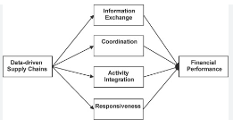
Figure 1: Data-Driven Supply Chain
(Source: Yu, et al., 2018)
Data-driven supply chain benefits the business by improving agility through prioritising decision-making based on data that leads to improved performance. In addition, it provides the capacity to scale by providing valuable insights driven through data and opening up doors for opportunities for businesses to scale (MedeirosandMaçada, 2022). Data-driven supply chain helps businesses make effective strategies by determining available unseen insights in their data that lead to making accurate predictions about the business (Ivanov, et al., 2019). The businesses are able to test various strategies based on the results of these analytics that further aid in making accurate predictions to benefit the business. It assists businesses to increase the visibility of the supply chain in the business and also increases the efficiency of the operations to meet customer satisfaction (Moshood, et al., 2021). Visibility in the supply chain also increases as it helps in risk detection and problem identification before it adversely affects the business.
Data-driven analytics has a crucial role play in the supply chain management of the agriculture sector it enhances agricultural production, elevates productivity and mitigates risk associated with it by discovering bottlenecks. In the agriculture sector supply chain includes activities starting from sourcing to production till bringing the product to the market and eventually to the customer (Lezoche, et al., 2020).
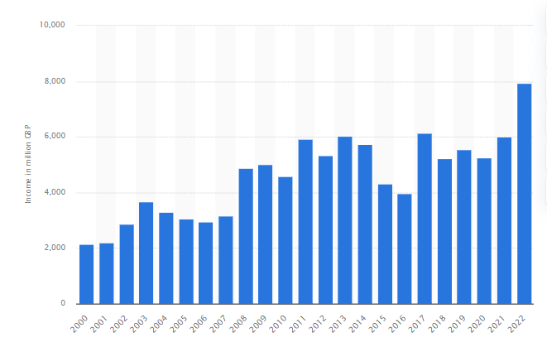
Figure 2: Total Income from the Agriculture Sector in the UK
(Source: Bedford, 2023)
As shown in Figure 2, the income generated by the agriculture sector in the UK from the year 2000 to 2022 has increased over time; the agriculture sector in the UK largely contributes to the economy of the country. In the year 2000, the total income generated by the agriculture sector was 2.15 billion, which has increased over time, and in the year 2022, it became 7.94 billion British pounds (Bedford, 2023). Data-driven supply chains in the agriculture sector play a significant role in making effective strategies by providing real-time data to businesses to discover the bottlenecks and opportunities present in the market. Additionally, they analyse and provide valuable considerations to ensure sustainability and increase productivity as well as efficiency. Data-driven analytics help businesses in optimising resources and identifying the gap that is present within the organisations and suggests strategies to overcome them (Yadav, et al., 2021). The agriculture sector is implementing data-driven strategies in their business to gain a competitive advantage in their market and to enhance their productivity and production as well. Additionally, with a data-driven supply chain, they can identify the bottlenecks of the supply chain that help them mitigate future risks and make strategies that can be beneficial to their business. Due to this, it became necessary to conduct research so that the role played by data-driven analytics in the supply chain can be examined thoroughly in the agriculture sector.

1.2 Problem Statement
The data-driven supply chain plays a significant role as it enhances production and productivity in the agriculture sector by providing valuable insights. There are various aspects highlighted by several authors that show data-driven supply chain increases agility, supply chain visibility, and optimum utilisation of resources in the agriculture sector (Yadav, et al., 2021; Moshood, et al., 2021). However, their studies are unable to acknowledge the significant role that data-driven supply chain plays in the agriculture sector due to limited knowledge and research in this particular sector. Hence, this research is conducted to examine the role of data-driven strategies in supply chain management in addition, to investigating various challenges and benefits that are associated with it. Further in this research, the impact of decision-making on supply chain practices in the agriculture sector is also analysed.

1.3 Research Rationale
There are challenges encountered by the agriculture sector in terms of using data to drive different strategies in the agriculture business and this hinders productivity of the agriculture sector and business. Lack of efficient resource management and incorrect decision-making have a negative impact on the development of organisations in the agriculture industry (Kamble and Gunasekaran, 2020). However, it is also an understanding that in this process, there is a significant use of a data-focused approach in the supply chain in the agriculture sector. Hence, with the intention of acquiring more comprehensive studies about the sustainable strategies applicable in the agriculture sector firms and the efficient utilisation of resources to boost productivity, this research is enabled. Also, it is necessary to undertake this research to bring out the difficulties that organisations encounter in the process of policy formulation for data-driven approaches in the agriculture sector.

1.4 Aims and Objectives of the Research
Research Aim
This study aims to examine the role that data-driven strategies play in supply chain management while considering the context of the agriculture sector in the UK.
Research Objectives
- To investigate the role of data-driven strategies in the supply chain in the agriculture sector of the UK.
- To analyse the benefits of data-driven strategies in enhancing the decision-making process concerning the agriculture sector.
- To highlight the challenges in implementing data-driven strategies in the agricultural sector of the UK.
- To identify future potentials and recommendations to improve the sustainability and decision-making in the agriculture industry.

1.5 Research Questions
Primary Question
What role is played by data-driving strategies in increasing the performance of the supply chain in the agriculture sector?
Secondary Questions
- What are the key hurdles and advantages of a data-driven approach and how does it affect the sustainability of the supply chain system?
- How does decision-making impact, the supply chain practices that are present in the agriculture sector?

1.6 Research Significance
In the era of digitalisation, data-driven strategies have become essential in the agriculture sector to improve the productivity and growth of organisations. The research is effective for the organisations, employees, and stakeholders associated with the agriculture industry. The investigation is beneficial in enhancing the knowledge to increase decision-making and sustainability in the supply chain in the agriculture sector (Elufioye, et al., 2024). Therefore, the research is significant for getting effective information and gaining in-depth knowledge about the function of data-driven approaches in enhancing the agriculture sector. The findings of the study help firms to make productive strategies so that there is proper decision-making and effective use of resources.

1.7 Theoretical Framework

Figure 3: Digitalisation in the Agriculture Sector
(Source: By Author)
The above figure shows the theoretical framework of data-driven strategies in the supply chain in the agriculture sector. Organisations can use the most recent technologies such as data analytics, AI, IoT and many more to enhance productivity and decision-making power. It is divided into three main areas comprising concerns about the benefits obtained, the difficulties associated with implementation and possible suggestions that would enhance sustainability improvement. Some of the benefits include efficiency gains, better forecasting and improvement in decision-making. Difficulties in the implementation range from issues such as costs, the privacy of consumers’ data and information, and the behaviour of the stakeholders towards change. Regarding the improvement of sustainability, the framework proposes the use of AI, machine learning, and other advanced analytics. The proposed approach covers the major aspects in order to promote decision support, the optimisation of decision processes as well as the improvement of effectiveness and sustainability considering the characteristics of agricultural organisations.

1.8 Research Structure
Chapter 1: Introduction: The segment of the study involves a short introduction to the selected topic and area of study. Furthermore, it helps to gain an understanding of the research rationale, research aim and objectives, research questions, and significance.
Chapter 2: Literature review: This chapter focuses on a critical analysis of the viewpoints and opinions of several authors that were done previously in the same area of study. It helps in gaining effective knowledge about the research and also provides the research gap of the prior studies. Journals and articles are collected from reliable and authentic sources which help in competent understanding.
Chapter 3: Research methodology: This specific chapter includes the footprints of various tools and approaches that have been used in conducting the research successfully.
Chapter 4: Data analysis: Comprehensive descriptions of the gated data have been composed from different sources in this particular chapter. This chapter helps us to understand the data to get a productive result.
Chapter 5: Conclusion and recommendation: This section focuses on the observation and discussion of data in a concise way. It gives useful results and suggestions for the research.

Chapter 2: Literature Review

2.1 Introduction
Data-driven strategies in the supply chain enhance the decision-making and productivity in the agriculture sector. This chapter particularly focuses on the viewpoints of various authors regarding the area of study. It generates a basic understanding of the research topic. Different PDFs, Journals, and newsletters are studied effectively to evaluate the topic. The critical analysis of the opinions of authors helps in increasing the knowledge of the research. Google Scholar has been used to gain effective knowledge about the topic. Moreover, the chapter is summarised after finding a gap where previous studies or scholars have not focused.

2.2 Theories and concepts used for effective supply chain management
As per the study conducted by Dias, et al., (2021), several theories have been adopted by the supply chain management of the agricultural sector such as institutional theory, resource-based view, transaction cost theory and many more. In the research, the author has focused on the effectiveness of applying the resource-based view (RBV) theory which refers to understanding the use of resources and their capabilities for creating products that better serve customers than competitors. In the agricultural sector, the resource-based view (RBV) theory can aid organisations in studying and analysing the interconnectedness between resources and financial success in management. Moreover, this theory can help measure farm performance and gain a sustainable competitive advantage. Whereas, the study byHamidoğlu, (2024), identified the game-theoretical approach which helps analyse the potential risks that can be raised in the agricultural market sector. The implementation of this theory has been successful in addressing several problems, such as climatic changes, utilising new tools, bargaining and resolving firm conflicts between household and business sectors.
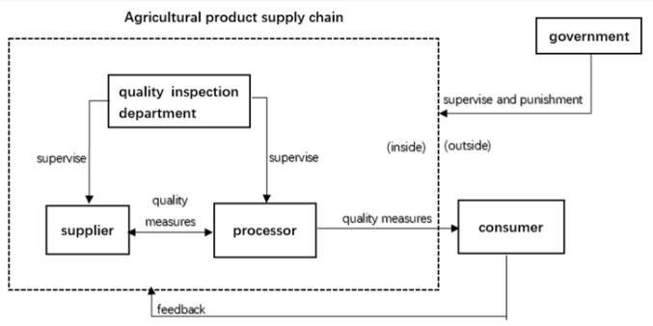
Figure 4: The Game Relationship Among Suppliers, Processors, And Quality Inspection Departments Of Agricultural Products Supply Chain
(Source: Wang and Xu, 2022)
As per the above image, the relationship between suppliers, processors and the quality inspection department in the agricultural supply chain has been analysed through game theory. This has been curated by determining the quality and safety of the agricultural products which results in obtaining stability under the revolutionising game model (Wang and Xu, 2022).
Moreover, the viewpoints of Bhatia, et al., (2024), argued that understanding the theory of transaction cost can lead to the growth of the firm in the agricultural sector and determine a significant effect on its supply chain management. This theory is required to compare the correlation between internal transaction costs and external value output of the firm. The transactional cost is dependent on the transactional contracts, such as the cost of finding associates, negotiating, exchanging and signing the contract. On the other hand, Oyedijo, et al., (2022), defined force field theory for the agricultural sector, in order to illuminate factors disturbing collaboration in the supply chain. This theory is helpful for the agricultural sector as it ensures that there is a balance between the forces of change and the ability to resist change in the organisation. Moreover, it enables managers to offer the changes and consider the dynamics while pursuing collaborative possibilities.

2.3 Role of a data-driven strategies in the supply chain in the agriculture sector
According to Yadav, et al., (2021), to improve competitiveness and sustainability in agriculture companies, performance management in the supply chain is essential. The paper explores the function of IoT in the communication process and data collection based on the operations of supply chain management. It is found that flexibility and responsiveness are the most vital key performance indicators for achieving sustainability in the agriculture industry. On the other hand, Kamble and Gunasekaran, (2020), lack of management and inefficient supply chains affect the agri-food supply chain. Technologies in the agriculture supply chain have been increasing such as the blockchain, big data, and IoT. These technologies are powerful in the sustainability of the supply chain. It is found that supply chain visibility and supply chain resources are the drivers for data analytics development and sustainability performance.
As per the views of Saiz-Rubio and Rovira-Más, (2020), investment in the data-driven strategies in the agriculture sector has been proven to enhance production and productivity by utilising the resources effectively. Data-driven approaches help small-scale farmers to provide information and innovation to improve their living and resilience. Raji, et al., (2024), stated that advanced analytics has improved the process of decision-making in the agriculture sector with the help of data drive insights to optimise the operation process and risk management. The paper investigates the role of advanced analytics, benefits, and challenges in the agriculture sector. Advanced analytics helps farmers improve crop yields and make decisions for betterment with the help of analysis tools and sensors (Ullah, et al., 2023). It is concluded that advanced analytics improves decision-making, drives sustainable growth, and enhances efficiency in the agriculture sector.
From the viewpoints of Linaza, et al., (2021), it has been observed that a data-driven approach in the agricultural sector has enabled precision farming, which allows the firms to understand the use of accurate and precise amounts of inputs, including water, fertilisers, pesticides and others. Also, it ensures that these inputs have been employed at a suitable time, in order to increase productivity and harvests. The data is derived from technologies, such as sensors, yield mapping, drones, geographic information systems and satellites to increase agricultural practices and improve crop yields and sustainability. In support, the views of Bhat and Huang, (2021), examined that in precision agriculture, the use of information and communication is important for sustainable development. Big data technology is one of the essential technologies used in farming as it provides effective information and helps in informed decision-making. The above picture shows the agriculture system. To enhance sustainable production in the agriculture sector, there is a need for technologies such as blockchain, AI, and IoT. These technologies in agriculture help to solve the present and future problems. Food problems can be solved globally with the use of a data-driven approach.
According to the study by Hatanaka, et al., (2022), it has been identified that a data-driven approach has a significant role in enhancing supply chain efficacy, sustainability and productivity in the agricultural sector. This approach has increased the value of the agricultural chain for consumers, farmers and society as it helps producers improve farming methodsthrough machinery, data collection and analysis. For instance, farmers can recognise and examine the ecological situations, in order to reduce ecological footprints. Moreover, they can use data analytics to understand resource usage, which, in turn, enhances practices such as thoughtfully using water, efficient soil conservation and precise use of chemical fertilisers and pesticides. On the other hand, the study by the Observer Researcher Foundation, (2024), stated that employing data-driven information in the supply chain management of the agricultural sector can minimise food waste production. Data-driven agricultural practices have been effective in increasing yield and maximising the use of resources, along with dropping waste production rates. Moreover, it empowers the farmers through information and innovation in improving livelihood and resilience. The research further examined that data driven by big data analytics tools and machine learning helps in tracking and monitoring the food production process in real time.
Furthermore, from the perceptions of Bag, et al., (2024), data-driven practices in the agricultural industry have been valuable in enhancing the flexibility of the supply chain. It further helps the farmers and organisations of the agricultural sector to enable sustainable sourcing as in the present scenario, a sustainable food system must meet the current demands. Along with this, agro-food systems must balance environmental, social and economic concerns in agriculture. The study further examined that data science plays a vital role in sustainable agronomy by encouraging farming efficacy and minimising ecological impact. In parallel, the viewpoints of Bachmann, et al., (2022), discussed that the use of data-driven technologies in the farming industry has the potential to enhance agricultural yield, sustainability and efficiency in the production process. Furthermore, the resource management strategies have allowed farmers to improve resource usage and decrease the environmental impact. Data analytics helps farmers manage the supply chain by identifying gaps and offering sustainability. This further can reduce food waste, improve the efficiency of the supply chain and minimise carbon footprint.
In essence, the above review has helped to analyse the pivotal role of a data-driven approach in the agricultural sector to improve its supply chain management. Data-driven agricultural practices vitally impact the supply chain by increasing flexibility and productivity, decision-making, responsiveness and operating processes. Moreover, it has been identified that a data-driven approach in the agricultural industry advances farming methods, allows precision agricultural tactics, reduces food waste and empowers sustainable sourcing.

2.4 Advantages of Data-Driven Strategies to Enhance the Decision-making Process Concerning the Agriculture Sector.
Data-driven strategies refer to the business approach that utilises the insights achieved through the derived data, guiding decision-making and improving overall operations. In this section, the research will focus on determining the benefits of data-driven strategies which can help the agriculture sector in improving its decision-making process.
According to the study conducted by Paul, et al., (2022), data-driven strategies benefit agricultural organisations and farmers in numerous ways. It helps them to make informed decisions by utilising real-time data. This further results in improving their technological practices and increasing profitability by ensuring efficiency, reducing cost and making smart choices. A data-driven approach helps farmers analyse the market conditions, demands and competitors’ pricing which further helps them to optimise profit and maximise revenue by identifying the range customers are ready to pay. In addition, analysis of climatic and soil conditions, weather forecasts and market demand reduces the risks and maximises the profits. On the other hand, authors such as Liang and Shah, (2023), highlighted that advanced analytics have improved the data-driven decision-making of optimal resource allocations in the agricultural sector. In agriculture, ideal resource allocation can be predicted through crop harvesting based on weather, soil and farming practices. Data-driven decisions ensure appropriate resource distribution, which results in improving crop quality and reducing environmental impact. For instance, data collected through the Internet of Things (IoT) can track soil moisture levels, thus, allowing farmers to irrigate the agricultural land as per the available real-time data.
Furthermore, as per the research conducted by Fenz, et al., (2023), data-driven tactics help farmers in the decision-making process of crop selection for plantations in agriculture. Farmers, producers and organisations can utilise the derived data to analyse which crop should be used to plant by identifying weather forecasts, soil conditions and market demands. Furthermore, it has been examined in the research that this approach predicts which crop to be used for the plantation of each field, prior to the harvest season, and the data is 60% accurate. By identifying the derived information, the agricultural sector can make informed decision-making and thus, result in increased growth of the industry as a whole. On the contrary, the study by Rustia, et al., (2022), explained that data-driven pest management helps farmers to develop techniques to manage pests. Moreover, making informed decisions on pest management aids farmers in anticipating and adapting to pest pressures, which, in turn, benefits them, ecosystems and future generations. It aids farmers in decision-making based on the existing pest condition and measuring environmental parameters. The authors further acknowledged that this helps agriculturalists to notice, classify and control pests sustainably and efficiently.
In addition, the research conducted by Kasera, et al., (2024), focused on data-driven tactics that boost the decision-making process in post-harvest activities. In other manners, it has been acknowledged that post activities of harvest such as selection, assessment and packing of crops can be employed through decision-making. This can further lead to decreasing the loss of age and enhancing the quality of the yield. Furthermore, this efficient way of solving matters enhances the effectiveness and efficiency of crop handling by the farmers. In the agricultural industry, the right decision-making in post-harvest activities enables farmers to get the right value in foods that are produced and also empowers them through increased yields, better health of the soils, control of pests and many more. In support, Chauhan, et al., (2022) examined the considerable transformation of the agricultural industry due to technological advancement such as big-data analytics. This tool provides real-time data to the farmers which empowers their decision-making process. Further, the author stated that data-driven decisions in post-harvest activities enable farmers to manage water, pest and environmental conditions impacting crop harvesting fostering a sustainable farming practice. Moreover, this strategy improves shelf life, maintains and determines quality, reduces postharvest losses, and preserves nutrient content, along with high earnings in the marketplace. Post-harvest activity includes technical and economic activities, along with pre-harvest treatment, safe harvesting, pre-cooling, washing, cold storage and many more.
As per the research conducted by Taylor, (2022), data-driven tactics have increased the decision-making efficiency in the agricultural industry. It has enabled farmers to make decisions after analysing the real-time data. The research surveyed that in 2020, there was a 12% increment in the implementation of data-driven decision-making, as compared to 2018. However, the response from 50% of the respondents indicated that decision-making through derived data needs to be improved. In parallel, the research by Statista, (2024), addressed the novel importance of technologies, automation and robotics in the manufacture of agricultural products. The study focused on another factor in the current world having pointed out the need to feed the increasing population and as a result, there have been improvements in agricultural yields to meet the global food demands. Such technological advancements in the likes of predictive analytics and big data analysis have provided the operators in the industry with opportunities to gather real-time data, analyse it and then make decisions to handle the challenges typical in the agricultural process.
In brief, the application of data-driven approaches in the context of managing and making decisions has been discussed. Analysing the articles of different authors, several strategies have been pointed out such as post-harvest activities, pest control, choice of crops, efficient use of resources, profitability and many more using derived data. In addition, this study has established that these strategies have improved the farmers' decision-making and the organisations of the agricultural industry.

2.5 Hurdles Faced in the Implementation of Data-Driven Strategies in the Agricultural Sector of the UK.
As per the views of Ingram et al. (2020), one of the most influential factors that hinder the adoption of data-driven approaches is the inadequacy of technical capabilities, which are crucial, particularly for rural areas. The authors of the research noted that there is a digital divide between the face web and the rural areas of the UK, which limits the use of big data solutions in the agriculture sector. There are few literacies, no internet or any other advanced technologies in the rural areas which is an issue for farmers to implement data in their farming. This fragmentation hampers the development of positive precision agriculture and innovations that are digitisation. In support, Klerkx et al., (2019), claim that limited access to appropriate digital resources is the reason for the low adoption of data-enabled technologies. The authors point out that it is crucial to specify that the mentioned strategies’ effectiveness depends on the presence of effective broadband connections and data availability. Without these, farmers are less expected to invest or to utilise information management and technology-based solutions to agricultural production remaining stuck in conventional practices.
Furthermore, from the viewpoints of Wolfert et al., (2018), despite the significance of a data-driven strategy in the agricultural sector, the barrier to skill deficiency among farmers, impacts its integration into the agricultural sector. The study further argued that data literacies play a central role in mitigating such issues. Most of the farmers have a low level of education and are unable to understand or apply data which results in rejection or low implementation of existing technologies. Furthermore, it has been identified that these issues require specific training and educational interventions which will facilitate farmer adoption of data farming.
In contrast, Rose and Chilvers, (2020), determined a wide approach to skill deficiency which includes cultural and psychological elements of data literacy. Furthermore, it has been explored that farmers’ distrust of new technologies, and their general disbelief in data systems can increase this gap created through of lack of skills.
In addition, another significant barrier to a data-driven approach in the agricultural sector, in the eyes of Rotz, et al., (2019), is the financial cost required to put in place data-driven measures. The authors noted that data-driven technologies are relatively capital-intensive with high initial costs needed to acquire and install these technologies and constant costs needed to maintain them, which is a major challenge for small and medium-sized farms. However, it has been noted that because of capital constraints, many farmers are unable to buy these technologies, limiting the amount to be gained from them in the agriculture sector.
On the other hand, Barnes et al. (2020) remain uncertain about the uncertainty of the return on investment in data-driven agriculture. The study pointed out that the failure to invest and innovate by farmers is due to perceived risks associated with innovation when they assume that there are economic benefits that they stand to gain from such approaches.
In the views of Lawson, et al., (2019), supply chain interruptions emerge as a key barrier in the implementation of data-driven strategies in the agriculture sector of the UK. Supply chain interruptions consist of weather conditions such as storms, floods, droughts, earthquakes, and hurricane significantly impacts crop yields. In addition to this, geopolitical conflicts also cause disruption of the movement of goods. Moreover, lack of government as well as agricultural regulation can cause ineffectiveness among the management of the agricultural sector. There are several issues such as transportation, shortage of labour, and problems at terminals of shipping interrupt the supply chain of the agriculture sector. According to Pascaris, et al., (2020), fluctuation in the demands of the market also appears as a bottleneck in the effective implementation of data-driven strategies in the agriculture sector of the UK. This is a significant challenge as it affects the income as well as profitability of farmers. There are several aspects that affect the fluctuations in the market such as the seasonality of products, rapid shifts in consumer preferences, weather changes, and other legislation changes. These are major determinants of fluctuations in the market demand for agricultural products.
Therefore, it has been identified that some of the significant issues encountered with reference to the applicability of effective data-driven strategies in the agriculture sector in the United Kingdom include the absence of technologies and skills and monetary problems. In addition to this, limited access to appropriate digital resources, and supply chain interruptions are key challenges in the data-driven strategy of the agriculture sector. Moreover, the fluctuating demands of the market such as shifts in consumer preferences, and regulations of government disrupt the agriculture market. Along with this, disruptions in the supply chain such as shortage of labour, technical issues and quality, as well as reliability on technology are bottlenecks that farmers of the agriculture sector in effective implementation of data-driven strategies. These issues can only be dealt with through the commitment of resources to infrastructure, training, and policy with clear guidelines on the support to be offered financially.

2.6 Future Avenues in the Agriculture Sector and Recommendations to Expand Sustainability Through SignificantDecision-Making

2.6.1 Future Avenues for the Agriculture Sector
In the views of Araújo, et al., (2021), there are several novel opportunities present in the market for the agriculture sector such as emerging and advanced technologies, financial support from the government, and expanding as well as growing market. Agreeing with the same Duckett, et al., (2018), stated that advanced technologies such as robotics and autonomous systems popularly known as (RAS) have been integrated by the government in order to innovatively transform the agriculture industry. Integration of technology facilitates enhancing productivity along with decreasing the mundane tasks of farmers such as irrigation and equipment management. Consequently, Khan, et al., (2021), reviewed that, technological advancements in the agriculture industry such as precision agriculture have been utilised by farmers. In the agriculture industry, geographical information systems, the Internet of Things, sensor technology and artificial intelligence have been used to gather and analyse information about soil, crops, and plants. These autonomous advancements uphold the possibility of transforming the agriculture sector in future by significantly impacting the operations of farmers.
According to Franks, (2022), the subsidies and financial assistance provided by the government have significantly influenced the agriculture industry and opened various subsequent avenues for farmers. For instance, as per a report published by the government of the UK, a new system was launched this year, in which farmers and land managers have been rewarded for producing public goods. Focused funding and various other facilities have been launched for the sustainable development of the agricultural sector and to ensure that farmers are working with their maximum potential to produce goods towards green growth ambition. In parallel, Zambon, et al., (2019), illustrated that there are various subsidies and sustainable farming incentives (SFI) agreements deployed by the government to offer financial support to farmers and help them in gaining benefits from it. For example, the UK government is funding new Countryside Stewardship (CS) schemes to grant no-value capital for farmers and focusing on improving habitat, increasing biodiversity and water management (UK Parliament, 2023). On the other hand, Rose, et al., (2021), stated that SFI schemes aid farmers in maintaining sustainable farming and land management practices that not only protect but also prove to be beneficial for the environment. The maintenance of the farm support budget also assists in opening future opportunities to agriculture sectors for their sustainable development.
On the other hand, Calicioglu, et al., (2019), described that the growing demand for sustainable products in the agricultural market also unlocks numerous prospects in the industry. Precision agriculture, carbon-neutral measures adopted by farmers, organic farming, and biodiversity enrichment uphold great significance in escalating sustainability among farmers. Consequently, De Roest, et al., (2018), asserted that to deploy as well as maintain sustainability in the agriculture sector, innovations that are technology-driven, production of locally sourced goods, production of speciality crops such as high-quality fruits and vegetables, and herbs have been encouraged by government. This support exposed various forthcoming opportunities in the agriculture industry such as access to new markets, development of advanced technologies to provide solutions for the agriculture industry, and increment of eco-friendly agricultural products. On the other hand, Trivelli, et al., (2019), stated that the integration of technological advancement, sustainable farming practices, and financial support offered by the government along with schemes launched by them to encourage the agricultural sector has assisted in opening an enormous amount of opportunities for their holistic and sustainable development.

2.6.2 Recommendations to Expand Sustainability Through Significant Decision-Making
According to Yazdani, et al., (2021), in the agriculture sector to ensure sustainability adopting eco-friendly and sustainable practices has been done through significant decision-making by taking the environmental, social, as well as economic aspects into consideration. In the agricultural industry, in order to formulate sustainable decisions policymakers and industry experts should consider sustainable development goals in contemplation. This consideration can be helpful in climate change along with the reduction of carbon emissions and other greenhouse gases. Agreeing with the previous author, Bartkowski and Bartke (2018), described that sustainable decision-making consists of integrating environmentally conscious supply chain management, eco-friendly production practices, and planning considering the ecosystem.
In addition to this, Bruno Soares, et al., (2018), illustrated that there are certain key measures that can assist in enhancing the quality of crops as well as the production rate. For instance, one must consider diversification in crops while deciding what to produce as this practice ensures the health of soil along with increasing biodiversity. Adopting this practice has proven to be beneficial for various farmers and the plantation of cover crops is also a sustainable practice integrated by farmers to prevent erosion of soil and increase organic matter to it. On the other hand, WheelerandLobley, (2021), depicted that providing education to farmers as well as offering training programs to them in order to enhance their skills and knowledge should be taken into consideration during the decision-making process for sustainable development of the sector. In addition to this, in order to expand sustainability in the agriculture sector various aspects are required to be assumed to gain maximum benefit from it.
In brief, it can be stated that the agriculture sector is a growing industry and consists of numerous future avenues that can be beneficial for the economy of the country as well as for farmers themselves. However, farmers find it difficult to identify these opportunities; the advanced and emerging technologies such as RAS, precision agriculture, IoT, geographical information systems, and sensor technology opened up opportunities to ease the operations of farmers. In addition to this, government schemes such as CS and SFI offer financial and other support to farmers for their sustainable development. Moreover, environment-friendly customers and other market aspects also help in the expansion and growth of the agriculture market.

2.7 Research Gap
Data-driven strategies are crucial for the supply chain to mitigate the issues related the supply chain management. Despite the vital role of data-driven strategies in the supply chain of the agriculture sector have been some challenges due to a lack of empirical research. Previous studies such as Dias, et al., (2021), Hamidoğlu, (2024), and Wang and Xu, (2022) explore data-driven applications and their use in different industries but do not have significant knowledge in the agriculture industry. In the agriculture industry, various elements such as weather, season, and perishable products impact data-driven strategies. Therefore, the research is needed to fill the knowledge gap by case analysis of the UK agriculture industry, and data-driven strategies that improve the supply chain network.

2.8 Summary
From the above review of the literature, it can be summarised that data-driven strategies in the supply chain system of the agriculture sector help in the sustainable decision-making process. These strategies assist in enhancing productivity as well as drive sustainable growth in the agriculture sector. Data-driven strategies such as data analysis methods, advanced technology and other farming techniques help in improving the decision-making process along with optimising the process of operations. The precision agriculture system helps ensure high productivity and maximises harvest whereas, big data analytics, autonomous farming systems, IoT, and GIS assist in the effective flow of information as well as minimising wastage. In addition to this, it provides several benefits such as enhanced profitability, optimum resource allocation, pest management, and post-harvest activities have been significantly impacted by these strategies.
Despite the several benefits it provides, there are certain challenges that are being faced by the agriculture sector in the effective implementation of data-driven strategies such as skill deficiency, and high investment costs in advanced technologies. In addition to this, supply chain disruptions, fluctuations in market demand, and limited access to the right digital resources are primary bottlenecks in the process of implementing data-driven strategies. Further, various opportunities have been discussed such as the growing market of agriculture, subsidies and schemes provided by the government to encourage farmers for more production. In addition to this, numerous advanced technologies that help in easing out the operations should be integrated by farmers to effectively implement data-driven strategies and sustainable performance in the market.

Chapter 3: Research Methodology

3.1 Introduction
It is a combined process that has some other procedures such as data collection, data interpretation, and data analysis to obtain the relevant results to justify the research question (Al-Ababneh, 2020). This chapter of the study contains the research design, framework, philosophy of the study, research approach, methods and strategy, and data analysis technique. It includes a variety of methods, tools and techniques to gather and analyse the data. The tools and methods that are used in the study are significant for obtaining the results surrounding the research subject. In addition, the reliability and validity of the research help to maintain the authenticity of the study.

3.2 Research Design and Framework
This is the outline of the research to collect and interpret the data with the help of selected methods and tools (Carter, et al., 2023). This study is based on the exploratory research design that is valuable to collect the new data surrounding the research subject. It helps to collect the data surrounding the supply chain challenges in the agriculture sector of the UK. It is also significant for the study to narrow down the research and develop a hypothesis in the study. The research framework is the foundation of the study that includes methods, tools, and techniques in a structure (Pathiranage, et al., 2020). This study employed a Saunders onion research model that helps to enlist the methods, tools, and techniques in a frame. It includes structure, approach, philosophy, data collection, method, strategy, and analysis method.

Figure 5: Saunders onion research model
(Source: Saunders, 2019)
Based on the above figure it can be stated that the very first layer of the onion model describes the selection of the research philosophy. This study selected the pragmatism research philosophy to select the appropriate methods and tools to justify the research question. The second layer of this onion model contains a research approach. In this study, the abductive research approach is significant for supporting the research philosophy. The third layer of the model describes the selection of a research method that is suitable for this study. This research employed the mixed method to gain real-time and existing data surrounding the supply chain in the agriculture industry of the UK. Forth layer of the Saunders onion research model describes the data collection for the research. This study employed both data collection methods primary and secondary to gain precise results. The last layer of this model contains information about the data analysis method. This study employed descriptive statistical analysis methods to analyse the data, graphs and charts help to understand the numerical data.

3.3 Research Philosophy and Approach
Beliefs and assumptions surrounding the research to select the methods and tools that are significant for the study are research philosophies that are valuable to analyse the data and justify the research question (Bergmann, 2023). This study is based on the pragmatism research philosophy that considers the best method to conduct the research and collect the data. It used multiple methods and strategies to interpret the data and justify the research question. This philosophy used the mixed method to collect the data and interpret the data. In addition, this research philosophy is suitable for collecting real-time data and existing data surrounding the supply chain in the agriculture industry of the UK. Pragmatism research philosophy is used in the study due to it helps to use practical applications that are significant for the research. It helps to select suitable methods and tools with the help of qualitative and quantitative research methods. It is due to the research at the time of multiple factors that impact the study.
Planning for the study that decides the methods and strategy for collecting the data, interpreting the data, and analysing the data is a research approach (Mulisa, 2022). This study needs a more descriptive style to understand the phenomena of the supply chain in the agriculture industry therefore, an abductive research approach is suitable for the study. This study helps to gain a deep understanding of the research subject with the help of a more descriptive style. This research approach is also suitable for the study to formulate the theories that are based on the collected data. This research approach uses both qualitative and quantitative research methods to shape theory and inform concepts. The adductive research approach is used in the study due to its several benefits such as more structure and suitability for collecting the qualitative and quantitative data. It helps the researcher to collect the data in a systematic way and analyse the data to answer the research question.

3.4 Research Method and Strategy
It is a process of study, that is valuable for the research to collect and analyse the data to address the research question (Dzwigol, 2022). As per the need of the study mixed research method is suitable for the study that helps to collect the numerical and subjective data. This method is used in the research to gain a deep understanding of the research subject. The research is based on the supply chain in the agriculture sector of the UK and needs first-hand data and existing data to analyse and obtain relevant results. In addition, the mixed research method contains both qualitative and quantitative data to collect the information surrounding the supply chain network of the agriculture industry. The use of both research methods such as quantitative and qualitative helps to gain a better understanding of the research (Taherdoost, 2022). It is also significant for credibility due to the collecting of data that is more reliable for the study.
The keyword research strategy is valuable to collect the qualitative data for this study and the survey strategy is to collect the quantitative data. Keyword research strategy helps to collect the relevant data for the study that exists on online data sources such as Research Gate, Science Direct, and Semantic Scholar. This strategy uses some keywords such as supply chain and agriculture sector that help to collect reliable data for the study. Furthermore, the study used a close-ended questionnaire to collect the responses of participants with the help of surveys. It is significant for the study to collect the data real-time data on the agriculture sector of the UK.

3.5 Data Collection Method
It is a process of research that helps to collect reliable and authentic data for the study. This is significant for the study to analyse the data and justify the research question (Mazhar, et al., 2021). The mixed method requires qualitative and quantitative data to interpret the data. Therefore, the study used primary and secondary data collection methods. The primary data collection method helps to provide quantitative data that is reliable for the numerical and factual data. However, the secondary data collection method collects qualitative data that contains subjective and non-numerical data for the research.
Survey strategy to collect the primary data from human respondents (Islam, et al., 2020). This strategy used a close-ended questionnaire to collect the responses of the 80-100 employees in the agriculture sector. These employees help to provide the current snapshot of the supply chain in the agriculture firms. The primary data collection method is significant for proving the first-hand data that is valuable for the study to gain a better understanding. The study used PIL (participants' information leaflet) is used to collect the consent of employees about the survey.
The secondary data collection used the keyword research strategy that helps to gather reliable journals, research, and articles for the study. This strategy used some keywords that are searched on online data sources such as Semantic Scholar, Google Scholar, and Research Gate. Some keywords such as supply chain, supply chain management, benefits of supply chain, agriculture industry, and agriculture industry of the UK help to gather reliable data for the research subject. Secondary data contains theories and concepts related to the supply chain that help to develop themes.

3.6 Data Analysis
Data analysis, on the other hand, is acknowledged as the analysis of data in a given study in a bid to arrive at a conclusion after critically evaluating the collected data (Popenoe, et al., 2021). This research employs two distinct forms of data analysis to identify the role of Data-Driven Strategies in Adapting to Supply-Chain: thematic and descriptive statistical data analysis. Given the nature of the data collected for the study, the thematic analysis method is employed in the current study since it focuses on the extensive analysis of qualitative data by using the theme-based approach. The thematic analysis leads to the creation of themes, based on qualitative data obtained from secondary sources using keywords extracted from them. Furthermore, the quantitative findings are explained and described by employing a descriptive statistical analysis technique that involves the utilisation of graphic displays of numerical data. The descriptive analytical approach helps to grasp the wide-ranging advantage of data-oriented techniques on the supply chain integrity within the UK agriculture sector by translating the numerical into more understandable forms such as diagrams or tables which are then analysed using regression analysis. The data is analysed using the SPSS software and formatted to a numerical system. The further interpreted data is transformed geometrically and in the form of charts and graphs for further interpretation.

3.7 Ethical Consideration
Ethical considerations are depicted as a set of ethical guidelines or principles that assist in upholding the ethical responsibility of the study. The research also adheres to all the standards of ethical conduct outlined by the University to ensure ethical practice is observed in the research. In the course of the survey, the study provides consent forms before the actual survey to seek consent from individuals in the agriculture sector. The survey is conducted for the candidates through LinkedIn. The candidates participate voluntarily and are not compelled to respond. The data provided by the participants, in the survey is recorded in a document, which is secured in password password-protected device and will be deleted on the completion of the degree programs. Besides this, while collecting the data qualitatively, the research also ensures that sufficient credit is given to the authors of the information collected. It also equally made sure that the information is well paraphrased to avoid cases of the problem of plagiarism in the research.

3.8 PRISMA Model
The Preferred Reporting Items for Systematic Reviews and Meta-analyses (PRISMA) model is a set of standards that outlines a methodology for improving the consistency, quality, and transparency of systematic reviews and meta-analyses of research (McGrath, et al., 2017). Therefore, the PRISMA model is an arranged method that the authors may use when presenting the procedure, making it a crucial guide for precisely defining important elements such as research selection, data extraction, and analytic techniques. The model provides consistency and trustworthiness in evidence foundation, increasing repeatability and enabling better-informed decisions.

Recognition
The research evaluates from*
The Datasets (n= 100)
Excluded studies**
(n = 23)
Studies for screening procedure
(n = 63)
Full text articles exclusion
(n = 15)
Qualitative method not used (n = 10)
Qualitative researches with mix methods (n = 5)
Articles with no full text published (n =5)
Studies significant for keywords, titles, abstract and full text assessment
(n = 40)
Included
Final included studies
(n = 5)
Sources rem
oved before the screening:
Similar studies (n = 15)
Removed by automation procedure (n =10)
Sources split for other causes (n = 12)

2.9
Screening

3.9 Hypothesis
H0: Data-driven strategies have a major influence on the decision-making approaches regarding supply chain management in the UK’s agriculture sector.
H1: Data-driven strategies do not influence the major decisive actions and supply chain management processes in the agriculture sector of the United Kingdom.

Chapter 4: Research Findings

4.1 Introduction
This chapter of the research helps in analysing the data by applying statistical and logical techniques in order to describe and evaluate the data. In this segment of the thesis, the data analysis process systematically gathers, normalises, transforms, demonstrates, assesses and interprets data to conclude outcomes. This chapter uses the thematic analysis method which uses the articles to examine the authors' point of view of the research topics for answering the questions. The authors' perceptions help in retrieving important information for drawing the conclusion effectively.

4.2 Thematic Analysis
References | Methodology | Findings | Keywords
Kamble, S.S., Gunasekaran, A. and Gawankar, S.A. (2020) Achieving sustainable performance in a data-driven agriculture supply chain: A review for research and applications. International Journal of Production Economics, 219, pp.179-194. | Systematic Literature Review | The data-driven AFSC in which the supply chain resources are useful for developing DAC and supply chain processes provides high supply chain information visibility. The AFSC data-driven strategy helps in accomplishing the goal of social, economic and environmental factors for enhancing the sustainable performance outcome. | Agriculture supply chain, food supply chain, sustainability, big data, blockchain.
Yadav, V.S., Singh, A.R., Raut, R.D., Mangla, S.K., Luthra, S. and Kumar, A. (2022) Exploring the application of Industry 4.0 technologies in the agricultural food supply chain: A systematic literature review. Computers & Industrial Engineering, 169, p.108304. | Systematic Literature Review | Technological advancement helps in Industry 4.0 to transform the agriculture business for the food supply chain in order to achieve the expected outcome of the smart agriculture sector to mitigate the challenges of food security, food waste and more. | Industry 4.0, technologies, agriculture, digitalisation, automation.
Mahroof, K., Omar, A. and Kucukaltan, B. (2022) Sustainable food supply chains: overcoming key challenges through digital technologies. International Journal of Productivity and Performance Management, 71(3), pp.981-1003. | Thematic Analysis | Sustainable supply chain management integrates the effective approach of circular economy which is helpful for saving the environment while reducing the negative social impacts. Furthermore, the findings indicate and represent the digitalisation strategies for introducing a smart agriculture sector through sustainable supply chain management, circular economy and digital technology. | Circular economy, sustainable supply chain, digital technology, food supply chain, UK
Sarker, M.N.I., Wu, M., Chanthamith, B., Yusufzada, S., Li, D. and Zhang, J. (2019) Big data-driven smart agriculture: Pathway for sustainable development. In 2019 2nd international conference on artificial intelligence and big data (ICAIBD) (pp. 60-65). IEEE. | Systematic Literature Review | Big data-driven smart agriculture is in trend because people are facing issues regarding food security, food safety and the high pressure of the population. The seven stages model helps in achieving the goal of sustainable agriculture with the help of big data technology. | Big data, data-driven, smart farming, smart agriculture and precision agriculture.
Chen, H.Y., Sharma, K., Sharma, C. and Sharma, S. (2023) Integrating explainable artificial intelligence and blockchain to smart agriculture: Research prospects for decision making and improved security. Smart Agricultural Technology, 6, p.100350. | Quantitative Analysis | The combination of artificial intelligence, blockchain technology and smart agriculture is beneficial for developing a food system which is efficient for an environmentally friendly agriculture industry. These initiatives are helpful for reducing the issues of disrupted supply chain, reducing wastage and food security issues which enhances sustainability. | Smart agriculture, blockchain, AI and supply chain.

4.3 Codes Table
Codes | Themes | Link with the research question
Data-driven, supply chain, sustainability, smart farming, agriculture supply chain | Data-driven strategies influence sustainability in the supply chain and enhance smart farming in the agriculture sector. | The data-driven strategies help in answering the primary question of increasing the supply chain performance in the agriculture industry.
UK, blockchain, big data, sustainable supply chain and AI. | Big data and blockchain are the major data-driven strategies that have a positive impact on the decision-making process in the supply chain of the UK agriculture sector. | The advanced technologies can help in mitigating the hurdles and maintaining the decision-making strategy in the agriculture sector.
Circular economy, digitalisation, automation, digital technology, big data, data-driven, precision agriculture, and industry 4.0. | Circular economy and Industry 4.0 are the major trends that are automating the supply chain and enhancing sustainability in the agriculture sector of the UK. | Circular economy and industry 4.0 trends help in sustainable supply chain management as they answer the secondary question of the thesis.

4.4 Themes Discussion

4.4.1 Data-driven strategies influence sustainability in the supply chain and enhance smart farming in the agriculture sector.
According to Kamble, et al., (2020), there are various issues in the agriculture supply chain such as industrialisation, management insufficiency, inaccurate information and inefficiency in the supply chain. To overcome these issues, the author suggests emerging technologies for enhancing the agriculture supply chain. Those emerging technologies are the Internet of Things, blockchain and big data technologies are beneficial for driving the supply chain of agriculture. The investments in the technologies and other aspects help in building a robust data-driven in the agriculture supply chain which is helpful for making informed decisions efficiently. There are three dimensions of sustainability development such as economic, social and environmental which are derived from the stakeholder and consumer needs. These three aspects are referred to the Triple Bottom Line framework which is helpful for balancing the focus on the sustainable dimensions to enhance the supply chain of agri-food. Supply chain visibility ensures the important information for controlling, monitoring and changing the strategies of the agriculture supply chain and operations from the acquisition of service delivery.
Development of a virtual supply chain by using the Internet of Things and sensors which can support the supply chain to controlling and managing products without accessing them physically. Supply chain resources are beneficial for decision-making in order to overcome complex issues by using a resource-based view model for a sustainable competitive advantage. As per the views of Sarker, et al., (2019), agriculture production is increasing in the market in the era of population growth through the technique of digitalisation of agriculture by using advanced technologies. Big data technology and practices are beneficial for solving the current issues in the agriculture sector. Technological advancement is a beneficial technique for establishing a smart farming strategy while enhancing data-driven strategies to make informed decisions. Smart technologies and devices involve cloud computing, the Internet of Things, and big data which foster the production of smart agriculture. Smart agriculture can handle the production of fish and animals by avoiding attacks, soil and environmental factors.
Big data applications are helpful in the agriculture sector as they can bring innovative, acceptable and potential changes in the supply chain of agri-food and food security which can maximise production. Big data technologies involve data analytics, sensor installation, benchmarking and prediction or management models for reducing the challenges regarding agriculture production. This approach is based on the ecosystem friendly which is helpful for biological, physical, economic and social science in which the big data tool is helpful to transform agriculture for smart agriculture.

4.4.2 Big data and blockchain are the major data-driven strategies that have a positive impact on the decision-making process in the supply chain of the UK agriculture sector.
The authors Mahroof, et al., (2022), stated that sustainable supply chain management (SSCM) and effective performance of the business such as business continuousness, waste reduction or reusing, approach of performance measurement and organisational learnings. These all factors can use digital technologies for the improvement in data-driven decision-making in the agriculture sector. For sustainable business performance and competitive advantage, the firms must include the ethics and sustainability aspects in their business strategies rubric. The UK agriculture firms need to use the potential digital technologies such as artificial intelligence, big data and blockchain to enhance the supply chain integrity. Big data uses real-time information for automation and optimisation of activities and processes for minimising operational costs and fostering the economic performance of the agriculture business. Artificial intelligence has the capability of reducing deforestation which is helpful and efficient for operational costs as well as it is also an environmentally friendly method for the UK.
The major challenges in the sustainable food supply chain are the increasing population globally, shortage in supply resources, socio-economic crises, climate changes, and consumer location. The firms can adopt the traditional Enterprise Resource Planning strategy which hampers the accuracy of effective decision-making techniques.
Chen, et al., (2023), highlighted that food safety hazards can be exposed and mitigated through Explainable Artificial Intelligence and blockchain technology. Blockchain technology can help in maintaining the food items through which smart agriculture can streamline the effective agriculture supply chain by connecting or making strong connections from the farmers directly with their potential consumers. Agriculture involves several elements such as land, animals and the production of food, fibre and other products which can be used by humans. Additionally, smart agriculture applies digitalisation strategies through advanced technologies and data analytics in order to maximise productivity and improve the processes of the United Kingdom's agriculture business. This strategy is beneficial for overcoming the major environmental impacts while reducing the wastage efficiently. The smart agriculture strategy utilises several techniques and tools such as sensors, drones, artificial intelligence and machine learning algorithms which are beneficial to monitor, control and maintain the soil, climate issues and crops effectively.
Explainable Artificial Intelligence can be used for the UK agri-food business to analyse the live stocks, behaviours, health and feed in order to provide appropriate suggestions to the farmers about how they can optimise animal nutrition. Further, they can also detect and identify the signs of any harmful diseases while improving animal welfare. For climate risk management, Explainable Artificial Intelligence has the capability of analysing the weather data and factors related to the planet and natural disasters to provide recommendations to the framers on adapting climate conditions.

4.4.3 Circular economy and Industry 4.0 are the major trends that are automating the supply chain and enhancing sustainability in the agriculture sector of the UK.
Yadav, et al., (2022), demonstrated that Industry 4.0 works across the agriculture food supply chain in order to handle the demand of the United Kingdom people for food or nutrition items. In addition, the people of the United Kingdom are also demanding for the food safety and security. This transformation in the era of Industry 4.0 is possible by including advanced technologies such as the Internet of Things, big data, cloud computing, blockchain and cyber-physical systems. These technologies have a specific and major role in making the agri-food supply chain eco-system smart in today’s era of digitalisation. These technologies can help UK agriculture businesses by providing them with low-cost solutions, providing strategies and empowering their sustainability in the agri-food supply chain. Moreover, blockchain technology helps in the change management concept by ensuring the safety and security of food. The technologies in Industry 4.0 involve augmented reality, autonomous robots, digital twins, artificial intelligence, virtual reality, and 3D printing. These technologies are helpful in satisfying the increasing demand of UK people regarding the quality and quantity of food.
Mahroof, et al., (2022), depicted that the circular economy is a beneficial strategy for the agriculture business to enhance performance while including modern economic systems and procedures. A circular economy-based production system has the ability to enhance the supply chain flexibility which includes the food industry through resource improvement and increment. The circular economy can be described as the process of a system restorative and regenerative by design. In this entire process, the system encourages the deployment and redeployment of the resources and ongoing research for identifying the value of the finished product across the entire product life-cycle. This is because the transformation of the circular economy from the linear process is crucial as it requires integrated support from the business's internal and external environment. The circular economy emphasises the business idea which strengthens the ecological systems and economic growth relationship. Digital technologies such as big data, blockchain and artificial intelligence are beneficial for enhancing the circular economy concept in which the utilisation of resources. This process involves the integration of reverse logistics to improve the material life-cycle and facilitate the use of technologies. The development of technologies enhanced the digital transformation initiatives for Industry 4.0 in order to offer a great potential to meet the people and business needs regarding sustainability and circular economy.

4.5 Findings from Questionnaire
Question 1: What is your age?
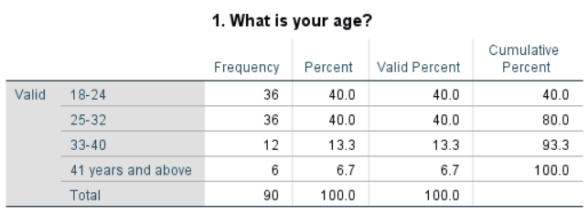
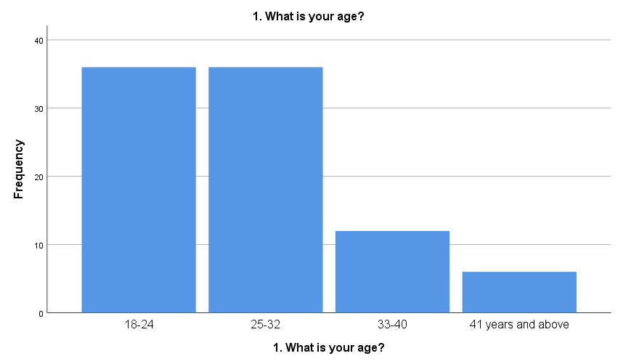
Figure 6: Responses to age
To maintain the efficiency of this research, the above figure reflected the participation of different people while assessing the role of data-driven strategies having a significant influence on the supply chain challenge especially in the UK agriculture sector. As a result of this, it is identified that people belong to the age group of 40 years and more. Out of the total participants age groups of 18-24 and 25-32 years contributed with 40%. It depicted that individuals are relying on the changes regarding supply chain management in agriculture firms and the majority of people belong to younger age categories. Furthermore, people of age groups of 33-40 contributed with 13.3% which is relatively low compared to the fresher participants in the agricultural industry of the UK. It depicts that, the industry is facing issues with maintaining integrity in actions while seeking suitable solutions regarding quality measures by enforcing data-driven decisions.
Question 2: How many years of experience do you have in the agriculture sector?
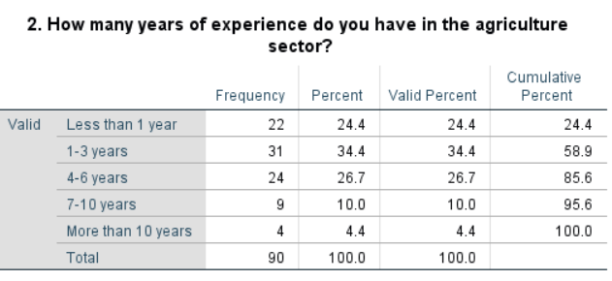
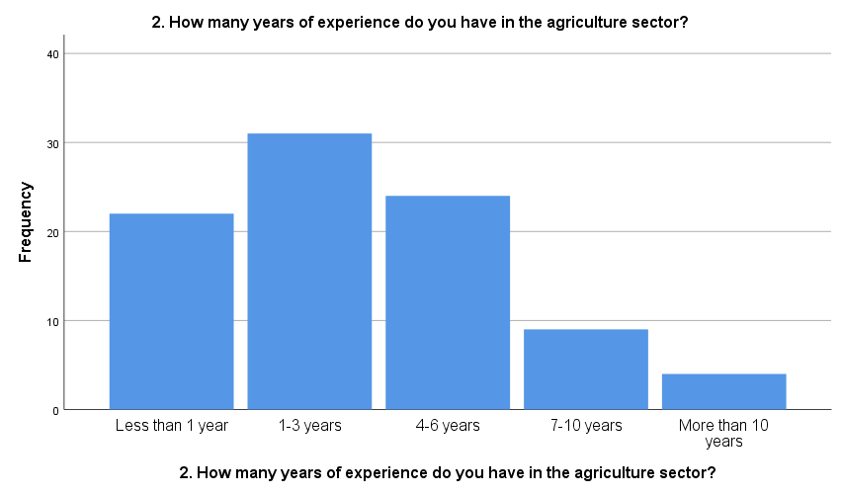
Figure 7: Responses to work experience
The above figure reflects on the work experiences gained in the UK’s agriculture sector directing on the challenges faced by individuals to cope with data-driven actions, especially in the supply chain resiliency. It reflected on the work experience data of workers associated with the industry from 1 year to more than 10 years. People belonging to the work experience group of 1-3 years are contributing with 23.4% contribution in the industry, which means that the UK’s agriculture industry is providing an opportunity to change adoption in their operations. Furthermore, people holding 4-6 years of work experience contributed with 26.7% share, which signified that the industry is providing exceptional potential to people to seek better opportunities. People working in the industry for more than 10 years are only 4% of the overall share, which means that firms are failing to integrate change regarding technology and innovative actions in their supply chain processes which directly influences the retention rates in the industry.
Question 3: Do you agree with the fact that data-driven strategies have significantly improved decision-making processes in the agriculture sector?
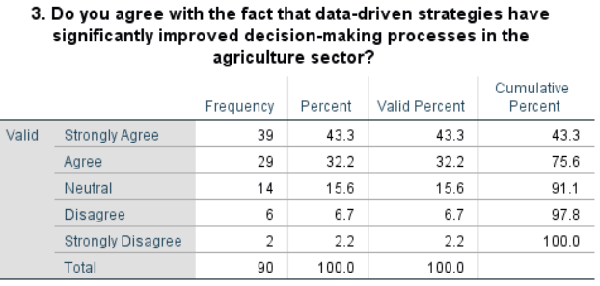
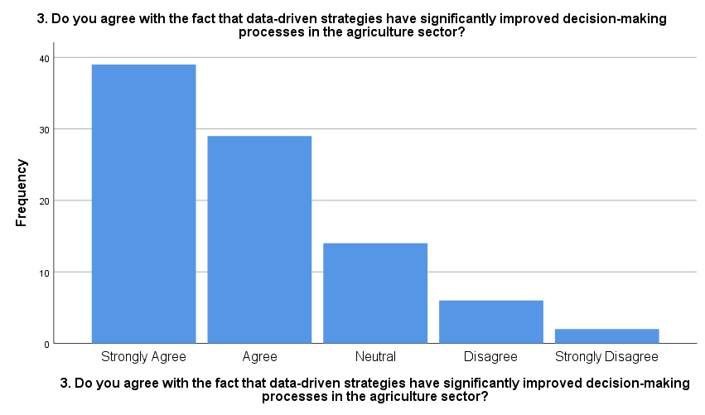
Figure 8: Responses to data-driven strategies in the supply chain of UK’s agriculture
From the above figure which reflects on the key participant's responses reflecting on the data-driven decision on the supply chain processes in the UK’s agriculture sector, around 43.3% of participants agreed with this statement. It defines that, adoption of data-driven actions need to be adopted on an immediate basis by UK’s agriculture firms are required to enforce change regarding technology integration in supply chain operations as this sector comprises major challenges regarding seamless deliveries. Furthermore, around 32.2% of people agree that data-driven actions need to be promoted by firms to maintain resiliency in their supply chain, which they sensed while working with companies integrating with technologies. Furthermore, 2% of contributors strongly disagreed with this and stated that firms are not required to entertain change by approaching data-driven activities in the supply chain processes. It directed that firms they are working with never engaged in adopting suitable tools and technologies in the supply chain processes in the UK’s agricultural sector.
Question 4: Do you think that the use of data analytics has enhanced the efficiency of supply chain management in your firm?
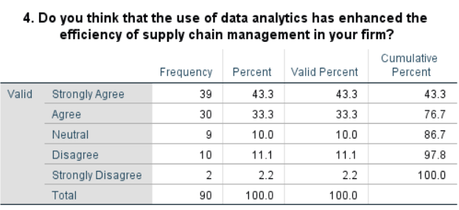
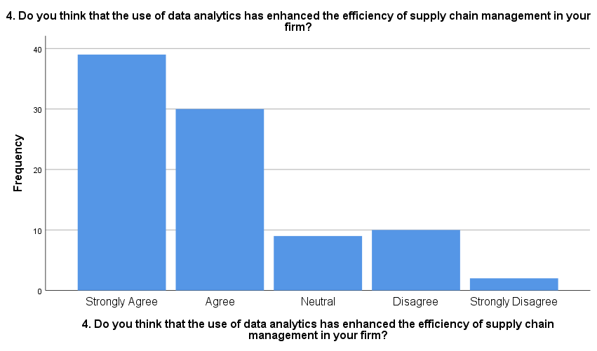
Figure 9: Responses to the use of data analytics in supply chain management
Reflecting on the key responses shown in the above figure regarding the use of data analytics in the supply chain processes, around 43.3 of the participants strongly agreed with this. It depicts that, they faced similar situations while working in the UK’s agriculture sector having major influences to adopt supply chain technologies to maintain a seamless work environment. Furthermore, 10% and 2.2% of people disagreed and strongly disagreed with this, which means that to some extent they faced issues in promoting data-driven and analytics processes while operating in the UK’s agriculture sector. It stated that where the majority of firms are integrating data analytics and technology strategies in the supply chain processes, some of them are not adopting these changes which negatively influences their ability to maintain resiliency in supply chain management. These operational flaws hinder individual firms' capability to maintain integrity and efficiency in actions when they are willing to entertain change regarding quality measures in the day-to-day business operations.
Question 5: Do you agree with the fact that data-driven approaches have led to better forecasting and planning in agricultural operations?
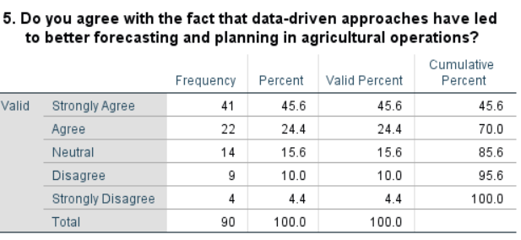
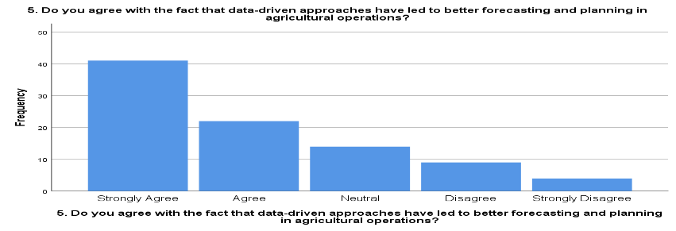
Figure 10: Responses to data-driven approaches leading to better forecasting and planning in agricultural operations
Reflecting on the above figure data, it is identified that 45.6% of people associated with the UK’s agriculture industry anticipated the change regarding data-driven action while promoting supply chain resiliency and fostering growth. It depicted that, firms they are working with have anticipated the active collaboration of technology-based change in the supply chain processes. Furthermore, 9% of participants disagreed with this and reflected that they never faced this situation while working with agriculture firms. It defines that some of the firms are not adopting sensible changes regarding data-driven approaches which significantly influence their capabilities to attain integrated growth. Lastly, around 4.4% of participants strongly disagreed with this, stating that they are working with companies that never opt for technology and data-driven action to maintain resiliency in their supply chain processes. This emerged as a challenging situation for those firms to attain growth in the UK’s agriculture sector.
Question 6: Do you agree that implementing data-driven strategies in the agriculture sector is challenging due to the lack of technological infrastructure?
The question represents that the frequency of people who strongly agree with the statement is 45 with 50.0 per cent and their cumulative per cent is also 50.0. In addition to this, the frequency of people which are only agreed is 23 with a percentage of 25.6 and their cumulative per cent is 75.6. The frequencies of neutral people are 12, disagree and strongly disagree are also 5. The total frequency of people is 90 with 100.0 per cent that acknowledging and answering the question during the survey.
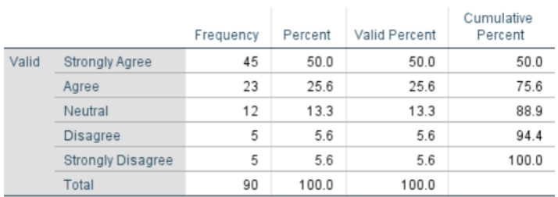
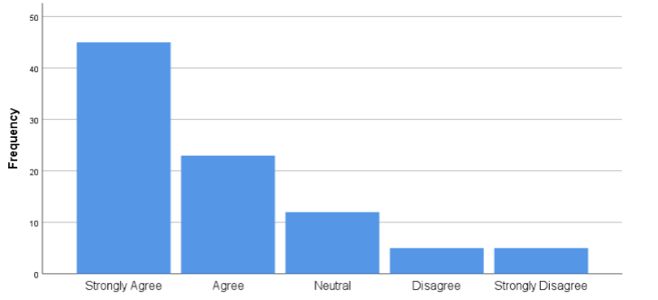
Figure 11: Analysis of data-driven strategies in the agriculture sector and the role of technological infrastructure
The above graph shows that people are strongly agree and concerned about the specific concept which is advanced technology infrastructure. In addition, agriculture businesses are facing issues in implementing data-driven strategies which have a significant impact on their market position due to a lack of technological infrastructure. The challenges can be acquisition cost, lack of standards, and lack of consistency and accuracy in the data can disrupt the process of implementing data-driven strategies due to a lack of technologies.
Question 7: Do you think that there is a shortage of skilled personnel to manage and interpret data within the agriculture sector?
According to the results, it can be analysed that the frequency of people who strongly agreed with the statement of skill shortage is the major issue in the agriculture sector. The frequencies of people with strongly agree statements are 43, agree are 24, neutral are 7, disagree are 12 and strongly disagree are 4 which shows that the overall collected frequencies are 90. The cumulative percentage of strongly agree is 47.8, agree is 74.4, neutral is 82.2, disagree is 95.6 and strongly disagree is 100.0.
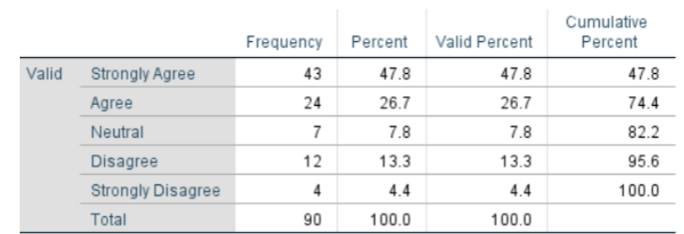
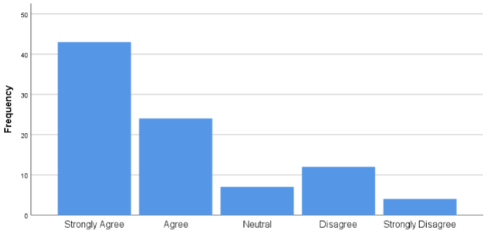
Figure 12: Shortage of skilled personnel to manage and interpret data within the agriculture sector
It can be identified that people strongly agree with the shortage of skilled personnel to manage and interpret data within the agriculture industry statement. People agree with the statement that skilled shortage is a major issue in the agriculture business which can negatively impact the management and interpretation of data in an authentic manner.
Question 8: In your opinion does the cost of adopting data-driven strategies is a significant barrier for the agriculture industry?
The frequency of people who strongly agree with this statement of adoption cost in the data-driven strategies is 38 and their per cent is 42.2. The frequency of people during the survey on the agreed point is 28, and neutral is 16. Disagree are 3 and strongly disagree are 5. The mean of this statement answered by people is 1.9889, the median is 2.0000 and the mode is 1.00.
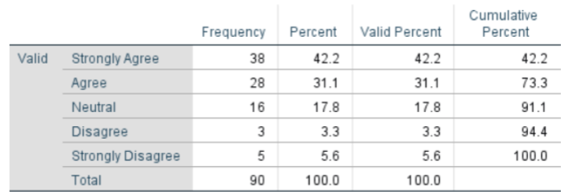
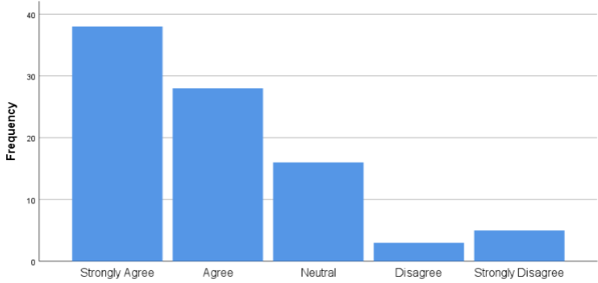
Figure 13: Evaluation of the cost of adopting data-driven strategies for the agriculture industry
The results indicate that the cost of implementing data-driven strategies is challenging for the agriculture sector as the issues involve initiative investments, maintenance costs, limited technological infrastructure, lack of tools and lack of access to resources. These issues can heavily impact the decision-making and data-driven strategies implementation in the agriculture industry.
Question 9: Do you agree with the statement that data-driven strategies play a crucial role in enhancing the sustainability of the agriculture sector in the future?
From the overall result, it can be identified that people who strongly agree with the question are 39 with a cumulative per cent of 43.3 while the people who only agree are 24 with 70.0 cumulative per cent. In addition, the people who think that data-driven strategies are not very efficient in enhancing sustainability within the agriculture sector come in a neutral state with a frequency of 13. The audience who disagreed with the statement that data-driven strategies are not efficient for fostering sustainable business came in disagree and strongly disagree level with 12 and 2 frequencies. The mean, median and mode can be calculated on the basis of responses collected from the people are 2.0444, 2.0000 and 1.00.
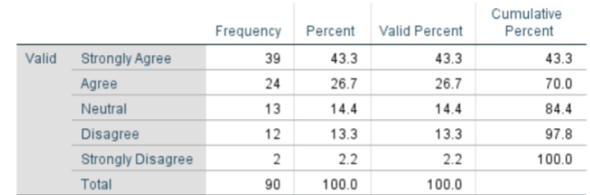
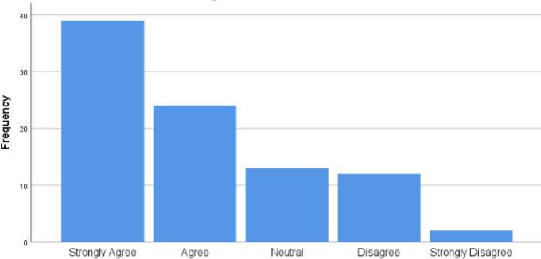
Figure 14: Data-driven strategies are efficient in enhancing the sustainability of the agriculture sector in the future
From the above figure, it can be examined that data-driven strategies such as data and analytics, farm management software, big data, automation, precision agriculture and weather sensors. These strategies based on the data-driven concept play a crucial and efficient role in enhancing the sustainable environment across the globe within the agriculture industry in the future.
Question 10: Do you think that there is potential for increased use of data-driven strategies to improve supply chain resilience in the agriculture sector?
From the survey, it can be measured that the percentage of people who responded to the statement and answered the question is around 50. From this percentage, it can be assessed that people who neutrally respond to the statement are 11 with 88.9 cumulative per cent as they think that the potential is neutral for increasing data-driven strategies. The mean of the audiences for this statement is 2.0222, the median is 2.0000 and the mode is 1.00.
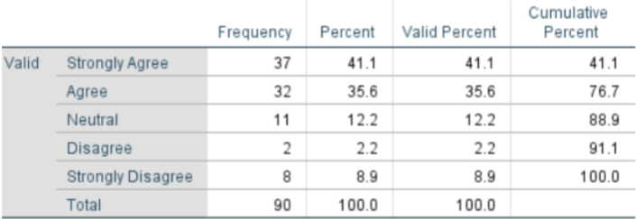
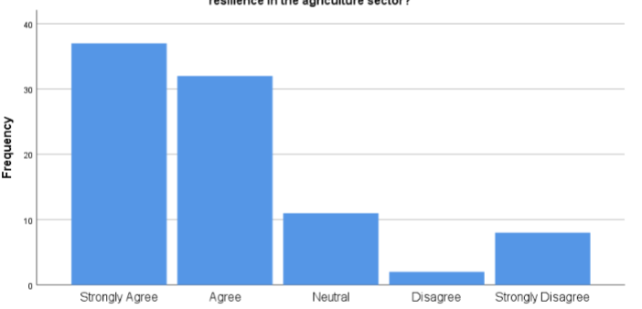
Figure 15: Potential for increased use of data-driven strategies to improve supply chain resilience in the agriculture sector
It can be acknowledged that the increment in the awareness of the usage of data-driven strategies and concepts has the potential to maintain the supply chain of a business. Further, the data-driven strategies in the agriculture business are efficient and beneficial for increasing profitability and improving the resilience of the agriculture business supply chain. Furthermore, the data-driven strategies make the process efficient for the agriculture business to handle the obstacles which disrupt their supply chain.
Question 11: In your opinion, what is the most significant future potential of data-driven strategies in agriculture?
The collected responses involve four options for people to select an appropriate answer which suits their opinions and satisfies their requirements. Those options are enhancing sustainability, improving supply chain efficiency, optimising resource allocation, and predicting market trends. Further, people are collaboratively and majorly focused on one point which is enhancing sustainability which is the future potential in the data-driven strategies in the agriculture business, the total responses are 40. The most significant potential of the data-driven strategies in the agriculture business, apart from sustainability, people also responded to improving supply chain efficiency options with 31 frequencies. The calculated mean for this question and responses is 1.8222, the median is 2.0000 and the mode is 1.00.
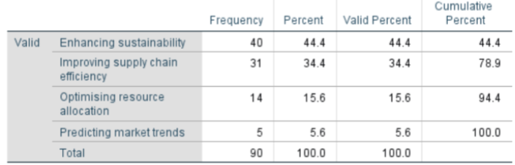
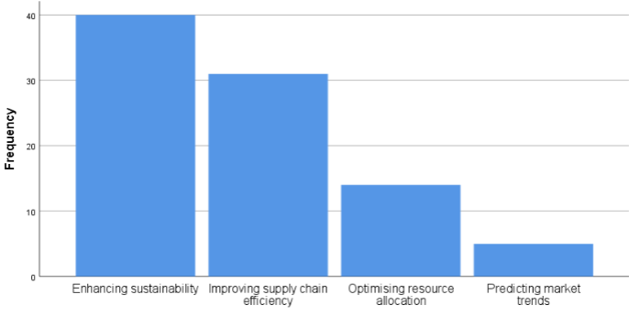
Figure 16: Future potential of data-driven strategies in agriculture
From the above chart, it can be understood that people do not agree on the predicting market trend option as compared to sustainability enhancement. Data-driven strategies have the potential to help the business to adopt strategies for developing their sustainable business while improving their efficiency of supply chain to gain a competitive advantage.
Question 12: Which data-driven strategy do you believe would most benefit your organisation in adapting to supply chain challenges?
This question involves four options for people to answer by selecting one appropriate or suitable answer. Those options are advanced analytics for demand forecasting, real-time data monitoring, predictive maintenance of equipment and data-driven resource allocation. The frequency of people who chose advanced analytics for demand forecasting and real-time data monitoring are same which is 33. Moreover, the mean of this question can be calculated as 2.0222, medina is 2.0000 and mode is 1.00ª.
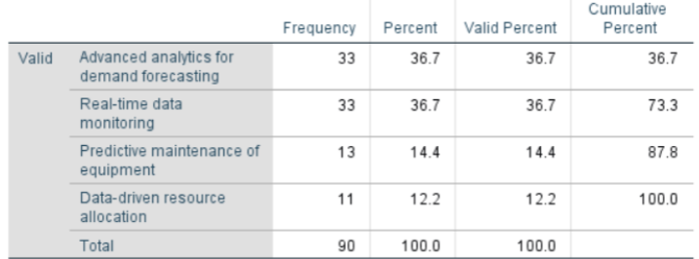
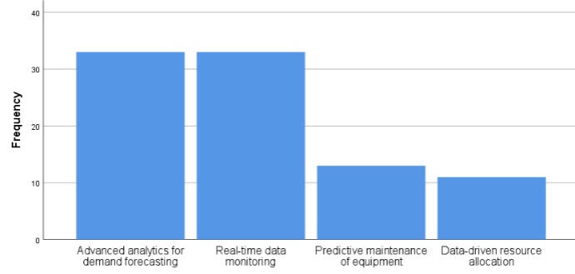
Figure 17: Beneficial data-driven strategies for organisations for adapting to supply chain challenges
It can be demonstrated that data-driven strategies can help the firm improve its efficiency while improving its supply chain to mitigate the issues effectively. Further, advanced analytics and real-time data monitoring are the major category which was chosen by the people that can help the agriculture sector mitigate its supply chain challenges. Predictive maintenance and data-driven resource allocation are the general strategies which have a poor impact and efficiency on the agriculture business as compared to other factors.

4.5.1 Correlation and Regression Analysis

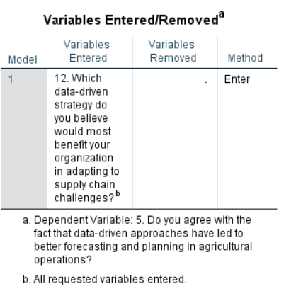
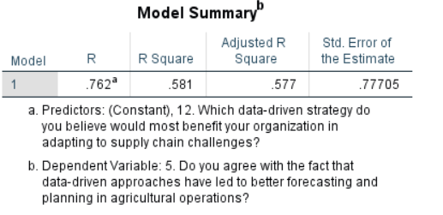
Figure 18: Results of Regression Analysis
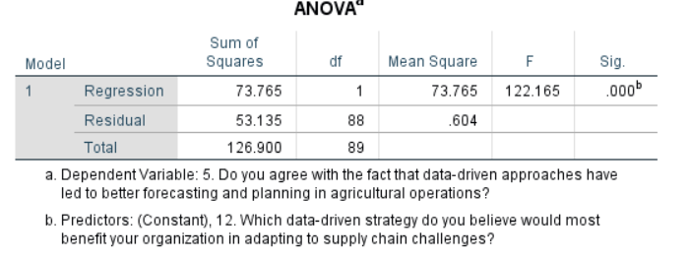
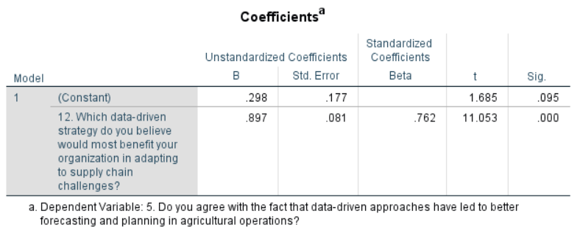
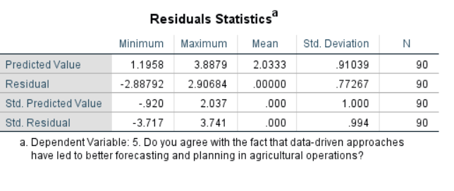
Figure 19: Results of Regression Analysis
From the above figure, it is identified that data-driven decision-making plays a significant role in the current supply chain processes followed by the firms operating in the UK’s agriculture industry. The information depicted through independent and dependent variable analysis shows a significant influence of data-driven actions in the supply chain challenges. The significant values calculated through the regression analysis calculated to generate the results within the 0.01 range reflect on the linear variable analysis processes. It drives the results by depicting the strong relation among the data-driven technologies used by firms to maintain efficiency and minimise the challenges in the supply chain processes. Furthermore, the ‘R’ value reflects that 76.2% define that firms have major opportunities to integrate data-driven actions while engaging in the supply chain management processes in the agriculture sector. Moreover, the ‘R Square’ value is 0.581, stating that approaching efficient data-driven strategies drives businesses towards exception growth by motivating resiliency in their supply chain processes.
Furthermore, reflecting on the coefficient data gathered by communicating with diverse people associated with the UK’s agriculture sector, data-driven decision-making positively influences smoothness in the supply chain processes. In support of this, the value of operational efficiency and likelihood of chances accounted for 89.7 which shows that data-driven decision provides extensive facilities for firms to maintain integrity in their supply chain processes. Hence, this analysis reflects on the positive support of Hypothesis H0 supporting the data-driven decision has a major influence on the decision-making processes in the supply chain management actions. It is stated because the selected variable for dependent and independent variables shows positive by enforcing correlation between both the variables. It helps in concluding that data-driven decision significantly influences the operational efficiency of firms operating in the UK’s agriculture sector and willing for long-term success.
Summarising the overall findings from the primary methods, answering the research question emphasising that data-driven strategies have a major influence on agriculture firms' capabilities and direct them to entertain technological development. It appreciated the firm’s capability to promote resiliency in their supply chain technology adoption strategies enforcing long-term growth of firms in agriculture growth perspectives. The overall findings of secondary methods, answer the research questions in which the data-driven strategies are mentioned for making informed decisions to improve the performance of the supply chain within the agriculture business. Big data and blockchain have a positive impact on the decision-making and supply chain of the agriculture sector. Furthermore, the circular economy is suggested to the industry to improve their sustainable supply chain performance efficiency while implementing data-driven approaches effectively.

Chapter 5: Discussion
From the literature review, the authors Yadav, et al., (2021), define that in order to improve the sustainability and attractiveness of the agriculture business in the market the management of performance is important. Technological advancement plays a vital role in the market as it helps in the agriculture supply chain by acquiring technologies such as blockchain, big data and the Internet of Things. According to Raji, et al., (2024), advanced analytics is a helpful data-driven strategy for improving the decision-making procedure with the help of in-depth information about data-driven to optimise the risk management and operation process. With the help of resource-based view (RBV) theory it is identified that agriculture firm enabled a precision farming strategy to understand the better use of precision and help the firm understand the overall usage of accuracy and harvests. Similarly, from the findings of secondary data collection, it can be identified that the heavy investment in the technology aspect helps in making informed decisions. Supply chain visibility, virtual supply chain development and other factors are helpful for precision farming which enhances the production process, minimises food wastage and enables sustainable sourcing. From the findings of primary data collection people strongly agree with the fact that data-driven strategies improve the decision-making process within the agriculture business.
The study conducted by Paul, et al., (2022), it can be defined that data-driven strategies provide several benefits to the agriculture sector and farmers in several manner. Data-driven strategies help in utilising and acknowledging real-time data to make informed decisions which is beneficial for improving the practices related to technological infrastructure and maximise profitability. The force field theory depicted those advanced analytics helps in improving the decision-making strategy within the data-driven concept through optimal resource allocations. This is because the ideal resource allocation can be forecast through crop gathering which is based on soil, weather and farming initiatives. The strategies of data-driven help in the decision-making procedure for farmers of crop selection, pest management, post-harvest events and technological advancement.
On the contrary, from the findings of secondary data, it can be defined that sustainable supply chain management helps in business productivity. For effective performance of the business by waste reduction, performance measurement, learnings and business continuousness are the factors which use the digital technologies. Advanced analytics helps in increasing productivity while improving the procedures of the agriculture sector across the UK. From the primary data collection findings, it can be understood that data analytics enhanced the efficiency of supply chain management. In addition, from the responses, it was examined that people strongly agree with the statement that the implementation of data-driven strategies in the agriculture sector is challenging. This challenge occurs in the industry due to the lack of technological infrastructure.
As per the views of Ingram, et al., (2020), the factors which affect the adoption of data-driven approaches are the appropriate capabilities of the inadequate technology. Reflecting on the enhanced production and productivity it depicted that limited access to digital resources is the main issue for the low adoption of emerging technologies because farmers are not expected to operate information technology and management solutions for the production of agriculture which is left fixed in conventional practices. In the views of Wolfert et al., (2018), skill deficiency is the main barrier among the farmers which impacts the integration into the agriculture sector. Considering the findings of primary data, it can be measured that people responded strongly agree with the statement of shortage of skills and its impact on the management and interpretation of data within the agriculture industry. Similarly, for this issue, the author suggested that Explainable Artificial Intelligence, big data and smart technologies are helpful for smart farming systems and overcoming issues in smart farming.
According to Araújo, et al., (2021), the future avenues for the agriculture sector are government support in terms of financials, emerging technologies and market expansion. The advancement in the technologies is precision agriculture which is utilised by the farmers in the agriculture sector. In addition to this, geographical information systems, sensors, artificial intelligence and more information have been collected and evaluated information about crops and plants. In the views of Yazdani, et al., (2021), the agriculture sector can make sure their adoption of eco-friendly and sustainable initiatives which can be done by making informed decisions effectively. For this process, the agriculture sector needs to consider factors such as economic, social and environmental to articulate the decisions for setting sustainable goals for reducing carbon emissions.
Similarly, from the findings of secondary data, the author suggested strategies for Industry 4.0 which can automate the efficiency of the supply chain. The circular economy and advanced technologies are beneficial for reducing carbon emissions and empowering sustainable supply chain management effectively. On the contrary, from the responses of people from the findings of primary data, it can be described that data-driven approaches are best for forecasting and planning within the agriculture firm and its operations. Further, in the sustainable agriculture business, people strongly agree on enhancing sustainability options which is the future potential of data-driven strategies.

Chapter 6: Conclusion

6.1 Introduction
This chapter offers extensive knowledge regarding the key insights gained throughout the operations helping to summarise the key findings gathered with the help of literature review and data analysis processes towards selected areas of analysis. It emphasises the key findings influenced by data-driven decisions having significant contributions in the supply chain management processes to implicate the change regarding efficiency analysis. To deal with the identified issues, this chapter further continued by recommending strategic actions to minimise the challenges in supply chain processes through efficient data-driven choices.

6.2 Conclusion
Reflecting on the major analysis of Objective 1 results, it is concluded that rising inefficiencies in the supply chain processes hinder the agriculture sector's reliance on effectively utilising the resources. The theoretical perspective defined through resource-based view theory resulted in leveraging the changes regarding resourcing compatibility and providing financial advantages. It has a major influence on minimising the risk regarding environmental, and climate situations and conflicting situations faced by the agriculture sector in their supply chain processes. Directing the change regarding data-driven actions is perceived as the most suitable solution for this sector, as it motivates to use of technologies like IoT, and data analytics to forecast the market demands. These techniques are directing firms to make smart choices especially while seeking better resource allocation and material needs fulfilment in the agriculture sector.
Following the key major findings of discussion, it focused on the technology upgradation in the supply chain management processes and emphasised the use of data-driven approaches as it helps to make decisions feasible for the environment as well as for the producers. It helps agriculture firms to entertain changes regarding smart decision-making by considering viability, accountability and process monitoring strategies in the supply chain operations. It motivates the firms to entertain change in their infrastructure helps to deliver the goods and services at the desired places and encourages overall competitive edge for firms in operational sectors.
Continuing this, Objective 2 is focused on critically analysing the data-driven actions followed by the firm and their influence on increasing the overall capabilities of farmers to gain optimum outputs through informed decisions. It defines that data-driven strategies are helping crop producers to consciously use the water source, fertilizers, and pesticides motivating them to increase productivity and minimise the environmental wastes. To fulfil the needs of real-time tracking, data analytics and activity monitoring processes data-driven technologies and approaches facilitate the change regarding resilient processing in the supply chain processes. It resulted in a beneficial contribution towards risk mitigation by promoting sequential processing of day-to-day actions especially to maintain seamless operations in the supply chain network.
Following the key findings, it is identified, that increasing the use of technology-based sources and tools in the farming sector, helps crop producers to maintain integrity in decisions by gaining insights regarding market demand. Especially in the UK’s agriculture sector, government support is also helping the people to integrate changes in their resourcing strategies and motivating competency in their supply chain processes. It defined that with the help of suitable technological upgrades agriculture sector operators promoted conscious production and calculated distribution approaches. This technique benefited them in entertaining sustainability in sourcing helping to contribute to the overall success of maintaining resiliency in the agri-food industry and promoting the change in supply chain processes in the UK’s agriculture sector.
Objective 3 defined that following the data-driven tactics has a major influence on the agriculture processing of firms to cope with revolutionised strategies influencing the decisions directed to the use of technological approaches. Factors like IoT, big data analytics, and predictive analysis approaches have a major influence on the producer’s capabilities to finalise the crop section, pest management and resource allocation to incorporate with the key harvesting needs. It defined that data-driven actions in the agriculture sector have a major influence on promoting productivity, cost minimisation and profitability margin elevation contributing to overall success. The major actions performed by the agriculture firm are manually done which increased their efforts to gain optimum results which somehow increased the chaos in their supply chain processes. These incidents increased the challenges for the UK’s agriculture firms to maintain resiliency in actions to empower change in maintaining the quality and efficiency of product and distribution processes.
Following the key findings, it is identified that data-driven decisions are empowering the firms to maintain resiliency in actions while engaging in the counterparts of the market. This has a significant contribution to agriculture sector actions to gain insights regarding market conditions, forecasting the weather patterns impacting their structural processing in the supply chain activities. Furthermore, the inadequacy in the post-crop activities is hindered by the inadequacies in the supply chain management which can effectively be minimised by adopting change regarding technology and data-driven dynamics. These changes could significantly influence the agriculture sector's ability to maintain long-term growth.
Furthermore, in Objective 4, it is identified that implementing the data-driven dynamics has a major influence on the agriculture sector's actions to adopt the changes to deal with substantial challenges. Technology upgrades and data-driven actions are approached through big data, blockchain and AI strategies optimising firms' capabilities to maintain integrity. These actions motivate the farmers to cope with margins and profitability attributes influencing firms' capabilities to maintain productivity levels. Following the key findings, inadequacies in technological development and higher costs of infrastructural alteration have a major influence on the wider operational spectrum in the agriculture sector. Following this, the supply chain management processes emerged with the deficiencies to handle challenges like inadequate resourcing, data integrity and innovation constraints. This has a major influence on the overall growth and efficiencies of the UK’s agriculture sector to intensify changes regarding global demand for quality sources.
Objective 5 reflected that the increased population have significantly contributed to the demand for food sources which emerged as an immense opportunity for the UK’s agriculture sector businesses to adopt suitable alternatives. Factors like continuous innovation, revenue stream expansion and compatible financial support are helping the industry to approach data-driven action and motivating them to promote resiliency in their supply chain processes. It contributes to the overall competencies of firms to follow environmental techniques, especially in their distribution network which is influenced by the resiliency attributes of supply chain management processes. Furthermore, the key findings reflect that firms are anticipating the change regarding technological integration, motivating them to follow sustainability goals by addressing the challenges in day-to-day operations. It directs to handle the unfavourable situations that occur while approaching the changes regarding data-driven actions, especially in their supply chain management processes. Technology and resource-based alteration are motivating firms to gain a competitive position in the dynamic world.

6.3 Recommendation
In the current scenario of the UK’s agriculture sector operations, the operators are trying to maintain resiliency and compatibility in actions by approaching data-driven actions, especially in their supply chain processes. Even though they tried hard to maintain integrity in their actions, somehow, they failed to gain a competitive advantage. To promote suitable alteration, the key recommendations are highlighted in further discussion.
Investment in digital infrastructure development: Focusing on the current situation of the UK’s agriculture sector, they encountered challenges to maintain viability in financial actions. Adopting the change towards digital development can effectively be approached by integrating change in supply chain processes (Yang, et al., 2021). Considering this, firms can anticipate the change by promoting connectivity, and seamless transaction of supply chain processes. These actions can direct the firms to deploy the changes regarding real-time decision-making motivating sustainability in the key agriculture operations. These changes can help the agriculture sector to build an uninterrupted supply chain network and gain competitive positions in the regional as well as global context.
Enhanced training and data literacy: Data-driven decisions are highly influenced by the individual’s capability to gain knowledge and understand the uses of advanced tools and techniques. It directs them to engage in learning that promotes digital literacy and encourages them to use technology-focused tools specially developed for data and information management. To increase this learning, the agriculture sector can promote training and development sessions to promote digital knowledge and data literacy among responsible participants (Bampasidou, et al., 2024). This will direct the farmers to use precedent farming techniques and appreciate the suitable transportation medium for safer delivery of agricultural goods. Through these actions, the firm can promote resiliency in educating the farmers and encourage them to access the technology-centric tool, especially in their supply chain processes, as it will direct them to handle the challenge and help to build a competitive business.
Promotion of sustainable agriculture policies: Following the case of the UK’s agriculture sector, the firm is facing issues in managing resiliency in supply chain management because of inadequate technology development. This can effectively be handled by promoting sustainable farming and product-delivering strategies by adopting data-driven insights, reduced water uses, and conscious use of pesticides and fertilizers. To build a competitive business, the agriculture sector firms must integrate sustainability policies, as they direct the business towards positive results (German, et al., 2020). Through this, agriculture sector businesses can adopt suitable technologies to direct the businesses towards advanced technology adoption and motivating technological expertise. Following these changes will surely help the UK’s agriculture firm to build an ethical business which can be motivated by approaching technological upgradation and aligning the core objective of business parallel to the agriculture sector policies. This will direct the firms to maintain integrity and efficiency in actions and promote overall competitiveness.
Adoption of supply chain transparency and traceability analysis techniques: In the current market scenario of the UK’s agriculture sector, companies are trying to approach technological upgrades especially to promote data-driven actions. To continue this development, they can approach the strategic changes that can contribute to the overall development of the industry by promoting transparency and traceability of day-to-day business actions. Following the market opportunities in the UK’s agriculture sector, firms have a greater opportunity to adopt changes in their supply chain by adopting suitable technologies like AI, IoT, data analytics and market dynamic analysis tools to gain insight into market demand. Maintaining resiliency in the supply chain product distribution network becomes an essential trait for companies to gain a competitive position in operational sectors (Tarigan, et al., 2021). Further, development through these technologies can help the firms to improvise transparency in their supply chain management processes and promote the timely delivery of goods and services at desired locations. By approaching these alternative actions, companies can build a competitive business capable to improvise continuously improving and maintaining overall competition in target markets.

6.4 Future Research Strategies
Reflecting on the key measure considered in this research, it is identified that it has some scope for improvement regarding the theoretical underpinning and gaining useful insights. Considering the research topic, it approached mixed methods, and to some extent, it created confusion in gathering relevant insight. Regarding the future perspective, the research could be conducted by following the qualitative methods which can majorly focus on the secondary data sources. This resourcing will help to gather more relevant and concise information considering the research topics and direct the responsible people to maintain integrity in research by underpinning the changes towards data-driven actions influencing the supply chain management process and identifying the challenges hindering the overall capabilities of the UK’s agriculture sector.

References
Al-Ababneh, M. (2020) Linking ontology, epistemology and research methodology. Science & Philosophy, 8(1), pp. 75-91.
Araújo, S.O., Peres, R.S., Barata, J., Lidon, F. and Ramalho, J.C. (2021) Characterising the agriculture 4.0 landscape—emerging trends, challenges and opportunities. Agronomy, 11(4), p. 667.
Bachmann, N., Tripathi, S., Brunner, M. and Jodlbauer, H. (2022) The contribution of data-driven technologies in achieving the sustainable development goals. Sustainability, 14(5), p. 2497.
Bag, S., Srivastava, G., Cherrafi, A., Ali, A. and Singh, R.K. (2024) Data‐driven insights for circular and sustainable food supply chains: An empirical exploration of big data and predictive analytics in enhancing social sustainability performance. Business Strategy and the Environment, 33(2), pp. 1369-1396.
Bampasidou, M., Goldgaber, D., Gentimis, T. and Mandalika, A. (2024) Overcoming ‘Digital Divides’: Leveraging higher education to develop next generation digital agriculture professionals. Computers and Electronics in Agriculture, 224, p.109181.
Barnes, A. P., Soto, I., Eory, V., Beck, B. and Moran, D. (2020) Assessing the economic viability of climate change mitigation measures in Scottish agriculture. Journal of Cleaner Production, 254, pp. 120-135.
Bartkowski, B. and Bartke, S. (2018) Leverage points for governing agricultural soils: A review of empirical studies of European farmers’ decision-making. Sustainability, 10(9), p. 3179.
Bergmann, J. (2023) Research Philosophy, Methodological Implications, and Research Design. In At Risk of Deprivation: The Multidimensional Well-Being Impacts of Climate Migration and Immobility in Peru (pp. 57-89). Wiesbaden: Springer Fachmedien Wiesbaden.
Bhat, S.A. and Huang, N.F. (2021) Big data and ai revolution in precision agriculture: Survey and challenges. Ieee Access, 9, pp.110209-110222.
Bhatia, M.S., Chaudhuri, A., Kayikci, Y. and Treiblmaier, H. (2024) Implementation of blockchain-enabled supply chain finance solutions in the agricultural commodity supply chain: a transaction cost economics perspective. Production Planning & Control, 35(12), pp. 1353-1367.
Bruno Soares, M., Daly, M. and Dessai, S. (2018) Assessing the value of seasonal climate forecasts for decision‐making. Wiley Interdisciplinary Reviews: Climate Change, 9(4), p.e 523.
Calicioglu, O., Flammini, A., Bracco, S., Bellù, L. and Sims, R. (2019) The future challenges of food and agriculture: An integrated analysis of trends and solutions. Sustainability, 11(1), p. 222.
Carter, S., Andersen, C., Stagg, A. and Gaunt, L. (2023) An exploratory study: Using adapted interactive research design and contributive research method. The Journal of Academic Librarianship, 49(1), p. 102620.
Chauhan, A., Brouwer, B. and Westra, E. (2022) Robotics for a quality-driven post-harvest supply chain. Current Robotics Reports, 3(2), pp. 39-48.
Chen, H.Y., Sharma, K., Sharma, C. and Sharma, S. (2023) Integrating explainable artificial intelligence and blockchain to smart agriculture: Research prospects for decision making and improved security. Smart Agricultural Technology, 6, p.100350.
De Roest, K., Ferrari, P. and Knickel, K. (2018) Specialisation and economies of scale or diversification and economies of scope? Assessing different agricultural development pathways. Journal of rural studies, 59, pp. 222-231.
Dias, C., Gouveia Rodrigues, R. and Ferreira, J.J. (2021) Small agricultural businesses' performance—What is the role of dynamic capabilities, entrepreneurial orientation, and environmental sustainability commitment?. Business Strategy and the Environment, 30(4), pp. 1898-1912.
Duckett, T., Pearson, S., Blackmore, S., Grieve, B., Chen, W.H., Cielniak, G., Cleaversmith, J., Dai, J., Davis, S., Fox, C. and From, P. (2018) Agricultural robotics: the future of robotic agriculture. arXiv preprint arXiv 18(6) pp. 06762.
Dzwigol, H. (2022) Research methodology in management science: Triangulation. Virtual Economics, 5(1), pp. 78-93.
Elufioye, O.A., Ike, C.U., Odeyemi, O., Usman, F.O. and Mhlongo, N.Z. (2024) Ai-Driven predictive analytics in agricultural supply chains: a review: assessing the benefits and challenges of ai in forecasting demand and optimizing supply in agriculture. Computer Science & IT Research Journal, 5(2), pp.473-497.
Fenz, S., Neubauer, T., Friedel, J.K. and Wohlmuth, M.L. (2023) AI- and data-driven crop rotation planning. Computers and Electronics in Agriculture, 212.
Franks, J.R. (2022) UK Agriculture at a Crossroads. Outlook on Agriculture, 51(4), pp. 448-459.
German, L.A., Bonanno, A.M., Foster, L.C. and Cotula, L. (2020) “Inclusive business” in agriculture: Evidence from the evolution of agricultural value chains. World Development, 134, p.105018.
Hamidoğlu, A. (2024) A game-theoretical approach on the construction of a novel agri-food supply chain model supported by the government. Expert Systems with Applications, 237, p. 121353.
Hatanaka, M., Konefal, J., Strube, J., Glenna, L. and Conner, D. (2022) Data‐driven sustainability: Metrics, digital technologies, and governance in food and agriculture. Rural Sociology, 87(1), pp. 206-230.
Ingram, J., Maye, D., Wheeler, R. and Kirwan, J. (2020) Migrant workers in the UK food supply chain: A labour geography perspective. Journal of Rural Studies, 76, pp. 1-10.
Islam, M.N., Islam, M.S., Islam, M.N. and Islam, M.S. (2020) Data collection and analysis. Islam and Democracy in South Asia: The Case of Bangladesh, pp. 49-65.
Ivanov, D., Dolgui, A., Das, A. and Sokolov, B. (2019) Digital supply chain twins: Managing the ripple effect, resilience, and disruption risks by data-driven optimization, simulation, and visibility. Handbook of ripple effects in the supply chain, pp. 309-332.
Kamble, S.S. and Gunasekaran, A. (2020) Big data-driven supply chain performance measurement system: a review and framework for implementation. International journal of production research, 58(1), pp. 65-86.
Kamble, S.S., Gunasekaran, A. and Gawankar, S.A. (2020) Achieving sustainable performance in a data-driven agriculture supply chain: A review for research and applications. International Journal of Production Economics, 219, pp.179-194.
Kasera, R.K., Gour, S. and Acharjee, T. (2024) A comprehensive survey on IoT and AI-based applications in different pre-harvest, during-harvest and post-harvest activities of smart agriculture. Computers and Electronics in Agriculture, 216, p. 108522.
Khan, N., Ray, R.L., Sargani, G.R., Ihtisham, M., Khayyam, M. and Ismail, S. (2021) Current progress and future prospects of agriculture technology: Gateway to sustainable agriculture. Sustainability, 13(9), p. 4883.
Klerkx, L., Jakku, E. and Labarthe, P. (2019) A review of social science on digital agriculture, smart farming and agriculture 4.0: New contributions and a future research agenda. NJAS-Wageningen Journal of Life Sciences, 90, pp. 100-112.
Lawson, B., Potter, A., Pil, F.K. and Holweg, M. (2019) Supply chain disruptions: the influence of industry and geography on firm reaction speed. International Journal of Operations & Production Management, 39(9/10), pp. 1076-1098.
Lezoche, M., Hernandez, J.E., Díaz, M.D.M.E.A., Panetto, H. and Kacprzyk, J. (2020) Agri-food 4.0: A survey of the supply chains and technologies for the future agriculture. Computers in industry, 117, p. 103187.
Li, Q. and Liu, A. (2019) Big data-driven supply chain management. Procedia CIRP, 81(2019), pp. 1089-1094.
Liang, C. and Shah, T. (2023) IoT in agriculture: The future of precision monitoring and data-driven farming. Eigenpub Review of Science and Technology, 7(1), pp. 85-104.
Linaza, M.T., Posada, J., Bund, J., Eisert, P., Quartulli, M., Döllner, J., Pagani, A., G. Olaizola, I., Barriguinha, A., Moysiadis, T. and Lucas, L. (2021) Data-driven artificial intelligence applications for sustainable precision agriculture. Agronomy, 11(6), p. 1227.
Mahroof, K., Omar, A. and Kucukaltan, B. (2022) Sustainable food supply chains: overcoming key challenges through digital technologies. International Journal of Productivity and Performance Management, 71(3), pp.981-1003.
Mazhar, S.A., Anjum, R., Anwar, A.I. and Khan, A.A. (2021) Methods of data collection: A fundamental tool of research. Journal of Integrated Community Health (ISSN 2319-9113), 10(1), pp. 6-10.
McGrath, T.A., Alabousi, M., Skidmore, B., Korevaar, D.A., Bossuyt, P.M., Moher, D., Thombs, B. and McInnes, M.D. (2017) Recommendations for reporting of systematic reviews and meta-analyses of diagnostic test accuracy: a systematic review. Systematic reviews, 6, pp.1-15.
Medeiros, M.M.D. and Maçada, A.C.G., (2022) Competitive advantage of data-driven analytical capabilities: the role of big data visualization and of organisational agility. Management Decision, 60(4), pp. 953-975.
Moshood, T.D., Nawanir, G., Sorooshian, S. and Okfalisa, O. (2021) Digital twins driven supply chain visibility within logistics: A new paradigm for future logistics. Applied System Innovation, 4(2), p. 29.
Mulisa, F. (2022) When Does a Researcher Choose a Quantitative, Qualitative, or Mixed Research Approach?. Interchange, 53(1), pp. 113-131.
Oyedijo, A., Francois Koukpaki, A.S., Kusi-Sarpong, S., Alfarsi, F. and Yang, Y. (2022) Restraining forces and drivers of supply chain collaboration: evidence from an emerging market. Supply Chain Management: An International Journal, 27(3), pp. 409-430.
Pascaris, A.S., Schelly, C. and Pearce, J.M. (2020) A first investigation of agriculture sector perspectives on the opportunities and barriers for agrivoltaics. Agronomy, 10(12), p.1885.
Pathiranage, Y.L., Jayatilake, L.V. and Abeysekera, R. (2020) Case study research design for exploration of organisational culture towards corporate performance. Review of International Comparative Management, 21(3), pp. 361-372.
Paul, K., Chatterjee, S.S., Pai, P., Varshney, A., Juikar, S., Prasad, V., Bhadra, B. and Dasgupta, S. (2022) Viable smart sensors and their application in data driven agriculture. Computers and Electronics in Agriculture, 198, p. 107096.
Popenoe, R., Langius-Eklöf, A., Stenwall, E. and Jervaeus, A. (2021) A practical guide to data analysis in general literature reviews. Nordic journal of nursing research, 41(4), pp.175-186.
Raji, E., Ijomah, T.I. and Eyieyien, O.G. (2024) Data-Driven decision-making in agriculture and business: The role of advanced analytics. Computer Science & IT Research Journal, 5(7), pp.1565-1575.
Rose, D. C. and Chilvers, J. (2020) Agriculture 4.0: Broadening responsible innovation in an era of smart farming. Frontiers in Sustainable Food Systems, 4, pp. 1-8.
Rose, D.C., Wheeler, R., Winter, M., Lobley, M. and Chivers, C.A. (2021) Agriculture 4.0: Making it work for people, production, and the planet. Land use policy, 100, p. 104933.
Rotz, S., Gravely, E., Mosby, I., Duncan, E., Finnis, E., Horgan, M. and Fraser, E. (2019) Automated pastures and the digital divide: How agricultural technologies are shaping labour and rural communities. Journal of Rural Studies, 68, pp. 112-122.
Rustia, D.J.A., Chiu, L.Y., Lu, C.Y., Wu, Y.F., Chen, S.K., Chung, J.Y., Hsu, J.C. and Lin, T.T. (2022) Towards intelligent and integrated pest management through an AIoT‐based monitoring system. Pest Management Science, 78(10), pp. 4288-4302.
Saiz-Rubio, V. and Rovira-Más, F. (2020) From smart farming towards agriculture 5.0: A review on crop data management. Agronomy, 10(2), p.207.
Statista. (2024) Agriculture. [Online]. Available at: https://statista.com/markets/421/agriculture/ [Accessed on: 29th August 2024].
Suri, S. (2024) The importance of data in transforming agri-food systems. [Online]. Available at: https://www.orfonline.org/expert-speak/the-importance-of-data-in-transforming-agri-food-systems [Accessed on: 29th August 2024].
Taherdoost, H. (2022) What are different research approaches? Comprehensive Review of Qualitative, quantitative, and mixed method research, their applications, types, and limitations. Journal of Management Science & Engineering Research, 5(1), pp. 53-63.
Tarigan, Z.J.H., Siagian, H. and Jie, F. (2021) Impact of internal integration, supply chain partnership, supply chain agility, and supply chain resilience on sustainable advantage. Sustainability, 13(10), p.5460.
Taylor, P. (2022) Data-driven decision-making in global organisations 2018-2020. [Online]. Available at: https://www.statista.com/statistics/1235409/worldwide-data-driven-decision-making-companies/ [Accessed on: 29th August 2024].
Trivelli, L., Apicella, A., Chiarello, F., Rana, R., Fantoni, G. and Tarabella, A. (2019) From precision agriculture to Industry 4.0: Unveiling technological connections in the agri-food sector. British Food Journal, 121(8), pp. 1730-1743.
UK Parliament. (2023) Farm funding: implementing new approaches. [Online]. Available at: https://commonslibrary.parliament.uk/research-briefings/cbp-9431/ [Accessed on: 5th September 2024].
Ullah, H., Ahmed, N., Khan, N.A., Senkus, P., Borda, R.C. and Huamán, J.M.C. (2023) Data-driven Approach to Assessing the Sustainability of Agricultural Supply Chains: A Review of Frameworks and Methodologies. Journal of Food and Agricultural Technology Research, 2(01), pp.01-34.
Wang, F. and Xu, Y. (2022) Evolutionary game analysis of the quality of agricultural products in supply chain. Agriculture, 12(10), p. 1575.
Wheeler, R. and Lobley, M. (2021) Managing extreme weather and climate change in UK agriculture: Impacts, attitudes and action among farmers and stakeholders. Climate Risk Management, 32, p. 100313.
Wolfert, S., Ge, L., Verdouw, C. and Bogaardt, M. J. (2018) Big Data in Smart Farming–A review. Agricultural Systems, 153, pp. 69-80.
Yadav, S., Garg, D. and Luthra, S. (2021) Development of IoT based data-driven agriculture supply chain performance measurement framework. Journal of Enterprise Information Management, 34(1), pp. 292-327.
Yadav, V.S., Singh, A.R., Raut, R.D., Mangla, S.K., Luthra, S. and Kumar, A. (2022) Exploring the application of Industry 4.0 technologies in the agricultural food supply chain: A systematic literature review. Computers & Industrial Engineering, 169, p.108304.
Yang, M., Fu, M. and Zhang, Z. (2021) The adoption of digital technologies in supply chains: Drivers, process and impact. Technological Forecasting and Social Change, 169, p.120795.
Yazdani, M., Gonzalez, E.D. and Chatterjee, P. (2021) A multi-criteria decision-making framework for agriculture supply chain risk management under a circular economy context. Management Decision, 59(8), pp.1801-1826.
Yu, W., Chavez, R., Jacobs, M.A. and Feng, M. (2018) Data-driven supply chain capabilities and performance: A resource-based view. Transportation Research Part E: Logistics and Transportation Review, 114, pp. 371-385.
Zambon, I., Cecchini, M., Egidi, G., Saporito, M.G. and Colantoni, A. (2019) Revolution 4.0: Industry vs. agriculture in a future development for SMEs. Processes, 7(1), p. 36.

Appendix

Questionnaire
1. What is your age?
- 18-24
- 25-32
- 33-40
- 41 years and above
2. How many years of experience do you have in the agriculture sector?
- Less than 1 year
- 1-3 years
- 4-6 years
- 7-10 years
- More than 10 years
3. Do you agree with the fact that data-driven strategies have significantly improved decision-making processes in the agriculture sector?
- Strongly Agree
- Agree
- Neutral
- Disagree
- Strongly Disagree
4. Do you think that the use of data analytics has enhanced the efficiency of supply chain management in your firm?
- Strongly Agree
- Agree
- Neutral
- Disagree
- Strongly Disagree
5. Do you agree with the fact that data-driven approaches have led to better forecasting and planning in agricultural operations? (DEPENDENT)
- Strongly Agree
- Agree
- Neutral
- Disagree
- Strongly Disagree
6. Do you agree that implementing data-driven strategies in the agricultural sector is challenging due to the lack of technological infrastructure?
- Strongly Agree
- Agree
- Neutral
- Disagree
- Strongly Disagree
7. Do you think that there is a shortage of skilled personnel to manage and interpret data within the agriculture sector?
- Strongly Agree
- Agree
- Neutral
- Disagree
- Strongly Disagree
8. In your opinion does the cost of adopting data-driven strategies is a significant barrier for the agriculture industry?
- Strongly Agree
- Agree
- Neutral
- Disagree
- Strongly Disagree
9. Do you agree with the statement that data-driven strategies play a crucial role in enhancing the sustainability of the agriculture sector in the future?
- Strongly Agree
- Agree
- Neutral
- Disagree
- Strongly Disagree
10. Do you think that there is potential for increased use of data-driven strategies to improve supply chain resilience in the agriculture sector?
- Strongly Agree
- Agree
- Neutral
- Disagree
- Strongly Disagree
11. In your opinion, what is the most significant future potential of data-driven strategies in agriculture?
- Enhancing sustainability
- Improving supply chain efficiency
- Optimizing resource allocation
- Predicting market trends
12. Which data-driven strategy do you believe would most benefit your organisation in adapting to supply chain challenges? (INDEPENDENT)
- Advanced analytics for demand forecasting
- Real-time data monitoring
- Predictive maintenance of equipment
- Data-driven resource allocation

Statistical Charts
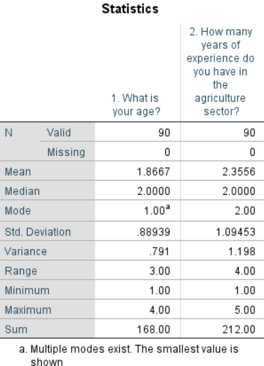
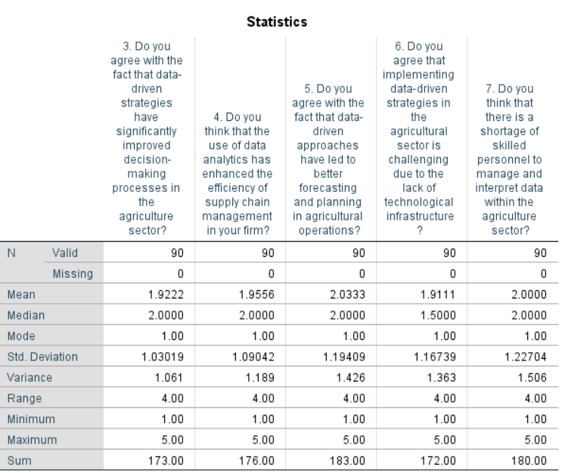
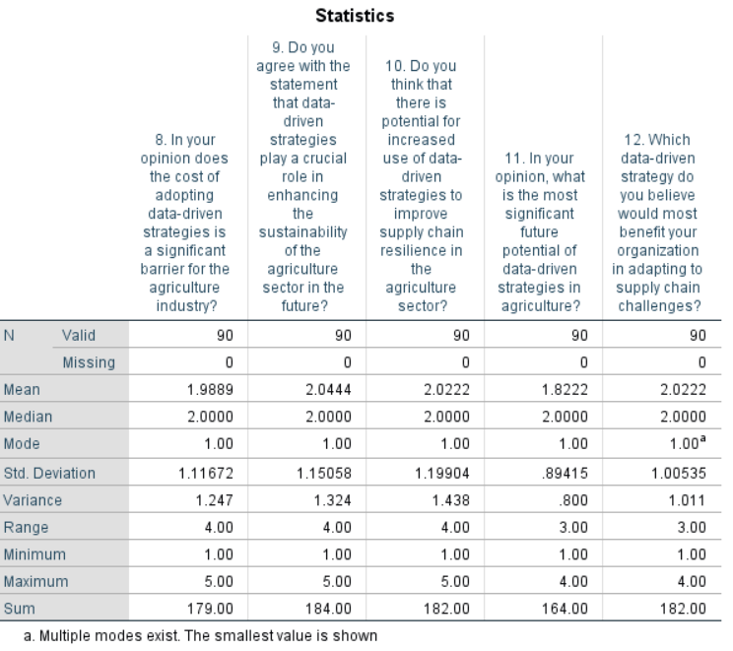

Regression


