

Programme: Master of Business Administration
Module: Financial Management
Module code: LCMB7002

Student name: 2420022
Student ID number: Khatijabibi Mahebubbhai Radhanpuri

Table of content
Introduction 3
1. Financial Health Check 4
1.1 Financial Statement of Toyota (Five-Year Review) 4
1.1.1 Income statement analysis 4
1.1.2 Balance sheet analysis 4
1.2 Liquidity Ratios 5
1.3 Profitability Analysis 6
1.4 Efficiency Analysis 7
1.5 Gearing (Solvency) Analysis 9
1.6 Investment Ratios 10
1.7 Cash Flow Position 11
2. Working Capital Management Analysis 13
2.1 Cash Operating Cycle Analysis 13
2.1.1 Inventory outstanding 13
2.1.2 Sales outstanding 13
2.1.3 Payables Period 14
2.1.4 Net Operating Cycle Evaluation 14
2.2 Working Capital Improvement Strategies 15
2.3 Short-Term vs. Long-Term Financing Evaluation 15
2.3.1 Short-Term Options 15
2.3.2 Long-Term Options 16
3. Strategic Financial Restructuring Plan 17
3.1 Address Financial Problems 17
3.2 Financial restructuring Options 18
3.3 Restructuring impact 20
3.4 International and Ethical Considerations 22
4. Investment Appraisal and Capital Budgeting 24
4.1 Three proposed investment projects 24
4.2 Critical Evaluation of the Efficiency of Projects 24
4.2.1 Project A 24
4.2.2 Project B 24
4.2.3 Project C 25
4.3 Combination of project best through Capital Rationing 26
4.4 Recommendation for managing companies performance 26
4.5 Non-financial risk associated with the project 27
Conclusion 28
References 29
Appendices 36
Appendix 1: Ratio analysis 36
Appendix 2: Investment appraisal 40

Introduction
Toyota Motor Corporation is a Japanese Automobile company that has emphasised on developing e-vehicles to meet the changing demands of the customers. The purpose of the report is to provide a critical evaluation regarding the financial performance of the organisation and its impact on its business activities.

1. Financial Health Check

1.1 Financial Statement of Toyota (Five-Year Review)

1.1.1 Income statement analysis
Toyota Motor sales showcase significant growth of about ¥27.2 trillion in 2021, with ¥48.0 trillion in 2025, showcasing its sustained recovery (Toyota, 2021; Toyota, 2025). The key trend is due to significant rises of the vehicle price, high rises on inflation and consumer shift towards other brands. The operating income is about ¥5.35 trillion in 2024, which decreases to ¥4.80trillion in 2025, leading to Toyota's comprehensive investment towards its electrification strategy and currency fluctuation (RTT News, 2025). The impact of this significant decline is due to the reduction of profit that has been addressed through significant human investment.

1.1.2 Balance sheet analysis
The balance of Toyota has been characterized through stable equity and liquidity by showcasing its ability towards “capital-intensive culture: enhancing brand value. The assets of Toyota is about ¥3,487.0 billion in 2025, which is about¥93,601.3billion (Macro trends, 2025). This in term encountered significant growth leading to an increase in its investment for plant, property, battery production, and existing financial services in the market. The rise of equity based will reach about ¥35.9 trillion in 2025 which in term showcases 38% stability by ability to manage debts for the development of EV plants.

1.2 Liquidity Ratios
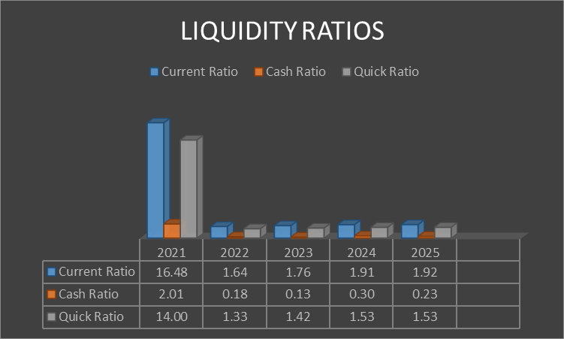
Figure 1: Liquidity Ratios
(Source: Toyota Corporation, 2021; Toyota Corporation, 2023; Toyota Corporation, 2025)
Trends
The liquidity ratios showcase the ability of the company by determining the debtor's ability to manage current debt obligations. The current ratio of Toyota has decreased by about 88.35%, leading to a significant decline in current assets and slow maintenance of debts, which in term affect brands to move forward. The overall sales dropped about 1.4%, leading to decreases in consumer purchasing of the product (khan, 2025). The cash ratio of Toyota decreased by about 88.56% regarding the ability to meet business liabilities, and the ability to deal with operational efficiency of the business. The cash reserve of Toyota is about $107 billion, which shows a short-term investment. The quick ratio of Toyota decreases by about 89.07% leading to a decrease in cash equivalence result with short term debt maintenance.
Strength
The strong cash generation leads to an improvement in business operations by the ability to deal with short-term liabilities and showcases overall debt maintenance
Threats
The company can meet short-term debt through significant funds and ability to manage investor sales which leads to enhanced business sales.

1.3 Profitability Analysis
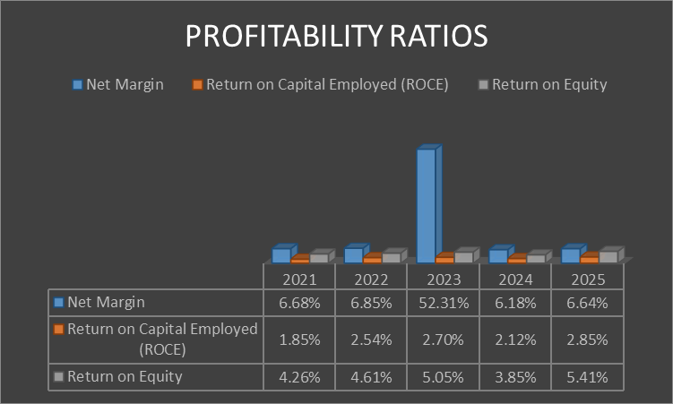
Figure 2: Profitability Ratios
(Source: Toyota Corporation, 2021; Toyota Corporation, 2023; Toyota Corporation, 2025)
Trends
The profitability ratio has assisted companies in developing a proper understanding of the revenue achieved from its business operations. On the other hand, the method also evaluates the sales growth of the organisations. Based on the above analysis, Toyota has increased its net profit by 7.18% in 2025. The improvement in the business income has helped the automobile company in enhancing its product quality. For example, Toyota has invested $912m in developing business units in West Virginia and Georgetown in 2025 (Toyota Motor Corporation, 2025). The investment has helped the organisation in meeting the product demand of the customers in the USA. On the other hand, Toyota has also increased its return on equity value by 26.65% in 2025 as compared to 2021. The enhancement in the internal investment has helped the organisation in meeting the financial requirements of its business operations. In addition, Toyota has also increased its ROCE value to 2.85% in 2025. The improvement in the income has helped Toyota in achieving financial stability.
Strength
The enhancement in the equity investment value has helped Toyota in reducing the occurrence of delays in the completion for the business operations.
Threats
The lowering of the net income has also hampered the competitive advantage level of Toyota over other organisations.

1.4 Efficiency Analysis
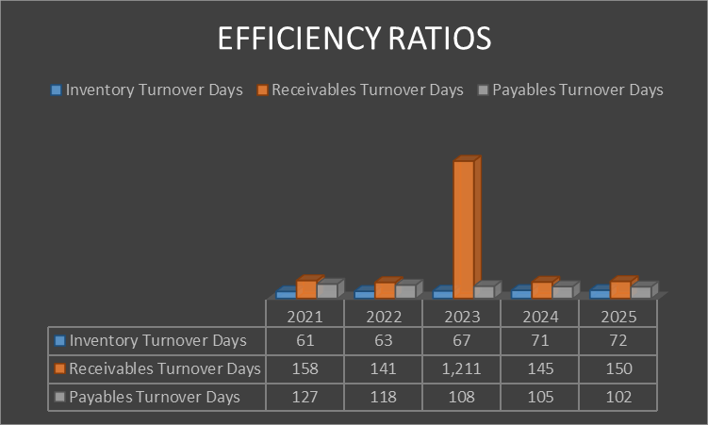
Figure 3: Efficiency Ratios
(Source: Toyota Corporation, 2021; Toyota Corporation, 2023; Toyota Corporation, 2025)
Trends
The efficiency ratios also illustrate the mixed performance trend associated with Toyota in the year from 2021-2025. Total of more than 18% rise also be defined in inventory days turnover from 61 days (2021) to 72 days (2025). As these inventory days slow down, the main reason is higher stock value. The cost of sale range is bound between ¥1,627,894m to ¥3,133,410m in 2025.
On another hand, receivable days are also assured with 11% improvement from dropping 158 days from 2021. However, its volatility also peaked in 2023 with a value of 1,211 days due to the sharp revenue drop to ¥379,891m. Also, the receivable ratios had also been stable in 2024-2025 with accumulations of 145-150 days that ensure more preferable industry standards for long term growth.
A total of 20% declining rate is also identified in Payables turnover days declined from 127 days (2021) to 102 days (2025). Thus, it is also to ensure faster payment from suppliers that is helpful to manage excess inventory value and venture cost associated with Toyota.
Strength
Improved payables efficiency with 20% faster payments and stable receivables post-2023 indicate stronger supplier relationships and consistent cash collection performance.
Threats
Rising inventory days by 18% and volatile receivables in 2023 reflect inefficiencies in stock management and inconsistent revenue-driven collection cycles.

1.5 Gearing (Solvency) Analysis
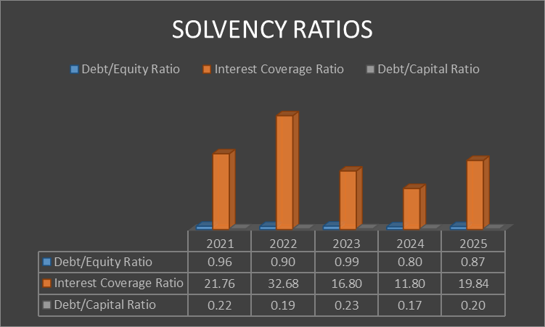
Figure 4: Solvency Ratios
(Source: Toyota Corporation, 2021; Toyota Corporation, 2023; Toyota Corporation, 2025)
Trends
The solvency ratio provides information regarding the business investment executed by the organisation for improving its productivity. On the other hand, the method also evaluates the internal and external management operations of the organisation. Toyota has reduced its debt/equity value by 11.45% in 2025 as compared to 2021. The decline in the debts has helped the automobile company in diversifying its business investments. For example, Toyota has invested £2.82bn in developing Lightweight Battery Electronic Vehicles in the UK (Toyota Europe, 2025). The investment has helped the automobile company in expanding its business operations. On the other hand, Toyota has also increased its debt/capital value by 5.26% from 2022-25. The enhancement in the equity capital has helped the organisation in ensuring smooth completion of its business operations. Toyota has achieved financial grants worth $841bn from the Japanese Government for enhancing the production of its e-vehicles in 2025 (Toyota Motor Corporation, 2025a). The improvement in the investment value has helped Toyota in improving its productivity.
Strength
The lowering of the equity value has helped Toyota in overcoming market uncertainties.
Threats
The lowering of the interest income has hampered the financial stability of the automobile company.

1.6 Investment Ratios
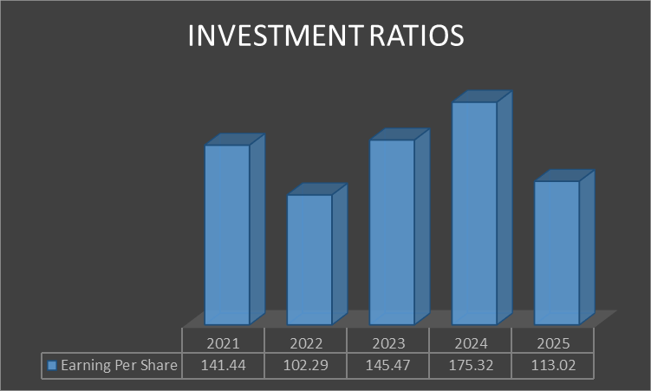
Figure 5: Investment Ratios
(Source: Toyota Corporation, 2021; Toyota Corporation, 2023; Toyota Corporation, 2025)
Trends
The investment ratio showcases profitability, value towards investment and efficiency that help investors in managing risk through long-term return. The earnings per share is about to decrease 20.09%, leading to low income, increasing expenses and shift in market sentiments which in term affect brand image. The company addresses issues in sharing of new bonds with USD 750 million in 2028, which include sustainable bonds by ability to showcase its recent development in the market (Cbonds, 2026). As business expenses rise, the operating profit leads to a rise by showcasing its solid foundation in the US, which in turn leads to a rise due to a significant cost reduction process.
Strength
Toyota showcases its significant recovery by enhancing the improvement of ROE and ability to deal with superior cost due to the presence of its competitors in the market.
Threats
The company faced stiff challenges at the supply chain and ability to invest in the EV segment which is more effective to meet competitiveness in the market.

1.7 Cash Flow Position
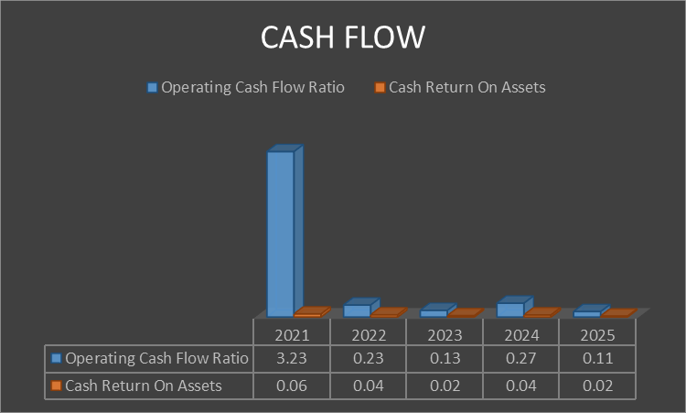
Figure 6: Cash Flow
(Source: Toyota Corporation, 2021; Toyota Corporation, 2023; Toyota Corporation, 2025)
Trends
The ratio provides details regarding the working capital management activities of the organisation. As per the above analysis, Toyota has reduced its operating cash value from 3.23 in 2021 to around 0.11 in 2025. The lowering of the financial resources has hampered the operational productivity of the company. For example, Toyota has reduced its operating profit value to $6.89bn due to the provision of import tariffs in 2025 (Leussink, 2026). The lowering of the income has adversely influenced the financial stability of the organisation. On the other hand, Toyota has also reduced its asset cash value from 0.06 in 2021 to 0.02 in 2025. The decline in income has increased market competition for Toyota.
Strength
The lowering of the cash flow has provided investment opportunities for Toyota that has increased its productivity.
Threats
The decline in cash value has also hampered the financial efficiency of the organisation that has lowered its product quality.

2. Working Capital Management Analysis

2.1 Cash Operating Cycle Analysis

2.1.1 Inventory outstanding
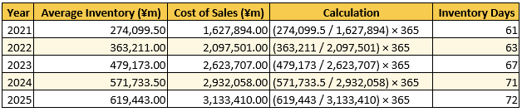
Figure 7: Outstanding Inventories
(Source: Self-Developed)
Toyota has increased its inventory days value by 17.1% in 2025 as compared to 2021. The enhancement in the stock management operations has increased the product price of the organisation. For example, Toyota has enhanced its operational cost to around $274bn in 2025 (Macro trends, 2025). The improvement in the developmental expenses has hampered the commodity demand of Toyota among its customers. On the other hand, Toyota has also increased its demand for its hybrid electric model that has caused supply chain issues for the company (Shah, 2025). Overall, the decline in the inventory management operations has adversely influenced the operational productivity of Toyota.

2.1.2 Sales outstanding
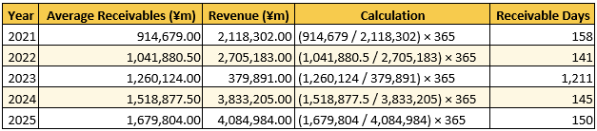
Figure 8: Sales outstanding
(Source: Self-Developed)
Toyota's accounts receivable days are about 150 days due to significant cash flow, high credit risk, which in term hamper operational efficiency of the business. The company showcases its revenue growth, leading to significant demand for EV vehicles. The operating profit of Toyota is expected to drop 10.4% due to certificate regulation and the ability to enhance short-term investment, which is expected to experience significant growth. The suspension in production of Toyota at the US market is due to high rises of quality issues and showcases stiff competition due to the presence of Chinese brands affecting overall sales of the business.

2.1.3 Payables Period
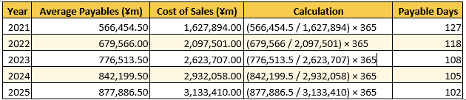
Figure 9: Payable Period
(Source: Self-Developed)
Toyota has reduced its payable period value from 127 days in 2021 to around 102 days in 2025. The organisation has focused on diversifying its business investments to ensure the smooth completion of its business operations. For example, Toyota has invested $1bn in developing e-vehicle manufacturing units in Kentucky. The investment has helped the automobile company in meeting the product demand of the customers in the USA (TOYOTA, 2026). Overall, the strengthening of the account payable and receivable value has helped Toyota in improving its goodwill among creditors.

2.1.4 Net Operating Cycle Evaluation
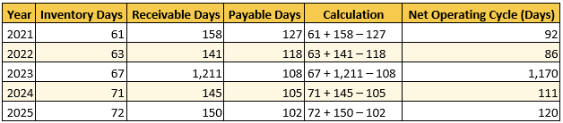
Figure 10: Net operating cycle
(Source: Self-Developed)
The net operating cycle of Toyota is about 120 days, which is due to efficient cash flow maintenance and avoiding production shortages. Toyota upholds financial stability with its net cash of about $-2.836B, leading to 121.69% decline from 2024. The company has a significant demand with an anticipated operating income 20.8% in 2026 due to high rises of tariff pressure and ongoing investment, which leads to enhanced overall sales (Walz, 2026). The net operating cycle has a negative affect on overall profitability due to a decrease in operating income and changes in currency fluctuation affect overall production.

2.2 Working Capital Improvement Strategies
Inventory management optimisation
Toyota strengthened its inventory maintenance through the “Just-In-Time” process by strengthening its demand forecasting through uses of Big data and AI which in term strength improvement in business operation. The company planned to invest about $10 billion USD to showcase its growth, by showcasing its investment on battery production capacity in the market (TOYOTA MOTOR CORPORATION, 2025). In 2025, the sales of electric vehicles is about 46.2% increases that vary based on accessing regional needs of Electric vehicles in the market. The adoption of electronic “Supply chain Finance” expansion helps suppliers to receive early payment by optimizing working capital to manage liquidity. This leads to rising operating expenses of Toyota of about $285.391Bin 2025, leads to a 4.07% increase, which encounters significant cost pressure (Macro Trends, 2025). Thus, centralized cash management is more effective to reduce borrowing and ability to monitor cash flow through significant decision making.

2.3 Short-Term vs. Long-Term Financing Evaluation

2.3.1 Short-Term Options
Trade credit
Toyota has a total debt of about $264.3 billion, which leads to a rise of about 6.9%, leading to high rises of profitability pressure (Finbox, 2025). The company slows down its annual profit, which is about 3.2 trillion Yen that varies based on fluctuations in currency and intense competition. The company encountered a traffic hit of about $9.5 billion, which in turn affected overall profit, leading to a production shift and supply chain exposure (Leussink, 2025). The company encountered substantial pressure in managing tariffs, which is about 1.450 billion Yen, showcasing a negative impact on operational income. Toyota has a net cash of about ¥15 trillion by ability to deal with massive disruption, which in term effects overall profitability (SPG Global, 2026). Toyota Motors has a direct impact on sales volume by its ability to manage inventory without cash outlay.

2.3.2 Long-Term Options
Bonds
Toyota issued $1.5 billion in 2025 for sustainable bonds which is more effective for relying on net zero emissions vehicles (Stock Titan, 2025). The impact of issuing the bond has a direct impact on accelerating the transition in business which in term showcases financial stability of the business. The impact of this bond has high demand which in term enhances investor confidence in order to achieve sustainable vision. The company showcases a significant investment of about 488,579 million yen in 2025, which is more effective for the development of equipment and plant through significant upgradation. The company manages its credit rating by showcasing high liquidity and enables it to improve funding rates through managing long term capital needs. The company diversifies its borrowing in geographical regions by ability to manage capital in international markets that address based on geographic consumer needs.

3. Strategic Financial Restructuring Plan

3.1 Address Financial Problems
Decline in Operational Revenue
The lowering of revenue has been an issue for Toyota that has also lowered its brand image among investors. For example, the organisation has reduced its net income from $26.8bn in 2024 to around $20.3bn in 2025 (Walz, 2026). The decline in the profit margin has also lowered the product demand for the company. On the other hand, Toyota has also increased its taxation value to $8bn due to an enhancement in automobile tariffs in 2025 (Walz, 2026). The increase in the business taxes has adversely influenced the financial stability of the organisation. Toyota has reduced its sales growth from 13% in 2024 to around 12% in 2025. The decline in the business income has also the competitive advantage for Toyota over other organisations.
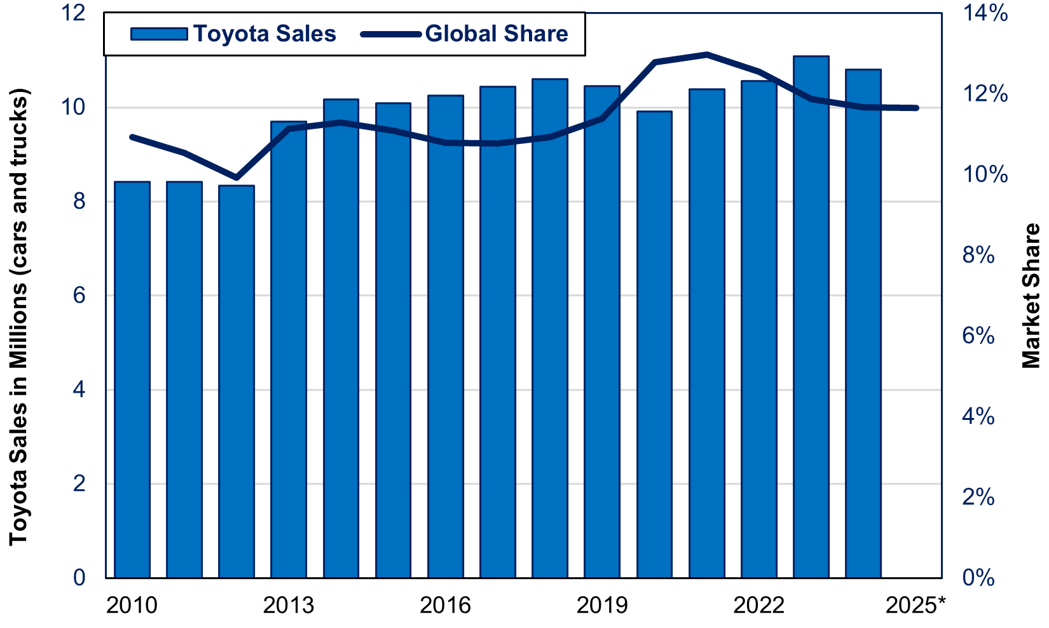 Figure 11: Sales Growth of Toyota
(Source: Japan Economy Watch, 2025)
Toyota Motor faced significant challenges, leading to a profit drop due to high rises in tariff pressure and currency fluctuation, which in turn hampered overall business reputation. The net income falls about25%due to high rises of labor costs and production shutdowns in the US (Walz, 2026). The company encountered significant regional loss due to high rises of sales in the North American region by showcasing its intense competition in the EV market. This in term incurred an operational loss of about $40 million in 2026 due to significant shift in US tariff and strong demand towards cost-cutting strategies which led to enhanced business sales (Walz, 2026). Despite falling revenue, the company slows down its incentives and relies on earnings from the value chain which in term showcases its significant growth in the market. The massive impact of this issue leads to an improvement for flow of tariff pressure which in term enhances substantial cash reserves in the market.

3.2 Financial restructuring Options
Merger and Acquisition
The inclusion of merger techniques helps organisations in reducing the occurrence of delays in the completion of business operations. For instance, Toyota has collaborated with Volvo Group with the intent to meet the hydrogen fuel requirements of its vehicles in 2025 (Brand Finance, 2025). In addition, the business tie-up has also helped the automobile company in improving its product quality. Toyota has also increased its brand value to around $60.7bn in 2025 (Volvo Group, 2026). The improvement in the product popularity level has also helped the company in strengthening its customer relationships. On the other hand, Toyota has also acquired Japan Inc worth $42bn for expanding its electronic products in 2025 (Reuters , 2025). The enhancement in the commodity line has helped Toyota in meeting the changing requirements of the customers.
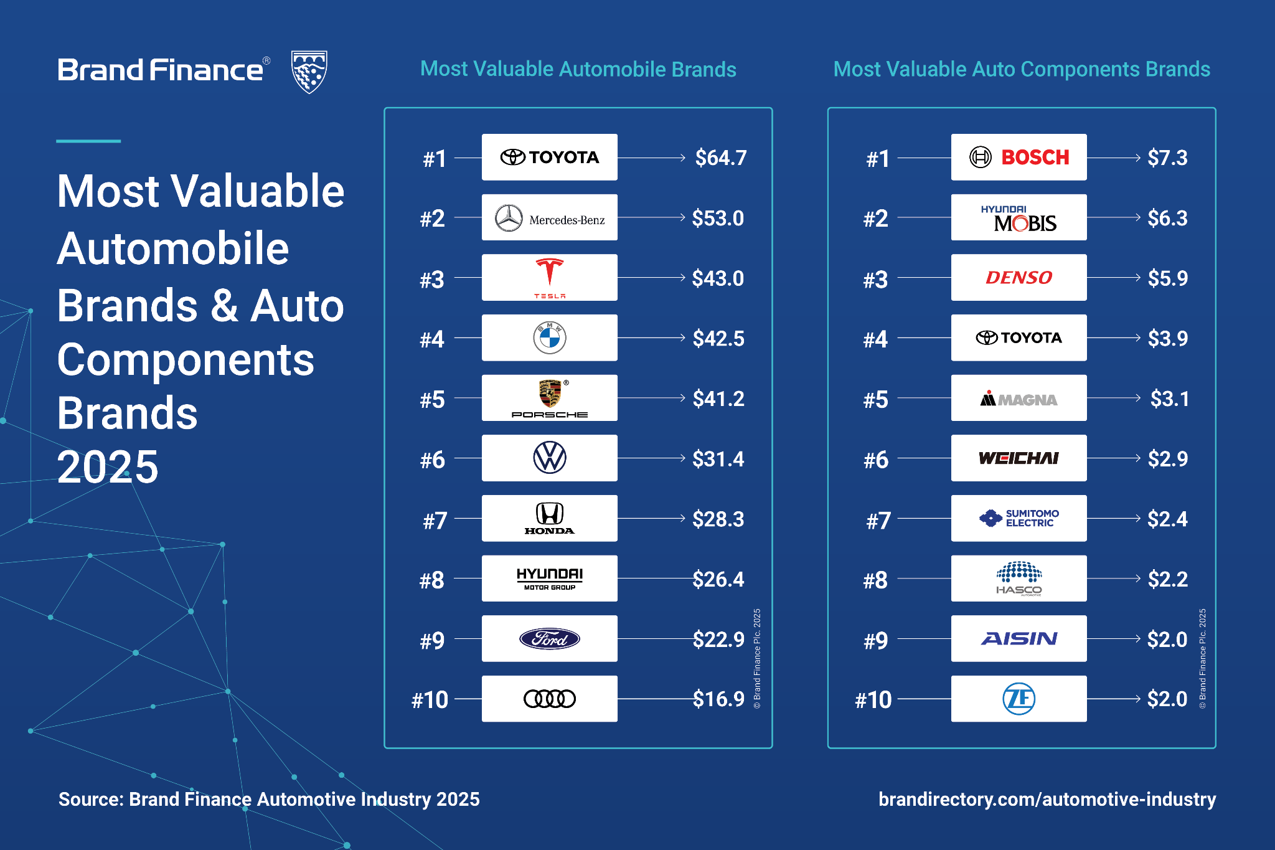
Figure 12: Brand Value of Toyota
(Source: Brand Finance, 2025)
Equity injection
Toyota Motor showcases its cash return by the ability to purchase 410 million treasury shares which is about 1 trillion yen based on buyback shares and enhancing capital efficiency through an ongoing share programme (Reuters Staff, 2024). The company has the ability to manage long-term shareholder bases through uses of the “keiretsu system” which is more effective for ensuring significant profit maintenance of the business. The company plans to deal with $19 billion for selling of new shares that are based on significant production of EV products and launching new electric vehicles through massive capital dealing (Uranaka and Shiraki, 2026). The company will manage its significant cash about ¥9.2 trillion in 2026 that is due to high liquidity to deal with R&D and financial stability to deal with uncertainty in the market. The significant treasury maintenance enhances efficiency in cash flow by optimising cash flow efficiency at different regions.
: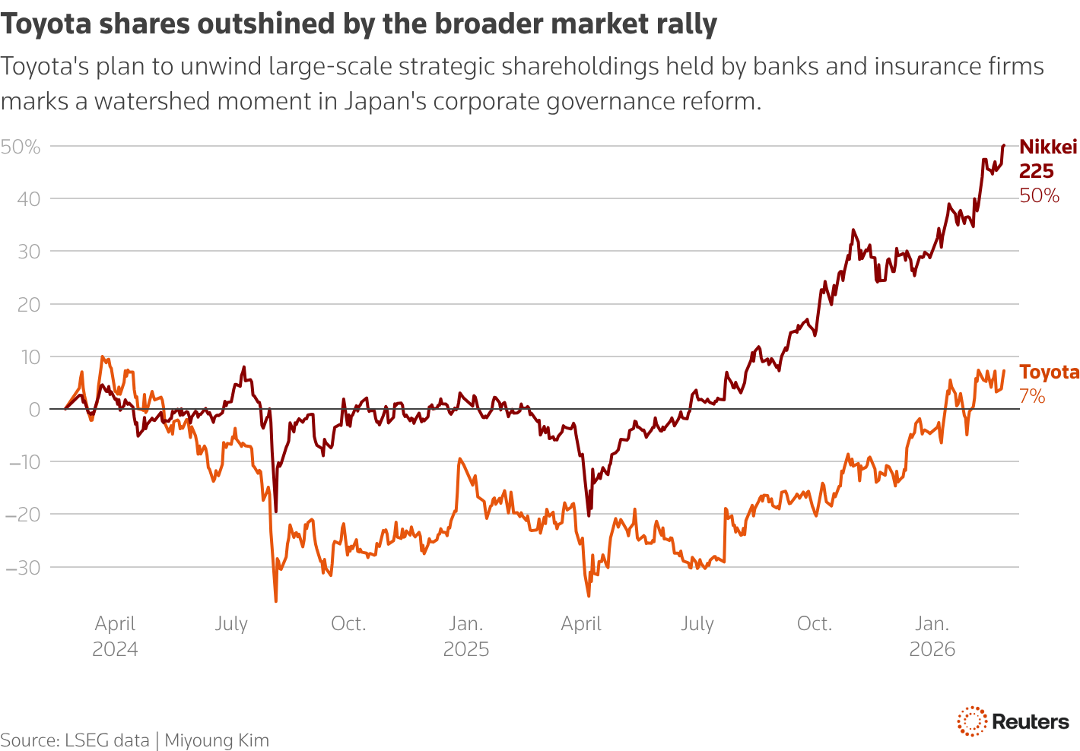
Figure 13: Toyota outstanding share
(Source: Uranaka and Shiraki, 2026)

3.3 Restructuring impact
Shareholder Value
Toyota has emphasised upon meeting the requirements of its investors with an intent to ensure smooth completion of its business operations. For example, the organisation has increased its dividend value from ¥40 in 2024 to ¥60 in 2026 (Market Screener, 2026). The improvement in the shareholder income has helped Toyota in strengthening its operational productivity. On the other hand, Toyota has also increased its EPS value to around ¥165.16 in 2025 (Macrotrends, 2025). The enhancement in the share value has helped Toyota in strengthening its investor relationship.
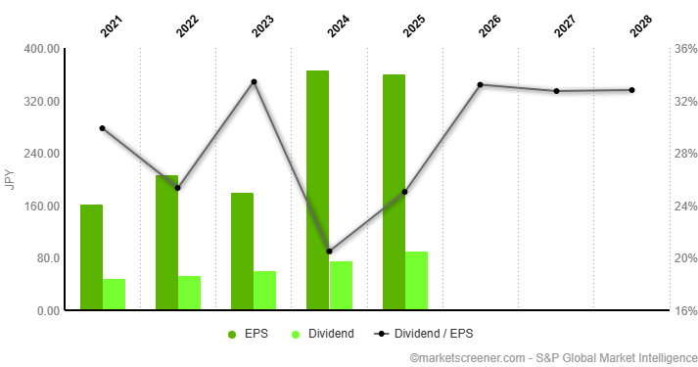
Figure 14: Dividend Value of Toyota
(Source: Market Screener, 2026)
Debt Structure
Toyota Motor's current debt is about $0.499 b in 2025, which leads to 81.98% decline from the previous year (Macro Trends, 2025a). The characteristics of the debt level is due to significant investment and protect companies from downtown due to short term debt maintenance. The rise of debt leads to significant investment for the development of new batteries in Europe and North America, and stiff competition by showcasing electrification. The impact of this debt pressure affects overall profitability, which in turn leads to a fall in overall operating income. The changes in currency fluctuation have been addressed through affecting high profit margin, which addresses pressure due to high interest burden.
Operational Flexibility
Toyota has focused upon adopting digitalisation in its business operations for improving its operational productivity. For example, the organisation has developed platforms such as “Toyota-i-Connect” that has provided product updates to the customers in 2025 (Toyota Motor Corporation, 2025a). In addition, the technique has also helped the company in enhancing the knowledge of the consumers regarding business offers and discounts. The inclusion of digitalisation has helped the automobile company in enhancing its operational efficiency.

3.4 International and Ethical Considerations
Taxation Rate
The enhancement in the business taxes has been a critical issue for Toyota that has also reduced its product revenue. For example, the organisation has increased its operational cost to $10700m due to improvement in business tariffs in 2025 (Takahashi, 2025). The enhancement in the product expenses of Toyotas has hampered its financial stability.
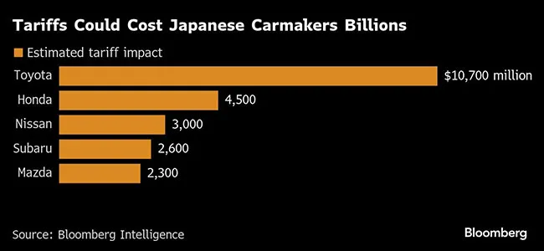
Figure 15: Operational Cost of the Japanese Automobile Companies
(Source: Takahashi, 2025)

CSR
Toyota has encountered a transition in the market through the adoption of sustainability and proper skill development programs, which in term showcases inclusive growth in the market. The company has offered 1,000 students by providing proper training for the skill festival which in term empower young youths to enhance improvement in manufacturing (Toyota Motor , 2025).This, in turn, leads to a slowdown in overall sales by putting pressure to deal with operational expenses and liquidity risk.
Inflation
Inflation has also been an important factor that has influenced the product demand of Toyota among customers. In Japan, the cost of the index value has increased from 2.55% in 2022 to around 2.15% in 2025 (Statista, 2026). The lowering of the inflation value has helped in increasing the purchasing power of the customers in the country.
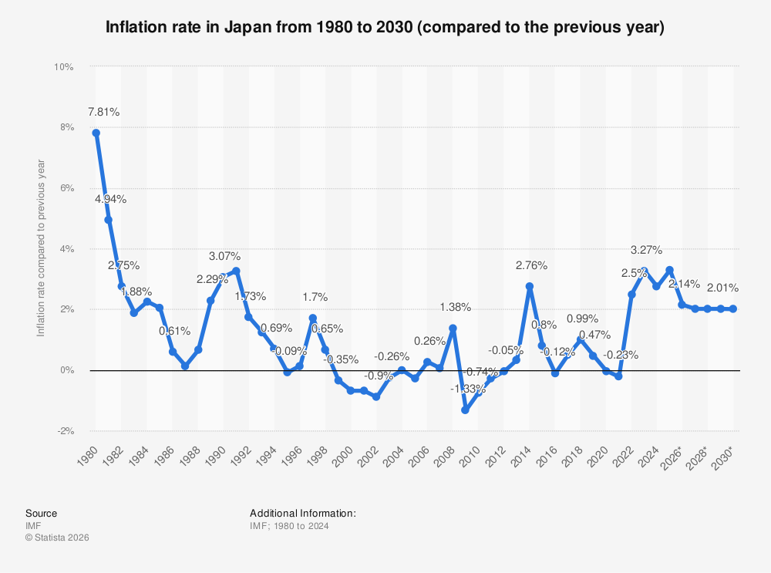
Figure 16: Inflation Rate in Japan
(Source: Statista, 2026).
Currency Risk
The company increased its long-term debt structure by about $150 billion in 2025, leading to currency fluctuation and high rises of credit rating (Macro Trends , 2025a). The company has the ability to manage debt by managing interest payments and through substantial cash flow investment. The company has the ability to manage interest coverage through significant borrowing, that address through presence of efficient production volume which is more effective to deal with significant stability in the market.

4. Investment Appraisal and Capital Budgeting

4.1 Three proposed investment projects
The three different types of project scenarios are also identified for Toyota with associated distinct portfolio timeframes between 1-5 years. Thus, project A generally attributed about initial investment £50m and generative cash flow pattern through moderate fluctuation that ensure to attract a lesser payback period effectively. On the other hand, project B and project C are also associated with the same initial investment cost of project A with higher potential in flow compared to this project. Overall, a higher cash flow also can be identified in project C and project B is generally provided stabilized cash flow value throughout the time period between 5 years.

4.2 Critical Evaluation of the Efficiency of Projects

4.2.1 Project A
Project A is generally attributed total of initial outlays for starting project £50m and ensure about total cash flow £54m. Thus, the total initial increasing rate of 8% also be relatively low as compared to the benchmarking standards. The discount rate selection is also most effective for present investment analysis with predicted future return value in an effective manner (Hayes, 2026a). The NPV value also declined by £41.32m due to selection of 10% discounting rate in predicting investment scenarios. As a result, a total of more than 17.3% shortfall is also defined as generating negative flow about -£8.68m throughout the time period of five years.
The first two years also generated positive returns while the third year declining trend is the main reason towards the worst performance of Toyota. The rise of year 1 is £9.09m and year 3 is £10.52m which is a 15.7% increasing rate. However, it has abruptly fallen towards £6.83m with a 52.7% decreasing rate in 2025 with a final value of £4.97m [Refer to appendix 2]. The trend also indicates a higher negative return potential through the project time period of five years with less return perspective. Overall, the payback period of 4.33 years of slow recovery covered 87% life of project ARR at 1.60% and IRR at 2.72% less adjustable as compared to 7% point associated with project A.

4.2.2 Project B
Project B is generally assured a consistent return throughout the time period of five years with initial outlay of about £50m. Cash flow generated in each year is equal to the increase of project B that also ensures a modest cash flow range at the end of the year with accumulated £55m. This is also indicated 10% modest increase with execution discounting rate of 10% in project life period. The NPV is the most significant financial metrics that are helpful to assess profitability with analysis of present value of cash flow in an effective manner (Lin, Dong and Zheng, 2025). Hence, overall a shortfall also identified about 16.6% shortfall with assured negative NPV of £8.30m ensure a total flow of £41.70m.
The declining trend was also identified from £10.00m in Year 1 to £6.83m in Year 5 with a total 31.7% decreasing in 2025 [Refer to appendix 2]. As per the view of Fernando (2026), the time value of money concept is highly acceptable for generating positive value of cash flow within the long term investment project effectively. Profitability aspects are also modest with a payback period of 4.55 years with ARR of 2% and IRR of 3.3%.

4.2.3 Project C
Project C also asserts a more stable financial target performance against investment outlay of £50m and total nominal cash inflows of £65m. Hence, a total of more than 30% increasing value of cash flow also be modified in the project life of five years’ time period. The slight negative NPV of -£1.98m also be identified at a 10% scouting rate with a total value of NPV of £48.02m. Hence, this also be indicated with only 3.96% shortfall associated with inflow of project C.
In the project period of year 1 to year 4 most trend recovery period for project in generating return from project C. Total of 275% growth also be identified in fourth consecutive years from £4.55m to £17.08m [Refer to appendix 2]. Hence, this also indicated stronger project performance in the mid-term period. The payback period refers to the actual time of recovery of invested value and its benchmark is always low preferred by investors (Kagan, 2026). Hence, the payback period of 3.6 years also assured a more effective benchmark with covered initial investment in 72% of project life time period in an effective manner. Overall, the profitability matrix also became stronger due to the ARR of 6% and IRR of 8.6% are effectively closer to the 10% industry benchmark value of project C.

4.3 Combination of project best through Capital Rationing
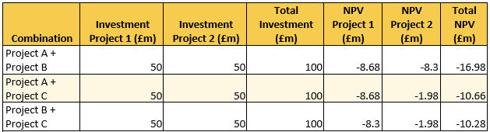
Figure 17 : Capital Rationing
(Source: Self-Developed)
The capital rationing method is most effective for investors towards proportional choice of project with limited capital assumption for a particular period (Hayes, 2026). The capital rationing limiting range is set out to be £100m that also be assured most suitable project associates for Toyota are project B and C. Hence, the option also ensures an initial investment of £100m with combined NPV of £10.28m. It is also most effective as compared to the project A and C with accumulated NPV range associated with -£10.66m. Further, project A and B also ensured a higher NPV range -£16.98m that demonstrated a negative adjournment among investors. Overall, project B and C are most suitable projects with lower NPV loss of -£1.98m and -£8.30m throughout the time period of the project.

4.4 Recommendation for managing companies performance
The adoption of a diversified investment strategy will help Toyota in meeting the financial requirements of Project C. For example, the organisation has invested $2bn in developing the “Toyota Digital Hub” for strengthening the inventory requirements of its business operations in 2025 (Toyota Europe, 2026). The infrastructural investment will assist the automobile company in meeting the operational requirements of its projects. On the other hand, Toyota has also achieved financial grants worth $20m from the UK government for enhancing the production of its e-vehicles in 2025 (Toyota UK, 2025).. The expansion of the financial resources has helped Toyota in ensuring smooth completion of its business operations.
Capital Rationing is the strategic process of setting a budget by restricting capital expenditure through diversified investment (Darmansyah, Ali and Parveen, 2025). Project C is a significant choice among the three Projects with its NPV which is slightly negative about 10%, which in turn affects the overall profitability of the business. Project C maximises the shareholder wealth by showcasing its acceptance, describing a positive NPV. The project C has an IRR of about 8.59% that is based on initial cash flow, which in term results in managing specific cash flow. Project C has high liquidity, which helps the company to recycle its capital, which in turn reduces overall value. The project can serve significant future opportunities, which is more reliable for paying off debt and lead to an improvement of the gearing ratio. The reason for investing at Project C has been to maximize wealth creation due to the presence of low cost and faster payback period, which is more reliable for dealing with financial distress.

4.5 Non-financial risk associated with the project
Customer Loyalty
As per the details provided in project C, the NPV value of the business plan is around £1.98 that has reduced the income of the organisation. For example, Toyota has reduced its sales volume to 806900 units due to lowering of the product demand in China (Nguyen, 2026). The decline in revenue has also hampered the goodwill of the automobile company among its customers. On the other hand, the average annual profits of Project C has been around £3.00 in 2025. The lowering of the income has also reduced the popularity of the business plan among the organisations. Overall, the decline in the project income of Toyota has hampered its customer relationship.
Political risk
Project C encountered political shifts due to changes in the tax rate, which had a strategic impact on investing in this project. Political shift in term leads to reduced capital investment and financial flexibility, which results in success (Banerjee and Dutta, 2022). The impact of political instability tends to expand business by addressing risk in initiating new ventures. Project C has a significant impact on dealing with prioritization changes that is due to ineffective alignment with the administration agenda and long-term changes in business regulation, which affect business operation.

Conclusion
Toyota showcases its significant success in managing efficiency and use of high-stakes capital, which is more reliable for significant transmission due to the massive production of electric vehicles. The organisation has strengthened its inventory and outstanding sales value in the cash operating cycle that has helped in meeting the financial requirements of its business operations.

References
Banerjee, P. and Dutta, S. (2022). The effect of political risk on investment decisions. Economics Letters, 212, p.110301. doi:https://doi.org/10.1016/j.econlet.2022.110301.
Brand Finance (2025). Toyota is the world’s most valuable auto brand, while Tesla continues to lose brand value | Press Release | Brand Finance. [online] Brand Finance. Available at: https://brandfinance.com/press-releases/toyota-is-the-worlds-most-valuable-auto-brand-while-tesla-continues-to-lose-brand-value.
bonds (2026). Toyota Motor Credit. Information about the issuer. (LEI Z2VZBHUMB7PWWJ63I008, SWIFT TMCCUS6LXXX). News and credit ratings. Tables with accounting and financial reports. [online] Cbonds. Available at: https://cbonds.com/company/33513/ [Accessed 16 Apr. 2026].
Darmansyah, A., Ali, Q. and Parveen, S. (2025). Sophisticated Capital Budgeting Decisions for Financial Performance and Risk Management—A Tale of Two Business Entities. Journal of Risk and Financial Management, [online] 18(6), p.297. doi:https://doi.org/10.3390/jrfm18060297.
Fernando, J. (2026). Time value of money explained with formula and examples. [online] Investopedia. Available at: https://www.investopedia.com/terms/t/timevalueofmoney.asp.
Finbox (2025). The Complete Toolbox For Investors | finbox.com. [online] Finbox.com. Available at: https://finbox.com/NYSE:TM/explorer/total_debt/.
Hayes, A. (2026a). Discount Rate Defined: How It’s Used by the Fed and in Cash-Flow Analysis. [online] Investopedia. Available at: https://www.investopedia.com/terms/d/discountrate.asp.
Hayes, A. (2026b). Introduction to Capital Rationing. [online] Investopedia. Available at: https://www.investopedia.com/terms/c/capitalrationing.asp.
Japan Economy Watch (2025). Toyota’s Blind Spot On BEVs. [online] Substack.com. Available at: https://richardkatz.substack.com/p/toyotas-blind-spot-on-bevs.
Kagan, J. (2026). Payback period: Definition, formula, and calculation. [online] Investopedia. Available at: https://www.investopedia.com/terms/p/paybackperiod.asp.
khan, N. (2025). Toyota Reports 4% Drop in 2024 Sales, Secures Position as World’s Top Automaker. [online] Yahoo Finance. Available at: https://finance.yahoo.com/news/toyota-reports-4-drop-2024-125041087.html [Accessed 16 Apr. 2026].
Leussink, D. (2025). Toyota warns of $9.5 billion tariff hit, slashes annual profit forecast. Reuters. [online] 7 Aug. Available at: https://www.reuters.com/business/autos-transportation/toyota-warns-95-billion-tariff-hit-slashes-annual-profit-forecast-2025-08-07/.
Leussink, D. (2026). Toyota expected to post third straight quarterly profit drop as costs, tariffs bite. Reuters. [online] 5 Feb. Available at: https://www.reuters.com/sustainability/sustainable-finance-reporting/toyota-expected-post-third-straight-quarterly-profit-drop-costs-tariffs-bite-2026-02-05/.
Lin, J., Dong, J. and Zheng, Y. (2025). Net Present Value As a Decision Tool During Investment: Evaluating the Effectiveness of Net Present Value (NPV) Against Traditional Investment Appraisal Techniques in Predicting the Financial Success of Technology Startups. Advances in Economics, Management and Political Sciences, [online] 217, pp.41–60. doi:https://doi.org/10.54254/2754-1169/2024.26903.
Macro trends (2025). FINANCIAL SUMMARY FY2025. [online] Available at: https://global.toyota/pages/global_toyota/ir/financial-results/2025_4q_summary_en.pdf.
Macro Trends (2025a). Toyota Long Term Debt 2006-2021 | TM. [online] www.macrotrends.net. Available at: https://www.macrotrends.net/stocks/charts/TM/toyota/long-term-debt.
Macro Trends (2025b). Toyota Net Current Debt 2010-2023 | TM. [online] www.macrotrends.net. Available at: https://www.macrotrends.net/stocks/charts/TM/toyota/net-current-debt [Accessed 14 May 2024].
Macro Trends (2025c). Toyota Operating Expenses 2006-2021 | TM. [online] www.macrotrends.net. Available at: https://www.macrotrends.net/stocks/charts/TM/toyota/operating-expenses.
Macrotrends (2025). Toyota Motor | 7203 - EPS Earnings Per Share. [online] Tradingeconomics.com. Available at: https://tradingeconomics.com/7203:jp:eps [Accessed 17 Apr. 2026].
Market Screener (2026). MarketScreener India. [online] MarketScreener India. Available at: https://in.marketscreener.com/quote/stock/TOYOTA-MOTOR-CORPORATION-6492484/valuation-dividend/ [Accessed 17 Apr. 2026].
Nguyen, K.P. (2026). Toyota Reports 2.3% Sales Drop as China Weakness Deepens. [online] Yahoo Finance. Available at: https://finance.yahoo.com/markets/stocks/articles/toyota-reports-2-3-sales-162301822.html [Accessed 17 Apr. 2026].
Reuters (2025). Toyota chairman proposes $42 billion acquisition of Toyota Industries, Bloomberg reports. Reuters. [online] 25 Apr. Available at: https://www.reuters.com/business/autos-transportation/toyota-chairman-proposes-possible-42-billion-acquisition-toyota-industries-2025-04-25/.
Reuters Staff (2024). Toyota expands share buyback plan to reflect share drop. Reuters. [online] 24 Sep. Available at: https://www.reuters.com/business/autos-transportation/toyota-expands-share-buyback-plan-reflect-share-drop-2024-09-24/.
RTTNews (2025). Toyota FY25 Profit Down; Lifts Dividend; Sees Weak Earnings, Higher Sales In FY26. [online] RTTNews. Available at: https://www.rttnews.com/3536891/toyota-fy25-profit-down-lifts-dividend-sees-weak-earnings-higher-sales-in-fy26.aspx [Accessed 16 Apr. 2026].
Shah, A. (2025). Toyota faces hybrid supply chain crunch as global demand surges. [online] USA TODAY. Available at: https://www.usatoday.com/story/money/business/2025/03/31/toyota-hybrid-supply-chain-struggles/82748396007/.
SPG Global (2026). Toyota Industries Upgraded To ‘A+’ On Group’s Inc | S&P Global Ratings. [online] Spglobal.com. Available at: https://www.spglobal.com/ratings/en/regulatory/article/-/view/type/HTML/id/3535114 [Accessed 16 Apr. 2026].
Statista (2026). Japan: inflation rate 1980-2030| Statista. [online] Statista. Available at: https://www.statista.com/statistics/270095/inflation-rate-in-japan/?srsltid=AfmBOopk-TTOtkv_NRgTJWiesYoWCiZidCz5F-ZmM743MIg5KGpD0ubD [Accessed 17 Apr. 2026].
Stock Titan (2025). [424B2] Toyota Motor Corporation American Prospectus Supplement. [online] @StockTitan_net. Available at: https://www.stocktitan.net/sec-filings/TM/424b2-toyota-motor-corporation-american-prospectus-supplement-4f9c0c87b0b1.html.
Takahashi, N. (2025). Japanese Carmakers Face $19 Billion Hit From Trump’s Tariffs - TT. [online] Transport Topics. Available at: https://www.ttnews.com/articles/toyota-honda-nissan-tariffs.
Toyota (2025). FY2025 financial results. [online] Available at: https://global.toyota/pages/global_toyota/ir/financial-results/2025_4q_presentation_2_en.pdf.
TOYOTA (2026). Toyota Announces $1 Billion Investment in Kentucky and Indiana Plants | Corporate | Global Newsroom | Toyota Motor Corporation Official Global Website. [online] Toyota Motor Corporation Official Global Website. Available at: https://global.toyota/en/newsroom/corporate/44129928.html.
Toyota (2021). FY2021 Financial Results. [online] Available at: https://global.toyota/pages/global_toyota/ir/financial-results/2021_4q_presentation_2_en.pdf.
Toyota Corporation (2021). 2021. [online] Available at: https://www.toyota-industries.com/investors/items/2021_annual_financial_report_E.pdf.
Toyota Corporation (2023). Annual Financial Report 2023. [online] Available at: https://www.toyota-industries.com/investors/item/2023_annual_financial_report_E.pdf.
Toyota Corporation (2025). 2025 TOYOTA INDUSTRIES CORPORATION. [online] Available at: https://www.toyota-industries.com/investors/item/2025_annual_financial_report_E.pdf.
Toyota Europe (2025). Toyota-led consortium secures UK government funding for micromobility feasibility study. [online] Toyota-led consortium secures UK government funding for micromobility feasibility study . Available at: https://newsroom.toyota.eu/toyota-led-consortium-secures-uk-government-funding-for-micromobility-feasibility-study/.
Toyota Europe (2026). Toyota builds European software capabilities with a new hub. [online] Toyota builds European software capabilities with a new hub . Available at: https://newsroom.toyota.eu/toyota-motor-europe-builds-european-software-capabilities-with-a-new-wrocaw-hub/ [Accessed 17 Apr. 2026].
Toyota Motor (2025). Toyota Kirloskar Motor Sends 100 Skilled Youth for Global Training to Japan. [online] Toyotabharat.com. Available at: https://www.toyotabharat.com/news/2025/tkm-sends-100-skilled-youth-for-global-training-to-japan.html.
TOYOTA MOTOR CORPORATION (2025). Toyota to Invest Up to $10 Billion Additional in Its U.S. Operations Over the Next Five Years | Corporate | Global Newsroom | Toyota Motor Corporation Official Global Website. [online] Toyota Motor Corporation Official Global Website. Available at: https://global.toyota/en/newsroom/corporate/43553969.html.
Toyota Motor Corporation (2025a). From Idea to Impact: How Toyota Connected India is Unifying Fleet Management for Smarter Mobility. [online] Toyotaconnected.co.in. Available at: https://www.toyotaconnected.co.in/article/from-idea-to-impact-how-toyota-connected-india-is-unifying-fleet-management-for-smarter-mobility [Accessed 17 Apr. 2026].
Toyota Motor Corporation (2025b). Japan: Government announces state aid to Toyota and further companies for EV battery development - Global Trade Alert. [online] Globaltradealert.org. Available at: https://globaltradealert.org/intervention/121317-japan-government-announces-state-aid-to-toyota-and-further-companies-for-ev-battery-development.
Toyota Motor Corporation (2025c). Toyota Announces $912 Million Investment in U.S. to Expand Hybrid Vehicle Production Capacity | Corporate | Global Newsroom | Toyota Motor Corporation Official Global Website. [online] Toyota Motor Corporation Official Global Website. Available at: https://global.toyota/en/newsroom/corporate/43577463.html.
Toyota UK (2025). Toyota-led consortium secures UK government funding for micromobility feasibility study - Toyota Media Site. [online] Toyota Media Site. Available at: https://media.toyota.co.uk/toyota-led-consortium-secures-uk-government-funding-for-micromobility-feasibility-study/.
Uranaka, M. and Shiraki, M. (2026). Exclusive: Toyota plans around $19 billion share sale by financial institutions. Reuters. [online] 26 Feb. Available at: https://www.reuters.com/sustainability/boards-policy-regulation/toyota-plans-around-19-billion-share-sale-by-financial-institutions-sources-say-2026-02-26/.
Volvo Group (2026). Toyota Motor Corporation aims to join Volvo Group and Daimler Truck as equal shareholder in the fuel cell joint venture cellcentric. [online] Volvogroup.com. Available at: https://www.volvogroup.com/en/news-and-media/news/2026/mar/toyota-motor-corporation-aims-to-join-volvo-group-and-daimler-truck-as-equal-shareholder-in-the-fuel-cell-joint-venture-cellcentric.html [Accessed 17 Apr. 2026].
Walz, E. (2026). Toyota net income fell almost 25% in the first nine months of FY2026. [online] Yahoo Finance. Available at: https://finance.yahoo.com/news/toyota-net-income-falls-almost-102700176.html.

Appendices

Appendix 1: Ratio analysis
Profitability Ratios:
Particulars | Details | 2021 | 2022 | 2023 | 2024 | 2025
Revenue (¥m | A | 2,118,302.00 | 2,705,183.00 | 379,891.00 | 3,833,205.00 | 4,084,984.00
Operating Profit/(Loss) (¥m) | B | 118,159.00 | 159,066.00 | 169,904.00 | 200,404.00 | 221,695.00
Net Profit/(Loss) (¥m) | C | 141,435.00 | 185,350.00 | 198,716.00 | 236,854.00 | 271,247.00
Total Assets (¥m) | D | 6,503,986.00 | 7,627,120.00 | 7,821,185.00 | 11,078,462.00 | 9,403,481.00
Current Liabilities (¥m) | E | 118,239.00 | 1,372,721.00 | 1,517,112.00 | 1,639,197.00 | 1,622,284.00
Equity (¥m) | F | 3,322,550.00 | 4,021,967.00 | 3,935,401.00 | 6,153,359.00 | 5,015,246.00
Net Margin | C/A | 6.68% | 6.85% | 52.31% | 6.18% | 6.64%
Return on Capital Employed (ROCE) | B/(D-E) | 1.85% | 2.54% | 2.70% | 2.12% | 2.85%
Return on Equity (ROE) | C/F | 4.26% | 4.61% | 5.05% | 3.85% | 5.41%
Liquidity Ratios:-
Particulars | Details | 2021 | 2022 | 2023 | 2024 | 2025
Current Assets (¥m) | A | 1,948,081.00 | 2,255,827.00 | 2,677,024.00 | 3,129,531.00 | 3,109,426.00
Inventories (¥m) | B | 292,461.00 | 433,961.00 | 524,385.00 | 619,082.00 | 619,804.00
Current Liabilities(¥m) | C | 118,239.00 | 1,372,721.00 | 1,517,112.00 | 1,639,197.00 | 1,622,284.00
Cash (¥m) | D | 238,248.00 | 247,085.00 | 202,731.00 | 496,849.00 | 378,455.00
Current Ratio | A/C | 16.48 | 1.64 | 1.76 | 1.91 | 1.92
Quick Ratio | (A-B)/C | 14.00 | 1.33 | 1.42 | 1.53 | 1.53
Cash Ratio | D/C | 2.01 | 0.18 | 0.13 | 0.30 | 0.23
Gearing Ratios:-
Particulars | Details | 2021 | 2022 | 2023 | 2024 | 2025
Total Liabilities (¥m) | A | 3,181,436.00 | 3,605,152.00 | 3,885,784.00 | 4,925,103.00 | 4,388,235.00
Total Equity (¥m) | B | 3,322,550.00 | 4,021,967.00 | 3,935,401.00 | 6,153,359.00 | 5,015,246.00
Operating Profit/(Loss) (¥m) | C | 118,159.00 | 159,066.00 | 169,904.00 | 200,404.00 | 221,695.00
Interest Expense(¥m) | D | 5,430.00 | 4,868.00 | 10,111.00 | 16,988.00 | 11,172.00
Shareholders capital (¥m) | E | 3,322,550.00 | 4,021,967.00 | 3,935,401.00 | 6,153,359.00 | 5,015,246.00
Total Debt (¥m) | F | 910,124.00 | 922,011.00 | 1,179,390.00 | 1,281,779.00 | 1,232,789.00
Debt/Equity Ratio | A/B | 0.96 | 0.90 | 0.99 | 0.80 | 0.87
Interest Coverage Ratio | C/D | 21.76 | 32.68 | 16.80 | 11.80 | 19.84
Debt/Capital Ratio | F/(F+E) | 0.22 | 0.19 | 0.23 | 0.17 | 0.20
Efficiency Ratios:-
Particulars | Details | 2021 | 2022 | 2023 | 2024 | 2025
Revenue (¥m) | A | 2,118,302.00 | 2,705,183.00 | 379,891.00 | 3,833,205.00 | 4,084,984.00
Cost of Sales (¥m) | B | 1,627,894.00 | 2,097,501.00 | 2,623,707.00 | 2,932,058.00 | 3,133,410.00
Opening Inventories (¥m) | C | 255,738.00 | 292,461.00 | 433,961.00 | 524,385.00 | 619,082.00
Closing Inventories (¥m) | D | 292,461.00 | 433,961.00 | 524,385.00 | 619,082.00 | 619,804.00
Average Inventories (¥m) | E=(C+D)/2 | 274,099.50 | 363,211.00 | 479,173.00 | 571,733.50 | 619,443.00
Opening Receivables (¥m) | F | 867,088.00 | 962,270.00 | 1,121,491.00 | 1,398,757.00 | 1,638,998.00
Closing Receivables (¥m) | G | 962,270.00 | 1,121,491.00 | 1,398,757.00 | 1,638,998.00 | 1,720,610.00
Average Receivables (¥m) | H=(F+G)/2 | 914,679.00 | 1,041,880.50 | 1,260,124.00 | 1,518,877.50 | 1,679,804.00
Opening Payables (¥m) | I | 519,330.00 | 613,579.00 | 745,553.00 | 807,474.00 | 876,925.00
Closing Payables (¥m) | J | 613,579.00 | 745,553.00 | 807,474.00 | 876,925.00 | 878,848.00
Average Payables (¥m) | K=(I+J)/2 | 566,454.50 | 679,566.00 | 776,513.50 | 842,199.50 | 877,886.50
Inventory Turnover Days | 365/(B/E) | 61 | 63 | 67 | 71 | 72
Receivables Turnover Days | 365/(A/H) | 158 | 141 | 1,211 | 145 | 150
Payables Turnover Days | 365/(B/K) | 127 | 118 | 108 | 105 | 102
Investment Ratios:-
Particulars | Details | 2021 | 2022 | 2023 | 2024 | 2025
No Of Share (m) | A | 1,000.00 | 1,812.00 | 1,366.00 | 1,351.00 | 2,400.00
Net Income | B | 141,435.00 | 185,350.00 | 198,716.00 | 236,854.00 | 271,247.00
Earning Per Share | B/A | 141.44 | 102.29 | 145.47 | 175.32 | 113.02
Cash Flow Ratios:-
Particulars | Details | 2021 | 2022 | 2023 | 2024 | 2025
Cash Flow From Operation | A | 382,386.00 | 321,085.00 | 194,964.00 | 443,590.00 | 171,578.00
Current Liabilities | B | 118,239.00 | 1,372,721.00 | 1,517,112.00 | 1,639,197.00 | 1,622,284.00
Total Assets | C | 6,503,986.00 | 7,627,120.00 | 7,821,185.00 | 11,078,462.00 | 9,403,481.00
Operating Cash Flow Ratio | A/B | 3.23 | 0.23 | 0.13 | 0.27 | 0.11
Cash Return On Assets | A/C | 0.06 | 0.04 | 0.02 | 0.04 | 0.02

Appendix 2: Investment appraisal


