Title Page

Name: George Thomas

P-Number: P149706

Module: Agent AI

Assignment: Search Algorithms

Lecturer: Gordon Dickers

Table of Contents
Introduction 3
Globals 4
Start Menu 5
Render 5
Find Start/End function 6
Draw 7
Find Item 8
Find Exit 9
Main 10
Testing and Screenshots 11
References 15

Introduction

In this assignment the task was to write a search AI for a pathfinding algorithm. The goal for this AI is to be able to search a dungeon in a dungeons and dragons style game for a specific item and then find the fastest route to the exit from the item. The AI that has been created has used stacks to store the AI location and visited locations. Initially the user will be able to select from multiple dungeons. The AI will then get the start location of the dungeon and will check all the locations adjacent to it to check if it is able to move in that direction, if it can it will add them to the stack and will move to one of the directions, it will continue to move until it is unable to do so. If the AI can’t move, then the top of the stack will be popped off. The AI will then check if it able to move from the location on top of the stack, if not the stack will be popped again. This will continue until the AI can move again. Eventually the AI will find the item it is searching for, when it does the location of the key will be stored and it will be used as the new start point. The AI will then begin to move again and will then be looking for the finish point after the item has been found. When the AI has found the exit, the program will finish, and it will report the location of the item to the user and how many steps the AI thinks it will take to complete the task. An attempt was made to implement Dijkstra’s search algorithm [2] however it was not completed.

Globals

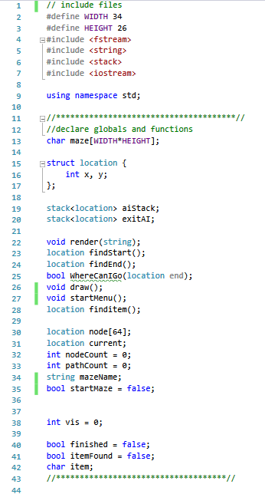
The program uses one structure for the position which has an x and a y coordinate. The maze array uses width and height to determine the size of the array.

Start Menu

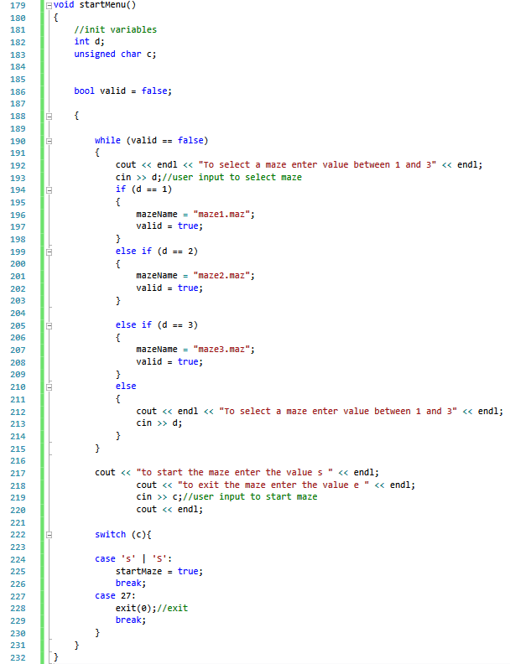
The start menu allows the user to choose a specific maze and then decide if they want to start or exit. The program asks the user to select a maze of their choice. If they input a value it will exit the loop. Then If the user inputs “s” then the program will start.

Render

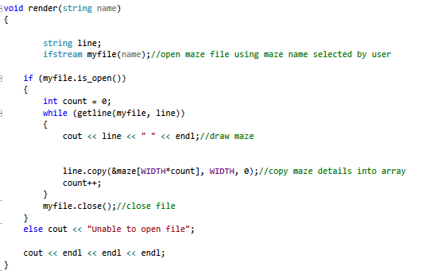
The render function reads the dungeon data from the selected file and then will print out the data as it reads it. It will also copy the data into the maze array that was initialised earlier. The render and start/end function have been taken from the Moodle example for file reader and finding start [1].

Find Start/End function

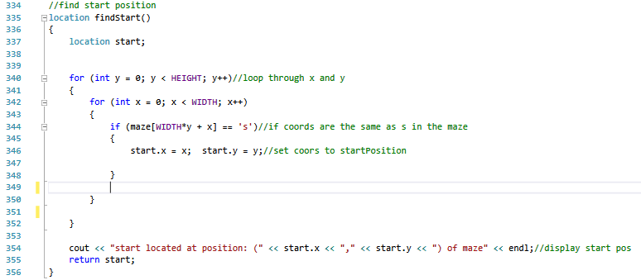

The function will search through the maze array until it finds the position which contains the character “s”. once it has found this it will store the location in the start variable. [1]
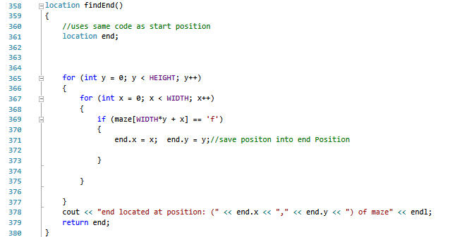

This function essentially does the same thing as the start function but it will search for “f“, and will store it in the end variable [1].

Draw

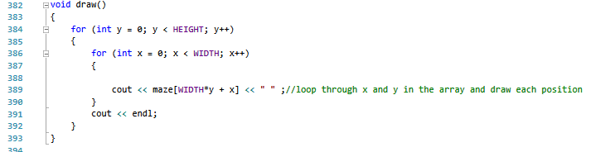
The draw function will loop through the array and will print every character in the array.

Find Item
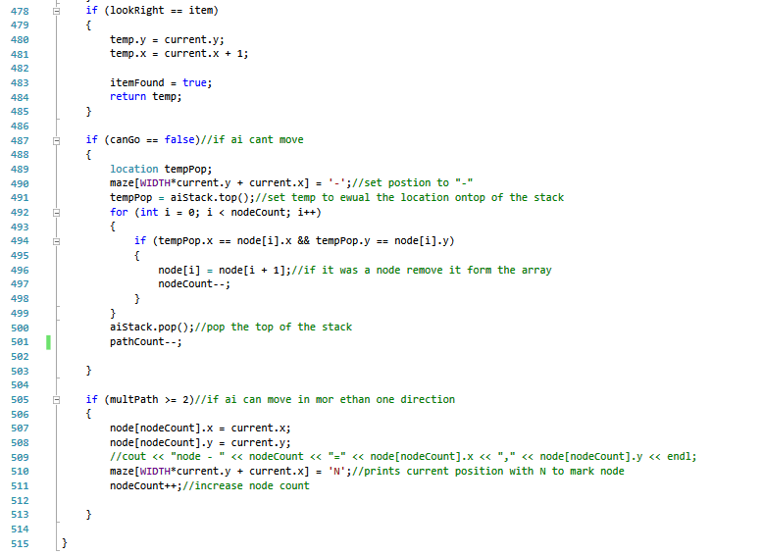
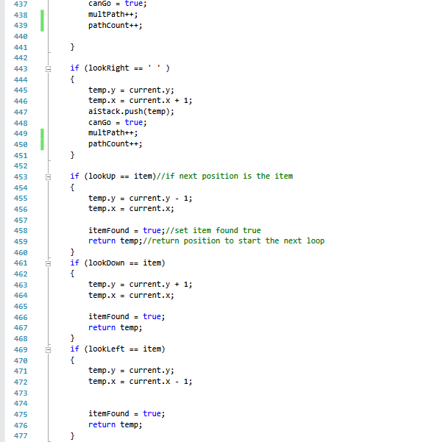
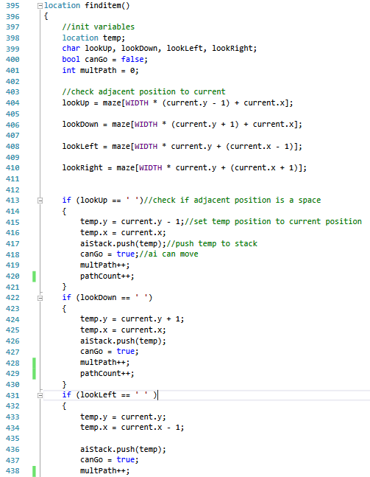
The find item function is used by the main to search adjacent position to the ai and check if it is able to move. If the adjacent position is a space then a temp value will store that location and push it into the AI Stack. Everytime a position gets pushed, the path count increases by one, this stores the amount of moves the ai takes.
The multPath counter is also increased by 1. This counter gets used at the end of the function, if the counter is a value of two or greater then the current position becomes a node. The idea of turning positions with multiple paths into nodes is an attempt at Dijkstra’s search algorithm [2]. The idea was that every node would see atleast two other nodes. The AI would then be able to run through the nodes, and be able to check the distance between the current node/position and the next node by comparing the positions. It would then close the node with the shortest distance and move to the closest one,while storing in memory which node it came from. This would in theory allow the AI to find the shortest path to its goal. Unfortuantely the idea was unable to be completed.
After initial checks, the function then checks again to see if the next position matches the item the AI is looking for. If it is the item its looking for then the itemFound will be set to true, and the position of the item will be returned.
If the AI finds that it is unable to move then it will first chek if the current position is a node. If it is it will remove it from the node array. The function the pops off the top of the stack and removes 1 from the path count, it will then cahnge the current position to a “-“.

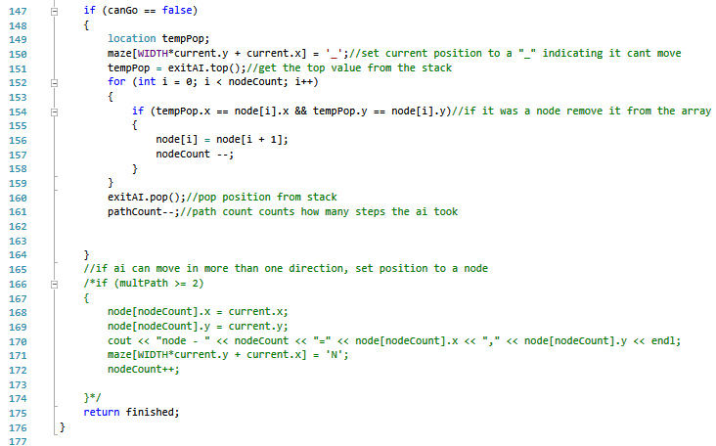
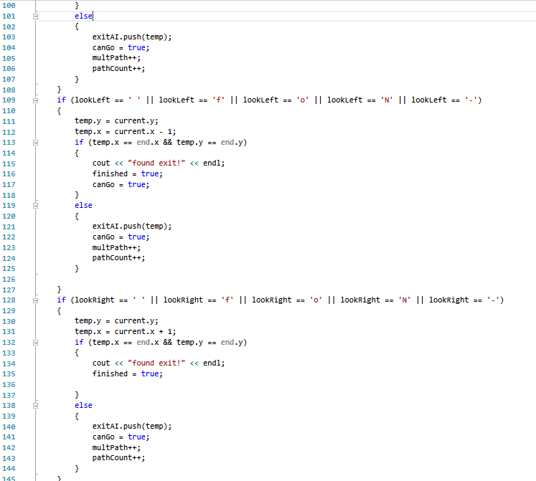
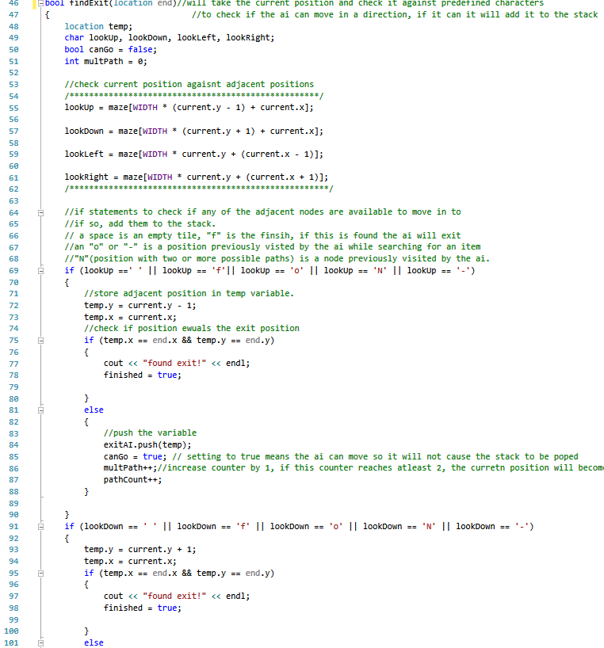
Find Exit

This code Is much of the same as the find item function. The AI checks if it can move but instead of looking for just a space, it will also look for “o”, “ ”, “-”, “N” and “f”.
The f is the finsih point. If it reaches that it will return finished as true and will exit the function. The space is an unvisited location and any other characters have been visited but since the AI might have already been to the exit the AI will be able to move back over the locations its already been to.

Main

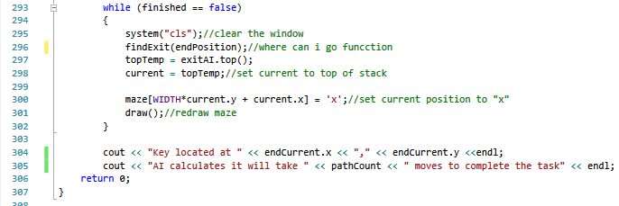
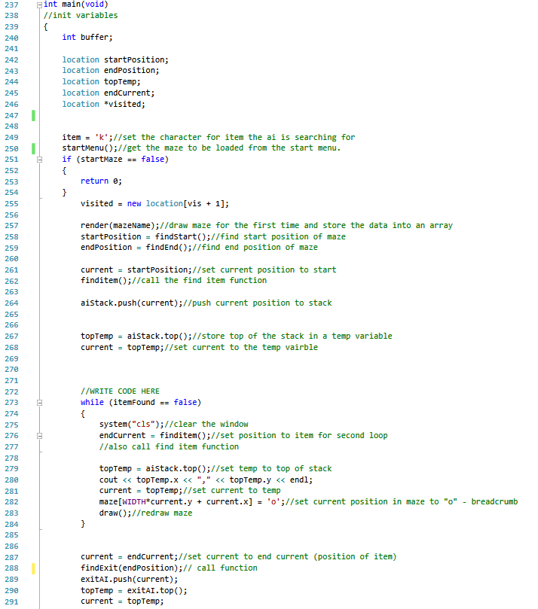
The AI’s current position is set to the start position and added to the stack.
The current position is then set to the top of the stack and the code enters the first loop. The code will clear the window [3], this allows for the maze to be rendered in the same spot allowing the user to “see” the AI move. It will loop until item is found, the loop calls the find item function and will set the top of the stack’s position to an “o” and will redraw the maze.
The function will then enter the second loop after setting current position to the items location and calling the find exit function once and pushing to the exit AI stack. The loop is the same as the previous but will end once the exit has been found and will set positions to “x”.
Once completed the function will output the items position to the user and how many steps the AI calculates it will take to complete the task.

Testing and Screenshots

To tests the code, I first test the start menu by entering the accepted values and some unaccepted values. I then run each maze through the code to check if they work. Each maze is different in size and position of the significant position.
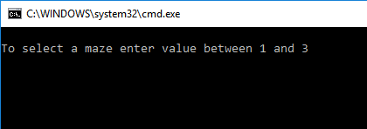
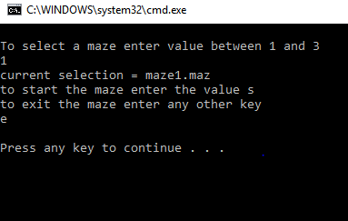
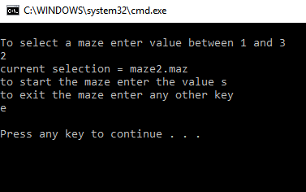
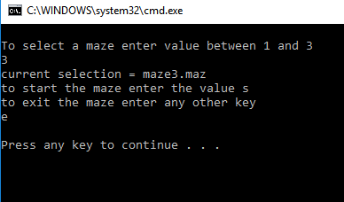
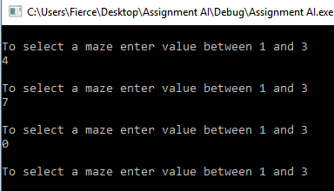
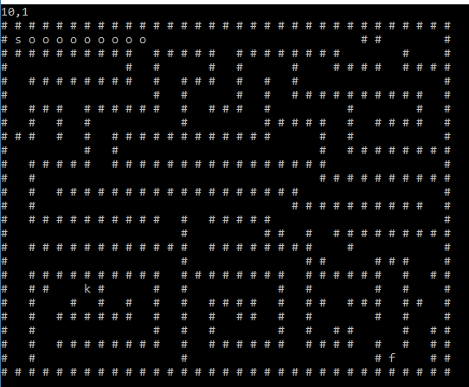
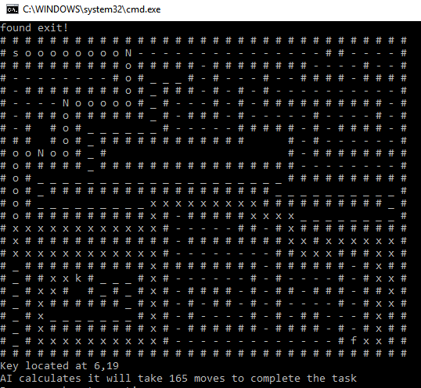
Maze 1 above.
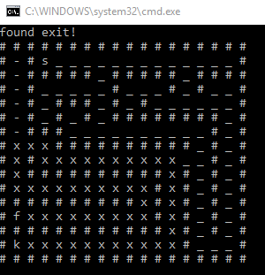
Maze 2 above.

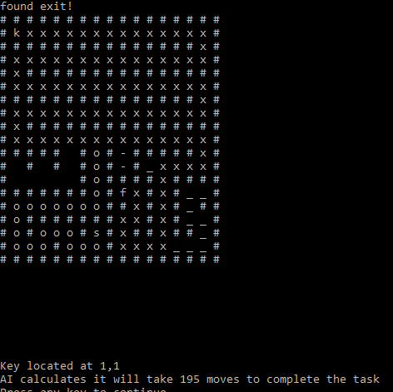
Maze 3 above.

References

[1] Gordon Dickers. file read with start position locator [WWW document]. Available: https://moodle.uwtsd.ac.uk/pluginfile.php/149017/mod_resource/content/0/main.cpp

[2] E.W. Dijkstra. (1959). A Note on Two Problems in Connexion with Graphs. [PDF Document]. Available: https://moodle.uwtsd.ac.uk/pluginfile.php/29424/mod_resource/content/0/dijkstra_paper.pdf
[3] www.cplusplus.com. Clear the screen[WWW Document]. Available: http://www.cplusplus.com/articles/4z18T05o/

