

Welsh Tedi Twt Activities in Foundation Phase.

Gweithgareddau Twt Tedi Cymraeg yn y Cyfnod Sylfaen.

Prepare a portfolio of activities that are delivered in your setting that promotes Welsh language, cultural, historical and geographical features.


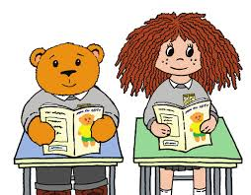
Contents Page

Rationale – Pages Three to Four.

Overview of Activities – Pages Five to Seven.

Evaluation – Page Eight.

Appendices – Pages Nine -

References – Page.

Rationale

This portfolio has been constructed to present activities used in a Foundation Phase (FP) setting to help deliver Welsh as a second language to pupils aged between three and seven years old. The setting will be discussed further throughout this document, and will now be referred to as School A.
According to their last Estyn inspection (2018), School A was known to have approximately three hundred and fifty pupils attending, with twenty nine percent identifying as having additional learning needs (ALN), above the national average at the time of twenty one percent. School A served, and still serves, a very diverse community in the local surroundings, with forty five percent of pupils having English as an additional language (EAL), between these pupils and their families, twenty-nine languages are spoken as a first language. None of the pupils speak Welsh as a first language, so will all follow the national curriculum within their class timetable to learn Welsh as a second language.
In the Foundation Phase Framework (2015), devised by the Welsh Assembly Government (WAG), the belief is:,
“During the Foundation Phase, children should learn to use and communicate in Welsh to the best of their ability. Children should listen to Welsh being spoken and respond appropriately in familiar situations, using a range of patterns.”
With this quote follows the framework, of skills and range of tasks and activities to enhance Welsh in FP, all to maintain the teaching of Oracy, Reading and Writing. The activities that will be portrayed in the Overview will show resources aimed to help mainly Oracy and Reading skills, but with the knowledge gained from the teaching of the resources, will later benefit the Writing skills needed to progress from FP to Key Stage Two (KS2), where Writing in Welsh will become a bigger part of the curriculum for those pupils.
The FP Framework for the teaching of Oracy skills in Welsh believe that the teaching should be through different mediums such as nursery rhymes, songs, stories and poetry, information texts – media and ICT texts, such as children’s TV programmes and animated tales on CD (WAG, P.37, 2015). Sianel Pedwar Cymru, or S4C as its commonly known show the television programme Cyw. Cyw is an educational programme in the medium of Welsh, and now they also have a website and an app available to be used both at school or at home, which can further the learning and teaching of the Welsh Language, all whilst being designed with Children in mind. Bright engaging colours, fun characters and an easy navigation system to help them all be child initiated and led (Thud Media, 2020).
Additionally, different areas in the classroom and of the school should be used, saying, Children should be given opportunities to experience activities both in indoor and outdoor learning environments (WAG, P.37, 2015). School A FP have two outdoor classrooms to benefit from, enhancing teaching in all areas of the curriculum not only the teaching of Welsh. Being able to use not only their designated playground but also these learning areas will mean children will be able to associate vocabulary previously taught, for example ‘Yn yr Ardd’ or ‘In the Garden’ into real life examples and experiences.

Overview of Activities

The Activities that will be discussed are delivered in School A’s FP classes. Tedi Twt a Doli Glwt resources were created by Caolfen Cymraeg San Helen, St. Helens Welsh Centre alongside the Local Authority (LA), with the help of a sponsorship or grant from Mudiad Ysgolion Meithrin and the Welsh Language Board. The resources were created to reinforce Welsh as a second language in English or Bilingual Medium Schools, and can also be used within Welsh Medium Schools to help enhance language skills of their pupils, with the use of toy characters, helping age appropriate engagement with the use of simple Welsh patterns and vocabulary.
There are numerous resources readily available in various forms including stories, both books and interactive stories using a computer and flashcards and snap cards, which can help create fun games and activities than can become child led enhancing memory skills as well as Oracy after the initial teaching from an adult. All resources can also be used further on displays in class, or around the settings, for children to use independently and help deepen their knowledge, familiarising themselves further with the characters, pictures, vocabulary and written words and phrases.
American born linguist Noam Chomsky, believed that humans were born with a predisposition to learn language, and that all children are born with what he referred to as a Language Acquisition Device (LAD) – to learn any human language. (Bates, P.210, 2019.) Bates describes further Chomsky’s theory that children have a critical learning age from birth to puberty, all school aged children, but they have an optimal learning age which is from the age of three to ten years old, primary school pupils.
To follow Chomsky’s theory, Bates wrote that these things need to be believed first, like Chomsky, you believe that children are born with the LAD wired into their brains, and that they do not just simply copy the language that they hear around them, but they deduce the rules from it. They can use these rules to produce sentences that they have never heard before for themselves.
The First Activity to be reviewed is part of the daily morning routine for School A. After pupils have completed the morning registers, they will be asked some Welsh Questions before they start their day of learning. This will take place whilst children are all sat together, focused on the teacher or adult in front of them. They will be asked Syt Wyt Ti? How are you? First, to give an opportunity for a check in with the children, with few answering out loud in front of their peers before the whole class question of Sut Mae’r Tywydd Heddiw? What is the weather like today?
(See Appendix One and Two) After children all agree and answer the question, a short song will be song with actions, usually to the tune of ‘The Addams Family’, two children will be offered to help dress Tedi twt on the Welsh display. There are a variety of weather appropriate outfits to help pupils decide on an outfit which would suit for the weather they were experiencing that day.

In 1957, opposite to Chomsky’s theory, B. F. Skinner explained his theory for language acquisition. As one of the pioneers behind Behaviourism, he believed that language development was accounted for by environmental influence. Skinner argued that children learn languages based on behaviourist reinforcement principles, or operant conditioning, associating words with meanings, or as in the case of the activities shown in Appendices one and two, with pictures. Positive praises then reinforce further the communicative value of the words and phrases being used. (Lemetyinen, 2012.)
It was very much a nature versus nurture argument between the two renowned theorists, Chomsky believing learning a language is something genetic or inherited – nature, whereas Skinny oppositely thought it be a learning process that developed with conditioning and work – nurture.
Regarding the activities shown in both appendices seen thus far, Skinners theory would be more relevant, as these are daily occurrences in the setting, conditioning the children with repetitive questions, answers and routines, and positive praises and reinforcements.

(See Appendix three) The second activity are a selection of flash cards with pictures and names from the topic of Yn Yr Ardd, or In the Garden. School A as previously mentioned have a small garden with an outdoor classroom situated within the grounds. It is used by FP classes throughout the year but particularly in the Spring and Summer terms when these flashcards become of use. The flash cards contain pictures of items usually found in gardens or various minibeasts and insects. All have a small picture of an illustrated creature or item with the name in Welsh underneath, and are the same images used in the story book, Yn yr Ardd with Tedi twt and Doli Glwt. They work well initially used as a whole class activity but can be used in other areas and tasks within the pupils learning experiences. This can be in enhanced provision tasks or used as a one to one activity with pupils who may need extra help with retaining the information or engagement, through games and repetitive actions.
Lev Vygotsky, emphasised importance of play through theories of a child’s development, Aubrey and Riley, (P.59, 2019), explain that Vygotsky believed children as young as three will experience gratification whilst developing skills for their future when engaged in play. He suggests imagination originates from action and play, children copying peers and adults will strengthen their imagination and their language and oracy skills.
Vygotsky’s theories about play are echoed by other theorists including Piaget and Montessori. Jean Piaget is argued to be one of the most influential cognitive theorists with his Constructivism theory. He believed that children experienced four stages of development, the Sensorimotor stage, pre-operational stage, concrete operational and then the formal operational stage, although he studied children’s cognitive development to understand these stages, they could include people of all ages (Bates, P.50, 2019.)
The Sensorimotor stage is where the initial learning takes place, through children using senses, touch and feel, exploring the items. Pre-operational will follow, where children start to have the ability to logically arrange and organise. The concrete operational stage is where thinking will become for structured and logical in the pupil’s development, where the final stage, formal operational, is when abstract thinking is now developed, and children can begin to use verbal reasoning. (Bates, P.50, 2019).
The Constructivism theory is used widely in FP, especially with the use of enhanced provision, or child initiated, child led tasks within classroom settings. Children are being able to self-explore items and tasks (sensorimotor), whilst learning from and engaging with peers during the session, before finally being able to voice reason and explanations (formal operational) to adults and pupils alike. This is usually achieved through play tasks, games and activities that a child would not necessarily consider academic, such as the flashcards (See Appendix three), that are used in the teaching of Welsh in these areas.
These would also fit in with Maria Montessori’s theory about the development stages of children. Aubrey and Riley (P.28, 2019), talk of Montessori, always having the child placed firmly at the centre of her work, she described the child as being unique and individual, having spiritual embryos with inner potential. The results showed that Montessori, as did Piaget, believed of children having stages of development and learning, with her first stage being an absorbent mind, usually developed between birth and six years old, the similar age of children who attend FP. During her early work in Rome, she witnessed children learning when not in a typical academic environment and saw progression where the child ‘learns everything without even knowing he is learning it’, proving her absorbent mind plane.
Aubrey and Riley (P.28, 2019.) further discuss the Montessori method with the notion of the importance of freedom and individual choice for children within education settings, helping them to become independent and creative learners who could absorb the world around them. This again, is a method that stands strong within FP classrooms, setting activities and tasks for children to access independently, and be as child initiated as possible dependent on ages and tasks set.

Evaluation

The curriculum for Wales is changing and is thought to be begin for many schools in September 2022. The curriculum currently shows Welsh as a mandatory core subject for leaners in Wales, and it has been since 1988, from key stages one, two and three, where it was added later in 1999 for learners in key stage four (WAG, 2017). With schools now starting to see how the curriculum will look for themselves as a setting, with the WAG quoting in their guidance,
“In advance of September 2022, all schools will be required to design their curriculum, including the supporting assessment arrangements, ready for its adoption.” (2020.)
With this being said to use within the Successful Futures Curriculum for 2022, produced by Professor Donaldson for the use in Wales, would School A redesign the Tedi Twt and Doli Glwt resources to make them individual and more familiar in association with the school, its badge and logo? This is unsure, but personally think the resources have been well used and have worked well in the years used previous, would it become appropriate to change? Families, siblings who have previously attended and children who would then be attending in Key Stage two, are already familiar with the resources, making potential homework tasks, easier for these families. Teachers who have been employed for a longer period of time, are fully aware of the way the teaching of Tedi Twt and Doli Glwt is being delivered, having to give someone the task of redesigning resources, would be a mammoth job in itself, on top of the already big task of adapting the new curriculum to suit School A.
The belief from myself, having helped to deliver these resources for over five years within the FP setting in School A, these resources have been used for such a long period in Wales, are provided to us, free of charge by the Local Authority and are now also readily available online to download using the HWB service, it would be an almost dishonour to remove the resources completely from the setting. Possibly we could modernise, or request modernisation, to help with our diversity amongst our pupils, or new characters produced to help children familiarise themselves within the stories and other resources.
Tedi Twt and Doli Glwt, whether it may be in their stories and adventures, or the games and activities the resources help provide, have become a Welsh staple inside classrooms within the FP settings.

Appendices

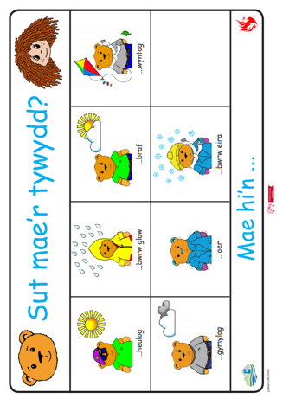
Appendix One.

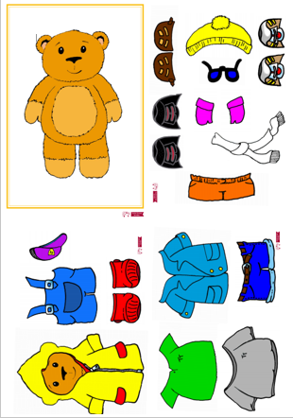
Appendix Two.

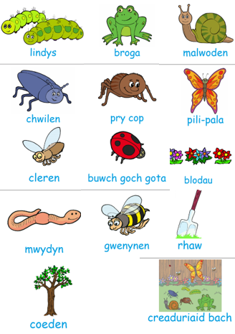
Appendix Three.

Reference List

Aubrey, K. and Riley, A., (2019). Understanding and Using Educational Theories. Page. 51. Second Edition. Sage Publications. London.
Aubrey, K. and Riley, A., (2019). Understanding and Using Educational Theories. Page. 28. Second Edition. Sage Publications. London.
Bates, B., (2019). Learning Theories Simplified. Page 210. Second Edition. Sage Publications. London.
Bates, B., (2019). Learning Theories Simplified. Page 50. Second Edition. Sage Publications. London.
Estyn, (2018). Website withheld to remain anonymous. (Last Accessed: 15th November 2020.)
Lemetyinen, H. (2012). Language. Available at: https://www.simplypsychology.org/language.html. (Last Accessed: 15th November 2020.)
Thud Media, (2020). Cyw. Available at: https://www.thudmedia.com/projects/web/cyw-website/. (Last Accessed: 15th November 2020.)
Welsh Assembly Government, (2015). Foundation Phase Framework. Available at: https://gov.wales/sites/default/files/publications/2018-02/foundation-phase-framework-revised-2015.pdf. (Last Accessed: 15th November 2020.)
Welsh Assembly Government. (2017). Welsh in Education Action Plan. Available at: https://gov.wales/sites/default/files/publications/2018-02/welsh-in-education-action-plan-2017%E2%80%9321.pdf. (Last Accessed: 15th November 2020.)
Welsh Assembly Government. (2020). Curriculum Wales Overview. Available at: https://gov.wales/curriculum-wales-overview. (Last Accessed: 15th November 2020.)

