Isiorono Marvelous Ewharekuko
Student Number: 2410703
Module: BMHP5015-Changemakers: Building Your Personal Brand for Sustainable Employment
Lecturer: Caroline Salami
Assignment: Component 1- Online Portfolio

Introduction
This is a reflective portfolio of my individual experiences and interaction with the online activities undertaken during the six weeks of this module about the development of my personal brand and promotion of my professional identity in health and social care. Each section represents a Moodle forum activity with screenshots of my own posts, and then there is a critical discussion about the activity in the forum with reference to relevant theory and literature. The reflections range from learning individual concepts (e.g., autonomy and self-awareness) to learning interpersonal skills (e.g., networking, emotional intelligence, stakeholder engagement and so on) and finally to the application of these ideas in the creation of a credible professional online presence.

Week 1: Autonomy, Self-Determination and Future Role
The Week 1 activities were introducing the concept of self-determination which was described in my forum post as the ability and right to make own choices and to control their own life without being forced upon or controlled by others. This is the key tenet of Self-Determination Theory (SDT) which states that in addition to competence and relatedness, autonomy is one of three psychological needs that underlie motivation and wellbeing (Deci and Ryan, 2000).
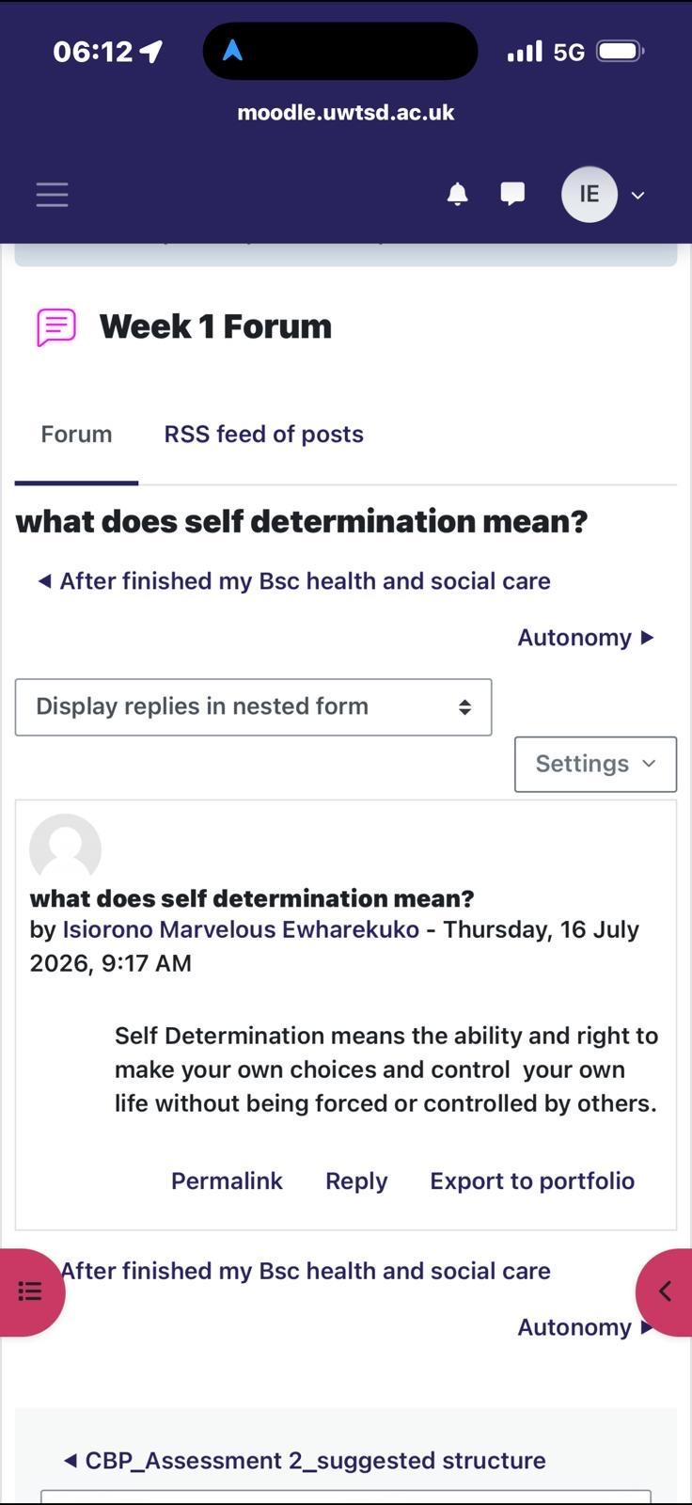
Figure 1: Forum post – what does self-determination mean?
From this, I thought that autonomy is the ability and freedom to make one's own choices and direct one's own behavior. Professionally, this has direct implications in a health and social care setting: Deci, Olafsen and Ryan (2017) suggest a link between autonomy supportive care environments in the workplace and higher intrinsic motivation, staff retention and decreased burn out – issues that are of concern in health and social care work. It means that I have to be conscious of my autonomy in developing my professional identity - not just self-promoting myself, but really taking control of how I present my skills, values and career direction instead of others.
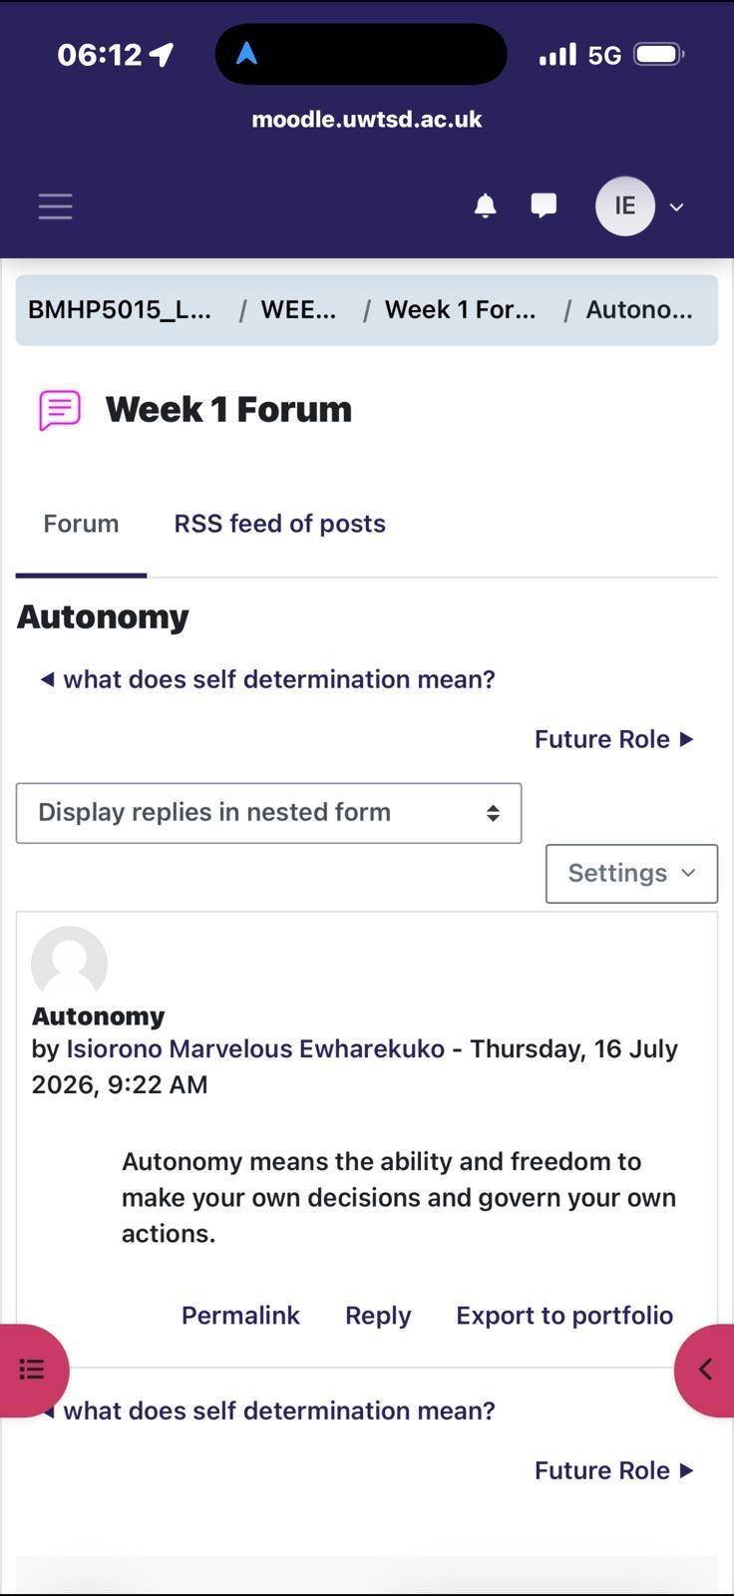
Figure 2: Forum post – Autonomy
Self-questioning about my future position, I discovered that my aspiration was to be a public health officer. With this theory, which was covered in the module, it is clear that there is a future role, meaning the motivation for the student has somewhere to flow – which is more sustainable than the external reward or obligation alone (Deci & Ryan, 2000). This early clarity now informs my approach to the remainder of the skills in this portfolio, with every of these remaining skills (self-awareness, networking, digital presence) being interpreted as a stepping stone towards this end goal, not some generic employability activity.
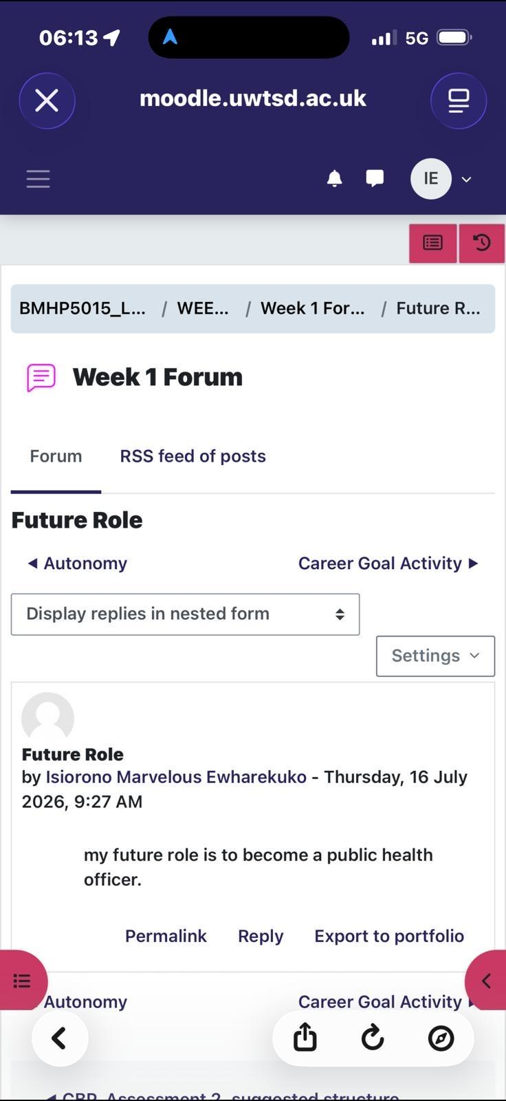
Figure 3: Forum post – Future Role

Week 2: Self-Awareness and Emotional Intelligence
During Week 2 I thought to myself, "self-awareness is key in health care because it helps health care professionals understand their thoughts, emotions, values, strengths and limitations, thus bettering the quality and safety of health care given to patients. This is in line with the previous literature on emotional intelligence (EI) in nursing and allied health fields, where self-awareness is always considered as the core element of the EI models along with self-management, social awareness, and social relationship management (Alsufyani, 2020).
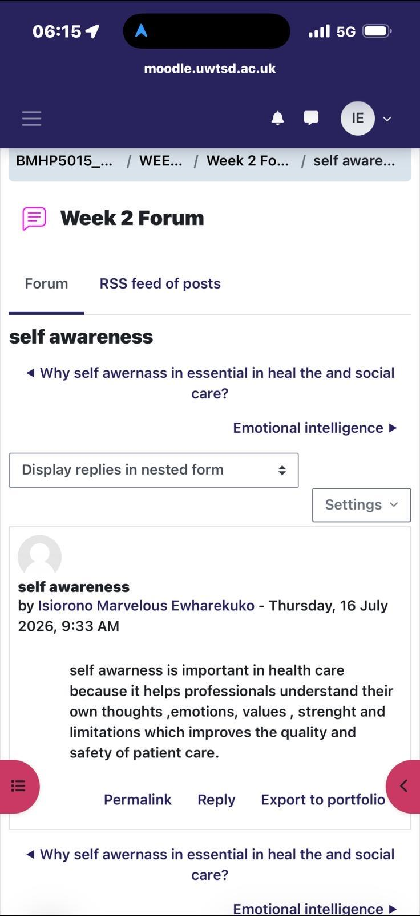
Figure 4: Forum post – Self-awareness
I then considered emotional intelligence as a broader concept, and explained how it is relevant and important in health and social care as it enables health and social care workers to recognise and regulate their own emotions and those of others, including patients, service users and families. Empirical studies lend support to this belief: In a cross-sectional study, it was found that nurses' EI, including self-awareness and social-awareness, was positively related to job performance and work engagement, as well as recommending the establishment of an environment in healthcare organisations that actively develops these competencies (Turjuman et al., 2023).
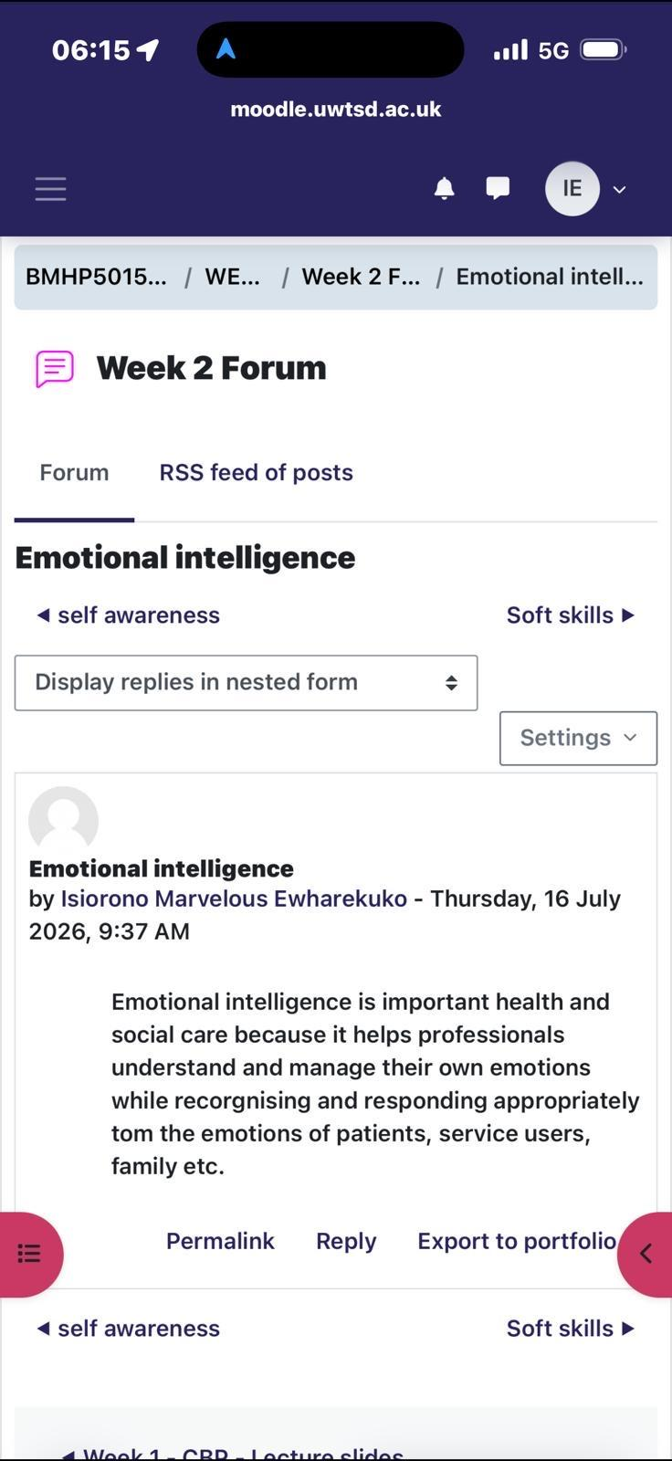
Figure 5: Forum post – Emotional intelligence
One of the difficulties noted is that self-awareness and EI are challenging to objectively measure and are frequently self-reported which leads to the problem of people either over- or under-estimating their own competence (Alsufyani, 2020). However, in the context of personal branding, it was clear to me that the ‘softer' skills of self-awareness and EI are as relevant to the credibility of the professional as technical skills and are therefore skills that can be demonstrated rather than claimed when presenting oneself professionally, in the health and social care sector.

Week 3: Networking Beyond My Immediate Field
For brainstorming Week 3, I was asked to reflect on an association with someone other than people within my industry or very similar to me. I recalled a time when my family was at a bar, I struck up a conversation with a music industry executive and in a matter of a few hours my cousin was signed to his label. The general principle is one from the social sciences, and in this example is beyond the scope of health or social care, but applies to professional practice: Social capital theory suggests that so-called ‘weak ties’ (contacts that are not as close as those in one's immediate network and are not as frequent for interaction) may lead to access to novel information, opportunities and resources not available through closer ties (Seibert, Kraimer and Liden, 2001).
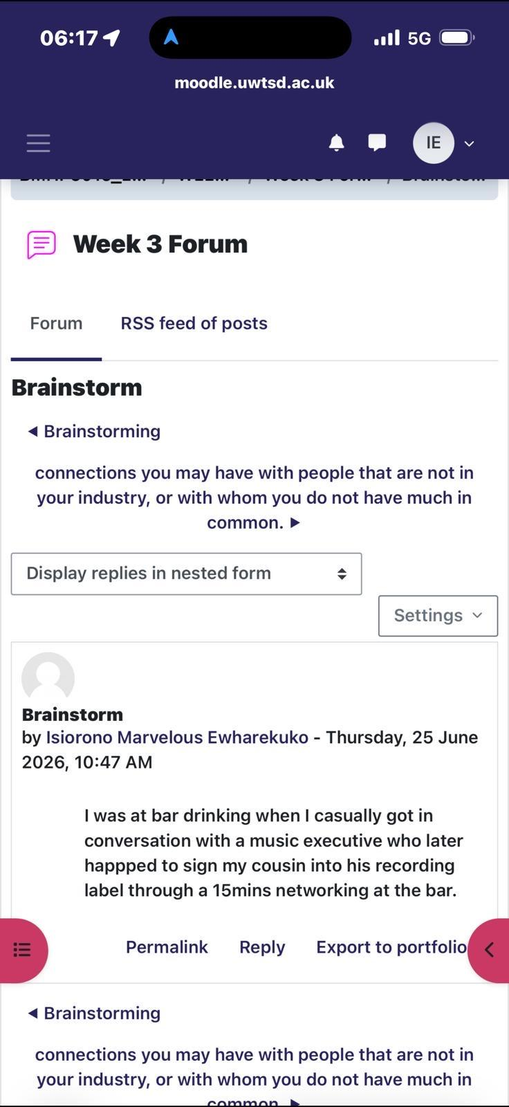
Figure 6: Forum post – Brainstorm
In thinking about this in terms of my future as a public health officer, it brings to mind the idea that professional networks should not be confined to those already working in the public health field. Similarly, the ‘structural holes' identified by Seibert, Kraimer and Liden (2001) as valuable sources of career-related social capital can be located in a range of contacts within community organisations, media outlets, education or the voluntary sector. This changed my perspective of networking activity for my personal brand: The value can be gained from unexpected and informal networking meetings as well as formal networking events.

Week 4: Bureaucracy, Hierarchy and Professional Networking
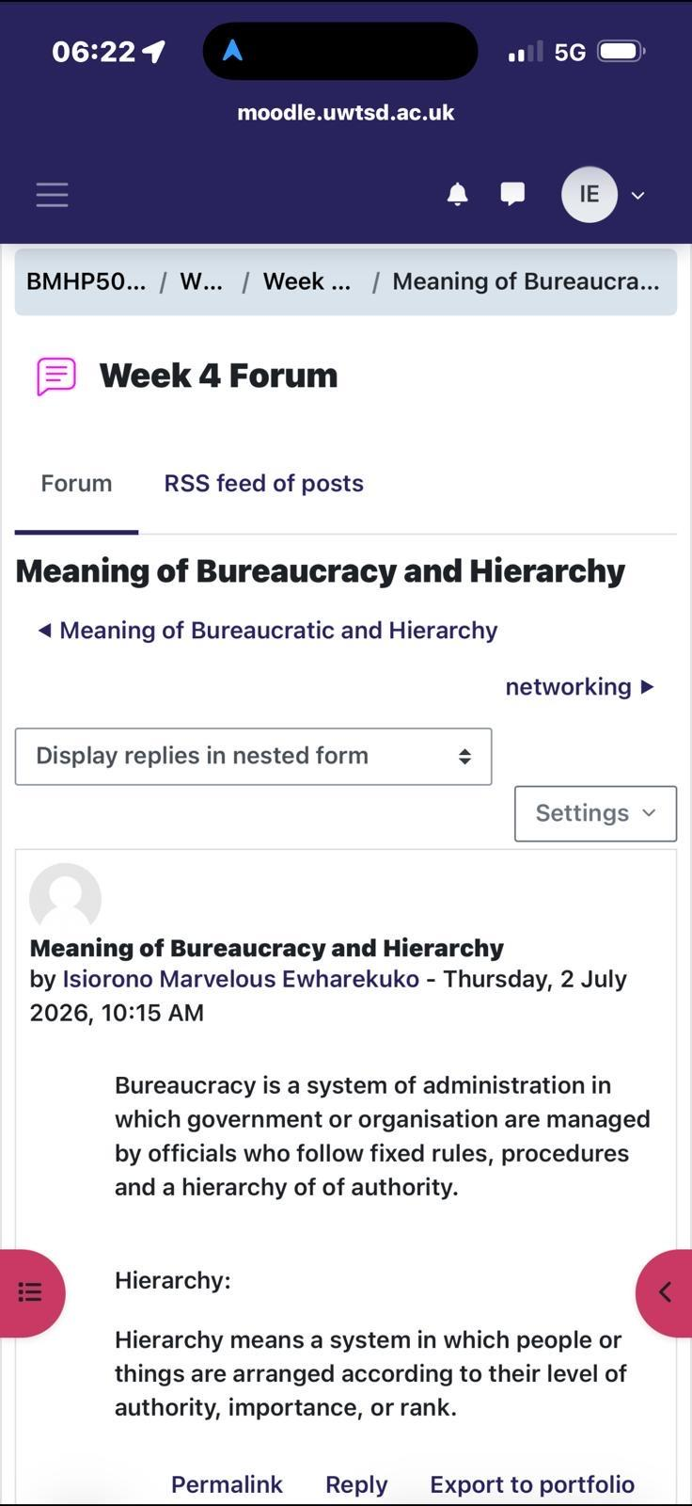
For the Week 4 activities I was given a task to define bureaucracy and hierarchy. Bureaucracy is a system of administration in which a government or organisation is managed by officials who adhere to rules, procedures and a hierarchy of authority, and hierarchy is a system of people or things that are ranked in order of authority, importance or rank. The following definitions are very similar to Weber's classical conception of bureaucracy, and include all the aspects described below: a clear chain of command, division of labour, standardised procedures, and impersonal, rule-based decision making (Weber, 1947).

Figure 7: Forum post – Meaning of Bureaucracy and Hierarchy
This concept can be applied directly to health and social care as organisations like local authority social services and the NHS are very bureaucratic. Bureaucratic structures provide consistency, accountability, and clarity of roles, but can lead to slow response to a dynamic working environment as argued by Asiri et al. (2020); which they suggest is a balance between formal hierarchy and shared vision that will enable flexibility and innovation in healthcare organisations. It's valuable for my own brand because it indicates that one can be effective in hierarchy and yet also communicate up is a viable professional skill in the marketplace.
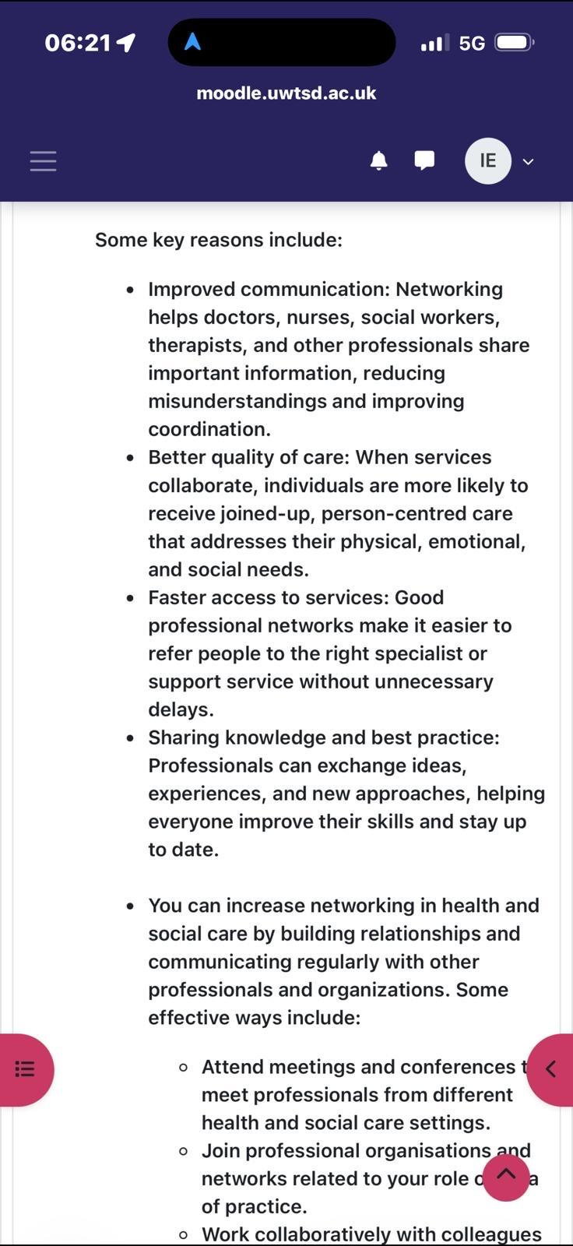
The forum this week also considered networking, reminding me that networking will help create better communication between doctors, nurses, social workers and others, minimise misunderstandings, facilitate better joined up care focused on the person, and enable quicker referral to specialist services. This further strengthens the argument advanced in Week 3 that professional networks are a type of social capital and can be cultivated by attending conferences, membership in professional organizations and inter-service collaboration (Seibert, Kraimer and Liden, 2001). Combined with the bureaucracy activity, this indicates that to be successful in a hierarchical health and social care system it is essential to respect the formal structures of authority as well as actively develop informal professional relationships which transcend levels of authority.

Figure 8: Forum post – Networking in health and social care

Week 5: Health Promotion Campaigns, Stakeholders and Networking Types
In week 5 I was tasked with thinking about a real public health problem – mental health campaign for the London Borough of Tower Hamlets. I thought, "The mental health crisis there is going to take a combination of improved access to services, prevention and tackling social determinants of mental health, as there are a lot of young, diverse people, high deprivation, and housing pressures in the borough. This stands in contrast to Marmot's (2010) theory of a social gradient, which proposes that the upstream causes of mental health inequalities include material deprivation and inequality, so that key elements of a successful local campaign should focus on more than just clinical services – it should also target housing, income and community conditions.
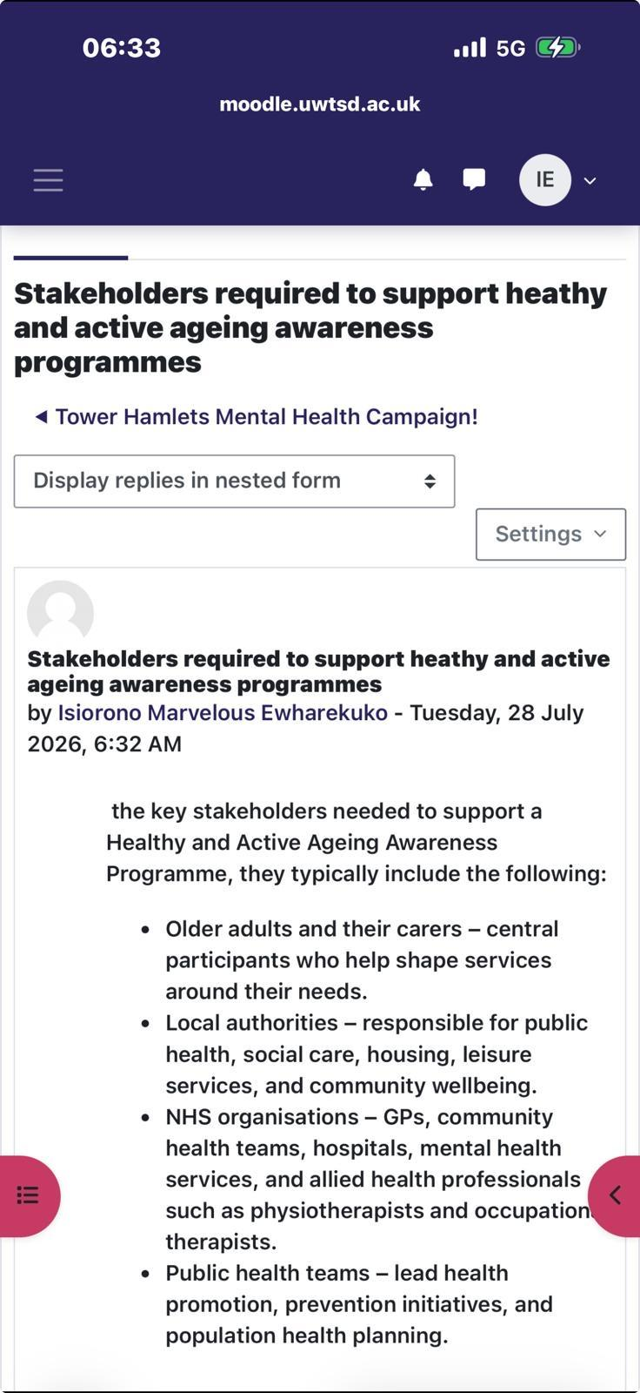
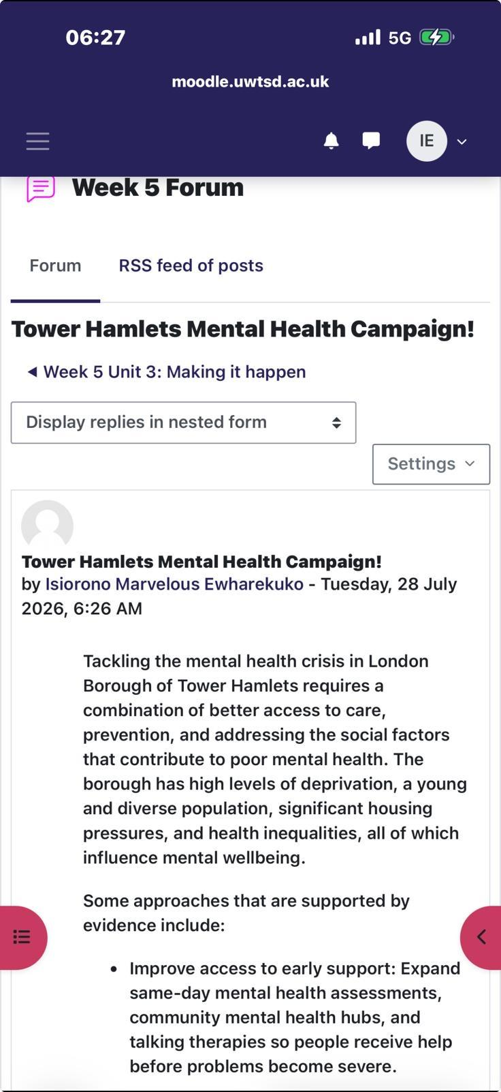
Then, I identified key stakeholders who I felt would be important to support a Healthy and Active Ageing Awareness Programme, including older people and their carers, local government, NHS organisations and the public health sector. Olughu (2025) identified that being flexible, communicating clearly and acknowledging lived experience as a kind of expertise, rather than professional knowledge, are essential to effective stakeholder engagement in public health projects. This strengthened my opinion that a strong personal brand in public health needs to be able to look at service users as partners in a brand, rather than as part of a campaign.

Figure 9: Forum post –Tower Hamlets Mental Campaign Figure 10: Forum post – A Healthy Ageing Program

Lastly, I distinguished professional and interprofessional and multi-agency networking. The collaborative working elements of interprofessional practice involves practitioners who hold different professions, and service users, working more closely together in order to achieve better outcomes—this is more and more essential as needs within health and social care become more complex, Murray et al. (2025) explain. Taking this a step further, multi-agency networking brings together completely separate organisations (such as the NHS, local authority and voluntary sector) with a common population need. In terms of my professional identity it was an exercise in understanding that the effective process of networking is not a single skill – it's a series of related practices, from the individual level of networking to formal cross-organisational networking partnerships.
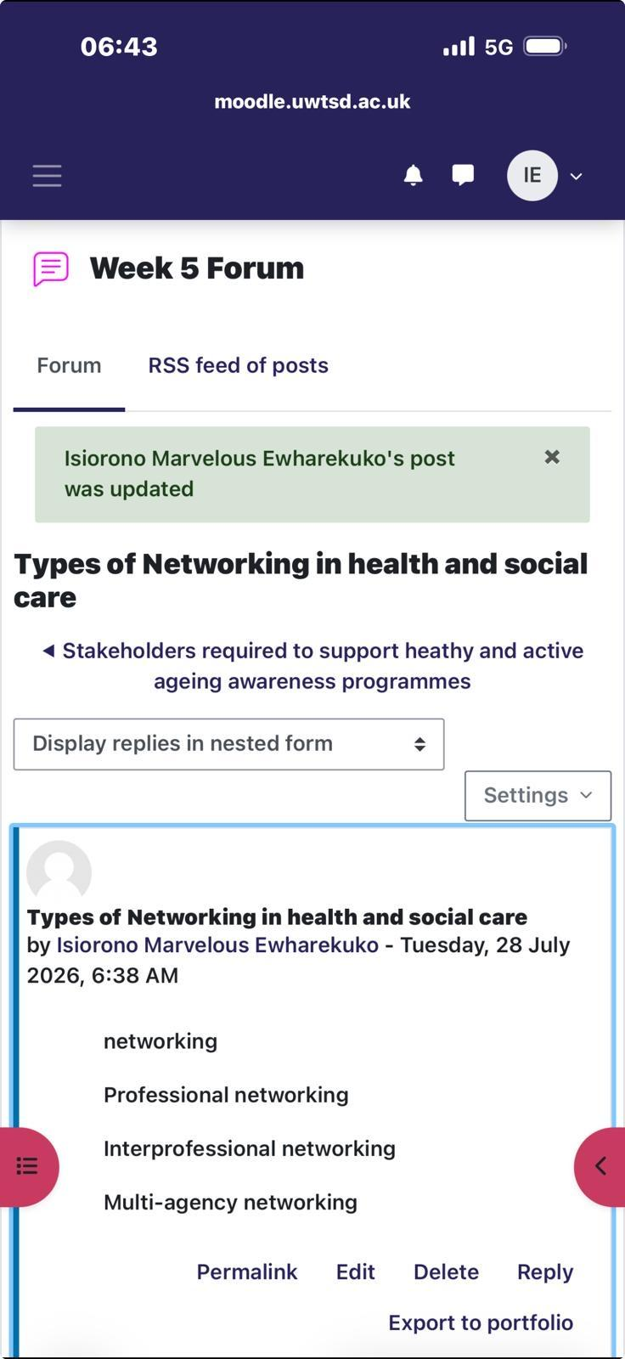
Figure 11: Forum post – Types of Networking in health and social care

Week 6: Building a Professional Online Presence
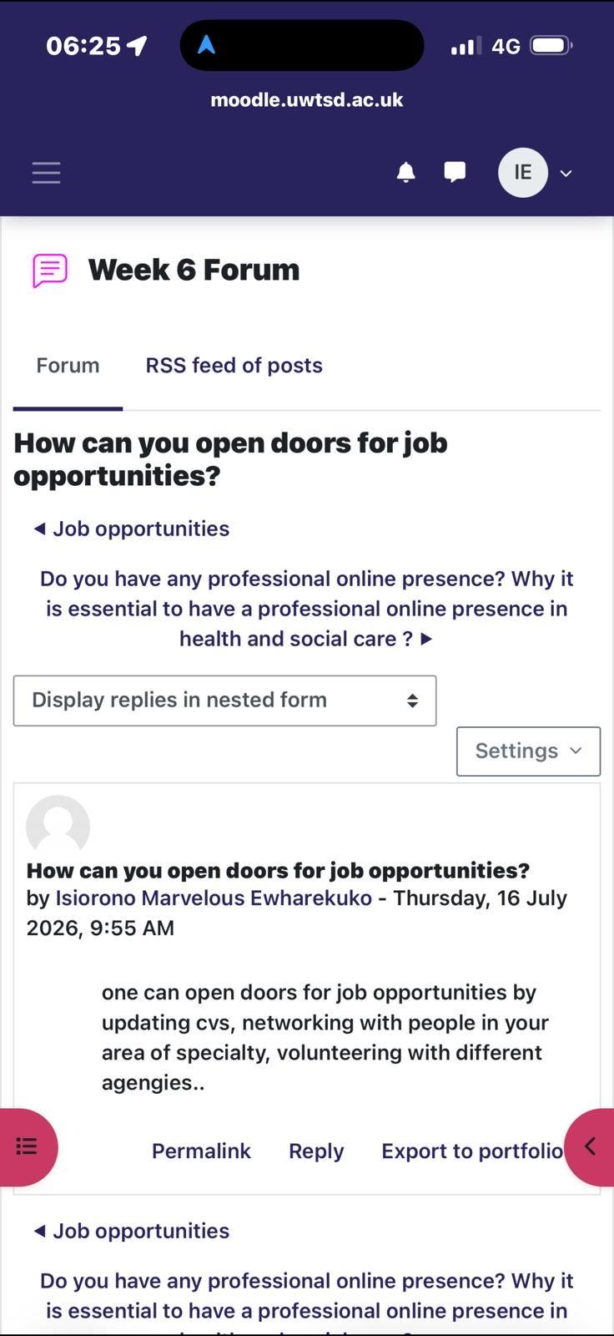
The final activities directly related to the module's theme the most, which is professional online presence. I thought that it is possible to create openings for careers by updating resumes, networking with folks in the expertise, and volunteering at various agencies. This mirrors the advice given in professional careers literature which also names an updated professional profile, the importance of networking and having practical experience as key pathways to sustainable employment in health and social care.

Figure 12: Forum post – How can you open doors for job opportunities?

In a video I then showed them all the different ends to which the different career paths they could take could go, depending on their preferences, and reinforced the notion that ‘personal branding' is not a one-size-fits-all thing, but rather a clear message about which of several valid career paths I follow, I am working in public health.
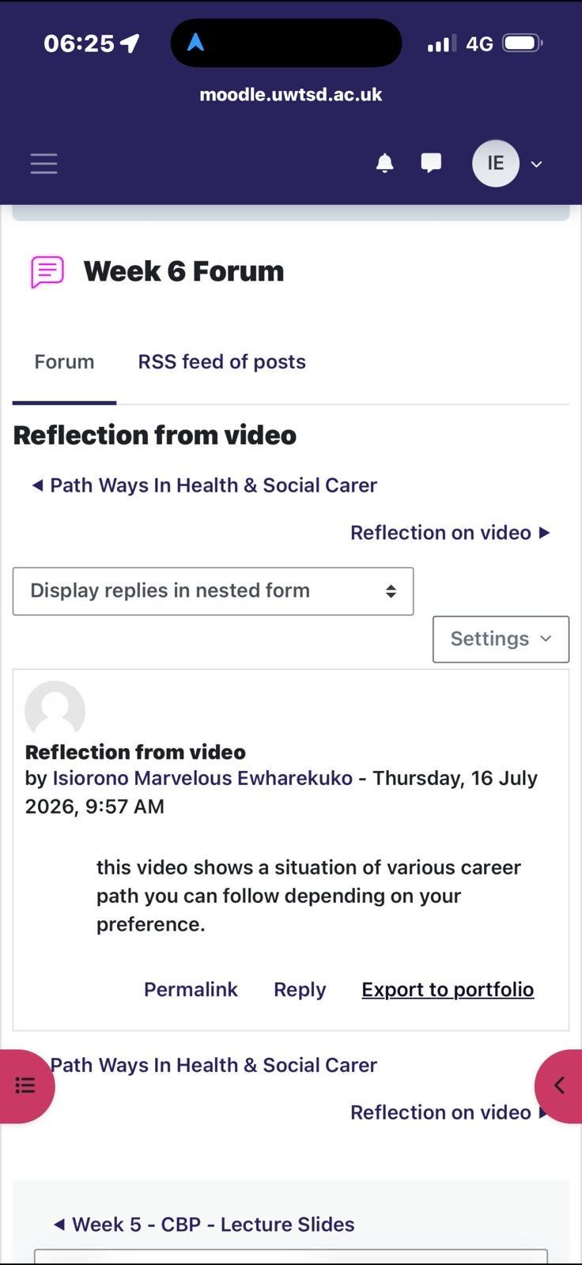
Figure 13: Forum post – Reflection from video
As to the question of having a professional online presence in answer to it, I said I do have a professional online presence, and that it is important in health and social care because it enables them to reach out to prospective clients, helps maintain trust, protects professional reputation, helps ensure that they meet professional and ethical standards, and it facilitates accessibility for the public to reach out to the professional. This is backed up by the regulatory guidance: Nursing and Midwifery Council (2019) states that social media can provide opportunities for professional relationships, being able to access support networks and continuing professional development, provided that it is used in a responsible way; but highlights the importance of registrants maintaining confidentiality, professional boundaries and public protection at all times. Likewise, a narrative review of digital professionalism in medical, nursing and allied health education revealed that social media holds promise of sharing knowledge and networking, but clear guidance is needed to help students and practitioners understand how to manage their personal and professional online identities (O'Connor et al., 2021).
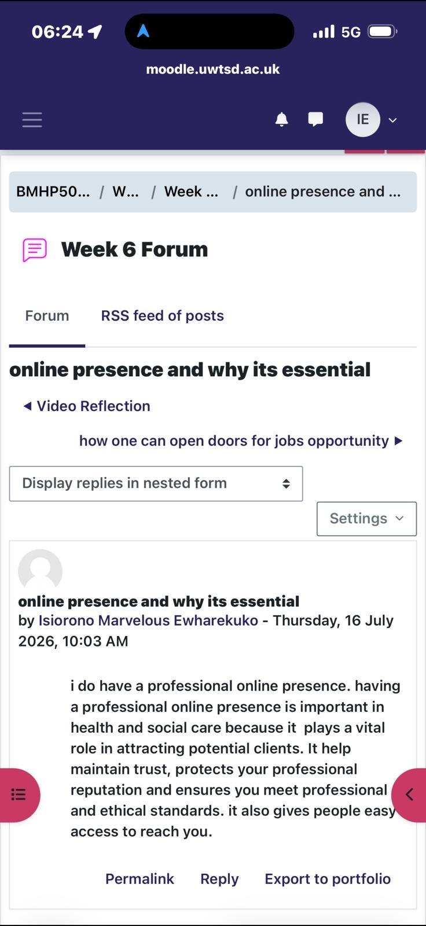

Figure 14: Forum post – Online presence and why it's essential
Finally, I thought about blogging; how it's used to share knowledge, to report back to the community and it's used for education and sharing information. Evidence from healthcare knowledge translation research: a survey of healthcare providers indicated that the majority of respondents felt blogs were a useful means of disseminating further professional development and maintaining awareness of recent evidence-based practice, and a significant proportion said they found blog content had resulted in a change in their practice (JMIR Research Protocols, 2023). I guess in my future role in public health, blogging might be a two-fold opportunity: to help reinforce my personal brand as a knowledgeable, engaged public health practitioner and to be a real public health communication tool.
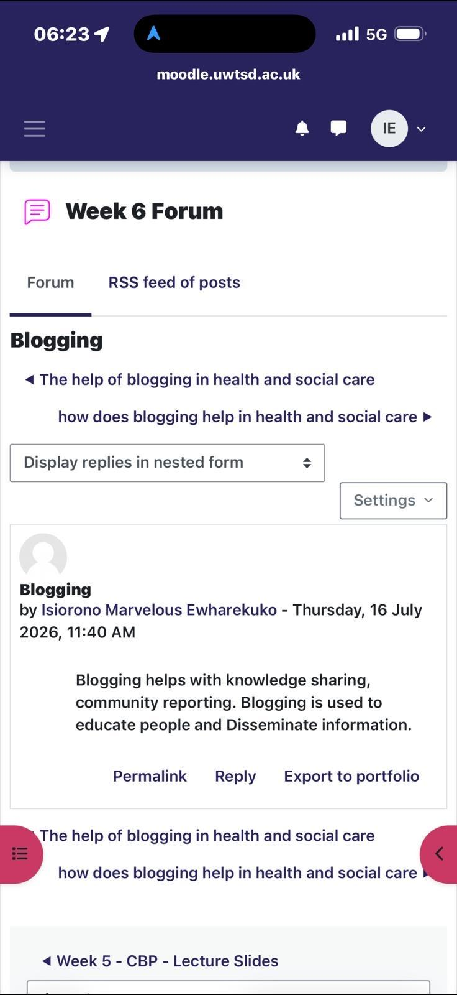
Figure 15: Forum post – Blogging

Conclusion
Through completing these online activities, I have discovered that developing a personal brand in health and social care is far more than a marketing 'trick' but is based on sound psychological and organisational theory. All of these activities occur within a hierarchy that can be explained by Weberian organisational theory (Weber, 1947; Asiri et al., 2020), the importance of social capital and networking theory (Seibert, Kraimer and Liden, 2001) to the study, and an explanation of why autonomy and self-determination (Deci and Ryan, 2000) are important in motivating sustained professional development. Combined with guidance on professional online conduct from the Nursing and Midwifery Council (2019) and O'Connor et al (2021), I have a better, evidence based definition of how I want to present myself professionally in person, and online, to achieve my future role as a public health practitioner.

References
Alsufyani, Y.M. (2020) 'Consequences of emotional intelligence in nursing: a concept analysis', Erbil Journal of Nursing and Midwifery, 3(1), pp.1–10.
Asiri, et al. (2020) 'The advantages and disadvantages of bureaucratic structure in healthcare organizations', International Journal of Management – Theory and Applications (IREMAN), 3(1), pp.1–12.
Deci, E.L. and Ryan, R.M. (2000) 'Self-determination theory and the facilitation of intrinsic motivation, social development, and well-being', American Psychologist, 55(1), pp.68–78.
Deci, E.L., Olafsen, A.H. and Ryan, R.M. (2017) 'Self-determination theory in work organizations: the state of a science', Annual Review of Organizational Psychology and Organizational Behavior, 4, pp.19–43.
JMIR Research Protocols (2023) 'The use of social media for dissemination of research evidence to health and social care practitioners: protocol for a systematic review', JMIR Research Protocols, 12(1), e45684.
Marmot, M. (2010) Fair Society, Healthy Lives: The Marmot Review. London: Institute of Health Equity.
Murray, J-L.K. et al. (2025) 'Interprofessional collaborative practice in health and social care for people living with multimorbidity: a scoping review protocol', Systematic Reviews, 14, 1.
Nursing and Midwifery Council (2019) Guidance on Using Social Media Responsibly. Available at: https://www.nmc.org.uk/standards/guidance/social-media-guidance/ (Accessed: 27 July 2026).
O'Connor, S., Zhang, M., Honey, M. and Lee, J.J. (2021) 'Digital professionalism on social media: a narrative review of the medical, nursing, and allied health education literature', International Journal of Medical Informatics, 153, 104514.
Olughu, K.N. (2025) Community-Driven Stakeholder Engagement Strategies in Public Health Projects. Harrisburg University Digital Commons.
Seibert, S.E., Kraimer, M.L. and Liden, R.C. (2001) 'A social capital theory of career success', Academy of Management Journal, 44(2), pp.219–237.
Turjuman, R. et al. (2023) 'Emotional intelligence among nurses and its relationship with their performance and work engagement: a cross-sectional study', Journal of Nursing Management, 2023, 5543299.
Weber, M. (1947) The Theory of Social and Economic Organization. New York: The Free Press.

