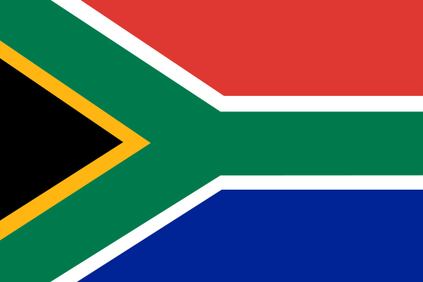

Industry Destination Review
  - South Africa
Molly Thomas | Global Tourism and Destination Management | 08/05/2020

Global Tourism
The growing process of globalization is continuously opening doors for tourists to visit new and exciting destinations. In 2019 1.5 billion international tourist arrivals were recorded, which is the tenth consecutive year of growth (UNTWO, 2020). This progressive level of increase allows lesser developed countries such as South Africa to tap into a market that has a great demand, that ultimately could provide the economic boost it needs to jump to developed country status. Analysis of the countries existing tourism industry suggests huge potential.

Country Overview
South Africa is located at the southernmost point of the African continent sharing borders with Namibia, Botswana, Mozambique, Zimbabwe and Swaziland, South Africa also encompasses the small nation of Lesotho (GOV.SA-1, 2020). 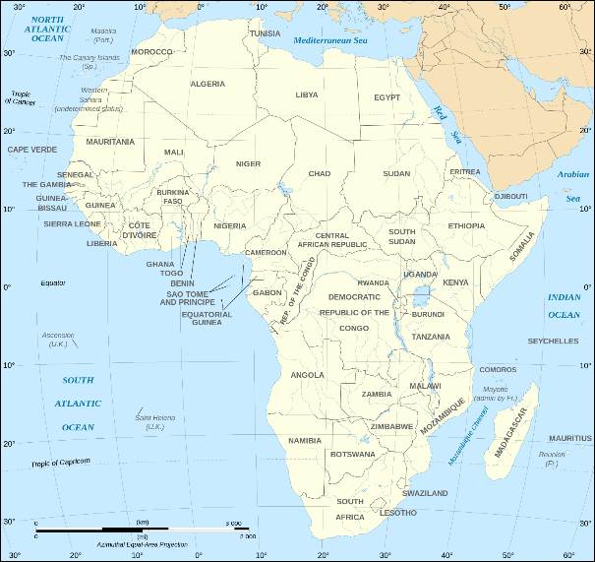
Image 1- Map of Africa
Covering 1,219,090 square kilometers South Africa is four times larger than the size of Italy (One World, 2020). The South African coastland spans around 3000km and meets the Atlantic Ocean on the west and the Indian ocean to the east. (Wepener & Degger, 2018).
The country consists of a vast central plateau that is bordered by a horseshoe shaped escarpment along the southern edge that leads to a narrow coastal plain before reaching the sea. The combination of its geographical location and the diversity of the topography in South Africa creates the opportunity for several biomes to flourish (Moore, et al, 2009). See appendix 1 for biomes in South Africa.
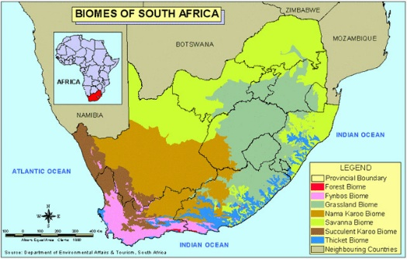
Image 2- Areas of Biomes

Safari Tourism
Safari tourism is one of South Africa’s unique selling points, with such a diverse range of biomes the opportunity for safari tourism and tourists to see animals in their natural habitat is huge. South Africa has twenty national parks which each host a variety of wildlife, such as ‘Addo Elephant National Park’ 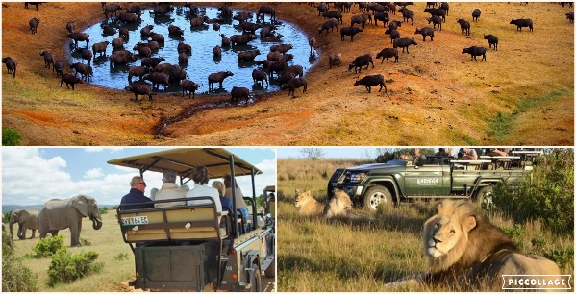where tourist have the opportunity to witness hundreds of elephants gathering at water holes every day (SA-V, 2020). Having developed over time from a form of hunting tourism, safari tourism now aims to protect and preserve the natural habitat and the animals, it is also an opportunity to educate people on the animals daily lives and history (Stone and Stone, 2015). These tours can be undertaken by hiking/walking, in open top 4X4 vehicles, and even helicopter tours, when traveling to South Africa 80% of tourists take part in some form of wildlife tourism (Kriek, 2017) and nature reserves on a continental scale contributed 3.9 million dollars in tourism revenue (African Parks, 2020).
Image 3- Safari Tourism
The climate of south Africa varies from Mediterranean to Temperate to Subtropical and a small area of desert climate. Unlike most countries South African climate is more heavily influenced by elevation, terrain, and ocean currents than latitude (Byrnes, 1996). This allows for a great marketing strategy aimed at promoting and showcasing the variety of climates on offer in South Africa and that there are areas to suit everyone’s weather/climate wants and needs.
Due to the size of South Africa it is often most time effective to take domestic flights between it’s most popular cities, Lonely Planet (2020) suggests that a budget airline flight from Johannesburg to Cape Town would cost as little as R1000 (£43). Alternative options for traveling across the country includes buses, these however vary in reliability. There is also the option of using the Shosholoza Meyl train service to major cities, travelling by tourist class is advised as the traveler will receive an authentic but safe and affordable travel experience (Lonely Planet. 2020). 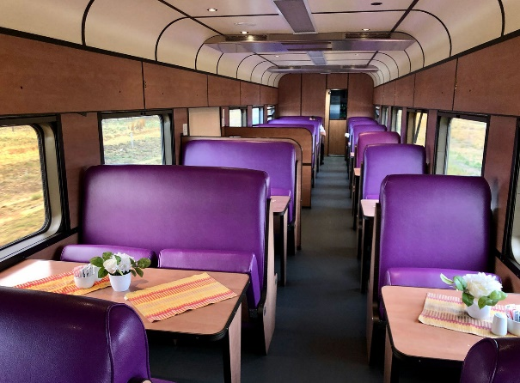
Image 4-Shosholoza Meyl Train
There are also several options for local transport, there is a wide range of city buses that have reasonable prices, shared taxis, private taxis which on average have a rate of R10 (£0.43) per kilometer. Most modes of public transport are a reasonable price. For the fittest tourist’s bike hire may be an option to explore the local area (Claassens, 2018).

Western Cape
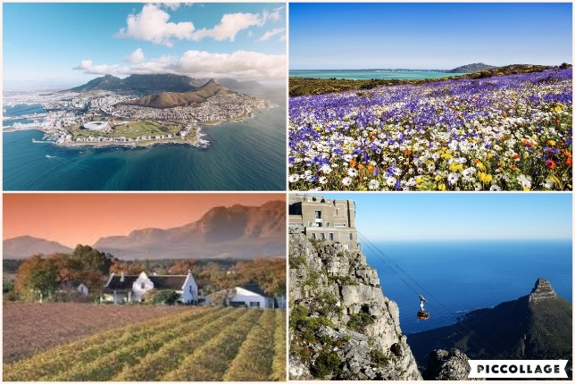
The Western Cape is a key tourist destination for both international and domestic tourists. This is where the city of Cape Town is located, in recent years there has been an 11.5% increase in international arrivals at the city’s airport (Western Cape Government, 2020). Attractions include the Cape Winelands district which hosts vast and beautiful vineyards offering tasting sessions of world-renowned wines (Cape Winelands District, 2019). The Western Cape also boasts the longest coastline of the four coastal provinces in South Africa and Table Mountain National Park (Western Cape Government, 2020). Table Mountain is a flat-topped mountain that sits at 1087 meters above sea level and is the backdrop to Cape Town, it has recently become one of the new seven wonders of nature. (New 7 Wonders, 2019).
Image 5- The Western Cape

KwaZulu-Natal
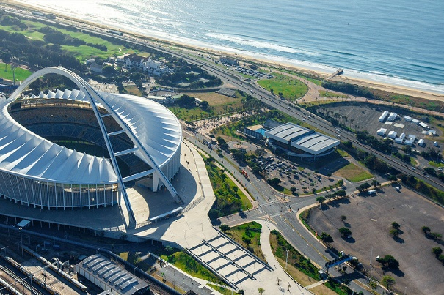
Another of South Africa’s coastal provinces, KwaZulu-Natal has a diverse landscape that makes it a prime tourist destination, with beaches, mountains, and an extensive savanna (Zulu.org, 2020). Hluhluwe-iMofolozi Park is the oldest game park on the African continent and one of the few reserves in this province that all of the Big Five can be seen, the land lies deep within the cultural Zululand (Hastings and Wilbanks, 2019). Durban is South Africa’s third largest city located directly on the east coast; it has been recently redeveloped for the 2010 World Cup with a focus on creating a tourist destination. Attractions include; uShaka Marine World (aquarium and water park), Moses Mabhida Stadium (Sports complex and football stadium) and The Phoenix Settlement, which is the land purchased in 1904 by Mohandas Gandhi that later became both his home and the location of the printing press he developed to spread his ideas (Griffin, 2014).
Image 6- Moses Mabhida Stadium

Culture
South Africa has the 26th largest population in the world. With four main ethical groups, the majority of which identify as Black African (80.8%). Due to the affects of HIV/AIDS there the life expectancy is relatively low at just 63 (CIA-1, 2020). However, on a positive note since 2010 there has been a 50% decrease in AIDS related deaths and a significant reduction in new HIV infections (UNAIDS, 2018). This is lower than that of most other global tourism destinations, for example life expectancy in France is 82 years (The World Bank, 2018). Having a youthful population (mean age of 28 years) is beneficial to the country as such a large workforce will allow for rapid economic growth (Basten, et al, N.D). Kenya, a country with similar tourism prospects has a much younger majority population with almost 40% aged 15 or younger and this could be detrimental to the counties growth as there is only a small percentage of the population of working age CIA: Kenya, 2020).
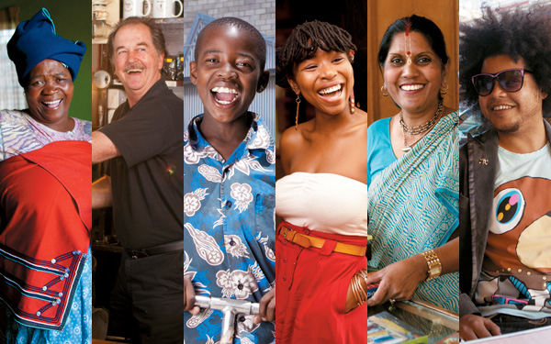
Image 7- Diversity of Population
According to the CIA (2020) there are over 11 official languages in South Africa with 24.7% speaking isiZulu most often, 12.1% speaking Afrikaans and 8.4% favoring English. English is however spoken across the country as it is the language of business, politics, and media (Brand South Africa, 2007). The knowledge and use of English is beneficial to the tourism industry as 350 million speak it as a first language and a further 430 million as a second language (Srinivas, 2019). Felter (2015) suggests that the large number of languages is due to the immense cultural diversity of the country.
It is thought that modern humans have lived on the land of South Africa for 100,000 years. However, the first European settlement was by the Dutch East Indian company in 1652 to supply passing ships with fresh produce. In 1795 British forces seized control of the area that is now known as Cape Town (Gov.SA-2, 2020). With such a varying population heritage and culture is very diverse and often referred to as the ‘Rainbow Nation’. A small example of the many cultures found in South Africa include the Zulu, Pedi, Hindu and Afrikaner people, they each have an individual characteristics such as lifestyle choices, values, traditions and spiritual/intellectual beliefs (SAHO, 2020). 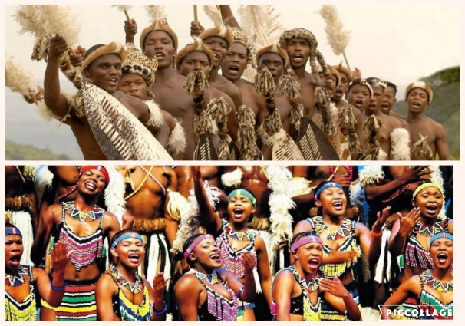
Image 8- Native Tribes (Top- Zulu, Bottom- Pedi)

Cultural Tourism
A growing demand for genuine cultural experiences has created the subset of Cultural tourism, “it is the single most important resource for international tourism” (Graham, et al, 2000). The multifarious cultures that prevail in South Africa means this type of tourism is in growing demand (UNTWO-2, 2020). This includes visits to world heritage sites such as Robben Island which was used between the 17th and 20th century to house a variety of groups, it was a prison, a hospital and a military base throughout this period (UNESCO-1, 2020). Richtersveld Cultural and Botanical Landscape is another area of cultural excellence, owned communally the land is still managed by the semi-nomadic Nama people, who aim to educate tourists on traditional practices and the value of tradition (UNESCO-2). There is a growing demand for education to help tourists understand the need for sustainable economic, social and cultural development that still conserves and protects vulnerable areas of culture and heritage within the destination such as tribes or historical landmarks(UNESCO, 2003).

Tourism Industry
The latest figures show that only 2.8% of South Africa’s Gross Domestic Product (GDP) was produced by the tourism industry this is greater than the GDP produced by the agricultural industry (StatsSA, 2018). Kenya’s percentage of GDP produced through tourism was 8.8% (Knoema, 2018), when comparing this to South Africa’s figure we can see there is a market for the types of tourism available as Kenya offers a very similar product. This suggests that there is an opportunity for South Africa’s economy to grow through the development of the tourism industry.
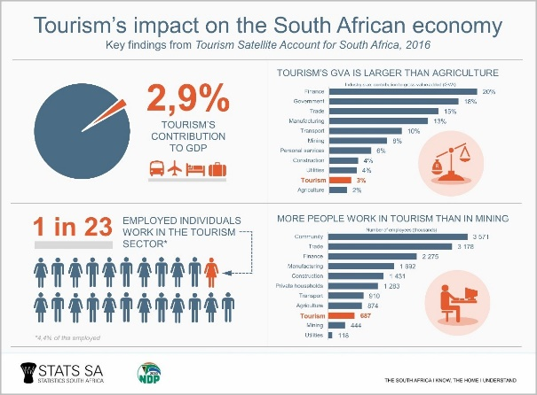
Image 9- Economic Impact
The increase of employment opportunities in South Africa is a significant indicator of the growing industry, between 2014 and 2017 64,000 new jobs were created, exceeding employment opportunities in traditional South African industries such as mining or transport and communications (StatsSA, 2017). Of those employed within the industry in 2017, 722,000 were specifically employed in accommodation services, which was an increase of 31,800 jobs since the previous year (World Tourism Organization-2, 2019). The provision of food, water and shelter are basic needs of Maslow’s Hierarchy of Needs (1943) (McLeod, 2020) and therefore the growth in employment suggests an improvement or increase in these services available to tourists in the form of hotels, restaurants, cafes and bars.

Accommodation
In the last quarter of 2019 whilst hotels dominated the accommodation sector holding 64.7% share of the industry, other forms of accommodation (Lodges/B&B’s/ Self-Catering) had the highest growth rate of plus 10.4%. Occupancy rates however were down 7.5% on the same period the previous year (Department of Tourism: Republic of South Africa, 2019). Due to the diversity of climates in South Africa the summer season (October- February) isn’t always the best time to visit, for example the best time to see the ‘Big Five’ is April and May (African Conservation, ND). European destinations deem the summer season their busiest period and have the highest number of tourists during the summer months (Dixon, 2018). See appendix 2 for examples of accommodation.

Food and Beverage
In January 2019 restaurants and coffee shops had more sales in both food and drinks than takeaway and fast food outlets (South African Market Insights, 2020). During a three-month period (April-May 2019) the food and beverage sector in South Africa saw a 4.8% increase in GDP contribution compared to the same period in 2018 (Krige, 2019).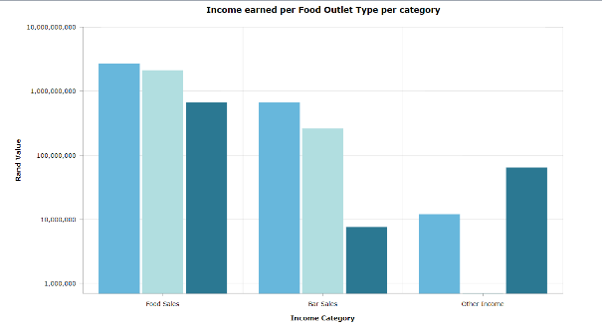
Image 10- Food and Beverage Breakdown
With influences from not only indigenous people but also European and Indian cuisine, there is several traditional foods that tourists must try, see appendix 3, (Best, 2020). There is also a draw for the niche gastro- tourism market to experience the world-famous Braai (type of BBQ) or tour the beautiful winelands.

Transportation
A key indicator of growth in the tourism industry is an increase in passenger arrivals by airplane. Data from the fourth quarter shows an increase of 2.2%, despite seeing a decrease of 27,310 international passengers, there has been a 4.3% uptake of domestic passengers (Department of Tourism: Republic of South Africa, 2019). Total arrivals in South Africa have been increasing steadily since 2014 (World Tourism Organization-2, 2019).

Industry Challenges
Shaw, et al (2012) identifies nine areas of risk to the south African tourism industry: operational, environmental, affordability, crime and politics, national image and competitiveness, business insufficiency, health, economic and transport risks. Looking at a selection of these will showcase potential unappealing factors that my influence prospective tourists (Honholz, ND). See appendix 1 for detailed evaluation of a variety risks to tourists in South Africa.

Growth & Development
Butlers (1980) product life cycle model can be applied to the tourism industry in South Africa, the model consists of a number of stages, the first stage is exploration as we saw earlier the European exploration began in the late 1700’s, the second is involvement, this is the start of the tourist market in a location, whilst the increase in tourists at this stage often applies pressure to infrastructure there is very little change to normal life of residents and high interaction between locals and tourists. Prior to the end of the Apartheid in 1994 there was very little tourism in South Africa (Grundlingh, 2009). By hosting a series of worldwide events, it was able to re imagine itself to domestic and international tourists and thus began its development stage of Butlers product life cycle.
In 1996 the first reconstruction and development program was laid out, with only 2% of the countries GDP being produced by tourism, there was an opportunity for growth and development. By setting out social, economic, and environmental objectives the documents aim was to boost tourism, these objectives included things such as.
- lengthening the tourism season in order to minimize the negative effects of seasonality
- To use tourism as a catalyst for human development, focusing on gender equality, career development and the implementation of national labor standards
- To promote pride in the cultural resources of the country
- To contribute to the development of a coordinated country-wide environmental strategy

(Government of South Africa Department of Environmental Affairs and Tourism, 1996)
Evidence suggests that South Africa is still in the development stage as a new plan was put into place in 2015. The tourism department set out a strategic plan to develop tourism by 2020. Their mission statement was “To grow an inclusive and sustainable tourism economy.” The document sets out an action plan to achieve this through; effective marketing, facilitating ease of access to service, enhancing the visitor experience, updating destination management policies and creating broad based benefits for all communities (Department of Tourism of the Republic of South Africa, 2017). The next stage is consolidation at this point all targets will have been met and the tourism industry will be thriving.
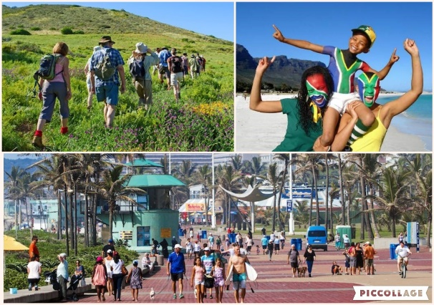
Image 12- Tourists

Tourist Demographics
Due to the current developing nature of tourism in South Africa currently the type of tourist attracted to the area are adventurers, Cohen’s (1972) tourist classification would define them as either drifters or explorers as they value the novelty of exploring a new destination. However, Safari tourism and other organized tours that will emerge tend to attract organized mass tourist that seek familiarity during their travels. Plog’s allocentric tourists ae the type of tourist South Africa is looking to advertise to, this type of tourist seeks the newest and most exciting adventures and immerse themselves in the cultures they visit. South Africa’s diverse culture and untouched areas of natural beauty make it an up and coming destination for these tourist (Cruz-Milán, 2017).

The Future
South Africa uses its diversity as the main focus for domestic and international tourism marketing. Due to the recent changes in leadership there has yet to be a specific strategy for tourism put in place and the long-term impact of COVID-19 on tourism is still relatively unknown. In the meantime, the general strategy is to increase international visitors, lengthen the average stay and disperse the seasonality of the industry (South Africa, 2020). In the forthcoming years, a boost in tourism to South Africa has the ability to provide economic stability and bring the country to a developed status.

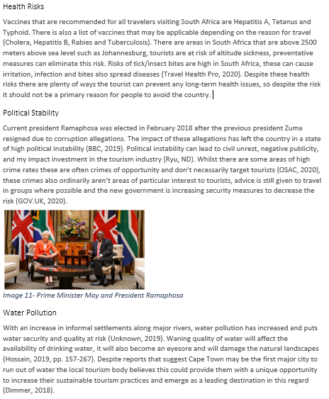
Appendix
Appendix 1- Risks

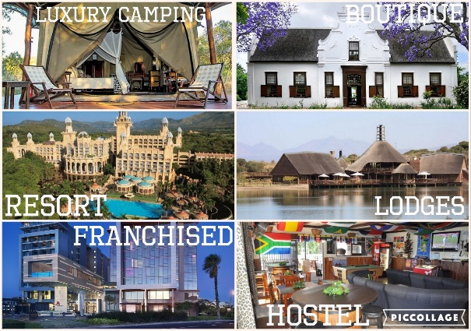
Appendix 3- Accommodation options in South Africa
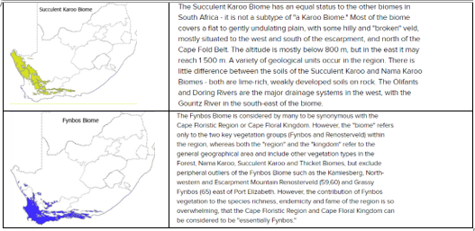
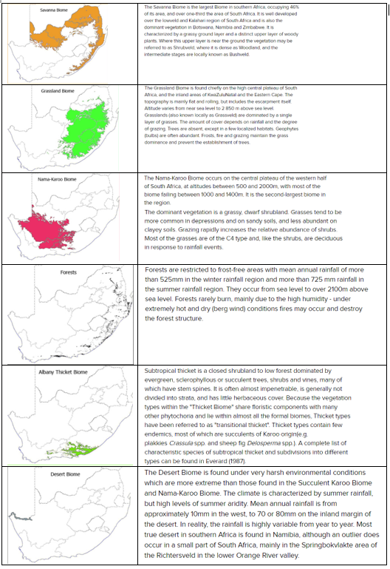
Appendix 2- South African Biomes (SANBI, 2020).
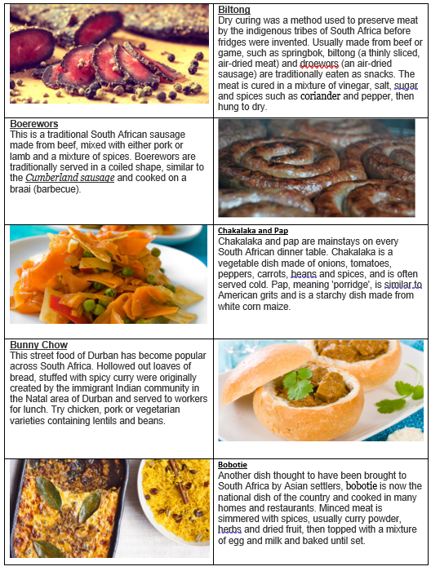
Appendix 4 - South African Food (Best, 2020).

Bibliography
African Conservation. (ND) South Africa’s Weather. [Online] Available at: http://www.photodestination.co.za/south-africa-weather.html (Accessed on:03/05/2020)
African Parks. (2020) Tourism and Enterprise: Economic Impact. [Online] Available at: https://www.africanparks.org/our-work/tourism-enterprise (Accessed on: 08/05/2020)
Basten, S., Loichinger, E., Lutz, W. (ND) Report I: Youthful populations, employment challenges and poverty in the least developed countries. [Online] Available at: https://f02bfb4a-a-62cb3a1a-s-sites.googlegroups.com/site/stuartbasten/admin/YouthfulpopulationsUNFPA.pdf?attachauth=ANoY7crbyi0OB_Kw8pWKVYDqMn0Zrla1N5SwtXsldSuVaibPqvWWVd9QKl-nlvoCqTT0zyktbbeqm3r3OJAG0zjCFEpu0zvh3JTJK7un8ockkBvoOnx7h-k4IwcCjVCb4KwZFpY8HobUrLVeyXAMbUALUqOohJv649ffeuu4eGh17tgSc6vMMRBZ99Nd-3WCYFA-V0YXQDaWWDMq8DK1eEEOyIfwJMN_J6OA7WUNFbzJTc68eqb1SCg%3D&attredirects=0 (Accessed on: 01/05/2020)
BBC. (2019) South Africa country profile. [Online] Available at: https://www.bbc.co.uk/news/world-africa-14094760 (Accessed on: 03/05/2020)
Best, C. (2020) Top 10 foods to try in South Africa. [Online] Available at: https://www.bbcgoodfood.com/howto/guide/top-10-foods-try-south-africa (Accessed on: 13/05/2020)
Brand South Africa (2007) South Africa’s Languages. [Online] Available at: https://www.brandsouthafrica.com/south-africa-fast-facts/geography-facts/languages (Accessed on: 01/05/2020)
Byrnes, R.M. (1996) South Africa: A Case Study. Washington: GPO for the Library of Congress. [Online] Available at: http://countrystudies.us/south-africa/38.htm (Accessed on: 24/04/2020).
Cape Winelands District. (2019) Cape Winelands Tourism. [Online] Available at: http://www.capewinelands.gov.za/SitePages/Cape%20Winelands%20Tourism.aspx (Accessed on: 02/05/2020)
CIA-1 (2020) The World Factbook, Africa: South Africa. [Online] Available at: https://www.cia.gov/library/publications/the-world-factbook/geos/sf.html (Accessed on: 01/05/2020)
CIA-2 (2020) The World Factbook, Europe: France. [Online] Available at: https://www.cia.gov/library/publications/the-world-factbook/geos/fr.html (Accessed on: 01/05/2020)
Claassens, C. (2018) How to Navigate Transport in South Africa. [Online] Available at: https://theculturetrip.com/africa/south-africa/articles/how-to-navigate-transport-in-south-africa/ (Accessed on: 07/05/2020)
Cohen, E. (1979). Rethinking the Sociology of Tourism. Annals of Tourism Research, 6(1), 18- 35. [Online] Available at: https://www.sciencedirect.com/science/article/abs/pii/0160738379900926 (Accessed on: 08/05/2020)
Cruz-Milán, O. (2017). Plog’s model of typologies of tourists. In L. Lowry (Ed.), The sage international encyclopedia of travel and tourism (pp. 954-956). Thousand Oaks, CA: SAGE Publications [Online] Available at: https://sk.sagepub.com/reference/the-sage-international-encyclopedia-of-travel-and-tourism/i9074.xml (Accessed on: 08/05/2020)
Department of Tourism of the Republic of South Africa. (2017) Annual report 2017/2018. [Online] Available at: https://www.gov.za/sites/default/files/gcis_document/201810/tourism-annual-report-2017-18.pdf (Accessed on:08/05/2020)
Department of Tourism: Republic of South Africa. (2019). Tourism Quaterly Performance Report: 4th Edition (October-December 2019). [Online] Available at: https://www.tourism.gov.za/AboutNDT/Publications/Q4%20Tourism%20Performance%20report%20%20-%20October%20-%20December%202019.pdf (Accessed on: 03/02/2020)
Dimmer, K. (2018) South African Tourism holding Steady. [Online] Available at: https://www.un.org/africarenewal/magazine/april-2018-july-2018/south-african-tourism-holding-steady (Accessed on: 08/05/2020)
Dixon, L. (2018) The Best Time to Visit Europe. [Online] Available at: http://www.photodestination.co.za/south-africa-weather.html (Accessed on:03/05/2020)
Felter, C. (2015) Why does South Africa have so many Languages? [Online] Available at: https://www.csmonitor.com/Science/Science-Notebook/2015/0421/Why-does-Africa-have-so-many-languages (Accessed on: 01/05/2020)
GOV.SA-1. (2020) Lets Grow South Africa Together. [Online] Available at: https://www.gov.za/about-sa/geography-and-climate#ocean (Accessed on:24/04/2020).
GOV.SA-2. (2020) About SA: History. [Online] Available at: https://www.gov.za/about-sa/history (Accessed on: 03/05/2020)
GOV.UK. (2020) Foreign Travel Advise: South Africa. [Online] Available at: https://www.gov.uk/foreign-travel-advice/south-africa/safety-and-security (Accessed on: 08/05/2020)
Griffin, S. (2014) Durban—10 Reasons to see South Africa’s best-kept city secret. [Online] Available at: https://edition.cnn.com/travel/article/durban-south-africa/index.html (Accessed on:02/05/2020)
Grundlingh, A. (2009) Revisiting the ‘Old’ South Africa: Excursions into South Africa’s Tourist History under Apartheid, 1948-1990. [Online] Available at: https://www.tandfonline.com/doi/abs/10.1080/02582470609464967 (Accessed on: 08/05/2020)
Hastings, K., Wilbanks, C. (2019) 12 Top-Rated Tourist Attractions in KwaZulu-Natal. [Online] Available at: https://www.planetware.com/tourist-attractions-/kwazulu-natal-saf-kz-kz.htm (Accessed on: 02/05/2020)
Hohnholz, L. (ND) Challenges and Opportunities face South Africa’s tourism industry. [Online] Available at: https://www.eturbonews.com/76146/challenges-and-opportunities-face-south-africa-s-tourism-industr/ (Accessed on: 03/05/2020)
Hossain, F. (2019) Sustainable Development for Mass Urbanisation. Amsterdam: Elsevier. [Online] Available at: https://www.sciencedirect.com/book/9780128176900/sustainable-development-for-mass-urbanization (Accessed on: 03/05/2020)
Knoema. (2018) Kenya- Contribution of travel and tourism to GDP as a share of GDP. [Online] Available at: https://knoema.com/atlas/Kenya/topics/Tourism/Travel-and-Tourism-Total-Contribution-to-GDP/Contribution-of-travel-and-tourism-to-GDP-percent-of-GDP (Accessed on: 08/05/2020)
Kriek, J. (2020) Developing Wildlife Tourism as part of a Sustainable Wildlife Industry. [Online] Available at: https://www.wrsa.co.za/wp-content/uploads/2017/11/Developing-wildlife-tourism-2017.pdf (Accessed on: 08/05/2020)
Krige, N. (2019) Fast food drives growth in food and beverage sector. [Online] Available at: https://www.thesouthafrican.com/news/fast-food-drives-growth-in-food-and-beverage-sector/ (Accessed on: 03/05/2020)
Lonely Planet. (2020) Getting Around. [Online] Available at: https://www.lonelyplanet.com/south-africa/practical-information/transport/getting-around/a/nar/f78ccb51-927a-47b9-877e-fee58689beff/355611 (Accessed on: 07/05/2020)
McLeod, S. (2020) Maslow’s Hierarchy of Needs. [Online] Available at: https://www.simplypsychology.org/maslow.html (Accessed on: 08/05/2020)
Monama, T. (2014) How SA commutes by percentage. [Online] Available at: https://www.iol.co.za/motoring/industry-news/how-sa-commutes-by-percentage-1721717 (Accessed on: 07/05/2020)
Moore, A., Blenkinsop, T., Cotterill, F. (2009) South African Topography and Erosion History: Plumes or Plate Tectonics? [Online] Available at: http://www.mantleplumes.org/AfricaTopo.html (Accessed on: 30/04/2020).
New 7 Wonders. (2020) Table Mountain. [Online] Available at: https://nature.new7wonders.com/wonders/table-mountain-south-africa/#about (Accessed on: 02/05/2020)
OSAC. (2020) South Africa 2020 Crime and Safety Reports. [Online] Available at: https://www.osac.gov/Content/Report/63e37d80-c040-462d-a868-181c51cf7188 (Accessed on: 13/05/2020)
Rutherford, M.C., Mucina, L., Powrie, L. (2006). Biomes and bioregions of Southern Africa. [Online] Available at: https://www.researchgate.net/publication/236982065_Biomes_and_bioregions_of_Southern_Africa (Accessed on 30/04/2020)
Ryu, S. (ND) Political Instability and its effects on Tourism. [Online] Available at: file:///C:/Users/molly/Downloads/Ms.%20Sarah%20Ryu.pdf (Accessed on: 03/05/2020)
SAHO. (2020) Defining Culture, Heritage, and Identity. [Online] Available at: https://www.gov.za/about-sa/history (Accessed on: 03/05/2020)
SANBI. (2020) Vegetation of South Africa. [Online] Available at: http://pza.sanbi.org/vegetation/fynbos-biome (Accessed on: 13/05/2020)
SA-V. (2020) Game Reserves and National Parks. [Online] Available at: https://www.sa-venues.com/game_lodges_nationwide_south_afr.htm (Accessed on:08/05/2020)
Shaw, G., Saayman, M., Saayman, A. (2012) Identifying the risks facing the South African tourism industry. [Online] Available at: http://www.scielo.org.za/scielo.php?script=sci_arttext&pid=S2222-34362012000200005 (Accessed on:03/05/2020)
South Africa. (2020) Our Commitment. [Online] Available at: https://www.southafrica.net/gl/en/corporate (Accessed on: 13/05/2020)
South African Market Insights. (2020) South Africa’s Food and Beverages Sector. [Online] Available at: https://www.southafricanmi.com/south-africas-food-and-beverages-sector.html (Accessed on: 03/05/2020)
Srinivas Roa, P (2019) The Role of English as a Global Language. [Online] Available at: https://www.researchgate.net/publication/334282978_THE_ROLE_OF_ENGLISH_AS_A_GLOBAL_LANGUAGE (Accessed on: 08/05/2020)
StatsSA. (2017) Tourism jobs grow despite sluggish economy. [Online] Available at: http://www.statssa.gov.za/?p=11800 (Accessed on: 02/05/2020)
StatsSA. (2018). How important is tourism to the South African economy? [Online] Available at: http://www.statssa.gov.za/?p=11030 (Accessed on:02/05/2020)
Stone, M.T., and Stone, L.S. (2015) Safari Tourism. [Online] Available at: file:///C:/Users/molly/Downloads/SafariTourism.pdf (Accessed on: 08/05/2020)
The World Bank (2018) Life Expectancy at Birth- France. [Online] Available at: https://data.worldbank.org/indicator/SP.DYN.LE00.IN?locations=FR (Accessed on: 01/05/2020)
Travel Health Pro. (2020) South Africa. [Online] Available at: https://travelhealthpro.org.uk/country/201/south-africa (Accessed on: 03/05/2020)
UNAIDS. (2018) South Africa. [Online] Available at: https://www.unaids.org/en/regionscountries/countries/southafrica (Accessed on: 13/05/2020)
UNESCO. (2003) Cultural Tourism. [Online] Available at: https://www.unesco.lt/uploads/file/failai_VEIKLA/kultura/kulturinis_turizmas/Baltic_Culture_Tourism_Policy_Paper_Short_Documen_%20Final%20_Checked.pdf (Accessed on: 13/05/2020).
UNESCO-1. (2020) Robben Island. [Online] Available at: https://whc.unesco.org/en/list/916 (Accessed on: 08/05/2020)
UNESCO-2. (2020) Richtersveld Cultural and Botanical Landscape. [Online] Available at: https://whc.unesco.org/en/list/1265 (Accessed on: 08/05/2020)
Unknown. (2019) Water pollution is a major threat to South Africa. [Online] Available at: https://averda.co.za/news/water-pollution-major-threat-south-africa/ (Accessed on: 03/05/2020)
UNTWO-1. (2020) International Tourism Growth Continues to Outpace the Global Economy. [Online] Available at: https://www.unwto.org/international-tourism-growth-continues-to-outpace-the-economy (Accessed on: 07/05/2020)
UNTWO-2. (20020) Tourism and Culture. [Online] Available at: https://www.unwto.org/tourism-and-culture (Accessed on: 08/05/2020)
Wepener, V., Degger, N. (2018) ‘South Africa’, in Sheppard, C. (ed) World Seas: An Environmental Evaluation, 2nd Ed. Cambridge: Academic Press. [Online] Available at: https://www.sciencedirect.com/science/article/pii/B9780081008539000063 (Accessed on: 24/04/2020)
Western Cape Government. (2020) Western Cape Tourism. [Online] Available at: https://www.westerncape.gov.za/general-publication/western-cape-tourism (Accessed on: 02/05/2020)
World Tourism Organization-1. (2019) International Tourism Highlights, 2019 Ed. UNWTO: Madrid. [Online] Available at: https://www.e-unwto.org/doi/10.18111/9789284421152 (Accessed on: 02/05/2020)
World Tourism Organization-2 (2019) Compendium of Tourism Statistics Dataset, UNWTO: Madrid. [Online] Available at: https://www.e-unwto.org/doi/pdf/10.5555/unwtotfb0710010020142018201911 (Accessed on: 02/05/2020)
World Travel and Tourism Council. (2013). Economic Impact 2013: France. [Online] Available at: https://web.archive.org/web/20131202222828/http://wttc.org/site_media/uploads/downloads/france2013.pdf (Accessed on: 02/05/2020)
Zulu.org. (2020) Experience Everything KZN. [Online] Available at: https://www.zulu.org.za/ (Accessed on: 02/05/2020)
Image 1- Map of Africa
Online Maps. (2012) Africa Country Map. [Online] Available at: (Accessed on: http://onlinemaps.blogspot.com/2012/03/africa-country-map.html08/05/2020)
Image 2- Areas of Biomes
Planet Botany. (2020) South Africa Biomes. [Online] Available at: http://planet.botany.uwc.ac.za/nisl/bdc321/ekapa%20cape%20towns%20lowlands/biomes/intro.htm#3 (Accessed on: 02/05/2020)

Image 3- Safari Tourism
Abercrombie and Kent. (2020) Wings Over East Africa. [Online] Available at: https://www.abercrombiekent.com/tours/wings-over-the-world/2020/private-charter-flights-east-africa-luxury (Accessed on 08/05/2020)
Goway. (2020) South African Tours, Safaris, Vacation Packages and Travel Experiences. [Online] Available at: https://www.goway.com/trips/dest/africa-and-middle-east/cntry/south-africa/ (Accessed on 08/05/2020)
Kariega. (2020) Kariega Private Game Reserve and Safari Lodges. [Online] Available at: https://www.kariega.co.za/ (Accessed on 08/05/2020)
Image 4- Shosholoza Meyl Train
Seat61. (2020) Train Travel in South Africa. [Online] Available at: https://www.mmstadium.com/explore-durban/book-a-helicopter-flip-over-moses-mabhida-stadium-this-festive-season/ (Accessed on: 08/05/2020)
Image 5- The Western Cape
Grossman, E. (2018) Great Escapes: South Africa’s Western Cape. [Online] Available at:https://www.barrons.com/articles/great-escapes-south-africas-western-cape-1535136512 (Accessed on 08/05/2020)
SA-V. (2020) Cape Winelands. [Online] Available at: https://www.sa-venues.com/attractionswc/capewinelands-attractions.htm (Accessed on 08/05/2020)
Stacker, O. (n.d) A windy day in Langebaan, Cape West Coast, South Africa. [Online] Available at: https://www.pinterest.co.uk/pin/295971006741543147/ (Accessed on 08/05/2020)
Table Mountain Aerial Cableway. (2020) Our African Wonder. [Online] Available at: https://www.tablemountain.net/ (Accessed on 08/05/2020)
Image 6- Moses Mabhida Stadium
Explore Durban. (2018) See Durban from the sky with a legend Heli-flip for only R350 pp! [Online] Available at: https://www.seat61.com/SouthAfrica.htm (Accessed on: 08/05/2020)
Image 7- Diversity of Population
Brand South Africa. (2007) South Africa’s Languages. [Online] Available at: https://www.brandsouthafrica.com/south-africa-fast-facts/geography-facts/languages (Accessed on: 08/05/2020)
Image 8- Native Tribes (Top- Zulu, Bottom- Pedi)
Answers Africa. (2020) 10 Famous South African Tribes. [Online] Available at: https://answersafrica.com/south-african-tribes.html (Accessed on: 08/05/2020)
Image 9- Economic Impact
StatsSA. (2018). How important is tourism to the South African economy? [Online] Available at: http://www.statssa.gov.za/?p=11030 (Accessed on:02/05/2020)
Image 10- Food and Beverage Breakdown
South African Market Insights. (2020) South Africa’s Food and Beverages Sector. [Online] Available at: https://www.southafricanmi.com/south-africas-food-and-beverages-sector.html (Accessed on: 03/05/2020)
Image 11- Prime Minister May and President Ramaphosa
Edie Newsroom. (2018) UK Government to Invest £56m in South African battery storage project. [Online] Available at: https://www.edie.net/news/8/UK-Government-to-invest--56m-in-South-African-battery-storage-project/ (Accessed on: 08/05/2020)
Image 12- Tourists
New World Immigration (2010) New Regulations for South African Tourist Visas. [Online] Available at: https://www.nwivisas.com/nwi-blog/south-africa/new-regulations-for-south-african-tourist-visas/ (Accessed on: 08/05/2020)
Unknown. (2015) A Significant Sector in the Development of South Africa. [Online] Available at: https://tosinakegbejo.wordpress.com/2015/02/27/a-significant-sector-in-the-development-of-south-africa/ (Accessed on: 08/05/2020)
Touropia. (2019) 15 Best Cities to Visit in South Africa. [Online] Available at: https://www.touropia.com/best-cities-to-visit-in-south-africa/ (Accessed on: 08/05/2020)

