

Business Name: Captain Cook

Student Name: Kamrul Hasan
Student number: 2023331
Module title: Managing Enterprise In The 21st Century
Module code: BMSW4006
Lecturer Name: Mushfiqur Rahman

Table of Contents
Introduction 3
Development, Milestone and Exit plan 3
Financial data 4
Profit and Loss account 4
Cash flow statement 6
Balance sheet 8
Conclusion 10
References 10

Introduction
When people dine at Captain Cook, they can count on first-rate service and a modern eating environment. A variety of fish, seafood, and unique ocean catch from across the world are on Captain Cook's new and updated menu. Captain Cook's menu also includes organic produce, fresh seafood from the local fishermen, and spectacular Mediterranean vistas. This article explains Captain Cook's financial statistics, milestones, and exit strategy.

Development, Milestone and Exit plan
Captain Cook offers high quality services to the people. The restaurant is established in partnership form. The restaurant is developed on three-type employee form like house staffs, general manager, and executive chief.
A major event or action in a project or company's journey serves as a milestone, signifying an important point in the project's development (Abrams, 2003). Achieving yearly or quarterly sales targets depends on meeting sales milestones. In the beginning, it's best to break it down into a number of distinct areas of opportunity (such as lead generation, retention and market expansion).
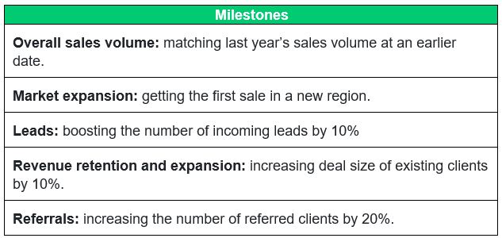
Source: Self-made
When a business owner decides to sell their company or a portion of their company, they create an exit strategy. There are a number of frequent departure methods for business owners, including initial public offerings (IPOs), strategic acquisitions, and management buyouts (Abrams, 2003). As long as the company is earning money, an exit plan may be devised that allows the business owner to either reduce their ownership in the company or depart the firm entirely. An "exit strategy" or "exit plan" might be implemented if the firm is losing money.
Additionally, different exit plans provide varied degrees of liquidity for small-business owners. For example, a strategic purchase can provide the most liquidity in the quickest length of time if the transaction is structured correctly (McKeever, 2018). For example, an IPO may not be the greatest exit plan during a recession or when interest rates are high, and a management buyout may not be appealing to the buyer when interest rates are low.

Financial data
A company's commercial activities and financial success are recorded in "financial statements," which are also known as financial reports. Financial accounts are regularly audited by government agencies, accountants, enterprises, etc. to ensure their correctness and for tax, financing, or investment purposes. • Audits of financial transactions and records (Moro-Visconti, 2021). Cash flow statements are a subset of financial statements known as balance sheets. Assets, liabilities, and stockholders' equity are all shown on a balance sheet. A large portion of an income statement is devoted to keeping track of a company over time. After deducting costs from sales, net income is the company's profit (McKeever, 2018). When calculating a company's capacity to meet its financial obligations, the cash flow statement (CFS) is a good place to start. Data from financial statements are used to assess a company's financial health and predict its stock price trajectory. An audited and reliable financial resource is the company's annual report, which includes its financial accounts. The company's current financial plan includes a profit and loss statement, a cash flow statement, and a balance sheet.

Profit and Loss account
In accounting, a profit and loss statement (also known as a balance sheet) shows how much money a company makes, spends, and spends over a certain period of time. In addition to the balance sheet and the cash flow statement, public companies must release the P&L statement on a quarterly and annual basis (Moro-Visconti, 2021). The P&L statement, balance sheet, and cash flow statement all work together to offer a comprehensive view of a company's financial health. Cash or accrual accounting methods are used to create financial statements. P&L statements should be compared from multiple accounting periods since any changes in the figures over time are more significant than the numbers themselves.
Operating revenue refers to revenue generated by the company's principal activity. A corporation that manufactures a product, or a wholesaler, distributor or store that sells the product, is referred to as a "principal activity" when it comes to generating money. Money from primary operations for a firm (or its franchisees) in the business of providing services refers to the revenue or fees collected in return for those services. Similarly (Pinson, 2008). The term "non-operating recurring revenues" refers to revenue generated by secondary, non-core company activity. Revenues from sources other than the sale of goods and services, such as interest on bank deposits, rental income from real estate owned by the company, royalties paid out, or revenue from advertisements displayed on real estate owned by the company, can be derived from these sources (Moro-Visconti, 2021). Earnings, often known as other income, are the sum of money earned through other activities, such as the sale of long-term investments. Non-business operations, such as the sale of a firm's outdated transportation van, underused property, or a subsidiary company, are included in this category. Receipts are not the same as revenue. When a product or service is sold, or a service is rendered, revenue is typically recorded at the time of the transaction. When money is received, it is recorded as a receipt in the books.
Company's primary activities that are not directly connected to the company's core function SG&A spending, depreciation or maintenance, and R&D costs would be included in such costs. Most budgets include wages, commissions, and other living expenses, such as electricity and transportation (Pinson, 2008). For non-essential operations like interest and fees on debts as well as interest and fees on loans. Long-term assets, one-time or one-off costs, or legal expenses that are involved with a loss-making sale of long-term assets. Although main revenue and expenditures represent the company's commitment and expertise in its core business, secondary revenue and expenses show the company's involvement and skill managing ad hoc, non-core businesses (Moro-Visconti, 2021). The company may be underutilizing its available cash by not growing production capacity or it may be struggling to gain a larger portion of the market due to competition if it is earning a significantly higher interest rate on money that is currently in the bank. Because the firm plant is located next to a major thoroughfare, the management is taking advantage of its resources and assets by renting out billboard space. The following Table 1 includes the income statement of Captain Cook considering estimated figure.
Table 1. Income statement of Captain Cook
 | £ | £
Revenues:
Sales | 50000
Others | 15000
Total revenues |  | 65000
Expenses:
Cost of goods sold | 16000
Salaries and wages | 8000
Transportation costs | 3000
Cost of fixed items | 12000
Advertising expenses | 3000
Research and Development expenses | 2000
Others | 5000
Total expenses |  | (49000)
Net profit |  | 14000
Source: self-made

Cash flow statement
CASH FLOW STATEMENT: A cash flow statement is a financial statement that shows the movement of cash and cash equivalents into and out of an organisation (CFS). In other words, the CFS evaluates a company's ability to generate cash, as well as the efficiency with which it manages its cash. The CFS is intended to be used in conjunction with the financial statements. The CFS is made up of cash from three sources: operational operations, investments, and financing activities (Moro-Visconti, 2021).
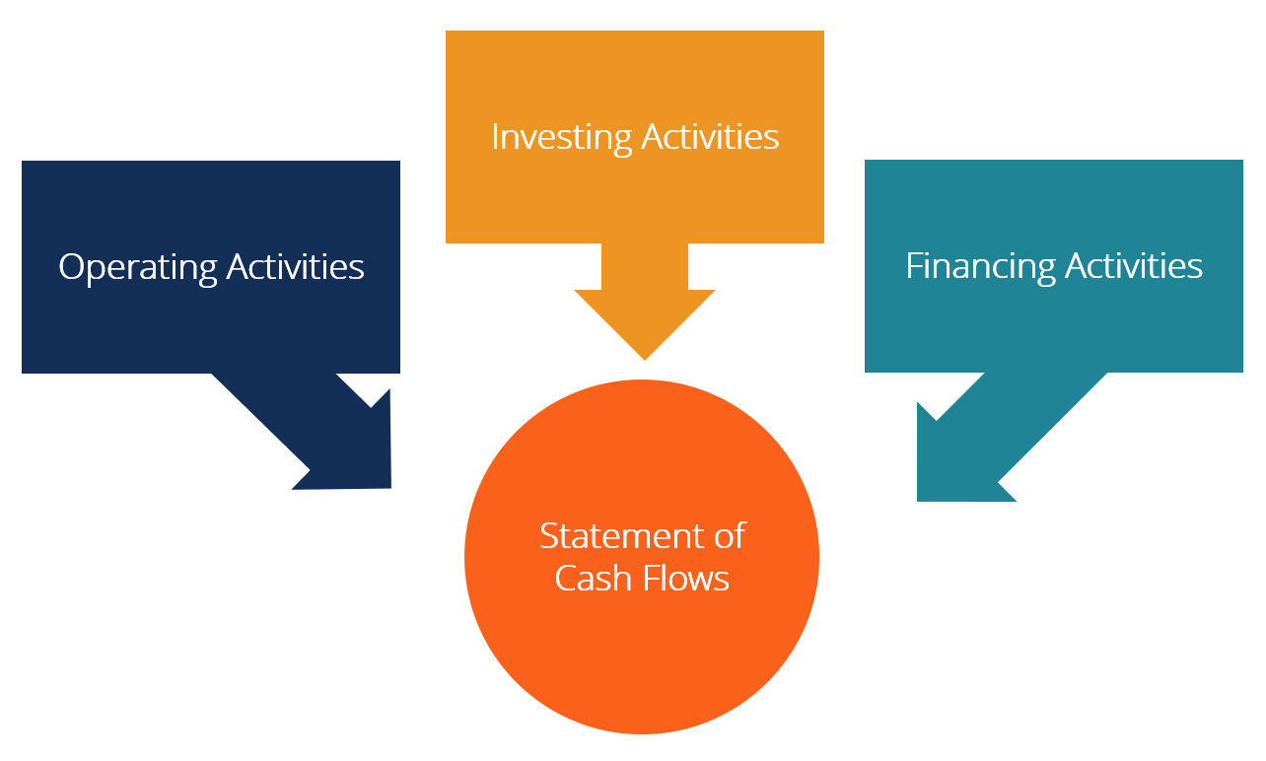
Figure 1: Activities of cash flows statement (CFI, 2021).
Operations are the primary source of revenue for the company. Sales, acquisitions, and other operational costs are often included in the cash flow from operations (Pinson, 2008). It is the acquisition and disposition of non-current assets and other investments that create cash flow from investing activities that are not cash equivalents. A large portion of investment cash flows is made up of the proceeds from the sale of property, plant and equipment (PP&E), non-current assets, and other capital instruments. Changing the quantity and mix of an entity's stock or borrowings generates cash flow, which is used to fund financing activities. The cash flows associated with borrowing and repaying bank loans, as well as the cash flows associated with issuing and buying back shares, are frequently included in financing calculations (Moro-Visconti, 2021). As a financing cash flow, dividend payments are included in the calculation of net income.
In the cash flow statement, interest expenditure can be shown in one of two ways under IFRS. When it comes to reporting operating cash flows, many firms include both interest received and interest paid. Interest received is considered an investment cash flow by some, while interest paid is considered a financing cash flow for others (Pinson, 2008). The finance director makes the choice on which approach to take. Interest paid and received are always considered working cash flows in the United States. There are a number of distinct cash flow measurements used by investment bankers and finance professionals. For DCF valuation, free cash flow is a standard metric. There is no one definition of free cash flow, and it may be measured and used in a variety of ways. Table 2 shows the cash flows statement of Captain Cook.
Table 2. Cash flows statement of Captain Cook
 | £ | £
Cash flows from operating activities:
Net income |  | 14000
Adjustments to net income for reconciling:
Depreciation (12000*5%) | 600
Decrease in accounts receivable | 10000
Increase in accounts payable | 6000 | 16600
Net cash from operating |  | 30600
Cash flows from investing activities:
Fixed assets purchased |  | (12000)
Cash flows from financing activities:
Notes payable |  | 5000
Net increase in cash |  | 13600
Cash at beginning |  | 10000
Cash at ending |  | 23600
Source: self-made

Balance sheet
A balance sheet is a financial statement that lists a company's assets, liabilities, and shareholders' equity (Pinson, 2008). When evaluating a firm, it is one of the three most significant financial statements to consider. As of the date of publication, it provides an overview of a company's financial condition (what it owns and what it owes) and its cash flow (Moro-Visconti, 2021). Balance sheets follow an equation that equates assets with liabilities and shareholder equity. The balance sheet is used to construct financial ratios by fundamental analysts.
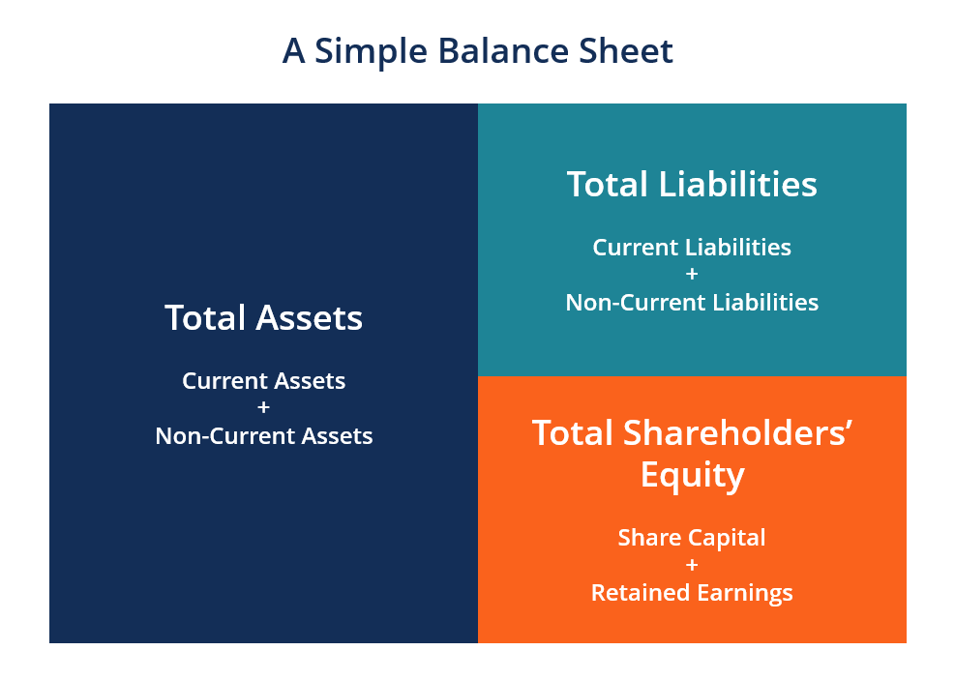
Figure 2: Balance sheet elements (CFI, 2021)
One of the most useful financial statements is this one. It is often possible to compute several financial ratios based on a company's balance sheet, such as its liquidity, its ability to pay its debts, and its efficiency (Pinson, 2008). The cash flow statement also uses changes in balance sheet accounts to determine cash flow. Plant, property and equipment changes are equivalent to capital expenditures less depreciation expenses when they are positive Depreciation expense may be used to compute capital expenditures, which can then be included in the cash flow statement as a cash outflow under cash flow from investment (Moro-Visconti, 2021). For a variety of reasons, the balance sheet is a critical financial statement. In order to gain a complete picture of a company's financial health, it can be seen on its own or in conjunction with other financial statements, such as the income statement and the cash flow statement Table 3 illustrates Captain Cook's balance sheet.
Table 3. Balance sheet of Captain Cook
 | £ | £
Assets
Cash | 23600
Fixed items | 12000
Accounts receivable | 13400
Total |  | 49000
Liabilities and Equity
Liabilities
Accounts payable | 11000
Notes payable | 10000
Total |  | 21000
Shareholder’s equity
Capital stock | 14000
Retained earnings | 14000
Total |  | 28000
Total Liabilities and Equity |  | 49000
Source: self-made

Conclusion
Captain Cook's business location is the subject of this investigation because of its exceptional meals and customer service-oriented culture. There are three levels of management inside the company: home staff, general manager, and executive chief. Customers will prosper if they have a positive mindset. The article details Captain Cook's growth, milestones, and exit strategy with financial facts.

References
Abrams, R.M., 2003. The successful business plan: secrets & strategies. The Planning Shop.
CFI, 2021. Cash flows statement. Available at: https://corporatefinanceinstitute.com /resources/ knowledge /accounting/statement-of-cash-flows/ accessed 5th December 2021.
McKeever, M.P., 2018. How to write a business plan. Nolo.
Moro-Visconti, R., 2021. FinTech valuation. In Startup Valuation. Palgrave Macmillan, Cham.
Pinson, L., 2008. Anatomy of a Business Plan. Aka associates.

